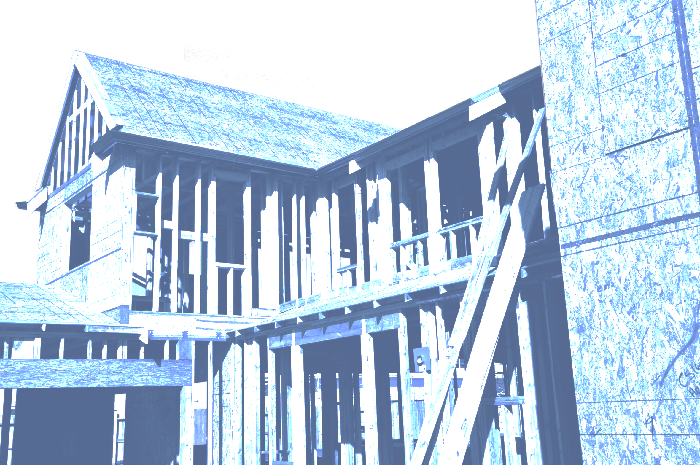

Continuing Education
Certificate of Completion

Completed a Continuing Education Course provided by the Utah Home Builders Association

Completion Date: | Course Instructor: PL Construction
CE Hours: 3 | Course ID: Continuing Education ... Salt Lake City Area

