Weddell Seals: Why did the population crash?

In this assignment, Northland Prep gets to work with B-009, “the Seal Heads” to help find out why the Weddell Seal Population at Big Razorback Island went down during so drastically in 2003. You will be looking at original research data collected by the scientists in Antarctica. Your conclusions will be sent to Dr. Jen Mannas (the scientist in the video).

Assignment:

- In groups of 4 spend 10 - 15 minutes carefully studying the data and graphs.

- With your group, formulate a hypothesis (an idea or theory) on why the seal population was lower in 2004 and what allowed the recovery in 2005, 2006 and 2007. You should be prepared to discuss and defend your hypothesis in front of the class with concrete examples from the data.

- Answer the following questions either on a whiteboard or on the worksheet. Answering the questions will help you to refine your hypothesis.

Questions:

- List 5 reasons that the Weddell Seal population could have been so much lower in 2004 compared to the historical average?
__________________ _____________________
__________________ _____________________
__________________ _____________________

- Which scientific data best correlates (compares) to the decline and then the recovery of the Weddell Seal population?
__________________ _____________________

- What is your hypothesis (idea) for the decline and the recovery in the Weddell Seal population at Big Razorback Island? Make sure that you reference at least 2 verifiable facts from the data/graphs.
_______________________________________ _______________________________________ _______________________________________
_______________________________________

- Are there variables that you think need to be studied that were not contained in the data? Are there pieces of information missing from the big picture?
_________________________________________ _________________________________________ _________________________________________

- If the Weddell Seals at Big Razorback Island, were the last 2000 Weddell Seals left on earth (fortunately they are not), what recommendations would your group make to help them survive?
_________________________________________ _________________________________________ _________________________________________
_________________________________________
_________________________________________ _________________________________________

- (Optional – Extra Credit) Please add any ideas, thoughts or comments you have for Dr. Mannas or B-009 on the back.

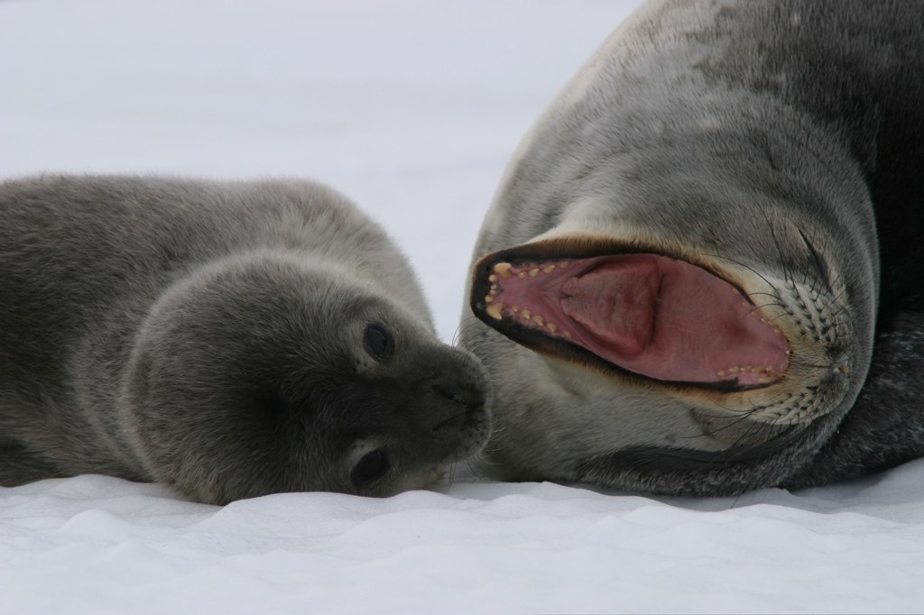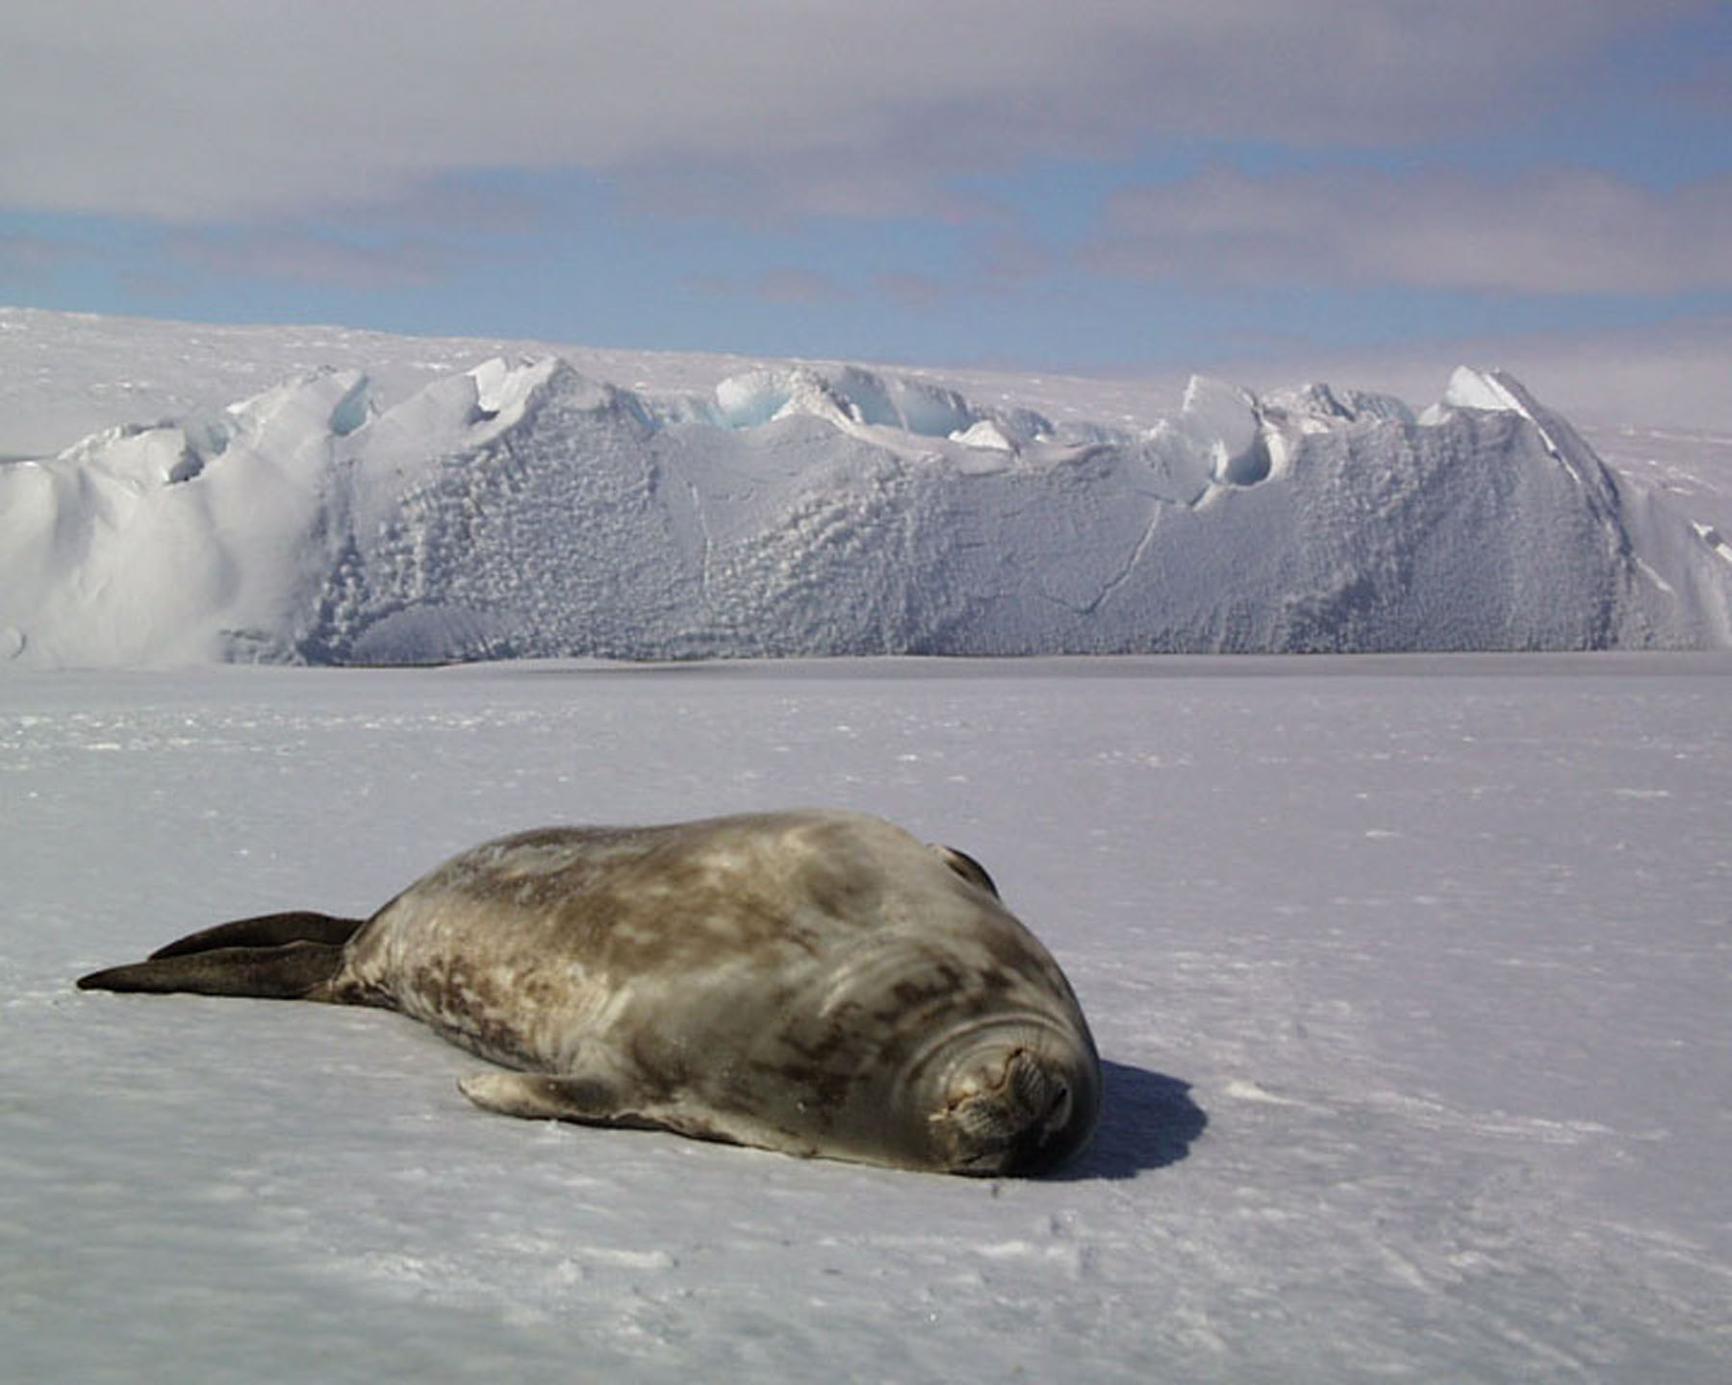
Special Thanks to Dr. Jen Mannas, B-009, The National Science Foundation, US Antarctica Program, and to Jackson Hole High School and all of the great students there.

