Watershed to Ocean: An Adventure in Project-based learning.
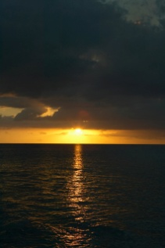
What is a watershed? What does a watershed have to do with the ocean? The ocean offers human beings plentiful and valuable resources. Since the first explorations of the sea, the ocean has offered adventure for those who were willing to challenge its magnificence. Let us start at a watershed and wind our way to the nearest ocean. Five students will work their way down a major river system to the ocean discharge. The students are as follows: Owen will track the Colorado River to the Gulf of California, Taylor will follow the mighty Mississippi River discharge into the Gulf of Mexico, Lexi will trace the St. Lawrence River discharge into the Gulf of St. Lawrence, Hailey will follow the cool Columbia River to the Pacific Ocean Basin, and Megan will focus on the Susquehanna discharge into the Chesapeake Bay Watershed.
Owen:
Read “Climatic Fluctuations, Drought, and Flow in the Colorado River Basin” at http://pubs.usgs.gov/fs/2004/3062/pdf/fs2004-3062_version2.pdf
Taylor:

Read: “Mississippi River Sediment Plume” AT
http://visibleearth.nasa.gov/view_rec.php?id=1650
Lexi:
Read “NASA MODIS Image of Sea Ice in the St. Lawrence River” at
http://spaceref.ca/missions-and-programs/nasa/aqua-satellite/nasa-modis-image-of-sea-ice-in-the-st-lawrence-river.html
Hailey:
Read: “Mapping Ancient Shorelines”
at http://oceanexplorer.noaa.gov/projects/02lewis/midcruise/midcruise.html
Megan:
Read “Modeling Circulation and Larval Transport in the Chesapeake Bay”
at http://www.ccpo.odu.edu/Circulation/1994/fall1994.html
Ideas:
“Watershed Activities to Encourage Restoration”
http://www.watershedactivities.com/projects/fall/h2omodel.html
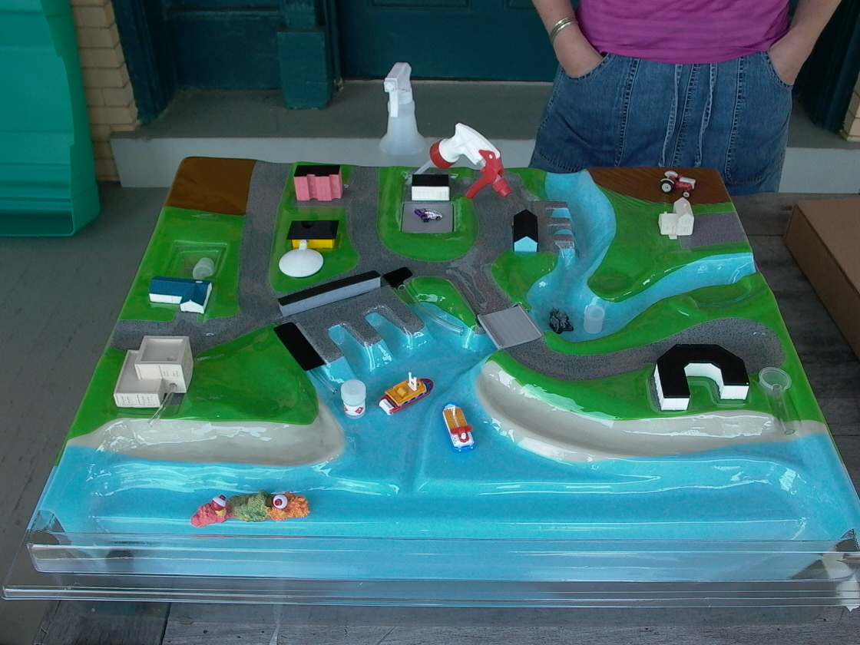
http://www.cleanoceanaction.org/index.php?id=111

