Force, gravity and motion Unit Plan
Background information
The Unit will be taught at Pencader Business and Finance Charter High School located in New Castle, Delaware. The school campus lies on the banks of the Delaware River just south of the city of Wilmington. The school is in an industrial/ commercial complex. Pencader has an enrollment of 405 students. The unit be the opening segment of the honors physics class. This class consists of 25 students. The class of 23 twelfth graders and 2 eleventh graders has 12 females and 13 males. The ethnic backgrounds are very diverse with students that have ties to India, Pakistan, Egypt, Serbia and Africa. There are six Caucasian students. Many of the students have been in classes with the researcher or have been On the Science Olympiad team coached by the researcher. Eleven students have not been in a class taught by the researcher.
Pencader Charter High School is a six year old stand-alone public school that is the only business school in the state. The school has been under formal financial review by the Delaware board of Education for three years. In Delaware, charter schools receive less funding per student than public schools that are not charter schools. The funding is sixty percent of the amount per student. Charter schools must find funding sources to balance the costs and Pencader Charter has had difficulty raising the need funds. The formal reviews have created an exodus of students from a high attendance of 635 to the current number of 405. The students that have stayed either want to be at Pencader or do not want to attend their feeder school. In the honors physics class, the students consist of more of the former than the latter. The class meets during the fifth and last block of the school day so often athletes are dismissed early.
The curriculum for the class consists of extensive use of models to each physics concepts. The students will engineer a roller coaster, a bridge made of spaghetti, two water bottle rockets, an airplane and a boat. The models will be tested and the testing data analyzed. This curriculum is very time consuming and the unit plan will include using a flipped classroom model to help create the time needed for the modeling activities while maintaining the scope of the material. This unit has been part of the Thinkforward webinar series about pictures of practice showing how STEM activities can be used in the classroom

Unit Questions
How are forces and motion related?
What does motion tell us about the forces acting on an object?
How can we calculate values for motion?
How can we calculate values for forces?
How can graphs show motion?
How does motion look on a graph?
Unit objectives
The students will be able to describe the different types of motion.
Students will be able to describe the different types of forces.
Students will be able to calculate forces and motion values.
Students will be able to use graphs to describe forces and motion.
Students will be able to graph forces and motion.
Students will be able to describe the relationship between forces and motion in complex systems including roller coasters and water rockets.
Students will be able to use math to describe motion
Students will be able to use writing to describe motion
State of Delaware Standards
Science Standard 1 Nature and the application of Science and technology
Understand that: Scientists conduct investigations for a variety of reasons including to explore new phenomena, to replicate other’s results, to test how well a theory predicts, to develop new products, and to compare theories.
Be able to: Identify and form questions that generate a specific testable hypothesis that guide the design and breadth of the scientific investigation.
A. Understand that: Science is distinguished from other ways of knowing by the use of empirical observations, experimental evidence, logical arguments and healthy skepticism.
Be able to: Design and conduct valid scientific investigations to control all but the testable variable in order to test a specific hypothesis.
C. Understand that: Theories in science are well-established explanations of natural phenomena that are supported by many confirmed observations and verified hypotheses. The application of theories allows people to make reasonable predictions. Theories may be amended to become more complete with the introduction of new evidence.
Be able to: Collect accurate and precise data through the selection and use of tools and technologies appropriate to the investigations. Display and organize data through the use of tables, diagrams, graphs, and other organizers that allow analysis and comparison with known information and allow for replication of results.
D. Understand that: Investigating most real-world problems requires building upon previous scientific findings and cooperation among individuals with knowledge and expertise from a variety of scientific fields. The results of scientific studies are considered valid when subjected to critical review where contradictions are resolved and the explanation is confirmed. Be able to: Construct logical scientific explanations and present arguments which defend proposed explanations through the use of closely examined evidence.
E. Understand that: In communicating and defending the results of scientific inquiry, arguments must be logical and demonstrate connections between natural phenomena, investigations, and the historical body of scientific knowledge. (American Association for the Advancement of Science, 2001)
Be able to: Communicate and defend the results of scientific investigations using logical arguments and connections with the known body of scientific information.
F. Understand that: Knowledge and skill from sources other than science are essential to scientific inquiry. These include mathematics, reading, writing, and technology.
Be able to: Use mathematics, reading, writing and technology when conducting scientific inquiries.
Science Standard 3 Energy and Its Effects
The flow of energy drives processes of change in all biological, chemical, physical, and geological systems. Energy stored in a variety of sources can be transformed into other energy forms, which influence many facets of our daily lives. The forms of energy involved and the properties of the materials involved influence the nature of the energy transformations and the mechanisms by which energy is transferred. The conservation of energy is a law that can be used to analyze and build understandings of diverse physical and biological systems.
A. Forces change the motion of objects. Newton’s Laws can be used to predict these changes.
B. Forces are mechanisms that can transfer energy from one object to another. A force acting on an object and moving it through a distance does work on that object and changes its kinetic energy, potential energy, or both. Power indicates the rate at which forces transfer energy to an object or away from it.
C. An object has kinetic energy because of its linear motion, rotational motion, or both. The kinetic energy of an object can be determined knowing its mass and speed. The object’s geometry also needs to be known to determine its rotational kinetic energy. An object can have potential energy when under the influence of gravity, elastic forces or electric forces and its potential energy can be determined from its position.
Rationale
This unit plan strung out of my workshop. I know how educational my Hot Wheels track system was for teaching the relationships between gravity and motion. I learned about the effect of gravity on projectile motion from throwing rocks, footballs, baseball and anything else. The rationale behind this unit lies in the question “how do you create enduring understanding”? Most educators would answer that the students need multiple exposure to the same concept. So here we are going to use three physic projects or activities to, hopefully allow students to create a durable understanding of the relations in forces and motion that rule everything that moves. A secondary rationale is tied to the concept of describing motion and forces. I have found that the students can make a graph but they are lacking in the skills required to read a graph and or interpret data from a graph. An example that highlights this statement is the difference between a speed graph being a straight line with no slope and an acceleration graph being a straight line with no slope. When we start those graphs mean the same to the students, no change in speed, but after a while the students begin to try to picture the motion shown in the graph. This point of understand is where we are trying to lead them.
Overview
The unit starts with motion in one dimension and ends with trajectory calculations. First the students with get an idea of the forces present thru computer simulations on the Phet site. When they have a handle on free-body diagrams we will begin the unit. The first lesson uses a product called Blue Track and Hot Wheels cars. The groups of students are given a paper with seven speed graphs and five acceleration graphs. They must work with the track and come up with track set ups that will make the car’s speed or acceleration match the graph. Then they must justify in writing why they believe that their track set up matches the graph. The graphs do not have numbers or units so the solutions are infinite. Students show their understanding by presenting novel solutions instead of just mimicking the graph with the track.

Outline
- Forces in one dimension via simulations
- Blue track activity
- Roller coaster construction and evaluation
- Foam rocket construction and trajectory calculations
- Four to five weeks
Lesson plans and NASA Resources
Blutrack
http://www.blutrack.com/
Assessment: The assessment for this activity come from the written lab report where each student has to explain how they set the track to make the motion of the car match the graph. The written justifications are a good measure of the student’s understanding of the physics principles and how they apply to this simple activity.
The lesson can be extended by this activity. In the blue track lab the acceleration graphs are the hardest to understand. In this activity the students make accelerometers to help them understand motion.
http://www.nasa.gov/audience/foreducators/topnav/materials/listbytype/Accelerometers.html
Roller Coaster
Assessment: Formal lab write up, Data analysis and presentation of data analysis.
Foam Rocket investigation
Main resource
http://www.nasa.gov/audience/foreducators/topnav/materials/listbytype/Rockets.html
Resource for activity
http://www.nasa.gov/audience/foreducators/topnav/materials/listbytype/Foam_Rocket.html
Resource for further investigation
http://teachspacescience.org/graphics/pdf/10000799.pdf
Assessment: Data tables.
Blue track activity / lesson plan
Time 3 days block schedule (85 minute period)
Objectives
This activity is designed to show twelfth grade students that they are not reading graphs as well as they believe.
Promote understanding, interpolation and interpretation of graphs.
Utilize previous force diagrams (free body) to justify motion.
Extend understanding of speed to acceleration. Students have a good understanding of speed but a poor understanding of acceleration and this activity helps create higher level thinking about the relationships between speed and acceleration.
Writing a justification for equipment set up. Students have not developed the skills to use science terminology in a persuasive writing assignment. They need practice and this activity allows for practice. Activities that follow this lab (Roller Coaster) will require the skills practiced here.
Essential question: What information can a graph display about the motion within a system?
Activity
Each group (3-4) of students is given a two meter section of Blue Track, two match box cars and a sheet of graphs with seven speed graphs and five acceleration graphs like the one below. The objective is to construct a track layout the created the changes in speed shown on the graph. This sounds easy but it is not as easy as it looks. The second part of the activity has the students using the same graph but now they need to set the track up to show acceleration changing as on the graph.
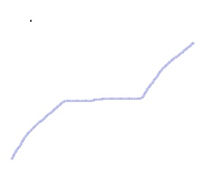
Even though they work in groups each student must turn in a write up the shows how the track was set-up and justify how that set-up created the desired change in speed of or acceleration. The acceleration section proved very difficult.

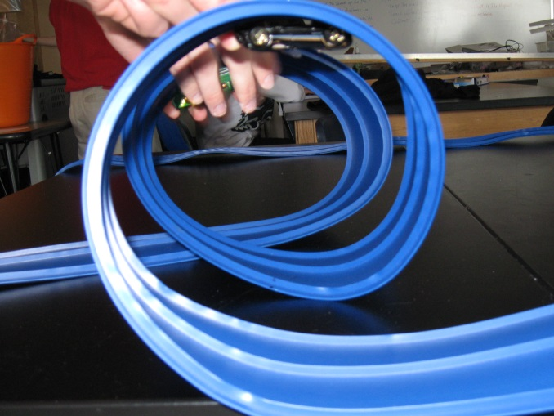

Roller coaster construction and evaluation activity lesson plan
Time: 2 weeks to 2 ½ weeks for construction then four days for evaluation of data.
Objectives:
Construct a roller coaster using foam pipe insulation and cardboard. It must be at least 1 meter high and 1.5 meters long. The entire structure must fit on a lab table (2 x 4 feet). A ball will roll on the track.
Analyze the data from the roller coaster
Lab activity begins when the roller coasters are constructed.
Roller coaster data collection
- Students use meter sticks to measure the height of the ball at 5 centimeter intervals on the track.
- Students calculate potential energy for each position. (mass of ball 28 grams)
- Students derive kinetic energy for each position
- Students use derived Kinetic energy to calculate velocity of the ball.
- Students use video analysis to measure actual velocity of the ball.
- Individual lab reports analyzing the data are submitted for grades
- Charts comparing data are constructed and the groups prepare a presentation on their data. The presentation should be based upon trends revealed by the data,
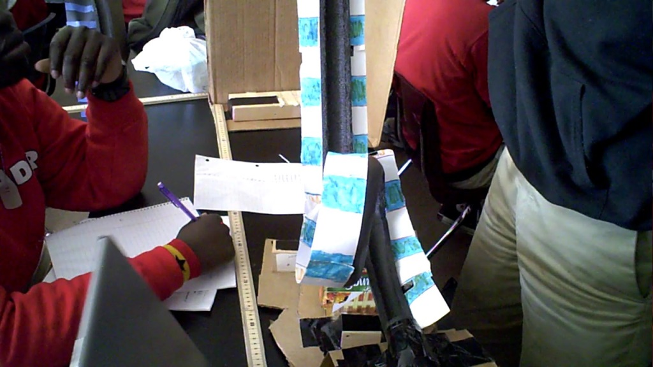
Using video for analysis

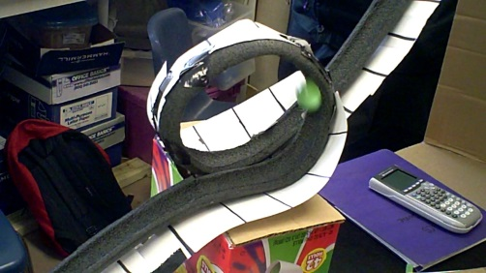
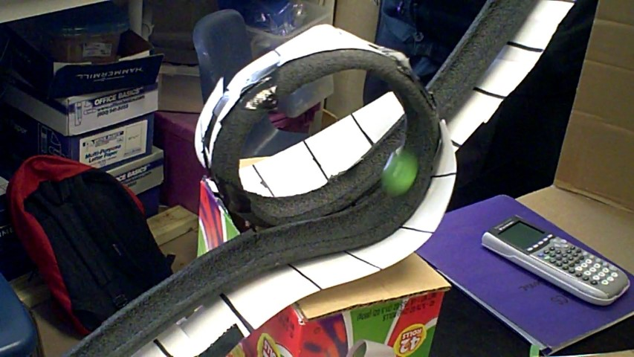

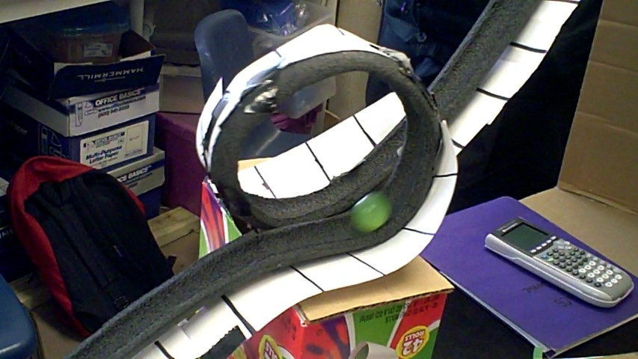

Foam Rocket construction and data analysis lesson plan
The first two lessons are of my own construction but for this lesson I use a resource from the Educators Guide to Rockets available from NASA. This section is located at the following web address.
http://www.nasa.gov/audience/foreducators/topnav/materials/listbytype/Foam_Rocket.html
The foam rocket is easy to build and can be used with any age group. To make this more revenant for my seniors I have extended the calculation section to include launch velocity, horizontal velocity, vertical velocity, time aloft and maximum height. This activity is a prelude to the water rocket building investigation that follows. This activity is designed to be quick to build but its real purpose is to introduce rocket aerodynamics and rocket trajectory calculations.
- Build the foam rocket and launcher
- Launch the rocket twenty times at different angles
- Half the angles should be below 45 degrees and the rest above 45 degrees
- Measure the distance the rocket travels.
We do this part in the gym because wind will change the flight distance significantly.
From the angle and distance we can calculate the other aspects of trajectory.
- Launch velocity = square root of distance (range) time gravity divided by 2 time the sine of the launch angle 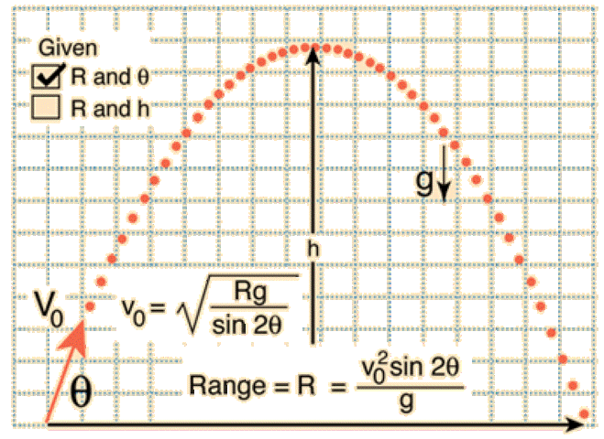
- Vertical velocity = launch velocity times sine of launch angle
- Horizontal velocity = launch velocity times cosine of launch angle
- Time of flight 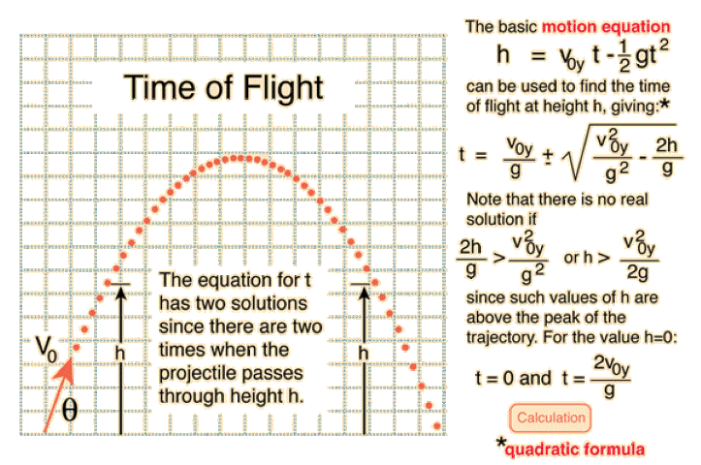
- Maximum height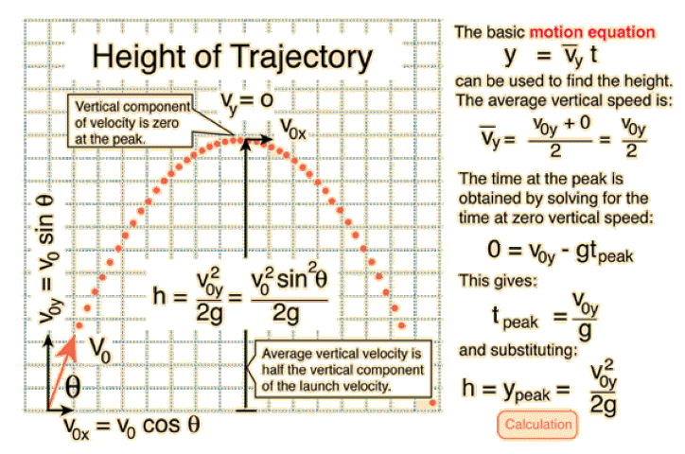
These calculations prepare the class for the air rocket and water rocket activities that follow and provide a fun method of incorporating math skills into science class by using an authentic activity

The equations and graphics come from Hyper Physics http://hyperphysics.phy-astr.gsu.edu/hbase/traj.html#tracon
This site is linked to my physics web site. https://sites.google.com/site/physicsmrblanch/

