Title: Climate Changes' Negative Biological Change on the Arctic Treeline
Authors: Raya-Jean Zaczyk School: Bow Memorial School Due Date: Nov. 13, 2011
Introduction:

Climate Changes' Negative Biological Change on the Arctic Treeline

Hypothesis: Will continued global climate change decimate the arctic Tundra/Taiga ecotone in favor of a Taiga biome throughout the polar ecosystem endangering the animals, vegetation, and wildlife along with the indigenous way of life forever?
The Indigenous or native people of the arctic and western scientists have noticed a change in the polar ecosystem. These changes are affecting the arctic peoples' way of life and that of the environment in which they live making it very important to all life, not just the indigenous people living in the area. Starting with the smallest animals, humans, insects, and sea life any life dependent on the arctic ecosystem is now facing climate changes that could make them extinct if these continue to negatively affect the arctic food web. Humans and animals are most notably affected by the changes to the arctic food web as changes in the vegetation at the Tundra and Taiga treeline become increasingly more common on a daily basis. A sustained climate change in this ecosystem spirals in the food web conversely affecting all living things. An example is the reindeer or the migrating wildlife, which is dependent on the arctic habitat to sustain them on their journey to and from breeding grounds, that could end up in a grocery store then on our dinner plate.
A plants' ability to produce food and energy for survival via photosynthesis in the active layers of permafrost has different requirements for sunlight, temperature, and water depending on its preferred habitat. Polar willow plants for instance had adapted to living with very shallow roots, required minimal water, and compact leaves (some covered in hairs) to survive in the extremely harsh Tundra conditions. Indigenous peoples' accounts have documented changes in both plant and root growth of some plant species including the polar willow, which now have grown upwards and not just close to the ground. The arctic people also have noticed a change in the increased diversity of the plants in their environment including more plant species or animals that have a higher dependence on sunlight that need to survive on Taiga land and its' food sources throughout the year. Currently, Tundra areas of the polar environment which previously allowed the lichens, mosses, and polar willow to thrive, are reacting to changes in temperatures along with increased precipitation and lower winds. The collision of the Taiga treeline advancing into Tundra lands at the ecotones is upsetting the delicate balance of the arctic tree line that has existed for centuries at an alarming rate. These climate changes are evidenced in huge population growths across planet Earth, the introduction of a modern human economy dependent on burning fossil fuels and a throw away lifestyle, all which have exponentially increased greenhouse gases. These climate changes have caused glaciers to melt rapidly further endangering the planet's fresh water supply and populations.
Indigenous knowledge expressed through literature or firsthand accounts of what foods they survived on year round along with western science through core samples, photographs, and satellite data readings have all documented monumental changes occurring in the polar regions caused by climate change. Local reindeer herders are impacted by the amounts and types of vegetation (protein content) available to the herds for their growth and survival throughout the year, which affect their animal populations and the ability of the herders to make a living in a global economy. The melting permafrost from increased temperatures has caused stability problems for buildings, vegetation, and transportation throughout the area as the active layer turns to water.
Results:
Piece of Evidence #1:
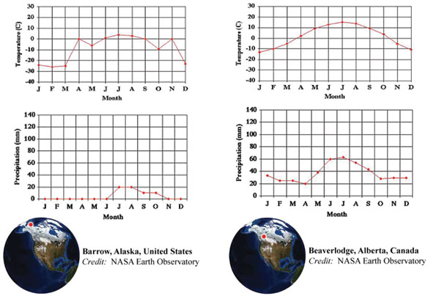
The temperature and precipitation are shown in the graphs detailing the differences in the Tundra and Taiga biomes. This shows how vastly different the conditions are for the amount of yearly precipitation and temperatures with the Tundra values only above freezing for three months during summer while the Taiga is unfrozen twice that amount of time. The precipitation amounts demonstrate the drier for eight months of the year and barely any precipitation when it does occur. Conversely the Taiga has precipitation each month of the year with about three times as much in the summer months alone than the Tundra receives in multiple years combined.

Piece of Evidence #2:
Scientists who study trees near the treeline have noticed changes in the way trees are growing. The tree below is not a White spruce, but is a similar tree, a Siberian larch. It grows at the treeline in central Russia. As temperatures have increased near the treeline, trees that used to look more like Picture a below, now look like Picture b or c.
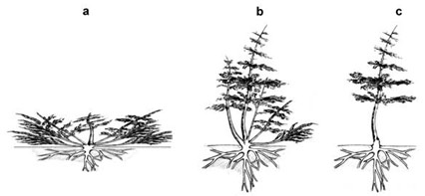
Three different growth forms of the Siberian larch tree.
Credit: Russian Academy of Sciences, Global Change Biology 2008.
The evidence for climate change in Tundra plants are shown in the above Siberian larch tree. It has adapted to the temperature changes by increasing the height of its leaves and the upward direction in which they now grow. No longer staying small and low to the ground (for temperature and wind protection) they have even grown wider branches. These plants also demonstrate a deeper root system as the permafrost has decreased in depth and duration at the treeline. The table below details the classification of the Tundra and Taiga biomes by definition.
Table 1. Differences between Tundra and Taiga
 | TUNDRA | TAIGA
Trees | No trees or only low-lying trees. Mostly grasses, small plants and shrubs with shallow roots | Many trees including White spruce, moderate to deep root depth
Weather | Very cold and windy. Average July temperatures below 10°C (50°F) | Average July temperature of at least 10°C (50°F)
Frozen Land | Only a thin layer of the ground thaws in summer; this active layer is 40 cm (~16 in) to 80 cm (~32in) thick, mostly continuous permafrost | A slightly thicker layer of frozen ground melts in summer. Active layer thickness 80 cm (~32 in) or more near treeline. Permafrost varies greatly from continuous to discontinuous/sporadic to none
Rainfall | Little rainfall | Greater rainfall

Piece of Evidence #3:
This is a short video from a Teachers' Domain/PBS/WGBH and native Inuit peoples' collaboration on climate change with western scientists. It details how important Indigenous Knowledge is, and evidences the changes in a local area over a sustained period. This vast knowledge chronicles the observations of the villagers from many various relationships and connections to the environment, not just a quick study when it is easy to use western equipment. http://www.teachersdomain.org/asset/ipy07_vid_inuitobserv/
Methods:
To begin this investigation I read and worked through the background information, investigative data of all kinds and drew conclusions as follows:
I read the background information in the Arctic Treeline investigation starting with the overview and documents in each of the Air, Land, Life, and Water categories on the SPRINTT website. As windows and questions opened up I answered them making inferences, hypothesis, and a final conclusion. The data was expressed in charts, graphs, maps and photographs, which all showed convincingly that climate change is occurring worldwide. Having firsthand accounts of living witnesses and historical literary accounts detail enormous differences in the polar weather conditions and the landscape. Scientists even told local Inuit people they were not having thunderstorms, because it was too cold where they lived, yet they experienced them all the same.
I looked at map evidence and compared the minimal prior background knowledge I had about the region to the detailed satellites showing the shrinking of the glacial and sea ice and treeline advancement. It made me believe that the arctic Tundra I saw at Denali National Park in 1990 was also being negatively affected by climate change. Knowing how delicate the balance of life surviving in the Tundra was, next I looked into the affects of climate change on the reindeer populations as evidenced by the local herders. This gave information on how the lower protein rich plants are replacing the Tundra plants at the Tundra/Taiga ecotones and adversely affecting the animal populations and herders' profits.
Then pulling all this information together I came up with a hypothesis of : Will continued global climate change decimate the arctic Tundra/Taiga ecotone in favor of a Taiga biome throughout the polar ecosystem endangering the animals, vegetation, and wildlife along with the indigenous way of life forever?
Discussion:
I believe global climate change is negatively impacting all forms of life in the arctic polar regions. My hypothesis: (Will continued global climate change decimate the arctic Tundra/Taiga ecotone in favor of a Taiga biome throughout the polar ecosystem endangering the animals, vegetation, and wildlife along with the indigenous way of life forever?) is proven correct. The Background and Overview knowledge given in the SPRINTT website/resources details major climate change in recent years resulting in:
- 1. Taiga encroaching further north into historical Tundra areas.
- 2. Taiga/Tundra ecotones changing worldwide.
- 3. Precipitation changes that show increases in Tundra and Taiga values.
- 4. Permafrost melting sooner and deeper in depth, and not refreezing as quickly, and
- 5. Temperatures increased in the polar areas causing an earlier spring, icepack melting, early vegetative growth, and delayed fall.
The negative impacts of climate change affects the Indigenous people first and foremost in their available food supply from all areas of their environment by decreasing edible vegetation and fish/sea mammal populations that are accessible in traditional ways. The melting of the permafrost is negatively impacting many Indigenous people's homes, which are no longer structurally sound in the wet, sinking ground. A follow up study could collect evidence from a variety of indigenous tribes from all the different areas of the arctic environment to compare how climate change has impacted availability of their traditional or cultural food sources. This would give western scientists an important comprehensive look at how life is changing throughout the arctic as a whole, not just data on little sections that are easily studied in a summer season.
Another follow up study could detail the foods the natives are using to supplement their shrinking diets of sea mammals, fresh water fish, and reindeer, caused by climate changes to determine if they now have cholesterol or other problems (cancers or vascular) commonly associated with a modern western diet compared to their ancestors. (A similar problem with high rates of diabetes and alcoholism have been documented in other indigenous populations around the world as they were removed from their native lands).

