THE EFFECT OF AN AGENT ADVERTISED TO REDUCE THE VISIBLE SIGNS OF AGING ON FACIAL SKIN
METHODS OF STEM - SCIENCE PROJECT SUSAN HALLSTROM
RESEARCH TOPIC
Do so-called “anti-aging” products work? I have reached the age where my skin, especially my facial skin in the areas around my mouth, eyes, and neck, is showing the effects of age. I have wrinkles and I don’t like them.
To combat the effects of aging, I purchased a two part skin care product from Mary Kay cosmetics, TimeWise Day Solution and Night Solution. The active ingredients listed on the label for the Day Solution include octinoxate, octisalate, zinc oxide and oxybenzone. The Night Solution must be proprietary because no ingredients are listed on the label. The directions state to apply the products to clean skin – the Day Solution in the morning and the Night Solution before bed.
My question is:
Will use of the Mary Kay TimeWise Day and Night Solutions in accordance with the directions provided visibly reduce facial wrinkles in the area around my mouth?
My hypothesis is:
I believe that I will notice a minimal improvement in the firmness of my facial skin if the products are used as directed. The maximum decrease in visible wrinkles may not be realized in thirty days.
INTRODUCTION
Many anti-aging creams, gels, etc. are available. The ingredients vary widely. I chose to try the Mary Kay products because I have been a Mary Kay cosmetic user for twenty years and I have a level of confidence in the quality of their products.
The product descriptions from the Mary Kay website follow:
TimeWise® Night Solution
A unique delivery system of encapsulated vitamins and antioxidants combined with collagen-enhancing peptides help fade away deep lines and wrinkles. Nutribeads® microcapsules are vitamin-packed. Rest assured your skin is being revitalized while you sleep. (1)
TimeWise® Day Solution Sunscreen SPF 25*
Think of it as a veil of defense. With an SPF of 25, this innovative product helps prevent sun damage such as lines and discoloration before they occur by blocking damaging UVA/UVB rays. A calming peptide helps relax expression lines. (2)
The Day Solution is primarily a sunscreen. The ingredients that are supposed to combat the signs of aging are contained in the Night Solution.
(NOTE: Contacted Mary Kay Cosmetics on April 11, 2010 to request active ingredients in the Night Solution. Currently, I have not been successful in obtaining the ingredients directly from Mary Kay Cosmetics)
The unofficial and unvalidated Night Solution ingredients I found via internet solution follow in the next section of this report.
The MayoClinic.com site asks a question similar to my project’s questions. Their question and answer follow:
“Do over-the-counter wrinkle creams really reduce the appearance of fine lines and wrinkles? The answer depends on many factors. Many wrinkle creams and lotions sold in department stores, in drugstores and on the Internet promise to reduce wrinkles and prevent or reverse damage caused by the sun.
Do they work? Research suggests that some wrinkle creams contain ingredients that may improve wrinkles. But many of these ingredients haven't undergone scientific research to prove this benefit.
If you're looking for a face-lift in a bottle, you probably won't find it in over-the-counter (nonprescription) wrinkle creams. But they may slightly improve the appearance of your skin, depending on how long you use the product and the amount and type of the active ingredient in the wrinkle cream.” (4)
This site provides general information regarding the effectiveness of a variety of active ingredients commonly used in wrinkle creams. The MayoClinic.com information regarding active ingredients follows:
- “Retinol. Retinol is a vitamin A compound and is the first antioxidant to be widely used in nonprescription wrinkle creams. Antioxidants are substances that neutralize free radicals — unstable oxygen molecules that break down skin cells and cause wrinkles. Retinol is less potent than the vitamin A derivative tretinoin, a topical treatment approved by the Food and Drug Administration (FDA) for treating wrinkles. Tretinoin is available only by prescription. Avoid vitamin A derivatives if you are pregnant or may become pregnant because they increase the risk of birth defects.
- Hydroxy acids. Alpha hydroxy acids, beta hydroxy acids and poly hydroxy acids are all synthetic versions of acids derived from sugar-containing fruits. These acids are exfoliants — substances that remove the upper layer of old, dead skin and stimulate the growth of smooth, evenly pigmented new skin. Because hydroxy acids increase your susceptibility to sun damage, always wear sunscreen during use and for at least one week afterward.
- Coenzyme Q10. Coenzyme Q10 is a nutrient that helps regulate energy production in cells. Some studies have shown reduction in fine wrinkles around the eyes with no side effects. Other studies show that application before sun exposure protects against sun damage.
- Copper peptides. Copper is a trace element found in every cell. In products applied to the skin, it's combined with small protein fragments called peptides. Copper peptides enhance wound healing. They also stimulate production of collagen and may enhance the action of antioxidants.
- Kinetin. A plant growth factor, kinetin may improve wrinkles and uneven pigmentation with minimal irritation. It's unclear how it works, but it may help reduce wrinkles by helping skin retain moisture and by stimulating the production of collagen. It may also be a potent antioxidant.
- Tea extracts. Green, black and oolong tea contain compounds with antioxidant and anti-inflammatory properties. Green tea extracts are the ones most commonly found in wrinkle creams” (4)
Two of the ingredients that Mayoclinic.com list as potentially effective in reducing the signs of aging are contained in the Mary Kay products. These two ingredients are retinol and the hydroxyl acids. Several other ingredients are moisturizing agents. These moisturizing agents provide protection against future signs of aging.
INGREDIENTS – THESE INGREDIENTS HAVE NOT BEEN VALIDATED!
The product is clear, yet some of the ingredients included in this list are dyes or colorants. A brief description of the chemical properties and cosmetic properties is included for selected ingredients.
Water
Butylene Glycol: a common humectant and solubilizer used in cosmetic and food preparations. Its safety and usage has been well documented and approved by such agencies as the US FDA, the US EPA, and the CTFA (5)
Glycerin: Glycerin (also referred to as glycerol) is a skin-friendly humectant which attracts water to the skin as well as a binding ingredient that occurs naturally in vegetable, as well as animal lipids. (6)
1-Methylhydantoin-2-Imide: helps to maintain a desirable pH mantle on the skin, and has been demonstrated to inhibit tyrosinase activity in the melanocytes. It can be used in applications such as the skin brightening products and fade creams to improve clarity and eveness of skin tone. (7)
Palmitoyl Oligopeptide: Palmitoyl Oligopeptides (also known as palmitoyl pentapeptide, Dermaxyl, Matrixyl) is a new amino-peptide (five amino acids linked together and attached to a fatty acid) developed by Sederma SA. It is one of the active ingredients found in Fresh Pout Lip Balm, Firming Peptide Eye Creme, Intensive Eye Therapy Creme, and SuperMax Multi-Peptide Skin Solution serum. Researchers have found that palmitolyl oligopeptides, when added to a culture of fibroblasts (key skin cells), stimulates collagen, elastin and glucosaminoglycans production. These are the key components of healthy-looking skin.
Clinically proven to reduce wrinkle depth by increasing hyaluronic acid and collagen production. Like Palmitoyl Pentapeptide-3, Palmitoyl Oligopeptide (PO)is a synthetic protein that is a fragment of collagen combined with palmitic acid to make it more lipophillic, to improve its stability and to enhance its affinity towards human skin. As with Palmitoyl Pentapeptide-3, one could look at PO as a man-made precursor to collagen. PO was developed through research to identify a substance that would behave similarly to retinoic acid but without its drawbacks, especially in regards to synthesizing collagen.
(8)
Palmitoyl Tetrapeptide-3: Palmitoyl Tetrapeptide-3 has been clinically proven to suppress the body's production of interleukins, the chemical messengers that trigger inflammation. Palmitoyl Tetrapeptide-3 is a synthetic peptide that is a fragment of immunoglobulin G that has been combined with palmitic acid to make it more lipophillic and thus enhance its affinity towards human skin. Palmitoyl Tetrapeptide-3 was discovered through research to learn how to suppress the body's production of interleukins, particularly IL6, since these are the chemical messengers that trigger the body's acute inflammatory response.
The hormone DHEA is directly responsible for maintaining the regulation of the production of IL6. This has even been demonstrated in the skin: when DHEA is present in sufficient amounts it is converted into a steroid hormone, androstenediol, which is directly responsible for maintain IL6 production and for maintaining local homeostasis of cytokine and interleukin production. As we age, DHEA is reduced and this directly leads to cytokine deregulation and the over-production of some interleukins and the under-production of others. As mentioned above, IL6 production is increased with negative consequences. Since UV radiation can increase IL6 production by five times, this process can significantly impact the skin. (9)
Tocopheryl Acetate: Tocopherol, or vitamin E, a fat-soluble vitamin is a naturally occuring antioxidant which can be isolated from vegetable oil. When isolated Tocopherol, is a viscous oil that varies in color from yellow to brownish red.
Rather than Tocopherol itself, esters of Tocopherol are often used in cosmetic and personal care products. These esters include, Tocopheryl Acetate, the acetic acid ester of Tocopherol; Tocopheryl Linoleate, the linoleic acid ester of Tocopherol; Tocopheryl Linoleate/Oleate, a mixture of linoleic and oleic acid esters of Tocopherol; Tocopheryl Nicotinate, the nicotinic acid ester of Tocopherol; and Tocopheryl Succinate, the succinic acid ester of Tocopherol. Potassium Ascorbyl Tocopheryl Phosphate, a salt of both vitamin E (Tocopherol) and vitamin C (Ascorbic Acid) may also be used in cosmetic products.
Other Tocopherol-derived ingredients that may be found in cosmetic products include Dioleyl Tocopheryl Methylsilanol, which is the dioleyl ether of Tocopheryl Acetate monoether with methylsilanetriol, and Tocophersolan, which is also called Tocopheryl Polyethylene Glycol 1000 Succinate. The addition of succinic acid and an average of 22 ethylene oxide groups to Tocopheryl makes Tocophersolan a water-soluble form of Tocopherol.
In cosmetics and personal care products, Tocopherol and other ingredients made from Tocopherol, including Tocopherol esters are used in the formulation of lipstick, eye shadow, blushers, face powders and foundations, moisturizers, skin care products, bath soaps and detergents, hair conditioners, and many other products. (10)
Vitamin E acetate: a powerful antioxidant, possess sing the ability to increase the moisturizsation of the skin's horny layer and thereby improve surface relief. D-Alpha-tocopheryl acetate is used in topical skin care products.

It appears that it can diffuse into skin cells where it is converted to d-alpha-tocopherol. D-alpha-tocopherol may protect skin against ultraviolet damage and is also a skin moisturizer. (11)

Retinyl Palmitate: Retinyl Palmitate is an extremely common ingredient that you can find in all kinds of anti-aging products. Retinyl Palmitate, sometimes called Vitamin A Palmitate or Retinol Palmitate, is a combination of Vitamin A and Palmitic acid and can be used as a vitamin supplement as well as a topical ingredient.

Vitamin A is a very popular anti-oxidant and is very common in beauty products because it helps fight acne, kills bacteria on the skin, and reduces the amount of oil that your skin produces. Vitamin A in the form of Retinyl Palmitate is often claimed to help make your skin look younger, smoother, and more firm. (12)
Ascorbyl palmitate: The most widely used fat-soluble derivative of vitamin C in skin care. It is nonirritating and more stable than vitamin C. Furthermore, ascorbyl palmitate is a fat-soluble antioxidant and is at least as effective as vitamin E in protecting the skin from lipid peroxidation (a key type of free radical damage in the skin). Unfortunately, it appears that the concentrations of ascorbyl palmitate achievable in skin care formulas do not boost collagen synthesis as much as vitamin C.
Numerous skin care products containing ascorbyl palmitate are commercially available. When buying products with ascorbyl palmitate (or other vitamin C-derived skin care for that matter), it is best to choose colorless or white formulation. That way you can spot the advanced stages of oxidation of the active ingredient by the emergence of a yellowish tint. Unfortunately, the lack of tint does not guarantee complete lack of oxidation because the early oxidation products are colorless. (13)
Crithmum Maritimum Extract: The antioxidant effects of seafennel (Crithmum maritimum L.) essential oil and rose (Rosa canina) methanol extract at different concentrations were tested in natural olive oil stored at 60 °C, by measuring peroxide values and free oil acidity after regular intervals. All concentrations of both plant extracts showed antioxidant effect compared with control in experiments. (14)

Geranium Maculatum Extract: Geranium oil has a couple of very positive effects on the skin - it boosts circulation and also invigorates the skin, while having a general cleansing action, but also balances the production of sebum and helps to improve skin elasticity. It is a boost to the lymphatic system as well .In skincare, it is mostly used to balance the skin and to create a balance between oily and dry skin, since it has the unique properties to balance sebum production in the skin (because it is an adrenal cortex stimulant), making it invaluable for those with combination, dry, dehydrated, or oily skin.
Due to this balancing action, it helps to boost and improve the elasticity of the skin.
When boosting the lymphatic system, excess water that may have been retained in the tissue is also released, which again translates into a firmer skin - also excellent if used when wishing to prevent cellulite. (15)
Mentha Arvensis Leaf Extract: The entire plant is Antibacterial, antifibrile. It yields an essential oil and menthol which exert, through their rapid evaporation, a slightly anesthetic, and anodyne local effect. It is effective in headache, rhinitis, cough sore throat, colic, prurigo and vomiting. Menthol obtained from this is used in balms. It is also used as Flavoring agent in culinary preparations. (16)
Anthemis Nobilis Flower Extract: The flowers of chamomile provide 1-2% volatile oils containing alpha-bisabolol, alpha-bisabolol oxides A & B, and matricin (usually converted to chamazulene). Other active constituents include the bioflavonoids apigenin, luteolin, and quercetin. These active ingredients contribute to chamomile's anti-inflammatory, antispasmodic, and smooth muscle-relaxing effects, particularly in the gastrointestinal tract. (17)
Rosa Centifolia Flower Extract: Rosa centifolia flower extract is an extract of the flowers of the cabbage rose, Rosa centifolia. It is classed as a biological product and is used as a miscellaneous skin-conditioning agent and fragrance ingredient. It is known as cabbage rose extract as well as rose extract.
This aqueous extract is not as concentrated as its volatile oil cousin, yet has the same benefits and therapeutic effects on the skin, with minor variances, as there is a slight difference in the chemical composition of the flowers.
The aqueous extract also contains a bit of tannin as well as a bitter principle, which translates into it having a more toning effect, which is helpful in tightening the skin. (18)
Orange Flower Extract: I didn’t find much on this ingredient.
Citrus Aurantium Dulcis (Orange) Flower Extract is an extract of the flowers of the orange,Citrus aurantium dulcis. See "Regulatory and Ingredient Use Information," regarding the labeling namesfor botanical ingredients in Volume 1, Introducti on, Part A.
CITRUS AURANTIUM DULCIS (ORANGE) FLOWER EXTRACT has reported used in the following product types: facial moisturizer/treatment (12); facial cleanser (6); moisturizer (6); anti-aging (3); body wash/cleanser (3); shaving cream (men's) (3); shampoo (3); sunscreen: moisturizer (3); around-eye cream (2); conditioner (2) (19)
Jasmine Extract: Known as the "king of flowers“ jasmine has been long used in perfumery and therapeutics. It has an exotic sweet floral fragrance. In human trials carried out in Austria, jasmine was shown to increase vigilance by 20%. Jasmine has been used to treat dermatitis and eczema, and is especially useful for dry, aggravated skin and scalp. (20)
Galbanum Gum Extract: The effects of galbanum are similar to those of asafoetida and ammoniac, being weaker than the former, but stronger than the latter. Upon the unbroken skin it produces papules, while it causes ulceration if the skin be broken. It controls excessive catarrhal discharges, and causes some arterial tension and cerebral fullness. It has been used in hysteria, chronic rheumatism, suppressed menstruation, leucorrhoea and chronic mucous affections of the air passages; and may be given in doses of from 10 grains to 1/2 drachm, in pill form, or in emulsion. Externally, a plaster is sometimes employed, as a mild stimulant and resolvent to indolent tumors; and the tincture has been efficient in scrofulous ophthalmia, or irritability or weakness of the eyes. (21)
Cananga Odorata Flower Extract: I didn’t find much information about this ingredient. Cananga Odorata Flower Extract is an extract of the flowers of the ylang-ylang, Canangaodorata. See "Regulatory and Ingredient Use Information," regarding the labeling names for botanicalingredients in Volume 1, Introduction, Part A.
CANANGA ODORATA (YLANG YLANG) EXTRACT has reported used in the following product types: exfoliant/scrub (3); moisturizer (3); facial moisturizer/treatment (3); shampoo (3); body oil (2); bar soap (2); facial cleanser (2); conditioner (2); bath oil/salts/soak (2); anti-aging (2) (22)
Black Currant Fruit Extract: Dye; Preservative: The oil from the seed is added to skin preparations and cosmetics. It is often combined with vitamin E to prevent oxidation. (23)
Propylene Glycol: As with water, propylene glycol is used in cosmetics mostly as a solvent and also helps to bind the various ingredients in a product. (24)
Hydroxyethylcellulose: Plant-derived thickening agent typically used as a binding agent or emulsifier. Also used (most often in styling products) as a film-forming agent. (25)
Mannitol: I believe this is a sweetener. I was not able to find information about its cosmetic value.
Acrylates/Vinyl Isodecanoate Crosspolymer: emollient, thickener, stabilizer, suspending agent (26)
Cellulose: mainly used to thicken and to stabilize cosmetics but due to its polymeric structure that acts as film forming agent, CMC is also used to improve moisturizing effects. (27)
Hydroxypropyl Methylcellulose: Cellulose is a naturally occurring component found in the cell walls of plants. There are many modified cellulose polymers including Calcium Carboxymethyl Cellulose, Carboxymethyl Cellulose Acetate Butyrate, Carboxymethyl Hydroxyethylcellulose, Cellulose Acetate, Cellulose Acetate Butyrate, Cellulose Gum, Cellulose Acetate Propionate, Cellulose Acetate Propionate Carboxylate, Cellulose Succinate, Cetyl Hydroxyethylcellulose, Ethylcellulose, Hydrolyzed Cellulose Gum, Hydroxybutyl Methylcellulose, Hydroxyethylcellulose, Hydroxyethyl Ethylcellulose, Hydroxypropylcellulose, Hydroxypropyl Methylcellulose, Methylcellulose, Hydroxypropyl Methylcellulose Acetate/Succinate, Methylcellulose, Methyl Ethylcellulose, Methyl Hydroxyethylcellulose, Microcrystalline Cellulose, Potassium Cellulose Succinate and Sodium Cellulose Sulfate that may be used in cosmetics and personal care products. These cellulose ingredients may be used in cosmetics and personal care products including bath products, hair products, eye and facial makeup, skin care products and shaving products (28)
Triethyl Citrate: Triethyl Citrate is used as a high boiling solvent and plasticizer for vinyl resins, cellulose acetates. It is a plasticizer permitted in the field of food additive, food contact material, medical, and pharmaceutical. It is used as a plasticiser and humectant for cigarette filters. It is widely used in cosmetics , lacquers and as a fragrance carrier. (29)
Acrylates/Ammonium Methacrylate Copolymer: This invention designs cosmetic compositions for improving the appearance of skin and nails. The invention provides a cosmetically acceptable composition for removing the appearance of wrinkles and for hardening nails. A method for reducing the appearance of wrinkles according to invention comprises applying to the skin a cosmetic composition comprising an effective amount of a superabsorbent ionic: polymer or copolymer comprising acrylate and/or acrylamide monomers or other suitable highly hydrophilic polymer in a topically acceptable vehicle, and allowing the vehicle to dry, so as to immediately and temporarily reduce all appearance of wrinkles without forming a visible film. (30)
Polysorbate 20: a substance used in shampoos and cleansers to build lather. (31)
Carbomer: Carbomer 940 is a polyvinyl carboxy polymer used as a viscosity enhancer, gelling agent, or suspension agent. (32)
Triethanolamine: Often used in cosmetics to adjust the pH, and used with many fatty acids to convert acid to salt (stearate), which then becomes the base for a cleanser. TEA causes allergic reactions including eye problems, dryness of hair and skin, and could be toxic if absorbed into the body over a long period of time. (33)
Disodium Edta: In cosmetics, personal care and skin care products, disodium EDTA is used as a preservative, stabilizer and purifying agent to keep formulas free of contamination from tap water. Disodium EDTA also helps the topical penetration of active ingredients in skin care. (34)
Talc: Talc has many uses in cosmetics and personal care products including as an absorbent, anti-caking agent and to improve the feel of the product. It is also used as a color additive and an inactive ingredient. Talc is approved by the Food and Drug Administration for use in ingested and topical drug products. (35)
Methylparaben: Methylparaben is an anti-irritant agent and water-soluble anti-microbial. It is an anti-fungal and very commonly used as a preservative for cosmetics, drugs and food items. It functions as a preservative as well as a bacteriostatic agent. Methylparaben is extracted from the benzoic acid that is derived from benzoin tree gum. It is considered both to be a phenol as well as an ester. (36)
Dmdm Hydantoin: DMDM hydantoin is a preservative that works by releasing formaldehyde into the product. DMDM hydantoin is used in shampoos and cosmetics to prevent molds, mildews, and bacterial spoilage. (37)
Mica: Mica is the main ingredient used in mineral makeup. The translucent version makes up the largest part of most mineral makeup formulas. It gives a creamy, smooth feel to the makeup and acts as an excellent filler. Since it is translucent, it does NOT give any coverage. (38)
Titanium Dioxide: This is an ingredient that is often found in cosmetics. It can successfully reflect UVA, UVB and UVC rays. The presence of this ingredient helps prevent skin cancer and premature aging of the skin. (39)
Ultramarines: Synthetic pigment
Red 30: Food Dye
METHODS
Prior to using the products, close-up photographs were taken of my face. In order to minimize variation in the photographs, I took them in a windowless room with specific lights turned on. All photographs will be taken under the same conditions with the same camera. In addition, I will sit in the same chair and make sure the camera settings do not change. Every effort will be made to keep the distance the same. The photographs were taken with a Kodak Easy Share M381. The camera has a setting for taking “pictures of self”. This setting was used for all photographs.
Every morning, the Day Solution will be applied as follows:
One depression of the pump will dispense the required amount of product. The amount will be applied to the area around my mouth down to my neck. If any additional areas are to be treated, additional product will be dispensed and applied. Only one depression of the pump will be applied to the mouth area.
Every evening, the Day Solution will be applied in the same manner.
Cleansing will occur twice daily. Mary Kay TimeWise 3-1 Cleanser will be used for cleansing.
Photographs will be taken at approximately two week intervals for six weeks. The photographs will be examined at the conclusion of the experiment by myself, my husband, Scott Hallstrom, and a colleague, Ziba Vossoughi. We will examine the photographs for any signs of change in my skin.
DATA
The initial photographs were taken several days prior to beginning use of the products on March 27, 2010. The next photograph was taken on April 21, 2010. These two photographs follow.
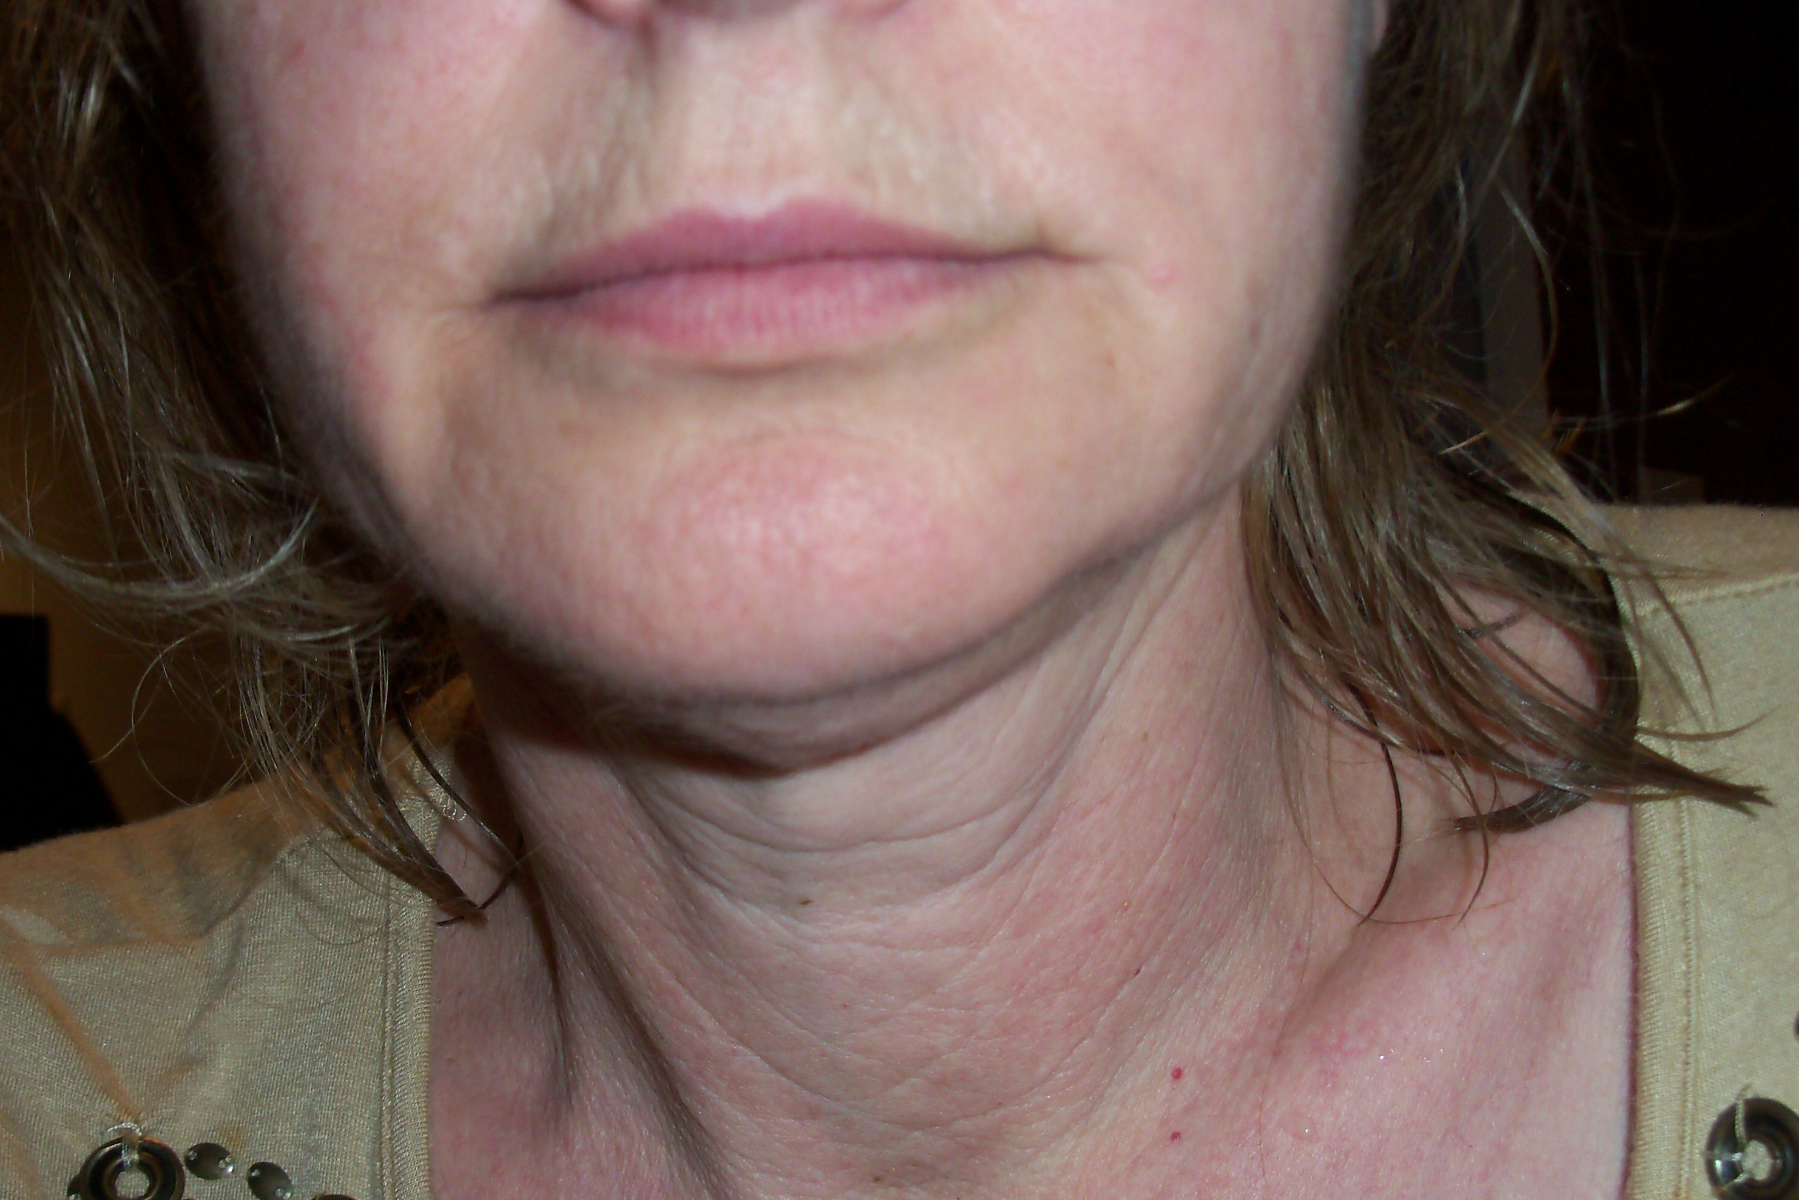
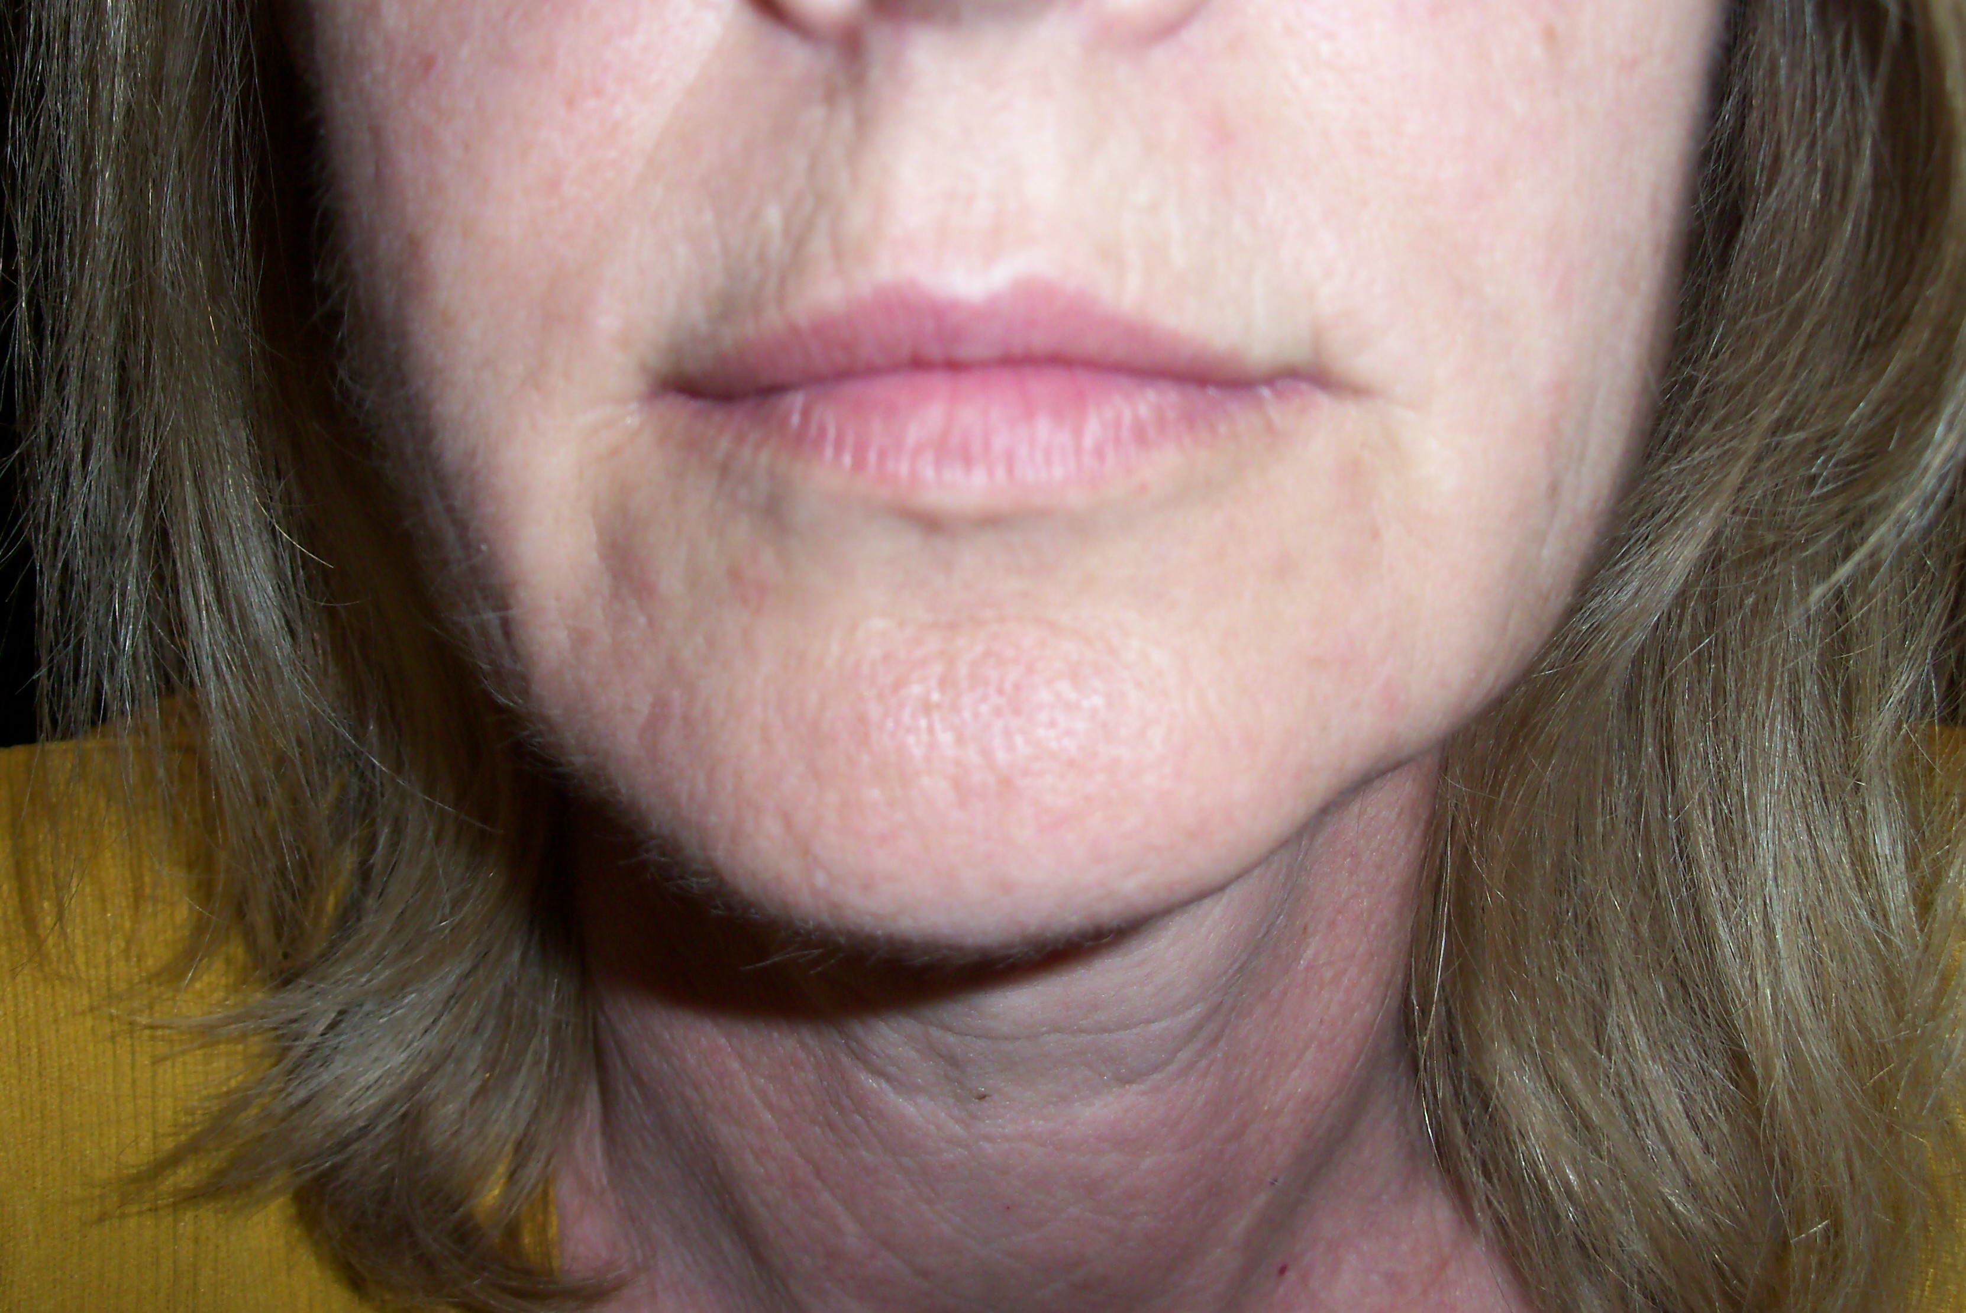

March 27, 2010 April 21, 2010
Prior to starting use of product Two weeks after initiating use of product
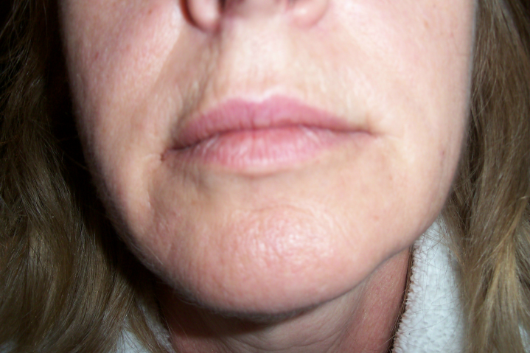
May 7, 2010
Four weeks after initiating use of product
RESULTS
Little visibly noticeable difference was discernable after four weeks of product use. I was aware of a noticeable improvement in the way my skin felt. My skin definitely felt smoother. The moisturizing agents in the products likely contributed to the improvement in the way my skin felt.
The three evaluators did notice a slight diminishing of fine lines in my mouth area. My neck area was unchanged.
CONCLUSION
The ingredients in the Mary Kay products include substances likely to reduce the signs of aging. I noticed no visual improvement after six weeks of product use, but I plan to continue using the product and making periodic comparisons to track the effectiveness of the product.
The best defense against the signs of aging were repeated in many sources – protect your skin from the sun. Exposure to the sun damages skin and that damage can be irreparable. I plan on using a sunscreen more faithfully. To be honest, I haven’t used a sunscreen at all because I like the tan I get in the summer.
We all know that exposure to the sun isn’t good for our skin. We all know that a tan is the skin’s response to injury. Yet, many of us view tanned skin as more attractive than protected skin. Many alternatives to obtaining a tan naturally are available. Tanning booths provide the means to obtain a tan by exposing your skin to concentrated radiation that mimics the sun. We can spray on a tan or get a tan from a bottle.
If we know that a tan is healthy, why do we still think a tanned body is more attractive? I don’t know the answer to this question.
This project provided me with the opportunity to apply the principles of nature of science. Much information is “out there” and much of it appears at first glance to be scientific in nature. However, upon closer examination, many of the sources are manufacturers or distributers of cosmetic products. Several of the sources included in this report are not of the scientific quality that would allow acceptance of the claims these products make.
In conclusion, I’m still aging and I don’t look better today than I did at the initiation of the experiment. I can slow the progress of aging if I use moisturizers and sunscreen regularly. If I want to reverse the signs of aging, I probably won’t be successful unless I choose to undergo cosmetic surgery.
I have one more avenue I want to explore. If we can exercise to improve muscle tone in our bodies, aren’t there exercises that would improve muscle tone in our necks and faces? I’ve done a preliminary search and nothing so far.

BIBLIOGRAPHY
- http://www.marykay.com/skincare/agefighting/10026919/10026919/default.aspx
- http://www.marykay.com/skincare/agefighting/10026905/10026905/default.aspx
- http://www.goodguide.com/products/141569-mary-kay-timewiser-night-solution
- http://www.mayoclinic.com/health/wrinkle-creams/sn00010; © 1998-2010 Mayo Foundation for Medical Education and Research (MFMER).
- http://www.healthy-communications.com/butylene.html
- http://www.dermaxime.com/glycerin.htm
- http://www.buyderm.com/ingredients/1Methylhydantoine2Imide.asp
- http://www.cellularskinrx.com/ingredients.html#palmitoyl
- http://www.cellularskinrx.com/ingredients.html#palmitoyltetra
- http://www.realself.com/ingredient/tocopheryl-acetate
- http://www.vitamins-supplements.org/tocopheryl-acetate.php
- http://www.theperformanceleader.com/retinyl-palmitate-review/
- http://www.smartskincare.com/treatments/topical/vitcderiv.html
- http://www.akademiai.com/content/m84017x500n67323/
- http://www.dermaxime.com/geranium-oil.htm
- http://www.pioneerherbal.com/natural-extracts/mentha-arvensis.html
- http://www.holisticonline.com/herbal-med/_herbs/h44.htm
- http://www.dermaxime.com/rose.htm
- http://www.cosmeticsdatabase.com/ingredient.php?ingred06=704317
- http://www.purist.com/ingredients.php
- http://www.purist.com/ingredients.php
- http://www.cosmeticsdatabase.com/ingredient.php?ingred06=707015
- http://www.mdidea.com/products/proper/proper00804.html
- http://www.dermaxime.com/propylene-glycol.htm
- http://www.cosmeticscop.com/dictionary_term.aspx?tid=1406&lid=510&term=hydroxyethylcellulose
- http://phoebe.pn-np.net/ingredient.php?lang=Thai&ingredient_id=1593
- http://www.chemopharma.com/cmc.htm
- http://www.cosmeticsinfo.org/ingredient_details.php?ingredient_id=1555
- http://chemicalland21.com/specialtychem/perchem/TRIETHYL%20CITRATE.htm
- http://www.google.com/patents?hl=en&lr=&vid=USPAT6139829&id=FaoFAAAAEBAJ&oi=fnd&dq=Acrylates/Ammonium+Methacrylate+Copolymer&printsec=abstract#v=onepage&q=Acrylates%2FAmmonium%20Methacrylate%20Copolymer&f=true
- http://en.mimi.hu/beauty/polysorbate_20.html
- http://www.ingredientstodiefor.com/files/Carbomer940.pdf
- http://www.organicconsumers.org/bodycare/toxic_cosmetics.cfm
- http://www.ehow.com/facts_5021460_disodium-edta-used.html
- http://www.cosmeticsinfo.org/HBI/26
- http://www.ehow.com/about_4691068_what-is-methylparaben.html
- http://sci-toys.com/ingredients/DMDM_hydantoin.html
- http://www.mineral-makeup-help.com/mica.html
- http://beauty.about.com/library/bltips117.htm

