Sandra Trevino, NASA 3-D Project VIEW, Mandatory Assignment #1
Instructor: Kristen Crawford
Mini Lesson: Using Water Vapor Formations to Create Best Fit Regression Equations and approximate area.
ENGAGE: Ask students if they have ever looked at clouds and what shapes the clouds make.
EXPLORE: What shapes did the students see, were the shapes of animals, objects, round, straight, etc.? How can the shapes be applied to mathematics? How can we graph the shapes made by the clouds and find the area of the shape?
EXPLAIN: Discuss with students the makeup of the cloud formations, shapes, curves and determine how to best collect data points from the graph.
ELABORATE: Students use their ability to graph lines and curves to determine a best fit line using a graphing calculator and approximate the area by adding the squares in their region.
EVALUATE: Compare solutions in the class with other groups that had the same regions. Were the equations of the curves and area similar answers?
DIRECTIONS: Have students work in pairs. Randomly assign students coordinate grids that have been predetermined by the teacher. Each pair of students will have one sheet of 1 cm squares transparency graph paper. For example: find the equation and approximate area for section C – E X 1 – 4. Students will place the transparency paper on top of the picture and plot points to create a best fit line. Students will also approximate the number of 1 cm squares in their grid that includes the cloud formation.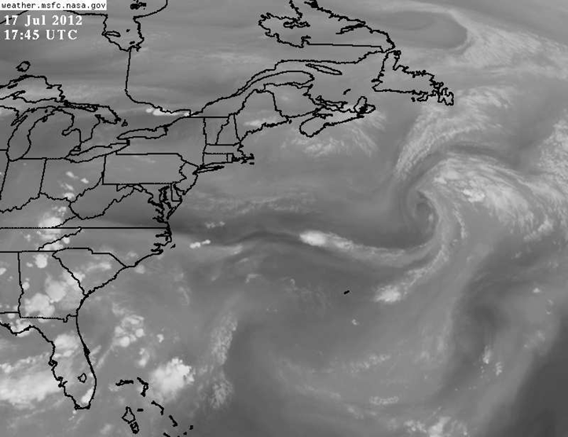
Image centered at Latitude= 37.19 degrees N, Longitude= 68.21 degrees W. X=250 Y = 73
References:

National Aeronautics and Space Administration. (2012) [Graph illustration weather July 17, 2012] MFSC Earth Science Office GOES-E Full Water Vapor. Retrieved from http://www.ghcc.mfsc.nasa.gov/cgi-bin/post-goes.

