ROBOTICS – Module 2 – Pre-, Post-Formative Assessment

- Define prototype:

- List the steps of the design process, or draw and label a diagram.

- Why do scientists use models in their inquiries?

- Explain what you think a sensor is.

- Describe how would you build a robot?

- What could you do to program your robot to perform tasks?

- Define observation:

- Define inference:

- How can you use observations to infer the solution of a problem?

- Describe an example of something that you could do to show that the greater the force you applied to an object, the greater its change in motion.

- List the forms of energy that you know about.

- Give an example of the flow of energy and how it transforms from one form of energy to another.

- What does a complete circuit look like? (draw and label each part)

- Each student will be given 6 cm cubes. Arrange your 6 cm cubes by stacking them in graduating columns to look like stairs. Draw the front, top and side views.

Front –

Top –

Side –

- Use the following rectangular prism to determine the answers.

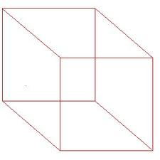

Name all of the vertices:

Name all of the edges:

Name all of the faces:
- Use the following the cube to determine the answer to each question.
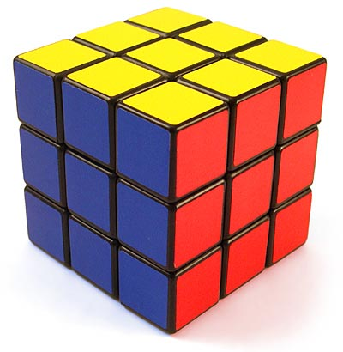

What is the perimeter of each face of the cube?

What is the area of each face of this cube?

What is the volume of this cube?

