Running head: Analyzing Fourth Grade Responses to the Day and Night Cycle 1

Analyzing Fourth Grade Responses to the Day and Night Cycle
Joni Cooke
Turner Elementary School

Analyzing Fourth Grade Responses to the Day and Night Cycle 2
Research Plan Draft
Description of Setting
My action research will be conducted at Turner Elementary School which is in Maine School Administrative District Number 52. Our district is located in the western foothills of Maine. This school district includes three towns which are Greene, Leeds and Turner. Turner is the largest town in this school district. My school district borders, Lewiston which is the second largest city in the State of Maine. It is a rural Maine school district with a total student population less than 2,500 students. In the town of Greene there is one elementary school which contains grades K-6. In Leeds, the school has just initiated a new four year old program. This school also has grades of K-6. In the town of Turner, there is a primary school for grades K-3 and Turner Elementary School which is the school where I teach which has grades 4-6. All the students, in our three town school district, are transported to Turner for grades 7th -8th located at Tripp Middle School and grades 9th through 12th at Leavitt Area High School.
Turner Elementary School has a student population of 214. This school offers the National Lunch Program which offers free and reduced priced lunches to students from lower income families. This school has a 40% free and reduced hot lunch population. Since the recession, the number of free and reduced students has risen due to many paper mills closing and higher unemployment. Just last year, the free and reduced lunch was at 35%. This is an increase of 5% in one year.

Analyzing Fourth Grade Responses to the Day and Night Cycle 3
I am responsible for two out of the four-4th grade classes housed in Turner Elementary School. My homeroom class, which I will be using for this study, has seventeen students, 9 girls and 8 boys. Ethnicity for my class is as follows: 1. Twelve percent, Latino and 2. Eighty-eight per cent, Caucasian. The Latino population supports the large commercial poultry operations located in Turner. The Caucasian population’s ancestry comes from various European countries. Forty-seven per cent of my students have individual educational plans for special education and .05 per cent of my class has just been identified for the gifted and talented program. Seventeen per cent of the students at this time are receiving assistance in reading.
The first assessment that the students take in the fall in my schools is the Northwest Evaluation Association. This is a national standardized test. Sixty-three per cent of the class met the growth target in reading. In mathematics, the class met the growth target at sixty per cent. The school target goal in reading at ninety per cent and in mathematics, the target goal is eighty per cent. The students are presently taking the New England Common Assessment Program in reading and mathematics. The results from that test are not available. Only fifth and eighth grade students are assessed on the Maine Educational Assessment for science.
Description of Data Collection
The data collection for my action research project will be gathered from my fourth grade homeroom group of seventeen students. To unveil the students’ misconceptions of the day and night cycle, this study will be constructed into three parts for triangulation and rigor. The first stage of the study will have the students illustrate and respond to, “Where does the sun go at
Analyzing Fourth Grade Responses to the Day and Night Cycle 4
night?” The second step for this study will be the students’ interview. I will interview two students, one boy and one girl with misconceptions about the sun’s location at night. Another question during the interviewing process will ask the students where the sun goes during the day. These interviews will be recorded, transcribed, and coded for patterns of misconceptions. Finally, the students will be given a science probe entitled “Darkness at Night.” This science probe was designed by Page Keeley (2007), past President of the National Science Teachers Association to reveal the students ideas about the day and night cycle.
As each step is taken, I plan to review the students’ work to construct better insights into their thinking about the day and night cycle. Then further steps will be to find NASA materials to untangle their misconceptions and build a firm foundation for their understanding of the sun’s location during the Earth’s rotation for the day and night cycle.
Triangulation & Rigor
The first step is to have seventeen fourth grade students draw and write a description based on the question, “Where does the sun go at night?” The data will illuminate how many students understood through their drawings and descriptions about the day and night cycle. The data from this will have a graph to show the results as well as their written responses.
The next step in this action research project is to interview one girl and one boy from this fourth grade class about their misconceptions pertaining to the sun’s location at night. Another question during the interviewing process will be to ask for the students where does the sun go during the day? These interviews will be recorded, transcribed, and coded for patterns of misconceptions.

Analyzing Fourth Grade Responses to the Day and Night Cycle 5
The final step will be having the students respond to the science probe entitled “Darkness at Night” (Keeley, 2007, p.172-176). This probe provides the students with a story about six friends trying to describe why the sky is dark at night. The students are asked to indicate which friend is correct in telling why the sky is dark at night. The results will have a plot line to show the results for each of the responses produced by the students. The students written responses will be coded for further patterns of their misconceptions. The data from this will be compared to the data collected from the first drawings made and the interviews conducted. If more interviews are needed for clarification on the “Darkness at Night Probe” it will done with the same coded procedure as before. This will be an added tool to look at the misconceptions of the day and night cycle in fourth graders.
Figure 1 –Darkness at Night Probe
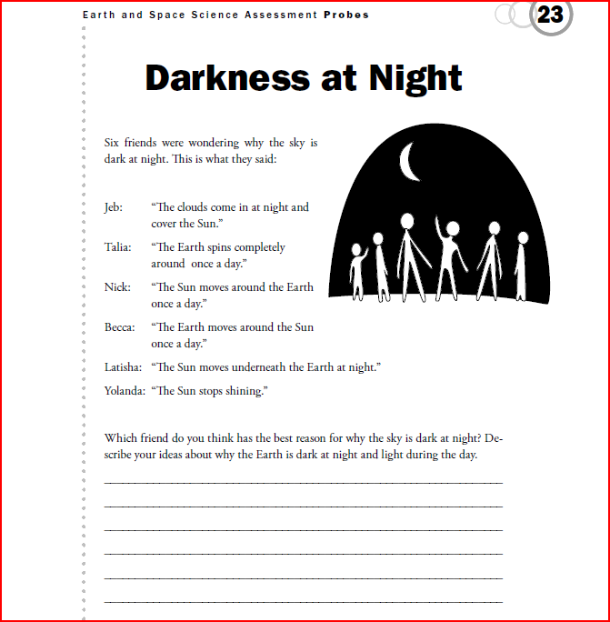
Analyzing Fourth Grade Responses to the Day and Night Cycle 6
Each step of the data collected will be reviewed by my district’s fourth grade leader and a research review panel. There will be three other teachers on this review panel who have their master’s degrees. This team of teachers has had experience in analyzing data from their own experiences in education. This will provide me a vehicle to validate the data I have collected and to defend my findings to them.
Description of Plan for Data Analysis
On October 5th through the 8th, students have been asked to draw with written responses to “Where does the sun go at night?” The interviews for one boy and one girl will be conducted on October 13th through the 16th. During the weekend their recorded responses will be transcribed and coded. Also during the week of October 13th through the 16th the students will have completed the science probe “Darkness at Night.” During the week of October 19th through the 23rd, I will present my finding to my review district team for my findings for discussion and rigor. It will also be at this time I will share my work with my core teachers taking this course for added insight.
I will make careful documentation of my finding so it can be replicated in the other fourth grade classes in my district. From my work, I will compile NASA materials that can be used in a fourth grade class to correct the misconceptions on the day and night cycle.

Analyzing Fourth Grade Responses to the Day and Night Cycle 7
References
Keeley,P. & Elberle, F., & Tugel, J. (2007). Uncovering Student Ideas in Science: 25 More Formative Assessment Probes. (Vol. 2). Arlington, VA: National Science Teachers Association.

