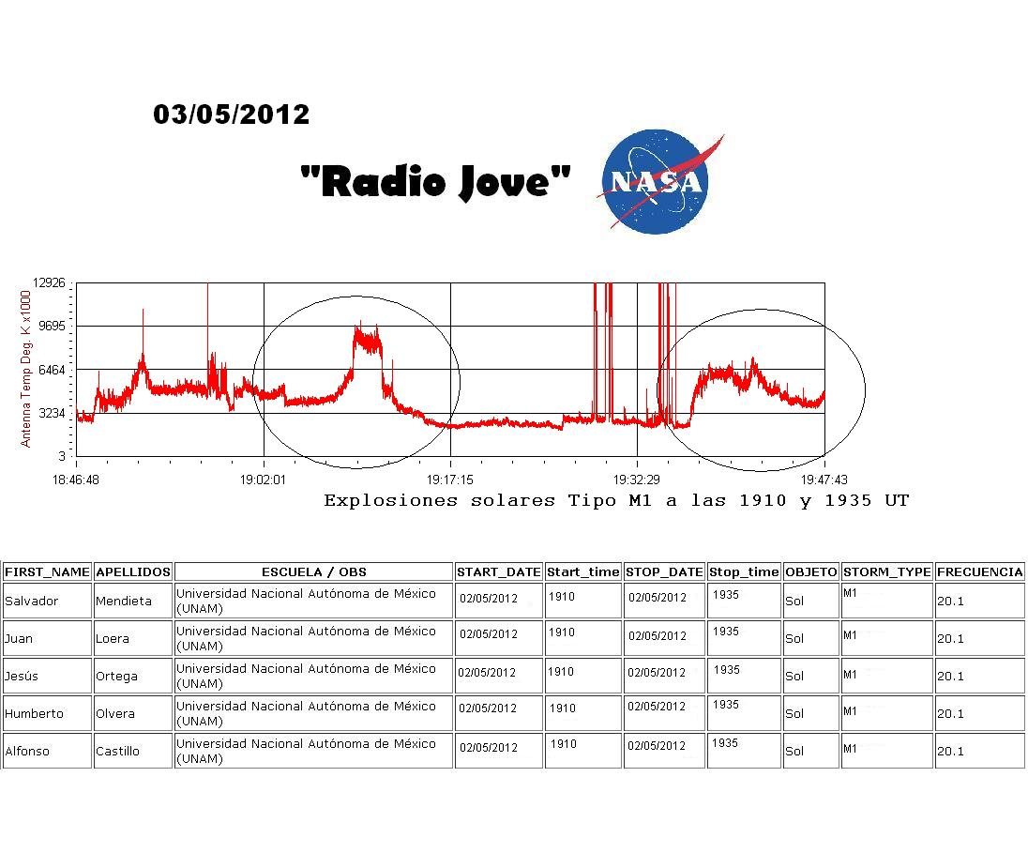
What are the “shark fin” increases shown in the graph caused by?

What is the range (in antenna Temp Deg. K x 1000) of the first circled activity on the graph?

How long does it take for the radio signal to reach the earth?

How long does it take for the particles to reach the earth?

Explain the solar activity X-ray activity scale, A, B, C, M, and X.

What could the sharp spikes indicate on this graph?

