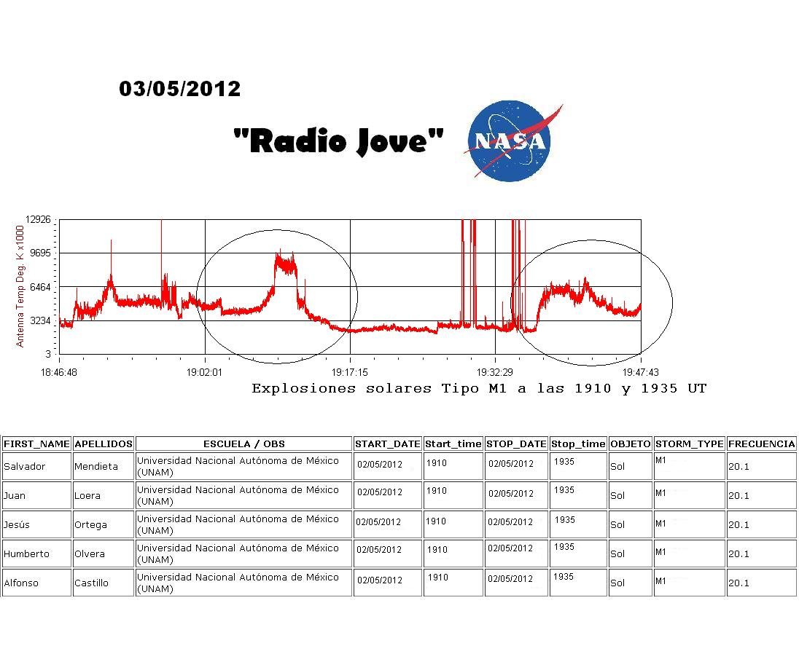
What are the “shark fin” increases shown in the graph caused by?

What could the lines that go to the top of the graph indicate?

Explain the solar activity X-ray activity scale, A, B, C, M, and X.

