Mission Paper
Jennifer Diaz
Humans in Space

The International Space Station is a large satellite that was built to conduct research on the effects of microgravity on physical and biological processes of living things. The station has been orbiting for twelve years and inhabited for nine years. During these twelve years the ISS has grown to house two separate crew quarters and run over one hundred experiments at one time. There have been 33 missions to accomplish this and completion will be in 2011. The early missions such as Space Transportation System 108 were to transfer crew, bring supplies, and logistic modules. Although the goal was to increase the capacity of the ISS, experimentation began very early. The STS 108 was transporting quail eggs to experiment the effects of microgravity on the embryonic stage of the quail eggs development. As more missions transported and installed more logistic modules it gave the ISS more room to hold and perform experiments. The power to the ISS to support life and experiments comes solely from the sun. This is why mission twenty-five delivered the last of eight solar panels. As the missions to the ISS come to an end experimentation is in full bloom.
Monday April 5, 2010, STS 113 Discovery will launch on a thirteen day mission to the ISS. STS 113 was nick named the “Experiment Express” because it will be carrying over 8 tons of science equipment and cargo. The crew of STS 113 will perform three space walks to replace a spent ammonia tank and will spend over one hundred hours unloading the cargo of its pay load and reloading it with trash, hardware, and science experiments. This mission will be the last opportunity to send a large amount of cargo back to earth, because Discovery carries behind its payload doors in its cargo bay “MPLM Leonardo”. Leonardo is a multipurpose logistics module that can carry more equipment to space than anything else that has been invented. Leonardo is one of the only space modules approved for travel because of its external temperature regulator; all other modules would burn up in earth’s atmosphere. Leonardo will soon be docked permanently at the ISS, therefore limiting mission capabilities of carrying a large amount of cargo up in space.
The timeline of STS 113 reflects a day by day outline of what needs to be done to accomplish its six objectives. The six mission objectives are to perform cargo transfer, replace a spent ammonia tank, retrieve an experimental Japanese seed module, return three stowage platforms, and transfer and install six racks. Racks are secure units for experiments and tools. On this mission the racks will hold exercise equipment used for muscle atrophy research, a minus eighty degree lab freezer, a (WORF) window observation research facility, processing racks for experiments and crew quarters.
The Experiment Express is important to education, life support of the ISS and to the possibility of going to Mars and beyond. In order to understand the impact of this mission on education, and the effect on humans in space travel it is important to learn about two components that are being transported via STS 113. The window observation research facility (WORF) is equipped with many attachments that will maximize the use of the lab window by attaching video recorders, scanners, and cameras. This will allow the window to store and transmit information and images from space. This information contributes valuable knowledge of earth science and increases our ability to understand weather, climate, as well as land and sea formations. NASA will be using this information for public outreach and educational opportunities (http://www.nasa.gov/mission_pages/station/science/experiments/Biopsy.html).
Possibly one of the most important ongoing experiments being conducted is the effects of microgravity on the human body. One major effect is muscle atrophy, which is the decrease in the mass of the muscle or wasting of the muscle. Examples of this are seen in paraplegics, quadriplegics, the elderly and patients who have limited mobility due to brain damage or surgery. On earth the only measures we use to fight this condition are rehabilitation and medication. In space scientist are measuring atrophy in extreme conditions. The major muscles that are affected in space are located in the legs, because microgravity pulls most of the body fluids towards the upper body this is also known as fluid shift. The muscles loose approximately 30% of its full ability within just 11 days of exposure to microgravity. Recovery of the muscles full performance does not come without hard work and some consequences. An astronaut works out hard in space and still battles the affects of microgravity on their skeletal muscles. This skeletal muscle atrophy can limit the mobility of the astronaut when on land, and will require therapy and an intense exercise regime to regain muscle mass. Microgravity has the opposite effect that working out has on the body. Instead of building muscle fibers, the fibers begin to shrink, becoming weak and tearing. As it stands the exercise regime in space has consisted mostly of cardiovascular conditioning and not on strength training which is used to build muscle fibers. At this time, space flight is relatively short in duration when compared to the future possibility of spending long periods of time on the moon or traveling to Mars.
Gravity is the force that pulls things towards earth and gives weight, so the question must be asked; how do you apply weight in a microgravity situation? Scientist thus far have not remedied this problem and further research is needed before astronauts go to Mars and beyond. In order to limit the effects of muscle atrophy, researchers have developed the muscle atrophy research exercise system “MARES”. The MARES is a more advanced system that can evaluate seven different human joints in nine different movements. The system will interpret the movements as they relate to understanding the possible counter measures that can be used to limit the effects of micro gravity on muscle atrophy.
There are many hurdles that scientists face when battling muscle atrophy in space. First, it is necessary to design an exercise unit that will fit in a very small space. The unit will need to record and communicate information about the muscles performance. Lastly, scientists will need to research and decide how much exercise is needed or resistance is necessary to keep astronauts muscle in tack. There is no way of knowing how long an astronaut can remain in space without permanent damage. STS 113 is transporting a negative eighty degree freezer which will carry rat tissue samples to run further experiments on the effects of microgravity and how long tissue can survive without permanent damage. The importance of these missions remains with the decisions about the future of NASA. The possibility of going back to the moon and visiting Mars and beyond depends on this research.

Picture 1 – healthy skeletal muscle and atrophied muscle

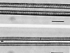
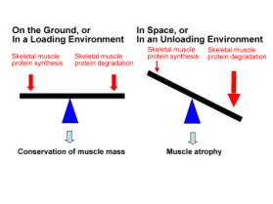

Picture 2 – Normal Environment vs. Microgravity environment Picture 3 - MARES

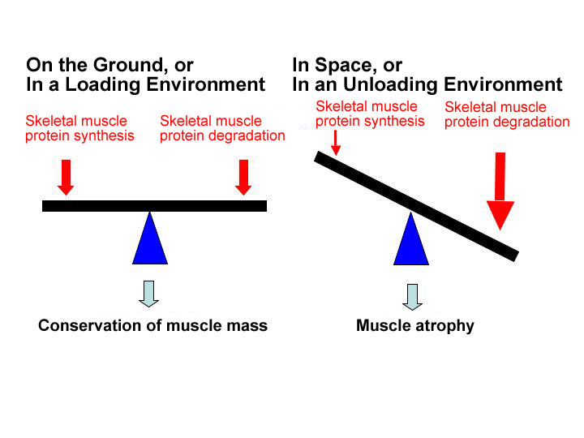

References

http://www.jaxa.jp/article/special/kibo/img/nikawa_photo_01_big_e.jpg
http://www.nasa.gov/mission_pages/station/science/experiments/Biopsy.html
http://www.spaceresearch.nasa.gov/general_info/pumpingiron.html

