Leadership Proposal
Payton
1. What is the title of your STEM professional development?
Science Articulation and Curriculum Development at Caruthers Unified School District
2. Why did you select the topic?
In the spring 2011, my school district asked me to write and submit a $30,000 Teacher Based Reform (TBAR) grant through California State University, Chico. The focus of this grant would be to promote collaboration between teachers at the primary and secondary school as well as improve science curriculum at the district. For the topic of the grant, I chose to focus on teaching and implementing the teaching strategy, inquiry, through hands-on activities in the classrooms. The initial grant proposal is listed below. The grant was accepted, and my school district has been implementing the grant since fall 2011. Despite drafting the grant to implement only inquiry and hands-on activities into the classroom, the grant has evolved to incorporating Interactive Science Notebooks, Curriculum Topic Studies, and the 5E’s teaching strategy.

TBAR Plan of Action
Professional Development Level | Professional Development Strategies/Resources
The “Baseline”:  The baseline includes building teacher content knowledge and grade-level curriculum development.  - Teachers need to develop their own science content knowledge to effectively teach students.  - Base-line grade-level curriculum based on research needs to be developed for students at each grade level.  *Teachers need to know what they have to teach! | - The top five most important concepts from state standards will be determined for each grade level.  - A Curriculum Topic Study (CTS) will be conducted for the topic at each grade level. For each concept, CTS provides adult content knowledge, student misconceptions, and effective teaching strategies for students at specific grade levels. Furthermore, the CTS provides the information that each student needs to know about the concept at their current grade level as well as what they should have learned at previous grade levels.  - Current research and other resources like the NSTA Misconceptions book series can be utilized to develop the base-line grade level curriculum.  - Professional development time will be allocated to developing teacher content knowledge and grade level curriculum.
The “Next” Level:  The next level includes teaching the curriculum at a higher-order thinking level and through creativity.  - Teachers will understand the most effective science teaching strategies.  - Teachers will utilize on a regular basis these strategies in their science classroom.  *Teachers need to know how to teach science in their classrooms! | - Teachers will learn and observe effective science teaching strategies including inquiry and Interactive Science Notebooks.  - Teachers will utilize these strategies in their science classroom.  - Professional development time will be allocated to developing effective science teaching strategies.

3. Who is your proposed audience (minimum 12)? Which teachers will you serve with your professional development and activities? What grades, subjects, and how many students do they teach?
For the TBAR grant, there are five teachers including myself, the team leader. The teachers are from various grade levels and include: Brook Bullock (5th), Diane Kruse (6th), Russell Mar (7th), and Becky Horg (8th). Even though 12 teachers are not included in the grant, the teachers are sharing with other grade level teachers the information and strategies they learn during TBAR. The subjects taught by the teachers vary depending upon the grade level. Subjects range from Earth, physical, and biological sciences. The number of students as well as subjects is in the table below.
Teacher | Grade | Subject | Number of Students
Brook Bullock | 5th | Earth and Physical Science | 38
Diane Kruse | 6th | Earth Science | 18
Russell Mar | 7th | Life Science | 68
Becky Horg | 8th | Physical Science | 78
Melissa Payton | 9-12th | Integrated Science/Chemistry | 78

4. What general science or mathematics concepts or learning goals are being addressed which can potentially replace classroom activities.
For this grant, there are pedagogy along with content learning goals. The primary pedagogy learning goal is for teachers to better understand their content areas and standards as well as learn effective science teaching strategies. For examples, teachers have implemented Interactive Science Notebooks into their classrooms, and they are learning about the 5E’s learning cycle. In terms of content learning goals, I plan to create a short, take home unit that incorporates NASA data. This unit will incorporate NASA data to help teach the concept of scientific inquiry and observation to students. Since there are different grade levels, I will create a basic unit with challenges and extra assignments that will benefit students in higher grades.
5. How and where do you intend to carry out your professional development? How long will the session be? When will it be held? Will teachers have access to computers?
The grant lasts for two years, and we have completed our first semester (fall 2011). We attend monthly hourly meetings at the elementary school after school on Wednesdays. The agendas for the meetings are listed below. The teachers have access to computers if they bring their laptop to the meetings.
TBAR INC.
Group 152

Agenda
April 27, 2011

- Fill out Forms
  - Payee form
  - Mileage form

- Discuss Action Plan Booklet

- Baseline Determination
  - Student Survey
  - Benchmark/Final Scores
  - Pacing Guide

- Next Meeting: May

TBAR INC.
Group 152

Agenda
May 18, 2011

- Login

- Science Surveys

- Pacing Guides

- Project Summary: Due May 23

- Baseline Determination: Due June 1

- Next Meeting: Early September

TBAR INC.
Group 152

Agenda
September 27, 2011

- Discuss Interactive Notebook Workshop: How can we apply this in our classroom?

- Discuss CSTA Conference

- Teacher Observations

- Next Meeting: October

TBAR INC.
Group 152

Agenda
October 26, 2011

- Discuss CSTA Conference—What did we learn and how can we incorporate this into our classroom?

- Discuss science lesson plans—Set up after school meetings with individual teachers in November.

- Next Meeting: November 30th?

TBAR INC.
Group 152

Agenda
December 14, 2011

I. Top 5 List:
A. Content
B. Process
II. Interactive Science Notebook Order Form
III. Discuss 5 E’s Lesson Plans
A. Engage and Explore
B. Explain and Extend
IV. Teacher Observations
V. Next Meeting: End of January
VI. Enjoy your well deserved break!!!

TBAR INC.
Group 152

Agenda
January 26, 2012

- Teacher Surveys

- Teacher Schedules and Observations

- Interactive Science Notebooks

IV. Next Meeting: February 22nd ???
6. What, in general, will your pre-survey and post-survey ask?
For the grant, I have already provided the teachers with pre-survey. The pre-survey as well as the results are listed below. Furthermore, I recently provided the teachers with a post-survey, and the survey as well as results is listed below.
Teacher Pre-Survey
Teachers’ PD INC Action Research Posting
Team #152
Melissa Payton, Team Leader
June 1, 2011

1. Revisit the project timeline for the purpose of detailing information about each event (e.g. which members will be participating), and the purpose of the event (e.g. design of assessment materials, new curriculum, organize dates for data collection).

Teacher leader and members met to discuss the timeline. Everyone agreed that the timeline is appropriate for the project, and that necessary changes could be made if needed to ensure that one cycle of the action plan can be completed within two years. Furthermore, teachers discussed that activities are flexible. For example, if a teacher feels that he or she finds a different workshop or conference may benefit his or her science teaching strategies, then a change may be made. The purpose of the workshops, observations, and conferences is to educate the teachers on effective science teaching strategies. The more knowledge they have regarding these strategies will result in greater teacher confidence in implementing hands-on and inquiry-based science activities in the classroom. These activities will result in an increase in engagement and understanding of science for the students. Therefore, the students will have an increase in confidence in doing science. Along with strengthening the science curriculum and increasing teacher and student confidence, collaboration among teachers is another goal of the project. The collaboration and observation activities will allow teachers to discuss the most effective science teaching strategies to incorporate in their science classroom. The current timeline is listed below.

Project Timeline:
Fall 2011:
• Teachers will participate in the grade level, physical science AIMS workshop.
• Teachers will observe another science classroom to find out how other teachers effectively teach science at their grade level.
• Teachers and the team leader will collaborate after school once a month about effective science teaching strategies.
• Teachers and the team leader will attend the California Science Teacher Association conference in October.
• Teacher leader will make an observation of each teacher.
• Teachers will submit science pacing guide to teacher leader.

Spring 2012:
• Teachers will participate in an AIMS science process and investigation science workshop.
• Teachers will observe another science classroom to find out how other teachers effectively teach science at their grade level.
• Teachers and the team leader will collaborate after school once a month about effective science teaching strategies.
• Teacher leader will make an observation of each teacher.
• Teacher leader will attend the National Teacher Science Association national conference in March.
• Teacher leader will collect and analyze evidence of student outcomes.

Fall 2012:
• Teachers will observe another science classroom to find out how other teachers effectively teach science at their grade level.
• Teachers and the team leader will collaborate once a month after school about effective science teaching strategies.
• Teachers and the team leader will attend the California Science Teacher Association conference in October.
• Teacher leader will make an observation of each teacher.

Spring 2013:
• Teachers will observe another science classroom to find out how other teachers effectively teach science at their grade level.
• Teachers and the team leader will collaborate after school once a month about effective science teaching strategies.
• Teacher leader will make an observation of each teacher.
• Teacher leader will collect and analyze evidence of student outcomes.
• Teacher leader will work with teachers to create and present a professional development presentation to other school districts.

2. Confirm that each event occurs at the most optimum place and time during the project. In some cases, you might need to move an event to better align with a particular phase of your action research model.

The timeline is appropriate to complete one action plan cycle within the two year project period. Teachers will spend the first year of the project being educated about effective science teaching strategies as well as collaborating and observing other teachers. The skills gained during this first year will be used to implement effective teaching strategies within the classroom. Although the second year also focuses on education, collaboration, and observation, there will also be implementation of teaching strategies in the classroom as well as reflection regarding the effectiveness of these teaching strategies.

3. Given the scope of the events, make sure that your team will be able to complete at least 1 cycle of action research by the end of the grant. If not, you will need to re-visit the model and revise the events in order to meet the project goals.

The action plan cycle will take the two years to complete. The problem for the action research plan for Team #152 has been identified. This problem is that the science curriculum and collaboration between science teachers at different grade levels needs to be strengthened. Along with strengthening how science is taught in the classroom and how teachers collaborate with each other, another aspect of the plan is to improve the confidence of science teachers and students in the classroom. Data has been gathered to determine how science is currently being taught at various grade levels within the district. This data was obtained through teacher and student surveys, pacing guides, and CST scores. Two different surveys were given to the teachers and students in grades 5, 6, 8, and 9. Both surveys contained a variety of self-assessment questions. The initial baseline data is listed in the next section. Over the two year project period, the team will be able to complete at least one full cycle of the action plan.

During the first year of the project, teachers will develop the skills to successfully implement science teaching strategies in the classroom. They will achieve this by participating in seminars, workshops, conferences, collaborations, and observations. The professional development opportunities teachers will participate in will help the teachers to develop the skills and confidence necessary to implement hands-on and inquiry-based activities in the classroom. At the end of the first year, data will be gathered and analyzed.

The second year will focus on evaluating the results and determining the next steps required to make any necessary changes in the action plan. This will include reflecting and acting on the evidence of the data gathered during the first year. Teachers will determine which hands-on and inquiry-based activities work best in their classroom. Then, they will work together to strengthen their science teaching skills by participating in more professional development opportunities like attending conferences, collaboration meetings, and observations. At the end of the second year, teachers will reflect on the success of the entire action plan cycle. The anticipated success will be an improvement in the science curriculum as well as the confidence in teachers and students at Caruthers Unified School District. To determine the overall success, more data will be gathered and evaluated. After analyzing the data, teachers will determine the next steps on how to continue using the action plan to further improve the science curriculum after the project has completed.

4. Look at your action research question and determine the student learning or affect that you would like to change as a result of your project. Collect some data that will help your team see and show the impact of your professional development activities.

The focus of this project is to make a positive change in the science curriculum at Caruthers Unified School District. This change includes strengthening the science curriculum by ensuring students have genuine science experiences like hands-on and inquiry-based activities. As well as strengthening the curriculum, other focuses of the project include improving collaboration between science teachers at different grade levels as well as increasing the confidence of science teachers as well as students. To determine if this project has been successful, a baseline that reflects the current science education at Caruthers must be determined. The baseline is determined utilizing a variety of data gathered from different sources. These sources include student test scores, pacing guides, and surveys. The results from the data are listed in Parts A-C below.

Students Part A:

Student CST science test scores were analyzed to determine the current academic success of the students. Test scores were analyzed from grades six to ten. A specific CST science test is given to students at the end of the 5th, 8th, and 9th grade school year, and the science content of each test differs. For each grade level, either the previous school year science scores were analyzed (6th , 9th, and 10th graders) or the fifth grade scores were analyzed (7th and 8th). Scores were taken from students across the entire grade level instead of according to specific teachers. Overall scores at specific grade levels rather than scores for specific students will be compared for this project. Analysis of test scores for each grade level is listed below (Figures 1-5 and Tables 1-5). An important outcome of this project will be to increase the number of students that pass the exams with Advanced or Proficient. If students are more engaged in the scientific process and better understand science material by participating in hands-on and inquiry-based activities in the classroom, then their CST science scores should improve over the course of the project. Similarly, if teachers more confidently teach the material and the students feel more confident in their science academic success, then this confidence shall also be reflected an increase in their CST science scores.

5th Grade Students: No scores available. Students have taken a CST Science Test at the end of this school year; however, they will not receive the results until the beginning of the next school year.

6th Grade Students: There is not a specific 6th grade CST exam for these students. Instead, the 2010 5th Grade Science Scores for each student were analyzed for this grade level.

Figure 1: Current 6th grade 2010 CST science scores (5th grade scores).

 | Student Scores | Percentage
Advanced | 9 | 12.85714
Proficient | 16 | 22.85714
Basic | 25 | 35.71429
Below Basic | 9 | 12.85714
Far Below Basic | 11 | 15.71429
Total: | 70
Table 1: Current 6th grade 2010 CST science scores (5th grade scores).

7th Grade: The 7th grade students do not take a CST exam in science. Therefore, the 2009 5th Grade CST scores were used 7th grade students.

Figure 2: Current 7th grade 2009 CST science scores (5th grade scores).
 | Student Scores | Percentages
Advanced | 6 | 7.894737
Proficient | 25 | 32.89474
Basic | 27 | 35.52632
Below Basic | 10 | 13.15789
Far Below Basic | 8 | 10.52632
Total | 76
Table 2: Current 7th grade 2009 CST science scores (5th grade scores).

8th Grade: The current 8th graders took a CST in science at the end of this school year; however, their scores are not available. As a result, their 5th grade CST scores were used to determine the baseline.

Figure 3: Current 8th grade CST science scores (5th grade scores).

 | Student Scores | Percentages
Advanced | 3 | 4.411765
Proficient | 12 | 17.64706
Basic | 26 | 38.23529
Below Basic | 15 | 22.05882
Far Below Basic | 12 | 17.64706
Total | 68
Table 3: Current 8th grade CST science scores (5th grade scores).

9th Grade: The 2010 8th grade CST scores were gathered for the current 9th grade students.

Figure 4: Current 9th grade CST science scores (8th grade CST scores).

 | Student Scores | Percentages
Advanced | 16 | 25
Proficient | 19 | 29.6875
Basic | 15 | 23.4375
Below Basic | 10 | 15.625
Far Below Basic | 4 | 6.25
Total | 64
Table 4: Current 9th grade CST science scores (8th grade CST scores).

10th Grade: The 2010 9th grade CST scores were gathered for the current 10th grade students.

Figure 5: Current 10th grade CST science scores (9th grade CST scores).

 | Student Scores | Percentages
Advanced | 3 | 2.5
Proficient | 16 | 13.3333333
Basic | 72 | 60
Below Basic | 16 | 13.3333333
Far Below Basic | 13 | 10.8333333
Total | 120
Table 5: Current 10th grade CST science scores (9th grade CST scores).

Students Part B:

Along with test scores, other forms of assessment are evidence of student learning as well as illustrate the type of activities in the science classroom. Images 1-4 show the types of activities that occur currently in the science classroom. Even though the images show 5th grade student work, this work reflects activities being conducted in other grade levels. As a result of the project, a positive outcome will be more images of student activities not only creating pictures of scientific concepts, but also of students participating in hands-on and inquiry-based labs.

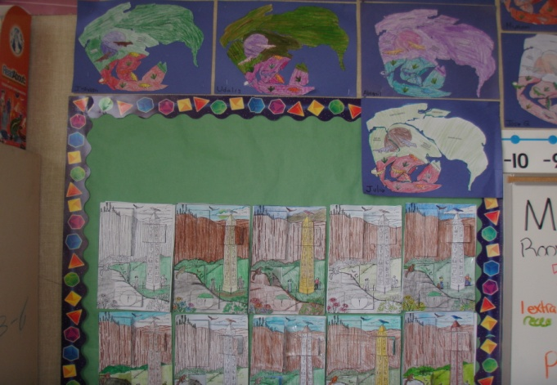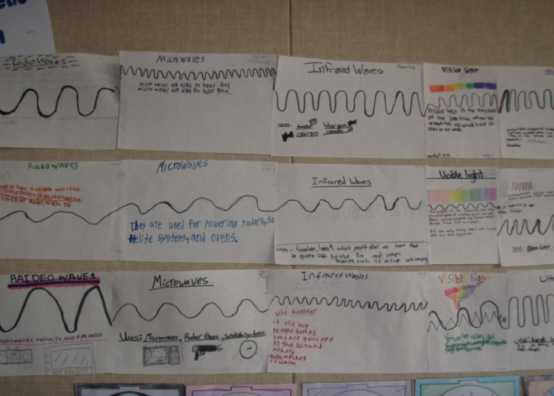
Image 1: 5th grade science illustrations. Image 2: 5th grade science illustrations.

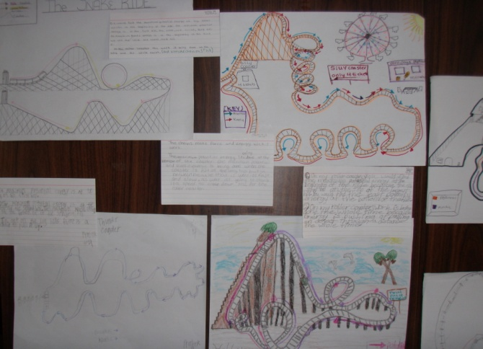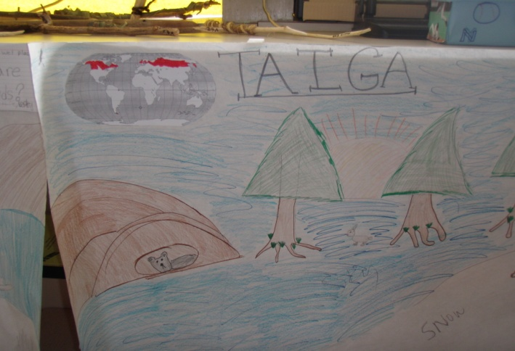
Image 3: 5th grade science illustrations. Image 4: 5th grade science illustrations.

Students Part C:

The following information was obtained from the Student Science Survey (see survey below). Students took a survey online which they answered a series of questions as honestly as possible (see Table 6 and Figures 6-9). These questions were used to assess the current attitudes of students in terms of science. A major focus of this project is to improve the confidence of students in science. Therefore, an expected outcome of the project will be an overall improvement in student attitudes towards science.

Survey:
Student Science Survey: May 2011
Directions: Please answer the following questions.

1. Check the activities you have done in your science class (you can circle more than one).
- Ask questions
- Work in a group
- Make a hypothesis
- Make observations
- Make measurements
- Collect data
- Analyze data
- Make conclusions
- Write in science journals
- Make graphs
- Answer questions from the textbook
- Listen to PowerPoint lectures

2. Do you like doing science labs?
- Yes
- No

3. On a scale from 1-10, circle the number that describes how much you like science.
1 2 3 4 5 6 7 8 9 10
Do not like science Love science

4. On a scale from 1-10, circle the number that describes how easy or hard science is for you to understand.
1 2 3 4 5 6 7 8 9 10
Science is very hard Science is very easy

5. On a scale from 1-10, circle the number that describes how easy or hard it is to do science labs.
1 2 3 4 5 6 7 8 9 10
Science labs are very hard Science labs are very easy

6. What do you like about science (you can check more than one box)?
- We do fun activities
- We learn about interesting things
- We watch interesting videos
- We go on fun field trips

7. How often do you learn about science in school (choose only one answer)?
- Everyday
- Every other day
- Once a week
- Once every two weeks
- Once a month

8. How often do you study science outside of school (choose only one)?
- Everyday
- Every other day
- Once a week
- Once every two weeks

9. What is your favorite subject in school (choose only one)?
- Math
- English
- Science
- Social Studies

10. In one sentence, type in the subject you chose for the previous question and why this is your favorite subject.

11. What is your grade in science (choose only one)?
- A
- B
- C
- D
- F

12. What is your grade in math (choose only one)?
- A
- B
- C
- D
- F

13. What is your current grade level?
- 5th
- 6th
- 7th
- 8th
- 9th

Survey Results:
 | On a scale from 1-10*, circle the number that describes how much you like science. | On a scale from 1-10**, circle the number that describes how easy or hard science is for you to understand. | On a scale from 1-10**, circle the number that describes how easy or hard it is to do science labs.
Grade 5 | 6.761905 | 6.095238 | 5.97619
Grade 6 | 7.274194 | 7.33871 | 7.33871
Grade 8 | 6.517241 | 6.627907 | 6.142857
Grade 9 | 5.8 | 6.313725 | 7.57
Table 6: Students answers to the student science survey.
*Scale 1-10 with 1 being “Do Not Like” to 10 being “Love.”
**Scale 1-10 with 1 being “Hard” to 10 being “Easy.”
Data includes average student scores.

Confidence in a subject is often reflected in how a student perceives that subject including how much they like it and its difficulty level. It is expected that the more confident a student is about a subject, the more positively that student will perceive the subject. The current perceptions of students are listed in the table above (see Table 6). An outcome of this project is to increase the confidence thereby increasing the positive perceptions of student towards science.

Figure 6: 5th grade student’s favorite subject response.

Figure 7: 6th grade student’s favorite subject response.

Figure 8: 8th grade student’s favorite subject response.

Figure 9: 9th grade student’s favorite subject response.

The above graphs represent the student’s favorite school subject (see Figures 6-9). There are numerous reasons why or why not a student likes a subject. However, it is assumed that confidence plays a role in whether or not they like a subject. An expected outcome of this project is that students will increase their confidence in science due to an increased engagement and understanding of the subject resulting from hands-on and inquiry-based activities. As a result, upon completion of the project it is expected that an increase in student confidence will result in more students choosing science as their favorite subject.

Teachers:

The following information was obtained from the Professional Development Survey (listed below). This survey was given to teachers and they were asked to honestly answer each question.

Teacher Science Survey
Caruthers Unified School District
Professional Development Survey
Name:______________________________Grade:______________Date:_________________
Directions: Please fill out this survey. The answers will be used to better help you with your science professional development. Please be as honest as possible. This information will only be used to help improve your science teaching and curriculum. Thank you for your time, and I am very excited to work with you!
Please circle answer that best fits you.
Have you read the book, “The National Science Standards?” | Yes No
Have you read the book, “Science for All Americans?” | Yes No
Would you like to visit science museums (like the Exploratorium)? | Yes No
Would you like to attend science teaching conferences? | Yes No
Would you like to take a science class at a college to help improve your science content knowledge? | Yes No
Would you like to attend science workshops? | Yes No
How often do you collaborate with other teachers at your grade level about science? | More than once a week  Once a week  A few times a month  Once a month  Never
On a scale from 1-10, how knowledgeable are you about your standards? | Not Very  Knowledgeable Knowledgeable  1 2 3 4 5 6 7 8 9 10
On a scale from 1-10, how knowledgeable are you with your content knowledge of the standards? | Not Very  Knowledgeable Knowledgeable  1 2 3 4 5 6 7 8 9 10
Which content areas do you feel are your strengths? List these areas.
Which content areas do you feel are your weaknesses? List these areas,
How often do you provide hands-on science activities to your students? | More than once a week  Once a week  A few times a month  Once a month  Never
How often do you provide inquiry-based science activities to your students? | More than once a week  Once a week  A few times a month  Once a month  Never
How often do you have your students collect and analyze science data? | More than once a week  Once a week  A few times a month  Once a month  Never
ON a scale of 1-10, how comfortable do you feel using hands-on science activities in the classroom? | Not Very  Knowledgeable Knowledgeable  1 2 3 4 5 6 7 8 9 10
On a scale of 1-10, how comfortable do you feel using inquiry-based science activities in the classroom? | Not Very  Knowledgeable Knowledgeable  1 2 3 4 5 6 7 8 9 10
Do you have a science curriculum pacing guide? | Yes No
List all the science professional development activities you have participated in the past.
How often do your students go on science related field trips? | A few times a year  Once a year  Never
List what you would like to learn from science professional development activities.
List some areas of your science teaching you feel you are strong at.
List some areas of your science teaching you feel you are weak at.
List ways that I can help you improve your science teaching?
List an specific professional development activities you would like to participate in.
Is there anything that you would like me to know about you?

Thank you!

Content/Standard Knowledge
Teacher | On a scale from 1-10*, how knowledgeable are you about your standards? | On a scale from 1-10*, how knowledgeable are you with your content knowledge?
Brook Bullock | 8 | 7
Diane Kruse | 5 | 5
Becky Horg | 8 | 8
Melissa Payton | 8 | 7
Table 7: Teacher responses for the teacher science survey.
*Scale 1-10 with 1 being “Not knowledgeable” to 10 being “Very Knowledgeable.”

To strengthen the science curriculum, it is imperative that teachers are proficient in their science content knowledge as well as the state standards. According to the survey (see Table 7), the majority of teachers are familiar with the state science standards. However, their content knowledge varies. For this project, a focus is to improve the content knowledge of teachers to improve their confidence in the science classroom. As a result, attending the physical science AIMS workshops and other workshops will improve the confidence of teachers in their specific content areas. A successful outcome of this project is for teachers to increase their scores for both knowledge of the standards and their content knowledge.

Science Pacing Guide
Teacher | Topic | Sub-Topic | Days | Standards | Activities | Resources | Assessments
Brook Bullock | Yes | No | Yes | No | No | No | No
Diane Kruse | Yes | No | Yes | No | Yes | Yes | Yes
Becky Horg | Yes | No | Yes | No | No | Yes | Yes
Melissa Payton | Yes | Yes | Yes | Yes | Yes | Yes | Yes
Table 8: Results from teacher pacing guides.

To improve the science curriculum at Caruthers Unified School District, it is important that teachers are organizing their curriculum according to state standards. The science pacing guide is an important component to this project since it will reveal whether or not the curriculum is standards based. While some of the teachers have pacing guides that are very detailed and aligned with state science standards, other teachers need to work on their pacing guides (see Table 8). Time will be provided during collaboration meetings to discuss ways of improving science pacing guides.

Hands-on and Inquiry Activities
Teacher | How often do you provide hands-on science activities to your students? | How often do you provide inquiry-based science activities to your students? | How often do you have your students collect and analyze science data? | On a scale from 1-10*, how comfortable do you feel using hands-on science activities in your classroom? | On a scale from 1-10*, how comfortable do you feel using inquiry-based science activities in the classroom?
Brook Bullock | A few times a month | A few times a month | Once a month | 9 | 8
Diane Kruse | Once a month | Rarely | Never | 7 | 4
Becky Horg | Once a month | Once a month | Once a month | 8 | 5
Melissa Payton | Once a month | Once a month | Once a month | 8 | 6
*Table 9: Teacher responses from teacher science survey.
*Scale 1-10 with 1 being “Not Comfortable” to 10 being “Very Comfortable.”

The primary purpose of this project is to improve the science teaching curriculum at Caruthers Unified School District by incorporating more hands-on and inquiry-based science activities in the classroom. The teacher survey asked questions that determined current science teaching practices as well as confidence levels. Science teaching practices include providing hands-on and inquiry-based science activities in the classroom. Confidence levels were asked in terms of providing the hands-on and inquiry-based science activities. The responses from the surveys reveal that overall the teachers are providing hands-on and inquiry-based science activities once a month (see Table 9). However, the frequency of these activities is low. A focus of this project is for teachers to increase their confidence and understanding of hands-on and inquiry-based science activities. They will also be required to implement hands-on and inquiry-based activities in their science classroom. As a result of the project, teachers will increase their frequency of providing these activities in their classroom that will lead to a stronger science curriculum.

Confidence levels among science teachers were determined by assessing how comfortable they feel about incorporating the activities in their classroom. In regards to confidence levels among teachers, the teachers scored a seven or above at incorporating hands-on science activities in the classroom. However, in regards to inquiry-based activities in the classroom, teachers are less confident. Their responses were lower compared to the hands-on activities. As a result, teachers need to build their confidence in incorporating inquiry-based activities in their curriculum. An expected outcome of this project will be for teachers to increase their confidence levels in inquiry-based activities by attending various workshops and conferences. Teachers should rate themselves higher in terms of knowledge and confidence at the end of the project.

Teacher Collaboration:

How often do you collaborate with other teachers at your grade level about science?
Teacher | Survey Response
Brook Bullock | A few times a month
Diane Kruse | Once a month
Becky Horg | Once a week
Melissa Payton | Once a month
Table 10: Teacher responses from teacher science survey.

How often do science teachers from different grade levels collaborate? Never

Successful teacher collaboration is another goal of the project. Currently, teachers collaborate with other grade level teachers. The current baseline for science collaboration among teachers in the same grade level varies (see Table 10). All the teachers meet at least once per month to discuss science teaching issues. However, to ensure that science is being successfully taught at all grade levels, it imperative that science teachers from different grade levels collaborate. For example, chemistry concepts are taught not only in high school chemistry, but during 8th grade. For students to be successful at high school chemistry, they need to have a strong science foundation during 8th grade. As a result, it is important for the high school chemistry teacher and 8th grade science teacher to collaborate to ensure students are well prepared for science at high grade levels. Furthermore, the 7th grade teachers that teach life science have shown an interest in collaborating with the biology teacher at the high school. Therefore, another purpose of this project is to strengthen the collaboration of teachers not only at the same grade levels but at different grade levels.

Teacher Post-Survey:

TBAR Fall 2011 Survey
Team #152
January 2012
Dear TBAR Teachers,
I hope the first semester of TBAR has helped you to think about and improve your science teaching strategies. I would like you to fill out the following survey to help us determine the strengths and weaknesses of the grant thus far. Please answer the questions as honestly as possible so that we can make the changes necessary to improve the grant professional development process. Thank you!
Melissa Payton

Survey:
1. In your opinion, has the TBAR grant helped you overall to become more familiar and confident with your science teaching? Why or why not?

2. If you attended the CSTA conference, how has this experience impacted your science teaching? Would you recommend attending more of these science-based conferences in the future?

3. How has the Interactive Science Notebook workshop helped you in your science classroom? Would you recommend attending workshops like this one in the future?

4. What is your opinion of the TBAR meetings? Is the time and day convenient for you? What do you like/dislike about the meetings? How can we improve the meetings?

5. Do you have any suggestions on how we can improve the overall TBAR professional development process?

6. What can Melissa and Gursharan do personally to help you become a more effective science teacher?
**The results of the post-survey are attached to the email.
7. What outcomes or expectations do you hope to see?
The outcomes that I expect from the grant includes increased collaboration between teachers at the primary and secondary school; increased confidence in terms of science content and teaching strategies; and utilization of NASA data in the classroom.
8. How will you follow up with teachers in attendance?
Since the grant is for two years, I will be able to develop a positive relationship with the teachers. I will follow up after the grant by continuing to offer my support to the teachers.
9. What methods of data collection (e.g. surveys, interviews) will you use to analyze the success of your professional development?
I have already given two surveys to the TBAR teachers. The surveys include a list of questions regarding their confidence in their science content and teaching strategies. I will continue to provide surveys to the teachers over the course of the two years. Furthermore, I will also interview the teachers.

