Exploring Mars: A New Twist on Earth Science
Content Option 4: Mars Missions Paper
Darcie S. Fregoe
February 2010

Mission 1: NASA’s Phoenix Mars Lander (pp. 1 – 3)
Mission 2: NASA’s MRO: Mars Reconnaissance Orbiter (pp. 3 – 5)
Mission 3: NASA’s Mars Exploration Rover Opportunity (pp. 6 - 7)

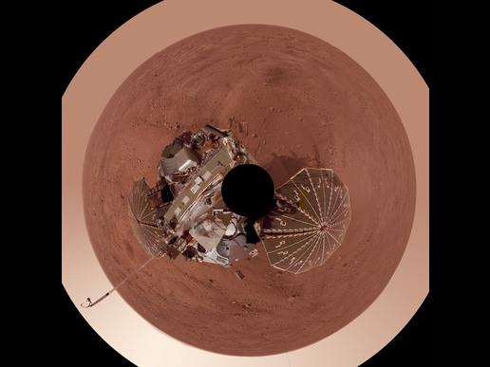
Mission 1:
NASA’s Phoenix Mars Lander
photo source: http://www.nasa.gov/mission_pages/phoenix/images/polar_AGU.html
Goals of the Mission: The Phoenix Mars Lander was sent to Mars in August of 2007 and arrived on the red planet in May 2008. It arrived on the northern polar region of Mars where it dug into the Martian surface with its robotic arm to reach the subsurface water ice. It brought the water and soil samples up to the Lander where they were (and continue to be) analyzed using sophisticated science equipment. These activities are helping it achieve its two major goals of the mission:
- To study the history of water in the Martian arctic
- To search for evidence of a habitable zone and assess the potential for life in the ice-soil boundary.

Instruments being used:
- Robotic Arm (RA) – built by JPL and designed to work like a backhoe with its up/down, forward/backward, side-to-side, and rotating movements. The Robotic Arm has dug trenches in the Martian soil, scooped up water ice and soil samples and then delivered them to Thermal and Evolved Gas Analyzer and Microscopy, Electrochemistry and Conductivity Analyzer instruments for detailed chemical and geological analysis.
- Robotic Arm Camera (RAC) – built by the University of Arizona and Max Planck Institute, Germany. Just above the scoop on the Robotic Arm this camera can be found. It takes full-color images close up of the Martian surface near the lander, the trench (floor and walls) the arm has previously dug, the potential soil samples in the trench, and it verifies the soil samples in the robotic Arm’s scoop before they are brought to the Thermal and Evolved Gas Analyzer. This camera views colors and grains in the scoop, and it looks for layering and soil texture in the walls of the trench.
- Thermal and Evolved Gas Analyzer (TEGA) –built by a team at the University of Arizona and the University of Texas, Dallas. The instrument was capable of doing more accurate analysis of carbon dioxide than similar instruments on previous Mars landers. It is comprised of a high-temperature furnace and mass spectrometer instrument which scientists used to analyze Martian ice and soil samples. It contains eight tiny ovens (the size of the ink chamber in a ballpoint pen) that will heat the samples up to 1800°F. The vapors from the samples are then transported to a mass spectrometer which will determine ratios of various isotopes of hydrogen, oxygen, carbon, and nitrogen, and give clues to the origin of the molecules, and possibly, biological processes that occurred in the past.
- Mars Descent Imager (MARDI) – built by Malin Space Science Systems. MARDI was designed to show the geographic landforms around Phoenix’s landing zone during the final three minutes of descent. However, MARDI was not used because of problems transmitting the large amounts of data during this critical time in the landing.
- Meteorological Station (MET) – built by the Canadian Space Agency. MET took daily temperature and pressure readings on the northern plains. It also has a Light Detection and ranging instrument (LIDAR) which is helping scientists learn how water is cycled between the frozen and gaseous states at the Martian polar region.
- Surface Stereo Imager (SSI) – built by the University of Arizona. SSI was Phoenix’s “eyes”. It provided NASA with high-resolution, stereo, panoramic images of the martian arctic. SSI used and advanced optical system that gave us 3-d images of geological context, and provided range maps to aide digging operations, and it made atmospheric dust and cloud measurements.
- Microscopy, Electrochemistry, and Conductivity Analyzer (MECA)- built by JPL. MECA was a wet lab that tested the Martian soil for pH, mineral composition, dissolved oxygen and carbon dioxide amounts. The other component of MECA is a set of probes that were placed into the soil in the trenches to test for temperature and thermal and electrical conductivity properties of the soil.

How does this mission fit into NASA’s vision for Exploration:
Phoenix was the first lander to return data from either polar region on Mars. It is helping NASA Scientists to “Follow the Water” and is providing important data to help NASA achieve the four science goals of NASA's long-term Mars Exploration Program.
- Determine whether Life ever arose on Mars (This is being done by evaluating and analyzing atmospheric gases and subsurface water and soil to determine if they are hospitable environments for extremophilic microbes and bacterial spores which can lie dormant in extreme conditions for millions of years.)
- Characterize the Climate of Mars (This is being evaluated by studying the amounts of water and carbon in the Martian atmosphere and identifying the isotopes of the present carbon dioxide gases in the atmosphere to determine if they originated from recent or ancient water sources.)
- Characterize the Geology of Mars
- Prepare for Human Exploration (This is being addressed by learning about the Martian climate and by gaining the ability to predict meteorological processes at work on the red planet.)
Findings: Results from Phoenix’s tests of soil and subsurface water samples from the northern polar region indicate that water has been present in liquid form and carved formations into the Martian landscape throughout its history and even in its recent past. The chemical isotopes from the carbon dioxide samples taken by Phoenix are helping to create a better understanding of the history of water on this now-barren planet. The isotopes of the carbon dioxide samples show that water probably existed in the near-freezing temperature range. They also show that hot spring activity, although present at times, was a rare occurrence in Mars’ history. (Webster and Jeffs, 2010)
NASA scientists are very interested in Mars’ climate history. By studying the water on Mars (frozen in and water vapor form) and its meteorological history, they can better understand Mars’ past climate and perhaps predict future weather patterns and processes.
Advanced Instruments compared to those used on Past Missions: Phoenix boasts a complex array of instruments that are improved variations of those that flew on the lost Mars Polar Lander. They are some of the most technologically advanced instruments ever sent to Mars. The Thermal and Evolved Gas Analyzer that identified Carbon Dioxide isotopes in the Martian atmosphere is far superior to the similar instruments used on the Viking Landers in the 1970’s.

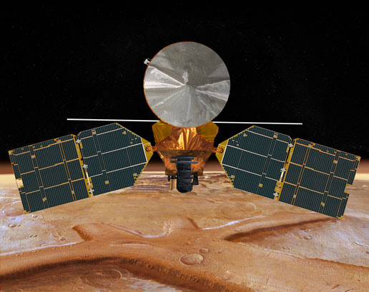
Mission 2:
NASA’sMars Reconnaissance Orbiter
Image Source: http://www.nasa.gov/mission_pages/MRO/multimedia/MRO-front-view.html

Goals of the Mission: The MRO was launched in August of 2005 and reached it orbit around Mars in the Fall of 2006. It continues orbiting Mars in an attempt to look for proof that water not just existed, but persisted, on Mars’ surface. The primary goals of the MRO are to:
- verify if there are deposits of minerals that form in water over long periods of time,
- spot any shorelines of ancient seas and lakes, and
- analyze deposits placed in layers over time by flowing water.
- It will also be able to tell if the underground Martian ice discovered by the Mars Odyssey orbiter is the top layer of a deep ice deposit or whether it is a shallow layer with the current atmosphere and its seasonal cycle of water vapor.
- establish a crucial telecommunication link for future spacecraft,
- use its experimental navigation camera to guide incoming landers to precise landings on Mars, which would allow for future landings in formerly -thought-of-dangerous areas of the planet.

Instruments being used on the MRO:
Cameras
- High Resolution Imaging Science Experiment (HiRISE) – will take hundreds high-definition pictures as it orbits around Mars. This allows it to see down to a three-foot object with extraordinary detail using visible wavelengths giving us better understanding of the surface structure. It also has the capability of using near-infrared wavelengths that will allow it to determine minerals present on the surface
- Context Camera (CTX) – provides lower-resolution images than the other two cameras, but provides a picture of a larger area to give scientists a better image of the terrain
- Mars Color Imager (MARCI) - provides daily weather reports including dust storms and polar cap changes. It is designed to produce a map of Mars that shows the changes in Mars’ climate and daily weather. MARCI also creates ultraviolet images at two wavelengths to check variations in ozone, dust, and carbon dioxide changes in the atmosphere.
Spectrometer
- Compact Reconnaissance Imaging Spectrometer for Mars (CRISM) - searches for residue of minerals that form in geothermal locations. It uses visible and infrared wavelengths to identify mineral composition and signature traces of water.
Radiometer
- Mars Climate Sounder (MCS) – observes the temperature, humidity, and dust content of the Martian atmosphere to gain a better understanding of Martian weather and climate patterns.
Radar
- Shallow Radar (SHARAD) – uses 15-25MHz to look for water or water ice within the first kilometer of Martian soil
Engineering Instruments
- Electra UHF Communications and Navigation Package – this is a telecommunications and radio package that acts as a relay and provides navigation for other Mars spacecraft by using precice Doppler data.
- Optical Navigation Camera – a non-necessary experimental camera that will be used to guide future spacecraft into Mars’ orbit with greater accuracy
- Ka-Band Telecommunications Experiment Package – an experimental radio that could provide greater quality on less power.
Science Facility Experiments
- Gravity Field Investigation Package – will determine the gravitational field using Doppler shift in radio signals to tell us the density of the atmosphere and the subsurface structure of Mars.
- Atmospheric Structure Investigation Accelerometers – is used to tell scientists the atmospheric density at MRO’s altitude

How does this mission fit into NASA’s vision for Exploration:
MRO is providing important data to help NASA achieve three of the four science goals of NASA's long-term Mars Exploration Program:
- Characterize the Climate of Mars
- Characterize the Geology of Mars
- Prepare for Human Exploration
Findings: NASA’s MRO continues to revolve around Mars today, four and a half years after it went into orbit . It has taken hundreds and hundreds high resolution pictures up close of the Martian surface. It has found sand-sized grains in linear dunes inside craters in the southern hemisphere (Webster, 2010) It has also found and photographed landforms carved out by winds, water, lava flows, and seasonal carbon dioxide ice. (Webster, 2010) MRO recently found hydrated silica mounds on an ancient volcano that could very well have created a habitable zone (warm and wet) for extremophilic microbes. (Webster Lewis, Brown, 2010). And in the fall and early winter of last year, the CRISM spectrometer was mapping out and sending travel path suggestions to scientists for NASA’s Mars Rover Opportunity to visit a crater called Endeavour. (Webster, Brown, Hoover, 2010)
Advanced Instruments compared to those used on Past Missions: The MRO contains several high powered cameras including the largest ever flown on a planetary mission. This camera can identify objects on the surface that are as small as your kitchen table. This is far more powerful than cameras used on previous missions. The MRO also uses a new spacecraft design from Lockheed Martin Space Systems that is more intelligent, more reliable, more responsive, and more productive than any previous Mars orbiter.” (http://www.nasa.gov/mission_pages/MRO/mission/index.html)
MRO is a pioneer spacecraft designed for aerobraking which is a difficult and meticulous phase of the mission as it uses the friction of the Martian atmosphere to reduce its speed to achieve its final position in orbit around Mars.

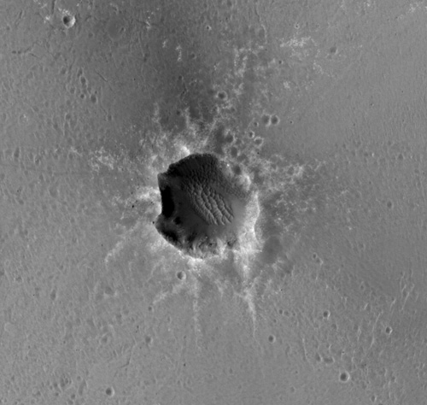
Mission 3:
NASA Mars Exploration Rover Opportunity
Opportunity
Photo Source: http://marsrover.nasa.gov/gallery/press/opportunity/20110104a/PIA13754_ESP_020758_1780_Oppty-at-StaMaria_br.jpg
Note – the tiny dot the arrow is point to is NASA’sMars Exploration Rover Opportunity. The picture was taken by the HiRISE Camera from NASA’s MRO (as discussed in the previous mission report) on New Year’s Eve 2010 at the edge of the Santa Maria Crater.

Goals of the Mission: Mars Exploration Rover B (MER-B) Opportunity was the second MER to launch. Opportunity left Earth on July 7, 2003 and arrived safely on Mars on the afternoon of January 24, 2004 at the Meridiani Planum. The two rovers’ goal was to explore Mars and look for clues about the history of water on Mars. Both had anticipated life expectancies of a year. Spirit continued into 2009,but Opportunity is still roaming the red planet today, 7 years later. The primary scientific goal of both Spirit and Opportunity is to look for and characterize rocks and soils on Mars that might hold clues to the history of water on Mars.

Instruments being used:
- Panoramic Camera (Pancam) This is used to determine the mineralogy, texture, and structure of the local terrain.
- Miniature Thermal Emission Spectrometer (Mini-TES): This is used to identify rocks and soils for and to help determine the processes that formed Martian rocks. It also provides an atmospheric temperature profile.
- Mössbauer Spectrometer (MB): investigates and analyzes the mineralogy of iron-bearing rocks and soils.
- Alpha Particle X-Ray Spectrometer (APXS): analyzes of the abundances of mineral composition of rocks and soils.
- Magnets: collect magnetic dust particles. Microscopic Imager (MI): for obtaining close-up, high-resolution images of rocks and soils.
- Rock Abrasion Tool (RAT): removes dusty and weathered rock surfaces revealing underlying material for analysis by instruments onboard.
How does this mission fit into NASA’s vision for Exploration:
MER Opportunity is providing important data to help NASA achieve two of the four science goals of NASA's long-term Mars Exploration Program:
- Characterize the Climate of Mars
- Characterize the Geology of Mars
Findings: MER Opportunity acts like a human geologist on Mars. After completing its primary missions in the spring of 2004, it and its team of scientists on Earth have been enjoying bonus missions criss-crossing 16.56 miles of the Martian terrain. (MER Mission, 2011) It has spent seven years photographing, studying, collecting, analyzing, and reporting on dozens and dozens of rocks and Martian soil samples giving scientists on Earth a greater understanding of the planet’s geologic and water history. (NASA, 2009)
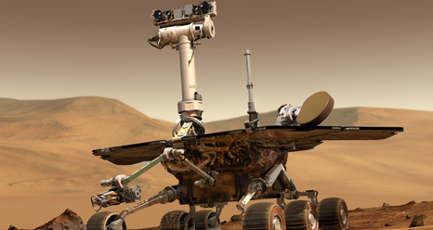
Image Source: http://www.nasa.gov/mission_pages/mer/index.html
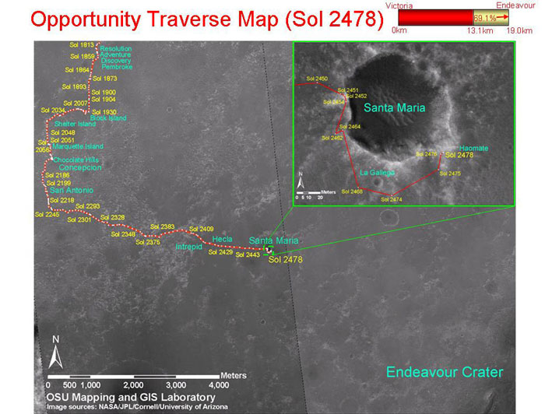
Image Source: http://marsrovers.nasa.gov/mission/tm-opportunity/images/MERB_Sol2478_3_br2.jpg
January 19, 2011 = Sol 2478 for Opportunity

Reference and Resources:
"Mars Exploration Rover Mission: Overview." Mars Exploration Rover Mission: Home. 23 Jan. 2009. Web. 19 Feb. 2011. <http://marsrovers.jpl.nasa.gov/overview/>.
"Mars Exploration Rover Mission: Press Release Images: Opportunity." Mars Exploration Rover Mission: Home. 4 Jan. 2011. Web. 19 Feb. 2011. <http://marsrover.nasa.gov/gallery/press/opportunity/20110104a.html>.
"Mars Exploration Rover Mission: The Mission." Mars Exploration Rover Mission: Home. 16 Feb. 2011. Web. 19 Feb. 2011. <http://marsrovers.nasa.gov/mission/status.html>.
"Mars Exploration Rover Mission: The Mission." Mars Exploration Rover Mission: Home. 27 Aug. 2007. Web. 19 Feb. 2011. <http://marsrovers.jpl.nasa.gov/mission/>.
"NASA - Overview." NASA - Home. Web. 19 Feb. 2011. <http://www.nasa.gov/mission_pages/MRO/mission/index.html>.
"NASA - Overview." NASA - Home. Web. 19 Feb. 2011. <http://www.nasa.gov/mission_pages/MRO/spacecraft/index.html>.
"NASA - Overview." NASA - Home. Web. 19 Feb. 2011. <http://www.nasa.gov/mission_pages/phoenix/mission/index.html>.
"NASA - Overview." NASA - Home. Web. 19 Feb. 2011. <http://www.nasa.gov/mission_pages/phoenix/spacecraft/index.html>.
Webster, Guy, and William Jeffs. "NASA - NASA Data Shed New Light About Water and Volcanoes on Mars." NASA - Home. 9 Sept. 2010. Web. 19 Feb. 2011. <http://www.nasa.gov/mission_pages/phoenix/news/phx20100909.html>.
Webster, Guy, Dwayne Brown, and Rachel Hoover. "NASA - NASA Spacecraft Provides Travel Tips for Mars Rover." NASA - Home. 16 Dec. 2010. Web. 19 Feb. 2011. <http://www.nasa.gov/mission_pages/mer/news/mer20101216.html>.
Webster, Guy. "NASA - Resumed Mars Orbiter Observations Yield Stunning Views." NASA - Home. 14 Jan. 2010. Web. 19 Feb. 2011. <http://www.nasa.gov/mission_pages/MRO/news/mro20100114.html>.
Webster, Guy, Richard Lewis, and Geoffrey Brown. "NASA - Silica on a Mars Volcano Tells of Wet and Cozy Past." NASA - Home. 31 Oct. 2010. Web. 19 Feb. 2011. <http://www.nasa.gov/mission_pages/MRO/news/mro20101031.html>.

