Florentia Spires
Methods of STEM Education

Description of Integrated Lesson Plan:
Students will engage in discussions relating to energy conservation when using appliances in their homes. They will explain that alternating current and direct current are responsible for the supply of most energy in their homes. They will research the different types of bulbs to learn about how they function and safety concerns affiliated with each type of bulb.

Students will use “Kill A Watt” meters to measure the energy consumption of different types of light bulbs most commonly used in the home. The lesson allows students to carry out calculations of the ratio unit cost per kilowatt-hour. Students will carry out mathematical calculations to problem solve and determine which type of bulb is the most cost effective when considering purchase price, cost of energy to use the bulb and finally the length of time that the bulb will light. They will gain additional practice with manipulating the formula triangle to check their work.

Finally, this lesson will help students lead discussions with their families and possibly educate them about energy conservation as it relates to the type of bulb and the depletion of fossil fuels. They will also be asked to include a component of the family discussion surrounding conservation and preservation of our Earth’s resources in general.

The integration is logical in this lesson because it provides a science content area that affords students to apply science knowledge in a practical way to their daily lives. Also, it allows students to understand that they are able to independently use math principles to make measurable comparisons of energy consumption of everyday appliances in order to save money for their families and simultaneously conserve our Earth’s energy resources.

Science Standards:
8.15 Students will be introduced to the analysis and description of Energy Transfer and Transformation.
8.16 Students will be introduced to the Law of Conservation of Energy.

Math Standards:
8.NSO-C.9. Solve problems involving ratio units such as miles per hour, dollars per pound, or persons per square mile.
8.DASP.1. Revisit measures of central tendency (mean, median, and mode) and spread (range) that represent a set of data and then observe the change in each when an “outlier” is adjoined to the data set or removed from it. Use these notions to compare different sets of data and explain how each can be useful in a different way to summarize social phenomena such as price levels, clothing sizes, and athletic performances.
8.DASP.3. Recognize practices of collecting and displaying data that may bias the presentation or analysis.

Common Core Standards:
Vocabulary Acquisition and use:
6. Acquire and use accurately grade-appropriate general academic and domain-specific words and phrases; gather vocabulary knowledge when considering a word or phrase important to comprehension or expression.
Comprehension and Collaboration:
1. Engage effectively in a range of collaborative discussions (one-on-one, in groups, and teacher- led) with diverse partners on grade 8 topics, texts, and issues, building on others’ ideas and expressing their own clearly.
Presentation and knowledge of ideas:
4. Present claims and findings, emphasizing salient points in a focused, coherent manner with relevant evidence, sound valid reasoning, and well-chosen details; use appropriate eye contact, adequate volume, and clear pronunciation.
Let There Be Light! - But At What Cost?

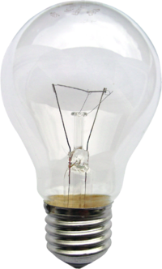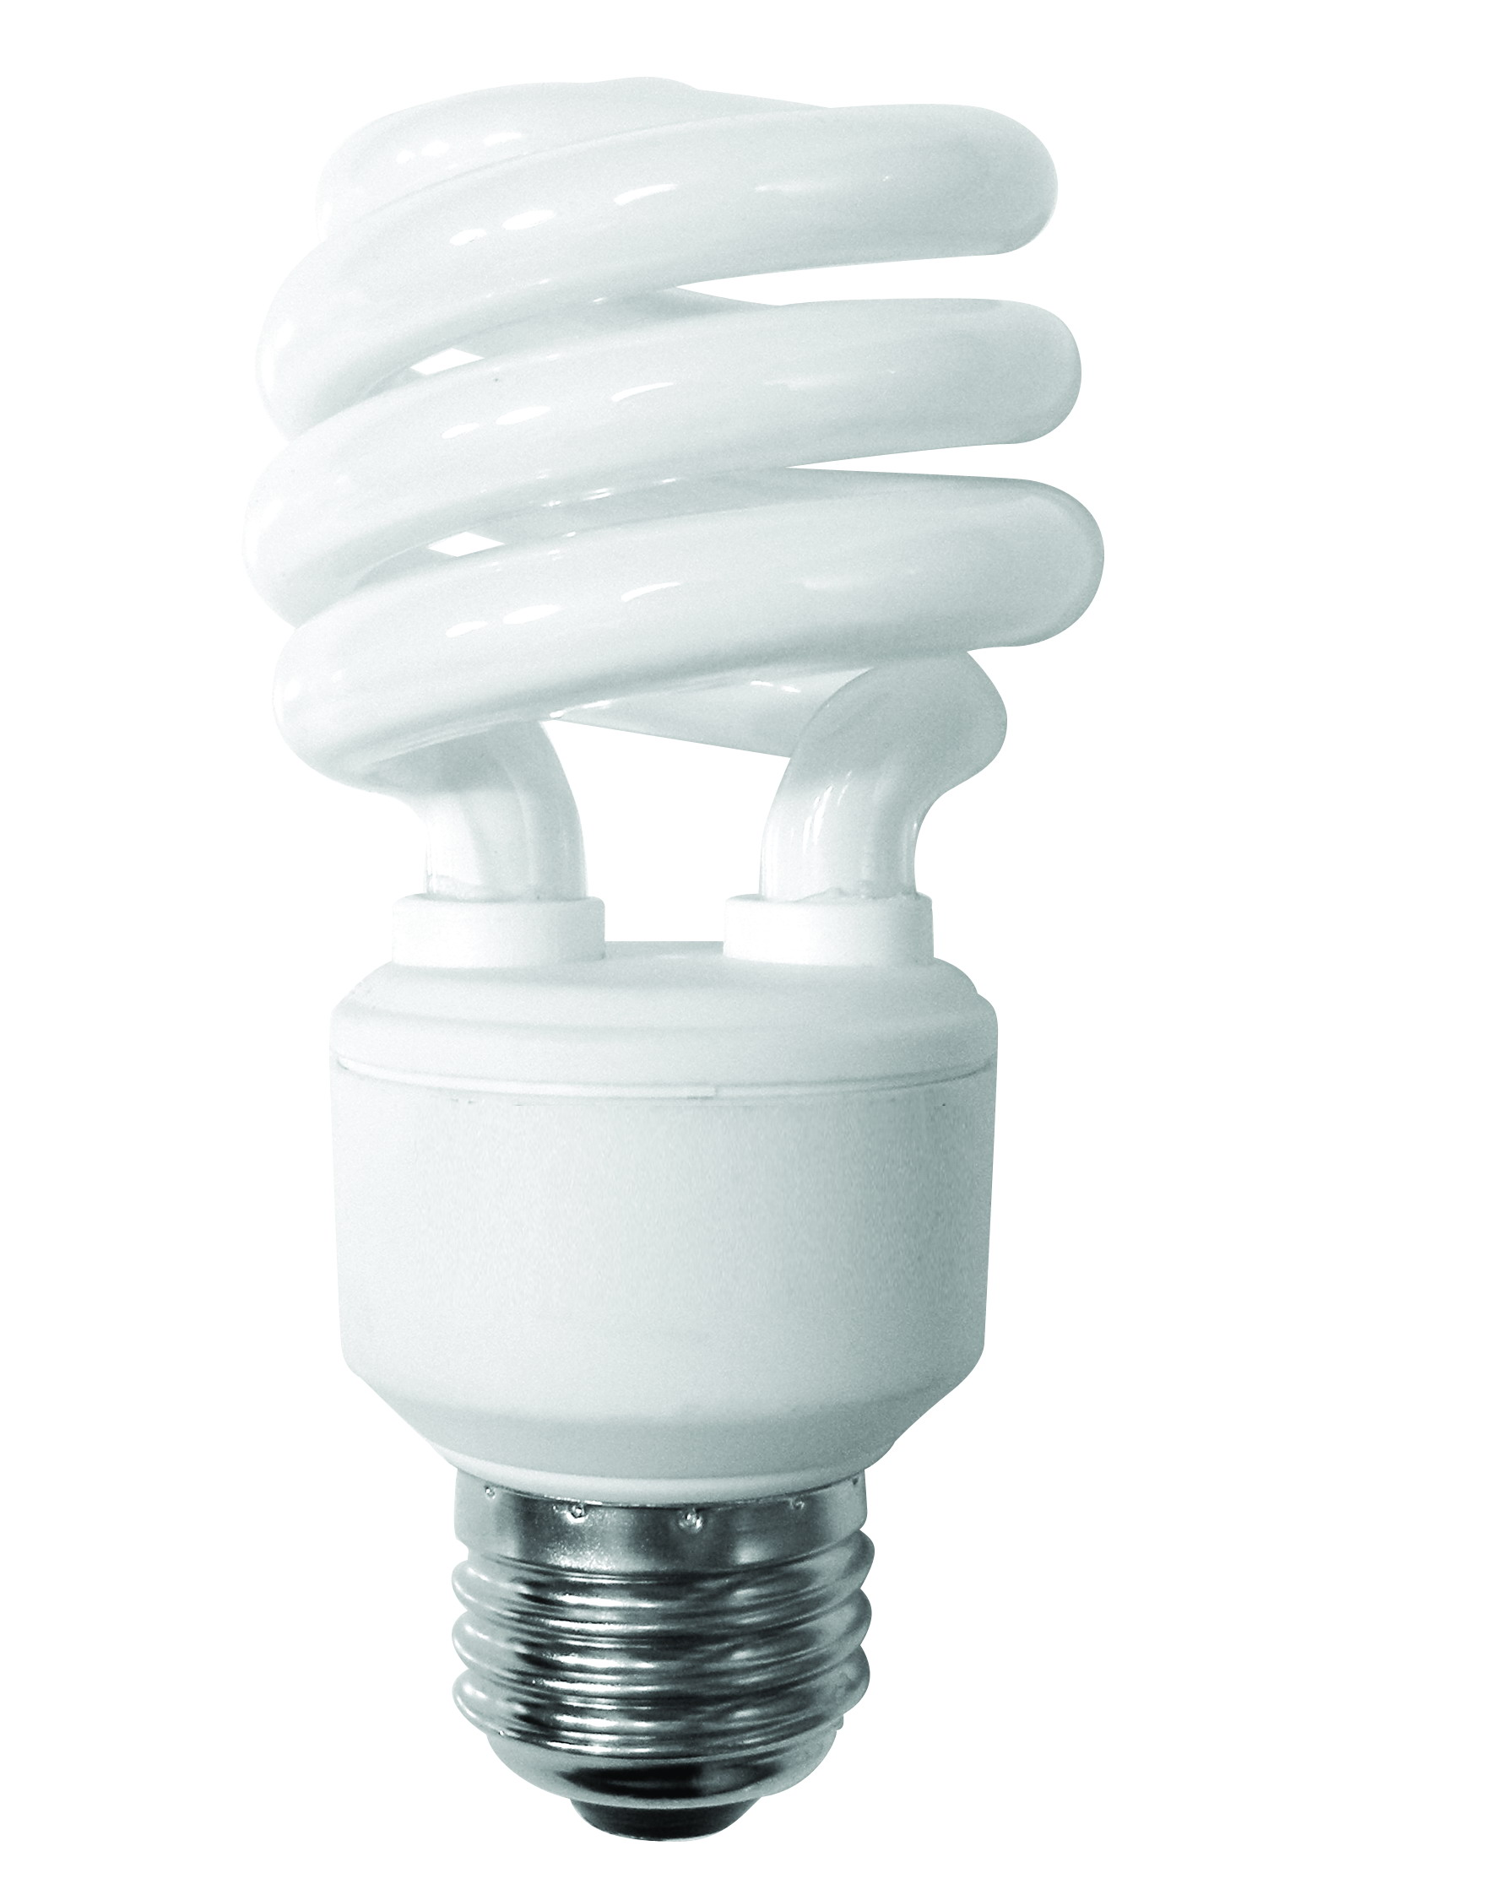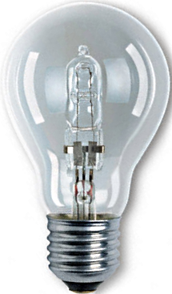

Research Questions:

- How do light bulbs work?
- Incandescent? _______________________________________________________________

- Halogen? _____________________________________________________________________

- Florescent? __________________________________________________________________

- How does a light bulb get energy in the home? ________________________________________________________________________________________

- What unit is used to measure energy consumption? _____________________________

- What is the cost of each type of light bulb?
- Incandescent? _________________________________
- Halogen? _________________________________________
- Florescent? _________________________________
- What health risk(s) is associated with each type of bulb?
- Incandescent? ________________________________________________________________________________________________________________________________________________________________
- Halogen?
________________________________________________________________________________________________________________________________________________________________

- Florescent?
________________________________________________________________________________________________________________________________________________________________

- What environmental hazards are posed by using each type of light bulb?
- Incandescent? _______________________________________________________________
- Halogen? _____________________________________________________________________
- Florescent? __________________________________________________________________

- How is each type of bulb disposed?
- I- ________________________ b) H- ________________________ c) F- _____________________

- Lab Activity:

Objective: Students will demonstrate their comprehension of energy
conservation by measuring various amounts of energy
consumption in different types of household light bulbs.

Question: Why do consumers choose to use different types of light bulbs in
their home?

Hypothesis: (Please record your hypothesis)

Materials:
- 1 incandescent bulb
- 1 halogen bulb
- 1 florescent bulb
- 3 kill a watt meters
- Calculator
- Pencil
- Alternating current

Methods:
- Go to the area in the classroom where one type of bulb is connected to the meter. (3 types of bulbs in different outlets of the classroom)
- Press the button that corresponds to the data that you need to record in the table below.
- Record the data in the table provided.
- Repeat steps 2 and 3 for each type of data present in the table below that you must record.
- Repeat steps 1 through 4 two more times for the other two types of bulbs listed in the table.

Record your data in the table below.

 | Incandescent | Halogen | Florescent
Price
Hazardous Components
Life Span
Voltage
Current
Wattage
Kilo Watt Hour

- Solve the following problems:
Find the actual cost per kWh to use each bulb?
The following information may help you..
(Actual bulb consumption (kWh) x cost per kWh = Actual cost per kWh of the bulb

Incandescent? _____________________________________________________________________

Halogen? ___________________________________________________________________________

Florescent? ________________________________________________________________________

- If the light is on for 6 hours a day, how much energy is consumed in one week for each type of bulb?
Incandescent? ______________________________________________________________________

Halogen? ____________________________________________________________________________

Florescent? _________________________________________________________________________

- What is the total cost to use each bulb for 6 hours in one week?
a) I-______________________ H- _______________________ F- ____________________________

- Keeping in mind cost, health, and environmental factors that you have learned about each type of bulb, which type of bulb would you advocate to your family to use in your home? Explain and support you bulb of choice in detail.
______________________________________________________________________________________________________________________________________________________________________________________________________________________________________________________________________________________________________________________________________________________________________________________________________________________________________________________________________________________________________________________________________________________

Energy Conservation Problem Solving Assessment/Rubric

Name(s): _____________________________________________________________________________
Date: _________________________________________ Class: (circle one) 8.4 8.5 8.6

Expert 4 | Expertly interprets and applies scientific observations, data, inferences, and conclusion to science and mathematical questions and problems.
Proficient 3 | Proficiently interprets and applies scientific observations, data, inferences, and conclusion to science and mathematical questions and problems.
Emergent 2 | Misinterprets and does not apply sufficient scientific observations, data, inferences, qualitative and quantitative supports to make accurate conclusions to science and mathematical questions and problems.
Novice 1 | Offers biased interpretations and does not apply sufficient scientific observations, data, inferences, and qualitative and quantitative supports to make accurate conclusions to science and mathematical questions and problems.

Energy Consumption Assessment:

Name: __________________________________________ Date: ________________________
Class: (circle one) 8.4, 8.5, 8.6

Your radio cost $10.00. It uses .75-kilowatt hours of power. Your town charges $0.30 kWh to use current.

- Calculate the amount to run your radio for 7 hours on Saturday?
- How much does it cost to run your radio for 7 hours during the month of April 2012, which has 4 Saturdays?
- What is the total cost to run your radio if it was only used during the month of April 2012?
- What is the most energy efficient type of bulb that offers sufficient safety for use in the home? Explain your choice in detail.
Answers:
- $1.58 /kWh
- $6.30 /kWh
- $16.30
- Answers will vary (support is essential here for legitimacy of any answer)

