NASA on the Moon Design Challenge
By: Heather Haberman

On December 1st and December 2nd I had the opportunity to do a brief engineering challenge with my Practical Biology classes. I chose to do the “Launch It” challenge since this would be the first design challenge they would have done on their own in class.
IDENTIFY THE PROBLEM
First I discussed rockets with my classes and I showed them a variety of photographs. I then explained that the students would need to design a rocket that could shoot 5 feet and hit a target. Next they fill out the first section of their “notebook” (see attachment). Some students had a difficult time identifying the problem they needed to solve. Some groups thought the problem was to simply get a rocket to fly, others thought it was to keep the air from escaping the straw. I had these groups go back and think about the goal of our project and with minimal coaching they were able to rewrite their problem statement to include the constraints.
BRAINSTORMING
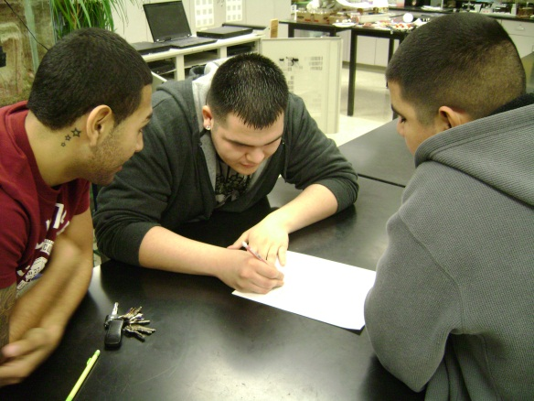
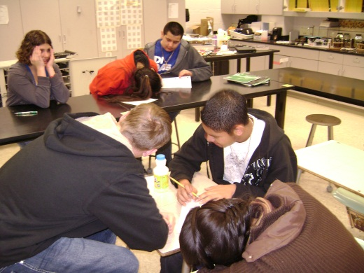
Students then were told to brainstorm some ideas and to come up with two designs that they could build and test. At first they had a difficult time with wanting to share their ideas with their team, but once they got started the ideas began to flow.
I find the lower functioning students are often fearful of being “wrong” or looking “stupid” to their peers. Once they realized that there were no stupid ideas when brainstorming they felt much more comfortable.

DESIGN
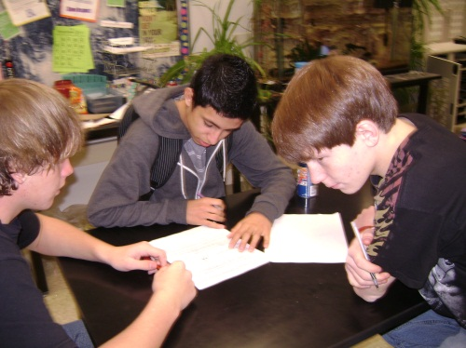
Each team had to draw two design sketches and explain why they chose these designs before they were allowed to get their supplies. It was interesting to see the variety some of the groups had. Some were very plain and simple and others were more complex.
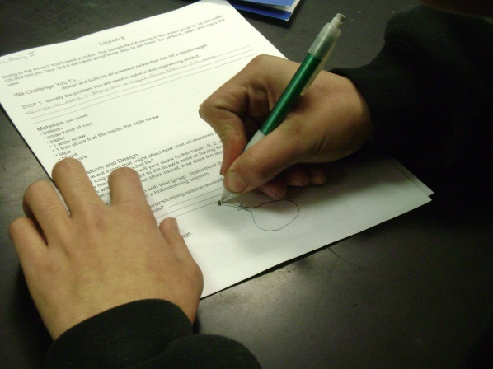
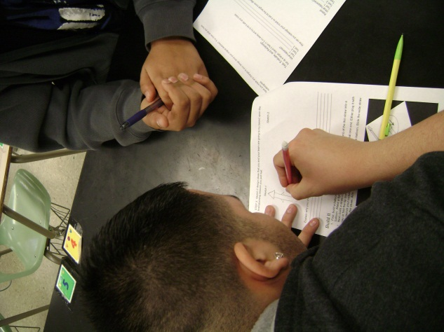
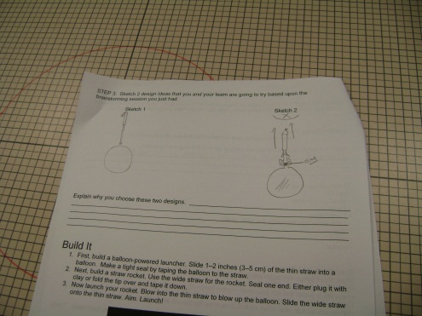

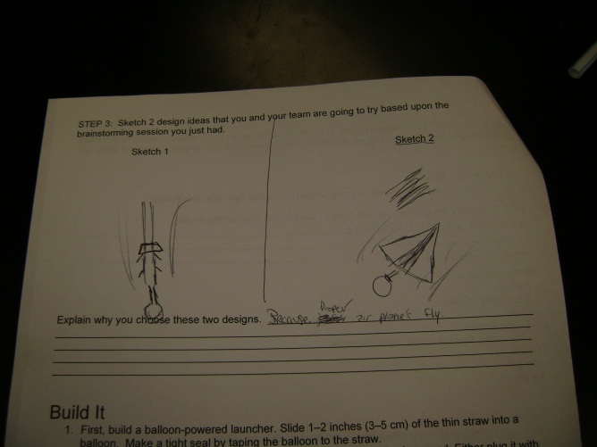
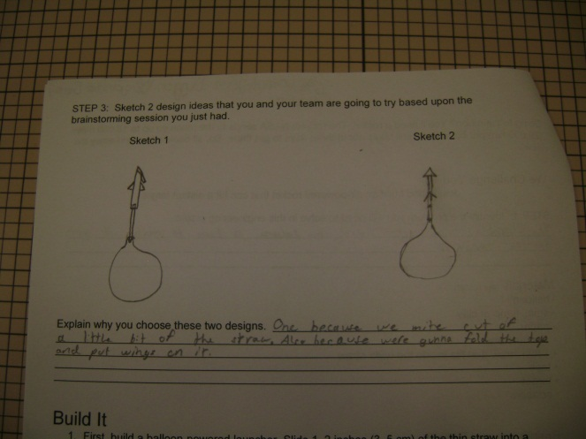

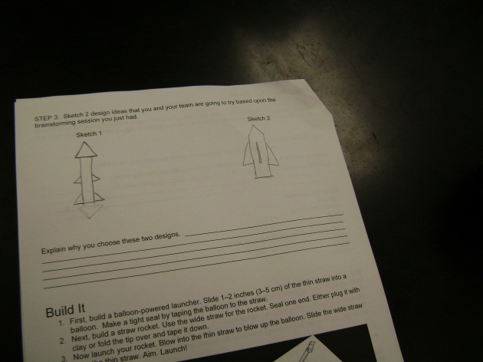
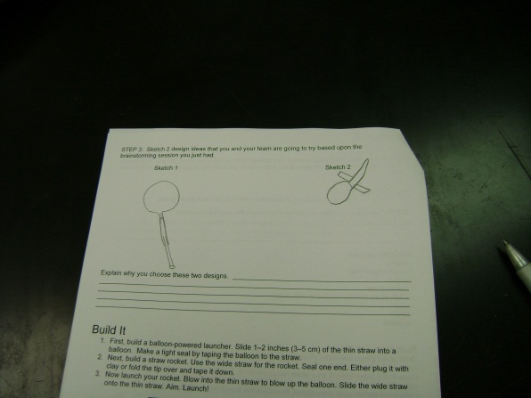

BUILD
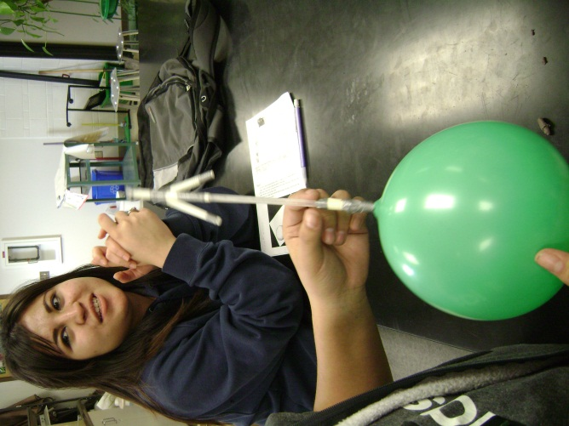
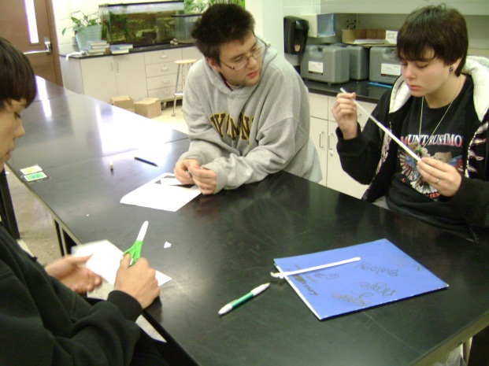
As the teams built their rockets some realized that they needed to make some modifications to their original design plan because their rocket was too heavy to launch.
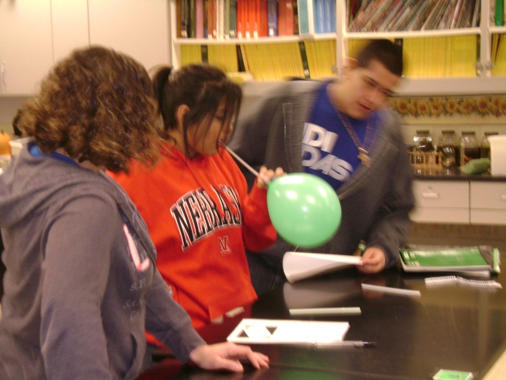
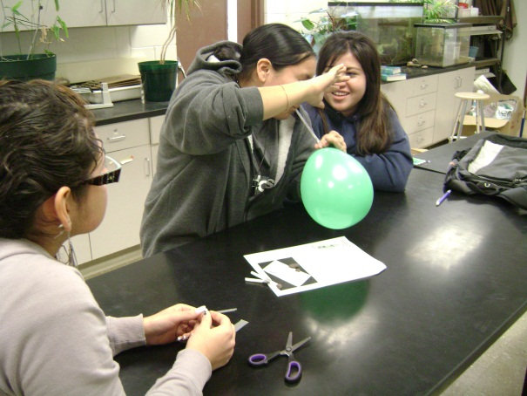

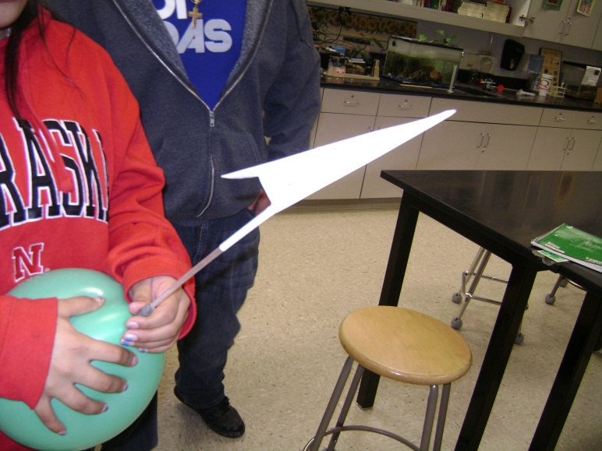

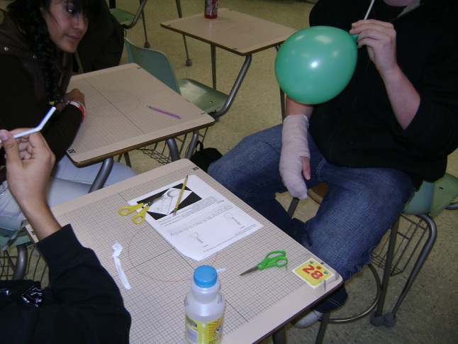

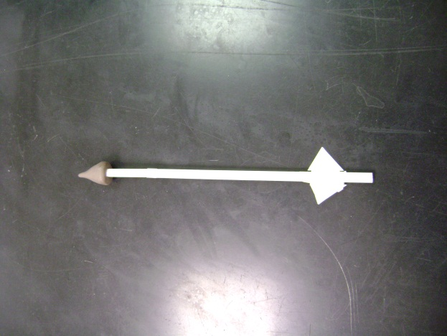

TEST AND EVALUATE
This was the most difficult part for the teams. Many groups had trouble getting their straw rocket to launch due to a variety of issues. The teams did a good job of isolating one variable at a time to try and determine why their rocket would not launch. A few teams were unable to figure it out in the time we had but many teams did.
It was fun to question the teams as they were testing their rockets “Why isn’t your rocket hitting the target consistently?” “Why won’t it go 5 feet?” “Why does it keep going to the left?”. I found that the students knew exactly why the rockets were acting the way they were. They displayed terrific critical thinking skills. They were also very eager to go back to their stations in order to make modifications and retest their designs.
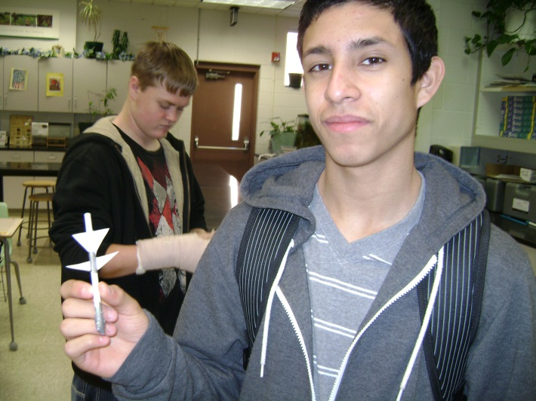
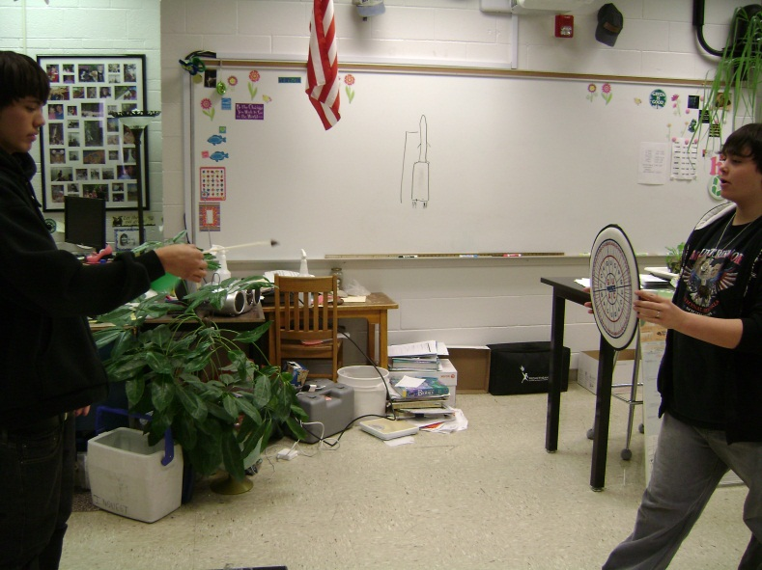

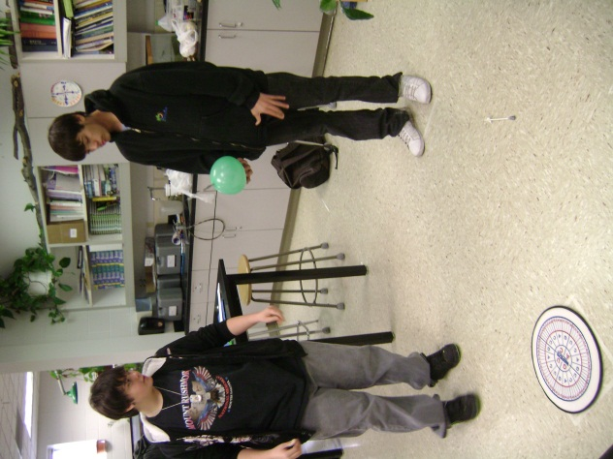
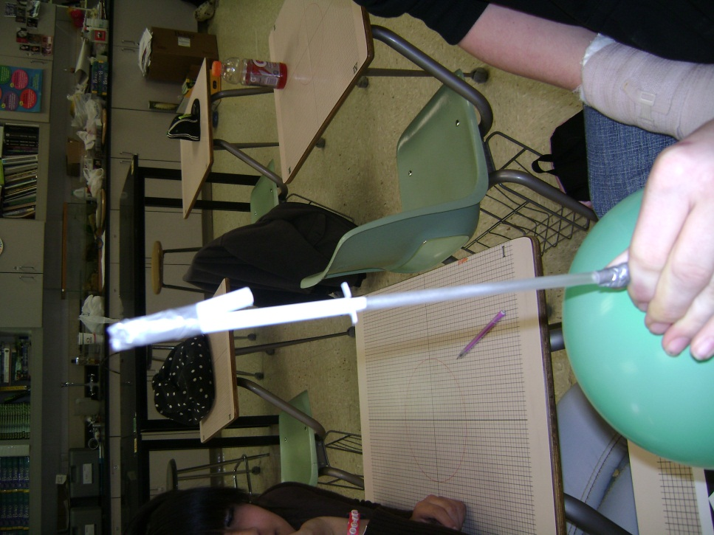

REDESIGN
The teams did a great job of making modifications as soon as they realized their rocket wouldn’t reach the target consistently. I noticed that most teams stuck with one design and continually made modifications to it rather than trying to completely redesign a new rocket. It was also fun to watch the teams collaborate and help each other in this “competiton”.
SHARE THE SOLUTION
Each team presented their rockets and explained to the class the results they were able to achieve. Each team took great pride in their rockets and did an excellent job of offering suggestions for improvement. Students that are usually very shy and reluctant to speak in front of others didn’t feel that way when they were sharing this project with the class.

STUDENT WORK
I kept all of the rockets my students designed as well as their “notebooks” (worksheets). I would be happy to mail them to you if you would like. Please send me an address to which I should ship them to.

This is the handout or “notebook” that my students filled out during their design project.
Launch It
Going to the moon? You’ll need a rocket. The rockets NASA sends to the moon go up to 18,000 miles (29,000 km) per hour. But it still takes about three days to get there. So, sit back, relax, and enjoy the view.

We Challenge You To…
…design and build an air-powered rocket that can hit a distant target.
STEP 1: Identify the problem you will need to solve in this engineering project. ________________________________________________________________________________________________________________________________________________________________________________________________________________________________________________
Materials (per rocket)
• balloon
• small lump of clay
• paper
• 1 wide straw
• 1 thin straw that fits inside the wide straw
• tape
• target
• scissors

Brainstorm and Design
Think about things that might affect how your air-powered rocket flies.
• How long will your rocket be?
• How many paper fins will your straw rocket have—0, 2, or more?
• How will adding weight to the straw’s nose or having fins affect how it flies?
• When you launch your straw rocket, how does the launch angle affect where it lands?

STEP 2: Brainstorm with your group. Remember that EVERYONE need to share their ideas. There are NO bad ideas in a brainstorming session.

Explain how your brainstorming session worked. How did you ensure everyone had a chance to contribute their ideas? ______________________________________________________________
________________________________________________________________________________________________________________________________________________________________

STEP 3: Sketch 2 design ideas that you and your team are going to try based upon the brainstorming session you just had.

Sketch 1 Sketch 2

Explain why you choose these two designs. _____________________________________________
________________________________________________________________________________________________________________________________________________________________________________________________________________________________________________________________________________________________________________________________

Build It
- First, build a balloon-powered launcher. Slide 1–2 inches (3–5 cm) of the thin straw into a balloon. Make a tight seal by taping the balloon to the straw.
- Next, build a straw rocket. Use the wide straw for the rocket. Seal one end. Either plug it with clay or fold the tip over and tape it down.
- Now launch your rocket. Blow into the thin straw to blow up the balloon. Slide the wide straw onto the thin straw. Aim. Launch!

Have you made any changes to your design since your original sketches? If so draw what you have redesigned.

Test, Evaluate, and Redesign
Set up a target. Stand 5 feet (1.5 m) away and try to hit it with your rocket.

What happened?
Test 1: _______________________________________________________________________
Test 2: _______________________________________________________________________
Test 3: _______________________________________________________________________

How can you redesign your rocket so it will hit the target more often? Sketch it below.

Retest
What happened?
Test 1: _______________________________________________________________________
Test 2: _______________________________________________________________________
Test 3: _______________________________________________________________________

Can you make your rocket hit the target every time?

HINTS: Try these things if your rocket:
• falls quickly to the ground—Reduce the weight.
• misses the target—Launch it at a different angle.
• won’t fly straight—See if fins make a difference. Also, try adding weight to the rocket’s nose.
• sticks to the launch straw—Make sure the launch straw is dry. If it isn’t, wipe it dry. Also, try blowing up the balloon more.

