2010 NASA Endeavor Summer Internship
Susan Hallstrom
Langley Research Center
Project Proposal Based on Internship Experience

INTRODUCTION

From July 19-July 30, 2010, I had the opportunity to work at the NASA Langley Research Center, Langley, VA. NASA is developing a high-tech Chemistry and Physics Atmospheric Boundary Layer Experiment (CAPABLE) observation site. The interns worked with various instruments on and around this site. NASA was looking for an Endeavor Fellow who would work with data comparisons from different types of photometric instruments that measured the same parameters in order to assess handheld instruments that are both user-friendly but accurate for use in school settings. A prerequisite for the internship was Excel proficiency.

I evaluated and compared data from Microtops, Calisph, and GLOBE handheld photometers. We also constructed a handheld photometer for use at the red wavelength. We had about four weeks of data from these instruments available. The handheld photometer was calibrated and we collected about a week’s worth of data after calibration. Comparisons of the readings from the four photometers were conducted.

The GLOBE (Global Learning and Observations to Benefit the Environment) program is a worldwide hands-on, primary and secondary school-based science and education program. GLOBE's vision promotes and supports students, teachers and scientists to collaborate on inquiry-based investigations of the environment and the Earth systems. GLOBE is working in close partnership with NASA, NOAA and NSF. During the course of the internship, some contact was made with GLOBE, however, the contact was of insufficient depth for me to develop a clear picture of how GLOBE would “fit” into the big picture.

As a “side” project, we assembled an outdoor camera mounted on a convex mirror for recording sky conditions at specific intervals. The purpose of this camera was to record daylight sky conditions on a routine basis. The sky conditions would be evaluated for cloud cover, cloud types, etc. That information would be valuable in assessing the validity of photometric data collected under various conditions.

We also compared infrared temperature readings taken simultaneously with the photometic data. Our goal was to establish a correlation between IR temperature readings and photometer transmittance data. The data collected provided no indication that a correlation could be established. Clear sky conditions are essential for the IR thermometer to give accurate readings. We did not have enough clear atmospheric conditions to gather sufficient data.

The educational application that follows includes the construction and calibration of a handheld photomer, collection of data from the photometer, and data analysis. Students would gather atmospheric data at specific intervals. There are mathematical manipulations ranging from basic algebra and geometry to rather challenging calculus. Much of the mathematical manipulation of data performed at LaRC was beyond my capability. The plan that follows is aimed at middle school or upper level elementary science classes working in collaboration with a high school environmental class.

A detailed discussion of the construction and calibration of the photometer may be found at

http://haze.concord.org/101.html#manual

Primary components of the construction and calibration of the photometer are detailed following.

CONSTRUCTION OF THE PHOTOMETER

Directions for the construction may be found at:

http://www.pages.drexel.edu/~brooksdr/DRB_web_page/construction/sunphotometer/photometer_V3.htm

The directions may also be found in Attachment 1.

If working collaboratively in a high school and middle/elementary school, a minimum of two photometers should be constructed – one for the high school and one for the middle/elementary school. Depending on the number of students and/or the number of classes participating in the project, two photometers per site might be more useful.

The directions include the materials list, well written directions for the construction of the photometers, and schematics.

CALIBRATION OF THE PHOTOMETER

The methodology for calibration of the photometer may be accessed at:

http://haze.concord.org/calibrate.html

A copy of the calibration procedure is included as Attachment 2.

The calibration process will require coordination by the teacher for students to collect data over the course of day. These data will be evaluated in accordance with the calibration mathematics discussed later.

The calibration of the photometer must be conducted when atmospheric conditions are clear. The coordinating teacher will need to have enough leeway in scheduling to conduct the calibration when atmospheric conditions are conducive to collecting valid data.

ANALYZING CALIBRATION DATA

The mathematical procedures used to analyze calibration data may be accessed at

http://haze.concord.org/analyze.html

The procedures are included as Attachment 3. The Attachment does not include the figures referenced in the site. The mathematics involved in the calibration procedure are more appropriate for high school. Collaboration with a higher level mathematics course might be appropriate for the data evaluation.

Attachment 1

Building a GLOBE Sun Photometer

Building a GLOBE Sun Photometer (pc board V3.0)
This document was last modified on 03/24/2009 19:06:39
The GLOBE Program establishes specifications for instruments. However, GLOBE does not sell instruments nor does it officially endorse specific instruments manufactured and/or sold by others. Most GLOBE protocols use readily available commercial materials and instruments. However, the situation for the GLOBE sun photometer is somewhat different because no commercial source exists.
This document describes how to build a sun photometer that meets the specifications established by the Science Team. Most components are commercially available, but the printed circuit (PC) board and LED detectors should be obtained directly from the Science Team. The parts suppliers listed below include those used by the Science Team in developing the current version of the GLOBE sun photometer, but the parts are available from other suppliers, too.
Although it is possible to build a GLOBE sun photometer "from scratch" (except for the LED detectors) a much easier approach is to work with parts identical to those used by the Science Team. A complete kit of parts, including a pre-drilled case and battery but NOT including the digital voltmeter required to monitor the output from the instrument, is available for $40 (check or money order from a U.S. bank or credit union, or PayPal using brooksdr@drexel.edu to identify the payee), from a not-for-profit corporation established by GLOBE PI David Brooks:
Institute for Earth Science Research and Education
2686 Overhill Drive
Norristown, PA 19403 USA
These instructions do not include general information on electronic construction, soldering techniques, or safety precautions, because they assume knowledge of and practical experience with such matters. It is especially important for students doing any kind of electronic construction to be under adult supervision for both practical and safety reasons. A soldering iron can cause serious burns. Some of the components of the GLOBE sun photometer are very heat-sensitive and can easily be destroyed by overheating during construction. Careless soldering techniques can produce solder bridges and/or cold solder joints, either of which will lead to an instrument that will not be work. Electronic components must be installed properly, including observing the polarity of some components. Neither the Science Team, nor the Institute for Earth Science Research and Education, nor the GLOBE Program can assume responsibility for improperly assembled instruments, and cannot promise to offer advice past that which appears in this document.
Having issued these caveats, it is nonetheless true that construction of a GLOBE sun photometer from a kit of parts is a perfectly reasonable undertaking for middle or secondary school students. Certainly, commercial instrumentation plays an essential role in making environmental measurements. However, it is a valuable experience for students to make their own instruments whenever possible, as this enhances their understanding of and appreciation for the challenges of making reliable measurements. GLOBE PI David Brooks, the developer of this kit, has worked with many groups of students and teachers to build GLOBE sun photometers. These experiences show that it is rare to find students or teachers with electronic construction skills. In every case, it has been necessary to provide a tutorial on electronic construction, some practice materials and components, and careful supervision of the process. It is easier to work in pairs, so it makes sense for each pair of participants to build two instruments.
A completed instrument must be calibrated. This is a challenging task and, at present, the Science Team is the only source of calibrated GLOBE sun photometers. It is an interesting exercise for high school students to perform a "Langley plot calibration" (as described elsewhere on this web site), but such calibrations will not be reliable unless they are done at sites (usually high elevation sites) with very stable atmospheric conditions.
The Science Team's goal is to try to support all serious efforts to collect aerosol data with the GLOBE sun photometer. If you build your own sun photometer, you are invited to discuss calibration issues with the Science Team before you undertake an aerosol measurement program. The good news is that it is possible to take measurements now and calibrate your sun photometer later. It is even possible to guess at an approximate calibration by taking measurements and estimating sky conditions through careful observation. GLOBE's computers will not accept measurements from an uncalibrated instrument, but you can work directly with the Science Team.
Parts
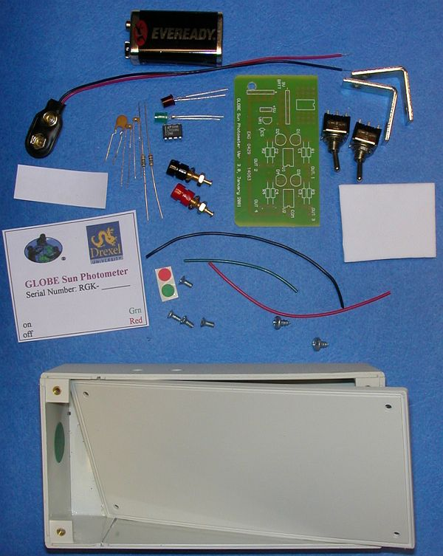
Item description and source
Case, 2"x3-1/8"x6", plastic, with lid and screws
Do not substitute a case of a different size and do not change the location of the printed circuit board inside the case, as described below.
(2) SPDT toggle switches
For the on/off switch, one terminal of one of the SPDT switch is not used.
9V battery snap connector
screws: (2) #6-1/4" pan head Phillips sheet metal
Screws can be round head or pan head, Phillips or slot, but I find Phillips head screws easier to work with. The sheet metal screws are for fastening the L-brackets (corner irons) to the top of the case.
pin plug jacks: (1) red and (1) black
(2) 1" x 1/2" zinc- or brass-plated corner irons (L-brackets)
These metal brackets are typically sold packaged with wood screws, but the sheet metal screws listed above should be used to fasten the brackets to the case.
PC board
You should use the PC board that has been custom-designed for the GLOBE sun photometer, which is available from the Science Team. In principle, it is possible to substitute a standard perf board configured for dual inline package (DIP) components, but this is not recommended.
op-amp, Linear Technology LTC1051CN8
Op-amps typically are available in more than one package configuration. The CN8 specifies an 8-pin dual inline package (DIP) configuration. Although other op-amps can be used, substitutions are not recommended.
LED detectors: Agilent HLMP-D600 emerald green, or equivalent; HLMP-3762 high intensity red, or equivalent
The LED detectors are the most critical components in the GLOBE sun photometer. The spectral response of these detectors has been studied extensively by the Science Team. In order for a sun photometer to be approved for use in the GLOBE program, its detectors must be obtained directly from the Science Team.
resistors: 2.0 Mohm, 1/4-Watt, 5% carbon film; 5.6 Mohm, 1/4-Watt, 5% carbon film
Different resistance values may be included with your kit. This is based on continuing instrument development by the Science Team and will not adversely affect the performance of your sun photometer. In any case, the larger of the two resistors (5.6 MOhm, for example) is always for the red channel and the smaller (2.0 MOhm) is always for the green channel. You can determine the value of resistors supplied with your kit by interpreting the colored bands painted around the body of the resistor. Here's a web link to an explanation of the color code.
capacitors: 0.1 uF ceramic disc (1), 220 pF polystyrene or disc (2)
The voltage rating and tolerance of these capacitors are not critical. The size and shape of the capacitors may vary from those shown in the photo.
hookup wire, 22 or 24 gauge solid or stranded
black, approximately 15 cm (6")
red, approximately 15 cm (6")
green, approximately 5 cm (2")
Stranded wire is OK, but it is somewhat more difficult to work with in the small holes of the PC board and the small terminals of the switches. It is easy to "nick" solid wire when you are removing insulation from the ends, which can cause the wire to break after it's soldered in place but, overall, solid wire is a better choice.
cyanoacrylate glue ("superglue") or two-part epoxy
For corner irons. This is not included. You can get this glue or epoxy at a hardware or home improvement store.
9V battery, standard rectangular
Any 9V battery should last many months in normal use. Alkaline batteries are more expensive than other types and are not required. You can use rechargeable batteries in this application, but it may not be worthwhile because of the very long life of regular batteries.
Foam battery insulator
Label for case
Red and green alignment dots for rear alignment bracket
Sticky paper for rear alignment bracket
Equipment/tools
soldering iron
25- to 40-Watt with small pencil tip. Do not use any kind of "soldering gun" or a soldering iron with a power rating of more than 40 watts. To minimize the chance for accidental burns, a cage-type soldering iron stand is highly recommended.
solder
This must be rosin-core solder specifically intended for electronic work. The most widely available diameter, 0.062” (1.6 mm), is a little large for work on this PC board, so 0.032” (0.8 mm) diameter solder is a better choice. Lead-free solder is available if you prefer to use that, but it is significantly more expensive.
screwdrivers
Phillips for case screws and Phillips or straight blade for battery and corner iron screws.
pliers
Regular, needle nose and diagonal cutting
small craft knife
This is needed to cut away the aluminum tape around the sunlight aperture.
small straight-bladed knife or wirestripping tool
forceps or spring-loaded clip-on heat sink. (optional)
For holding parts and wires in place. Surgical forceps will also work as a heat sink -- these are often available from tool suppliers. Spring-loaded clip-on aluminum heat sinks are often included with soldering iron kits.
magnifying glass (optional)
This is handy for examining your solder connections on the PC board.
digital voltmeter
Any digital voltmeter or multimeter will do. One possibility is RadioShack's Model 22-802 digital multimeter (about US$25). It has an auto-ranging DC volts scale and is small enough to fit into a shirt pocket. It is also small enough to be attached to your sun photometer with Velcro tape so one person can make measurements easily. Another possibility is Kelvin Electronic's 50LE digital multimeter (about US$8, see www.kelvin.com). This is a very inexpensive digital meter that appears to be satisfactory for this purpose.
The voltmeter is needed both to test your sun photometer during construction and to make measurements with a completed instrument. An analog voltmeter is not accurate enough to use for these measurements.
Step-By-Step Instructions for Building a GLOBE Sun Photometer
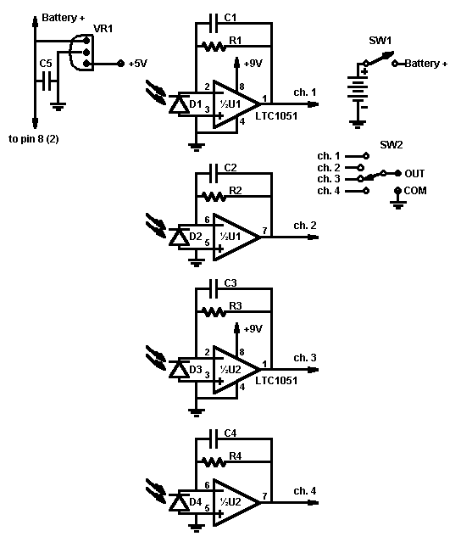
The schematic diagram for the GLOBE sun photometer is shown at the right. This diagram uses standard symbols to show how the circuit operates, but it is insufficient as a guide to actually building such an instrument. If you do not have any experience with electronic construction, get help from someone who has. This is not a difficult project, but it is easy to make mistakes and VERY difficult to correct those mistakes later! It may be a good idea to practice soldering some components before tackling this project. Buy a piece of "perf board" (available at RadioShack and other electronics stores) and a few resistors and capacitors and practice soldering them.
The GLOBE version 3.0 printed circuit (pc) board used provided with the kit is the same board used by the Science Team for its own instruments. It is a multi-purpose board (including space for two additional detectors). Consequently, not all the connections on the board are used for the GLOBE two-channel sun photometer. As you go through these assembly instructions, it is important to use only the indicated connections on the pc board. The accompanying photos are important guides to where parts do and do not go.
In some of the steps below, you are instructed to strip the insulation off the ends of wires. You can do this with a small knife or a wirestripping tool. In either case, if you are using solid (rather than stranded) wire, you must be careful not to "nick" the relatively soft copper. Once the wire is nicked, it may break when it is bent. Unless noted otherwise, you should strip about 6 or 7 mm (1/4") of insulation of the end of the wire. Both ends of the wire should be stripped even if a particular construction step involves connecting only one end. If you haven't done this before, practice on some pieces of wire.

A. Prepare the Channel Select Switch
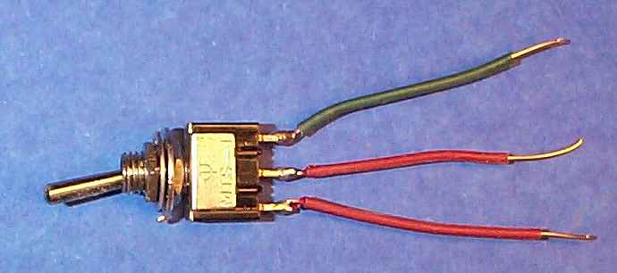
There are two SPDT (single-pole, double-throw) switches supplied with the kit. One will be prepared now and the other will be used later.
It is easy to overheat the solder terminals on these small switches, so be prepared to work quickly. Test the "feel" of the switch action before you solder the wires. If the action changes significantly after you connect the wires, the switch may be damaged.
Cut and strip three pieces of wire:
4 cm (1-1/2") red wire, with one end stripped 1 cm (3/8")
4 cm (1-1/2") green wire
4 cm (1-1/2") red wire
Using needle-nose pliers, form a small hook in one end of each wire. For the first (red) wire, the hook goes in the end with 1/4" of insulation stripped off. Connect the hooked end of the first (red) wire to the center terminal of the switch and gently crimp the hook around the terminal. Solder it in place. In the same way, connect and solder the green wire to one of the outer terminals and the remaining red wire to the remaining outer terminal. Make sure that none of the wires are touching adjacent wires or terminals.
B. Wire the Printed Circuit Board.
The photo shows an older version of the pc board. On newer kits, the top corners will be square and the bottom corners will be slightly broken. This is to allow the board to fit in the channels in the sides of the case even if there is a little cement at the bottom of the channel. (The case sides are cemented in place.) The copper traces on this PC board are fragile, so you must be careful not to overheat the connections. Parts mounted on the PC board are always inserted from the printed (front) side of the board and soldered on the back side.
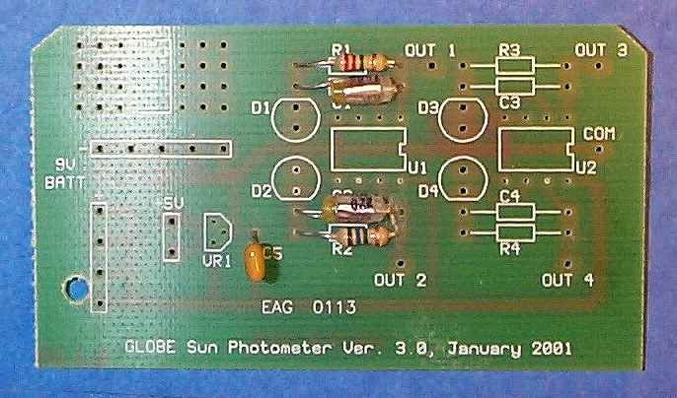
For steps 1-5, the direction of the component leads does not matter. The components should be mounted close to the front surface of the board.
1. Solder the 2.2 MOhm resistor (red-red-green, or the smaller value of the two resistors provided) at component position R1. Do not overheat the resistor. Trim the excess resistor leads from the back of the pc board.
NOTE: The resistor values supplied with your kit may be different from 2.0 and 5.6 MOhm. (In the photos shown in these directions, R1 is 2.2 MOhm (red-red-green)). Regardless of the values, the smaller of the two is always R1 and the larger is always R2. Click here for a resistor color code chart. or do a search for "resistor color code" on the web.
2. Solder one 220 pF polystyrene capacitors at component position C1. Do not overheat the capacitor, as you may actually melt the plastic housing. Trim the excess capacitor leads from the back of the pc board.
3. Solder the 5.6 MOhm resistor (blue-green-blue, or the remaing resistor) at component position R2. Do not overheat the resistor. Trim the excess resistor leads from the back of the pc board.
4. Solder the remaining 220 pF polystyrene capacitor at component position C2. Do not overheat the capacitor. Trim the excess capacitor leads from the back of the pc board.
5. Solder the 0.1 uF ceramic disc capacitor at C5. Trim the excess leads from the back of the pc board.
For steps 6 and 7, the orientation of the components is critical. Do not reverse the pins of these components!
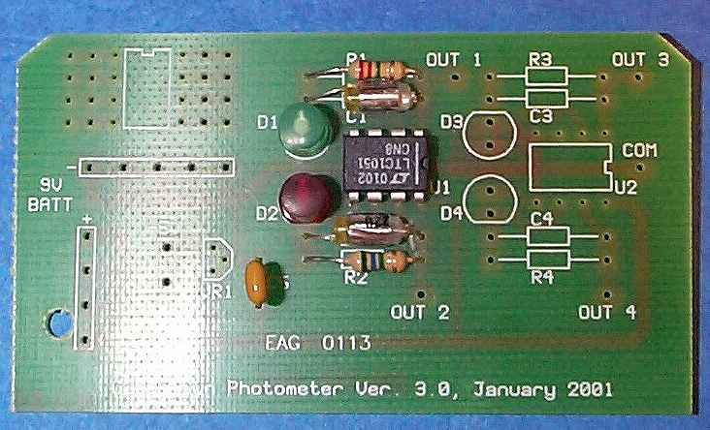
6. Solder the op amp at component position U1. The notch and/or white line printed on the top of the op amp case must match the position of the notch printed on the PC board. This stripe is clearly visible in the photo. Note that, because the lettering on the op amp is upside down, the op amp appears to be mounted upside down on the pc board. The op amp in the photo is, in fact, mounted properly. It may be necessary to gently straighten the op amp pins so they will fit in the holes. Make sure that all eight pins are in their respective holes AND THAT THE OP AMP IS PROPERLY ORIENTED! Solder all pins. In order to avoid overheating the op amp, wait a few seconds between each pin.
7. Solder the green LED at component position D1 and the red LED at D2. The small flat place on the shoulder of the LED housing must match the flat side of the drawing on the front of the PC board. Note that the flat place on the green LED faces "up" on the pc board and the flat place on the red LED faces "down." MAKE SURE YOU HAVE PROPERLY ORIENTED THE LEDs BEFORE YOU SOLDER THEM! IMPROPERLY ORIENTED LEDs ARE THE MOST COMMON CONSTRUCTION MISTAKE. It is very easy to overheat these LED connections. Make sure your soldering iron tip is clean. Try to minimize the time during which the iron is in contact with the LED pins and PC board connectors. Make sure the LED housing fits flat against the front surface of the PC board. This is much easier to do with two people -- one to press the LED against the surface of the board and the other to solder the pins. After soldering one pin (it doesn’t make any difference which one you do first), check to make sure that the LED housing fits flat against the front of the board. If it does not, reheat the connection and gently push the housing down against the board. Wait at least 15 seconds between soldering the first and second pins. Trim the excess leads from the back of the board.
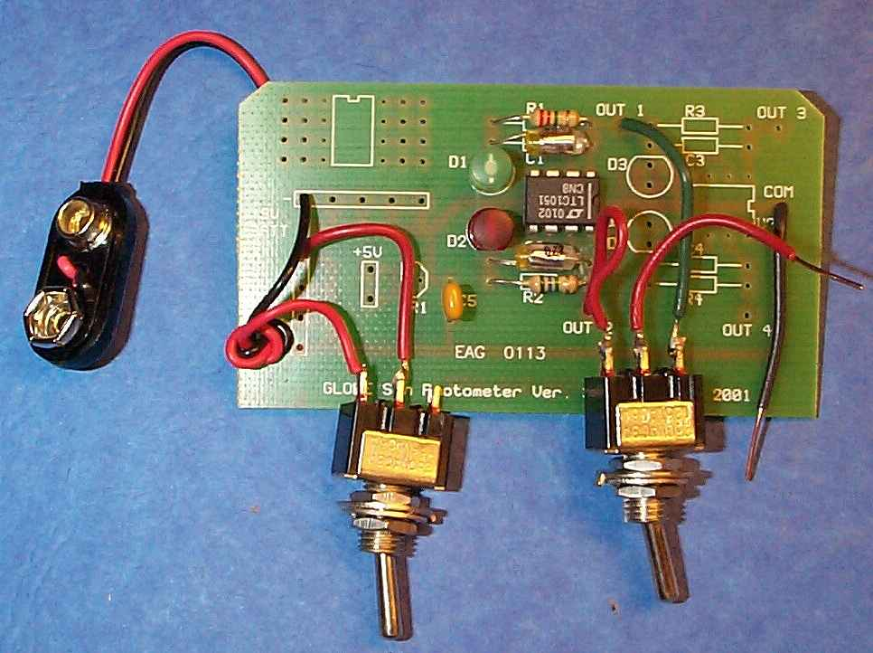
8. Insert the two battery connector wires through the hole from the back of the board. Tie a single loop knot about 3 cm from the end of the wires. (See the photo.)
9. Solder the black wire from the battery connector to a -9V BAT connection point on the PC board. There is a line of 5 possible connection points for -9V. In the photo, the black wire is attached to the leftmost of these 5 connection points.
10. Cut and strip a 3 cm (1-1/4") piece of red wire. Make a hook in one end of the wire and connect it to the center terminal of the remaining SPDT switch. Solder the other end of the wire to a +9V BAT connection point. There is a line of 4 possible connection points for +9V. In the photo, the red wire is attached to the topmost of these 4 connection points.
11. Make a hook in the end of the red wire from the battery connector and solder it to an outer terminal of the switch.
12. Cut a 4 cm (1.5") piece of black wire. Strip 1 cm of insulation from one end and 7 mm from the other end. Solder the end with 7 mm of insulation stripped off to the COM connection point at the righthand side of the PC board.
13. Solder the green wire from the channel select switch to the OUT 1 connection point. Solder the outer red wire to the OUT 2 connection point.
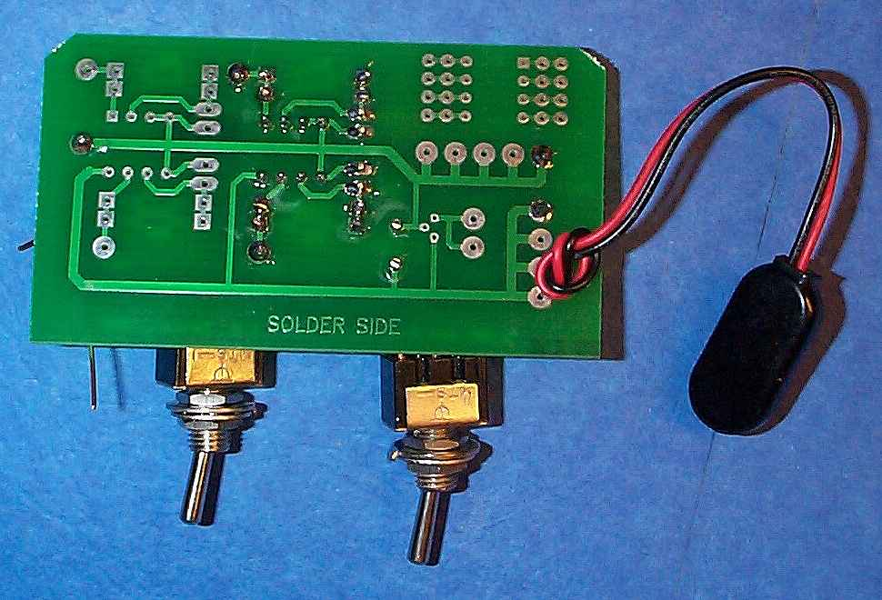
This completes the wiring of the pc board for the GLOBE two-channel sun photometer. The photo at the right shows the back of the completed pc board. Note that all leads are trimmed close to the board. The solder connections are clean and shiny, with no large "blobs" of solder or "crud" from a dirty soldering iron tip on any of the connections. As noted at the beginning of these instructions, there are many connection points on the pc board that are not used for this particular instrument.
C. Connect the battery and test the sun photometer.
It is helpful to complete the connections in the order given so that you can test the operation of the instrument before mounting it in its case.
1. Make sure the on/off switch is off -- when the switch toggle "points" toward the unused terminal of the switch, the switch is in the off position. In the above photo of the completed pc board, the on/off switch is in the on position. Install the 9V battery in its clip by pushing the clip firmly down on the battery terminals. Note that the terminals are different so the battery will connect only one way.
2. At this point, you can test the entire circuit. This is easier to do with two people. Read through all these instructions first so you will know what to look for. Throughout this test, you must make sure that the bare ends of wires from the switches and PC board do not touch each other anywhere.
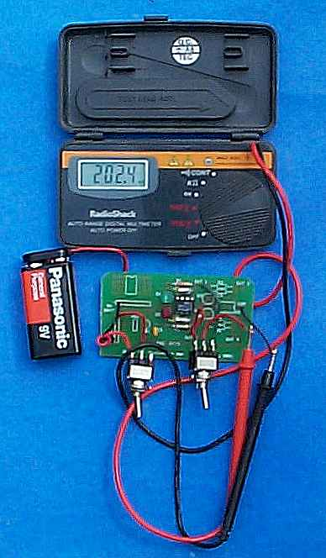
For testing and using your sun photometer, use a digital voltmeter (dvm) rather than an analog meter. Be sure to select a DC volts setting. Some dvms are "autoranging," which means they will select an appropriate DC volts range when a signal is applied to the test leads. In other cases, you must manually select a range. Typical ranges are 200mV, 2V, and 20V.
When a dvm is connected to the output of your sun photometer with the battery switch off, you will see "junk" readings on the voltmeter, but not the 0V you might expect. This is normal behavior for dvms. If you do not see the voltages indicated below when the on/off switch is on, your sun photometer is not working.
To test the circuit, hold the voltmeter leads against the output leads from the circuit board. The positive (red) lead from the voltmeter should contact the red wire coming from the center terminal of the channel select switch and the negative (black) lead should contact the black lead from the COM connection. In the photo, a hook has been bent in the end of each output wire so that they will make good contact with the dvm leads. These hooks will be needed later, too, when you complete the final assembly of your sun photometer.
Turn the on/off switch on. Depending on how well you can shield the LEDs from light, your dvm should show a voltage of no more than a few millivolts. With the LEDs exposed to sunlight, test both channels by changing the position of the channel select switch. (It doesn't matter which channel you test first.) You should see an output of at least a few hundred millivolts. In the photo, the dvm shows an output of about 202 mV for the red channel. This test was made on a cloudy day. This wouldn't be an acceptable condition for making a real measurement, but it is OK for testing the circuit.
If you have made a mistake in wiring the PC board, you will not see appropriate voltages at the output. Such mistakes can include a short circuit somewhere on the PC board. This can cause the battery to get warm, or even hot, to the touch. This is serious and you must find the source of the problem before proceeding. Probably you will need to replace the battery, too.
3. When you're done, be sure to turn off both the sun photometer and your digital voltmeter.
If your circuit passes this test for both channels, you are ready to install the PC board, battery, and switches in the case. It is unlikely that your sun photometer will not work if you have been careful with construction. The components used to construct this instrument are very reliable and I have personally NEVER had a properly constructed sun photometer fail to work. However, the emphasis is on "properly constructed." If your sun photometer doesn't work, it is almost surely due to an error on your part. Check your work, especially the polarity of the LEDs and op amp and, using a magnifying glass, the quality of the solder connections.
As you will find if you have to try it, it is very difficult to remove and reinstall improperly connected components. The copper traces on this PC board are delicate and it is easy to destroy the traces in the process of removing and reinstalling components. For all practical purposes, the op amp cannot be removed once it is soldered in place unless you have equipment specifically designed for desoldering delicate electronic components. If not, you are better off starting over. With a great deal of care, it is possible to reinstall the other components.
D. Install the PC board and battery in the case.
NOTE: In newer versions of the sun photometer kit, holes for the pin jacks are in a line parallel to the top of the case, rather than perpendicular to the top of the case. In this case, modify Step 1 to include installing both the black and red pin jacks. The black pin jack should go in the hole closer to where the PC board will go. Later, when you get to Step 10, you can ignore the instruction to install the red pin jack.
1. Install the black pin jack in the case. The black jack goes closer to the bottom of the case. The black plastic ring goes on from the inside of the case, with the small "shoulder" fitting into the 7 mm (1/4") mounting hole. Slide the lock washer over the threaded end, and then screw on the nut. Tighten the nut with pliers. Make sure it is tight, as it is hard to reach this nut after the assembly is completed. The red pin jack will be installed later.
2. Attach the alignment brackets with the sheet metal screws. The part of bracket that sticks up from the case goes at each end of the case. Place a straight edge (like a ruler) on the case along the side of the brackets to make sure they are straight. Tighten the screws, making sure that the bracket alignment doesn't change. Place a small drop of superglue on each side of each bracket where it sits on the case. Be careful not to let this glue get on your fingers or clothing, as it is impossible to remove and can irritate your skin. Let the glue dry for several minutes. Put a piece of sticky-back paper over the front of the rear bracket (opposite from the end with the sun aperture), press it firmly in place, and trim it neatly around the edges of the bracket with a sharp knife. (You can cut this piece of paper from one side of the GLOBE Sun Photometer label.)
You can use two-part epoxy in place of, or in addition to, the superglue to attach the brackets to the top of the case.
3. Remove the backing from the GLOBE Sun Photometer label and press it in place on the front of the case so that the on/off and grn/red text will be aligned with the holes. (Hold the case up to a strong light to help with the alignment. Using a craft knife, cut out the label over the holes.
4. Remove one nut and both washers from both toggle switches. Discard the larger flat washers, but keep the small toothed lock washers. On each switch screw the remaining nut down to the end of the bushing against the switch housing. Tighten it gently. (It is sufficient just to use your fingers for this.)
5. Gently twist the on/off switch so that the unused terminal is facing away from the PC board. Gently twist the channel select switch so that the terminal with the green wire is facing toward the PC board.
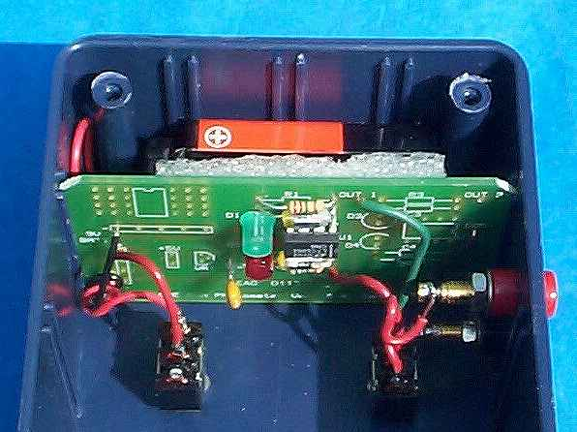
6. Slide the PC board into the slot nearest the end with the toggle switch holes. The front side of the board should, of course, face toward the end of the case with the sun aperture hole in it. The battery clip fits in the space behind the PC board. Guide the two toggle switches into their holes. Use needle nose pliers to gently bend wires as needed so that the toggle switches fit into their holes. Try not to bend a wire where it connects to the PC board, as this is where the wire is mostly likely to break because of a nick that you may have made when you were stripping it. If a wire breaks, unsolder the broken end from the PC board, restrip the wire, and resolder it. (The original lengths specified for the wires are long enough to allow you to do this.) When you are done with this step, the PC board should rest on the bottom of the case and the switches should be in their holes oriented as noted in the previous step. Make sure no wires are near the LEDs, where they could block sunlight shining on the ends of the LEDs.
7. Make sure the on/off switch is in the "off" position. Snap the 9V battery into its connector. Hold the piece of foam plastic against the back of the PC board and push the battery into place, between the end of the case and the foam plastic. Be sure that the foam plastic is between the battery and the back of the PC board.
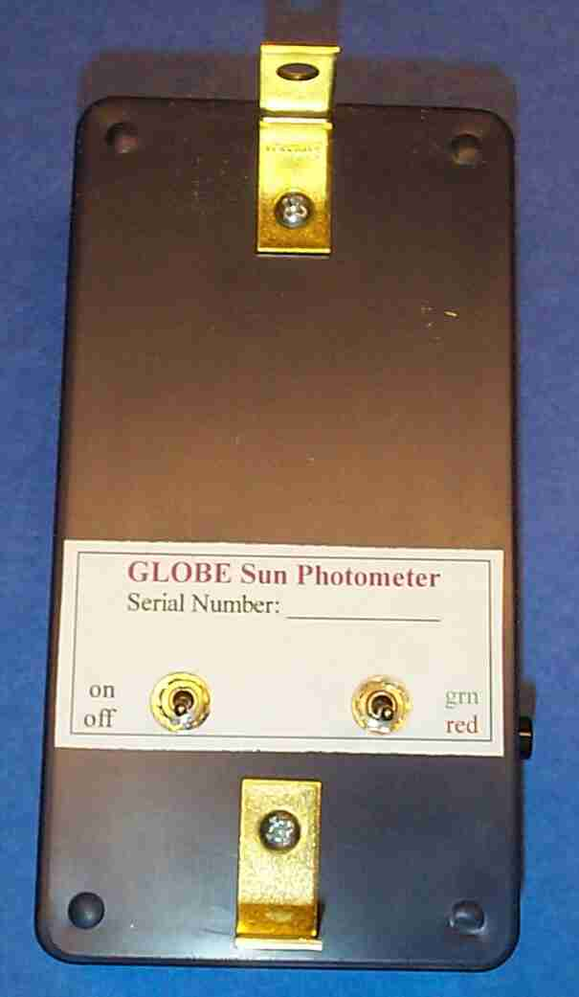
8. From the outside of the case, slip the lock washer and nut over the protruding threaded bushing of the on/off switch and screw the nut on. Tighten this nut with pliers. Do the same with the channel select switch. It easy to strip the threads of these small nuts. If that happens, you can switch this nut with the one currently screwed down against the switch housing and try again. Be careful not to put pressure on the toggle with the pliers while you tighten the nuts, as it is easily broken.
9. Using needle nose pliers, make a loop in the end of the black wire coming from the COM connector on the PC board. (You may already have made this loop when you tested your circuit in sunlight.) Wrap this loop around the end of the black pin jack and solder it in place. This connection requires much more heat than connections made on the PC board and it is important to heat the pin jack sufficiently that solder flows around the wire and the jack terminal. I have found a 15-watt soldering iron insufficient to make a secure connection to the pin jacks.
10. Install the red pin jack in the remaining hole. Make a loop in the end of the red wire coming from the center terminal on the channel select switch and solder it to the red pin jack. When you finish this step, make sure that wires do not touch adjacent terminals on the channel select switch. Check to see that the nuts on the on/off and channel select switches are tightened from the outside of the case. It is important for the switches to be aligned as shown in the photo. Make sure that the black pin jack does not touch any terminal of the channel select switch.
NOTE: As you should know from reading the protocols, it is important to try to keep your sun photometer as close to room temperature as possible (around 20°C) when you are making measurements, because the output varies a little with temperature. This problem cannot be solved completely except by actively controlling the temperature of the electronics -- a solution that is much too expensive for this GLOBE instrument. It is possible, however, to employ simple passive techniques. I have made an outer case of 1-cm thick rigid plastic foam (Styrofoam) with cutouts for switches, etc., held together with aluminum tape. This is especially useful in the summer, as the white styrofoam is an excellent reflector and insulator.
E. Test your completed sun photometer in sunlight. Do this with the case cover off.
1. Plug your digital voltmeter into the output jacks. Select a DC volts setting. If the range must be manually set, use a range that will measure up to 2V.
2. Take your sun photometer outside and turn the on/off switch on. Position the open side of the case so sunlight falls on the detectors. Your voltmeter should read somewhere between 0.5 V and 2 V in full sunlight. Test both channels. It is possible that the output voltage for one or both channels in full sun will exceed 2V. This is OK, but you may need to choose a different DC volts scale on a dvm that is not autoranging.
If if it not possible to test your sun photometer in sunlight, it should respond even to bright artificial lights. In my own shop, sun photometers typically read a few tens of millivolts when I hold the detectors close to a double-tube fluorescent fixture.
F. Complete the assembly of your sun photometer.
1. Make sure there is no dust or debris inside the case. Gently clean the ends of the LEDs with the corner of a damp paper towel. After doing this, do not touch the ends of the LEDs with your fingers.
2. Determine which way the cover fits best -- usually one orientation lines up with the sides of the case a little better. Fasten the adhesive foam plastic strip on the inside of the cover so that it will press down on the edge of the circuit board when the cover is fastened to the case. (The purpose of this strip is to keep the circuit board in place, pushed against the bottom of the case.)
3. Attach the cover with the four self-tapping Phillips head screws.
4. Follow the alignment procedure described elsewhere on this web page.
Your GLOBE sun photometer is now ready to use. Note that there is space for a serial number on the label. Your sun photometer must have a serial number before you can enter measurements through the GLOBE web site. Serial numbers are assigned only to instruments that have been calibrated by or in consultation with the Science Team.
Parts Included With Kit
Be careful not to lose any parts, as no duplicate or extra parts are provided.
One GLOBE sun photometer case, predrilled, with screws for cover
One GLOBE sun photometer printed circuit board, Version 3.0
One 2.2 MOhm, 1/4W, 5% carbon film resistor (color coded red-red-green-gold, or some other value)
One 5.6 MOhm, 1/4W, 5% carbon film resistor (color coded green-blue-green-gold, or some other value)
One 0.1 uF ceramic disc capacitor
Two 220 pF polystyrene capacitors
One LT1051CN8 op amp
One red LED (modified by GLOBE Science Team)
One green LED (modified by GLOBE Science Team)
Two SPDT miniature toggle switches with hardware
One 9V battery
One snap-on battery connector
One red pin jack with hardware
One black pin jack with hardware
Two #6x1/4" sheet metal screws
6" #22 red wire
6" #22 black wire
2" #22 green wire
Two L brackets (corner irons)
One self-adhesive label
One piece of aluminum tape
One square of foam plastic

Attachment 2

Calibration of the Photometer

How to Calibrate the TERC VHS-1 Sun Photometer
QUICK START! You can begin using the TERC VHS-1 immediately without calibrating it. Just remember to record your measurements and the date and time you made them in your notebook. But eventually you must calibrate the instrument. You can then insert all the data you previously collected into your calibration formula. | All Sun photometers determine the clarity of the atmosphere, and thus the blockage of direct sunlight caused by haze, smoke, dust and smog, by measuring the intensity of sunlight. When properly calibrated, different Sun photometers will give nearly the same result.

One way to calibrate a Sun photometer is to illuminate its detector with light from a calibrated light source known as a standard lamp. The problem with this approach is that calibrated lamps cost hundreds of dollars. And they must be powered by very stable power supplies that cost a few thousand dollars.
Fortunately there's a free, highly stable standard lamp that anyone can use. It's the Sun! Although sunlight varies slightly in intensity during the solar cycle, for practical purposes, the Sun can be considered a standard lamp. In fact, for more than a century scientists have used the Sun to calibrate various kinds of Sun photometers.
During the early 1900's, Samuel Langley and Charles Abbot of the Smithsonian Institution perfected the method used to calibrate Sun photometers that is still used today. The method is named for Langley in honor of his pioneering work in this important field.
You can use the Langley method to calibrate a TERC VHS-1 so that its accuracy is as good as a professional instrument costing hundreds of dollars.

Calibration Supplies
Be sure to collect all the necessary supplies BEFORE your calibration session. Otherwise you may get off to a late start. Before beginning, decide how you will measure the Sun's angle at each measurement. You can use the TERC VHS-1 spreadsheet that accompanies this manual. If you don't have access to a computer, you can use one of the methods described in the Appendix.
Here's a challenge: Measure the Sun's angle using the TERC VHS-1 spreadsheet and one or more of the methods described in the Appendix. Then compare your results.
In addition to what you will need to measure the angle of the Sun (see TERC VHS-1 spreadsheet or the Appendix), here's what you will need:
- TERC VHS-1 Sun Photometer (completely assembled and working)  - Digital voltmeter  - Digital watch or clock  - Method for measuring the Sun's angle (see separate section)  - Notebook and a pen or pencil  - Sunglasses, a hat and possibly sun screen  - Linear graph paper and digital calculator with natural logarithm  - (ln) and sine (sin) keys  ...or...  - Computer with spreadsheet software  - Comfortable, safe place to sit while making measurements  - Cold drinks and snacks | An Important Note About Sun Safety... You'll need to spend up to half a day in the Sun to calibrate the TERC VHS-1. Half a day in the Sun can cause fair-skinned people to get a sun burn, so be sure to wear long sleeves and rub sun screen on exposed skin if you are susceptible. No matter what shade or color your skin is, be sure to wear a hat and sunglasses to protect your eyes from the ultraviolet radiation (UV-B) scattered from the sky. Skin color doesn't matter when it comes to protecting your eyes from dangerous UV-B!  WARNING: AVOID DAMAGE TO YOUR EYES! NEVER LOOK AT THE SUN, EVEN WHILE WEARING SUNGLASSES! ALWAYS WEAR SUNGLASSES WHEN LOOKING AT THE SKY!

Calibration Procedure
You will need to make observations over a wide range of Sun angles to calibrate the TERC VHS-1. This is the same method pioneered by Samuel Langley nearly a century ago. For best results, begin early in the morning and make measurements until the Sun reaches the highest point in the sky. Or begin when the Sun is at its highest point and measure until evening. If you have a full day, making measurements all day will give you two calibrations.
  - Select a day when the sky is blue with few or no clouds.
  - Calibrate your watch against the time signals broadcast by radio station WWV at the frequencies of 5, 10, 15 and 20 MHz.
  - Before each calibration measurement it's important to check the sky to make sure no clouds or cloud haze cover the Sun. Block the Sun with a book or other opaque object held at arm's length and look for nearby clouds or cloud haze.
WARNING: ALWAYS WEAR SUNGLASSES WHEN LOOKING AT THE SKY! NEVER LOOK DIRECTLY AT THE SUN EVEN IF YOU ARE WEARING SUNGLASSES!
  - Switch the TERC VHS-1 switch to the ON position, press the Sun port on the instrument against a dark object (black paper or your clothing) and write the number displayed by the voltmeter in the third of four columns in your notebook. This number is known as your instrument's dark signal. You must measure it each time you measure the Sun.
  - Carefully point the VHS-1 at the Sun by centering the bright circle of light that passes through the upper angle bracket directly over the Sun target. While holding the VHS-1 as steady as possible, read the voltage indicated on the voltmeter. The numbers on the voltmeter display will flicker up and down. For best results, pick the highest number that appears when the unit is pointed directly at the Sun. This number is called the Sun signal. Write the Sun signal in the third column in your notebook and the exact time in the first column. Here is a sample notebook entry for the prototype TERC VHS-1 from 17 March 1996.

  - Time Dark Sun Sky

  - Signal Signal Condition

  - 012:47:40 0.235 3.12 Clear

  - If you plan to determine the Sun's angle using one of the manual methods described in the Appendix, try to make your Sun angle and VHS-1 measurements as close together as possible. Ideally, one student should make the VHS-1 measurements and another the Sun angle measurements while a third student records the data in the notebook.
  - Space your measurements 15-20 minutes apart when the Sun is high in the sky. As the Sun rises (or descends), make the observations more frequently.
Figure 5 shows how the Sun's angle over the horizon changes much faster in the early morning and late afternoon than at midday.
PLAN AHEAD! Before its time to increase the number of measurements, be sure you have something to drink and maybe some snacks. Use the rest room before beginning your rapid series; there won't be time during the actual measurements!
  - Before ending your calibration session, review your notes to make sure everything is legible and complete. Do not guess any times you may have forgotten to record! Instead, don't use any data when you don't know the time it was measured. Write a brief summary about the sky conditions during the measurement time. When you are satisfied that your notes are complete, you and any others who helped should sign and date the notebook.

Attachment 3

Analyzing the Calibration Data

Analyzing Your Calibration data
You will use the data from your Langley test to find what's called the extraterrestrial constant, the signal the TERC VHS-1 would give at the top of the atmosphere (4). In other words, if you took the TERC VHS-1 along on a trip into Earth orbit in the Space Shuttle, the signal you would measure using the TERC VHS-1 during a space walk should be very close to what you measure on the ground using the Langley method.
There are several ways to analyze your data to find the extraterrestrial or ET constant, all of which should yield the same result. After you find your instrument's ET constant, you will insert it in a formula that will give you a standardized measurement of haze known as aerosol optical thickness (AOT).
When you made your Langley measurements for a range of Sun angles, each time the angle changed the thickness of the atmosphere (the air mass) between you and the Sun changed (see Fig. 6.). When the Sun is straight overhead, its light passes through one thickness of atmosphere or one air mass. The air mass (m) increases as the Sun moves closer to the horizon. The m for each of your measurements is 1 divided by the sine of the Sun's angle (<) above the horizon or m = 1/sun<.
If you make a graph of the natural logarithm (ln) of the signal you measured versus m when you made the measurement, the data points should fall along a straight line out to an m of 10 or so, assuming the sky conditions were stable during your measurement period. If you extend the straight line, the ET constant will be where the line crosses the air mass axis at m = 0. When m = 0, there is no air mass, which means this is the signal the TERC VHS-1 will give if you could take it to the top of the atmosphere.
Several methods are available for extracting the ET constant from your Langley test data. They should all give similar or nearly identical results. All three methods perform what is called a linear regression on your data. Briefly, a linear regression fits the equation for a straight line, in this case, ln of signal = a + (b x air mass), to your data. You then use this equation to find the signal for m = 0.
The first two methods require that you determine the air mass for each measurement. The TERC VHS-1 spreadsheet does this automatically, and can be downloaded from: ftp://ftp.concord.org/pub/haze/vhs1-download/ The methods given in the Appendix require that you use a calculator to convert the Sun angles to the respective air masses. The air mass is the reciprocal of the Sun's angle above the horizon, so enter the angle and press the SIN key. Then press the 1/x key to get the air mass.

A. Graph Paper Method
  - Make a table of the TERC VHS-1 measurements for a range of air masses up to about 10. The first column should be the air mass (m) for each measurement and the second column the Sun signal - the dark signal.
  - Add a third column to your table for the natural logarithm (ln) of the signal. (Use a scientific calculator with a ln key.)
  - Print this title on the abscissa (x or horizontal axis) of the graph: Air mass (m).
  - Print this title on the ordinate (y or vertical axis) of the graph: ln of signal.
  - Label the major divisions of the abscissa 0 to 10, as shown in Fig. 7.
  - Plot the pairs of data in the first and third columns on your table on the graph.
  - Use a straight edge to draw a line through the center of the points. Extend the line to the ordinate as shown in Fig. 7.
  - The ET constant is where the line crosses the ordinate. Find the value at this point and write it on your graph as you will need it for the haze formula. The ET value derived from the hand drawn graph in Fig. 7 is based on the first Langley test made with a prototype TERC VHS-1. The ET constant is 1.292, which is very close to the values given by the calculator and a computer program.

B. Scientific Calculator Method
  - Make a table of the TERC VHS-1 measurements for a range of air masses up to about 10. The first column should be the air mass (m) for each measurement and the second column the Sun signal - the dark signal.
  - Add a third column to your table for the natural logarithm (ln) of the signal. (Use a scientific calculator with a ln key.)
  - Enter the data pairs into a scientific calculator capable of performing a linear regression.
  - Insert the coefficients given by the calculator to calculate the ln of the signal when m = 0. This number is the ET constant, so write it on your table. The ET constant for the prototype TERC VHS-1 is 1.2946.

C. Computer Spreadsheet Method
The TERC VHS-1 spreadsheet program (5) automatically determines the air mass for each data point. You can then use a scientific calculator, the spreadsheet's regression function or curve-fitting software to find the formula for the best fit through the points. The TERC VHS-1 spreadsheet can be downloaded from: ftp://ftp.concord.org/pub/haze/vhs1-download/
Fig. 8 shows a computer-generated graph of the all the data from the first Langley test of a TERC VHS-1. Notice how the data begin to curve when the air mass exceeds about 10? This established that the upper air mass limit for this instrument is m = 10. Fig. 9 shows a second computer-generated graph for only the data up to m = 10. Notice how the points appear to form a straight line?
Figure 10 shows that the points in Fig. 9 form a very straight line indeed. This graph was made with a powerful curve-fitting program called TableCurve (Jandel Scientific). In only seconds, this program fitted the data to hundreds of mathematical functions. It then drew the graph in Fig. 10 for the straight line formula (y = a + bx). The program also gave the coefficients for the formula and the value of the Sun signal for m = 0 (the ET constant). The ET constant for the prototype TERC VHS-1 is 1.2946, the same number provided a little more slowly by a standard scientific calculator using the same data.

