Integration of NASA Endeavor Science Fellowship Courses By Lesa Roe
Below are examples of how I have integrated resources and information learned from the courses I have completed through the NASA Endeavor Science Fellowship program. Thank you for the opportunity to learn and become a better teacher.
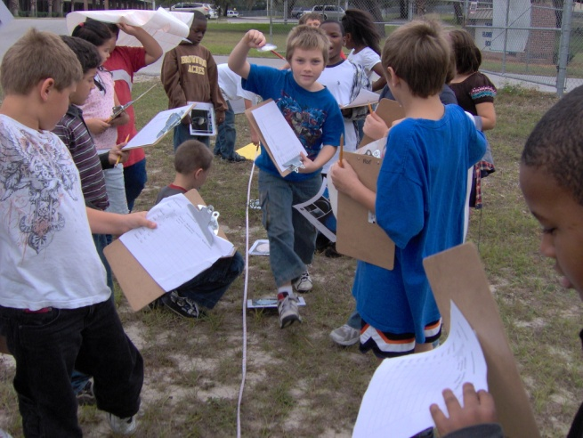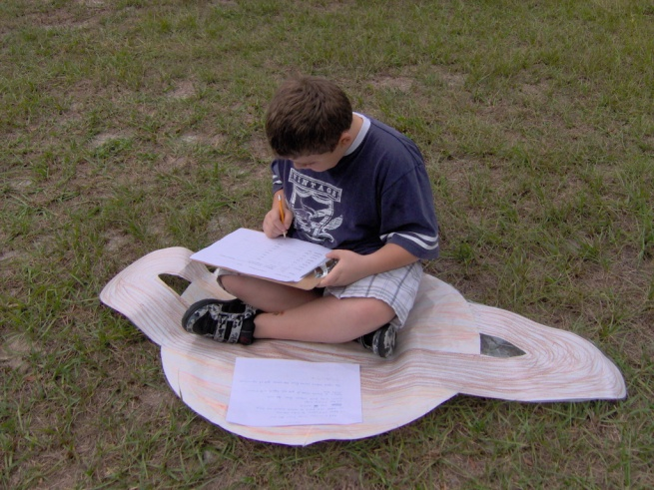
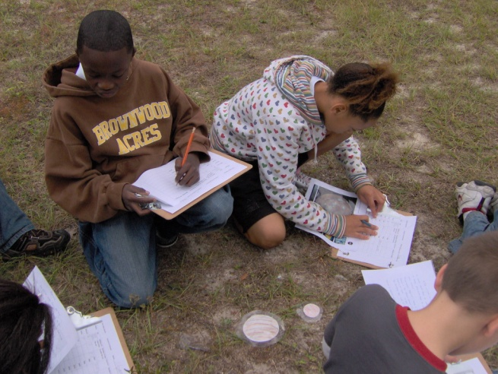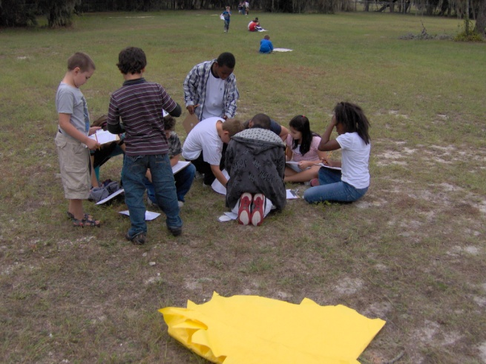
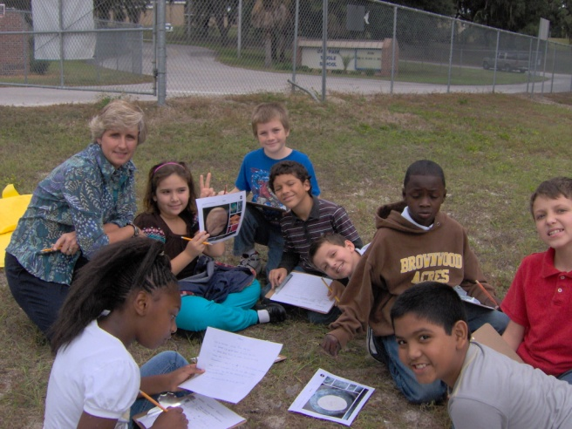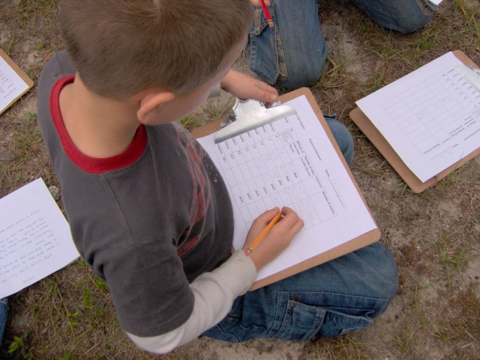
Third grade students learn about the Solar System by mapping out a scaled model on the playground, then “traveling” to each planet to record information about each planet which included number of moons, days/years of rotation, temperature ranges, what planet name meant and more.
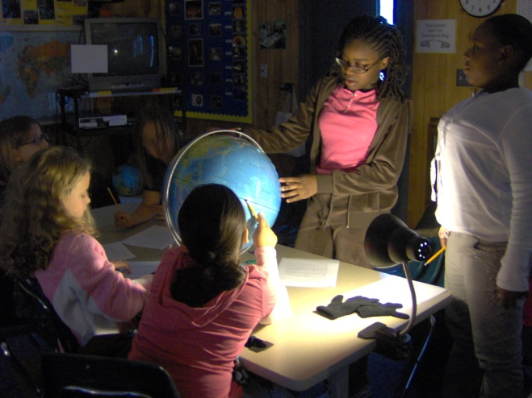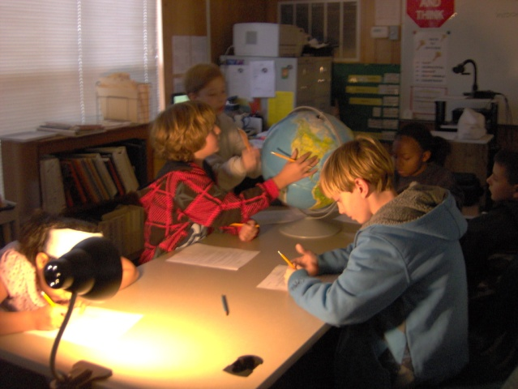
Fourth grade students explore and learn about the earth’s rotation, and what causes day and night through use of globes and desk lamps.
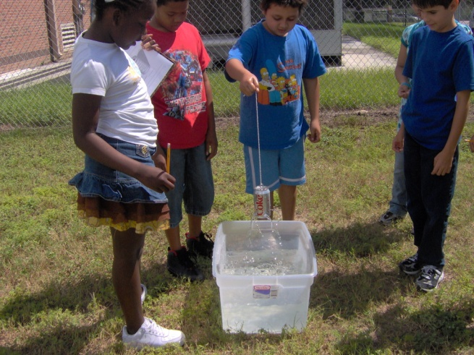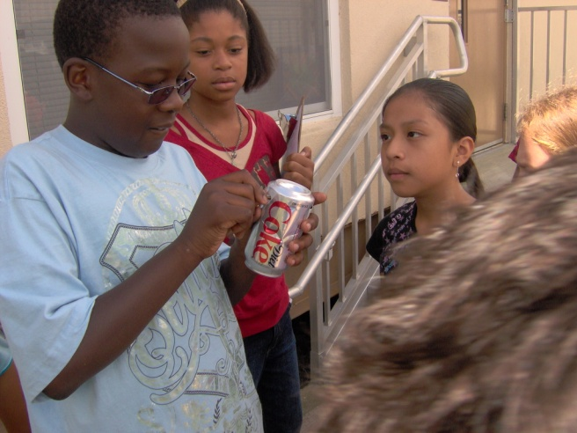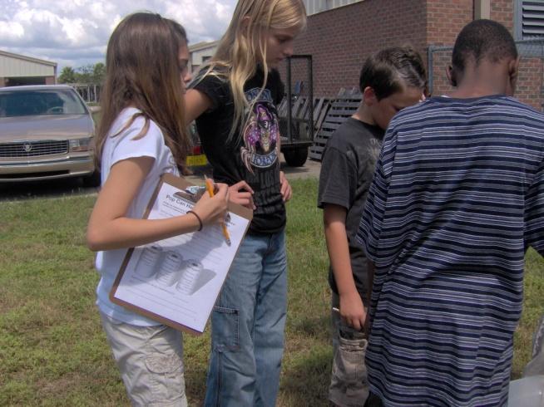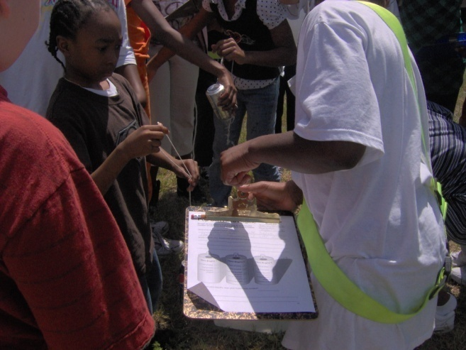
Fifth grade students conduct physics lessons as they create a “hero engine and learn about the history of space exploration.
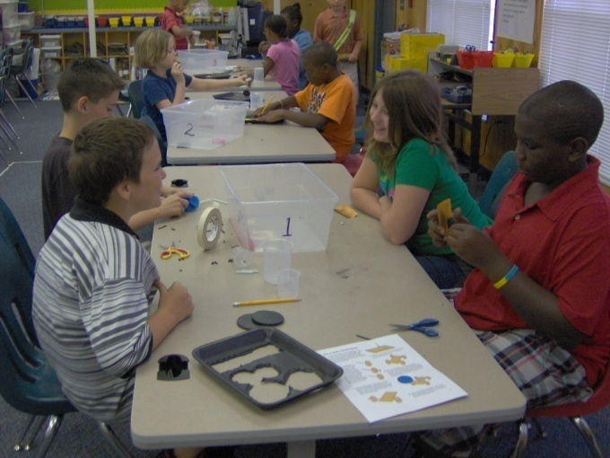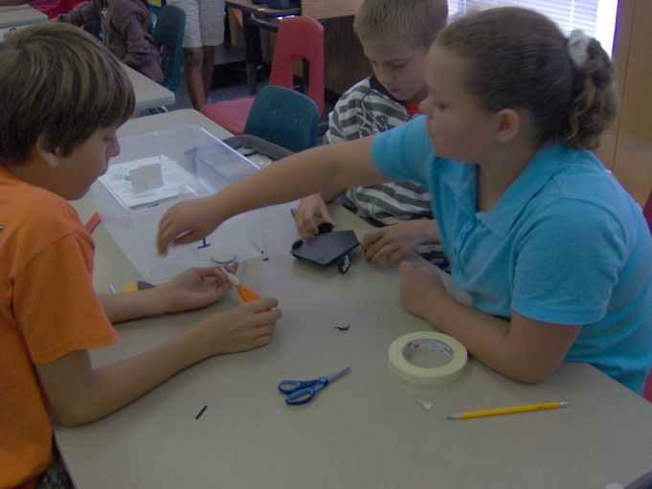
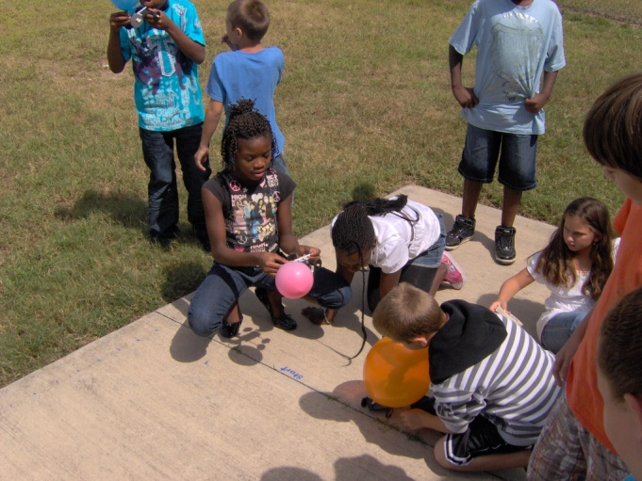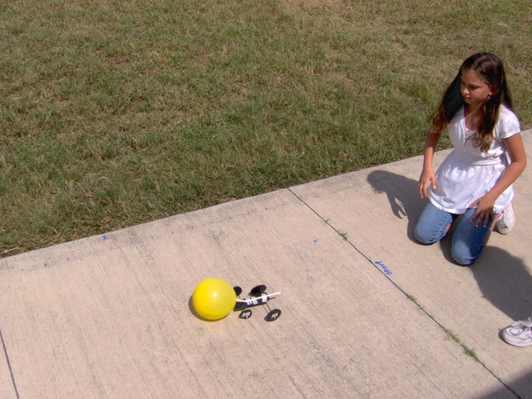
Fifth grade students create rocket racers to study Newton’s laws.
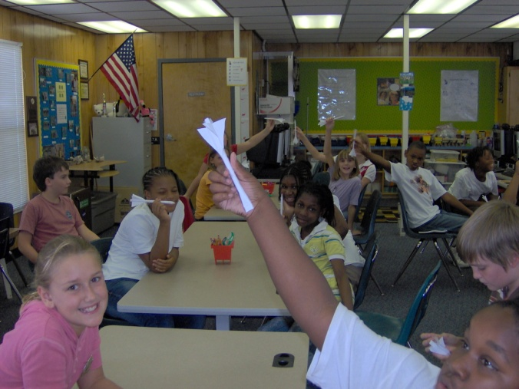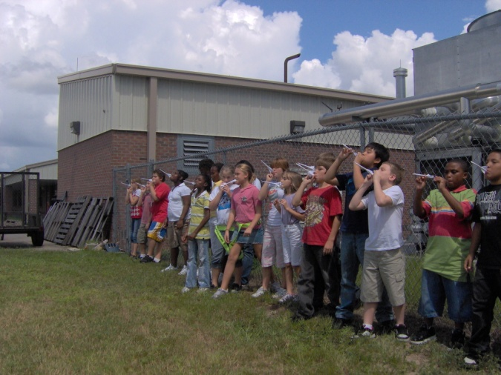
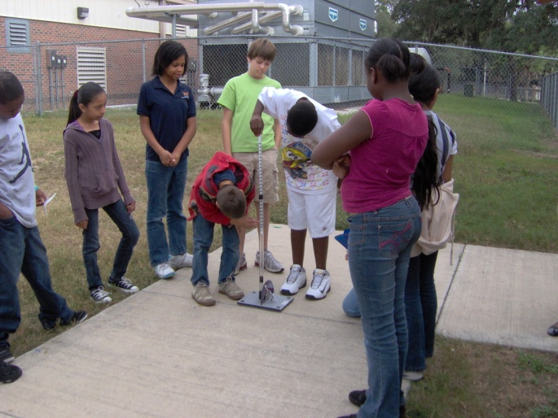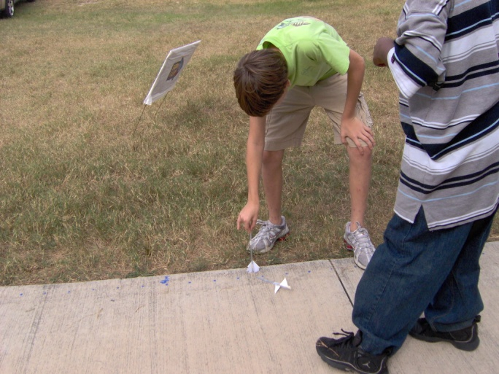
Fifth grade students continue to learn about rocketry as they create two different types of straw rockets and explore variables that effect launch distance and height.
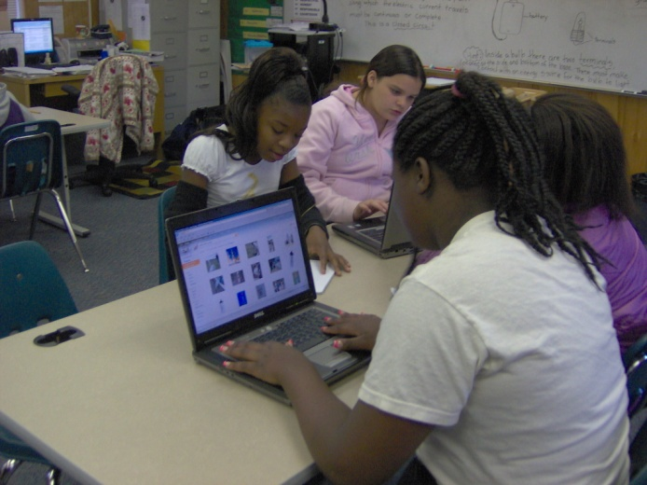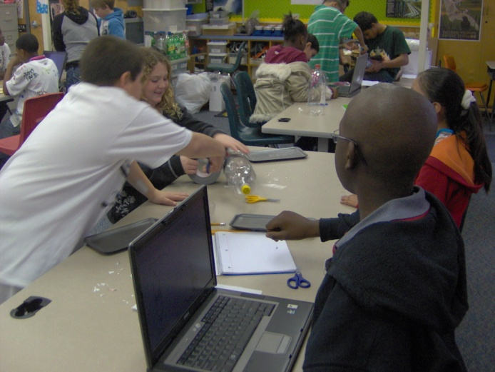
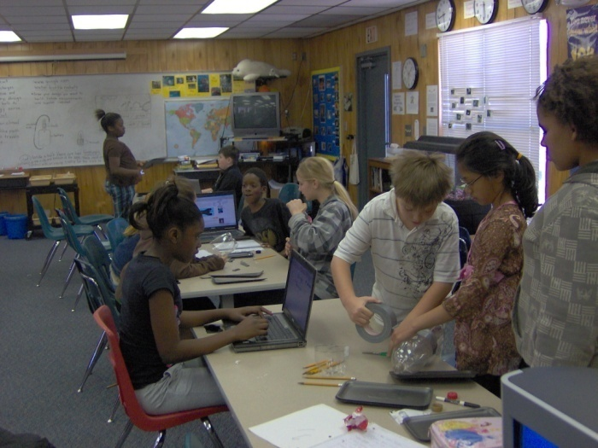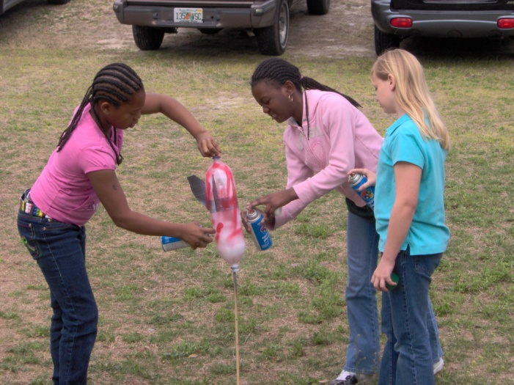
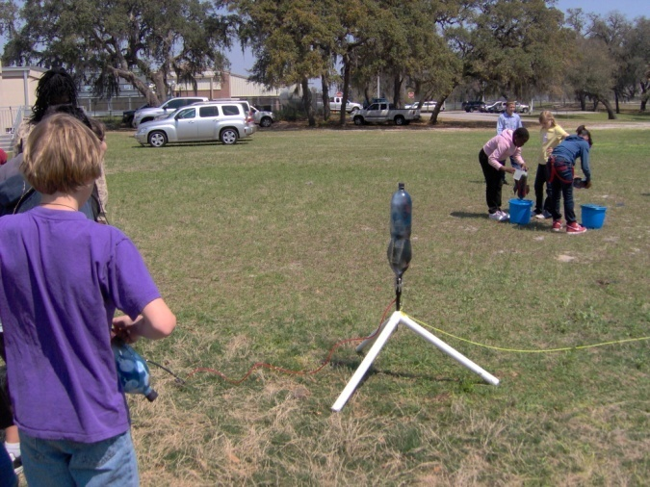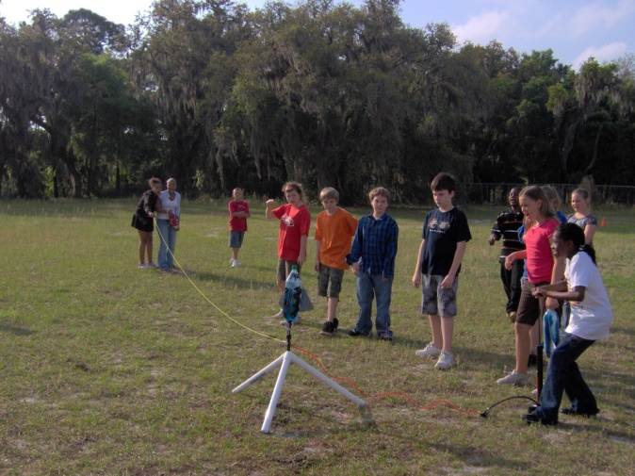
Fifth grade students conducted on line research of water bottle rocket designs, chose a design as a team, wrote down details, measurements and procedures for their design, then created their rockets. When students came to science enrichment the next week, they had the opportunity to launch their water bottle rocket. Students conducted repeated launches to see observe the variables of water and air pressure to see how those elements affected their launch. Students also compared designs to see what may have caused some rockets to launch further than others.
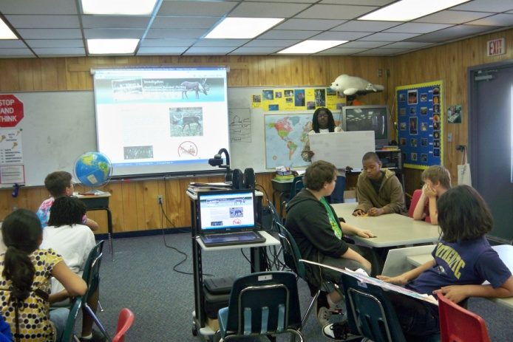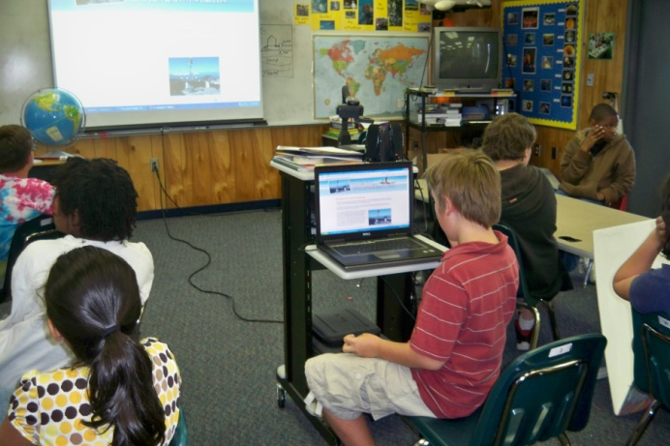
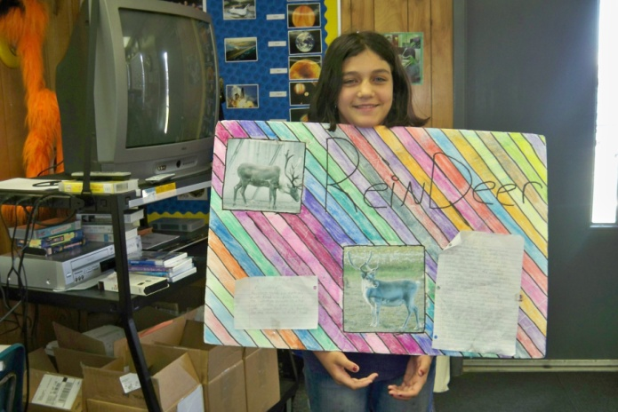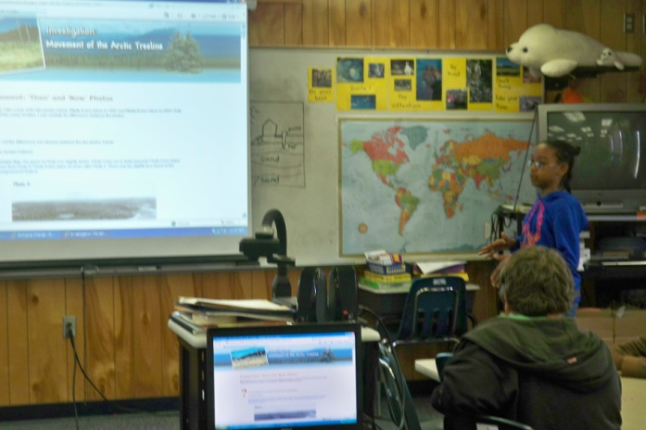
Fifth grade students conducted on line polar research using the SPRINTT web site and shared their findings with their peers.

