HOW TO FIND ONLINE JOURNAL ARTICLES
- GOOGLE SCHOLAR
-Go to www.google.com
-In the search bar, type in “google scholar” and click on the first link.
-This will bring you to the Google Scholar search engine and will only search scholarly articles.
-Type in only key words in your search, for example, “concept mapping, assessment” instead of “use of concept mapping as an assessment tool”
- After you write your keyword search, you can narrow your search to only show PDF files (files you know you will definitely have immediate access to). To search this way type in, “filetype:pdf” after your search. Your search should look something like this:
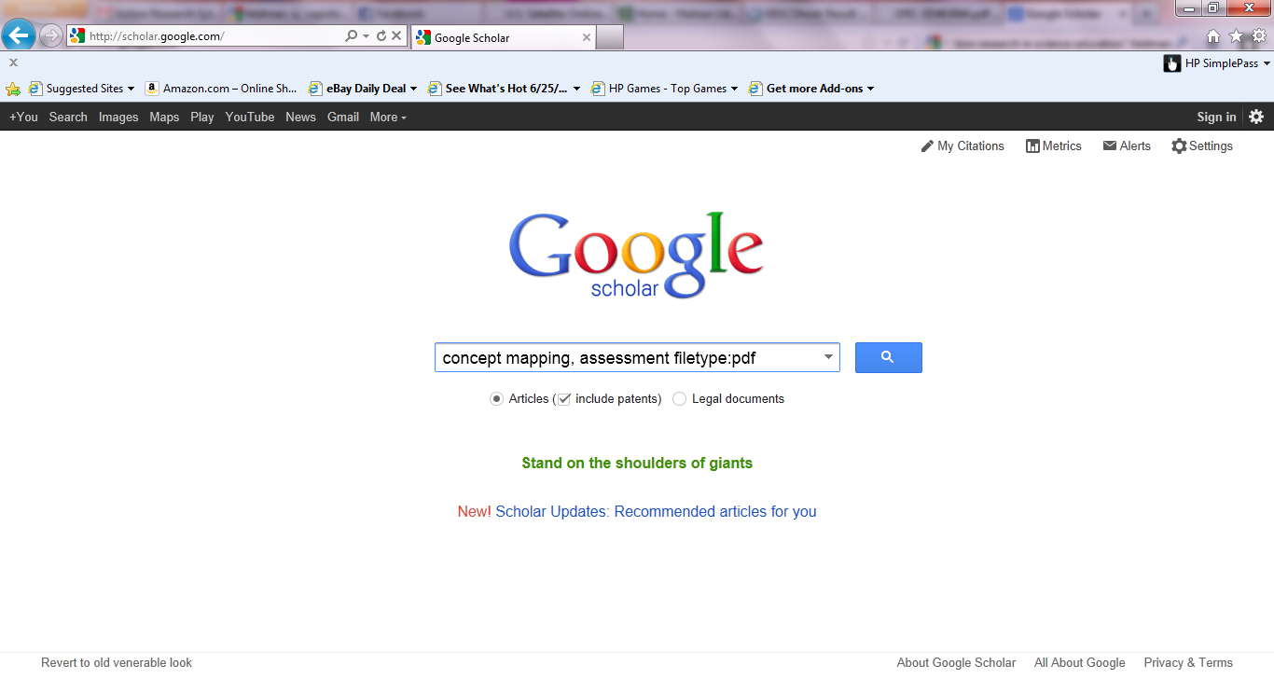

2) ADAMS LIBRARY
- Go to Adams website
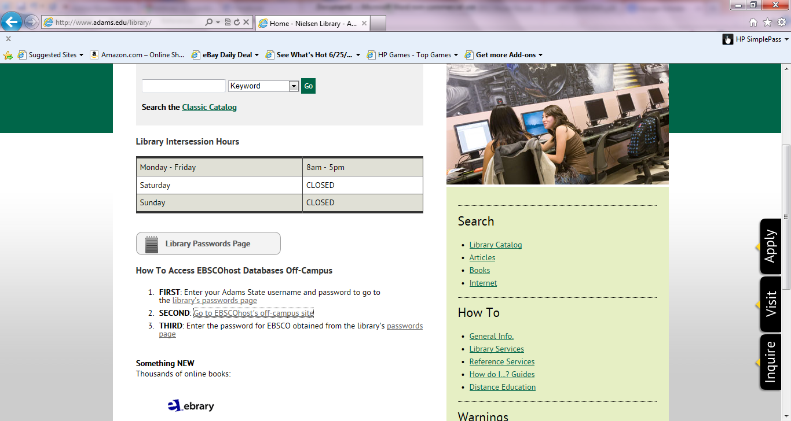
-Click on “Go to EBSCOhost off-campus site and log in (username: windy, password:weather)

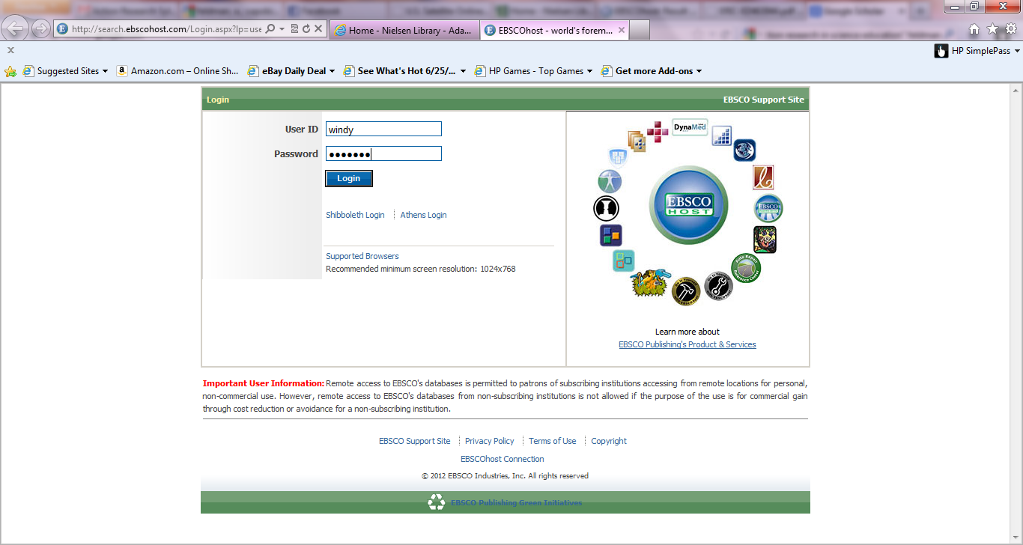

-Click on EBSCOhost
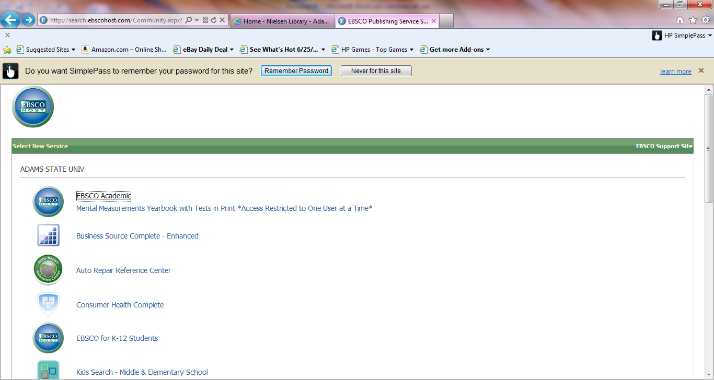

-Click the “Select” box to select all options, then click “continue”
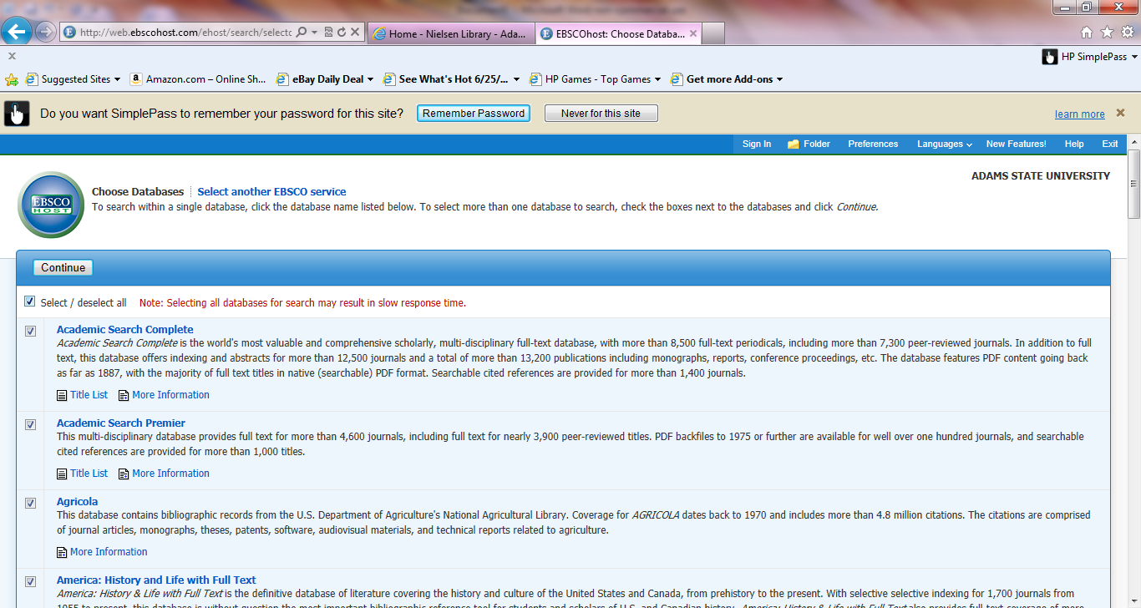

-Type in ONLY your key words (try to separate content, for example “concept mapping” is separated in the search from “assessment”) this way EBSCOhost will search for each phrase independently from one another. If you search “concept mapping assessment” the search will focus on finding those three terms together, limiting the results.
-Select the “Full text” option. This helps to limit your search to the articles you directly have access to.

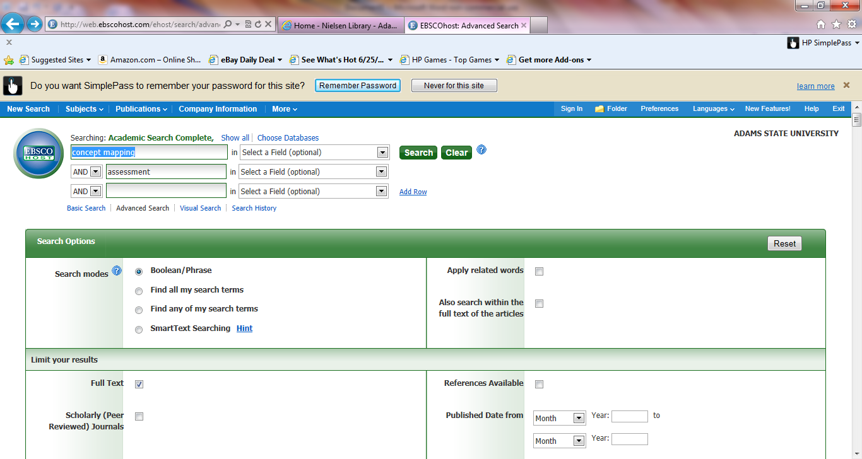

Research Tips:
-Save yourself the hassle of going from website to website trying to access an article by limiting your search/results to only full text or PDF versions.
-Keep your search to a bare minimum. The more words you put in your search, the further you limit your results.
-Often times there are different words/phrases that mean the same thing. For example, culturally relevant pedagogy, culturally sustaining, culturally appropriate pedagogy are all phrases used to describe the same idea in education. Try searches with all varieties.
-Remember! This is often a tedious process, but the more you do it, the quicker you learn the “tricks” to researching.
-Be patient. If you feel like you are hitting a wall in your research, step away from your computer and try again tomorrow.
-Most of what you read will not be directly used in your project, but I am certain you will learn a great deal about education throughout the process. That is the beauty in research! In the end, it will be rewarding.

