http://news.discovery.com/tech/tech-tracks-sharks.html

Discovery News > Tech and Gadgets News > Tracking a Great White

Tracking a Great White Data from an advanced electronic tag reveal a great white shark's movements and behavior.
Tue Jul 28, 2009 12:36 PM ET
Content provided by IEEE Spectrum
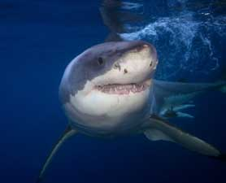
Great white shark behavior, social structure and mating habits are still mysteries to human.
iStockPhoto
Ever since the 1975 summer blockbuster Jaws, the specter of a great white shark lurking under sparkling blue waves has haunted beachgoers. Part of what makes great white sharks so frightening is that we simply don't know all that much about them.
But researchers at the Monterey Bay Aquarium, in California, took a big step forward in penetrating the secrets of the great white shark, thanks to the capture of a young female shark in August 2005 and a fourth-generation electronic tracking tag.
It Started With a Catch
This adventure started when a commercial halibut fisherman in Southern California inadvertently caught the young great white. Monterey Bay Aquarium marine biologists trucked her north and put her in the aquarium's 3.8-million-liter ocean-water tank, where she made history as the first great white shark to survive for an extended period in captivity. By March she had grown to 1.93 meters and was wearing out her welcome, snacking on a few of the smaller sharks that shared her tank. It was time to release her -- and find out what she would do after that.
It isn't easy to track a great white. To obtain basic information from large, oceangoing fish like tuna, researchers use tags with microprocessors and flash memory that record various parameters, such as water pressure and light levels. These implanted tags can give some information about fish behavior over a period of time, as long as someone catches the fish and finds and turns in the tag.
But many such tags are never turned in, so information acquired in this way is sketchy at best. And such implanted tags make little or no sense for a fish that is not expected to be recaptured and kept, like a great white shark.
GPS for Sharks
Enter the PAT -- for pop-up archival transmitting -- tag, developed over the past five or six years by researchers initially interested in more accurate data about the travels of bluefin tuna. PAT tags do not have to be recovered. Rather, after a predetermined time, they break away from the fish and float to the surface, and then transmit data to receivers that are part of the Argos satellite system, an internationally operated satellite location and data collection system dedicated to monitoring the environment.
PAT tags have become successively more sophisticated, and the one that researchers from the Monterey Bay Aquarium and California's Stanford University attached to the great white shark's dorsal fin represents the current state of the art. About the size of a handheld microphone, it has twice as much onboard flash memory as its predecessors (2 megabytes) and incorporates fast-response thermistors to provide new temperature readings every 10 seconds. Its maker is Wildlife Computers, in Redmond, Wash.
The shark was released with the tag on March 31, 2005, and on April 30, 2005, an electric current passed through the metal pin that attached the tag to a thin plastic line fixed under her skin by a surgical dart. The current caused the pin to quickly corrode and break loose. A bulbous float carried the tag to the surface and oriented the antenna upward; at a scheduled time, it began transmitting to an Argos satellite.
The amount of data that can be transmitted is limited -- 10 000 packets of 32 bytes each over seven days -- so the microprocessor on board the tag summarized the data and then selected individual days of data to transmit in a random order. (That way, in case of premature battery failure, data transmitted would still be representative of the whole time recorded.)
Because so little information is available about great white sharks, says Randy Kochevar, a marine biologist at the Monterey Bay Aquarium, researchers wanted to have as much data from the tag as possible -- more than could be transmitted before the batteries failed. They were able to recover the tag and all the data, including water temperature readings, by homing in on the radio signal it was sending.
Watching From a Safe Distance
From this information, researchers could put together a complex picture of the shark's behavior. Computers at Stanford's Hopkins Marine Station, in Pacific Grove, Calif., working from sunrise and sunset times derived from the light sensor, could estimate the shark's location each day and map her travels -- an odd journey that took the shark far out to sea before she turned to head south to her home waters. Researchers theorized that she was choosing warmer waters.
The experiment was, in the eyes of the researchers, a resounding success. In the first place, says Kochevar, "since this was the first time anyone kept a white shark in captivity for so long, the mere fact that she went back into the ocean and thrived was a great relief to us all."
Not Just for Sharks
Especially intriguing is the prospect of using PAT tags not only to gather information about fish behavior but also to penetrate the mysteries of the ocean itself. "One of the things we began realizing through this project was that marine animals can obtain data that could otherwise cost millions of dollars to get," says Kochevar.
Take the elephant seal. "One seal dives to 600 or more meters 60 times a day throughout the North Pacific," he says. "If you have a tag on this animal, you can get a temperature profile of the ocean. Measure salinity, too, and you would have a full-featured oceanographic profile."
The Monterey Bay Aquarium is working with the Sea Mammal Research Unit of the University of St. Andrews, in Scotland, to develop a temperature and salinity tag. Meanwhile, the great white shark, free of her PAT tag, wanders the Pacific in secret, bearing only a thin plastic strip with a number to identify her in the unlikely event that she is ever recaptured. Monterey Bay Aquarium marine biologists are out there roaming the ocean, too, in search of a second great white to recruit for their research tracking program.
Tags: Animals, Computers, Football Receivers, Great White Sharks,

Oceanhttp://www.pelagic.org/overview/1111_021111_TVShark.htmls
Front Page > National Geographic Channel
Satellite Tags Keep Track of Great White Sharks
Karen Kersting
National Geographic Today
November 11, 2002
When Sean Van Sommeran was a boy, out for a day's fishing with a family friend near Ano Nuevo Island, a mile off the coast northwest of Santa Cruz, California, they saw a great white shark devour an elephant seal.
"That left an impression," said Van Sommeran, a former commercial fisherman and now founder and CEO of the Pelagic Shark Research Foundation in Santa Cruz. "It was back in the mid-seventies, and I'd just seen the movie Jaws and read the book."
Now, in the same area, Van Sommeran comes face to face with great white sharks almost every day in season. His mission is to help scientists better understand the behavior of Carcharadon carcharias by tagging the animals and documenting their movements.
During late summer and early fall, when a large breeding colony of northern elephant seals gathers at Ano Nuevo, great whites—at about 21 feet long and 4,800 pounds—come to feed.
Van Sommeran and his six-person team head out in a launch and maneuver close enough to a shark to reach out with a pole, pierce the skin behind its dorsal fin and attach a metal acoustic or satellite transmitter.
Enticing the Great White
Waves around Ano Nuevo can reach 12 feet. "So, you're in a small boat, big swells, big sharks, you know, what could go wrong?" Van Sommeran said.
"One of the main goals is to find out what the population structures are and where the home bases are," said Heidi Dewar, a marine biologist at the Southwest Fisheries Science Center in La Jolla, California.
"It helps us to know what the sharks are encountering in the wild and if they are going to waters controlled by countries where there's no protection afforded them," she said.
Conservation rules offer limited protection to sharks off California and in some other countries, including Australia, Mexico, and South Africa. Elsewhere, sharks are fair game for fishermen and poachers, some of whom take the animals only for their fins, valued in Asia for shark-fin soup.
Van Sommeran's team entices the white sharks with plywood lures designed to look like a seal from below. "They come up slowly and just sort of nudge the lure," he said. At just the right moment a tagger makes his move.
"Between mid-October and mid-November, sharks spend a lot of time near the coast looking for seals but they really only kill very few before they move on," said Peter Klimley, a marine biologist at the University of California–Davis.
Seals have so much fat, Klimley explained, that a shark that eats just half of one can keep going for a month and a half.
Satellite and Acoustic Tags
Scientists know little about where great white sharks migrate when they stray from coastal feeding areas.
Satellite tracking has surprised researchers by showing that some sharks even make round trips from California to Hawaii between winter and spring—up to 40 miles a day, said Andre Boustany, a graduate student at Stanford University in Palo Alto, California.
After six months the satellite tags pop off the shark and float to the surface, where they transmit data.
"Knowing that sharks travel so far brings up new conservation issues," Boustany said. "We may need to look at protecting the animal on an international level."
According to estimates, 100 to 300 great white sharks frequent areas near the California coast.
"We don't really think they're terribly endangered, but it's worth looking at," Klimley said. "There's not been a good population estimate because it involves significant tagging of individuals and tracking over long periods of time."
The science of tagging sharks is still relatively new. Researchers use acoustic tags, which transmit radio signals over a short range, in addition to the newer satellite tags.
Acoustic tags send continuous radio signals, even while underwater, providing a real-time window into the shark's world: how far and how fast the shark is moving, its body temperature and water depth and even how many tail flicks it takes to propel the shark along.
For Van Sommeran, the close encounters are brief but intimidating. "Afterwards you do notice that your hands are trembling," he said. "This is 'Jaws' after all."
Van Sommeran doesn't believe that the great whites, for all their ferociousness, want to prey on him. "They're essentially indifferent to humans," he said. "We're just not fat enough."
Sharks have an image as terrifying, mindless feeding machines. In fact, the great white, Klimley said, is "a beautiful, awe-inspiring, gigantic animal, but it also has interesting, complex behavior that we're only starting to understand."
National Geographic Today, 7 p.m. ET/PT in the United States, is a daily news journal available only on the National Geographic Channel. Click here to learn more about it.
For More Information About Sharks:
Bookmark the National Geographic News index page for daily stories about animals
National Geographic Guide to Animals and Nature
Smithsonian References on Sharks
National Geographic News Stories About Sharks:
Shark Gives "Virgin Birth" in Detroit
Shark-Soup Boom Spurs Conservationist DNA Study
Shark "Photo of the Year" Is E-Mail Hoax
Great Whites May Be Taking the Rap for Bull Shark Attacks
Scientists Study Nurse Shark Mating Habits
Researchers Tag Sharks to Study Breeding Habits
Crittercams Provide Insights into Nurse Shark Behavior
Jaws Author Peter Benchley Talks Sharks
Do Hammerheads Follow Magnetic Highways in Migration?
Shark Nursery Yields Secrets of Breeding
South Africa Rethinks Use of Shark Nets
Sharks Falling Prey to Humans' Appetites
Satellites Clear Up White Shark Mysteries
Are People Eating Sharks Out of Existence?
Shark Sites for Kids on Nationalgeographic.com:
Creature Feature: Great White Sharks
Ten Cool Things That You Didn't Know About Great White Sharks
Print 'N' Go Coloring Book: Great White Sharks
Shark Surfari: Online Quiz
Related Lesson Plans:
Lesson Plan: A Trip to the Beach
Lesson Plan: Are Sharks As Dangerous As We Think They Are?
Lesson Plan: Does the Hammer Help?
Lesson Plan: Sharks—Setting the Record Straight
Lesson Plan: Sharks—Should They Be Afraid of Us?
Lesson Plan: What's the Hammer For?

http://news.nationalgeographic.com/news/pf/17709083.html


Satellites Spy on Lives of Great White Sharks
Sharon Guynup
National Geographic Today
September 22, 2003
Last May, a small fishing boat plied the waters of Mossel Bay, South Africa, in pursuit of great white sharks. Scientists hooked a seven- footer, fought the fish for a couple of minutes until it calmed, then towed it towards the 100-foot (30-meter) research vessel that waited nearby. The team onboard guided the shark into a metal crib, and hoisted it on deck with a hydraulic lift.
Marine biologist Ramon Bonfil and four South African colleagues leaped into the crib with the shark, steering clear of its fearsome jaws. After quickly covering its eyes, they power-drilled small holes in the animal's dorsal fin and bolted on a small satellite transmitter.
A veterinarian pumped water over the animal's gills and administered antibiotics and vitamins to counteract the stress of capture. Others measured and sexed the animal—and in under five minutes, the shark was back in the water, swimming away.
"We were like a Formula One pit crew," said Bonfil, a shark expert with the Wildlife Conservation Society in New York City who heads the project.
The team tagged eight sharks with "real time" transmitters. These instruments track the sharks' day-to-day movements for three to six months, sending the data to Bonfil's laptop via email each time their fin breaks the surface. "They're very large animals, so potentially they can swim very long distances, but do they?" asks Bonfil.
Mysterious Fish
The great white shark is the largest predatory fish, much-feared and greatly maligned by humans. But despite their notoriety, little is known about their basic biology or habits, their numbers, where they go—where they mate and birth their young remains a mystery.
To answer these questions, scientists are using two types of satellite transmitters to track the whereabouts of great white sharks from each of the world's hotspots: South Africa, California, and Australia.
In 2002, he began tagging sharks in collaboration with the South African government and the Universities of Cape Town and Pretoria, originally fitting 16 sharks with pop-up tags. The team will return in November to fit another 26 sharks with both types of transmitters.
A second type of transmitter, a pop-up archival tag, is easier to attach and gives scientists different information. From aboard ship, it is darted into a shark's back. This tag collects data on water temperature, dive depth, and light levels once every minute for up to 12 months. Then it is electronically detached from the shark. When it floats to the surface, it uploads the data, along with its position, to a French satellite—which is then beamed to scientists' computers.
State of the White
Shark populations have declined over recent decades. Sharks first appeared in ancient oceans 400 million years ago, evolving into apex predators, but they are not able to withstand predation today by humans.
Great whites are pursued by trophy-hunting fishermen for sport and for their jaws, which can fetch tens of thousands of dollars. Many also die as bycatch, drowned on commercial longlines or in gill nets that catch everything that swims by.
A recent study by scientists at Dalhousie University in Nova Scotia, Canada, revealed that North Atlantic great white shark populations fell by 79 percent from 1986 to 2000.
Depleted populations are slow to recover. Great whites grow slowly, not reaching maturity until around the age of 12, and then produce few offspring. Globally, they are classified as a vulnerable species.
Great white sharks are protected off coastal waters in just five nations, including South Africa, the United States, Malta, Namibia, and Australia. But these countries' 200-mile-wide (322 kilometers) coastal areas may prove insufficient to protect great whites from fishing fleets. "The problem is that there aren't any global conservation laws," said Andre Boustany, a marine biologist at Stanford University in Palo Alto, California.
Tracking Great Whites
Tagging sharks is a difficult process and transmitters are expensive, but this technology is helping to identify great whites' home ranges—and how much time they spend outside protected areas.
Researchers at Stanford began tagging sharks off California's Farallon Islands in 1999. Studies had revealed that whites congregated there from late summer to early winter—then disappeared. "We wanted to figure out where they were the other half of the year," said Boustany.
"The most startling discovery was how much time these sharks were spending thousands of miles from land." One shark traveled 2,360 miles (3,798 kilometers) to Hawaii. Another three were tracked to the subtropical eastern Pacific between Baja California and Hawaii, about 1,500 miles (2,414 kilometers) from land.
They spent up to six months there—and did lots of deep diving, down to nearly 2,000 feet (610 meters). Subsequent tagging corroborated these routes.
Wide-Ranging Sharks
"We assumed that these were coastal fish, hanging out in temperate waters, but found out that they spend about half their life in deep, subtropical waters," said Boustany.
To adjust from temperate 50- to 60-degree waters (10-16 degrees Celsius) to 80-degree (27 degrees Celsius) subtropical waters, the sharks may have some thermo-regulatory ability, says Michael Domeier, president of the Pfleger Institute of Environmental Research in Oceanside, California, whose team tracked whites who spend half the year near Guadalupe Island off Baja.
Both Domeier's Mexican whites and Bonfil's South African whites also showed wide-ranging, deep-diving behavior. Bonfil followed one shark over three months that traveled 1,000 miles (1,609 kilometers) into unprotected waters in Mozambique.
Other researchers documented the same behavior across the globe. In 2000, scientists with the Commonwealth Scientific and Industrial Research Organization in Victoria, Australia, traced a young male shark's route from the Victorian Coast to Tasmania and back—1,830 miles (2,945 kilometers) in 129 days—until communication was lost.
Spying on Great Whites to Protect Them
Ultimately, researchers hope these studies will provide the scientific evidence needed to better protect great whites. Defining migratory routes and birthing grounds could help conserve sharks—and be used in public safety, said Domeier.
"We're finding that [California whites] spend half or more of their time in international waters—so we need international management to protect them effectively," said Boustany.
Bonfil would like to see the sharks listed as part of the Convention on International Trade in Endangered Species, which could limit or prohibit trade in jaws and other great white parts. "They're not the killing machines we see in the movies," said Bonfil. "They are a potentially dangerous top predator, like a lion or a tiger, that has an important role in the ecosystem," said Bonfil.
National Geographic Today, 7 p.m. ET/PT in the United States, is a daily news journal available only on the National Geographic Channel. Click here to learn more about it.
Got a high-speed connection? Watch National Geographic Today in streaming video.

http://sos.noaa.gov/datasets/Ocean/shark.html

- HOME
  - What is SOS?
  - What is NOAA?
  - Contacts
- DATASETS
  - Atmosphere
  - Land
  - Ocean
  - Models/Simulations
  - Astronomy
  - Extras
  - Recently Added
  - Copyright Notice
- SUPPORT
  - How To
  - SOS Yahoo Forum
  - Video Tutorials
Top of Form
Bottom of Form
Skip secondary navigation
Data Catalog
Atmosphere
Land
Ocean
Models/Simulations
Astronomy
Extras
Recently Added!
Copyright Notice
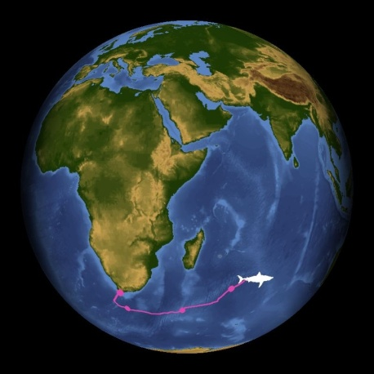Shark Migration (3mb)

Great White Shark Migration

Description:
Before satellite tagging technology became feasible, it was thought that great white sharks (Carcharodon carcharias), spent most of their time close to the coasts feeding on seals and sea lions. With the advent of satellite tagging technology, many new behaviors of the great white shark have been discovered. By tagging a shark with a satellite transmitter, scientists are able to track the movement of the shark for extended periods. In 2001, a shark tagged off of the coast of California was tracked all the way to Hawaii, 3,800 km (2,280 miles) away. The shark spent the winter there before returning to waters closer to California. Several other sharks tagged off the coast of California also were tracked traveling great distances from California.
More recently, in November of 2003, about 30 great white sharks were tagged off of the coast of South Africa. Most of the sharks stayed near Africa, but one of these sharks really surprised researchers when it traveled all the way to Australia. This journey of 11,100 km (6,897 miles) took the shark only ninety-nine days. This is considered to the farthest known distance traveled by a shark. The shark's tag detached when the shark was just south of Exmouth Gulf in Western Australia. Less than nine months later, scientists were truly surprised to find the same shark back in waters near South Africa. Using identification techniques with the dorsal fin, scientists were able to confirm that this shark was the same on that had traveled to Africa in the previous months. The total round trip from Africa to Australia and back is 20,000 km (12,400 miles), which is by far, the farthest known trip taken by a shark. This dataset follows the shark from South Africa to Australia.

Notable Features:
- Relatively direct route of the shark from South Africa to Australia
- Total trip of almost 7000 miles only 99 days

Data Category
Major: Ocean

Keywords:
Ocean, migration, tracking, animal tagging
Data Set Name | Shark Migration
Data Set Directory Name | shark
Data Set Source | Dr. Ramon Bonfil, Wildlife Conservation Society
Data Set Developer | Rick Kohrs, SSEC, Space, Science, and Engineering Center
Visualization Developer | Rick Kohrs, SSEC, Space, Science, and Engineering Center
Audio | No
Contact | Rick Kohrs, SSEC, Space, Science, and Engineering Center
Download | FTP
Privacy | Accessibility | Disclaimer | Copyright Notice
Contact the Webmaster
NOAA | Earth System Research Laboratory
Global Systems Division | Technology Outreach Branch

http://www.whitesharktrust.org/migration.html
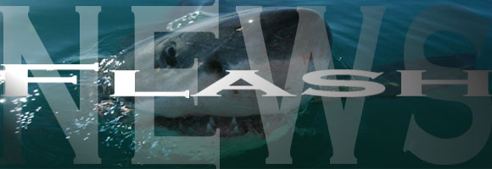

South Africa - Australia - South Africa
This is the first evidence of inter-continental trans-oceanic return migration of Great White Sharks (Carcharodon carcharias) and the implications of this discovery were extremely important for conservation efforts to help list this species on the CITES Appendix II in October 2004.
The Wildlife Conservation Society in association with Marine and Coastal Management, the White Shark Trust, the Universities of Cape Town and Pretoria and the South African Museum tagged white sharks off the Western Cape (South Africa) between June 2002 and November 2003 with 25 pop-up archival satellite transmitting (“PAT”) tags, 7 near-real-time satellite (“satellite”) tags and 25 acoustic tags to study their spatial-dynamics. Using high-resolution photographic fingerprinting techniques the White Shark Trust also recorded the daily presence/absence of individual White Sharks off Gansbaai (34°39’S 019°24’E; Western Cape) since October 1997.
On the 7th of November 2003, a circa 380 cm (about 12.5 feet) total length female Great White Shark was tagged with a PAT (Pop-up Archival Transmitting) satellite tag in an area known as Haibaai near Dyer Island, Gansbaai, Western Cape, South Africa.
On the 28th of February 2004, the PAT tag released itself from the Shark at the pre-programmed date. The pop-up location indicated that this Shark travelled in 99 days to a location 2 km from shore and 37 km south of the Exmouth Gulf in Western Australia (22°01’05”S 113°53’13”E) about 11'000 kms from her tagging site.

 | Read the scientific article published in Science on the 7th of October 2005 for more information...


Moreover, this Shark is well known to the White Shark Trust photographic identification database as she has been visiting Dyer Island since 1999 when she was first recorded. On the 20th of August 2004, Michael Scholl was conducting his ongoing fieldwork around Dyer Island when he spotted the very distinctive dorsal fin of this same Shark.
The White Shark Trust identification reference number for this Shark is WST/1308. The Wildlife Conservation Society reference number for the tag is WCS/P12. But in honour of Nicole Kidman, famous Australian actress and known for her love for Sharks, we decided to call her 'Nicole'. We will refer to this Shark as Nicole or 1308/P12 in this article.
The present web page discusses these results in depth and presents some additionnal information and photographs that could not be included in the published article. Sections of the following text form part of the original published article. Contact us for a PDF version of the original article published in Science or read it online.

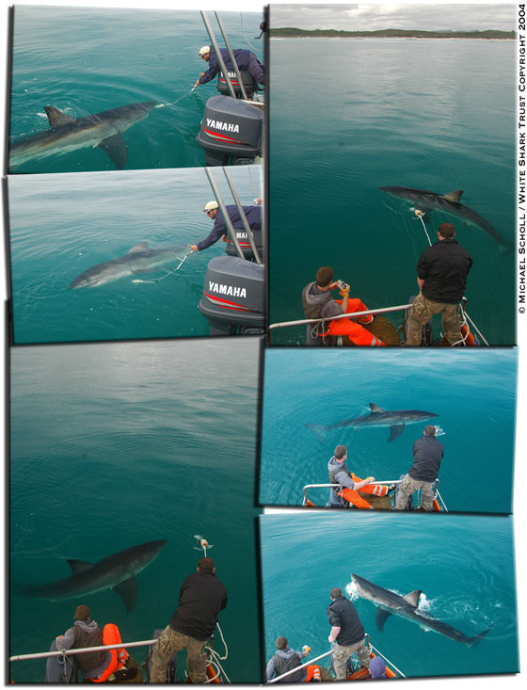

Figure 1 shows the approximated path followed by Nicole from the tagging site in Holbaai on the 7th of November 2003 to the PAT pop-up site just off the west coast of Australia on the 28th of February 2004. This path is the result of complicated calculations from the geolocation data collected by the PAT tag during the 99 days.
Unlike a SPOT (Smart Position Only Tag) satellite tag which needs to break the water surface to emit a signal that can be picked up by the ARGOS satellite system to get a location, a PAT tag is an inactive satellite tags until the pop-up date at which time the tag detaches itself from the Shark and floats to the surface and only then starts transmitting.
During the attachment period, the PAT tag will record three parameters: swimming depth, ambiant water temperature and light intensity. All the depth and temperature information is summarised for each day and stored in the internal memory (hence the archival name). From the light sensor, the tag estimates sunrise and sunset times for every day and these are also stored in the internal memory.

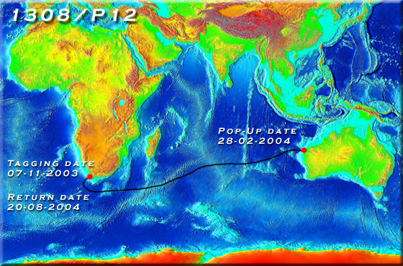
Figure 1a: Return intercontinental transoceanic migration of Shark 1308/P12 between Dyer Island (Gansbaai, Western Cape, South Africa) and the northwestern coast of Australia plotted on a topographic map. Black line is an estimated path followed by the Shark from South Africa to Australia from analysing the geolocation data recorded by the PAT tag.

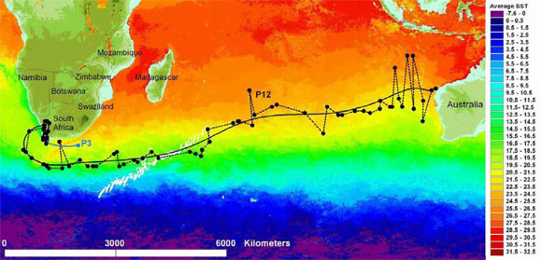
Figure 1b: Transoceanic migration of a white shark from South Africa to northwestern Australia and possible first leg of a second transoceanic-migrating shark. Geolocation-estimated positions of shark 1308/P12 (black dots) based on light-intensity records and possible path during this migration (solid line). The start of another possible migration to Australia is shown by the auto-release location of the PAT tag from shark P3 (blue line and square). Tagging and popup dates are: 1308/P12: 07/Nov/2003 and 28/Feb/2004; and P3: 14/Apr/2003 and 25/Dec/2003. Sea Surface Temperature (SST) is an average composite of daily 4-km resolution MODIS data for 23/Nov/03-28/Feb/04. Southwest Indian Ridge shown as white depth contours (100-2,000 m). Scale bar represents 6,000 km.

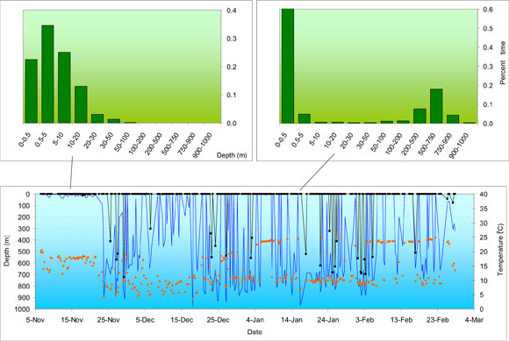
Figure 1c: Transoceanic migration of a white shark from South Africa to northwestern Australia. Differential time-at-depth patterns during the coastal (left) and oceanic (right) legs of Shark 1308/P12 showing strong preference for the first 0.5 m of depth, then for depths of 500-750 m during oceanic travel. Minimum (black line and squares) and maximum (bright blue line) depths and minimum temperature (orange dots) visited by 1308/P12 during the coastal and oceanic legs of its movement; all data in 6-hr periods; arrow marks beginning of transoceanic migration.

At the pre-determined pop-up date, the tag detaches itself from the Shark and floats to the surface. This is when the PAT tag starts transmitting all the data accumulated and stored in the internal memory. The ARGOS satellite system will pick up the signal and will be able to pinpoint the location of the now drifting PAT tag.
Hence, with PAT tags, we only have two very precise GPS (Global Positioning System) locations for the Shark: the tagging site (from the boat GPS) and the pop-up location. So how did we plot the path shown in figure 1?
From the estimated sunrise and sunset times calculated and recorded by the tag... These times can be compared to the internal clock which is synchronysed to the tagging site for example. As the Shark is moving east or west (longitude), sunrise and sunset times will vary and an estimated location can be calculated. The location is not precise and only long range movements can be analysed with this geolocation system. This geolocation can further become more precise when integrating the water temperature and maximum depth (the Shark is likely sometimes to go to the sea floor if diving) data into a global GIS system. But the resulting movement plot will never be very precise, it will remain an estimated path.


PAT or Pop-up Archival Tag is ready for deployment on the tagging pole.

Shortly after the PAT tag pop-up date at the end of February 2004, the information collected and stored started to be transmitted back to the ARGOS headquarters and further forwarded to Dr. Ramón Bonfil at the Wildlife Conservation Society (WCS) headquarters in New York. Dr. Ramón Bonfil is the project leader of the South African satellite tagging project in collaboration with Marine and Coastal Management (DEAT-MCM). The White Shark Trust, the University of Cape Town, the South African Museum and the University of Pretoria are also part of this collaborative effort to better understand the movement patterns of White Sharks using satellite tracking technology.
The news of this extraordinary voyage from South Africa to Australia were extremely exciting, but had to be kept quite at the time due to publishing constraints.

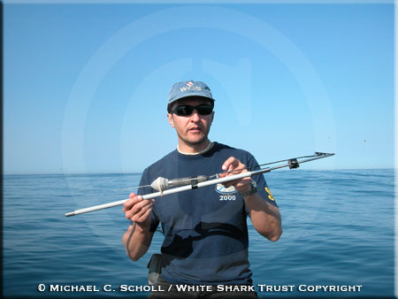
Dr. Ramón Bonfil of the Wildlife Conservation Society holding a PAT tag on the tagging pole ready for deployment.

This shark’s circa 10,800 kilometer course entailed an anticlockwise semi-circle 500+ kms south of Cape Agulhas (the Southernmost point of the African continent), followed by an extraordinarily direct eastward path towards NW Australia, indicating that white sharks do not need oceanic islands as gateways for transoceanic migration as previously hypothesised. Nicole travelled at a minimum speed of 4.7 km/h during this journey, the fastest sustained long-distance speed recorded among shark species and comparable to that of some of the fastest swimming tunas.
Photographic fingerprinting allowed identification of this shark back at its original tagging site off Gansbaai on 20 August 2004 (see below and figure 3). This migration circuit is remarkable not only because it starts and ends in the exact same location but also because it is the fastest known transoceanic circuit-migration among marine fauna, taking just under nine months to complete a circa 20,000 km trip.

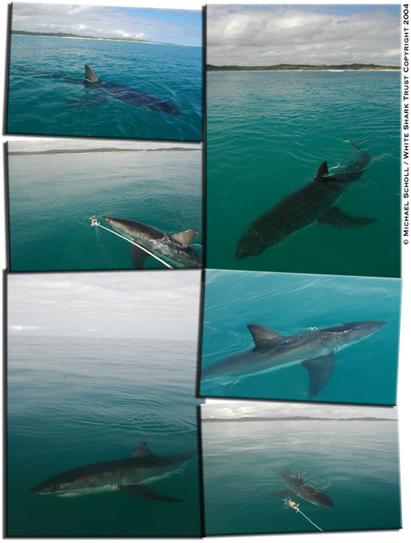

Figure 1a and 1b illustrate the hypothetical plot (solid black line) of the migration route followed by Shark 1308/P12 over a topographic (depth) map and SST (Sea Surface Temperature) map respectively, from South Africa to Australia. Geolocation positions (black dots) obtained from the PAT tag's light sensor are indicated in Figure 1b from which the estimated plot (solid line) was calculated.
We analyzed the satellite-transmitted summary data to reveal the diving pattern of this shark and discovered that daily, during the onward journey from South Africa to Australia, the Shark took frequent deep-dives, reaching record maximum depths (980 m) and ambient temperatures (3.4°C), and spent 18% of the time at depths of 500-750 m (Figure 1c). Surprisingly, it spent significantly more time just below the surface (top 0.5 m) while in oceanic waters (61%) than when it was in coastal waters (23%), swimming most of the time (66%) above 5 m during this trip. This preference for just-below-surface-swimming during oceanic travel constitutes a previously-unknown behavioural pattern for white sharks and suggests that similar to other vertebrates, it may have used visual stimuli, perhaps in the form of celestial cues, as an important navigational mechanism in addition to, or instead of following gradients in earth’s magnetic field as commonly accepted for sharks.

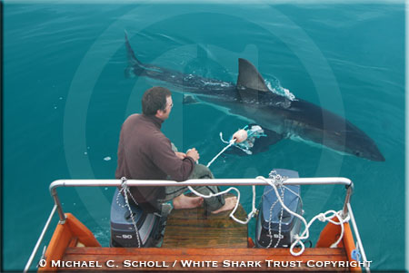
Michael Scholl and Shark 1308/P12 on Lamnidae, the White Shark Trust research boat, on the 21st of August 2004.

Michael Scholl of the White Shark Trust started looking at the photographic identification database which he has been building since 1997. Shark 1308/P12 is a well known Shark to Michael Scholl's fieldwork and database. She was recorded for the first time on the 19th of September 1999, five years prior to the present news.
This Shark has been sighted 38 times over the past six years (1999 - 2004). Figure 2 shows the periods when Shark 1308/P12 was observed in the Dyer Island area. The numbers indicate the number of days this Shark was observed each month.

 | 1999 | 2000 | 2001 | 2002 | 2003 | 2004
January
February
March
April
May
June |  |  |  |  | 1
July |  | 2 |  | 1
August |  |  | 1 | 3 |  | 3
September | 1 | 1 |  | 3 | 1 | 1
October | 2 |  | 1 |  | 2 | 8
November |  | 1 | 1 |  | 1 | 2
December |  | 1 |  | 1

Figure 2: Presence period of White Shark 1308 / P12 at Dyer Island from the photographic identification database from 01 January 1999 through 31 December 2004. Numbers indicate the number of days this Shark was observed for each month.

A clear and certainly very interesting pattern emerges from this chart: Nicole has been observed every year since 1999 between June and December, but never during the rest of the year (January through May). Remembering that this Shark was tagged in November, turned up in Australia at the end of February, and sighted back in South Africa in August, we can hypothesise that this Shark might be taking this return trip to Australia every year... for maybe and at least the past five years...
Remembering also that a 380 cm TL (total length) female White Shark is still immature as far as we know... Why would a Shark undertake this yearly migration?

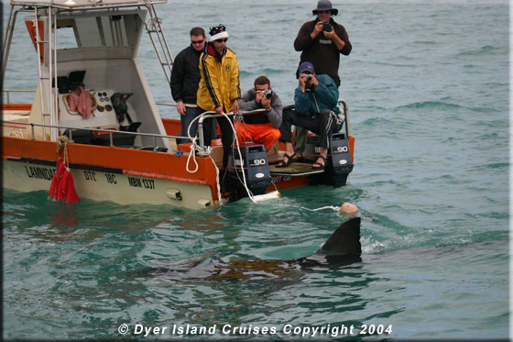
The White Shark Trust field research team (from left to right: Callum Call, Holly Frank, Andy Brandy Casagrande, James van den Broek are field research assistants of the White Shark Trust, and Michael Scholl in the back on the riht) with Shark 1308/P12 swimming past Lamnidae. Photograph taken by Dyer Island Cruises, the local boat based Whale Watching company.

Figure 3 illustrates the photographic identification methodology designed and developped for White Sharks by Michael Scholl, and demonstrates that the Shark tagged with PAT tag P12 on the 7th of November 2003 is indeed the same Shark photographed on the 20th of August 2004 after her return trip to Australia.
Figure 3 compares one identification photograph taken the day of the tagging on the 7th of November 2003 to another picture taken on the first subsequent observation on the 20th of August 2004.
Figure 3a compares the trailing edge of the first dorsal fin. The white lines link corresponding notches between the two identification photographs, clearly demonstrating that the two images are from the same Shark. Figure 3b shows the left side of the Shark's body behind the dorsal fin where PAT tag P12 was inserted on the 7th of November 2003. On the bottom picture, the tag is absent as it had popped-up (28 February 2004) nearly six months prior to the second picture being taken (20 August 2004). Nevertheless, three apparent white scars are still clearly visible: tag insertion point, scratch scar from the overgrown tag lead and from the buldging tag flotation.
Figure 3c and 3d further illustrate the positive identification of this Shark between 07/11/2003 and 20/08/2004 by comparing small pigmentation features present on respectively the left and the right side of the first dorsal fin.

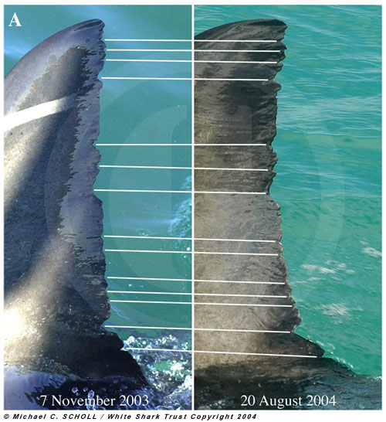
Figure 3a: Photographic fingerprints of Shark 1308/P12 at tagging (07 November 2003) and upon return to tagging location in Gansbaai (20 August 2004) after its transoceanic migration to Western Australia: Trailing edge of first dorsal fin showing unique notch pattern allowing identification; white lines connect corresponding notches on both photographs;

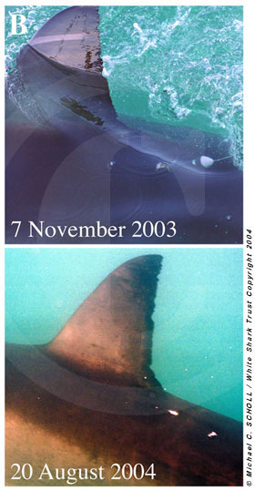
Figure 3b: Photographic fingerprints of Shark 1308/P12 at tagging (07 November 2003) and upon return to tagging location in Gansbaai (20 August 2004) after its transoceanic migration to Western Australia: Position of PAT tag after tagging (top panel), and healing scratch scars left after tag release (bottom panel);

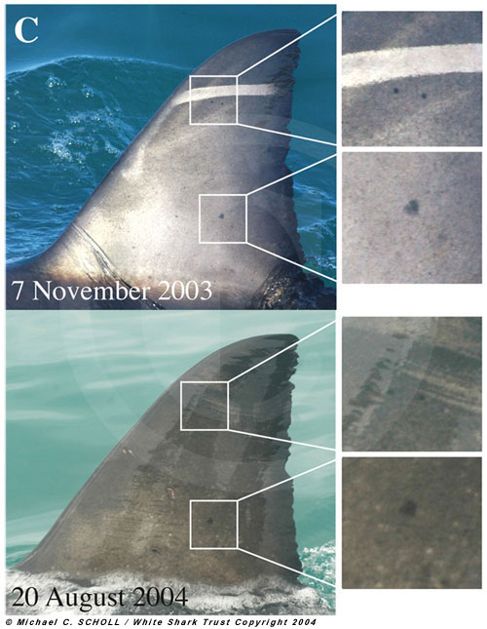
Figure 3c: Photographic fingerprints of Shark 1308/P12 at tagging (07 November 2003) and upon return to tagging location in Gansbaai (20 August 2004) after its transoceanic migration to Western Australia: Left side of first dorsal fin with magnified details (left inserts) showing unique black pigmentation pattern aiding fingerprinting;

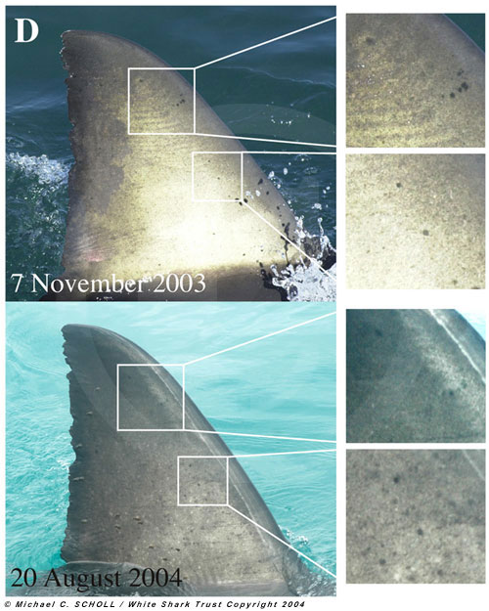
Figure 3d: Photographic fingerprints of Shark 1308/P12 at tagging (07 November 2003) and upon return to tagging location in Gansbaai (20 August 2004) after its transoceanic migration to Western Australia: Right side of first dorsal fin with magnified details (left inserts) showing unique black pigmentation pattern aiding fingerprinting.

Logged photographic data show shark 1308/P12 was a seasonal visitor (June-December) to the Gansbaai area (Figure 2), having been recorded 28 times during 1999-2004, suggesting that it is a South African shark and that the transoceanic circuit-migration could be an annual natal-homing event.
A second PAT-tagged shark (unsexed, ca. 200-230 cm TL; number P3) travelled to an offshore location 242 km SE of Port Elizabeth where its tag detached on 26/Dec/2003, in what appeared to be the start of a migration towards Australia (Figure 1b).

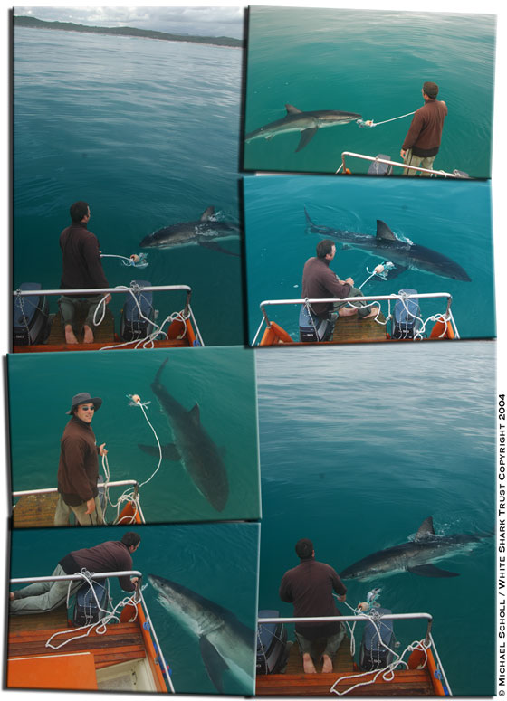

The transoceanic circuit-migration of Nicole is of key importance: it is the first direct evidence of connectivity between widely-separated white shark abundance centres, critical for our understanding of white shark population structure and for conservation and management. Our results also confirm philopatry in White Sharks.
In addition, the size of Shark 1308/P12 suggests it could reach sexual maturity soon and we speculate that it could eventually mate off Australia. In this event, the likely return of this shark to give birth off South Africa would provide further support to general reproductive behaviour theories of marine fauna and signal the need for protection of pregnant females facilitating a crucial genetic link between distant subpopulations.

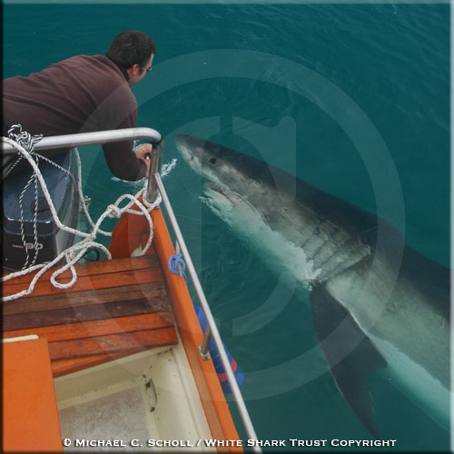
Michael Scholl of the White Shark Trust in a close-encounter with Shark 1308/P12 on the 21st of August 2004 after the Shark's return to South Africa

On a smaller scale, white sharks frequently perform long-distance coastal circuitmigrations (>2,000 km) from well-known abundance sites in the Western Cape, first northeastwards using well-defined underwater corridors along the continental shelf and sometimes very close to shore, to waters off KwaZulu-Natal and beyond, then returning to Western Cape sites after periods of 4-6 months (Figure 4).
Two out of six satellite-tagged sharks that were tracked for >2.5 months and one PAT-tagged shark showed long-distance coastal circuit-migrations back to their exact original tagging site.
Shark S1 (a 284 cm TL female) tagged in Mossel Bay (34 deg 08 min S 22 deg 07’ min E) during May 2003 completed the first directly-observed long-distance circuit-migration for a shark or ray species, moving in 65 days to waters just northeast of Delagoa Bay (Mozambique) and outside the South African EEZ where white sharks are legally protected (Figure 4a). It returned to Mossel Bay 162 days after tagging and was photographed with the transmitter still attached to its dorsal fin.
Another shark double-tagged with satellite and acoustic tags in Mossel Bay during May 2003 (number S2, a 310 cm TL female), followed a close-inshore path to the Tugela Bank where it last transmitted 46 days after tagging. This shark was recorded by our acoustic-tag bottom-monitors back at its original tagging site 123 days after tagging (Figure 4a).
Shark P11 (a PAT-tagged 388 cm TL male) moved between Gansbaai and the Tugela Bank between 5/11/2003 and 31/01/2004 (Figure 4b), then was re-sighted, captured and fitted with a satellite tag in Gansbaai on 26/05/2004.
Individual white sharks commonly disappear from Mossel Bay and Gansbaai but eventually return to these preferred sites after several months of absence (Figure 5), further suggesting that these long-distance circuit-migrations are common.

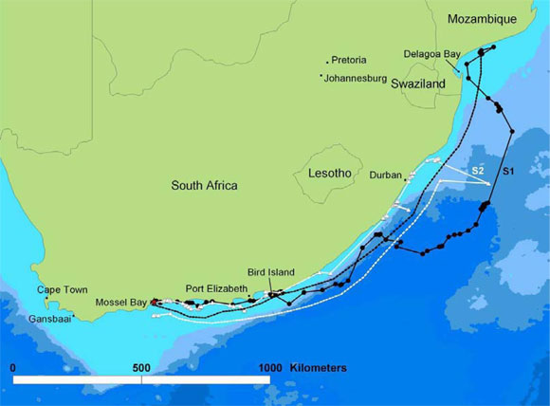
Figure 4a: North-eastward long-distance circuit-migrations of South African sharks. Tracks of two satellite-tagged sharks showing long-distance circuit-migrations and crossing to Mozambique; shark S1 left Mossel Bay after tagging (24/May/2004), moved rapidly to Bird Island residing within a limited area (385 km2) for 27 days, continued northeast along the shelf-edge then in deep water beyond the Agulhas Current, reaching Mozambique 65 days after tagging. Transmissions ceased after 11 days in Mozambique to resume at Bird Island 62 days later; shark S1 returned to its original tagging location on 2/Nov/2003. Shark S2 tagged on 31/May/03 with satellite and acoustic tags, travelled steadily along the coast to the Tugela Bank in 37 days where it ceased transmitting 9 days later, and was recorded by bottom-receivers back in Mossel Bay on 1/Oct/04. Red star is tagging location; dashed line is movement between long periods without transmissions.

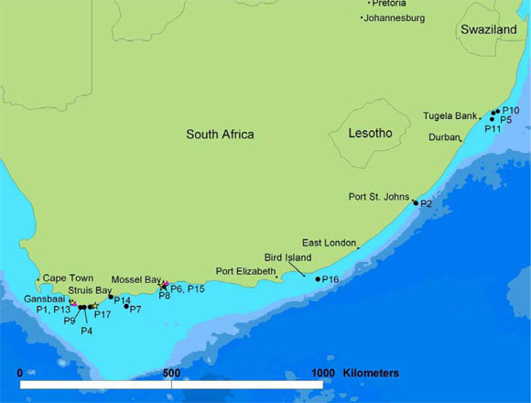
Figure 4b: North-eastward long-distance circuit-migrations of South African sharks. Movements of 15 PAT-tagged sharks that travelled to shelf waters; yellow stars show tagging sites, black circles pop-up locations, pink triangles represent two tags popping-up in the same location.

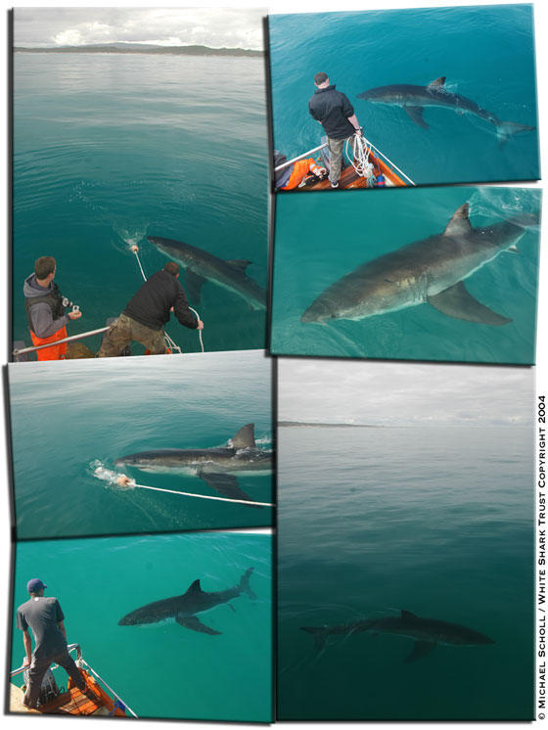

Four additional PAT-tagged sharks (numbers P2, P5, P10, P16) travelled to points close inshore scattered along the Eastern Cape and KwaZulu-Natal. Their movements and those of sharks S1, S2 and P11 indicate that white sharks might be using the most-parsimonious route along the continental shelf and close inshore (avoiding the strong south-bound Agulhas Current) when travelling towards the Tugela Bank or further north (Figure 4b). The relative large number of white sharks moving to the rich environment of the Tugela Bank which hosts important fishery resources and serves as nursery ground to a number of teleosts and elasmobranchs suggests that these long-distance coastal circuit-migrations might be feeding-related events.
Other white-shark’s spatial-dynamics patterns include small-scale return migrations and site fidelity. Four satellite-tagged sharks showed small-scale return migrations (<1,000 km) including one shark making a short westward trip and returning to its tagging site after travelling 19 days and 970 km, and three other sharks moving alternatively for periods of 75-201 days between close-to-shore Western Cape locations < 200 km apart.
Site fidelity is evidenced by the remarkable return of shark 1308/P12 to Gansbaai, as well as by shark S1 in its repeated visits to and residency in a small area east of Algoa Bay (Bird Island) and Mossel Bay (Figure 4a) and by three PAT-tagged sharks (numbers P13, P8 and P1; Figure 4b) and an additional satellite-tagged shark that remained in their tagging locations for periods of 29, 33, 75, and 32 days respectively. We found additional evidence for site fidelity in the extended residence of white sharks in Gansbaai (up to 68 days) and Mossel Bay (up to 211 days) and their propensity to return to these areas after considerable periods of absence (Figure 5).

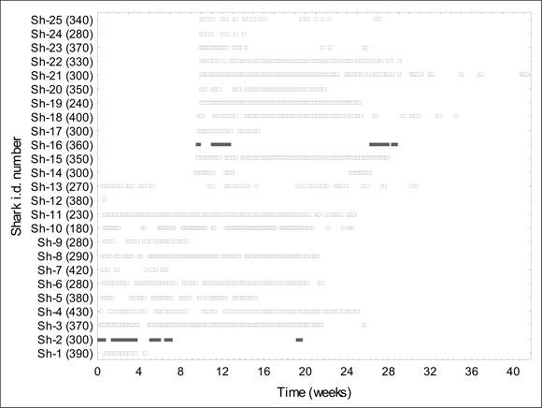
Figure 5a: Residence times of white sharks in two high-abundance areas in the South African coast, showing site fidelity and periods of absence followed by return. Presence-absence of 25 acoustically-tagged sharks in Mossel Bay. Maximum residence was 211 days (sh-13); maximum absence with a return was 95 days (sh-16). Numbers in brackets on the y axis are visually-estimated total lengths in cm; starting date for x axis is 1/Jun/2002; solid squares are males, empty squares females, circles unsexed sharks.

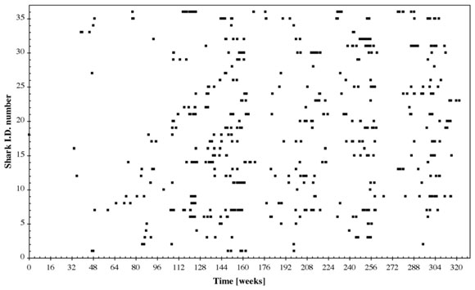
Figure 5b: Residence times of white sharks in two high-abundance areas in the South African coast, showing site fidelity and periods of absence followed by return. Presence-absence of 36 sharks photographically fingerprinted off Gansbaai (Dyer Island and neighbouring areas) for which records span more than 3 years. Maximum residency (absence of less than one week not considered) was 64 days (shark number 36), maximum absence with a return was 1'381 days (shark number 33)..



Management of white sharks, and perhaps many marine top-predators, can not be effected locally, or even regionally. Our studies show that we do not clearly understand the way in which identified populations, or subpopulations, are connected. Long-distance and transoceanic migrations expose great whites to increased risk of mortality as sharks migrate out of domestically-protected waters in South Africa into neighbouring or remote countries sometimes located across entire ocean basins.
An increasing global demand for shark products, coupled with our findings, suggest that global protective measures, such as the CITES Appendix II listing, were needed to ensure the effectiveness of local protective legislation and management regulations currently in place in a handful of countries.
Furthermore, the possible genetic flow between distant white shark subpopulations likely plays a pivotal role in the maintenance of their genetic variability. Its disruption via the extirpation of one of these subpopulations, or from the killing of the migrating sharks (especially pregnant females), could have disproportionate negative consequences for biodiversity and conservation, and further highlights the need for more effective and broader management and conservation measures for marine apex-predators that include multinational and international waters.

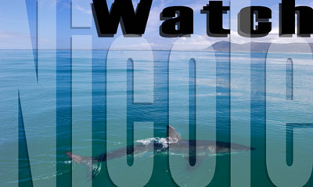
Click on the image above to read about updates of Nicole

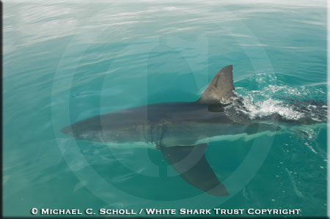
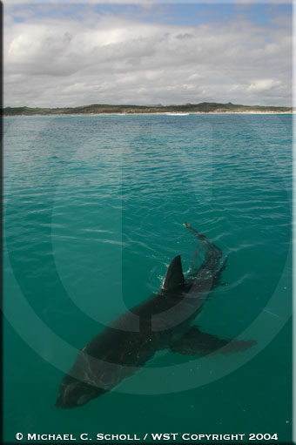

Methods
Pop-up archival tagging
Pop up archival tags have been described in detail elsewhere. Briefly, these instruments record temperature, pressure (translated to depth) and light intensity every 15-120 sec for the period of deployment and automatically release themselves at a pre-programmed date. Once they float to the surface they transmit a summary of the recorded data to polar-orbiting satellites carrying the Argos System.
PAT tags built by Wildlife Computers, Redmond, WA were attached by inserting a dart on the shark’s back just below the base of the first dorsal fin as the shark swam next to the vessel. PAT tags were programmed for deployment periods of between 9 and 53 weeks and data collection frequency was set to either every 30 or 60 sec depending on deployment period. Tags were programmed using temperature bins with upper limits at 0, 5, 7, 10, 12, 15, 17.5, 20, 22, 24, 27, and 30° C; depth bin upper limits were 0, 0.5, 5, 10, 20, 30, 50, 100, 200, 500, 750, and 900m.
Sharks were attracted to our vessel by releasing a trail of fish oil, shark liver or other marine products, then lured into tagging position by pulling a rope with a large bait. The size of PAT-tagged sharks was visually estimated by 3 qualified observers and an average or range was recorded.
Satellite tagging
Two types of satellite tags built by Wildlife Computers were used.
Smart Position and Temperature Transmitting (SPOT) tags measure ambient temperature from –2.2 to +50 °C, with a resolution of 0.2 °C. SPOT tags were deployed disabling the temperature recording program in order to maximize battery life.
Satellite Depth Recording (SDR-T16) tags record and summarize data on dive depth and duration, and time spent at user-programmed depth ranges up to 1,000m. Summary data for the previous 24 hrs is sent with every transmission. SDR tags were programmed using depth ranges with upper limits of 0, 8, 12, 16, 20, 52, 100, 200, 500 and 760 m.
Both types of satellite tags transmit radio signals to the Argos System at 9 frequencies of 40-45 sec; a salt-water switch allows the instrument to send a transmission whenever it clears the ocean surface.
Sharks were attracted to the surface as described above, where individuals were selected and caught on baited hooks and lifted out of the water using a purpose-built metallic cradle fixed to the side of a research vessel. Satellite tags were fixed to the first dorsal fin using nylon pins, brass washers and steel nuts. The choice of metals intends to ensure tag-shedding after approximately 9-12 months. Each shark was measured on a straight line to the nearest cm for fork and precaudal length.
Acoustic tagging
A continuing acoustic telemetry study has been conducted in Mossel Bay since June 200114. Six VR2 bottom-monitors (VEMCO, Shad Bay, Nova Scotia) were placed between 34° 07-15 S and 22°06-08 E and two others were added in June 2002.
Acoustic transmitters (V16, RCODE 69 kHz, VEMCO) were similarly attached as for PAT tags. Acoustic pulse-rate was set at 40-70 seconds and battery life was estimated at 14 months.
Bottom-monitors archived the presence of tagged white shark within a 400 m range (environmental conditions may result in a wide range of detection distance). A shark was considered present if a single detection at any bottom-monitor was archived on a given day.
Photographic Fingerprinting
White sharks were identified off Gansbaai (Dyer Island and neighbouring areas) using a photographic fingerprinting methodology based mainly on features of the first dorsal fin’s posterior margin and other fin characteristics. Attraction was similar to that described above.
Photographs recorded both sides of the first dorsal fin whenever possible using either a 35 mm camera and slide film, or a high-resolution digital camera. Body markings and sketches of any recognizable features completed the identification record.
Data comprised 900 fieldwork days (average of 3.5 days/week) and 4,024 hours of observation in the field (average 4.5 hours/day) during the period 6/Oct/97-28/Feb/04.
No fieldwork was conducted during the following 10 periods: January-July 1998, March 1999, mid May 2000-mid June 2000, 20 September 2000-6 October 2000, mid March 2001-early May 2001, November 2001, April 2002-mid May 2002, 14-31 December 2002, March 2003, second half of November 2003, and mid-January early February 2004.

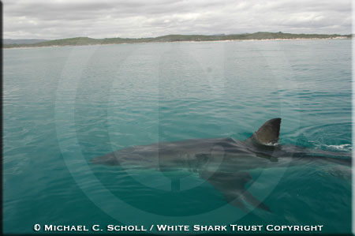
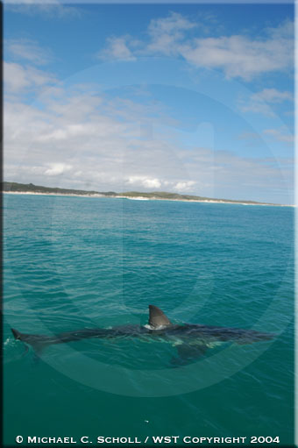

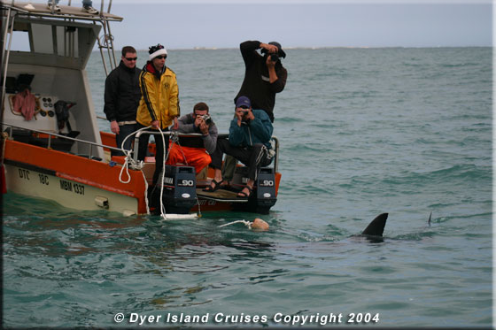

Acknowledgements
Financial support for the PAT and satellite-tag study was provided by the Roe Foundation, WCS, and the South African Government. A complete list of sponsors for the photographic-ID study is available here. The acoustic-tag study was financed by the South African Government and contributions from IFAW, WWF, and PADI Aware.
The authors’ appreciation goes to: the Natal Sharks Board and particularly Sheldon Dudley, Geremy Cliff, Kevin Cox and Wayne Harrison for valuable field-work assistance and helpful discussions in the satellite-tag study, and to Sheldon Dudley for assistance in the design and supervision of the acoustic-tag study; to Andre Boustany, Heidi Dewar, John Stevens, David Holts, Lee Hulbert, Rachel Graham and Michael Domeier for advice and help with tagging methodologies and equipment; to Barbara Mangold (formerly WCS), Chap Masterton, Sven Parsons, Pieter Koen, Dion Woodborne, and Pierre Fréon (MCM) for the monitoring and health maintenance of sharks during satellite-tagging; to Linda Staverees and Dandy Reynolds (MCM) and Michael Rutzen for support and assistance with satellite-tag field work; to Laurent Drapeau (MCM) for providing GIS shape files of Southern Africa; to Smit Marine for maintaining bottom-receivers, Marthan N. Bester (University of Pretoria) for supervision and Deon Sadie (formerly University of Stellenbosch) for conception of the acoustic tag-study; to Roy and Jackie Portway for assistance in program design and logistical support in acoustic study and field-assistance in satellite-tag study. Ramón Bonfil conceived, designed and led the PAT and satellite-tag study, data analysis and publication write-up. Michael Meyer assisted with design and co-led implementation of the PAT and satellite-tag study and assisted with the acoustic-tag study. Michael C. Scholl developed and implemented the photo-identification study and data analysis, and assisted with the PAT and satellite-tag field-work. Ryan Johnson co-designed and conducted the acoustic-tag study and data analysis, and assisted with design and implementation of satellite-tag study. Shannon O’Brien co-led the PAT and satellite-tag data analysis and preparation of figures for publication, and assisted in field work. Herman Oosthuizen co-led the PAT and satellite-tag study and assisted in field work, and designed and led the acoustic tag study. Stephan Swanson and Deon Kotze assisted with preparations and field work for the acoustic, and PAT and satellite-tag studies. Michael Paterson co-led equipment design and assisted with fieldwork for the satellite-tag study.
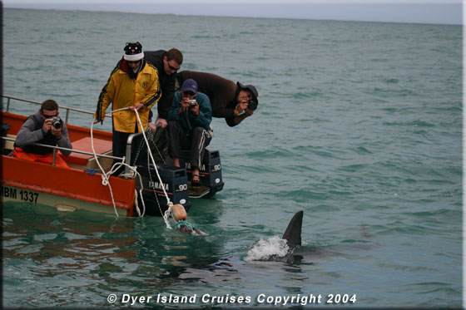

Nicole in the News around the World...
Great white shark's oceanic adventure | The Register
The Australian: Great whites surf the continents [October 07, 2005]
Newsday.com: Shark proves a prodigious swimmer
The Seattle Times: Nation & World: Satellite tracks shark on 12,000-mile swim
IOL: Great White's incredible journey to Oz
Requins: des globe-trotters au cœur froid
Edicom: News - Brèves on-line
Un lien entre requins blancs australiens et africains
Le Matinternet -- L'actualité au moment où vous la voulez -- 24h/24h -- www.matin.qc.ca --
Le Quotidien Permanent du Nouvel Observateur- Un lien existe entre requins blancs australiens et africains --par Randolph Schmid--
Canoë - Techno-Sciences - Un lien existe entre requins blancs australiens et africains
Requins: des globe-trotters au cœur froid - Sciences
Requins: des globe-trotters au cœur froid, Sciences de la vie
Die lange Reise der ''Nicole'' - sueddeutsche.de - Wissen
Marathon-Hai: Nicoles rasante Reise durch den Ozean - Wissenschaft - SPIEGEL ONLINE - Nachrichten
Berliner Morgenpost: Weißer Hai schwimmt Rekord
Bieler Tagblatt Letzte
wissenschaft.de - Das Wandern ist des Haies Lust
Hai "Nicole" Aus aller Welt Boulevard FOCUS Online in Kooperation mit MSN
Nordkurier.de
Deutschlandfunk - Forschung Aktuell - Flexible Haie
Haifisch «Nicole» schwimmt um die halbe Welt - Wissenschaft & Technik - News - Blick Online
Pressehaus Heidenheim
SVZ online: Deutschland/Welt "Hai schwimmt Rekordtempo"
Berliner Zeitung: Wissenschaft - Weißer Hai reist elftausend Kilometer weit
OVB online - Nachrichten aus Stadt und Landkreis Rosenheim sowie Mühldorf
OVB online - Nachrichten aus Stadt und Landkreis Rosenheim sowie Mühldorf
RNZ-ONLINE
Krone.at Kronen Zeitung Österreich Wetter aktuell Sport Nachrichten kostenlos Partner Horoskop gratis Multiplayer Spiele Download Billig Flug Reise Ticket Shop
DONAUKURIER online
Zoologie: Hai Nicole ist der schnellste Fisch
Rekord: Weißer Hai wurde über 20.000 km verfolgt auf nullzeit.at - Tauchen, Segeln und Surfen in Österreich und dem Rest der Welt - Wassersport total!
AM - US scientists track great white shark across ocean
Telegraph | News | Nicole the shark's record-breaking swim
SBS - The World News
Independent Online Edition > World Environment : app6
Scotsman.com News - International - Shark tailed for 12,000-mile round trip
World news from The Times and the Sunday Times - Times Online
Great white shark laps Indian Ocean. 07/10/2005. ABC News Online
NPR : Great White Makes Marathon Swim
BBC NEWS | Science/Nature | Great white's marathon sea trek
Great White Breaks Distance, Speed Records for Sharks
IOL: First tracking of shark's long haul to Oz
SA, Aussie sharks 'linked'
Science News Article | Reuters.co.uk
The Daily Telegraph | Great white ways
MSN-Mainichi Daily News: Features
SA scientists track great white shark across the ocean : Mail & Guardian Online
Great white shark sets trans-oceanic swimming record - World - smh.com.au
DeHavilland: political news feed, public and current affairs, news information service:dehavilland
DIVE Latest News - Speed Dating
icWales - Shark Nicole criss-crosses Indian Ocean
Great white shark tracked on epic swim - World News - Webindia123.com
KESQ NewsChannel 3 Palm Springs, CA: Shark clocks more than 12,000 miles crisscrossing Indian Ocean
Newswise | Great White Shark Travels Farther, Faster than Any Other Shark Known
Great White Shark Sets Ocean-Crossing Record
Marathon-Hai: Nicoles rasante Reise durch den Ozean - Wissenschaft - SPIEGEL ONLINE - Nachrichten
Hai "Nicole" Aus aller Welt Boulevard FOCUS Online in Kooperation mit MSN
Great white shark sets trans-oceanic swimming record - World - smh.com.au
World news from The Times and the Sunday Times - Times Online
N24.de - Weißer Hai schwimmt Rekord
NETZEITUNG WISSENSCHAFT: Weißer Hai schwimmt Rekord
Telegraph | News | Nicole the shark's record-breaking swim
Newswise | Great White Shark Travels Farther, Faster than Any Other Shark Known
Great white is star traveller - DIVERNET News for Divers
IOL: Nicole the shark makes a record ocean journey
Le Journal du dimanche: Animaux - Daniel Cherix
AMERIKA WOCHE - Die deutsche Zeitung für Amerika
The Telegraph - Calcutta : International
World news from The Times and the Sunday Times - Times Online
Independent Online Edition > Environment
Newsday.com: Shark Nicole Clocks More Than 12,000 Miles
MSN-Mainichi Daily News: Features
Great White Breaks Distance, Speed Records for Sharks
Newswise | Great White Shark Travels Farther, Faster than Any Other Shark Known
The China Post
Reuters AlertNet - Great white shark crosses Indian ocean -- and back
Great White Breaks Distance, Speed Records for Sharks
SA, Aussie sharks 'linked'
Monterey County Herald | 10/07/2005 | Local scientists turned shark chasers go high-tech
Great white shark tracked on epic swim - World News - Webindia123.com
SBS - The World News
Nicole Kidman's shark namesake swims long path
Guardian Unlimited | Science | Scientists track shark's 12,000-mile round-trip
AM - US scientists track great white shark across ocean
Scotsman.com News - International - Shark tailed for 12,000-mile round trip
Great White Shark Sets Ocean-Crossing Record
Great white shark's oceanic adventure | The Register
Great white shark sets trans-oceanic swimming record - World - smh.com.au
Discovery Channel :: News :: White Shark Travels Shocking Distance
Great white shark laps Indian Ocean. 07/10/2005. ABC News Online
Great white shark crosses Indian ocean - and back
Newswise | Great White Shark Travels Farther, Faster than Any Other Shark Known
Merkel limited mandate - The Boston Globe
The Telegraph - Calcutta : International
World news from The Times and the Sunday Times - Times Online
Newsday.com: Shark Nicole Clocks More Than 12,000 Miles
MSN-Mainichi Daily News: Features
TampaBay.com - Hot Topics
Great White Swims Over 12,000 Miles | Outside Online
New Zealand news on Stuff.co.nz: Jaws drop at results of great white study
Great white crosses ocean -- and back - The Boston Globe
Mercury - Great white's long trek astonishes researchers
"The Waterbury Connecticut Republican American Newspaper"
Gulf Daily News
DIVE Latest News - Speed Dating
Great white is star traveller - DIVERNET News for Divers
All Headline News - Surprising Journey Reveals Great White Vulnerability - October 31, 2005
IOL: Great White's incredible journey to Oz
Research Notebook
The Daily Telegraph | Great white ways
The Australian: Great whites surf the continents [October 07, 2005]
Star-Telegram | 10/07/2005 | Shark proves link between distant populations, report says

Click on the image above to read about updates of Nicole

