Heather Haberman, Comparison of Three Design Models
Tufts University
#2
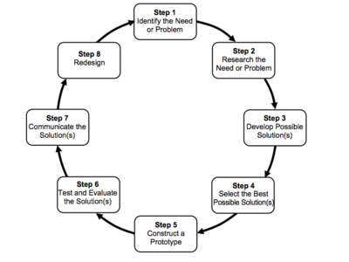
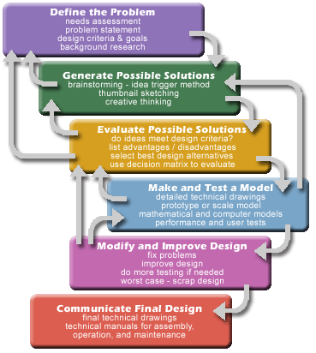
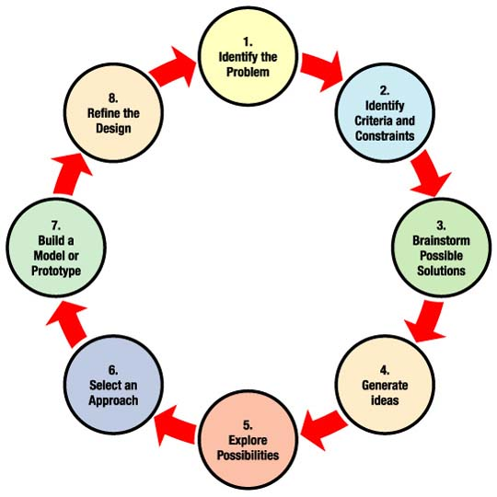
#3
NASA #1

ALL THREE Only NASA #1 Only Tufts #2 Number 3 doesn’t have anything unique.
- Start with a problem to be solved. 1. Identifies constraints. 1. Isn’t cyclic in nature.
- Possible solutions. 2. Doesn’t include communication.
- Select the best solution. 3. Doesn’t specifically mention research.
- Construct a model or prototype.
- Modify the original design.
- Go back to the original problem.
Reflection on all three models: I like that #2 isn’t a circle but let’s the viewer know you can return to any point in the process at any given time. I think that it’s very important for people to consider the constraints they are working with and for them to communicate their findings to others in an effort to improve upon the original design. (I did notice that NASA includes this step in their elementry version but not this upper level chart.) I like the simplicity of only using one or two words in the chart but the explainations that #2 provides are very helpful for students that might not understand things in general terms. Overall I like #2 the best as an introduction to the design process.

