Earth System Rocks!
Teacher: Date:
Sharlene Willard
Duration:
Approximately 7 days
Subject area / course / grade level:
Earth Science, Mathematics Engineering, Technology Grades 4-7
California State Standards:

Earth Sciences

Grade four
4. The properties of rocks and minerals reflect the processes that formed them. As a basis for understanding this
concept:
- Students know how to differentiate among igneous, sedimentary, and metamorphic rocks by referring
to their properties and methods of formation (the rock cycle).
Grade five
- Students will: Classify objects (e.g., rocks, plants, leaves), in accordance with appropriate criteria.
Grade six
- Students know evidence of plate tectonics is derived from the fit of the continents; the location of
earthquakes, volcanoes, and mid ocean ridges; and the distribution of fossils, rock types, and ancient climatic zones.
- Students know Earth is composed of several layers: a cold, brittle lithosphere; a hot, convecting
mantle; and a dense, metallic core.
Grade seven
- Students know that the rock cycle includes the formation of new sediment and rocks and that rocks are often found in layers, with the oldest generally on the bottom.

National Science Education Standards
(Content Standards: 5-8, National Academy of Sciences, c. 1996)

Science as Inquiry - Content Standard A:
As a result of their activities in grades 5-8, all students should understand that:
- Some changes in the solid earth can be described as the rock cycle.” Old rocks at the earth’s surface weather, forming sediments that are buried, then compacted, heated and often recrystallized into new rock. Eventually, those new rocks maybe brought to the surface by the forces that drive plate motions, and the rock cycle continues.
1.8 Use mathematics in all aspects of scientific inquiry.

K-12 Engineering/Engineering Technology:

Procedural Statements:
Standard One: Students will apply the engineering design process, troubleshooting, research and development, invention and innovation, and experimentation in problem solving and engineering design.

Students will:
1P1: Learn that the engineering design process includes defining a problem, brainstorming, researching and generating ideas, identifying criteria and specifying constraints, exploring possibilities, selecting an approach, developing a design proposal, making a model or prototype testing and evaluating the design using specifications, refining the design, creating or making it, and communicating processes and results.

2) Connecting Engineering to Science, Technology, and Mathematics

Standard Two: Students will develop an understanding of the essential concepts of and how to apply science, technology, and mathematics as they pertain to engineering design.
Overview:
This unit was designed to facilitate students’ understanding of the rock cycle and the three main groups of rocks, though an interdisciplinary learning approach that integrates Earth science concepts with complementary technology, engineering, and mathematics (STEM) concepts. It was also designed to promote the use of higher order thinking skills and appeal to different sensory modalities, by incorporating various multifaceted lessons that includes, 1) pre-activities /lessons on the lithosphere from Project 3D-VIEW [Virtual InteractivenEnvironmental Worlds] 2) stimulating, hands-on classroom activities that include research, model building, collaboration, real-world application, and presentation; and 3) a wonderful culmination activity that introduces students to geotechnical engineering
Lesson objective(s):

Students will understand
- That our earth is a system changing over time as a result of forces acting within its layers and its surrounding atmosphere.
Students will know …
- Rocks come from magma or lava, as well as from sediments that build up in layers. As all rocks from earth’s surface weather,
form sediments and become buried and heated (through pressure or direct heat), they may crystallize into new rock. Eventually those new rocks may be brought to the surface by forces that drive plate motions (The Rock Cycle).
- The earth is layered with a rigid shell, a hot mantle and a dense metallic core.
- Some changes on the earth can be very slow, such as weathering and mountain building, and some can be very fast—such as
volcanoes and earthquakes.
Students will be able to …
- .Use data about a rock’s physical characteristics to explain the rock’s history and connection to the Rock Cycle.
- Create a model of landform (a volcano) and explain rock formation
- Identify examples of geologic changes on the earth’s surface in the local
- Explain the processes that occur when rocks are changed from one form to another.
- Design an investigation, make simple observations, make generalized inferences from their observations, and apply their understanding of the Rock Cycle and different rock forms.
Differentiation strategies to meet diverse learner needs:

In an effort to address various learning modalities, various media and other technological resources has been infused throughout the lessons. Additionally, students will be permitted work collaboratively in pairs /teams on various activities, although they must be able to demonstrate individual acquisition and applicability of knowledge through various forms of assessments.
Materials:  Model Volcano  - Paper cup  - Plaster of Paris  - Crayons  - Water  - Safety goggles  - String  “Building Materials  - Three rocks labeled A, B, and C  - Nail  - Sandpaper  - Penny  - Hand Lens  Multimedia Resources  - Google-Earth-Geology-Field-Trip/  - Virtual Volcano Web site  - Interactives Rock Cycle  - How It’s Made: Road Salt DCL video | Materials:  “Rock Cycle Fudge”  - 1/3 cup silt (evaporated milk)  - 1 cup quartz crystals (sugar)  - 1 tbs. sediments (margarine)  - 1 cup limestone pieces (mini marshmallows)  - 1/4 cup sandstone pieces (pecans)  - 3/4 cup basalt pieces (chocolate chips)  - 1/2 tsp. (vanilla extract)  - Measuring bowl, spoon, cup, wax paper, wooden spoon, microwave  General  - NASA – Project 3D-View Curriculum  - Rock collection

Day 1
(Project 3D-View Name That Volcano!)
(Follows Project 3D- Lesson 10-Investigating Lava Flow)
ENGAGEMENT
- Teacher will activate students prior knowledge about volcanoes, by asking:,
  - What is a volcano? Can anyone describe some of the characteristics of a volcano?
- Teacher will remind students that they previously learned that volcanoes are mountains that can erupt with lava due to forces below the Earth’s crust, and prompt students to share what they had previously learned about magma and lava
- As further review, teacher will ask students why the stickiness and flow of magma is important to understand when studying volcanoes.
- Teacher will explain to class that they will now see a demonstration of a volcano.
- Teacher will place the model “volcano” in a central location in the classroom and ask the students:
  - If they have ever seen a demonstration like this before. (Many of them are likely to have seen this demonstration when they were younger.)
  - To predict what she will do to make the volcano “erupt.” (Accept all answers.)
  - To pay careful attention to the sights, sounds, and smells of the “eruption” and to record detailed observations in their notebooks.
- Teacher will demonstrate the eruption with the materials prepared prior to the lesson, then ask the students:
  - To explain why the volcano “erupted.” (Chemical reaction of the vinegar solution and baking soda.)
  - If they think this demonstration accurately simulated the look, feel, and smell of an erupting volcano, as well as the processes that cause real volcanoes to erupt. (No – a real volcano would produce heat, the lava would be bright, and it might smell smoky or like sulfur. The processes would also be MUCH different – instead of a chemical reaction from adding an external solution, real volcanoes erupt because of internal processes in the Earth.)
- Teacher will tell students they will now watch a video clip of an actual volcanic eruption. And ask them to observe the characteristics of the eruption and record their observations in their notebooks, alongside or below their observations about the simulated volcano.
- Teacher will play Project 3D – View Volcano video - Dynamic Earth: Lithosphere (lesson 1); then lead the class in a discussion contrasting the two eruptions; based on the observations they recorded in their notebooks. Some questions to ask are:
  - What differences did you observe between the simulated volcano and the actual volcano in the video? (Simulation had bubbles instead of lava; there was no heat or pressure involved in the simulation; no blast; consistency of lava was different; lava flow in the simulated volcano did not cool and harden to form surface features; etc.)
  - Based on what you observed from the video, what do you think you might see, hear, and smell near a real erupting volcano? (Flowing lava, spewing ash, rumbling, landslides, falling rocks, smoke, ground and buildings shaking)
  - What are some of the consequences of volcanic eruptions? How might an eruption change the area surrounding the volcano? (Lava cools and creates new surface features, changes landscape, starts fires, etc.)
  - What can scientists tell from the lava at different eruption sites? (Temperature based on color and brightness, how and when the lava was formed, some information about patterns of eruption)
- Tell students that, as they saw in the video clip, volcanoes occur when _____, which is____ ___ beneath the ___surface, erupts through openings in the ____. Once the ____ has reached the surface, it is called ____...
- Teacher will open the Virtual Volcano Web site and display on a screen for the class. Click “Enter” to enter the site, and then click the “Inside a volcano” link on the left side navigation menu. Walk students through the different features of the volcano.
- Teacher will explain that while the basic process by which volcanoes erupt is the same for all volcanoes, not all volcanoes are the same.
EXPLORATION
- Divide the class into pairs or groups, with each pair/group at their own computer.
- Direct pairs/groups to the Virtual Volcano Web site and ask them to click on the “Volcano types” link in the left side navigation menu.
- Ask students to read about the three types of volcanoes listed: Stratovolcano, Cinder Cone, and Shield, and to notate the distinguishing features of each type of volcano, including how they are formed, what they look like, and examples.
- Distribute the “Volcano Types Organizer” (PDF) (RTF) for students to record their observations. Give students 5-10 minutes to complete the activity.
EXPLANATION
.
- When students have finished, check for comprehension by asking students to share their answers with the class
- Review correct responses as whole-class.
- Ask students, based on the information they now have about volcano types, what factors they think might contribute to creating different types of volcanoes and eruptions? (Lava consistency/viscosity, lava cooling, force of eruption, location.)
- Ask students to click on the “Build your own volcano and watch it erupt” link, and visit that section of the Web site on the class computer as well. Point out that the viscosity ( ) and gas levels of magma contribute greatly to the type of volcano that will be formed.
ELABORATION

- Students will work in pairs
- Tell students you would now like them to complete the activity and build their own volcanoes.
- Tell students that there is also a fourth type of volcano that can be created; if they find it, they should fill in its information on the Volcano Types organizer.
- Give students 5-10 minutes to complete the activity.
- . Ask students how they created the different volcano types. Ask if anyone found the fourth type of volcano, and what it is. (Lava dome.) Review the information about lava domes.
EVALUATION
- Check for comprehension during class discussions
- On-going informal observations
- Completion data sheet. Worksheets
- Formal assessment
- Grading Rubric
Day 2
(Project 3D-View – The Rock Record –Lesson 5)
Day 3/4
(Liquid Rocks)
ENGAGEMENT

    - Teacher will activate students prior knowledge about Plate Tectonics (review of Project 3D-View –Lesson 4- A Deeper Look at Plate Movement, and Lesson 5- The Rock Record: Searching for Volcanic Evidence), by asking:
  - What is the Pangaea?
  - What are the layers of the Earth?
  - What causes plates to move?
  - Describe the connection between the mantle and volcanoes (“The mantle is making up of melted rock called magma. Heat and pressure from the mantle move upward and are released when volcanoes erupt. This upward movement forces magma to rise and explode or flow from volcanoes.)
  - Compare lava and magma (Lava is liquid rock at the surface of the Earth and magma is the same rock beneath the surface.)
  - Describe the difference between volcanic (extrusive) rock and plutonic (intrusive) rock (Extrusive volcanic rocks (lava) are cooled outside of the volcano, above the earth’s surface, whereas intrusive plutonic rocks (magma) are cool inside the lithosphere.)
- Teacher will distribute sample igneous rocks to students and explain that the rocks were made by volcanoes.”
    - Teacher will then distribute magnifiers to students, allowing time for exploration and observations.
EXPLORATION:
    - Students will work in pairs to read text book selection on formation of igneous rocks.
    - Students will examine their rock samples and record their observations with notes and labels in their Science notebooks / activity sheets.
    - If using basalt and granite, use a digital microscope and projector if available to look at each igneous rock, discussing how these two rocks make up a large part of the Earth’s crust.
EXPLANATION
- When students have finished, check for comprehension by asking students to share their answers with the class
- Teacher will show the pumice or scoria and say, “This rock has lots of holes. That is from the gas that comes
- out of a volcano,” and so on, using the information cards that came with your set of rocksand
ELABORATION:
- Teacher will reemphasize the following points:
  - Magma rising to Earth’s surface and cooling form igneous rocks such as basalt, and some magma not making it to the surface but slowly cooling under the surface forming igneous rocks such as granite.
  - The rate of cooling and types of minerals present in the magma determine what type of igneous rock it will form (include terms intrusive and extrusive, with definitions and examples)
- Teacher will pose the following questions to students:
  - How does magma rise?
  - What happens to magma, lava and ash during an eruption?
- Students will work in teams to construct a model volcano (letting it harden overnight) and making it erupt, following directions on Activity Sheet 5
- Students record observations on Activity Sheet, Part B, describing what they observed as the volcano was placed in the heated water, and hypothesizing why the melted wax breaks through the plaster.
- Students will connect each “part” of their volcano to an actual volcano.
- Students will share and record notes about igneous rocks, explaining how they are formed

EVALUATION:
- Check for comprehension during class discussions
- On-going informal observations
- Completion data sheet. Worksheets
- Formal assessment
- Grading Rubric
EXTENSION

- Students will discuss and then write a brief essay that focus on the accuracy and function of the model, along with an explanation of how this models the formation of igneous rocks

Day 5
(Are All Rocks Created Equally?)
(Rock Formations)
ENGAGEMENT:
- Teacher will begin lesson by having volunteers describe the process of igneous rock formation, and then ask the class:
  - What does the presence of igneous rocks reveal to geologists about the area where they are found? (prior volcanic activity)
  - Do we live near any volcanoes? Does anyone remember the approximate distance from our school to the nearest site that provides evidence of volcanic activity? (As calculated in Lesson 7 – The Rock Record-using the Evidence of Volcanic Activity and Molten Rock Map.
- Teacher will explain to students we live quite a distance from any volcanoes, and yet there are rocks everywhere. Where did these rocks come from? Are all rocks formed the same way?
- Class will view BrainPop! Video – “Types of Rocks”
- Class will discuss the information presented in the video and complete the accompanied on-line quiz.
- Teacher will project the website Rocks - http://www.mcsdk12.org/curr/webquests/rocks/rockswebquest.htm and explain the activities for exploration.
EXPLORATION:
- To assist students in conceptualizing the formation, characteristic, and categorization of rocks; students will work in pairs to complete the above-notated webquest, entailed Rocks.

EXPLANATION:
- Teacher will explain that there are three kinds of rocks – igneous, sedimentary and metamorphic, and that .the way they are formed determines the kind of rock that they are.
- Class will review Rocks worksheet.
- Each pair of students will share their discoveries about a specific type of rock (from their Name that Rock worksheet)
ELABORATION:
(Adapted from: Google Earth Geology Field Trip)
- Pass around the rock samples (if you have them) and ask for student observations.
- Ask students the following questions.
- Which rock types would you expect to find on a field trip to the beach? (Mostly sedimentary rocks because sand builds up on the beach and over time can form sedimentary rocks.)
- Which rock types would you expect to find near the volcanoes in the Sierra Nevada? (Mostly igneous rocks because they are formed when molten material from volcanoes cools and hardens.)
- Where in California would you expect to see metamorphic rocks? (You can find metamorphic rocks anywhere where rock has been changed by heat and pressure. This could be near the coastline, where two plates once collided and now move in opposite directions along a series of faults including the San Andreas Fault. You could also find them in the mountains where mountain building could have caused serious heat and pressure.)

Procedure
- Tell students that they are going to go on a virtual geology field trip to see some places where they can find sedimentary, metamorphic, and igneous rocks in California.
- Open the kmz file entitled “California Geology Flight.” This will open the Google Earth application.
- Start by double clicking on “California.” This view will show a cluster of points in the Bay Area and a cluster in the Sierras. Explain to the students that your virtual field trip will involve looking at geology close to home and then further away in the Sierras.
- Then, double click “Bay Area.” This will zoom into a view of only the Bay Area. Tell students that you will look at four different rocks in the Bay Area.
- Explain that the Bay Area is located on a fault line and near the ocean. Both of these geographic features greatly affect the types of rocks that are distributed around the Bay Area.
- Start with the first rock, sandstone, and proceed to give your students a tour of the four Bay Area rocks.
- To fly to each rock, double click on the Academy logo next to each rock type on the left panel.
- Once you reach the location, you can click on the logo once more to bring up the balloon of photos and information. (Note that you can also click on the name of the rock type on the left –in blue. This will bring up the balloon of photos and information. A double click will fly you to the appropriate location.)
- Read the balloon text out loud to your students and have a discussion about how each rock type was formed. (Use the information from the teacher worksheet to flesh out what is written in the balloons.)
- For each rock location, you can pause to discuss relevant issues such as how the visible topography was formed, what rocks are used for in everyday life, how and why rocks are mined, and the environmental issues associated with mining.
- At each location have students fill in the appropriate section on their worksheet.
- After visiting the four Bay Area rocks, double click on “Sierra Nevada.” This will zoom into a view of the Mono Lake area of the Sierra Nevada. Tell students that you will now fly to the mountains and look at 5 rocks from this region.
- Double click on “Mono Craters.” This will fly you in closer to a view of the volcanic landscape.
- Discuss how the Sierras were formed: Today, California’s faults are mostly transform faults (where plates grind past one another), but there used to be a subduction zone off the coast of California. At subduction zones, oceanic crust is subducted beneath the continental crust. When oceanic crust subducts, it melts, causing large plumes of magma to rise. In California, these large plumes of magma resulted in mountain building and volcanoes. When the magma cooled, it formed the igneous granite that comprises the base of the Sierras. As volcanoes erupted, mountains formed, rivers were born, and other geologic processes occurred in this area. Many metamorphic, igneous, and sedimentary rocks formed.
- Explore the five Sierra rocks as you did with the Bay Area rocks. Have the students continue to document what they are learning on their worksheets.

Wrap-Up
Discuss with the students:
- What surprised you about your virtual field trip?
- Why are there so many different types of rocks in California? (California is tectonically active and showcases a variety of different geologic processes including sedimentation, metamorphism, and volcanic eruptions.)
- What questions do you have about California geology?
EVALUATION:
- Check for comprehension during class discussions
- On-going informal observations
- Completion data sheet. Worksheets
- Formal assessment
- Grading Rubric

EXTENSION:
- Spend time flying over California’s major geologic features.
- Have students take turns explaining some of the features that you can see.
Day 6
(Everything Must Change!)
(The Rock Cycle)
ENGAGEMENT
- To begin the lesson, teacher will have an outline of the rock cycle on the board with igneous, sediment and metamorphic annotated (each student will also receive an outline of the rock cycle), and ask?
- Based on the explorations we have done thus far and the readings we have done in class, do you believe that sedimentary, igneous and metamorphic rocks are all related?
.
EXPLORATION:
- Students will work in pairs (or groups), to compare notes, discuss the formation and characteristics of rocks, and to formulate their hypotheses. Students will substantiate their hypothesis with information and examples from past class activities and prior knowledge... (10-15 min)
EXPLANATION:
- Volunteers will share their hypothesis with with the class.
- Teacher / volunteer will explain that diagram on the board represents the rock cycle and that rocks are continually changing over time.
- Class will view BrainPop video The Rock Cycle, and complete the on-line quiz at the end
- Teacher will project the Interactives Rock Cycle website on the screen/board, and review the site with the students.
ELABORATION
- Students will work in pairs to explore the Interactives Rock Cycle website and to complete their individual Rock Cycle diagrams and Mapping the Rock Cycle worksheet.
- Upon completion of this activity, Students will share acquired knowledge –
- Class will review the Mapping the Rock Cycle worksheet.
- Volunteers will help complete the class rock cycle diagram.
EVALUATION:
- Check for comprehension during class discussions
- On-going informal observations
- Completion data sheet. Worksheets
- Formal assessment
- Grading Rubric
EXTENSION:

- In this activity (Rock Cycle Fudge), students will actually “participate” in the rock cycle.
- They begin the cycle with sediments that they weather into little pieces that form sedimentary rock.
- The “rock” changes when pressure and heat are applied and metamorphic rock is created!
- This “rock” is melted into magma and cooled to end the cycle as igneous rock

Day 7
(Made of Rocks..,)
ENGAGEMENT:
- Volunteers will pass out the fudge the students made the day before.
- While students enjoy their rock treat, teacher will encourage them to ‘share their thoughts about Rock Cycle Fudge), and how it compares to the Rock Cycle.
- Teacher will then ask the class if people could actually eat rocks
- Teacher will pour table salt into a bowl and solicit the student’s prior knowledge about salt. What is table salt? Where does it come from? How is it formed?
- Class will view the two minute video clip entitled, How It's Made: Road Salt, and discuss the formation, mining process, chemical composition and differences and uses of rock and table salt.
EXPLORATION:
- Students will work in pairs to explore some common uses for various types of rocks and minerals.
- Students will complete the accompanied Rocks and Minerals in Everyday Life, worksheet.

EXPLANATION:
- Students will share the results of their explorations with the class.
- Student’s”Rock Home” annotations will be projected on the screen/board via the document camera for class viewing.
- To reiterate the important and abundance of uses of rocks in our everyday lives, teacher will ask the class, how would the world be different if there were no rocks? (There would be no bricks, concrete buildings, roads, and many other familiar items. Cemeteries would be without gravestones. Bathrooms would be without marble.)
- Teacher will remind students that mineral resources such as copper, silver, oil, and iron must be mined in order to make the materials that we use at home, play, or work
ELABORATION:

- Students will work in teams to complete the Building Materials Task.
  - Students are presented with three rocks and a variety of tools and are asked to investigate the properties of the rocks to see which rock will be best for building tables and benches for a museum picnic area.
EVALUATION:
- Check for comprehension during class discussions
- On-going informal observations
- Completion data sheet. Worksheets
- Formal assessment
- Grading Rubric
References:
- “Building Materials,” ©1997-2005 SRI International, Center for Technology in Learning. http://pals.sri.com/tasks/5-8/Museum/

- “Feeling Hot, Hot, Hot!” Produced by Thirteen© 2012 Educational Broadcasting Corporation. http://www.pbs.org/wnet/nature/lessons/feeling-hot-hot-hot/activities/1532/

- “Google Earth Geology Field Trip,” © Copyright 2012 California Academy of Sciences
http://www.calacademy.org/teachers/resources/lessons/google-earth-geology-field-trip/

- “How It's Made: Road Salt”© 2012 Discovery Communications http://science.discovery.com/videos/how-its-made- roadsalt.html

- “Interactives Rock Cycle “© Annenberg Foundation 2012
http://www.learner.org/interactives/rockcycle/diagram.html

- “Rocks” – webquest Copyright © 2010 MCSD.
s http://www.mcsdk12.org/curr/webquests/rocks/rockswebquest.htm

- “Rock Cycle Fudge “Copyright © 2009 by SGEEI
http://www.treasuresforteachers.org/library/Rock%20Cycle%20Fudge.pdf

- “Rocks and Minerals in Everyday Life, “http://www.lilburnes.org/Students/Piece_of_the_rock/everyday_lives.htm

- “Volcano Explorer Image,” © 2012 Discovery Communications, LLC. http://dsc.discovery.com/convergence/pompeii/interactive/interactive.html

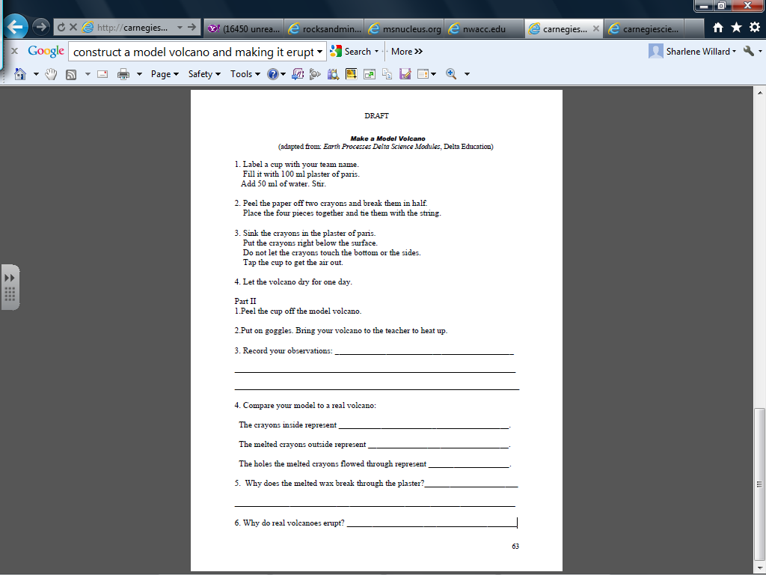

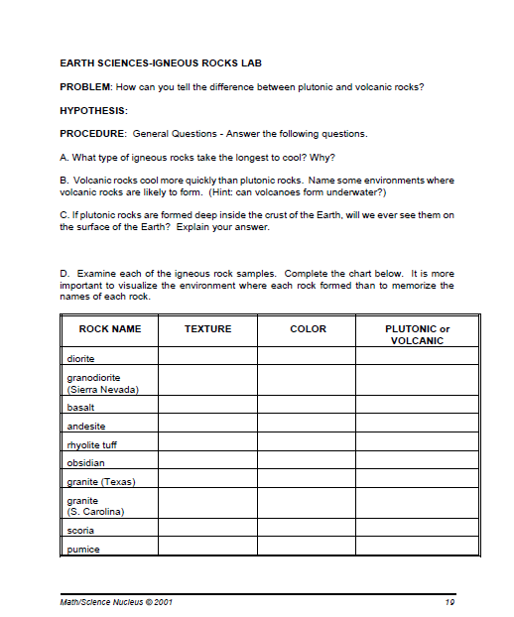

Rocks
Use the information on the webquest and websites to complete the worksheet.
1. What are Igneous Rocks and how are they formed?
2. In each square, name an igneous rock. Draw a picture of the rock
Name of Rock | Rock Illustration | Did it cool quickly or slowly? | How do you know?
Name of Rock | Rock Illustration | Did it cool quickly or slowly? | How do you know?
Name of Rock | Rock Illustration | Did it cool quickly or slowly? | How do you know?

1. What are Sedimentary Rocks and how are they formed?
2. In each square, name a sedimentary rock. Draw a picture of the rock
Name of Rock | Rock Illustration | How is it used?
Name of Rock | Rock Illustration | How is it used?
Name of Rock  s | Rock Illustration | How is it used?
Name of Rock | Rock Illustration | How is it used?

1. What are Metamorphic Rocks and how are they formed?
2. In each square, name a metamorphic rock. Draw a picture of the rock
Name of Rock | Rock Illustration | What is the name of the original rock?
Name of Rock | Rock Illustration | What is the name of the original rock?

Rock Webquest Page | Igneous Rocks | Sedimentary Rocks | Metamorphic Rocks | Rock Worksheet | Name that Rock | Name that Rock Worksheet | The Rock Cycle | Resources

http://www.mcsdk12.org/curr/webquests/rocks/rocks%20Worksheet.htm

Name that Rock!
Play the game Name that Rock! Use the information to complete this chart. Find information for two metamorphic, two sedimentary and two igneous rocks.
Name of Rock | Rock Characteristic | Rock Characteristic
Name of Rock | Rock Characteristic | Rock Characteristic
Name of Rock | Rock Characteristic | Rock Characteristic
Name of Rock | Rock Characteristic | Rock Characteristic
Name of Rock | Rock Characteristic | Rock Characteristic
Name of Rock | Rock Characteristic | Rock Characteristic

Rock Webquest Page | Igneous Rocks | Sedimentary Rocks | Metamorphic Rocks | Rock Worksheet | Name that Rock | Name that Rock Worksheet | The Rock Cycle | Resources

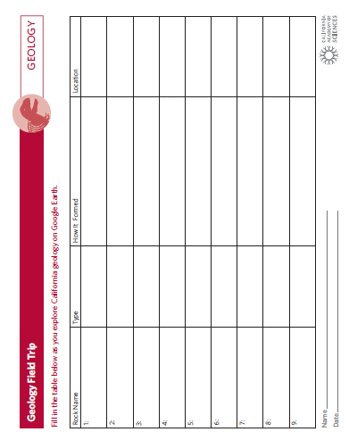

Mapping the Rock Cycle

The rock cycle illustrates the ways rocks change from one form to another. Rocks are constantly undergoing weathering, melting and being altered to form new rocks. The diagram below is a great way to illustrate the connections between these processes. As you know there are three types of rocks: igneous, metamorphic, and sedimentary. Write the correct word in the blank next to the rock type. Also, place the terms sediments and molten rock in the correct places. There are several different processes in the rock cycle which cause rocks to change form. Write the terms melting, heat and pressure, compaction and cementation, solidifying, weathering and erosion in the correct blanks. Fill in these terms as you proceed in a clockwise direction on the diagram. Once you have
done this you have created a finished map of the rock cycle.

Visual Learning Company
Page

Mapping the
Rock Cycle Cont.

Name:

Answer the following questions:

1. What forces change sedimentary rock into metamorphic rock?

2. How is molten rock formed, and what type of rock does it create when it hardens?

3. Describe how sediments form.

4. Provide an example of each of the three rock types.

5. Explain why the rock cycle is referred to as a “cycle”.

Visual Learning Company
Page
24

Changing Rocks

Background: Rocks on Earth are constantly being recycled. While rocks in one place
are being broken down into smaller pieces, rocks in another place are being made as
molten rock hardens. The continual process of rocks changing and being made into other
types of rocks is referred to as the rock cycle. In this activity we will use candle wax or
crayons to model the processes similar to those in the rock cycle.
Materials: safety goggles, several different colored crayons or several different colored
candles, paper, plastic knife, electric hot plate, small metal pan or can, small clear
plastic vial
Activity
1. Obtain a pair of safety goggles and place them over your eyes before starting the
activity.
2. Obtain several different pieces of colored wax or crayons (take the paper off).
3. Using the plastic knife, carefully scrape off thin shavings of wax. Keep each colored
wax in a separate pile.
4. Take the first pile of shavings and sprinkle them into the clear plastic vial. Gently
pack the shavings into the vial with your finger.
5. Go through the same process with the remaining piles of colored shavings, inserting
them one layer at a time.
6. Observe the layers of shavings through the side of the plastic vial. This “rock”
symbolizes a sedimentary rock.
7. Using the plastic knife and your finger, carefully remove the rock from the vial.
8. Hold the sedimentary rock in the palm of your warm hand and close your fingers
over it so it is completely covered by your hand. tightly hold and occasionally
squeeze it for two to three minutes.
9. Take the “rock” and fold it. Tightly hold it in your hand another two minutes.
10. This type of rock represents a metamorphic rock.
11. Place the metamorphic rock in the metal pan or can.
12. Place the pan or can on the hot plate and turn the heat to medium-low.
13. Observe how the rock changes over several minutes. The liquid wax represents
molten rock.
14. When the rock has completely melted, turn off the hot plate.
15. Let the rock cool overnight, and observe it the next day. This type of rock
represents an igneous rock.

Answer the Questions on a separate piece of paper.

1. What were the characteristics of your sedimentary rock?
2. How was the sedimentary rock changed into a metamorphic rock?
3. What did the liquid wax represent, and what happened when it cooled?
Visual Learning Company
Page
25
The Rock Cycle

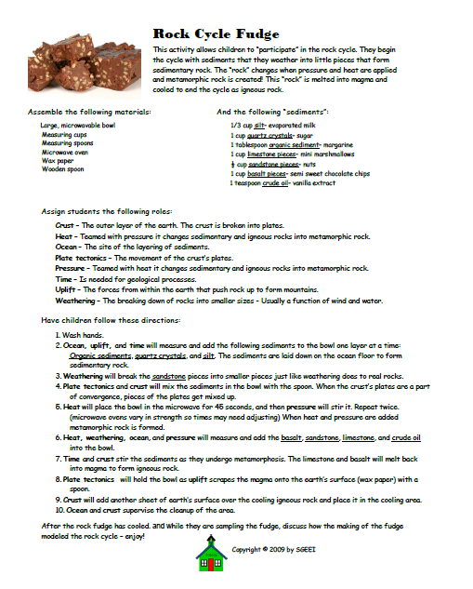

Rocks and Minerals in Everyday Life
Rocks and Minerals in Everyday Life
Name:
Can you imagine your world without rocks and minerals?

After exploring some of the common uses of rocks and minerals at http://www.lilburnes.org/Students/Piece_of_the_rock/everyday_lives.htm
- Complete the chart at the bottom of the page.
- Annotate the types of rocks/minerals used in a typical home. (You may draw additional items)
- Color your home and include a Rock landscape.
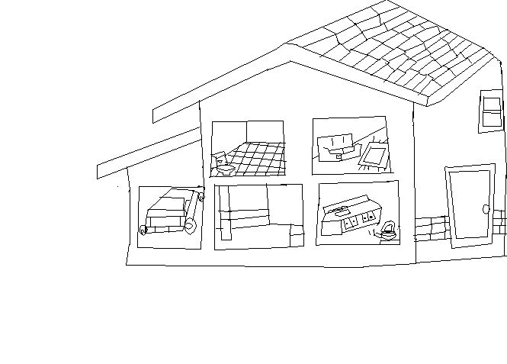

NAME | DESCRIPTION | USES | TYPE

Rocks and Minerals in Everyday Life cont.
NAME | DESCRIPTION | USES | TYPE

Building Materials
Task with Student Directions
Contributed by: The RAND Institute (RAND)
Spring 1993 Research Pilot
Task: Your team plans to use rocks from the area to create picnic tables and benches in the nature-watch picnic area. They found three rock samples that they would like to use. Since these rocks are part of the natural environment, they can be worn down by wind, rain, running water, and physical abuse. Your job is to choose the best rock that will last for the longest period of time under these conditions.
Materials:
- Three rocks labeled A, B, and C
- Nail
- Sandpaper
- Penny
- Hand Lens
Directions:
- Using your hand lens, observe your three rocks.
- In the chart below, describe what each rock looks like.
- Include three features of each rock in your description.

Descriptions
Rock A
Rock B
Rock C

- Based on your observations, which of these three rocks (A, B, or C) would be best for building the tables and benches?
Rock

Explain why

Directions:
- Look at the tools in Bag #1.
- Use the tools in Bag #1 to test your rock samples.
- You may use 1, 2, or all 3 tools on each rock.
- For each rock, describe which tools you used and tell what happened to the rocks when you used the tools.
- Record your results in the chart below.

Tools and Results
Rock A
Rock B
Rock C

- What are some of the other things you could do to the rocks to determine which one would last the longest? Explain why.

- Using your results, which rock (A, B, or C) would you recommend to use to build the benches and tables?
Rock

Explain why

- How can the weather wear down the rock benches and tables over time? Explain how.

©1997-2005 SRI International, Center for Technology in Learning. All rights reserved. Terms of Use

Building Materials
Rubric
Contributed by: The RAND Institute (RAND)
Spring 1993 Research Pilot
Big Idea E-3: Geological, geomorphic processes explain the evolution of the Earth.
Exemplar: The Earth undergoes various change processes which have caused its features to change over time. These processes have caused different types of rocks and minerals to form. Wind, water, and ice have changed the Earth's surface over time by wearing down or building up identifiable land forms.
Big Idea E-10: Weather affects living and non-living things.
Exemplar: Weather is unpredictable, varied, and affects daily life. Weather plays a role in the cycles of living and non-living things.
Item Number | Component Rubric
1. Observations of rocks | 4= Provides (3) in-depth and valid descriptions of the properties of each rock with good attention to details.  3= Provides (2) adequate and valid descriptions of the properties of each rock with attention to detail; or  Provides (3) adequate and valid descriptions of the properties of (2) rocks with attention to detail;  2= Provides (1) partially adequate description with some attention to detail of the properties of each rock; or  Provides (2) partially adequate descriptions with some attention to detail of the properties of (2) rocks; or  Provides (3) partially adequate descriptions with some attention to details of the properties of (1) rock, other rocks may be blank;  1= Provides (1) vague or inadequate description with no attention to detail of the properties of each rock; or  Provides vague or inadequate descriptions with no attention to detail of the properties of (1) or (2) rocks;  0= Rewrites question and directions;  Response is off-topic;  No response or inappropriate writing or drawing.
2. Explain why | 4= Names a rock.  In-depth response clearly based on student's observations. Scientifically appropriate and valid rationale describing why this rock would be best for building tables and benches.  3= Names a rock.  Adequate response mostly based on student's observations. Scientific rationale describing why this rock would be good for building tables and benches.  2= Names a rock.  Partially adequate response which may be based on student's observations. May attempt to contain scientific reasoning, misconceptions are obvious. May attempt to describe why rock would be O.K. for building the tables and benches; or  Does not name a rock.  Partially adequate response based on student's observations. Attempts to contain scientific reasoning and describes why rock would be O.K. for building the tables and benches.  1= Does not name a rock.  0= Rewrites question and directions.  Response is off-topic.  No response, or inappropriate writing or drawing.
3. Describe and Explain  Describe - used nail to scratch the rock.  List - nail, penny, etc. | 4= Describes all tools used on each of the three rocks. May include additional tests such as "rock scratches rock," or "finger nail to scratch rock," etc. In-depth description of what happened to all three rocks for each tool used.  3= Describes most tools used on each of the three rocks.  Adequate description of what happened to all three rocks for each tool used.  2= May list tools used for each of the three rocks.  Partially adequate description of what happened to all three rocks; or  May attempt to describe tools used on 2 rocks.  Partially adequate description of what happened to same two rocks. 1= May list tools for 1 or 2 rocks.  Vague or missing description of what happened to these rocks, or may list tools without providing description of what happened; or  May describe tools for 1 rock and provide description of what happened for the one rock.  0= Rewrites question and directions.  Response is off-topic.  No response, or inappropriate writing or drawing.
4. Other things, reasons and explain.  Appropriate: Rock scratch rock, Fingernail, Vinegar/Acid Rain, Weight, etc.  Inappropriate: | 4= Lists at least 3-4 other tests/things that are appropriate and valid. Appropriate and valid rationales/explanations for each test describing why this test would be conducted.  3= Lists 2-3 other tests/things that are appropriate and valid. Mostly adequate rationales/explanations for each test describing why this test would be conducted.  2= Lists 1-2 other tests/things that are partially appropriate and some may be valid. Partially adequate rationales/explanations for each test which may describe why this test would be conducted; or  Lists 3-4 other tests/things that are partially appropriate and may be valid. No rationales or explanations.  1= May attempt to list other tests/things that are inappropriate. May attempt to include vague/inappropriate rationales/explanations. May list some inappropriate tests/things and no rationale/explanation.  0= Rewrites question and directions.  Response is off-topic.  No response, or inappropriate writing or drawing.
5. Relationship between data and conclusions | 4= Names a rock.  Rationale demonstrates in-depth understanding of weathering, erosion, and the effects of weather on the surface of the earth.  Clearly and effectively shows relationship between data and conclusions. Explanation describes why this rock would be good for building tables or benches. Hardness of rock/last longest.  3= Names a rock.  Rationale demonstrates adequate understanding of weathering, erosion, and the effects of weather on the surface of the earth.  Shows relationship between data and conclusions. Explanation describes why this rock would be good for building tables or benches.  2= Names a rock. (May not name a rock)  Rationale demonstrates partially adequate understanding of weathering, erosion, and the effects of weather on the surface of the earth. Many misconceptions are evident. Some attempt may be made to show relationship between data and conclusions. Explanation may attempt to describe why this rock would be O.K. for building tables or benches, but is vague and flawed.  1= Does not name a rock.  If a rationale is present, there is very limited understanding of weathering, erosion, and the effects of weather on the surface of the earth. Many misconceptions are evident. No attempt to show the relationship between data and conclusions. No attempt to describe why this rock would be O.K. for building tables or benches.  0= Rewrites question and directions.  Response is off-topic.  No response, or inappropriate writing or drawing.
6. Explain and apply. | 4= Explanation clearly and effectively demonstrates in-depth understanding of how the effects of weather (rain, wind, ice, snow, etc.) have changed the surface of the earth over time and how this might effect the benches and tables because they are made of rocks. May also include discussion regarding weathering, erosion, acid rain, and pollution, and properties of rocks. (Water gets into cracks, freeze, break rocks apart; wind acts as sandpaper and wear down; etc.)  3= Names a rock.  Rationale demonstrates adequate understanding of weathering, erosion, and the effects of weather on the surface of the earth. Shows relationship between data and conclusions. Explanation describes why this rock would be good for building tables and benches.  2= Names a rock. (May not name a rock)  Rationale demonstrates partially adequate understanding of weathering, erosion, and the effects of weather on the surface of the earth. Many misconceptions are evident. Some attempt may be made to show relationship between data and conclusions. Explanation may attempt to describe why this rock would be O.K. for building tables and benches, but is vague and flawed.  1= Does not name a rock.  If a rationale is present, there is very limited understanding of weathering, erosion, and the effects of weather on the surface of the earth. No attempt to show the relationship between data and conclusions. No attempt to describe why this rock would be O.K. for building tables and benches.  0= Rewrites question and directions.  Response is off-topic.  No response, or inappropriate writing or drawing.

©1997-2005 SRI International, Center for Technology in Learning. All rights reserved. Terms of Use

