Action Research: Integrating Science Across the Curriculum in the Elementary Classroom

Diane Gruber

NASA Endeavor Fellow

Action Research

November 15, 2010

Professor Amanda Gunning

Action Research: Integrating Science Across the Curriculum in the Kindergarten Classroom

Introduction
Have you ever heard of an overcrowded curriculum? Well, it is a hot topic among teachers today. Schools are constantly implementing new pieces into curriculum-technology, mathematics, reading, and other subjects, such as art, music, and handwriting. However, the down-side to all of this is that science is essentially being “eliminated” from curriculum due to several outside factors, including lack of time, bad textbooks (or lack of science curriculum), and a lack of materials provided for the teachers.
In 1998, the National Research Council published Every Child a Scientist: Achieving Scientific Literacy for All, and stated that:
“Preparation for a more scientifically and technologically complex world requires the best possible education. Beginning in kindergarten, children must learn how to think critically, synthesize information accurately, and solve problems creatively. They also need new skills–facility with computers, the ability to communicate using all available media, and familiarity with the science and technology that form the foundation of the modern world. . . .

Perhaps the most important role of science is to sustain that sense of awe and wonder in young people that comes from exploring and understanding the natural and technological world. Because science can make a unique difference in a child’s life, it is important for it to be a central part of the school curriculum. When it is well taught and student engagement is high, science can be the academic subject that keeps a child’s natural love of learning alive.”

Science is all about the “awe and wonder”. Our job as elementary teachers is to maintain, or keep alive, that sense of “awe and wonder” in our students’ lives, especially beginning in Kindergarten. Through research and action research in a Kindergarten classroom, I have found that integration of science is possible and beneficial to students.

Rationale
A survey conducted by Carol Stuessy and James F. McNamara of Texas A&M University found that science was “largely neglected in Texas Public Schools” (Swann, 1999). The reasoning behind this: 66.2 percent of teachers surveyed believed that science was not a high priority in their school, 60 percent said that they spent less than 2 hours per week teaching science, 66 percent said that there is a lack of time “in general” in the school day to teach science, 35 percent of teachers stated that there is a lack of materials, and more than 60 percent of teachers are not satisfied with the materials they do receive to teach science (Swann, 1999).
Below you will find a comparison of the above survey and a survey that I conducted for Kindergarten Teachers at Castleberry Elementary in Fort Worth, Texas, in Spring 2010. The results from the Castleberry Elementary Kindergarten Teacher Survey are discussed later on in this paper.
Figure 1, Elementary Teachers’ Attitudes Toward Science:
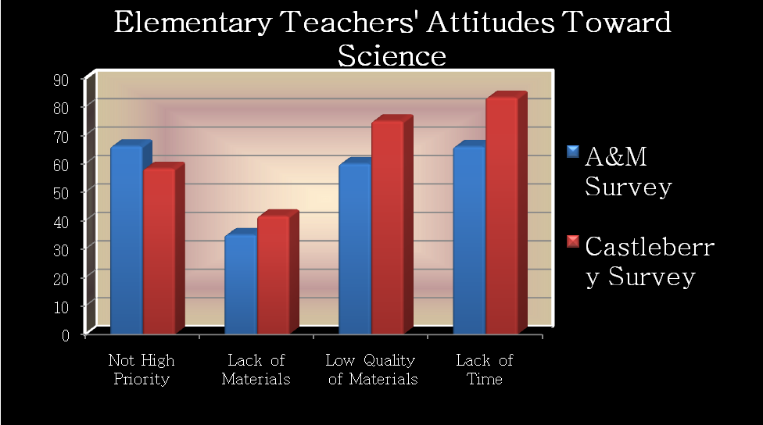
The results of the above surveys took me back to my student-teaching days. Pre-service teachers take science methods courses to enhance their student-teaching experience to become better science teachers. However, research shows that more and more pre-service teachers are taking a “step back” into a sort of “reverse metamorphosis-instead of the lowly caterpillar metamorphosising into a beautiful butterfly, these enthusiastic and energetic student teachers, with a zeal to teach science to elementary students, were being transformed into the ineffective inservice science teachers thoroughly highlighted in the research literature” (Plourde, 2002). I find that teachers are reverting back to how they were taught science in elementary school when they start their careers. There are so many other pressures in your first year of teaching that all of the strategies that were learned are not used.
This situation that is occurring all over Texas is similar to the situation at my school, which includes grades Pre-Kindergarten, Kindergarten, and First Grade. Teachers believe that there is no time in the day for science. In conversations with teachers at my school, I found that they feel very similar to the teachers surveyed by Texas A&M University’s Survey Research Group, as shown in Figure 1, above. Our school is constantly implementing new things from handwriting to reading, to math, but science seems to get pushed to the back burner. With these findings in mind, there are several remedies that have been suggested to solve these problems in science education, but one solution might be the most effective: integrating science across the curriculum. If time is the problem, why not multi-task? Using NASA Endeavor resources through the courses I have taken, I aim to research these benefits and create a new research plan based on the findings to benefit my students, school, and district.

Past Research Studies and Questions
In the past, there have been several studies that research the topic of integrating subjects, including science, across the curriculum (Hinde,2005; Parker, 2005; Czerniak, Weber, and Sandmann,1999). Integration of subjects in general is summarized and defined by Parker (2005) as stated:
“…a curriculum approach that purposefully draws together knowledge, perspectives, and methods of inquiry from more than one discipline to develop a more powerful understanding of a central idea, issue, person, or event. The purpose is not to eliminate the individual disciplines but to use them in combination” (452–53)

One that is most familiar to science educators, as well as other educators, is Project 2061. It was created in 1985 to help all Americans become science literate, which included math and technology, since our world was changing quickly into a more technological, science-savvy environment. This project stated that it wasn’t asking teachers to teach more content, but to teach the essentials more effectively (AAAS, 1993). It further stated:
“The present science textbooks and methods of instruction, far from helping, often actually impede progress toward science literacy. They emphasize the learning of answers more than the exploration of questions, memory at the expense of critical thought, bits and pieces of information instead of understandings in context, recitation over argument, reading in lieu of doing. They fail to encourage students to work together, to share ideas and information freely with each other, or to use modern instruments to extend their intellectual capabilities” (AAAS, 1993, Introduction Online).

By integrating science, math, and technology into other subjects like reading and social studies, teachers are providing students with several opportunities to expand their science knowledge.
Teachers often find that science is often pushed out of the daily schedule due to state-mandated blocks of time for literacy and math. Marzano (2003) stated that teachers need 15,465 hours to teach the content in the standards, but teachers only have 9,042 hours of instructional time in a regular school year.
In the Texas A&M study stated in the Rationale section, teachers complained that there was a lack of time to teach science and other teachers said that they teach less than 2 hours of science per week. When I began my research in the 2009-2010 school year, I knew that teachers in my school “skipped” science some days because we were required in the school district to have 30 minutes of reading intervention and 30 minutes of math intervention, 90 minutes of uninterrupted literacy, 60 minutes of math, and the rest of the day is lunch, recess, specials (library, art, music, and PE), and a 30 minute block of computer lab twice a week. On top of that schedule, our school had implemented a new handwriting program, which called for an additional 15-20 minutes per day and somewhere in the mix was supposed to be a separate 30 minutes of science! See Figure 2a below.
This current school year (2010-2011), our school has changed the layout of our schedule from last year, which includes an increase in the subject areas of math and science. Currently, the school district’s requirements are as follows (after much discussion on the need for science/technology time during each school day!). See Figure 2b below.
Figure 2a, Required Minutes for Kindergarten (2009-2010):
English Language Arts (ELA) 90 minutes
Response To Intervention (RTI) – ELA 30 minutes
Handwriting Without Tears Program 15 minutes
Scholastic Text Talk Program 30 minutes
Math 60 minutes
RTI – Math 30 minutes
Social Studies 30 minutes
Science 30 minutes
Other times
Lunch 30 minutes
Computer Lab 30 minutes (2 times per week)
Specials (Library, Art/Music, PE) 45 minutes
Recess 20 minutes

Total 440 minutes

Total 435 minutes

Figure 2b, Required Minutes for Kindergarten (2010-2011):
English Language Arts (ELA) 90 minutes
Response To Intervention (RTI) – ELA 30 minutes
Math 75 minutes
RTI – Math 30 minutes
Social Studies 30 minutes (3 times per week/integrated ELA)
Science 45 minutes
Other times
Lunch 30 minutes
Computer Lab 30 minutes (2 times per week)
Specials (Library, Art/Music, PE) 55 minutes
Recess 20 minutes

Total 435 minutes

As a Kindergarten teacher, it is often natural to merge subjects together (although I have overheard a few veteran teachers say, “We’ll talk about that in Science time today.”). We do numerous activities for comprehension in Kindergarten, especially lots of graphic organizers. In discussing science topics, we often use these graphic organizers from reading and incorporate them into our science lessons to organize our thoughts. If we are measuring how far our Alka-Seltzer rockets (experiment from Steve Spangler Science) are traveling, we use number sense and perhaps non-standard units of measurement. In regards to technology, we would create a PowerPoint of science vocabulary words and maybe a quiz that is appropriate for Kindergarten to test or assess our knowledge. So, it’s natural to integrate subjects in the primary grades.
When the National Research Council created the National Standards for Science in 1996, it stated that there would be less emphasis on “treating science as a subject isolated from other school subjects” and more emphasis on “connecting science to other school subjects, such as mathematics and social studies” (NRC, 1996). It just makes sense to teach science in a way that relates to other subjects, whether it be connected with literacy through non-fiction picture books, or connected with math by measuring with our feet how far our Alka-Seltzer rocket went from where the rocket was launched. If time is something that teachers do not have, then why not make the most of what we have now?
Proposed New Topic of Study and Reasoning
Through action research in the classroom, I want to study how my students benefit from integrating science into other subjects and compare it to allocating a certain time for science each day. I propose that students will use their knowledge from other subject areas and learn to apply it in real-life situations. I believe students should be exposed to STEM subjects (science, technology, engineering, and mathematics) in primary grades to build the foundation for well-rounded science-literate human beings. I believe that schools should consider science education reform to help students learn that to live and work in the future, they must be science-literate in order to advance in their own lives.
Methods
I used my whole Kindergarten class as the control group, which consisted of 19 students, ages 5 through 6. I had 2 weeks of integrated science lessons and 2 weeks of allocated time for science. I documented students’ experiences, attitudes, and responses by taking pictures and making notes during the 4-week time period. I had to decrease my initial study proposal from 6 weeks, which included 3 weeks of integrated science lessons and 3 weeks of allocated science time, because of end of the year school events-state testing, field trips, award assemblies, etc.
I also created a survey for Kindergarten Teachers to assess attitudes toward science education in our school for the 2009-2010 school year. I wanted to know how the teachers at my school felt about our science curriculum.

Findings
The results after surveying 12 Kindergarten teachers are listed in Figure 2 below. A majority of the Kindergarten teachers were not teaching science on a daily basis during the 2009-2010 school year.
Figure 3, Science Education Survey for Kindergarten Teachers, 2009-2010 School Year:
 | Strongly Disagree | Disagree | Neutral | Agree | Strongly Agree
1. Science education is taught in my school on a daily basis. | 2 | 5 | 0 | 5 | 0
2. I consider myself to be “science literate”. | 0 | 5 | 0 | 6 | 1
3. I am comfortable in teaching science. | 0 | 3 | 2 | 4 | 3
4. I feel that if I do not teach science in Kindergarten, older elementary grades will make up for what I did not teach. | 2 | 4 | 3 | 3 | 0
5. I collaborate with my colleagues in my grade level to make sure we are all “on the same page”. | 0 | 3 | 0 | 7 | 2
6. I collaborate with my colleagues in older grade levels to align what I am teaching in science now. | 2 | 7 | 0 | 3 | 0
7. My school provides times to specifically align science standards. | 0 | 3 | 2 | 4 | 3
8. My school provides resources/materials for me to teach science. | 0 | 5 | 3 | 3 | 1
9. I have enough time to teach science each day. | 6 | 4 | 0 | 2 | 0
10. I think my school provides us with quality materials for science lessons. | 9 | 0 | 0 | 3 | 0

I found a correlation between the survey I created for Castleberry Kindergarten Teachers and the Texas A&M survey done in 1999, with the issues that were occurring in the elementary science classroom.
My students were more engaged when other disciplines were integrated along with science. They wanted to write about what they experienced. They wanted to talk about how their rocket flew farther or 3 more feet than their friend’s rocket. They were excited and incorporated what they were learning in other subjects to science.
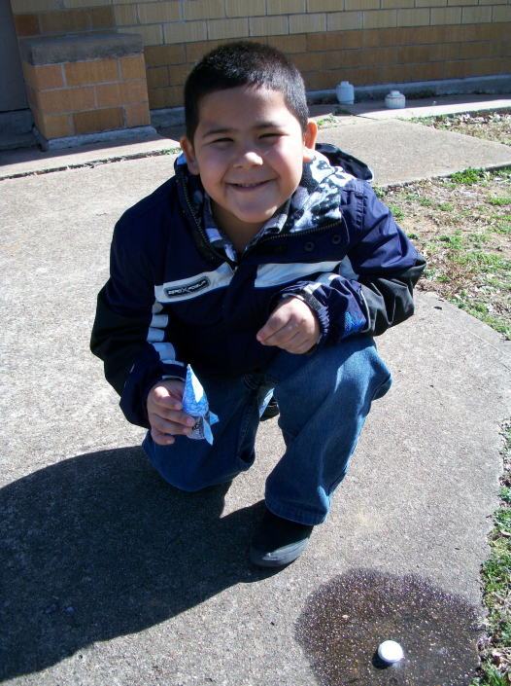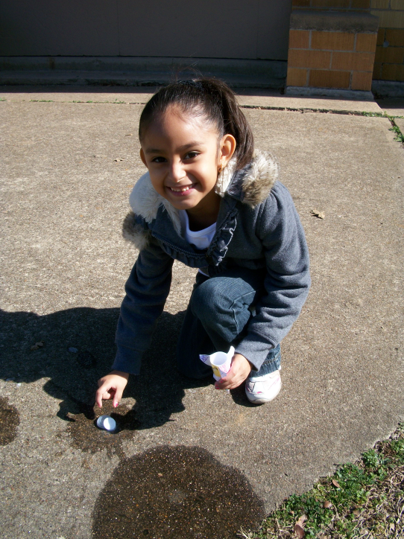

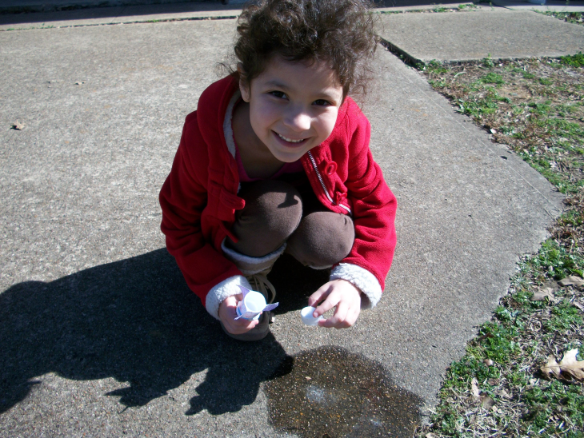
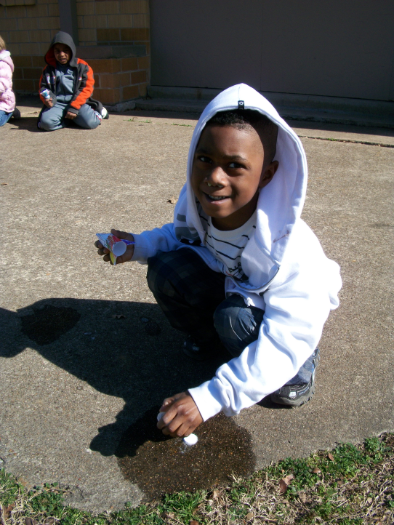

Students that had behavioral problems on a regular basis were very involved in science and always wanted to do more “experiments with Mrs. Gruber”. They discussed our rocket experiment at recess time with other students from other Kindergarten classes on several occasions, stating, “We did our rocket experiment and my rocket went higher than the school!” Then, they would use comparative language and discuss what had occurred and why it had occurred to the best of their ability. (Most students understood the concept of the Alka-Seltzer tablet when put in the water created bubbles and the lid popped off when there wasn’t enough room inside the film canister.) Our discussion is pictured below:
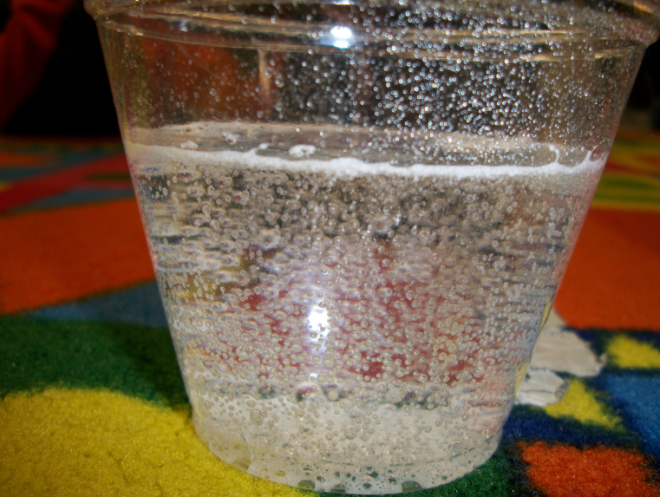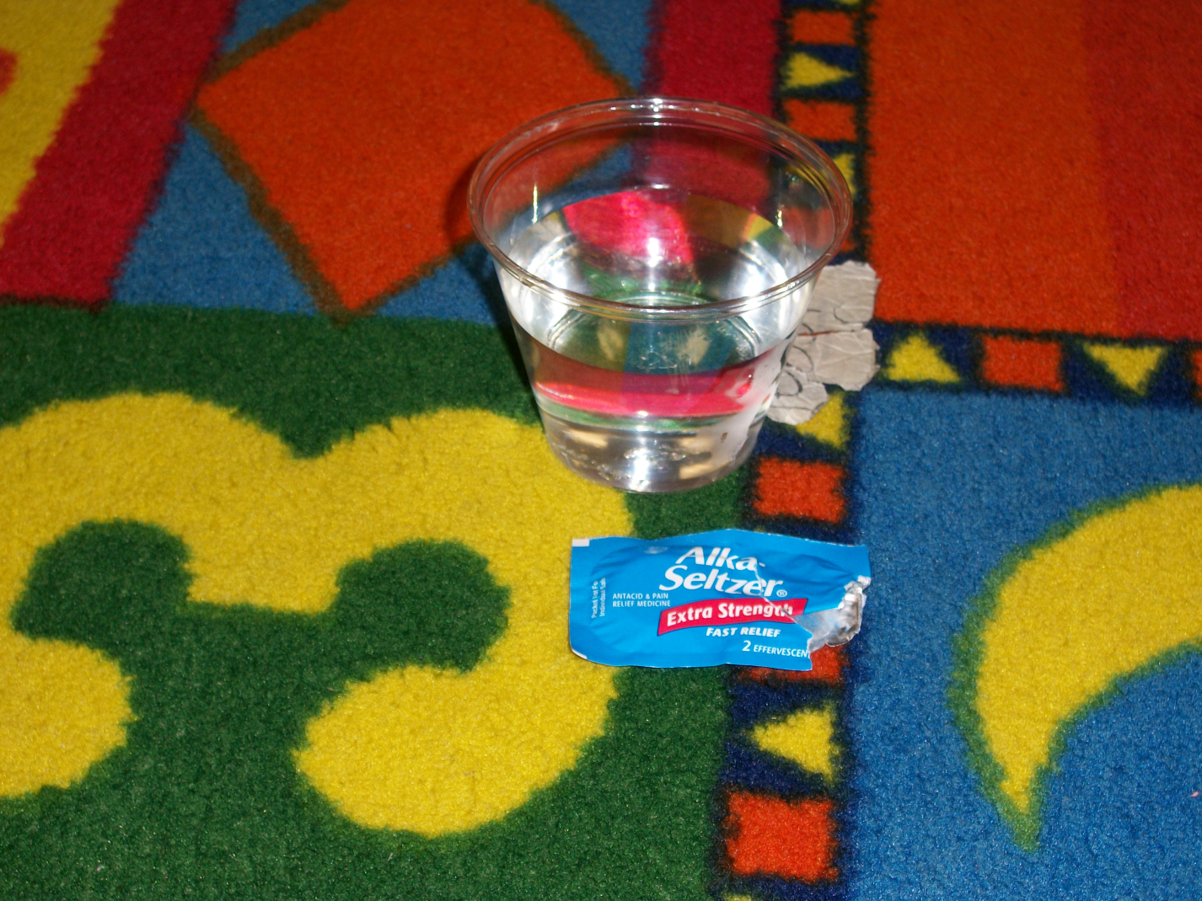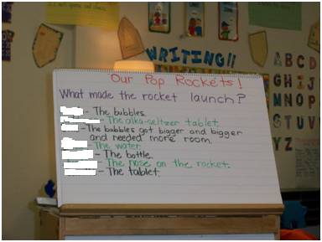

On the opposite end, when Science was only discussed during “Science time” on the class schedule, students seemed less interested in the topic we were discussing, which were butterflies. (will add butterfly observation pics/journal entries/etc…) When students were talking or asking me a question about butterflies during the day, outside of the allotted science time, I told them that they could ask me later when we did science. They seemed to lose interest quickly and forget what they were going to ask me when science time began. The students were still excited, but not as involved as they were with the Alka-Seltzer rocket experiment.
I did not observe students discussing science topics outside at recess or during any free moment at school. I observed that children are trained to do what the teacher says, but when prompted at science time to discuss butterflies, students forgot their train of thought and interest because they were interested earlier in the day, but I did not react to their natural curiosity, so the students assumed that what they were curious about was not important or relevant. This was upsetting to me!!! I had to keep in mind that I was doing research and could not interfere with it!
Conclusion
With the integration of science, mathematics, engineering and technology across the curriculum, national standards, national science reform, and benchmarks for science, students will benefit from the tremendous strides of science education in order to create science-literate human beings in the future. I hope my study will encourage elementary teachers to be open to science reform and expect students to pursue and excel in STEM careers in the future.

References
(2009, September). EDITORIAL: stem: it's elementary, too!. Technology & Children, pp. 2-18. Retrieved from Academic Source Premier database.

American Association for the Advancement of Science. (1993). Science for all Americans: Project 2061. New York: Oxford University Press.

Czerniak, C. M., W. B. Weber, and A. Sandmann. 1999. A literature review of science and mathematics integration. School Science and Mathematics 99 (8): 421–30.

Every Child a Scientist: Achieving Scientific Literacy for All (1998): The National Research Council (pp. 4-6). Washington: National Academy Press.

Hinde, E. (2005). Revisiting Curriculum Integration: A Fresh Look at an Old Idea. Social Studies, 96(3), 105-111. Retrieved from Academic Search Complete database.

Marzano, R. J. 2003. What works in schools:Translating research into action. Alexandria,VA: Association for Supervision and Curriculum Development.

McMurrer, J. “Instructional Time in Elementary Schools: A Closer Look at Changes for Specific Subjects,” A report in the series, From the Capitol to the Classroom: Year 5 of the No Child Left Behind Act, Center on Education Policy, Washington, DC, 2008.

National Research Council (1996). National Science Education Standards, National Academies Press, Washington, DC. Retrieved January 10, 2010, from http://nap.edu/catalog/4962.html.

Parker, W. C. 2005. Social studies in elementary education. 12th ed. Columbus, OH. Pearson Merrill, Prentice-Hall.

Plourde, L. (2002). Elementary science education: The influence of student teaching—Where it all begins. Education 123: 253–259.

Swann, P. (1999). Science in Texas elementary schools: a report on the Texas poll. The Texas Statewide Systemic Initiative Issue Brief, 1-4.

