Joan Preston
Data Analysis Draft
Action Research
April 19, 2011

I have conducted action research about the following question: Will teaching three engineering design lessons in a technology class have a positive affect on middle school students’ attitudes and interest levels towards science and engineering? I am interested in this because I am currently working to implement STEM activities into the middle school curriculum in Allentown School District (ASD) in Allentown, PA. I will need to present my findings to help the STEM committee decide whether to have a course dedicated to engineering or to incorporate engineering activities into the current technology education classes.

The ASD is the third largest school district in the commonwealth with nearly 18,000 students in 23 schools. While the districts’ population grows its tax base is shrinking due to closing businesses in the downtown area. This coupled with federal budget cuts threaten eliminations to our middle and high school course list. At the middle school level technology education has been spared but may be modified. There are two high schools and four middle schools that provide secondary education to the city’s youth. I will be doing my research at Trexler Middle School (TMS). TMS has a student population that is reflective of the districts’ overall demographics. The ethnic percentages include 65% Hispanic, 18% Black and 15% White with a small percentage of Asians and American Indians. There are a high percentage of students at the poverty level, 87%. Performance on the state assessment shows only 49% proficient or advanced in Reading and 58% proficient or advanced in Math. The writing and science results are even lower with a 40% and 22%, respectively.

My research was done with one heterogeneous 8th grade group during their six week technology education course. This group has a total of 21 students, 10 girls and 11 boys. There are 13 Hispanics, 5 Blacks, and 3 Whites. Together, the technology teacher and I taught three hands-on design lessons and had a group of women from the genetic engineering department at a local women’s college come out to do a DNA activity. Each lesson took approximately 3 days. I began the first lesson on the first day of the new cycle. Two of the engineering design lessons, “On Target” and “Breezy Blimps” were from Design Squad, a PBS program and website full of resources for teachers, students and parents (“On the Moon,” 2008) (“Design Squad,” 2009). The third activity, Design a prosthetic Leg was adapted from the lesson “Prosthetic Party” from TeachEngineering.org (Podlogar, Zarske& Carlson, 2008). I selected lessons in different areas of science including space exploration, aviation, and medicine to try to appeal to the students’ many interests. Each of the activities followed the same engineering design process, which included, Identifying the problem, brainstorming, designing, building, testing and evaluating, redesigning and sharing.

Descriptions of the Four Activities
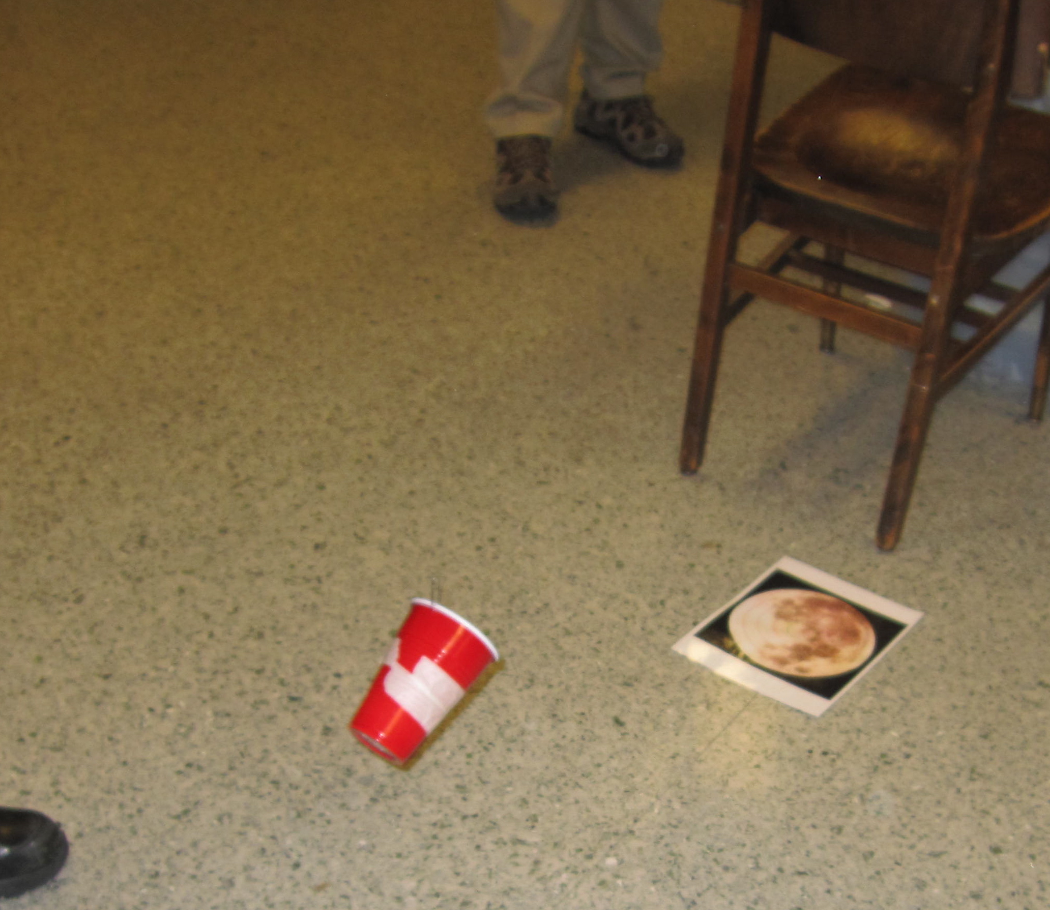
On Target-On the Moon Challenge
Students are given background information about the LCROSS mission that NASA launched in 2009. During this mission NASA crashed a satellite into a crater on the south pole of the moon to create a plume of lunar dust that rose above the surface. A second satellite then flew through the plume taking readings to determine the composition of the dust. Students were given the task of designing a launcher that would deposit a marble onto a target at a given spot. They were given plastic cups, fishing line, a marble, tape and notecards. I demonstrated how a zip line could be constructed that would carry the cup over the target. Students had to make alterations to the cup to get it to release a marble at the right moment. They were not allowed to touch the cup or the marble once in flight.

Breezy Blimps-Helium Balloons
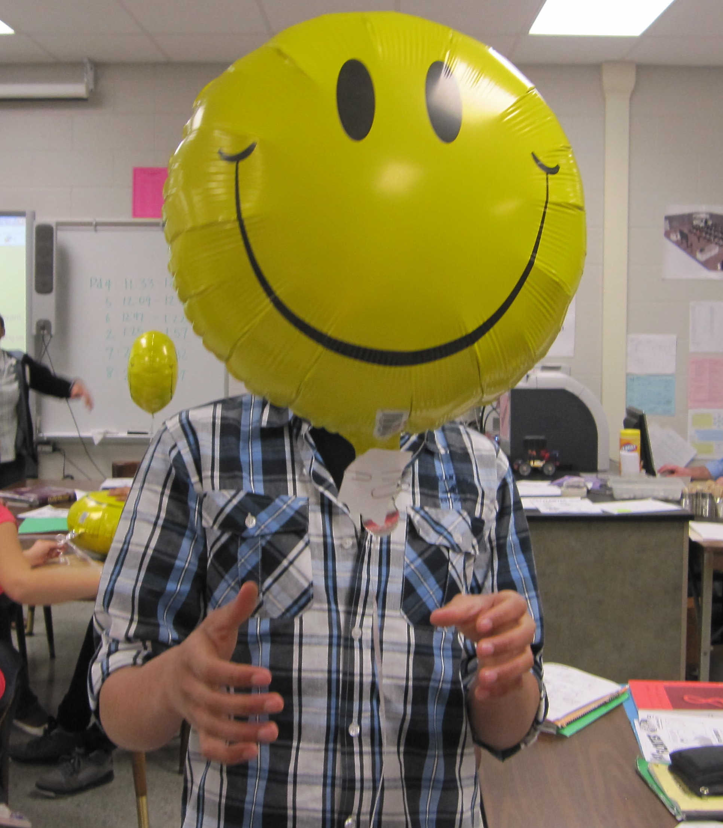
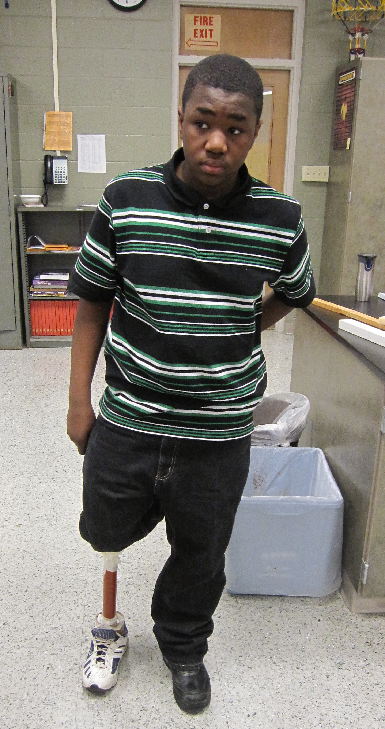
Students were given one helium Mylar balloon and asked to make it neutrally buoyant by adding paperclips to the bottom of the balloon. After achieving neutral buoyancy students were to make their balloons move in a specific course by decreasing air pressure around the balloon. They were given cardboard to fan around the balloon. After students were successful at this they were given a second balloon to add to the first. They were given some basic information about aerodynamics and drag. Students were then given the challenge of designing a blimp that would travel in a straight line. They were given the two balloons, tape, paperclips, and paper. A track was created where students could do trials.

Prosthetic Leg Design
Girls | Pre | Post
Attitudes toward Sci/math importance | 50 | 69.4
Interest in Structure Design | 18.2 | 3.7
Interest in helping people | 15.2 | 33.3
Interest in improving design | 27.3 | 38.9
Understanding what scientists and engineers do | 36.4 | 50
Interest in Science/Engineering career | 18.2 | 5.6
Boys | Pre | Post
Attitudes toward sci/math importance | 42.5 | 65.6
Interest in Structure Design | 36.7 | 33.3
Interest in helping people | 23.3 | 41.7
Interest in improving design | 50 | 59
Understanding what scientists and engineers do | 40 | 41
Interest in Science/Engineering career | 20 | 25
Students were presented with a timeline showing how prosthetics have evolved from the Ancient Egyptians to the present. They were given the challenge to design a leg that would attach securely to a shoe, be comfortable, on the knee and withstand the weight of a person. A box of miscellaneous items was presented for their use. The box contained heavyweight cardboard tubing, 1 inch diameter wood dowels, PVC piping, sponges, rags, sneakers, duct tape, bungee cords and string.

DNA Crime Scene
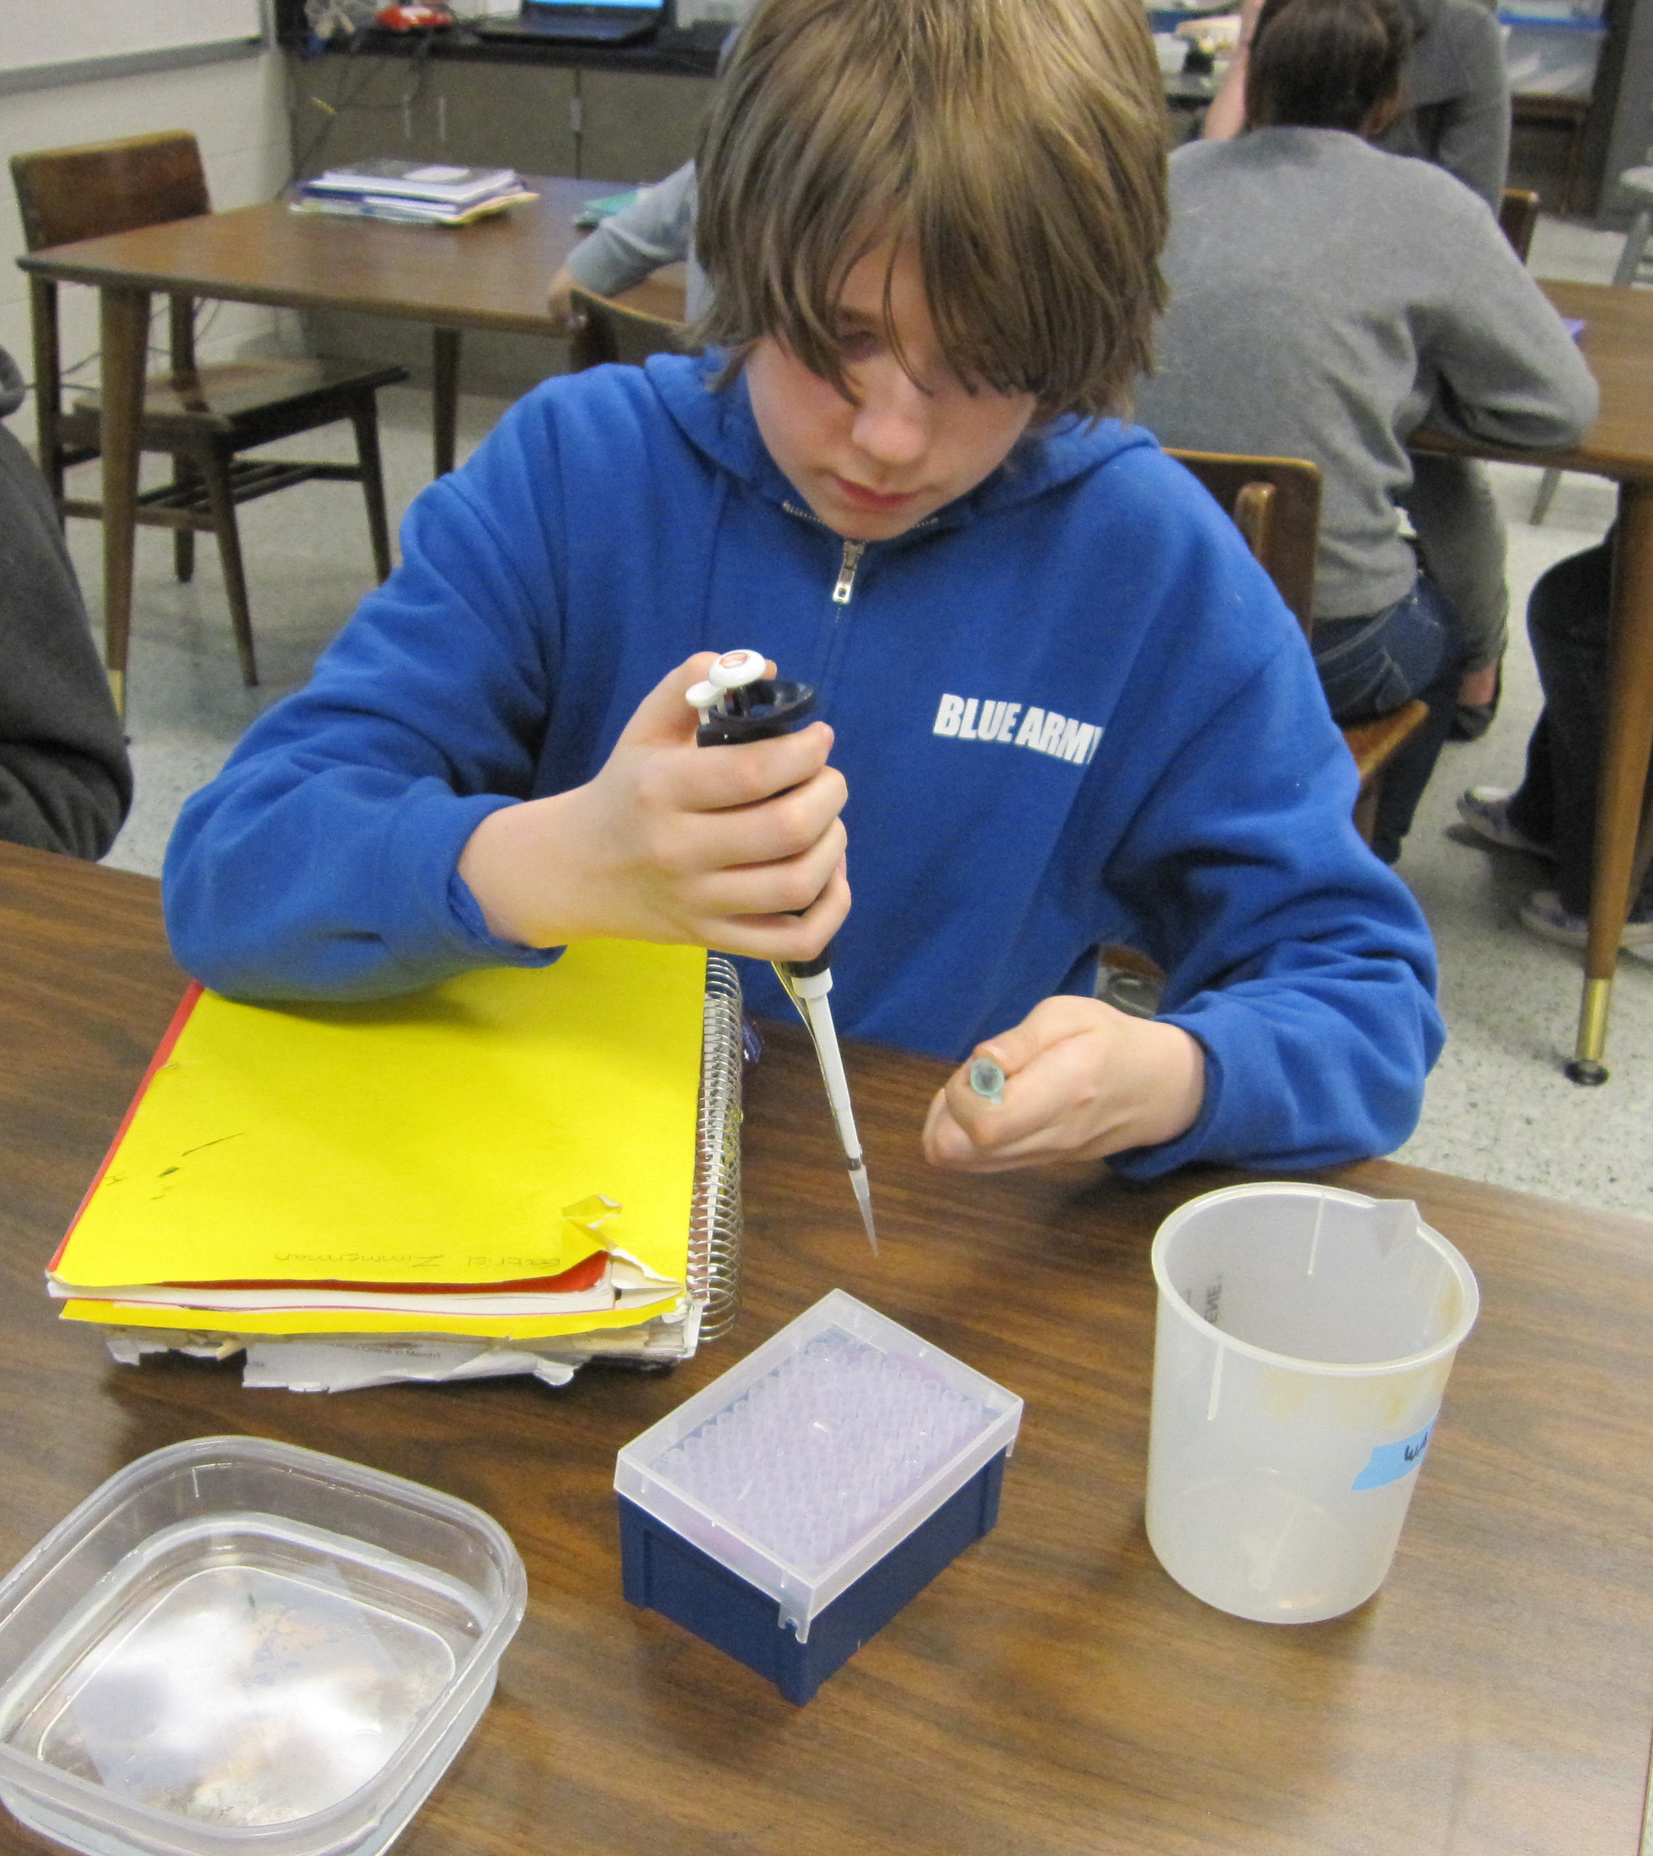
Undergraduate students from a local women’s college came in to do an activity as part of their Genetic Engineering Outreach Club. The college students brought real scientific equipment like pipettes, gels and electrophoresismachines. Students practiced extracting DNA from vials and injecting it into gel pockets were it would go through, electrophoresiswhich allowed the DNA to separate. On day two they examined the gels to lookfor similar patterns in the DNA samples taken from the crime scene and those taken from suspects.
Table 1

Survey Results (percentage of positive ratings)
Before starting the activities I gave the students a survey about general knowledge, attitudes, and interests about science and engineering. The survey had 20 questions that pertained to six general themes: Attitude toward importance of science and math, Interest in designing structures, Interest in helping people, Interest in improving design, Understanding what scientists and engineers do and Interest in career in science or engineering. The questions were answered by selecting a number in a range from 0 to 8. I separated the range into three categories of Negative, Neutral, and Positive. The students were asked to fill out the survey anonymously. The only personal information that was asked was sex and ethnic background. I was most interested in the differences between girls and boys but asked for ethnic information in case I wanted to explore the differences among sub groups as well. Students were given the same survey after the four lessons were taught and the results were tabulated. Ten girls and 11 boys took the pre survey and 9 girls and 8 boys took the post survey. A select group of five students, 3 boys and 2 girls, (those who turned in the parent permission slip) were also given an additional questionnaire to complete at the end and were interviewed about their answers to these questions. The survey results showed some positive movement towards a better understanding and greater interest from both girls and boys but showed negligible change in regards to more interest in STEM careers. Table 1 shows the Pre and Post survey averages of the positive responses to each category.

Both girls and boys showed increased positive responses to categories; “attitudes toward sci/math importance”, “interest in helping people”, “interest in improving design” and “understanding what scientists and engineers do.” Both girls and boys showed a decrease in “positive responses to interest in structure design.” Boys showed a slight increase in “interest in science/engineering careers” while girls showed a significant decrease in this category. Since the surveys were completely anonymous there was no way of tracking individual changes in responses. Some students transferred out of the class and others did not participate in all activities due to a lack of cooperation. One other factor that may have affected the results was alack of knowledge about which careers are considered science and/or engineering. I know of one student I will refer to as “Lexi” who stated she wanted to be a pediatrician or someone who helped children with medical problems. Another female student told me she wanted to work in forensics and a third girl “Laura” wanted to be an engineer or orthodontist. However the surveys only showed one female had circled having a high interest in engineering and one girl was neutral about being a scientist. This demonstrates a contradiction in the results of the survey.

There were 3 boys (Brad, Greg and Cory) and 2 girls (Lexi and Laura) who were interviewed one-on-one for additional information. Each interviewee was given a questionnaire with the following questions.

- Did these activities give you more insight into the career of Engineering?
If yes, how did your attitude change towards engineering?

- Do you think you are now more interested, less interested or have the same level of interest toward a career linked to engineering? Why?

- Which type of group were you most comfortable working in, mixed group of boys and girls or a group of just boys or just girls? Why?

- Of the four activities we did which one did you find most interesting?
On Target-moon landing
Breezy Blimps-helium balloons
Prosthetic Leg
DNA Crime Scene Investigation
Why do you think you found that particular activity more interesting?

- List any questions you have about classes in engineering, or jobs in engineering?

- If you could help design an engineering course for middle school what types of activities would you like to incorporate into the program?

Responses to #1 and #2
Table 2
Question 1 | Did these activities give you more insight into the career of Engineering? If yes, how did your attitude change towards engineering?
Brad | Yes, They do more for other people.
Greg | Sort of, I think engineering helps the way people live.
Cory | Not really
Laura | Yes, Now I know exactly what engineers do and I respect engineers more because they pretty much make the things in our life possible.
Lexi | Yes, I didn't really think engineering was important but now I see it can make a difference in life.

Question 2 | Do you think you are now more interested, less interested and have the same level of interest toward a career linked to engineering? Why?
Brad | It stayed the same.
Greg | I'm not that interested in engineering because I'm not interested in that stuff.
Cory | Same level because I like working with electronics.
Laura | I am more interested in a job in engineering because before I didn't really know what they did and I found out they make things, which I love.
Lexi | I am more interested because now I see my thoughts can be heard out and put actions to it.

Four out of five students interviewed had positive attitude changes toward engineering (Table 2). The boys; however, still had many misconceptions about the field of engineering. When Cory was asked why he answered “not really” he stated “most of the things you taught us I already learned because I have 6 or 7 science kits (at home).” When I probed Cory more about what he thought an engineer did it was clear he did not have a good understanding of what a career in engineering was. He stated, “An engineer can be many things. An engineer can be simply a trash man because they do engineering cleansing the building so technically they do engineering because they’re using tools.” I then asked him, “Can anyone using tools be considered an engineer?” His response, “No, they must also make tools . . . they build things or fix things. . . or make things like a baker.” I can tell he is not clear on the design process engineers use. This surprised me because Cory was involved in all the activities; although, I did notice he did not work with a team. He always went off on his own to work and allowed others in his group to be just bystanders. Brad also missed some valuable information. He claimed to want to be a video game developer when hegets older. I asked him if he thought that career choice involved engineering, and I was surprised by his response, “A little with the computers and developing new game systems.” He didn’t make the connection that the design process would be needed to create new video games.Greg thought that an engineer was “a construction worker” and that they “built buildings and bridges” at the beginning of the class. When I asked Greg if engineers needed to be creative he said, “ I don’t think they need to be creative all the time like if someone wants them to build a bridge they probably will have to build a bridge the way it’s suppose to be built.” This statement led me to believe that he still thinks of engineers as construction workers. He goes on to talk about engineers who build cars and houses use more creativity.
Question 3 | Which type of group were you most comfortable working in, mixed group of boys and girls or a group of just girls or just boys? Why?
Brad | Mixed group because [there are] more ideas.
Greg | I am more comfortable working in a mixed group because it helps get more answers.
Cory | Mixed, more ideas
Laura | I was most comfortable working with girls because we had pretty good ideas and I don't think the boys took anything seriously.
Lexi | Just girls because I know that some of us get along and most were not so controlling. The boys weren't as mature and they weren't really sharing.
I have a particular interest in the girls I interviewed and was happy to hear that they both learned valuable information about engineering through the activities. Lexi stated, “I basically thought that it (engineering) really wasn’t needed and I really wasn’t interested in it and that it wasn’t important.” When I asked what she thought now she said, “I think that it’s kind of important to many people and that I want to be more interactive with it . . . I want to do more with it (engineering).” I went on to ask her what she thought an engineer was before taking the class. Her response, “I really thought that they basically worked on cars.” Laura had a similar response when asked what she thought engineers did. Laura answered with, “I thought of a guy working with tools. . .but then I realized that it’s not just guy work-anybody can do it and it involves tools but it’s basically just your ideas and trying to design something.”
Table 3
Responses to #3

I found the results of question 3 amusing (Table 3). All the boys said they liked working with the mixed groups because the girls gave them ideas. The girls, on the other hand, said they liked working with all girl groups because the boys were too immature. I asked Laura to give me more information about it. She agreed if she had the right boys in her group (boys who took the activity seriously) that she wouldn’t mind working in a mixed group. Lexi described her experience working with the mixed group, “[Boys] wanted to take over more. They wanted to control it. The girls gave me my space and let me [express myself] and they thought [my ideas] were nice.” This led to the understanding that age level or maturity level of the students should be taken into consideration when forming groups. While I maintain the idea that students should get practice working with other students unlike themselves I do feel it is equally important to give them opportunities to work in groups where they feel most comfortable. Having various types of groupings throughout the course is probably best.

Table 4
Responses to #4
Question 4 | Of the four activities which one did you find most interesting and why? On Target-Moon Landing, Breezy Blimps-Helium Balloons, Prosthetic Leg, DNA Crime Scene
Brad | Prosthetic Leg-It was more creative
Greg | Prosthetic Leg-we got to be most creative with this one.
Cory | DNA Crime Scene- Because I like Forensics.
Laura | DNA Crime Scene-I think I found the DNA Crime Scene more interesting because a job I want to have in the future is a forensics scientist
Lexi | Prosthetic Leg-It caught my attention more because I always wanted to do something like this because my uncle has one and I wanted to see how it worked?

Of the four activities we did the DNA Crime Scene was the least like an engineering design project;however, the students got to use real equipment. My helium balloons and plastic cups could not compare. The whole group was well behaved and engaged during the first day of the DNA lab when the equipment was being used. For that reason, I expected the DNA Crime Scene to be the most popular among my small group. I was delighted to see that 3 out of 5 chose the prosthetic leg activity (Table 4). Even tough they had cardboard rolls, sponges and duck tape for equipment they enjoyed the creativity of the design project. The first two activities-On Target and Breezy Blimps had a basic design that had to be tweaked. The Prosthetic Leg Design started from a blank piece of paper. This made a difference. I wanted to start off with baby steps, which is why I began with activities that focused on improvements or additions rather than raw designing. I still think that it is important to start off this way, but as students become more comfortable with the design process less structured projects should be done.
Table 5
Question 6 | If you could help design an engineering class for middle school what types of activities would you like to incorporate into the program?
Brad | Make cars, planes and other vehicles
Greg | Activities that let the kids be creative and use their imagination
Cory | Design a car with a little engine
Laura | I would like to do all the activities we did and maybe actually design a product
Lexi | Breaking things up and putting them back together again
Responses to #6

Students did not respond well to Question 5 on the questionnaire, which just asked them to write down questions they had about engineering classes or careers. Only one student, Laura, had a question pertaining to engineering careers, so I asked each of them in the interview if they would consider taking another engineering class at the high school level. All 5 of them said they would at least consider taking another class. Both girls said they definitely would while the boys gave a more tentative “maybe” or “probably.” They all had advice for me about what to put in the course plan for next year (Table 5) which was Question 6. The overall theme in all their suggestions is to do more realistic projects. The students showed obvious excitement at using real equipment and tools with the DNA activity. Although the school budget is limited using some actual tools and hardware would raise the interest level for students.

After analyzing the survey results, the interview notes and the observations I do not believe implementing a few activities into the current technology curriculum will adequately inform middle school students about engineering. Many of the students still had the perception that engineering jobs were not for them even though they did have increased interests in the components that make up engineering like helping people improve their lives, and making improvements to designs (Chart A and B). They failed to make the connection to the field of engineering. The boys I interviewed all failed to see how their interests such as being creative, designing video games and liking electronics were connected to engineering. Three brief activities did not give students enough insight into the world of engineering.

It is my recommendation that the ASD create a full 6 week course in at least two out of three grades in middle school. This will make a much greater impact on students’ attitudes and interest towards engineering. There should be time for engineering careers to be highlighted, so students can ask questions and get examples of all the different types of engineering jobs and characteristics that make up this exciting field. Grouping should be flexible and vary between same sex grouping and mixed grouping throughout the course. The course should be sure to address the misconception that all engineers are men who work with tools to build structures. The course work should include realistic designing projects where students build actual working models with tools and hardware. Allowing students to progress quickly from guided design improvement activities to less structured open ended design activities will keep them engaged and interested for the duration of the course.

Chart A

Chart B

Resources

On target. (2008). In C. Randall & J. Pedersen (Eds.), On the

moon (pp. 27-31). Retrieved from

http://pbskids.org/designsquad/parentseducators/guides/

activity_guide_moon.html

Podlogar, M., Zarske, M. S., & Carlson, D. W. (2008).Prosthetic Party [Lesson Plan]. Retrieved
March 3, 2011, from Integrated Teaching and Learning Program, College of Engineering,
University of Colorado at Boulder website: http://www.teachengineering.org/

Unit 3 breezy blimps. (2009). In C. Randall & L. Feinberg

(Eds.), Design squad teacher's guide (pp.30-42). Retrieved

fromhttp://pbskids.org/designsquad/parentseducators/

guides/index.html

