How can a science notebook benefit a student in a 9th grade physical science class?
Tegan Byerly
NASA Endeavor Action Research
Fall 2012

Introduction
Organization in a seven period day with 200 students and six classes challenged me greatly last year as a first year teacher. My 200 freshmen also found this a struggle as they entered high school and the learning environment changed so drastically from middle school. If unaddressed a lack of organization can lead to a loss of assignments as well as connections between subject matter. The physical science curriculum in Idaho is very broad, covering many topics shallowly and sometimes it can be hard for students to grasp the relationships between content. This year I would like to help my students and myself become more organized which I hope will lead to a more coherent progression of the curriculum, an improved attitude towards science, and a greater self-efficacy in the laboratory setting. I would like to try using lab notebooks to help achieve this goal.
Literature Review
Using lab notebooks is a controversial practice in our science department at Vallivue High School. About half of the science department believes that there is no real value behind using them, while the other half believes that they are very beneficial for students. Ann Bowers, a high school teacher for 30 years, has used notebooks for the past 20 years in physics, chemistry, and physical science classes. When I asked her why she used them after a department meeting, she replied, “for the same reason that scientists use a lab notebook; so the students can have a clear record of what they have done and can go back and reference it when they need to” (A. Bowers, personal communication, May 10, 2011). The beginning of the statement was enough to hook me on the idea, even though the evidence I had so far was anecdotal.
Just as the NASA Endeavor programs seeks to improve the authenticity of science lessons and interactions in the classroom, so does the new Framework for K-12 Science Education published by the National Research Council for the National Academies (2012). The new Framework stresses the importance of teaching students how to “do science” and how scientists actually work using short-term practices such as a specific lab activities and long-term practices such as studies of laboratory notebooks and published texts. According to some experienced teachers in my district, using lab notebooks can provide that authentic experience of doing science.
The Framework (2012), emphasizes practices such as the different components of the scientific method, but presents the scientific method as a flexible and circular pattern that can be adjusted based on the problem that is trying to be solved. According the Framework (2012), “The actual doing of science or engineering can pique students’ curiosity, capture their interest , and motivate their continued study (p. 43).” Using lab notebooks to record observations and make hypotheses contributes to this idea that the scientific method is not a linear, unchanging method. The students can use the notebooks to improve their confidence in using the scientific method to solve problems if they know they can always adjust it based on solid evidence and observations.
An NSTA journal, The Science Teacher, also published an article that supports the idea of authenticity of science by using lab notebooks. Roberson and Lankford (2010) found that by using specific guidelines with notebooks, teachers can follow student progress, while the students create a useful and long-term reference for themselves. They also discuss that when the students practice science by using notebooks they can become more scientifically literate, which is increasingly important in today’s society. As more and more jobs become technology related or require scientific problem solving skills, it is important that students are able to communicate effectively in the scientific community.
Hanare (1985) also agrees with this idea in his book, Writing the Laboratory Notebook, because just as scientists pause and reflect upon what they are writing, students are forced to do that as well when they utilize notebooks. The Common Core State Standards for English Language Arts & Literacy in History/Social Studies, Science, and Technical Subjects (2010) emphasis the fact that every teacher, no matter the subject, has a shared responsibility for ensuring that students develop their literacy skills. The writing and reflection done in lab notebooks relates well to the common core standards, especially the technical writing and procedural interpretation.
When students pause to reflect and think about the material, it can lead to an improvement in the responses and understanding(????). By recording their labs in the notebooks it can lead to greater achievement and then hopefully to a greater self-efficacy in science. Phillips (1920), supports this with a study that found evidence that recording information in lab notebooks was a valuable method for students to retain information. A more recent study by Hyers (2010) also supported this by reasoning that notebooks “encourage more frequent thinking about course topics, foster development of writing skills…”. He cautions however that while his research shows notebooks to be beneficial, they are not equally beneficial for all students based on gender, GPA, and other subgroups.
Deluca (2011) found important data that supported the use of lab notebooks to improve achievement on assessments and ability to “do science” but did not find an increase in student interest. The interest of those students did not change based on surveys and conversations with individual students. This finding worries me with my study as I hope that the notebooks will help to improve students’ attitudes towards science, especially with the national push to interest students in STEM subjects.
Deluca (2011?), also found that the notebooks increased his own organization and helped the students be better organized. The students were able to reference past data and apply it to new concepts more readily, and he was able to better identify what he wanted the students to do in order to evaluate the effectiveness of the lesson and connection to the curriculum. This is something that I hope to gain from this study and something that I hope will benefit students as well. When the students are better able to draw connections to information, they will hopefully be able to use the information better on assessments and retain it longer.
Many studies have shown that a set method of organization and developing organizational skills helps students to be more successful academically (Anday-Porter et al. 2000). Sedita writes an on-line newsletter for LDOn-line, which is a leading website that provides tips to help learning disabled parents, teachers, and students and brings up some very important points about all students and their study skills (2006). Sedita recommends several ideas to improve student organization including “treat organization skills a part of the regular curriculum” and “organize and clearly explain all assignments and classwork to avoid confusion (p. 1).” Using a lab notebook would do both of those things. It would help the students to know the standard format for all labs, notes, and assignments as well as integrating the organization of the classroom into an everyday routine.
Description of Setting
The study took place at Vallivue High School in Vallivue School District #139, Caldwell, Idaho, which is the largest geographical district in the state. It is a predominantly a rural district with many students coming from ranch or farm families as well as a large migrant field-worker population. This group tends to be highly transient and students often move in and out of the district depending on the time of year. The high school serves over 1,900 students within grades 9-12 . Of this population, over 40% qualify for free and reduced lunch and 47% of students are classified as minorities. Spanish is spoken by many students and about 15% of the Hispanic students only speak Spanish at home.
The study participants are mostly freshmen students, with a few upperclassman that are repeating a Freshman level science course. Of those students, 105 are enrolled in honors physical science sections, while the other 83 are enrolled in general sections of Physical Science. Class sizes range from 22 to 37, with honors sections having more students per period than the general. In the three general sections, there are 25 students that receive special education services and 3 students that are enrolled in the English Language Learners program. All students in 6 different periods were involved in the study.
Data Collection
Three forms of data will be collected to triangulate the results, including a personal journal/reflection log, student surveys and informal student interviews. In order to implement data collection with student surveys and observations, the notebooks had to be set up first. During the first week of school students were required to obtain a notebook specifically for science. If they did not have one by the second week of school, they were provided one. All students had a specific notebook by the end of the second week when they were required to assemble their notebooks for the year. The first four pages were dedicated to organizational items. In each notebook, students wrote a table of contents on the first two pages, then glued in their syllabus and safety contract to the third and fourth page. Labs and class activities started on the next page. Students also numbered all the pages in all of their notebooks. Students use the lab notebooks on a daily basis to record ideas, procedures, conclusions, and notes.
In order to answer the question about the notebooks helping me to stay more organized, I kept a short journal detailing my thought process while using these. Every week or when I feel the need to record something, I wrote down a short note about what was effective or what was not regarding the lab notebooks. This served as something that I could use to reflect upon individual assignments and the role that the notebooks are playing in my classroom on a weekly basis.
I also kept an observation journal of my students. The following are specific notebook uses that I will be looking for and informally recording in my journal:
- Updating the table of contents daily
- Getting notebooks out and ready before class starts
- Using the notebooks for study guides or to answer questions on other assignments.
- Using the notebooks to reference previous labs if there is a question on a new, but similar lab.
For each class, I collected the notebooks once a week to monitor progress on our learning objectives and grade the work that had been produced.
To collect data on student opinion, students took a survey using Google Forms and answered questions about their attitudes towards science and various activities. The survey was conducted in October, because the students have been in school for a little over a month and they have become accustomed to the structure and daily routines of my classroom. October is also a great month, curriculum wise for Physical Science due to the activities in science. The general students used this month to build balloon cars to demonstrate concepts in motion and forces and used the lab notebooks to record all data, engineering and design challenges and project outcomes. The honors students designed many of their own labs to test concepts about forces and motion and used the notebook full of past labs as a reference guide to create new and more in depth labs.
The survey was taken all students that were present. The results were analyzed using basic statistical methods, including finding the mean and the most common answer using Microsoft Excel software. The responses to the survey led informal student interviews to give opinions on specific activities and if they used their notebook to help them with those or not. When analyzed together, the observations of students with informal interviews, my own personal journal and the survey questions, provided me with information to determine if the lab notebooks organized the students and myself to help produce a more coherent progression of the curriculum, an improved attitude towards science, and a greater self-efficacy in the laboratory setting.
Data Analysis
Three methods were used to collect data including informal interviews with students, a survey, and my own observational journal. Each served to give important information in determining if the lab notebooks organized the students and myself to help produce a more coherent progression of the curriculum, an improved attitude towards science, and a greater self-efficacy in the laboratory setting.
My observation journal spanned the longest time in terms of data collection and proved to be very beneficial in my own personal reflection. As the month of October progressed, I recorded more observational entries in a journal. There were several themes revealed by reading rereading my journal and highlighting the words or phrases that appeared more than twice. Two main themes that appeared were the use of the notebooks to record data and notes but the most prevalent theme was using the notebooks as a reference. I recorded students flipping back through their notebooks to access previous labs to help them with other assignments. For example, on October 30th the students were to complete a test review and compared to previous reviews, it was very quiet and not many students were raising their hands for help. As I walked around the classroom and watched them work, I realized that they were using their lab notebooks as a resource. When they did that, they had fewer questions and were able to find all the necessary information on their own (Personal Journal, 10/30/12).
I also kept a digital photojournal. I had student TAs take pictures once a week of individual student projects and then the classroom in general. Looking back at the pictures I could have a sense of when lab notebooks were used and how they helped the students learn. Below are three of the pictures from this journal that show students actively using their journals and how data was recorded on a daily basis.
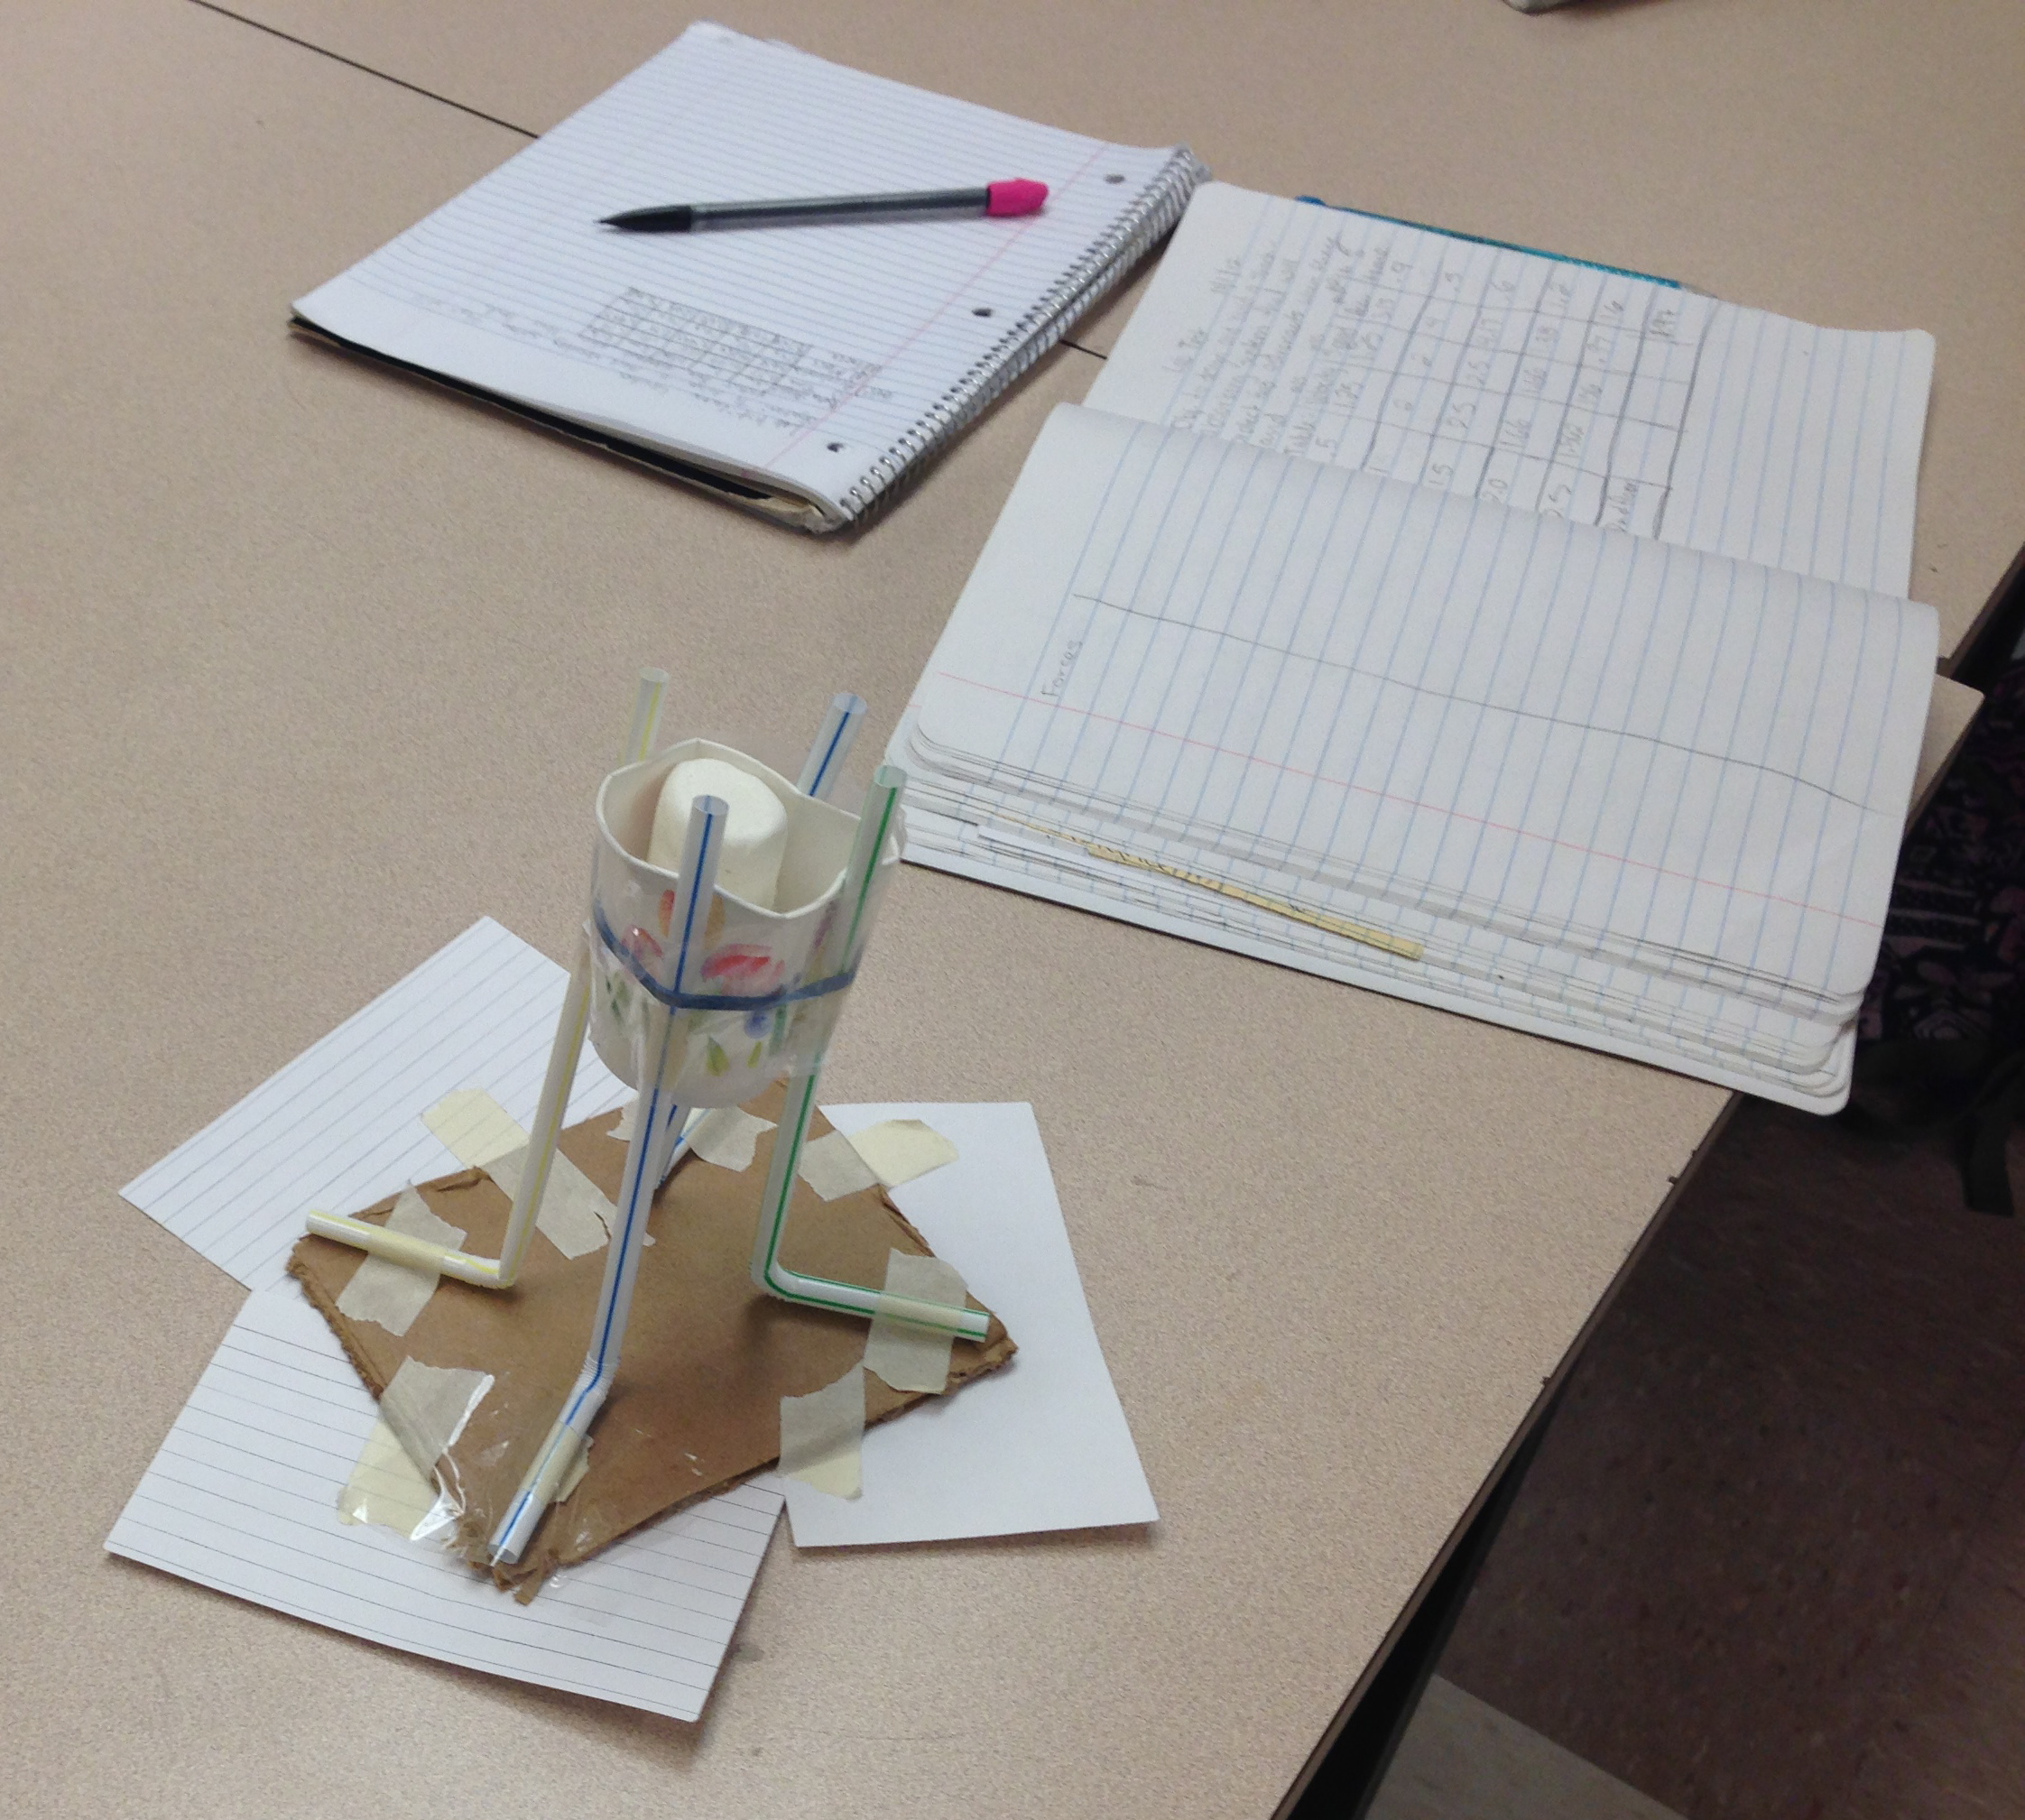
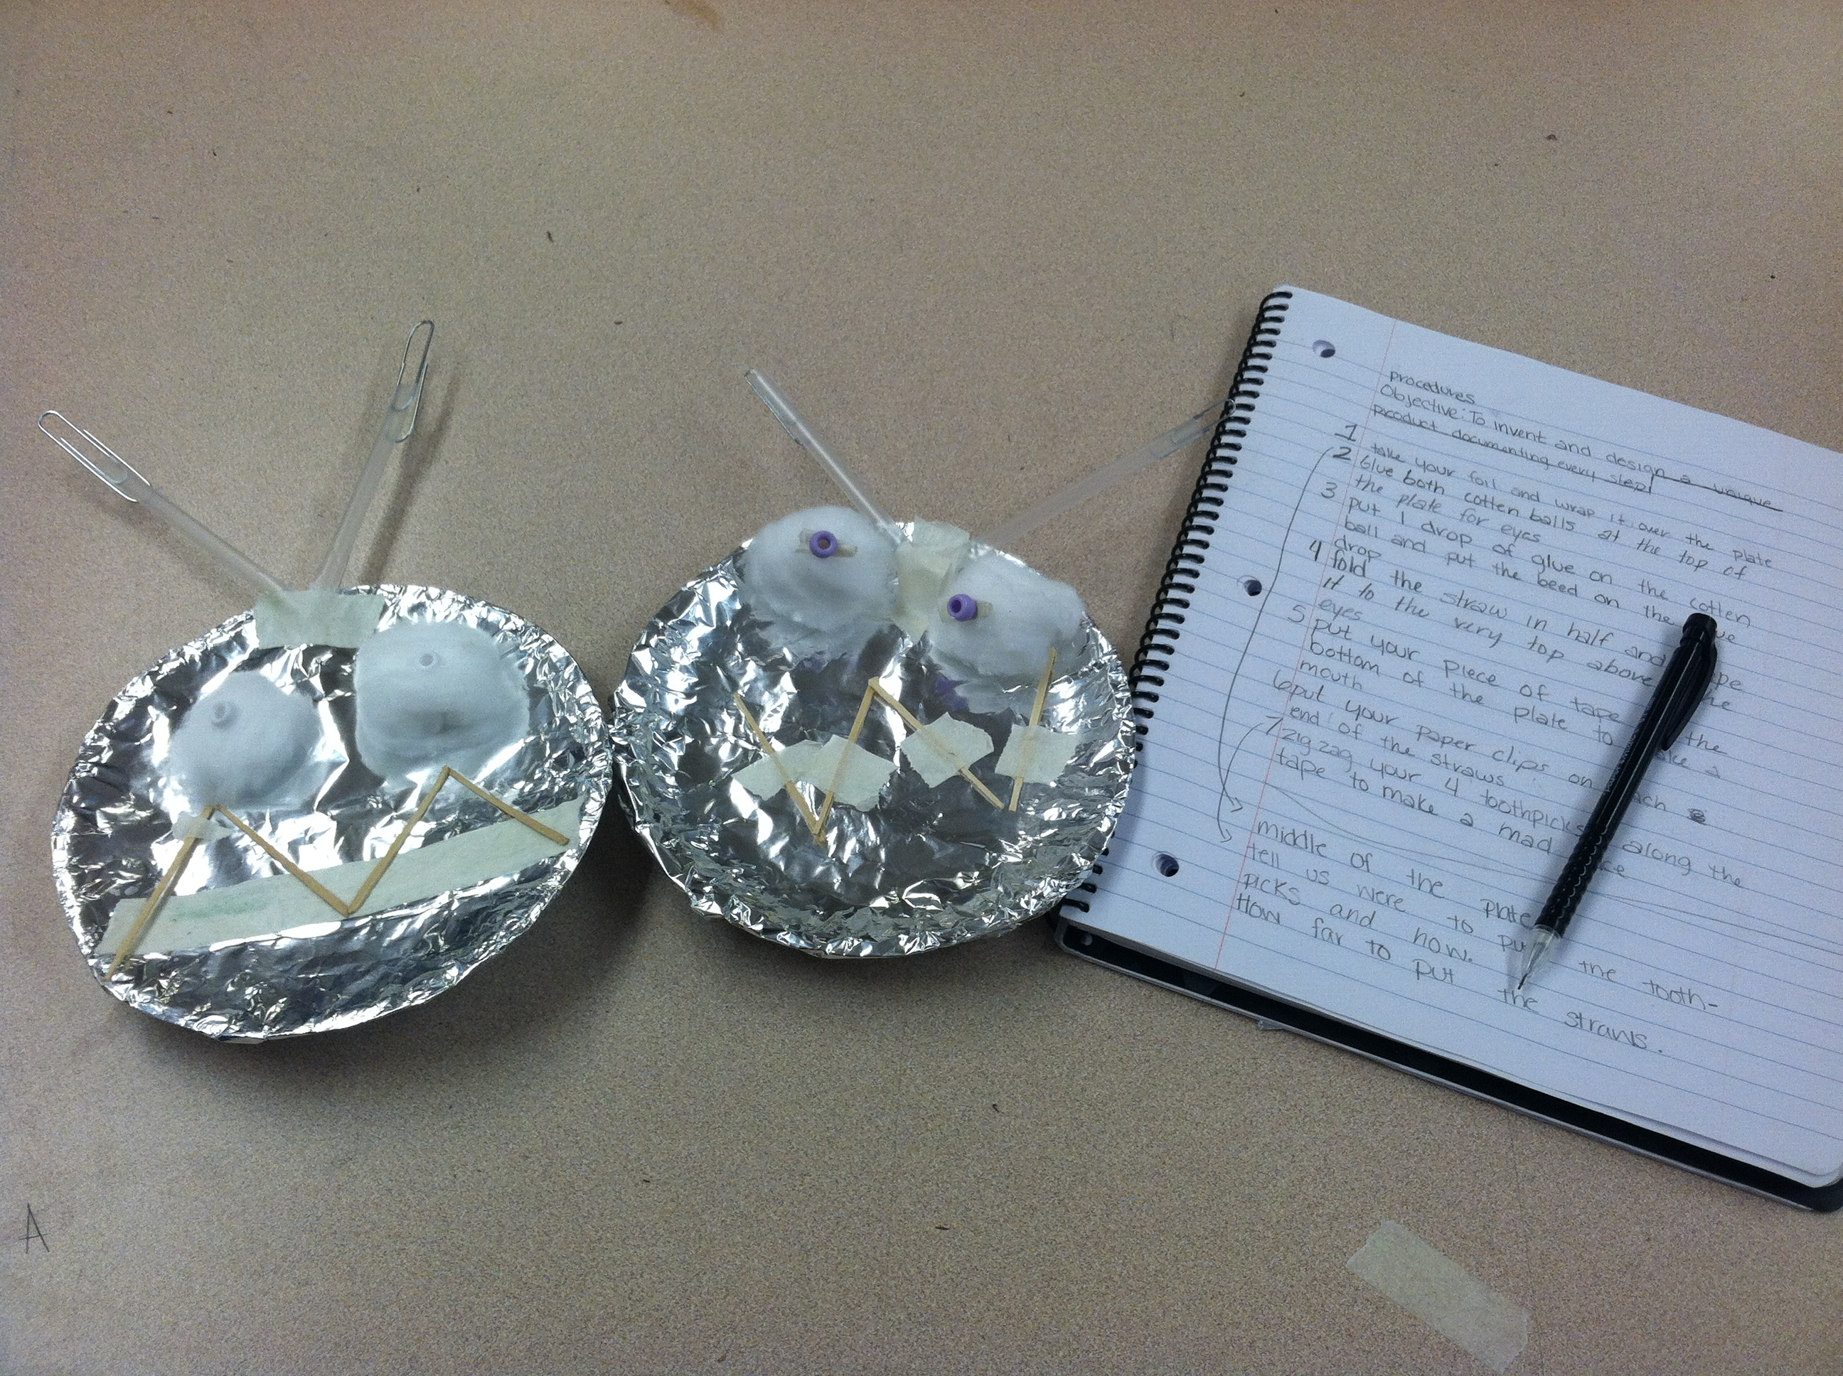
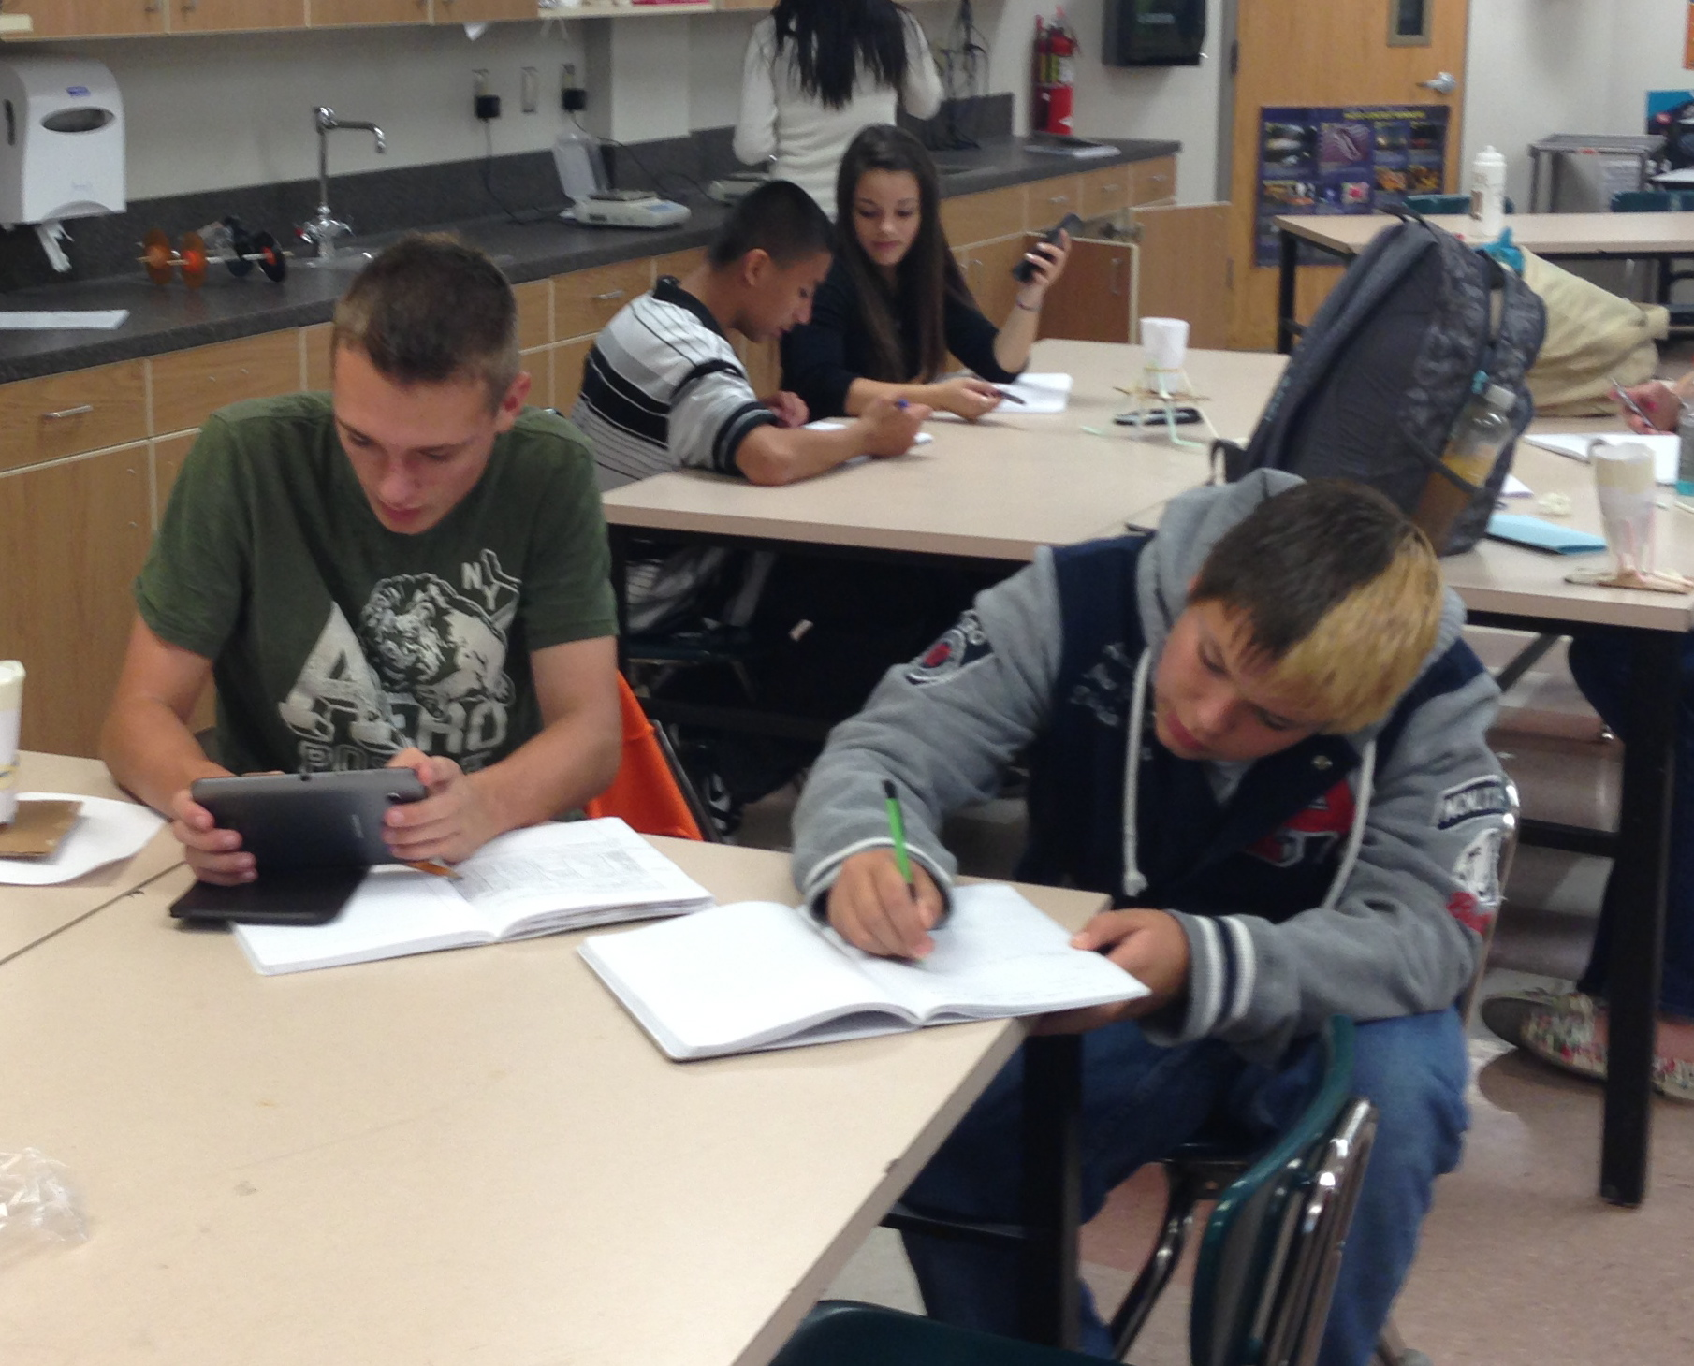
Figure 1. – This picture shows an assignment in which students had to create a procedure to build something and record it in their lab notebooks (Upper Left).

Figure 2. – The pictures shows an engineering challenge project from NASA’s On the Moon Educator Guide and the data that was collected along in student lab notebooks (Upper right).

Figure 3. – This picture shows four student doing a lab write up and calculations in their lab notebooks (Right)
Communication and discussions with other teachers about the notebooks were also recorded in my journal. David Ruffing (Personal Communication, 2012), a special education teacher that leads a study skills class for students receiving special services, asked me what the students that he mentored could be doing to help themselves in science. I showed him the lab notebooks and asked him for support with those in study skills. Those students are currently doing well in my class and do not have any missing work.
The next factor that was analyzed were student surveys. They were asked a series of questions about their organization, how much they liked science and what they thought their lab skills were. The data collected was use to drive informal student interviews. Over the course of two days, I shared the results from my survey with the classes and told them I would be asking them some follow up questions informally throughout the period while they worked.
Table 1 shows that the honors and general students reported the same amount of organization in everyday life, but honors students felt slightly more organized in science, while general students felt less organized. When I asked my students in general classes about the organization, one student reported that they didn’t know what to do with assignments that didn’t have to go in the lab notebook. She stated that if she had to put everything in one spot that would make her feel more organized (Personal interview, 10/22/12). The honors student that I asked about organization claimed that since the class was lab based it helped him feel more organized than other classes because everything could go in his notebook (Personal interview, 10/23/12). Table 2 shows the factors that help student feel organized in science and the lab notebooks were the number one item in both general and honors class by a large margin.
Table 1 and 3 show how the students feel about science. On average the students enrolled in honors liked science more than the students in general sections, but both groups rated science above a 3 on a scale of 1 to 5 as shown in table 1. When the students were asked to share how their feelings had changed towards science since the beginning of the year, 48% of the honors students didn’t have a changed opinion, but 47% of the general students like science more than they did at the beginning of the year. When interviewed, a student from my general section stated that in science this year, they were able to do more labs and that made her like science more (Personal Interview, 10/23/12). My honors students reported a decreased interest in science, with 18% reporting that they liked it less than at the beginning of the year. I asked for volunteers to speak with me about that piece of data and one student reported that he thought science was more work in high school and when we moved at such a fast pace in the honors course, it made it more difficult and so he liked it less (Personal Interview 10/23/12).
The final questions in the student survey asked about lab skills. Students rated their lab skills fairly high at 3.8 in the honors sections and 3.1 in the general sections as shown in Table 1. In Table 4 about a third of all students reported they felt their lab skills had improved, while about 60% of students overall, thought their skills were about the same as when the class started. When asked both general and honors students said that they were confident in their abilities to follow instructions to complete the labs and that by doing more labs they thought their labs skills could improve more.

 | Organization in everyday life | Organization in science | Attitude Towards Science | Lab skills
Honors | 3.5 | 3.7 | 3.7 | 3.8
General | 3.5 | 3.2 | 3.2 | 3.1
Table 1. Students were asked to rank the above categories on a scale of 1 to 5, 1 being the worst and 5 being the best. To answer the attitude towards science and the lab skills questions, the students were asked to reflect back to the beginning of the year and rank it based on what they thought then.

 | Science Notebooks | Weekly Agenda | Class Reminders | Website with Calendar | Other
Honors | 82% | 20% | 41% | 16% | 3%
General | 69% | 26% | 29% | 11% | 2%
Table 2. Students answered the question: “What helps you be organized in science?” They could select as many options as they wanted and insert other.

 | Like it More | Didn’t Change | Like it Less
Honors | 28% | 48% | 19%
General | 47% | 33% | 3%
Table 3. After answering how the students felt about science at the beginning of the year, they were asked to consider how they like it now.

 | Better | Same | Worse
Honors | 31% | 64% | 4%
General | 36% | 57% | 5%
Table 4. After students ranked their lab skills at the beginning of the year, they were asked how their lab skills were comparatively.

Discussion
These results are similar to what Delcuca (2010) also found in his study. Students overall gained skills by using the notebooks, but it didn’t necessarily increase the interest for some groups. This finding is also supported by Hyers (2010), who stated that the notebooks are not equally beneficial for all. My data and observations show that the notebooks helped different students in different ways. Some liked the organization of them, while others found it difficult, while others now like science more and some don’t. Phillips (1920) also saw the observation almost 100 years ago in his study that found evidence that notebooks are valuable for students to record and retain information. Sedita (2006) supports this idea that a set method of organization is very beneficial for students, especially with students that receive special services. Bowers (Personal communication, May 10, 2011) had claimed, the notebooks were helping to give students an authentic experience with science.

Conclusion
Overall, I feel that lab notebooks are extremely beneficial and help students be more successful in science. The data that I have collected and the observations that I have made show that notebooks are a beneficial addition to my classroom. I do think that there is some room for improvement with their use, however. I like the forced organization and that it did help my Honors classes feel more organized, yet I want to make sure that all classes are benefiting. AVID, which is a new program at our school, suggests a different way to do notebooks called an Interactive Notebooks. This method is a little more structured and incorporates all assignments into the notebook. I think it would help my general students feel more organized in science. Further research could look at the effectiveness of AVID in my classroom because as Sedita (2006) suggests, it focuses on incorporating organization into the regular curriculum to help students do better.
My data is inconclusive when it comes to the other two factors I was looking at in my study. Students did in general show an increased interest in science and gained or maintained lab skills, but there is no conclusive evidence that this was due to the lab notebooks. Several students mentioned labs when I interviewed them about how their views on science had changed this year and when they talked about their lab skills. I would like to see what type of labs make the students like science more and become more engaged in the subject.

Resources
Anday-Porter, S. Henne, K. & Horan, S. (2000) Improving student organization skills through the use of organizational skills. Master’s Thesis. Saint Xavier University, Chicago, IL.

Byerly, Tegan (2012) Personal Journal.

Bowers, Ann (2012) Personal Communication.
Common Core State Standards for English Language Arts & Literacy in History/Social Studies, Science, and Technical Subjects. 2010. Common Core State Standards Initiative.

Deluca, J.J. (2011) The effect of science notebooks on student achievement. Montana State University. Bozeman, MT.

Gilbert, J. & Kotelman, M. (2005). Five good reasons to use science notebooks. NSTA Science and Children. Nov/Dec. 28 – 32.

Hyers, A. (2001) Predictable achievement patterns for student journals in introductory earth science courses. Journal of Geography in Higher Education. 25(1), 53-66.

Kanare, H.M. (1985) Writing the Laboratory Notebook. American Chemical Society. Washington, DC.

National Research Council of the National Academies. ( 2012). A Framework for K-12 Science Education: Practices, Crosscutting Concepts, and Core Ideas. Board n Science Education. The National Academies Press, Washington, DC.

Phillips, T.D. (1920) A Study of Notebook and Laboratory Work as an Effective Aid in Science Teaching. The School Review, 28, 451- 453
Roberson, C. & Lankford, D. (2010) Laboratory notebooks in the science classroom. NSTA The Science Teacher, 077, 5

Ruffing, David (2012). Personal Communication

Sedita, J. (2006) A call for more study skills instruction. LD On-line Newsletter. Accessed on 8/24/12 from: http://www.spiritlakeconsulting.com/SLC/sharedfiles/library/books/LDOnLine_%20StudySkillsInstruction.pdf

Various Students enrolled in Physical Science (2012) Personal Communication.

