What Impact Does a Robotics Afterschool Program and Middle School Course Have on Students’ Interest in Pursuing a STEM Career?
Andrea M. Burns
NASA Endeavor Program Adam State College

Introduction
Anne Chesnutt Middle School is a small school with only seven hundred nine students. This school is comprised of 16.5% or 117 Caucasian students, 62.6% or 444 African American students , 1.1% or 8 Indian students, 2.4% or 17 Asian students, 12.3% or 87 Hispanic students, 4.7% or 33 Multiracial students and 0.4% or 3 Pacific Islander students. Approximately 58.4% of our students are eligible for free or reduce lunch. For many years we have been a Title I school.
In 2010, our district received a Department of Defense Education Activity (DoDEA) Science and Math Grant. This multi-million dollar grant requested money to begin a STEM initiative to motivate and stimulate African American Students by starting a robotics program at one high school, two middle schools, and seven elementary schools. The purpose of this grant was to provide high poverty schools with Science and Math technology, STEM equipment, teacher professional development, and high student academic support. This grant promised to create a few FIRST Lego League (FLL) Robotics Teams. It was the financial support of this grant that allowed Anne Chesnutt Middle to start a robotics team.
This investigation evolved from three years of observations on a newly formed afterschool robotics club. In 2010, there were 15 students interested in the robotics program. Of this small diverse group of learners there were 12 boys and 3 girls in the 6th, 7th, and 8th grade. I observed that the female students did not touch the Legos to build or program (LabVIEW). The girls watched as the boys built and programmed the Lego Mindstorm Robots. I could not help but wonder, why weren’t these students engaging in the learning experience?
During the second year, there was an increase in the number of students interested in the robotics club. I found it odd that the second year of the program would produce a greater number of girls joining the program when the girls from the first year did not actually participate much. The girls from year one were mere observers. I entered year two believing that it would be another year of the girl observers.
This group of girls seemed more comfortable with building and programming. Half of the girls in this group participated in programming and less than half participated in the building process. I asked the girls if they had Legos at home and they would always respond, “No, but my brother has some.” Even though these girls were more interested and more involved than the first group, I found myself as a science teacher explaining how to program in terms of dancing and steps. I used what I termed “Girl programming language”. I noticed that their robots performed with greater accuracy when they programmed in terms of “dance steps.”
This year, the third year, forty-one percent of my students are girls. All of these girls are excellent programmers and they build. They appear to program faster and more accurately than the boys. I do not speak “girl programming language” to them. They are having fun with their robots. Girls hold eight of the ten positions on my FIRST Lego League (FLL) Team.
The purpose of this research project is to see if these female minority students truly interested in STEM as a career. All of my observations lead me to believe that it is this type of student that will go to college, major in a STEM related area, and get a STEM job someday. I have never observed, in the area of STEM, anything like these young ladies. They are smart, talented, and amazing.

Literature Review
STEM is an acronym for science, technology, engineering and mathematics. It’s no secret that women continue to be underrepresented in the fields of science, technology, engineering, and mathematics (STEM) which will have ramifications not only for individual women, but for their families, and society as well. Although women embody nearly half of all U.S. paid workers, they occupied just one quarter of the U.S. STEM jobs, according to the Commission on Professionals in Science and Technology. Despite the need, the demand for STEM workers by American employers, the United States is failing to produce enough workers to meet the growing need. Too many students are not receiving access to quality STEM education programs.
Sixty percent of the people NASA employs are professional scientist and engineering or persons with a minimum of a bachelor’s degree in the STEM career field. NASA is continually seeking talented scientists. The Pathway Program is way for students and graduates to gain federal employment. Three Pathways Program (Intern Employment Program, Recent Graduates Program and Presidential Management Fellows Program (PMF) are available to assist individuals in their endeavors to have a career in STEM. Maybe one day a few of my students may work for NASA in the area of robotics or mechanical engineers or computer engineers.
This literature review examines the statistics on the unemployment rate of STEM workers, how much money they make in comparison to a non-STEM employee, the lack of female and minority representation in the STEM fields and psychological factors that contribute to the ongoing underrepresentation and two key criteria that influence progression through the STEM educational pipeline and into the workforce (proficiency in math and interest). It discusses how girls perceive STEM subjects and jobs, how family influence can affect a student’s career path (encourage or discourage interest in STEM like stereotypes or lack of exposure to STEM careers), the future career plans of my students and if they will seek careers in STEM.
In 2010, there were seven point six million STEM workers (roughly five point five percent of the workforce) in the US displaying about one in eighteen workers being STEM worker. STEM employment is only a small fraction of the total U.S. Employment even with high growth in technology. STEM occupations are projected to grow by seventh percent from 2008 to 2018 compared to nine point eight percent growth from non-STEM workers.
The Bureau of Labor Statistics predicts a stead, continued strong growth in STEM job openings through 2014 with emphasis on life sciences, environmental sciences and engineering. The largest group of STEM employment is in the areas of computer and math field with almost half (forty-six percent). The second largest group is engineering with employment numbers around one –third (thirty-three percent).
STEM degree holders enjoy higher earnings regardless of whether they work in STEM fields or not. The average salary of STEM workers are sixty- six percent higher than that of a non-STEM workers, according to the National Association of Colleges and Employers. Two thirds of STEM workers have at least a college degree compared to less than one-third of non-STEM workers. STEM workers command higher wages, earning around twenty-six percent more money than non-STEM workers.
No matter how great the income, colleges and universities are turning out fewer and fewer STEM degree holders. Even though the number of students receiving a four year degree has increased, the percentage of students graduating with STEM degrees is decreasing. STEM degree holders numbered about twenty-four percent of the graduating class in but in 2009, fifty-seven percent of the bachelor degree holders earned were by women. But there was a four percent decline in female graduates with a math or statistics degree and a ten percent decrease in computer science degrees.
There are psychological barriers that are persistent in the life of a female student that can hinder her ability, participation as well as interest in Science and Math courses. From early childhood to adulthood, women and girls encounter overt and subtle messages that lead them to believe that failures in STEM disciplines are due to lack of ability (Dickhasuer & Meyer, 2006). Female children are stereotyped by their parents and their teachers. For example, teachers evaluate their males students’ mathematical ability as being higher than their females’ despite performance measures that indicate roughly equal ability (Tiedeman, 2000).
All children are unconsciously and consciously being influenced about their roles in society, their own abilities, and their futures. Parents are having a dramatic impact on their children’s ideas and thoughts about of math and science earlier, developmentally, than they may even realize. Preschoolers entering vary greatly in their mathematical knowledge (Starkey, Klein, & Wakely, 2004). This can translate to varied mathematical abilities and achievement levels in a classroom. A girls’ belief about their math ability predicts their later achievement (Kenney-Benson, Pomerantz, Ryan, & Patrick, 2006).
In a longitudinal study, found that the frequency in which parents engaged in discussions about number, counting numbers and number matching (referred to as “number talk” in this study) with their fourteen to thirty month old children varied greatly from family to family, and that this variation predicted the children’s ability to understand the cardinal meanings of numbers at forty-six months or ages (Levine, Suriyakham, Rowe, Huttenlocher, & Gunderson, 2010),. Comparably, in observations done on parents and their children at a children’s museum in California, research observed parents were twenty-nine percent of the time more likely to provide their male child with a scientific explanation about the exhibits and would only provide an explanation nine percent of the time to their female child even though neither child initiated interaction more than the other. The differences in explanation frequency by child’s gender were the greatest in father-child dyads; that is whether fathers spoke often or seldom to their children about scientific concepts, they were much less likely to speak to a daughter about them than to a son (Crowley, Callanan, Tenenbaum & Allen, 2001).
The explanations of scientific concepts by parents are important to developing scientific reasoning skills in young children. Some young girls are entering school barely exposed to math and science due to lack of parental dialogue. Children who do not receive adult explanations of scientific phenomena are unlikely to develop their own explanations (Crowley & Siegler, 1999). Social roles are being defined at an early age by the parents and this has a direct impact on how their child might perform academically as a result of this strong, daily, continuous influence.
A teacher’s attitude and experience toward math can have a powerful effect on their student’s math performance. A teacher may evaluate girls’ math ability as lower than boys’ ability, despite, the fact that young boys and girls perform at roughly the same level on average (Dickhauser & Meyer, 2006). Further, teachers tend to attribute the math success of males more to high ability rather than less to high effort. Most teachers assume that male students have a higher ability to think in a logical manner. It appears that some teachers maybe reflecting societal stereotypes rather than creating them.
Words are powerful. Mothers’ and teachers’ ability beliefs have a strong influence on the child’s own ability perceptions. Girls tend to perform to what is spoken about them. Girls rely on a teacher evaluation as a measure of their mathematical ability rather than other objective measures of their performance. This perception may cause those students to underestimate their own ability. And this underestimation of their ability may in turn be detrimental to future performance, as judgment of one’s own ability has been found to be correlated with achievement ( Muzzatti & Agnoli, (2007). The female child’s perception about her math ability can be shaped by factor that have nothing to do with her ability. I suspect that the same will be true also for science, for computer science, for technology, and for engineering.
Likewise, several studies on parental attitudes and expectation about science have found that parents: believe that sons are more interested in science than daughters (Tenenbaum & Leaper, 2003, Andre et al.,1999); have higher expectations of boys’ performance than girls’(Andrea, Whigham, Henderickson,& Chambers, 1999); believe science is more difficult and less important for girls than boys (Teneenbaum & Leaper, 2003; Andrea et al.,1999); and engage in more complex dialogue about scienific concepts with boys than with girls (Tenenbaum & Leaper, 2003;Saucerman & Vasquez, 2010). Mothers and fathers believe that boys are more competent in math than girls
The female student suffers from psychological issues like the result of this lack of science and math ability, lack of self-esteem, and lack of self-efficacy which are learning barriers to succeeding in the secondary course work and programs that would prepare her for the STEM field. The bible says as a man thinks in his heart so is he (proverb 23:7). Negative stereotypes and words about their math and science abilities have made into their ears, into their hearts and into their minds. Female students and minorities do not enter the STEM field because they feel they won’t succeed.
Students who graduate high school proficient in math are generally ready to purse STEM majors in college. An analysis of twelfth grade student’s STEM interest and proficiency produced daunting results: (1) of the sample population, few twelfth graders were both STEM interested and math proficient ( only twenty-three percent); (2) those twelfth graders that were math proficient had low interest in STEM; (3) African-American students were least likely to pursue undergraduate STEM degrees; (4) minorities are more likely to be STEM interested but are not math proficient ( students were within reach of the benchmark score of proficient most missing it only by four point). These students, within four points of pass, could still enter the STEM career field but would be required to have remediation.
In this study less than half of the twelfth graders meet the math proficiency benchmarks that indicate readiness. Less than six percent of all African Americans that were interested in STEM and college were ready in math. Only seventeen percent of all twelfth graders are proficient in math and interest in STEM careers. Students are interested in STEM careers but perceived themselves not math proficient did not pursue a career in this area.
Methods
Prior to this investigation, students were taught basic computer programming skills using LABVIEW software from the LEGO Mindstorm Robot Kit. Students were taught how to assemble the basic taskbot found in the manual that accompanied the Mindstorm Robot Kit. During this investigation students were asked to complete programming tasks related to the 2012 FIRST Lego League Challenge. Everyday upon entering class students would: 1) get a laptop computer; 2) get their robot; 3) being working on their program for one of the tasks on the challenge board; 4) use the USB cable to download the program from the computer into the Mindstorm; 5) go to the board and run the program. After making observations about how well the robot completed the task, the programmer would determine if they had to rewrite the program or move on to another task on the board. This was the daily class procedure.
In this investigation, observations were made as the students worked to build and program their robots with special attention paid to females and minorities. Students were free to program, design, and move about the classroom. Students were able to critique their classmates. Students were able to ask for help from the teacher or their classmates concerning programs or building issues.
Results/Findings
A survey was given to a total of twenty- two student (59% male and 41% female). One half of the students surveyed were minorities (Black and Hispanic students). Almost half of students surveyed were in the eighth grade while the other half were in the seventh grade. At least one sixth grade student participated in the survey while two students did not respond to the question addressing their grade level. The median age of the students surveyed was thirteen. According to the data, for the vast majority of the students, this was their first year in the robotics program.
One hundred percent of the students surveyed replied that they liked the robotic program. When asked if they would recommend the program to someone else all with the exception of two female students (one Asian and one Black) replied that they would. The same is true for the number of people who said they would share their experience with others. I felt that these students liked this STEM program and that this program was a positive experience for all of them.
The students felt that were smart, capable, good in mathematics and science. This was an indicator to me that they were not affected by the stereotyping we still do in terms things that boys can do and things that girls cannot do. When asked if they felt if girls were smarter than boys they responded favorable. These young ladies believe that the sky is the limit and they can do anything they set their mind to.
They responded favorably to having the support of their families which I can certainly attest to because of the level of parental involvement in the program. Their families travel with us out of town to compete because there are no local teams. The provide snacks, donate money and help out in any way they can. The data in this area seem to correlate to the results and the findings of the research done by the Girl Scouts of American. Yes, females and minorities are interested in STEM. They do like math and science. They are doing well in these subjects.
I noticed during the interviews that the families of the girls are helping shape their current career choices. Subject A, a Caucasian female, when asked what did she want to be when she grew up stated that she wanted to be and artist or veterinarian. According to the research, parents and educators inadvertently communicate dissuading messages to girls about relative math and science abilities and interest (Saucerman and Vasguez, 2010). As the interviewer, it was clear to see that this young lady is torn between what she is interested in doing and what she is expected to do by her family.
“Everyone in my family wants me to be an artist but I like science. I just don’t know.” Subject B, an African-American, when asked the same question said “I want to be and entrepreneur with a doctorate in physic and try to build my own machines. My dad is into business. He is trying to be an entrepreneur.” When subject C, a Caucasian, was interview and the question was asked of her state,” A veterinarian because I love animals and because I want to be in the medical area. I am going to help animals. My mom is going back to school to be a nurse.” This was supported by research which states that females and minorities go into the biological area of science or the medical profession as doctors, nurses, and other medical personal (Department of Labor, 2001)
My survey revealed the following: 1) one hundred percent of the students survey want to have a high paying job; 2) only thirty-six percent of the children said they would like to be scientist even though sixty- eight percent are in math and seventy-seven percent in science; 3) sixty-eight percent of the students wanted to know more about careers in STEM; 4) about six percent of the class knew a women in the STEM field.
This data reveals an anomaly, what I observed and thought was happening was not represented by the data. My data correlations with what I've read, women are underrepresented. Students loose interest in math and science in secondary school. This program does not seem to be having the impact that I would like for it have. But I also realize that middle school students are trying to figure out who they, what they like and what they want to be. I believe it is too early to tell what impact this program is having.

Table 1 Data on STEM interest

PHOTOGRAPHS
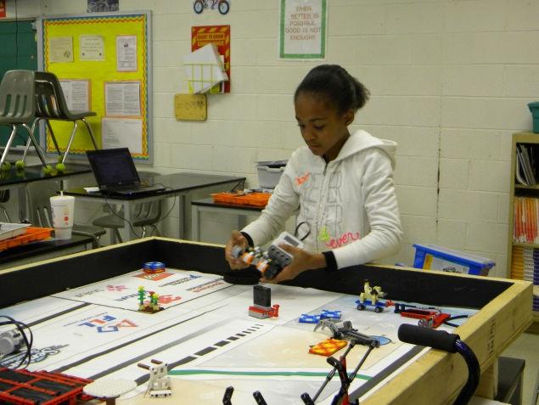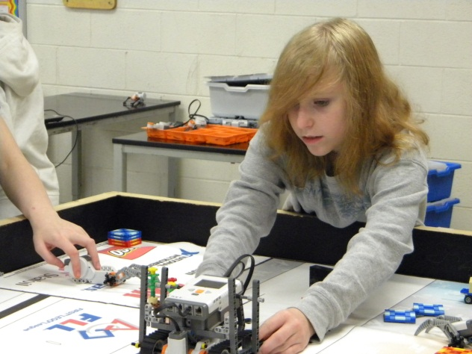
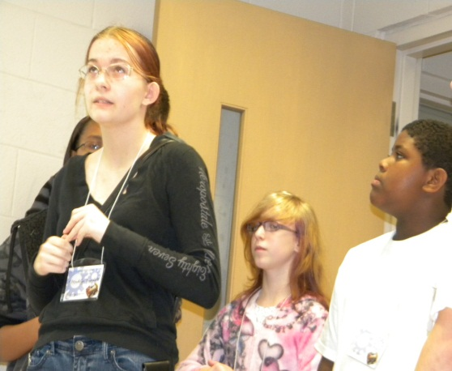
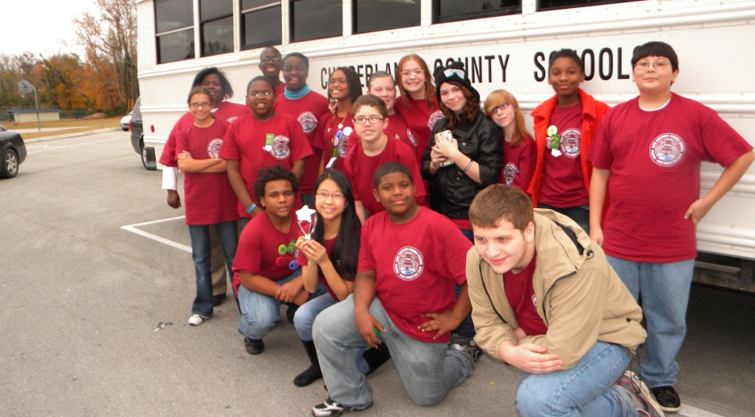

Discussion
The data was really perplexing to me. I was certain that I was meeting for hours after school with a group of female and minority students interested in STEM but that wasn’t the case. I discovered that many educators are not prepared to teach STEM programs/classes. The implications and expectations of the industry are far from being reached. Teachers need training by STEM professionals so that the expected outcome is met by the conclusion of the taught curriculum.
Schools systems purchase a variety of products with the STEM label but STEM in not being taught in schools. A true STEM program teaches science, technology, engineering and mathematics with math being the key to STEM proficiency. I strongly feel that we, as educators, need to ensure that students in k-12 students receive an adequate math and science preparation.
This research left me with a lot of questions. What can I do to better prepare my science students for a future in the STEM workforce? Where is the disconnect? Why do the female and minority students not comprehend math by high school? How can they spend three and four hours after school and not be interested in becoming a STEM scientist? How can students be interested in math and science but only a few of them want to pursue a career as a scientist? How can these young ladies, who can build and program robots so accurately, have no desire to working in the STEM areas in college? Do students who are so young really know what they want to do for a career? What can I do to get female and minority students to consider a future career in STEM? Where will the future engineers for NASA come from?
Further training, on my part in the area of STEM, as well as future research are needed to answer these question.

References
Crowley, K., Callana, M.A.,Tenenbaum, H.R. & Allen E. (2001). Parents explain more often to boys than to girls during shared scientific thinking. Psychological Science, 12, 258-261.
Crowley, K., & Siegler, R.S. (1999). Explanation and generalization in young children’s strategy learning. Child Development, 70, 304-316.
Dickhauser, O., & Meyer, U. (2006). Gender differences in young children’s math ability attributions. Psychological Science, 48, 3-16
Kenney-Benson, G. A., Pomerantz, E. M., Ryan, A. M., & Partick, H. (2006). Sex differences in math performance: The role of children’s approach to schoolwork. Developmental Psychology, 42, 11-26.
Levine, S.C., Suriyakham, L., Rowe, M. L., Huttenlocher,J., & Gunderson, E. A. (2010). What counts in the development of young children’s number knowledge? Developmental Psychology, 46, 1309-1319.
Pantic, Z. (2011). STEM Sell. The New England Journal of Higher Education Summer 2007. 25-31.
Saucerman, Jennifer., & Vasquez, Kris.(2012). Psychological Barriers to STEM Participation for Women over the Course of Development. Averno College Research Center For Women and Girls. 2011 , 1-12
Starkey, P., Klein, A., & Wakely, A. (2004). Enchancing young children’s mathematical knowledge through a pre-kindergarten mathematics intervention. Early Childhood Research Quarterly, 19, 99-120.
Tenenbaum, H.R., Leaper, C. (2003). Parent-child conversations about science: The socialization of gender inequities? Developmental Psychology, 39, 34-47.
Tiedemann, J. (2000). Parents’ gender stereotypes and teachers’ beliefs as predictors of children’s concepts of their mathematical ability in elementary school. Journal of Educational Psychology, 92, 144-151.
U.S. Department of Commerce. (2011). Women in STEM: A Gender Cap Innovation. Economics and Statistics Administration, Issue Brief 04-11, August 2011.
U.S. Department of Commerce, (2011). STEM : Good Jobs Now and for the Future. Executive Summary. Economics and Statistics Administration, Issue Brief 03-11, July 2011.

