Running Head: STEM integration in Elementary Classrooms with Special Needs Students

STEM for All
STEM Integration in Elementary Classrooms with Special Needs Students
Michele Bubley Wiehagen
Endeavor Fellowship
Teachers College Columbia University

Abstract
Elementary teachers and classes were selected to participate in a pilot STEM program. These teachers received training and were part of a professional learning community to strengthen their content knowledge and help change their perceptions of students with disabilities being able to function in a STEM classroom. Teachers’ perceptions did change, now understanding that all of their students could successfully participate in STEM content lessons. The findings suggest that if teachers are given the tools and the content knowledge then their perceptions of students with disability greatly changes, therefore making students with disabilities more successful in an elementary school setting.

Statement of Problem
STEM (Science, Technology, Engineering and Math) is the wave of the future. Integrating these subjects is key to creating a stronger workforce and country. Students need to be exposed to STEM integration starting at the elementary level. Elementary teachers are expected to be “experts” in all content areas since they are required to teach it all, though most elementary teachers lack a background in the STEM subject areas. This leads to a negative perception on STEM in the classroom. Though negative perceptions are harmful to all students it is even more detrimental to students with disabilities, teachers thinking that they are unable to contribute to the STEM classroom. This research is focused on changing teachers’ perceptions and what impact that has on the performance of students with disabilities in a STEM classroom.
In my current position, as the Elementary Science District Resource Teacher, for Title I schools, I am also responsible for the STEM initiatives that are to be implemented within our elementary science curriculum. My background in teaching has always been within the highest need schools, those at 98% free and reduced lunch. Additionally, most of my teaching experience has been with the students with disabilities or exceptional student (ESE) population, ranging from students with autism to students with severe learning disabilities. Given that this has been my background, I have had many experiences knowing that these populations of students are extremely capable of thinking like engineers. As I have been in the DRT role I have been given the privilege of modeling lessons for teachers who struggle with thinking that this population cannot complete STEM design challenge lessons that I have written to embed in our science instruction.
With these experiences I want to share with teachers quantitative and qualitative data that our Title I ESE population will excel with the open inquiry design challenge STEM lesson model. I will focus my attention and data collection on fifth grade at our lowest performing schools within our district. Since I am not the classroom teacher I have strong partnerships with the fifth grade teachers who teach science for these students. I will work closely with the teachers, modeling, co-teaching and building their background knowledge in science. I will work with them weekly and collect data through informal and formal assessments.
I currently have written lessons for our Title I schools to replace concepts in the curriculum map with open inquiry STEM lessons. I will work with the teachers in these settings to implement these lessons with fidelity. My goal is to help build the background science content knowledge for these teachers so their perception of STEM, specifically towards the ability of our ESE students to change.
With the background content and STEM knowledge I have gained through the Endeavor program I have been able to take this and help create the curriculum for our district. I know that my perceptions have changed as I have had the formal professional learning dialogue and feedback with teachers through the Endeavor program from different states. My goal is to share this content knowledge with teachers so they in turn can feel successful and pass on the STEM knowledge to their students.
According to a statement released from President Barack Obama, “Strengthening STEM education is vital to preparing our students to compete in the 21st century economy and we need to recruit and train math and science teachers to support our nation’s students.” The White House outlines the goals to increase STEM education, including the following:
- “Increasing STEM literacy so all students can think critically in science, math, engineering and technology;”
- “And expanding STEM education and career opportunities for underrepresented groups, including women and minorities.” (White House Office of the Press Secretary, 2010)
These goals are not only the goals of the President but are also the goals of most school districts. The questions that many educators and policy makers are trying to answer are- how does this look in a school; Who teaches this; Which students are getting this opportunity? The NASA Endeavor program has built a cadre of teachers that is starting to explore and educate others in the field of STEM.
The problem is most student are not exposed to STEM, though studies show that “more than half (57%) of STEM college students say that, before going to college, a teacher or class got them interested in STEM” (Harris Interactive, 2011). Many teachers are uncomfortable with teaching STEM in their classrooms and there are many negative perceptions that everyone will not be successful in STEM. These perceptions do relate to the success students think they will have in STEM. This action research will look at the perceptions teachers and students have in relation to STEM and how this impacts the special needs population. In the case of this action research, the special needs population consists of any student who has an Individualized Educational Plan or IEP. This group of students is of particular interest because, as I have taken courses in the Endeavor program I have done my model lessons, unit plans and studies with teachers that teach in an inclusion setting. The number one comment from these teachers has been that the STEM lessons I have planned along with them is that the special needs students will not be successful. The teachers did not believe that the students would be able to handle the cognitive thinking ability of STEM.
Literature Review
Much research has been done on the integration of STEM in schools, specifically in elementary schools. Research suggests that elementary teachers need to improve their content knowledge in the areas of math and science in order to feel comfortable with the inclusion of STEM in their classrooms. One way to gain this background knowledge is through the use of Professional Learning Communities (PLC’s). PLCs are a time where groups of teachers have a chance to engage in professional dialogue, learn with one another, and to find solutions to classroom problems. The findings of the positive impact of PLCs with STEM teachers can be found in the report from that National Commission on Teaching and America’s Future: STEM Teachers in Professional Learning Communities: From Good Teachers to Great Teachers. This study was published in 2011, and the researched found that, “STEM teaching is more effective and student achievement increases when teachers join forces to develop strong professional learning communities in their schools” (National Commission on Teaching America’s Future, 2011, p. 8). This study is crucial to this action research project in that at the elementary level it has been noted that teachers are not prepared to teach STEM lessons and that uncomfortableness transfers to the students’ perceptions on STEM. This study is relevant because, as the researcher, I have seen how PLCs impact a teacher’s level of understanding and knowledge in the science and mathematics content areas. The National Commission on Teaching America’s Future research supports the above claim, “[Our study’s expert advisers] attested to finding increased student learning of mathematics and science in their experience and investigation. The panel strongly stated the learning teams (PLCs) can be an effective professional development model for all STEM teachers educating all types of students” (National Commission on Teaching America’s Future, 2011, p. 10). This study shows how effective the PLCs can be for changing teachers’ perceptions, even those teachers who teach the special needs population in inclusion classrooms. The implications of other research that has been done on this topic is “that there is a great need for awareness raising at both the administrator and teacher levels” when it comes to STEM education (Brown, Brown, & Merrill, 2011, p. 8).
STEM provides teachers and students a chance to think outside the box. Many of the students who are classified as special needs students need opportunities to show what they know in a creative, and often team work settings. “Children with disabilities have a right to an appropriate education and to be involved in the classroom community” (Leatherman, 2007, p. 594). The challenge occurs when teachers have low expectations or feel the students with special needs cannot contribute or be a part of a STEM lesson.
I think a great example of having STEM for all is that of a study done at Moon Area Elementary School Challenge Program. In this program, students participated in the TOYChallenge National Toy Design Competition at Robert Morris University. Researchers tracked the students’ work ethic, thinking, creativity, and progression through this design challenge. Though the study did not release any empirical data nor did it specify the cognitive levels of the students, this challenge and scenario could be posed to varying ability levels. It did show greater motivation, higher level thinking, good communication skills, as well as a positive attitude towards the subject area. Every student has “experienced” a toy; many of the toys may be disappointing to a child. This disappointment can motivate and stimulate the child to design a new toy based on experiences to which most children have access. “Through active learning, knowledge is directly experienced, constructed, acted upon, tested or revised by the learner. Active learning’s critical components include using multiple senses and doing” (Sirinterlikci, Zane, &, Sirinterlikci, 2010, p. 14).
Many studies, (such as; Jane Leatherman’s “I Just See all Children as Children”: Teachers’ Perceptions About Inclusion) have been done on teachers’ perceptions of teaching students with special needs and many studies have been done on the implementation of STEM at the elementary level, (such as; Dr. Chris Rogers and Merredith Portsmore’s Bringing Engineering to Elementary Schools; Eric Matson, Scott DeLoach, and Robyn Pauly’s Building Interest in Math and Science for Rural and Underdeserved Elementary School Children Using Robots; STEM Teachers in Professional Learning Communities From Good Teachers to Great Teachers done by the National Commission on Teaching and America’s Future). There is limited research available about the special needs achievement in STEM related courses. As a researcher I chose to merge the two because of the growing population of special needs students, especially in the urban schools, as well as the perceptions teachers have on the inclusion model that many districts have adopted. I have witnessed many instances where a STEM lesson or design challenge would have been appropriate to use in a classroom and the teacher chooses not to because he or she does not believe their students could handle the tasks. I plan on conducting many model lessons, interviews with students, videotaping of discussion among student engineers, and using quantitative data through rubrics and assessments. I will form teacher PLCs in order to have the academic discussion, plan STEM lessons with the teachers as well as plan assessments. Through these conversations I hope to help the teachers identify ways that the lesson can be differentiated so there is access for STEM for all.
Methods
Participants
The methods that were used for this research included surveys, interviews, model lessons, transcripts of videos, assessments, as well as observations. The teachers were selected through an application process (Appendix A). Teachers had to teach fifth grade math and science in an urban school that had at least 98% of the students qualifying for free and reduced lunch. Teachers that applied also had to have at least 15% of their students labeled as qualifying for Exceptional Student Education (ESE) services. (Appendix B) The teachers that submitted an application had to be willing to commit to monthly PLC’s, allowing videotaping to occur in their classroom, implement a STEM integrated lesson every Monday during their science time, keep a reflection log as a teacher and keep documentation in the student notebooks.
The application was sent to all of our Title I schools (91) with an overview of the program. Over eighty teachers applied to be part of the program, from those 65 teachers were chosen. These 65 teachers come from 21 schools and were chosen due to the fact that their schools were ones that as the researcher I had the most access to. The demographics of the schools range from those with migrant populations to those with a high population of homeless students. It is interesting to note that there were 48 female teachers and 17 male teachers selected. All of these teachers were departmentalized, teaching just math and science with a classroom of at least 18 fifth graders. The years of teaching were also noted with 14% of the teachers in years 1-3, 68% of the teachers in years 3-9, and 18% of the teachers with 10 or more years in the district. Teachers’ professional development records were also taken into consideration. Teachers had to have completed at least 5 math or science trainings in the past two years to make sure they were up to date on best practices (Appendix C).
Teachers did not receive monetary compensation, though they did receive professional development hours towards recertification for every PLC they attended. They also received all necessary materials for their classroom to complete the STEM lessons as well as a copy of the STEM curriculum. As part of their participation the teachers were invited to join the district in the already established Hillsborough Robotics Program, along with resources provided. All 65 of the teachers that originally started with the program have continued with the PLCs and are continuing to model best practices in STEM education.
Materials
Once participants were chosen through the application process they were given a survey to determine their perceptions as well as their background knowledge on STEM education. (Appendix D) Their students also were given a survey to note their perceptions on STEM. (Appendix E). Teachers then were given a calendar of PLC dates (Appendix F) that they were required to attend. The participants were given a notebook for their continued reflections as well as notebooks for all of their students to track their progress through the study. Through the attendance in PLC’s teachers received all the necessary materials for lessons (Appendix G) including the literature connections and LEGOs if needed within the lesson.
The writing of the curriculum and lessons occurred prior to each PLC. With the guidance of the mathematics District Resource Teacher we were able to create lessons that integrated the Florida curriculum within each of these lessons. Teachers were given dedicated uninterrupted science time on Mondays in order to pilot these lessons.
The use of questionnaires and videotaping collected the majority of the data. Students were videotaped throughout different stages in the design process tracking their thoughts and perceptions of STEM. Teacher participants documented their own reflections through personal dialogue in their notebook and pictures of the students interacting.
Procedure
After participants were selected based off of their application, they were then given a pre survey. This survey measured their knowledge of STEM and their perceptions on the success students would have with the STEM lessons. The students within the classes were also given a perception survey. The results were collected and PLC’s were designed to address the needs of the teachers. The PLC’s met monthly and were designed to go through the lesson with the teachers as if they were students. Based on feedback from the PLC, lessons were then changed to meet the needs of the cadre of teachers that were implementing the lessons. The PLC’s also gave teachers a forum for discussion as well as conversation about the content. This strengthened their background knowledge in both math and science. Once the teachers were given the lessons they then were required to submit the dates they were planning on teaching the lessons in the classroom. I then created a calendar of support to model, co-teach and observe the lessons. During these visits I was able to video tape the students interactions, take anecdotal notes of the teacher behaviors as well as the student behaviors and interview some of the students and their thoughts on the lessons. I was able to identify those students that were labeled ESE because I had the teachers put a different color sticker on the cover of their notebooks. When working in engineering teams the students were always paired up heterogeneously usually due to the reading ability from each student. There was one engineering lesson for every Monday usually four per month. The teachers were first given an intro lesson so the students learned what an engineer was and how to move through the design process that was created for our district (Appendix H). Then the students engaged in topics such as structures, gravity, space, plants and animals, within each lesson the students were given a scenario, a planning sheet, a request for a proposal, and a career profile sheet of specific engineering careers.
The interviews and video tapes were all transcribed. Looking through the transcriptions I was looking for phrases that represented perceptions on the student learning, such as “Math and Science are Fun!” “I am good at Engineering” “I will be an Engineer when I grow up.” The math DRT independently looked at the transcriptions to collect perception data as well. The student notebooks were collected and notes of common themes were made as well as their answers to the essential science, math and engineering questions. Student responses were tallied if they were correct. The students were given a pre test and a post test based on the science and math that was taught through these STEM replacement lessons. This data was collected and growth was recorded between the two tests.
Findings
Through the pre surveys, 78% of teachers surveyed answered that they strongly agreed that they know what STEM is, but only 15% of the teachers could strongly agree with the understanding of how to incorporate STEM into the classroom setting. From this grouping of teachers 92% of them stated that they strongly agreed that all students were capable of learning. Though the strongly agreed that they knew about STEM instruction, 86% of students strongly disagreed that they knew what STEM was.
The teachers reported that they believed all students could learn, but through transcripts of interviews it was noted that 67% of the time these same teachers made comments such as, “What are my ESE students going to do?” or “How can I make this easier for the ESE students?” therefore negating their pre survey data.
Through the anecdotal notes, conferencing with students and using student notebooks, the students succeeded in the actual lessons. They were able to demonstrate a final product then write an argumentative piece explaining why their product was the best, or most efficient, depending on the lesson. This data was disaggregated by looking at the commonalities of their writings and the support they were able to add to their writing pieces. The writing DRT from our district was able to help score these writings using the language from common core. Students showed through their work that they were proud of their finished products- this was evident in the interview phase, where every student wanted to share every piece of their STEM designs with the researcher.
It was noted that the ESE students were able to succeed through these STEM lessons, through the anecdotal notes, 78% of the time the students labeled as ESE were the ones that were most successful in the actual builds or designs of the final product. The students that were labeled gifted, struggled and showed signs of frustration 50% of the time with the builds. During 45 videotaped interviews, 38 of the students expressed that they were having fun learning math and science.
The formal assessment showed that the students were gaining the scientific and mathematics concepts through these lessons. There was a 48% increase of scores from the pre test to the post test. When compared to similar schools that were not participating in these STEM lessons this showed a larger increase.
The teachers filled out a post survey as well as took a mini content test at the end of the study. Teachers’ perceptions changed and through their written reflections, it was evident that they started thinking of their ESE students as students that can do STEM.
Discussion
Though this study is just the beginning of a journey, the teachers made phenomenal growth in their content expertise and comfort level of STEM. Through the PLC’s teachers gained knowledge, a wealth of resources and a cadre of other professionals that they could call upon. I believe that the strength of these lessons really came through the dialogue and interactions at these PLC’s. Multiple times it was noted in teacher reflection notebooks that they looked forward to the learning environment of the PLCs.
This comfort level transferred to the delivery of the lessons in the classroom, through the reflection notebook one could actually see the change teachers were making in their perceptions of what students; specifically the ESE students were able to handle. Quotes from teachers that reflect the overall consensus of the group were extremely rewarding. One skeptical teacher had reported that, “They (ESE) students do great! They (ESE students) work cooperatively with their general education peers, and now have been able to even build on their own.” This is a powerful statement because it gave the ESE students a feeling of belonging in the classroom, and gave them an area to shine in.
Through the student conversations, interviews and notebooks, the students began to think of themselves as engineers, they have become better communicators, as well as showed a greater tendency to want to work in teams rather than individually through this process.
“I really like STEM lessons because it mixes math and science together,” was a quote from an ESE fifth grade student, “It’s like we are playing in school!” This is the overall sentiment of all of the students that were interviewed, from across the differing schools. The student perceptions of these STEM lessons helped make a positive impact on the teachers’ perceptions and enthusiasm for this project.
This project is continuing with this group of teachers. They have all shared how powerful the PLC meetings were and have chosen to continue them throughout the year. These teachers and classes have also been invited to become a Hillsborough Robotics School, which implements STEM lessons through the use of robotics (Appendix I). As this project continues I would like to track the choices of electives students make as they move into middle school. I would like to partner up with the middle school magnets that have a STEM theme so the students that excel can continue to be cultivated in this education.
I think that this research only solidifies previous research that was done. Like Leatherman in her study of “I Just See All Children as Children,” the ESE students were able to think creatively and participate successfully in thinking outside the box. Research like this suggests that our inclusion model we are currently using in our district does work if the teachers are trained. The teacher training (PLC) are the essential component to the impact of this work. Successful PLC’s have been researched to have a positive impact on the learning environment according to the study from that National Commission of Teaching America’s Future in 2011. I would like to further the research by continuing to look at the effectiveness of these teacher PLCs.
Conclusion
Based on previous research as well as data collected through this study it is evident that teacher perceptions make an impact on student learning. It is also evident that STEM can be for all students. The exceptional education students made as many learning gains as their general education peers when it came to formalized testing (with their accommodations), and made more gains through the informal conversations. The PLC’s are what impacted this study the most as shown in the teacher reflection logs. This is important to any future projects or studies to show that the education of teachers is just as important as the education of the students.
As this research progresses I would like to continue educating the adults so they can understand their underlying perceptions and how it impacts the classroom environment. I would also like to use these teachers as peers for a new group of teachers looking at schools that are not labeled as Title I.
All students can benefit from the creativeness and exposure of STEM lessons. Our goal as educators is to create thinkers and problem solvers- these lessons allow students to invent and have multiple solutions. It teaches student to defend their results- it give access for STEM for ALL.

References
Brown, R, Brown, J, Reardon, K, & Merrill C. (2011, March). Understanding STEM: Current
Perceptions. Technology and Engineering Teacher (5-9).

Harris Interactive (2011). STEM perceptions: Student and Parent Study Parents and Students
Weigh in on How to Inspire the Next Generation of Doctors, Scientists, Software Developers and Engineers. Commissioned by Microsoft Corporation. Retrieved from
http://www.microsoft.com/en-us/news/presskits/citizenship/docs/STEMPerceptionsReport.pdf

Leatherman, J. (2007, December). “I Just See All Children as Children”: Teachers’ Perceptions
About Inclusion. The Qualitative Report (12, 594-611).

Matson, E, DeLoach, S, & Pauly, R. (2004, July- December). Building Interest in Math and
Science for Rural and Underdeserved Elementary School Children using Robots.
Journal of STEM Education. (5, 35-46).

National Commission of Teaching America’s Future (2011). STEM Teachers in Professional
Learning Communities: From Good Teachers to Great Teachers. http://nctaf.org/wp-
content/uploads/2012/01/NCTAFreportSTEMTeachersinPLCsFromGoodTeacherstoGrea
tTeaching.pdf

Rogers, C, & Portsmore, M. (2004, July- December). Bringing Engineering to
Elementary School. Journal of STEM Education. (5, 17-28).

Rush, C, & Harrison, P. (2008, September). Ascertaining teachers’ perceptions of working with
adolescents diagnosed with attention-deficit/hyperactivity disorder. Educational
Psychology in Practice (23, 207-223).

Sirinterlikci, A, Zane, L, & Sirinterlikci, A. (2009, December). Active Learning Through Toy
Design and Development. The Journal of Technology Studies (35, 14-22).

The White House, Office of Press Secretary. (2010). President Obama Announces Goal of
Recruiting 10,000 STEM Teachers Over the Next Two Years. Retrieved from
http://www.whitehouse.gov/the-press-office/2010/09/27/president-obama-announces-goal-recruiting-10000-stem-teachers-over-next.

Appendix A Application

Stem for All

School/Teacher Application

DUE by August 6, 2012 4:00pm Fax to 813-272-4515

Attention: Michele Wiehagen, Elementary Science District Resource Teacher, Title I

School Information
School Name
Principal Name |  | AP Name
Teacher 1 Name |  | Any background in robotics? YES NO  If YES, explain:
Years Teaching
Are the teachers able to commit to the all the mandatory training dates? YES NO
Are you all able to commit to the below requirements? YES NO

Teacher Leadership Roles
Science Leadership Roles | Date | Math Leadership Roles | Date

Please attach your PDS training record.

Disclaimer and Signature
I certify that my answers are true and complete to the best of my knowledge.
If this application leads to selection, I understand that false or misleading information in my application may result in forfeit of spot.
Principals Signature |  | Date
Teacher 1 Signature |  | Date

Application to Participate in STEM for All
Please answer the following questions briefly, but completely. You may adjust the document space as needed.

1. STEM for ALL is part of a larger initiative to infuse STEM focused lessons into our instruction. What is STEM and why do you feel that your students would benefit from these types of lessons?

2. Name two Math or Science trainings that you have attended over the last year and give an example of how each one has impacted your classroom instruction. How do you see these trainings supporting STEM education?

3. Within STEM lessons and design challenges, students work in design teams to solve problems. In your classroom, how do you build a climate conducive to learning from each other and cooperative problem solving?

4. Why do you want to implement this program with your students?

5. The Hillsborough Robotics Program includes an extension component for students who show a high interest and competency level with the robotics lessons in the classroom. This extension component involves a more sophisticated robot with more sophisticated programming. This extension component goes above and beyond the lessons in the classroom. How would you find time to provide this extension component to those interested and capable students?

6. Please attach your classroom demographics from the Instructional Planning Tool.

By submitting this application you are agreeing that if you are selected you will:
- Implement STEM replacement lessons for math and science curriculum
- Participate in interviews, book studies and surveys
- Allow Michele Wiehagen, District Resource Teacher to co-teach or observe your classroom
- Participate in monthly PLC’s
- Work closely with your ESE support staff.

Signature: _____________________________________________________________________________________

Appendix B- Completed Application with student demographic data
Application to Participate in STEM for All

Name: Eric N. Law School: Hugo Schmidt Elementary School
Please answer the following questions briefly, but completely. You may adjust the document space as needed.

1. STEM for all is part of a larger initiative to infuse STEM focused lessons into our instruction. What is STEM and why do you feel that your students would benefit from these types of lessons?
The STEM initiative is a cross-curricular approach to integrating Science, Technology, Engineering, and Math into the mainstream classroom through a hands-on and real world approach that will motivate students in all areas. Our students have and will continue to benefit from this construct in that it demonstrates the applicability of all of the aforementioned components and the ways in which they may use it both in the classroom and in the real world. Through the hands-on methods used in STEM, students harness multiple learning modalities and increase buy in exponentially.
2. Name two Math or Science trainings that you have attended over the last year and give an example of how each one has impacted your classroom instruction. How do you see these trainings supporting STEM education?
Training 1: Math Activities to Support Intervention - This training allowed for working with and implementing various math materials (Lakeshore purchased) that can be infused into the classroom and lessons seamlessly. This allowed me to further enhance the presentation quality of lessons with supplemental computer programs and activities that students could cooperatively work with.
Training 2: Connecting National Geographic Science and Reading - This training not only provided familiarity with the new National Geography Science series, but also invaluable and unique ways in which to utilize the series, which is STEM heavy. There was a noticeable increase in student interest with the new series as well as enjoyment of the associated activities, fostering an excellent learning environment.
Both trainings support STEM education in that they connect to multiple disciplines and heavily emphasize the use of both Math and Science through the lessons drawn from them.
3. Within the robotics and design challenge lessons, students work in design teams to solve problems. In your classroom, how do you build a climate conducive to learning from each other and cooperative problem solving?
In the classroom, I foster a climate of learning by emphasizing discovery. When approaching math and science lessons, students are often given group/cooperative time to explore the lesson and presented problems before a formal lesson is given, thus providing ownership of any creative solutions that are found. This in turn drives the lesson and allows students to feel empowered in their learning.
4. Why do you want to implement this program with your students?
Having successfully implemented the program for the past two years, I have seen first hand the success that it is and the way in which it excites the students to learn and discover a great deal across both math and science disciplines. I find that it infuses both exactly as the STEM initiative envisions. It is universally applicable for a wide range of students, from ESE to AGP, and therefore has the power to motivate students of all levels.
5. STEM for all includes an extension component for students who show a high interest and competency level with the robotics lessons in the classroom. This extension component involves a more sophisticated robot with more sophisticated programming. This extension component goes above and beyond the lessons in the classroom. How would you find time to provide this extension component to those interested and capable students?
What has been done in the past, and will continue to be done, is that the Robotics Team at our school attends two trainings a week directly after school and works on their programming and designs at that time. The extension in an after school environment lends itself to a relaxed atmosphere while simultaneously fostering a competitive team that has clear goals in mind in both the NXT and Spontaneous Challenge areas.

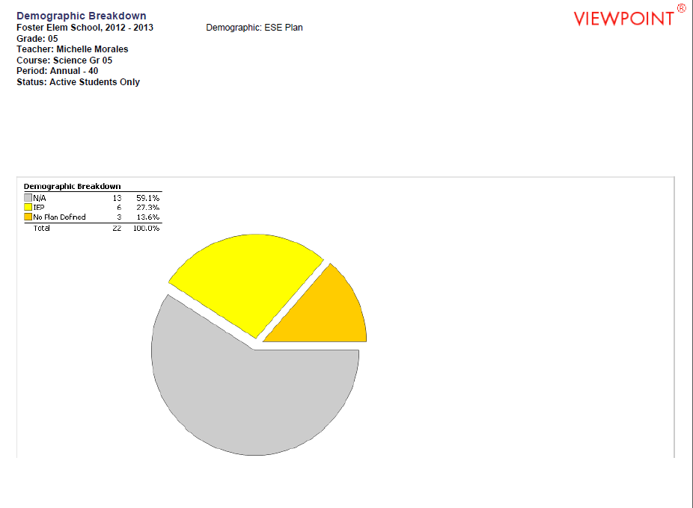

Appendix C Professional Development Record

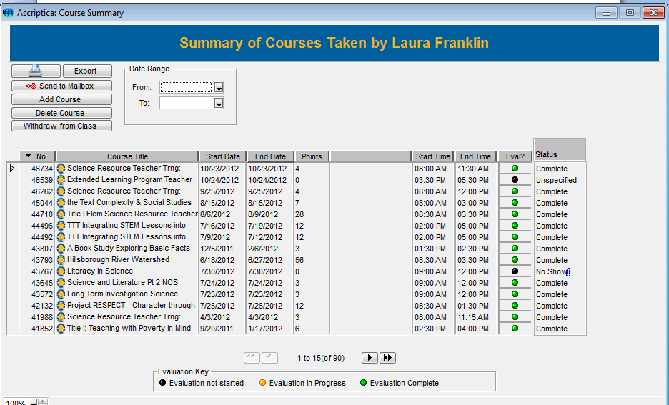

Appendix D- Teacher Survey
Teacher Survey Perceptions on STEM
Please answer honestly and send back to Michele Wiehagen, ROSSAC route 7. Please submit it anonymously.

- I know what STEM is.

Strongly disagree Disagree Neutral Agree Strongly agree

- I know how to incorporate STEM into my daily instruction.

Strongly disagree Disagree Neutral Agree Strongly agree

- I believe all students can learn.

Strongly disagree Disagree Neutral Agree Strongly agree

- I feel that learning can be fun.

Strongly disagree Disagree Neutral Agree Strongly agree

- I feel confident in teaching science.

Strongly disagree Disagree Neutral Agree Strongly agree

- I feel confident in teaching math.

Strongly disagree Disagree Neutral Agree Strongly agree

- I feel confident in teaching technology.

Strongly disagree Disagree Neutral Agree Strongly agree

- I feel confident in teaching engineering practices.

Strongly disagree Disagree Neutral Agree Strongly agree

- I am aware of the Next Generation Science Standards and Frameworks.

Strongly disagree Disagree Neutral Agree Strongly agree

- I believe that student achievement can increase through integrating instruction across curriculum.

Strongly disagree Disagree Neutral Agree Strongly agree

Appendix E Student Survey
Student Survey Perceptions on STEM
Please answer honestly and send back to Michele Wiehagen, ROSSAC route 7. Please submit it anonymously.

- I know what STEM is.

Strongly disagree Disagree Neutral Agree Strongly agree

- I like learning math.

Strongly disagree Disagree Neutral Agree Strongly agree

- I know I am a good student.

Strongly disagree Disagree Neutral Agree Strongly agree

- I like learning science.

Strongly disagree Disagree Neutral Agree Strongly agree

- I like learning technology.

Strongly disagree Disagree Neutral Agree Strongly agree

- I like learning engineering.

Strongly disagree Disagree Neutral Agree Strongly agree

- I know I can think creatively.

Strongly disagree Disagree Neutral Agree Strongly agree

- I am good at solving problems.

Strongly disagree Disagree Neutral Agree Strongly agree

- I am good at inventing solutions.

Strongly disagree Disagree Neutral Agree Strongly agree

- I like working with others in school.

Strongly disagree Disagree Neutral Agree Strongly agree

Appendix F Calendar of PLCs
STEM FOR ALL AND Robotics Support and Competition Schedule (2012-2013)

Final date to submit applications for the program: June 8th @ 4:00PM
All schools will be notified of their inclusion status on June 11th

PLC’s:
Should be attended by at least one person from each school site
Unless otherwise stated, all PLC’s will begin at 3:30 PM and end at 6:00 PM.
Locations will be announced via an email reminder prior to the meeting date.
Wednesday, September 5th
Wednesday, October 3rd
Wednesday, November 7th
Wednesday, December 5th
Wednesday, January 30th
Wednesday, February 20th
Wednesday, March 20th

NXT Support Training/Practice:
Anyone new to the NXT portion of the Hillsborough Robotics Challenge will want to attend the intro training.
NXT Intro Training: Saturday January 12th from 8:00 AM until 1 PM
NXT Support PLC’s will be set up on Thursday’s during the months of January, February, and March.

Appendix G- STEM Curriculum Replacement Lesson
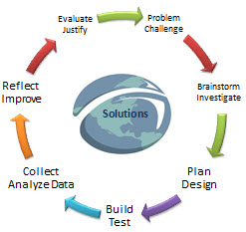
StEm
Title: Hurricane House

Grade Level: 5
Objective:  Students will design a structure that can withstand the wind field from an approaching hurricane. | Focus Concept/s:  Forces  Model Building
Essential Question/s:  How can we help to minimize wind damage to structures within the path of a hurricane? | Connected Benchmark/s  SC.5.N.1.1 - Define a problem, use appropriate reference materials to support scientific understanding, plan and carry out scientific investigations of various types such as: systematic observations, experiments requiring the identification of variables, collecting and organizing data, interpreting data in charts, tables, and graphics, analyze information, make predictions, and defend conclusions.  SC.5.N.2.1 - Recognize and explain that science is grounded in empirical observations that are testable; explanation must always be linked with evidence.  SC.5.P.13.1 - Identify familiar forces that cause objects to move, such as pushes or pulls, including gravity acting on falling objects.  SC.5.P.13.2 - Investigate and describe that the greater the force applied to it, the greater the change in motion of a given object.
Vocabulary:  Force  Hurricane  Civil Engineer  Blueprint  Client  Model  Request for Proposal  Prototype | Materials:  Hair dryer or similar wind producing device  4 index cards  4 Straws  4 Craft sticks  ½ stick of clay  4 Pipe cleaners  fabric scraps  Saran wrap  Tape or glue  Science Notebooks and graph paper.
Problem/Challenge (Engage):

- Set the Stage: Read the Book- The Three Little Pigs- a Graphic Novel on Myon.com

-Present to students the following scenario:

Mama Pig realizes two of her little pigs need help building a home. They have relocated to live in Tampa, Florida. Her biggest concern is that in Tampa, there are hurricanes with winds that blow 120 mph; this has much more force than what the Big Bad Wolf produced. She has contracted you and your partner as the head architectural engineers for this project. She wants you to build her a model of a house using the given materials. She will then test the strength of your house. If your model can withstand her wind test then you and your partner may receive the contract.

-Explain to students that they will become Civil Engineers. Give students the “Becoming a Civil Engineer” Career Profile sheet. Have the students read the career profile from: (from http://www.discoverengineering.org/). (Sheet is attached at the end of the lesson plan), it reads:

What would it feel like to have the expertise to build a school that could withstand an earthquake, a road system that puts an end to chronic traffic jams, or a sports stadium that offers everyone a great view? As a civil engineer, your job would be to oversee the construction of the buildings and infrastructure that make up our world: highways, skyscrapers, railways, bridges, and water reservoirs, as well as some of the most spectacular and high-profile of all engineering feats—think of the world’s tallest building, the towering Taipei 101 in Asia, or the Chunnel, the 31-mile-long tunnel beneath the English Channel. Civil engineers are fond of saying that its architects who put designs on paper, but engineers who actually get things built.

-Have the students paste the career profile in their notebooks.

-Discuss with students the career choice of becoming a civil engineer. How do these engineers impact the world around them?

-Introduce students to the Design Challenge Planning Sheet and have them complete the 1st section by writing the problem/challenge. Depending upon your students abilities break students into teams of 2 to complete this design challenge.
Brainstorm/Investigate (Focus Concepts):

Students will utilize their design challenge planning sheet to brainstorm 4 possible solutions to the problem/challenge. For each brainstormed idea, they should explain the pros and cons of each. If students need suggestions, have them examine the materials to help with their brainstormed designs. Students do not need to use all of the materials in the materials list. However, they are on a budget and may not use more than what the materials list calls for.
Plan/Design (Blueprint):

Once students have brainstormed their ideas. They will need to select their first choice and create a blueprint of their design that will be their prototype. This can be created within their student notebooks or completed on a piece of graph paper. Remind students that blueprints are detailed outline or plans of action. They should include sizes and dimensions of materials including length, width, height, etc.

Pass out the Request for Proposal or RFP paper for the student- read through the proposal with the students.
(Teacher Note- A Request for Proposal or RFP is an invitation to suppliers or builders to submit a plan or proposal to provide a product or service to a client.)

Discuss with your students:
Who is your client?
What type of product do we need to create?
Why should we create a model as the prototype for the client?
What have others done to solve this problem?
What are the item specifications and restrictions?
Show students the different materials they have to work with.
Remind students they must estimate how much of each material they need.

Build/Test:

During this phase of the design process, students are actively involved in the creation of their prototype according to their blueprint. Once groups have completed building their prototype, they may begin to test them. Setup in the classroom an area that has been arranged to model hurricane force winds using a wind powered device such as a hair dryer. Place and X on the table or counter out of masking tape. This area will mark the spot in which the team’s prototype will be placed. From the center of the X measure out a distance of 30-45cm and place a piece of tape in a horizontal line from the X. This will mark where the hairdryer will be placed to simulate the hurricane type winds. Students will record data according to the steps outlined below.

***Teacher note: It may be necessary to test ahead of time the power of the wind producing device from a desired distance to ensure a fair amount of wind to test the prototype. Too much wind and no student designs may work and the same goes if there is not enough wind. Test the force using an assortment of the student materials to see how the wind affects the items. You will want to keep the amount of wind pretty consistent for all engineering teams. The distance may need to be adjusted based upon your discretion.

Collect/Analyze Data:

Prior to testing, students need to create some sort of data collection chart. Remind students that data can include both quantitative and qualitative data. Examples of quantitative data could include: time (until first piece of material is blown away in their design, how long the structure lasted in the position before moving, etc. Qualitative data could include things such as the movement of the structure as the winds affected it, other observations that could be made as a result, etc.

Reflect on Improvements:

Once students have had the opportunity to test and collect data on their design, they can reflect in their notebooks or on their planning sheet, upon the results as it relates to their individual designs. Questions such as: Was it the best solution? Would one of the other ideas have been better? Why or Why not? What would you have done differently? How would you improve your design?

If time permits, students could improve their designs or choose an alternate from their brainstormed ideas to build, retest, collect data, and reflect. Explain that this is the process engineers go through in the real world.
Evaluate/Justify:

Have engineers defend their product. Have them write a brief summary of why their prototype is the most effective and why Mama Pig should select your proposal.
Have engineers think about what their materials represented in their prototype- what types of materials would you need in the final structure?

Appendix H- Intro to STEM lesson
STEM
Design Challenge Introduction Lesson
Grade 5 Suggested Length: 45 min.
Lesson Objective: Students will learn and practice the steps of the STEM Design Process.
Benchmark: SC.5.N.2.1 Recognize and explain that science is grounded in empirical observations that are testable; explanation must always be linked with evidence.
Essential Question: What is the Design Process?
Key Vocabulary:
STEM, Design Challenge, Problem, Investigate, Analyze, Evaluate

Materials: paper, 30 cm of scotch tape, Design Challenge planning sheet, and a copy of the Design Process Model, scissors

Procedure:
1. 5-7 minutes: Ask the students to discuss with a shoulder partner what S.T.E.M. stands for.
Then discuss how STEM may be related to “Design Challenge”. (Possible responses: Design
refers to planning and building something, possibly a structure; a challenge is something
that is not easy; STEM relates to Science, Technology, Engineering, and Mathematics).

2. 8 min: Show the class and distribute the Design Process Model and explain each step. These can be found in the document titled Design Challenge Loops. Students can glue or paste the design challenge loop into their notebooks.
- Problem/Challenge: You or your team will be given a Problem/Challenge to solve.
- Brainstorm and Investigate: Your team will brainstorm possible solutions to the
Problem or Challenge and explain the pros and cons of each possible solution.
- Plan and Design: Sketch a blueprint of the solution you feel is best. Plan how you will
build your design.
- Build and Test: Your team will now use your plan or design to build and test your
solution. Start collecting data as you test.
- Collect and Analyze Data: Create some type of data chart to collect data throughout
your trials. Analyze the data.
- Reflect and Improve: Was it the best solution? Would one of the other ideas have
been better? Why or Why not? What would you have done differently? How would
you improve your design?
- Evaluate and Justify: Discuss your findings with the other engineers in the classroom.
Draw a conclusion using your data to justify your thoughts.
*Use the data and collected observations to design and test a NEW prototype.*

3. 20 – 25 min. Practice: Have your students practice going through each step with a modified
Challenge that is provided below. (Most challenges will last 3-4 days, giving students more
time on each step and the ability to improve and retest their solution. For today, our
objective is to give students the chance to experience every step). Give each student/team
a Design Challenge Planning Sheet (See attached file titled Design Challenge Planning 5th Intro Lesson). The Problem/Challenge is:
“The City of Tampa has asked teams of engineers to design a new building
For Downtown Tampa. They would like a building that adds beauty to the
skyline, but is also stable. Each team will build a paper tower out of paper
and tape as a model for the City of Tampa.”
The objective is to build the tallest tower while maintaining its standing position when the desk is shaken for 10 seconds.

Rules: You cannot tape the tower to anything else (like a wall, chair, or ground). You cannot use materials other than one piece of paper and the provided tape.

4. 5 min. After students have gone through all steps of the challenge, share as a group how they feel about the design process. They can notebook about the following questions or choose certain ones based upon the needs of your class. What did they think worked well? What could they have done better? How well did they work as a team? How successful was their tower?

Appendix I- Robotics Replacement Lesson

Science Benchmark:
SC.5.P.13.3 Investigate and describe that the more mass an object has the less effect a given force will have on the object’s motion.

Pre-requisite Benchmarks:
SC.5.P.13.1 Identify familiar forces that cause objects to move, such as pushes or pulls, including gravity acting on falling objects.
Students should be able to reference Newton’s three laws of motion.

Essential Questions:
Science Essential Question:
How does an object’s mass affect how its motion reacts to a given force?

Engineering Essential Question: (worm gear)
What affect does the worm gear have on an engineering design?

Lesson Length:
- Approximately 2 class periods

Materials:
- 12 LEGO WeDo kits
- 12 Computers
- Robotics Notebooks
- Tractor Pull Instructions
- Hexagram mass set
- Green spring scales
- Snack size Ziploc bags
- Construction paper
- Construction paper rectangles
- Literature Connection: Do-4U the Robot Experiences Force and Motion or National Geographic Text pages 250-263

Pre-requisite Check (Question of the Day):
From Mini Assessment SC.5.P.13.1
Have students use their active thinking skills to answer the following question.
At the circus, an acrobat stood on one end of a seesaw, or lever. A heavy weight was dropped onto
the other end, and the acrobat flew high up in the air. What force was used to operate the lever?
A. magnetism
B. gravity
C. friction
D. electricity
Discuss correct answers with students; you should be able to see misconceptions students may have if you had them use the active thinking technique.
** Note active thinking is simply having students think through every answer choice. Students will write what their thinking is by every answer choice, therefore being able to justify the correct answer, as well as you will be able to see if there are any misconceptions with their learning.

Procedure:
Engage:
- Review with students the function of a spring scale.
- Give each pair of engineers a Ziploc bag, a spring scale, and an assortment of hexagram weights.
- Have students explore by adding different weights in the bag and hanging them from the spring scale.
- Have students record the data from the amount of force required to lift the bag full of weights off their desk.
Mass of hexagram weights in the bag | Amount of force required to lift the bag off the desk
50 grams | Measured in Newtons
75 grams | Measured in Newtons
100 grams | Measured in Newtons
- Discuss the findings as a class. They should come to the conclusion that the more mass the more force it takes to move the mass.

Explain:
- Read Do-4U the Robot Experiences Force and Motion Pages 3-14. Have students pay special attention to the science vocabulary the robots use in the text. If you do not have access to this text then have students read the National Geographic Text Pages 250-263.
- Create a foldable (see attached for an idea) to review vocabulary words: gravity, force, inertia, acceleration, friction. On one pocket, label it vocabulary term, the next one definition, and the last one picture/example. Give students another piece of construction paper to cut “cards.” On one set of cards have students write a vocabulary word on each one. On another set of cards have students write their student friendly definition. On the last set of cards have students draw a picture or example of the terms.

Explore:
- Read to students the following scenario: Max and Mia are visiting their Uncle Bill. He owns a horse racing farm in Kentucky. Owning the farm is a lot of work! Max and Mia have been asked to help, but they surely have a lot to learn first! Uncle Bill has asked them first to bale the hay in the fields.
- Watch the video clip to introduce students to baling hay.
- Have students reflect in their notebooks whether the hay baler is a robot. Have them justify their answer.
- Read to students: Now that you have baled all the hay on the farm it is time to feed the horses. The horses live in a different pasture so you will need to move the bales of hay across the fields.
- Watch the video clip of the tractor moving hay.
- Max and Mia tried to push the bales of hay and did not have any luck. They loved the idea of using the tractor; they want to be able to move the most bales of hay at one time.
Construct:
- Allow the students to build the tractor using the build instructions provided.
- Allow students to program their tractor so it pulls the grey 8x16 plate. (Students should be able to create a simplistic program that will run the tractor. If they are unable to you may want to differentiate the engineering/ programming piece and give students the following version of the program.)
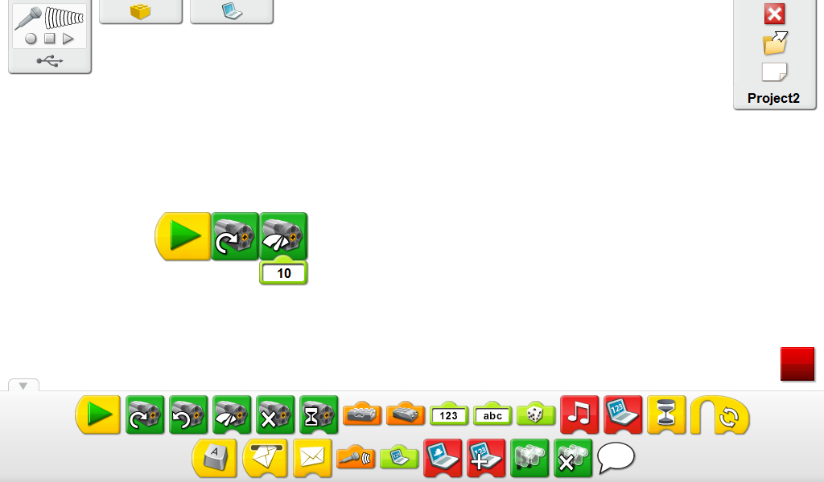

Practice/Application of Concept:
- Tell the students: Max and Mia want to move the hay in the least amount of trips. You will use the green 10 gram mass weights to represent one hay bale.
- Explain to the students that in this investigation they will be increasing the motor speed as we test out different amounts of bales of hay the tractor will pull.
- Discuss with the students that by increasing the motor speed we will be increasing the force at which the tractor is pulling.
- Allow students to explore with the different motor speeds and different masses attached to the tractor. When the tractor can no longer pull at the set motor speed it has reached capacity for the amount of mass it can move.
Have students record their findings of the maximum mass each motor speed is able to pull.
Have them test the tractor at motor speed 3, 5, 7 and 10.

Motor Speed | Maximum mass of hay bales | Number of bales of hay
3
5
7
10

Explain/Evaluate: (Can be through robotics notebooks or questioning)
Science Concept:
- How did the change of mass affect the force needed for each tractor pull?
- Have students use their vocabulary words to explain the motion of the tractor pull?
- Have students create a line graph with their data.

Extend/Enrich: (NOT ALL STUDENTS WILL REACH THIS STEP)
- Students may further explore the tractor by replacing the worm gear with another type of gear. Why was the worm gear chosen for this build? Allow students to work with the backward engineering and the types of gear.

** Teacher note, before starting the investigation with the students you may want to discuss different variables to keep constant:
-the surface the tractor is traveling on
-the distance you want the tractor to have to travel
-the placement of the weights
-Are you stopping the program every time you add weight?

