Appendix 1A
The Design Notebook of Renae Kelly

- Identify the problem

How can I design a spacecraft that will absorb the shock of landing enough to keep two “astronauts” safely inside the craft as it lands? How will I slow it down first, and then how can I get it to “softly or gently” touch down on the landing surface?

- Brainstorming
“If _____ [I do this] ________, then __________ [this] _____ will happen.”

What kind of shock absorber can I design? Do I need large springs or smaller ones?
If I fold the shocks with six sections across the length of the card, ___________will happen.
If I fold the shocks with seven sections across the length of the card, __________will happen.

How can I make sure the craft remains upright and does not tip over upon landing?
If I create a triangle base using three straws and attach the shocks to the straws, then the craft lands upright almost every time I drop it.

- Design
I can tape the triangle straw platform to each of the three shocks and then attach the other end of the shocks to the cardboard platform.

Next I will add the straw streamers to the cabin by poking five holes spaced evenly across the bottom of the upper rim of the glass.

Then I will add cabin and the straw streamers (as thought of in a redesign of the first solution) to the top of the cardboard platform using a rolled up piece of masking tape on the bottom of the cup, and supporting the cup with additional tape touching the sides of the cup and the top of the cardboard platform.

- Build
It appears that the shock absorber with seven sections was superior to the one with only six sections, so I will attach the seven section absorber to the straw platform

Step 1: Fold the three index cards with seven equal sections folded in a back and forth format .
Step 2: Create a triangle shape using three straws, slipped inside another straw where the two ends meet. Tape down, to secure the joint.
Step 3: Tape the ends of each shock absorber to the middle of the cardboard platform, creating a triangle shape with the edges of the three shock absorbers and secure with tape.
Step 4: Tape the other ends of each shock absorber (index card) to one of the straw platform triangle sides so that each shock is in the middle of one side of the triangle, with one shock connected to one side of the triangle.
Step 5: Using a pencil, poke five equidistant holes in the bottom of the upper rim of the Styrofoam cup and insert a plastic straw end from the outside of the cup, and tape down the two to two and a half inches of the straw inside the cup to the side of the cup in order to keep the excess straw pieces inside the cup out of the way.
Step 6: Bend the straws so that they are angling about 45 degrees from the upper edge of the cup.
Step 7: Attach the cup (cabin) to the cardboard platform with a loop of tape on the bottom of the cup, so that is exactly at the center of gravity in order to land in an upright position. Secure it with more strips of tape on the sides of the cup and on the top of the cardboard platform.
Step 8: Set two astronauts inside the cabin of the spaceship. Secure with the rubber bands hooking onto each of the straw streamers and then across to the opposite side of the cup and straw streamer on that side. Secure with tape to keep the rubber bands from slipping out of place.
Step 9: Launch and watch your spaceship land safely upright, with the astronauts safely inside the spacecraft the entire time.

- Test and Evaluate
Each time I dropped the cardboard platform with the shocks and landing support attached to it, it landed upright, but fell at a fairly fast speed. It was then that I decided I must find a way to slow it down and thought of adding the streamers of straws from the cabin of the aircraft.

Dropping the redesigned spacecraft with the straw streamers, it consistently landed fairly gently and upright each time, without ever ejecting any of the astronauts.

- Redesign
What can I add to the craft to help it slow down as it prepares to land?
Can I find a way to use some of the straws as “streamers” to slow the speed down as it is dropped from greater heights, so that the landing is more smooth?

How might I be able to make use of the three rubber bands and mini-marshmallows that were included in the materials list?
If I use the rubber bands to cross over the top of the cabin, attaching to the straw streamers, I can be more assured that the astronauts will not bounce out of the cabin and will remain safe.

If I use the miniature marshmallows as landing gear on the straw landing platform, it may be able to soften the landing even more. I would tape one in each corner of the triangle and then tape two more on each of the sides, sharing equal distance between each of the marshmallows.
- Share the solution

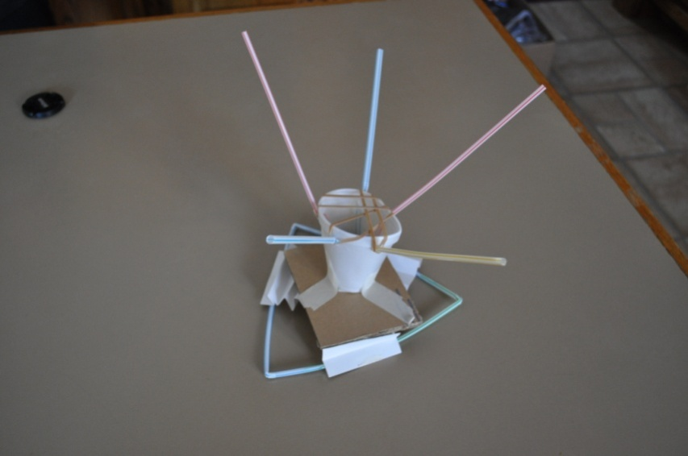

Appendix 1B
(will include scanned copies of student engineering notebook pages, but do not have access to the scanner from home)
(Will include pictures of students’ prototype solutions to the challenge)

Categories | H | T | S | Percentage | Total
Complete and Thorough Documentation: | 24 | 9 | 10 | 15.7% | 43 total
Redesign - Too General for Ideas to Move Forward: | 11 | 54 | 47 | 40.9% | 112 total
No Redesign after first testing prototype: | 26 | 19 | 37 | 29.9% | 82 total
Incomplete report, important documentation missing: | 31 | 5 | 1 | 13.5% | 37 total

Appendix 2A
Pre and Post Content Assessment data

Contest Pre and Post Data
Final Score | Post |  | Final Score | Pre
1 |  |  | 2
2 |  |  | 2
2 |  |  | 2
2 |  |  | 3
2 |  |  | 3
2 |  |  | 3
2 |  |  | 4
3 |  |  | 4
3 |  |  | 4
3 |  |  | 4
4 |  |  | 5
4 |  |  | 5
4 |  |  | 5
4 |  |  | 5
4 |  |  | 5
4 |  |  | 5
4 |  |  | 5
5 | Mean | 6.648 | 6 |  | Mean | 7.407
5 | Median | 5 | 6 |  | Median | 7
5 | Mode | 5 | 6 |  | Mode | 7
5 |  |  | 6
5 |  |  | 6
5 |  |  | 7
5 |  |  | 7
5 |  |  | 7
5 |  |  | 7
5 |  |  | 7 |  | median
6 |  |  | 7
6 |  |  | 7
6 |  |  | 7
7 |  |  | 8
7 |  |  | 8
7 |  |  | 8
7 |  |  | 8
7 |  |  | 8
8 |  |  | 9
8 |  |  | 9
8 |  |  | 10
9 |  |  | 10
10 |  |  | 10
10 |  |  | 10
10 |  |  | 10
10 |  |  | 11
11 |  |  | 11
12 |  |  | 11
12 |  |  | 12
12 |  |  | 12
12 |  |  | 12
13 |  |  | 12
14 |  |  | 13
15 |  |  | 14
16 |  |  | 15
16 |  |  | 17
359 |  |  | 400
Range: 15 (1-16) Range: 15 (2-17)
Four students answered at least 70% of the questions correctly on the post test, while only three students answered with a passing score on the pre test.

Appendix 2B
Results for: Nebraska 4-H Robotics : GPS/GIS and SPIRIT Content Quiz – Post
Question | 6 | 7 | 8 | 9 | 10 | 11 | 12 | 13 | 14 | 15 | 16 | 17 | 18 | 19 | 20 | 21 | 22 | 23 | 24 | Final Score
Pre Content | 28 | 18 | 25 | 37 | 13 | 36 | 9 | 41 | 11 | 13 | 29 | 27 | 23 | 11 | 15 | 16 | 18 | 21 | 9 | 400
Post Content | 31 | 18 | 18 | 26 | 13 | 27 | 10 | 26 | 17 | 16 | 24 | 19 | 19 | 15 | 18 | 18 | 17 | 19 | 8 | 359
Amount of Change | 3 | 0 | -7 | -11 | 0 | -9 | 1 | -15 | 6 | 3 | -5 | -8 | -4 | 4 | 3 | 2 | -1 | -2 | -1 | -41

6) | Multiple Choice: For each of the following questions, circle the letter of the answer that best  answers the question.  1. In order to follow a delayed sequence of set movements, without direct user control, a  robot must be _____

 |  | Percentage | Responses
A. controlled by a remote. |  | 13.2 | 7
B. computerized. |  | 26.4 | 14
C. programmed. |  | 58.5 | 31 +3
D. trained. |  | 1.9 | 1
Total responses: |  |  | 53

7) | 2. A programming “loop” does which of the following?

 |  | Percentage | Responses
A. Starts the program code |  | 26.4 | 14
B. Stops the program code |  | 24.5 | 13
C. Performs multiple functions |  | 15.1 | 8
D. Repeats a section of program code |  | 34.0 | 18 +0
Total responses: |  |  | 53

8) | 3. A computer program consists of ______ that tells the computer to do something.

 |  | Percentage | Responses
A. sensors |  | 47.2 | 25
B. code |  | 34.0 | 18 -7
C. lights |  | 11.3 | 6
D. robots |  | 7.5 | 4
Total responses: |  |  | 53

9) | 4. Which of the following enables a robot to investigate and react to its environment?

 |  | Percentage | Responses
A. Tires |  | 28.3 | 15
B. Sensors |  | 49.1 | 26 -11
C. LCD panels |  | 13.2 | 7
D. Mechanical arms |  | 9.4 | 5
Total responses: |  |  | 53

10) | 5. What is a computer program?

 |  | Percentage | Responses
A. Computer generated text |  | 19.6 | 10
B. The hardware that controls a computer |  | 45.1 | 23
C. Instructions written in a language a computer understands |  | 25.5 | 13 +0
D. Language that is built into a robot |  | 9.8 | 5
Total responses: |  |  | 51

11) | 6. Which of the following is a wireless connection?

 |  | Percentage | Responses
A. Bluetooth |  | 52.9 | 27 -9
B. RCX |  | 23.5 | 12
C. USB |  | 13.7 | 7
D. Serial port |  | 9.8 | 5
Total responses: |  |  | 51

12) | 7. When programming your robot, a switch block or if/else/then statement is used to _____

 |  | Percentage | Responses
A. ask a question. |  | 18.9 | 10 +1
B. stop the program. |  | 39.6 | 21
C. speed up the program. |  | 32.1 | 17
D. repeat the code. |  | 9.4 | 5
Total responses: |  |  | 53

13) | 8. Which of the following is an example of multi-tasking?

 |  | Percentage | Responses
A. Having your robot move forward on a table |  | 11.8 | 6
B. Having your robot turn to the left for 2 seconds |  | 31.4 | 16
C. Having your robot measure a distance as it identifies an object to lift |  | 51.0 | 26 -15
D. Having your robot use its light sensor |  | 5.9 | 3
Total responses: |  |  | 51

14) | 9. The process of refining an instrument, like your robot, so that it is as accurate as possible  by collecting information about how far your robot will travel in a given amount of time  and using the information to estimate how long it will take the robot to go a given distance  is called _____

 |  | Percentage | Responses
A. a ratio. |  | 30.2 | 16
B. the Pythagorean Theorem. |  | 22.6 | 12
C. a threshold value. |  | 15.1 | 8
D. calibration. |  | 32.1 | 17 +6
Total responses: |  |  | 53

15) | Amie and Cody are engineers working to design a robot that will be able to plant trees in a fruit  production orchard with apples, apricots, oranges and/or peaches. They need your help to apply  the steps of the Engineering Design Process. Answer the questions below to provide your  assistance.  10. Which of the following would not be part of the problem that Amie and Cody need to  solve in order to begin designing their robot?

 |  | Percentage | Responses
A. The robot must be able to travel in standing water. |  | 30.2 | 16 +3
B. The robot must be able to avoid obstacles such as large rocks and existing trees. |  | 34.0 | 18
C. The robot must be able to go to a specific location, using GPS. |  | 26.4 | 14
D. The robot must be able to dig a hole. |  | 9.4 | 5
Total responses: |  |  | 53

16) | 11. As a part of the design process, Amie and Cody visit an engineering library to look at  existing patents. Which step in the Engineering Design Process are they doing?

 |  | Percentage | Responses
A. Identify the problem |  | 21.2 | 11
B. Research the problem |  | 46.2 | 24 -5
C. Select a solution |  | 21.2 | 11
D. Construct a prototype |  | 11.5 | 6
Total responses: |  |  | 52

17) | 12. Amie and Cody are reviewing the possible solutions to select one to test by building a  prototype. Which of the solutions below do you think is most important to the project?

 |  | Percentage | Responses
A. The robot should operate quietly to lessen the disturbance to wildlife in the area. |  | 7.5 | 4
B. The robot should be on tracks to cover diverse terrains. |  | 18.9 | 10
C. The robot should have a camera so the operators can see what it is doing from anywhere with an Internet connection. |  | 37.7 | 20
D. The robot should have a robotic arm that can do tasks such as dig the hole, place the tree and replace the soil. |  | 35.8 | 19 -8
Total responses: |  |  | 53

18) | 13. Which of the following strategies would be important to evaluating Amie and Cody’s  solution?

 |  | Percentage | Responses
A. Testing the prototype by planting trees in different orchard settings or environments |  | 25.5 | 13
B. Asking other engineers on your team to review their design and prototype |  | 19.6 | 10
C. Check the design with specialized computer software to find potential flaws |  | 17.6 | 9
D. All of the above |  | 37.3 | 19 -4
Total responses: |  |  | 51

19) | Technology – Robotic Programming  Use the obstacle course shown to answer the robot programming questions below. The dashed  line(s) shows the path of the robot. The solid line is a black electrical tape one inch wide.  14. Which sensor is most likely used to navigate the robot between points A and C?

 |  | Percentage | Responses
A. Light |  | 28.3 | 15 +4
B. Sound |  | 24.5 | 13
C. Touch |  | 20.8 | 11
D. Ultrasonic |  | 26.4 | 14
Total responses: |  |  | 53

20) | 15. Which of the marked points on the image above corresponds to the pseudocode shown  here:  Loop 4 times – Forward one tire rotation, Turn ninety degrees right

 |  | Percentage | Responses
A. Point B |  | 34.0 | 18
B. Point D |  | 34.0 | 18 +3
C. Point E |  | 20.8 | 11
D. Point F |  | 11.3 | 6
Total responses: |  |  | 53

21) | 16. At point F, the robot spins counterclockwise for at least 1080 degrees. Which  pseudocode line would cause the robot to turn 1080 degree?

 |  | Percentage | Responses
A. Forward, left motor 10 rotations |  | 15.4 | 8
B. Forward, right motor 10 rotations |  | 34.6 | 18
C. Forward turning to the left, left and right motors 10 rotations |  | 34.6 | 18 +2
D. Forward turning to the right, left and right motors 10 rotations |  | 15.4 | 8
Total responses: |  |  | 52

22) | 17. Which of the marked points in the image above corresponds to the pseudocode shown here: Wait until touch, reverse two wheel (720 degrees) rotations

 |  | Percentage | Responses
A. B |  | 25.0 | 13
B. D |  | 23.1 | 12
C. E |  | 32.7 | 17 -1
D. F |  | 19.2 | 10
Total responses: |  |  | 52

23) | 18. Which of the sensors listed would most likely not be used to complete this challenge?

 |  | Percentage | Responses
A. Light |  | 3.8 | 2
B. Sound |  | 36.5 | 19 -2
C. Touch |  | 26.9 | 14
D. Rotation |  | 32.7 | 17
Total responses: |  |  | 52

24) | 19. Which pseudocode is the most reliable way to program the robot at point C (find the tower and then turn, using an ultrasonic sensor) in the image above?

 |  | Percentage | Responses
A. Forward 2.3 wheel rotations to the tower |  | 20.8 | 11
B. Forward 828 degrees to the tower |  | 35.8 | 19
C. Forward 1.6 seconds to the tower |  | 28.3 | 15
D. Forward until 15 inches from the tower |  | 15.1 | 8 -1
Total responses: |  |  | 53

Appendix 3
Sampling of Pre and Post Interest Survey Questions

Pre
Post

Pre
Post

Pre
Post

Pre
Post

Pre
Post

Pre
Post
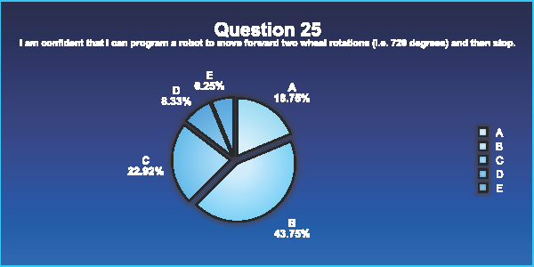

Appendix 4A
Student Survey Results
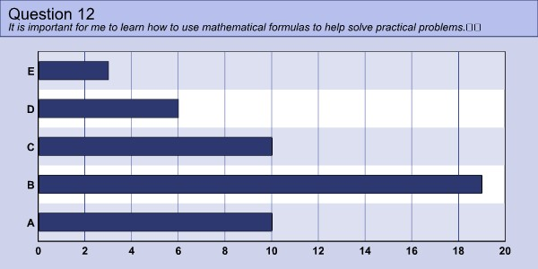
60 percent of students agree mathematical formulas are helpful in solving problems.
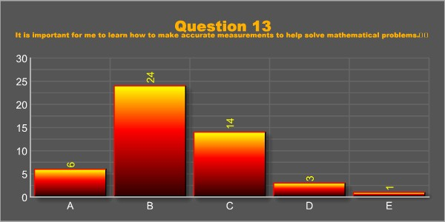
62% think it is important to use accurate measurements to help solve mathematical problems

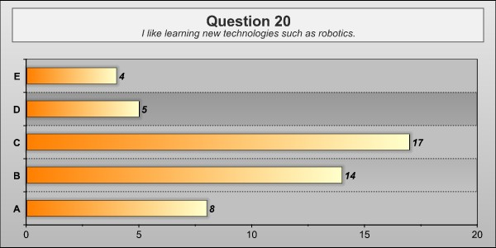
45 % of students liked learning about robots, while 35% were neutral about it.
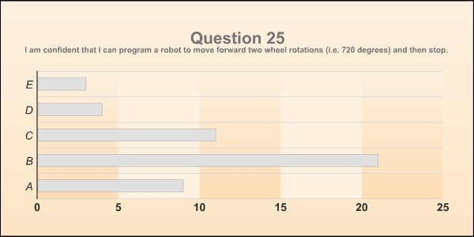
62.5 % were confident they could program the robot similar to the challenge in lesson one.
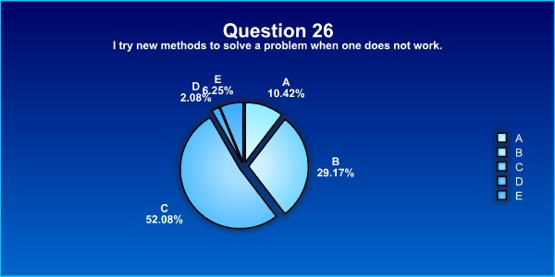
Only 39.6% of the students try new methods to solve a problem when one does not work.
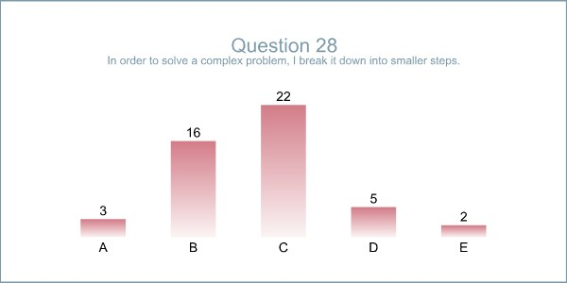
Only 39.6 % break down a problem into smaller steps to solve a complex problem.
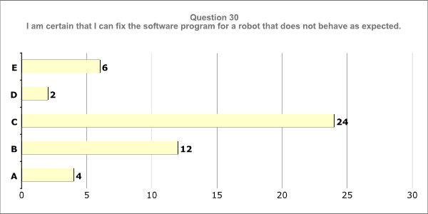
Only 33% felt they could fix a software problem when the robot did not behave as expected.

Appendix 4B
Student Survey Feedback
For you personally, what was the best part of the lesson? Why?
Complete list of all responses given to this question
- playing with the puppy robot
- working with the robot
- working with the robots
- messing around with the robots but really i didnt really like the unit.
- the robot
- learning about robots because ive never seen one like the ones we used
- The best part of this project was that we got to see how the robot goes back and forth.
- watching the robot run
- watching the robot run fast becouse it was the most excting part
- Making the robots turn
- I liked programing the robot.
- makeing the robot move because it helped see far it wint
- i think that the bast part of the lesson was seeing the robots acctually do what you showed them to do.
- the best part of the lesson was when we got to see the robot do the actions that we programed
- i think the best part of this lesson is seeing how the robot worked when the programing is set
- downloading the programms and seeing if they would work
- makeing the robot move because it helped you see how much u did
- seeing your robot do what you told it to do
- The best part was that we actully made the robot move which was very fun.
- the best part was seeing the robot move because i know that i was the one who did it
- the best part was watching the robots do what you told them to do
- being able to program a robot to do what i want it to
- I liked making the robot do different things because I like to expirement and try different things.
- The best part to me was when we got to test the programs because we got to see if our programs worked
- i think the fun part was when we prgramed the robot
- programing the robot to go forward
- Having the robot to go a certain distance and the come back.
- Calculating the rotations of distace because it was the easier thing to do
- making the robot move
- getting to make the robot a certain distance and back
- The best part was that we were able to see what we had done.
- full speed ahead because you made it go fast
- none of it it was to confusing

- I didnt have a favorite part of the lesson. I didnt like it.

- i honestly think that it wasnt that interesting to make the robots! because im not really that into robots!
For you personally, how could the overall lesson or activity be improved?
Complete list of all responses given to this question
- if we did it longer

- more activiys
- getting more time to work on the project
- BY maybe working more on the project
- slow it down
- add another day so we could do the robot challenge
- I think that the lesson should have been longer.
- I think the lesson could be improved by more time to program different things on the robot instead of just moving around so I mean like talking or jumping.

- letting us figure more stuff out kon uor own
- well they could make it alot more interesting for everyone and let the kids choose the partners they wanted and let the kids to more movements instead of just straight lines and twisting
- Maybe have us do diffrent experiments and we teach the class what other things can be done by the robot.
- you could let us build the robots
- you could lets us build the robots
- if we got to actually make the robot instead of just programing the robot.
- by us making the robot on our own
- to try and learn more.
- more on how to program and the affects of it
- i would have liked a little more guidance in the project
by getting a better understanding
- i think that it could be improved by makind it easier and less math.
- More directions.
- i think the lesson could be improved by making less math in it
- trying to make the programing a little bit easyer then how it is because it is very confusing
- doing more videos to explane better
- like sometimes the things that they made us do were confusing so i didn't understand them.
- it could be better explained on wheels and distance because the videos were very confusing and i had no idea what i was doing
- having a little easyer dirrection on how to make the program
- I think it could be improved by making the "blank canvas" easier to understand.
- Help people so they can enjoy it like everyone else.
- have battles
- have races to see whos is beter
- i think it needs to be more fun! because i thought it was boring and i was nott interested!
- make it more interesting

- you could have done a better program to make fun
- It could be a little more fun by making the videos or robotics a little harder to do.
- making it go straiter
- by having the robot go faster
- Nothing
- i dont really know
- at the end i felt smarter

Anything else to tell me about this activity?
Complete list of all responses given to this question
- it was fun
- it was fun
- It was really fun but went really fast
- It was fun to do.
- Fun
- A.W.E.S.O.W!!!!!
- It was interesting.
- it was fun to program them
- I just really liked when we made it move. I really liked that.
- the activity ws very exciting
- I liked when we seen the robot move
- That it was an o.k. activity for us to do.
- this activity was kind of fun but not much
- it was boring
- it was boring
- i thought it was boring
- it was fun ang kinda boring
- it shold be more fun, it was veryyyyyyyyy boring and dull and i was very disappointed
- i think we need to have some more fun and not watch all the videos. they got verrrrrryyyy boring
- i did not like eny of the robots
- i didnt like wheels and distance
- have races and have it go longer distances.
- It would be more interesting if you would have harder tricks like spinning or jumping
- it would of been funner if we could of just done what we wanted to on the robot
- no nnot really
- no
- nooooo
- No
- noi
- no
- nope
- no
- no!
- no
- no
- No
- nope
- no
- Nope
- no
- no
- No.
- no.
- no

