Can Entomophobia be reversed in female students in a classroom setting?
Angeline Pesek-Brown
Action Research
Spring 2010
The Problem:
Insects and spiders are easily attainable scientific specimens for classroom use. But, when insects and spiders are introduced in my classroom setting, girls often recoil in fear, scream, or become bystanders in the activity. Some refuse to participate at all. This fear limits the education of female students, and their possible future career choices. It also limits the teacher when trying to teach concepts using these creatures such as classification, observation and inquiry skills, ecology, and environmental conservation. All of these concepts are science education priorities.
Research on gender:
Research shows that the fear of animals in children is more prevalent than fear of the dark (Meltzer, Vostanis, Dogra, & Doos, 2009). The most prevalent fear in girls was fear of animals (Meltzer, Vostanis, Dogra, & Doos, 2009). In the classroom, research shows there are gender differences in students when it comes to hands-on science activities involving living creatures. Boys are not fearful of these creatures, are more curious, and seem to have a greater knowledge and interest in nature (Shireen Desouza & Czerniak, 2002). Girls, on the other hand, were fearful of arthropods, and were more submissive during those classroom activities (Shireen Desouza & Czerniak, 2002).
Some research suggest that a girl’s fear of spiders and snakes originates in infancy, and is related to being habituated to negative facial expressions when presented with a spider or snake (Rakison, 2009). Girls in this study could more rapidly associate the pictures of snakes or spiders with the negative facial expression. Boys in this study did not have the same reaction, leading to the conclusion that the human female fear mechanism functions differently (Rakison, 2009). This may contribute to female student’s fear of these creatures.
***Research on Exposure to Nature:
Once, during a summer school class, I took a group of students to a petting zoo. One of the girls was hysterically afraid of the chickens. She had never seen a live chicken before. When I was a girl, we often caught insects, went on nature walks, and studied all sorts of creatures. This, I believe, is why I have an appreciation of these things, and am not afraid of them. So I asked myself, would exposure to these things change the minds and attitudes of girls that are afraid? Some researchers have studied what effect exposure to these animals has had on female students.
One researcher’s reason for this fear could be lack of experience with snakes, spiders, insects, and animals as a whole. Pavol Prokop in a study with Slovakian school students concluded that children with pets benefit by increasing their knowledge of animals (Prokop, Prokop, & Tunnicliffe, 2008). Prokop and his colleagues suggested that science classroom activities should be more focused on raising invertebrates in order to change children’s attitudes and increase their knowledge about them (Prokop, Prokop, & Tunnicliffe, 2008).
Girls have little knowledge of wildlife compared to boys (Huxham, Welsh, Berry, & Templeton, 2006). Their knowledge of mammals was far better than those of birds and arthropods (Huxham, Welsh, Berry, & Templeton, 2006). In this study, boys fared better at knowledge and identification of species at all ages but the youngest. Girls in particular lacked knowledge of even local species (Huxham, Welsh, Berry, & Templeton, 2006). The researchers in this study concluded that study of easily attainable species of arthropods was not accessible to students and because of this, girls in particular lacked knowledge of these species (Huxham, Welsh, Berry, & Templeton, 2006).

This may contribute to the reason why numbers of women working in science careers are still below men. The field of entomology is a prime example. According to the Council of Entomology Department Administrators, the number of graduate level female entomologists is well below that of male entomologists. Data collected by CEDA in 2009 shows that 303 men were full professors of entomology in an accredited institution of higher learning, while there were only 39 females working in the same capacity. Any interest that can be improved or generated in the classroom will hopefully lead students, male or female, into entomology or careers in other scientific fields.
The purpose of this study, therefore, was to determine if there can be a change in attitude among female students in regard to arthropods, through education about specific species, as well as exposure to live species. Through this two-fold approach, hopefully minds of female students will be changed and will, at the very least give them an appreciation of nature, but at the upmost, interest them in the biological sciences.
DESCRIPTION OF THE SETTING
** The setting for this study was two fourth grade science classrooms in Gibbon, Nebraska. This small school located in south central Nebraska is in a town of approximately 1,700 residents. The population for this school is diverse, with nearly fifty percent English Language Learners, and forty-eight percent are at the poverty level. There are 54 students in this class, thirty are female, and twenty-four are male.
This study centered on whether or not a female student’s perceptions about insects could be changed through education and exposure. Therefore, the main participants were female, though the male students participated in classroom activities. These participants were selected through an initial questionnaire. This questionnaire centered on a student’s perceptions of animals in general, whether or not they have pets at home, their time spent in nature areas, and their perception of insects. Three female students with negative perceptions of insects were selected. Two female Hispanic students and one female Caucasian student were the selected participants. These three students were interviewed to get additional perspectives about their feelings having to do with insects.
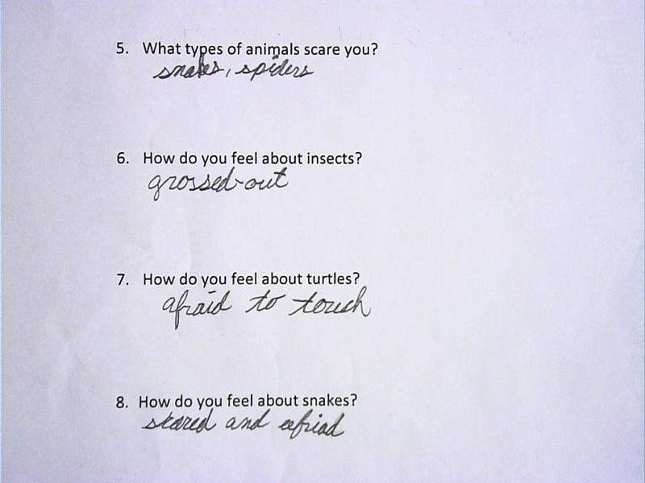
This is a small section of student A’s questionnaire. She shows on question number 6 that she is “grossed out” by insects.
DESCRIPTION OF DATA COLLECTION/TRIANGULATION
After the initial questionnaire, all the students in the class were educated about different types of insects. They learned about their eating habits, their preferred environment, and their lifecycle. All of the students in the class were also exposed to both live and preserved insect specimens. They were allowed to interact, touch, and in some cases, hold the insects. In addition, they listened to a presentation given by a female entomologist.
After each of the classroom experiences, the students wrote in their journals about their experiences that day, and what their feelings were about the particular activity. The journals were collected and the three test subject’s entries were used as data to determine whether or not the education and exposure given to them was effective. Pictures were taken of the various activities, in order to have a record of the student’s attitudes, feelings and level of participation during the activities. Teacher observations of the three female student’s participation in the activities were collected.
After all of the classroom sessions, the three female students that were selected for the study were again interviewed. They were asked what part of the classroom experiences they liked, what they did not like, and what information they learned about insects. They were also asked if their perceptions about insects had changed, and what changed their minds.
RESEARCH METHODOLOGY RATIONALE
According to Tierney and Dilley, interviewing is key to many forms of qualitative education research (Tierney, W.G.; and Dilley, P., 2002). It is a way of determining what a researcher thinks or feels about his or her world (Rubin, Herbert J.; and Rubin, Irene S., 2005). Interviewing was important to my research because I heard from my students themselves how their perceptions were formed, what their perceptions are, and how they changed because of what I did in my classroom.
In the book Observation Techniques, Structured to Unstructured, Bill Gillham writes that “structured observation is as accurate as a questionnaire is of what people think” (Gillham, 2008). Observations were an important component in my research because I could see how my students interacted and reacted during the project, providing an extra piece of useful data to determine if the project was successful.
DATA ANALYSIS
SELECTION
In all, three female students were selected for the study based on their initial questionnaire, which indicated that they were scared of insects. This questionnaire also asked how many pets they have at home, what type of pets they have, what type of outdoor activities they have participated in, and what types of animals they had held in their hands. All of the students selected for the study had pets ranging from horses to brine shrimp. As for the animals they have held or touched, all three girls stated that they had held a snake at least once, but none had or would touch an insect. As stated before, all of the girls had stated that they were scared of insects.

INITIAL INTERVIEW
The girls were then interviewed about their feelings for insects. The feelings were:
A: “I think that they are gross, but I am interested in them”.
B: “Sometimes they scare me because once a black beetle bit my neck”.
K: “I don’t like ants because they bite”.
When asked on the questionnaire how their parents felt about insects, all of the girls selected stated that their mothers were scared of insects. Student B also added that her grandmothers, older sister and younger sister were also afraid of insects. All of the girls stated that their fathers were not afraid of insects, and Student A stated that her father was “not afraid of anything”.
CRICKET ACTIVITY
In the first class period, the lifecycle and anatomy of the cricket was discussed, and students worked with live crickets that were contained in Petri dishes that were taped shut to prevent escape of the insects. The girls all indicated that crickets had “three parts”, “antennae”, “wings”, and “lots of predators”. When asked how they felt about this activity, the girls had this to say:
A: “Gross, because I think that insects are gross, but they are interesting to learn”.
B: “I’m okay about them, but sometimes they creep me out”.
K: “I feel excited about working with insects because they don’t bite and hurt people.”
Teacher Observations
Student A appeared to hang back at first, but then picked up the Petri dish and examined the cricket inside. She spoke to her classmates about the number of legs the insect had, and one of them wrote it down. At this point, she seemed to be more relaxed about the activity.
Student B joined right in to the activity. She was the one in the group writing down the observations. She noticed that the cricket given to her group was missing antennae. She then asked why it was missing, to which I replied that it probably happened while they were being captured for class. Student B seemed relaxed, was smiling through most of the activity, and seemed to enjoy herself.
Student K had a very apprehensive expression on her face when the activity began, but soon joined in. She was pointing to the cricket, actually picked up the dish on a couple of occasions, and even provided some observations.
FILM
The next day, the students were shown a film about the lifecycles of ants, silkworms, and spiders. There was a discussion following the film on the difference between spiders and insects. The girls wrote in their journals about the “silky clothes” silkworms provide for us, how “ants can lift more than they weigh”, and that “spiders have eight legs, but insects have only six”. For their feelings on this activity, the girls had this to say:
A: “I feel cool, because they are nice to learn”.
B: “I absolutely love them”.
K: “I feel great. I want to touch some of them”.
COCKROACH ACTIVITY
On Wednesday of that week, I allowed the students in groups to write down observations on Madagascar Hissing Cockroaches, which were also in sealed Petri dishes as the crickets were. The students could then examine the cockroaches from all angles. We then read and discussed information on these insects, and made a list of what we learned on the board. The students then wrote in their journals about this activity. The girls learned “the difference between a male and female”, “how they hiss out of holes on their bottom”, and that it “has sticky feet, and does not fall when you turn it upside down”. For their feelings, the girls had this to say:
A: “Cool, because it is nice to learn”.
B: “I love them”.
K: “Great, I want to hold them”.
Teacher Observations
Student A was slightly apprehensive and held back at first when the dishes containing the cockroaches were handed out to the groups. She soon joined in the activity, picking up the dish carefully with two fingers and turned it upside down. She told her group scribe to write down that the cockroach’s feet were sticky. She was then smiling and pointing as she counted the legs, and noticed that her group’s cockroach was female after being shown the difference between a male and female hissing cockroach.
Student B joined in the activity immediately, but asked if the cockroaches could get out of the container. She started leading the group (which is a normal role for her), and became the scribe, writing down the information as her group made observations on color, gender (they had the only male), leg number, and the fact that they could not hear it hissing.
Student K joined in the activity, but sat a bit away from the group. As the observation time went on, she moved closer, and by the end she was leaning down with her nose nearly touching the Petri dish. She was smiling, pointing, and discussing what she saw with the rest of her group. They took observations on number of legs, number of parts, gender, and color. Student K also raised her hand to add to the class discussion on the insect.
LADYBUG ACTIVITY
During the following class period, the class examined Ladybugs, again in Petri dishes. Before examining them, we started a K-W-L chart. The students stated that they knew that they had spots, the number of spots equals their age, they had three life stages, they fly, they are an insect, and they are different colors. They wanted to know how long their wings are, how long they live, why they have spots, whether or not they have an exoskeleton, what they eat, and how long they can fly. We then read and discussed information on the Ladybug, and listed what we learned, and which items on the “know” list were incorrect. Any questions left were assigned to certain students to research and report to the class the next day. The girls in the research project wrote in their journals that “Ladybugs were sent into space in 1999”, “the females are bigger than the males”, and “Ladybugs do have an exoskeleton”. Their feelings on the activities were:
A: “Cool, it is nice and cool to learn about insects”.
B: “I love them”.
K: “I am really excited”.
Teacher Observations
Student A was happy to join into this activity; she was all smiles and was bouncing in her seat. She and another group member had their heads down almost touching the dishes with their noses. She used her magnifying glass to see the insects better. She and her group members wrote down that all of their Ladybugs had different numbers of spots.
Student B joined in and took over as the leader. She showed the others how to use the magnifying glasses, and was holding the dish for most of the activity. She was observing the insects from all angles with the magnifying glass. She was also telling the scribe of their group to write down observations on spot number, leg number, and color of the Ladybugs.
A VISIT FROM A FEMALE ENTOMOLOGIST
The last activity was a visit from a female entomologist from the University of Nebraska-Lincoln. She discussed the parts of an insect, gave an introduction of the insects and non-insects that she brought with her, and also discussed how while some insects can be harmful, the majority of them are not. She also had the students guess which of the creatures that she brought with her were native to Nebraska. During the rest of class, the students were allowed to view boxes of mounted insects including some tropical butterflies and a huge Hercules beetle. The students were also allowed to hold and touch mealworms, Tobacco Hornworm caterpillars, Madagascar Hissing Cockroaches, and a six inch long millipede (which is not an insect, but still an arthropod). One live specimen presented, the Giant Water bug, was not available for the students to hold, but for them to observe only. Finally, the students painted using maggots that were dipped in paint and then allowed to crawl across the paper. The girls had this to say about this class in their journals”
A: “I learned that water bugs can bite. I learned that millipedes do not bite”.
How do you feel about working with the insects?
“Nice, because they are nice to learn (about)”.
B: “That millipedes aren’t insects and that mealworms turn into beetles, and that giant water bugs are harmful”.
How do you feel about working with the insects?
“I love them”.
K: “Some insects are harmful. Some of them are scary”.
How do you feel about working with the insects?
“I was kinda afraid, but I felt great”.
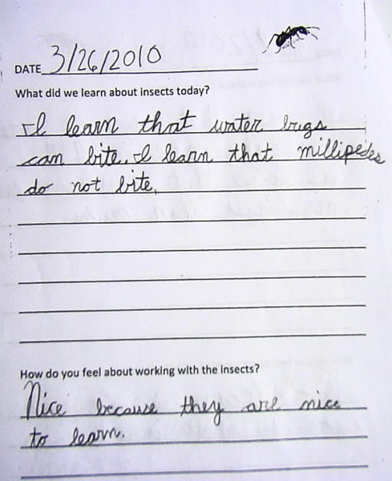
This is a page from the insect journal written by Student A. Notice that when she writes about her feelings, she feels “nice”.
TEACHER OBSERVATIONS
When the live insects and other arthropod species were taken out so that the students could touch them, Student A stood at the back of the group and watched for a minute or so. She then moved toward the students holding the hissing cockroaches. She first touched one being held by another student with one finger. She petted the insect like you would a dog or cat with her finger. She then held out her hand flat and the other student holding the insect put it in her outstretched hand. She grinned and posed with the insect when she noticed that I was taking pictures. She then handed the insect off to another student and watched as the entomologist was talking to some students about the water bug she brought with her. Student A then moved to the containers of mealworms, and again reached in with one finger. She then moved to some students that were holding caterpillars and watched for about a minute. She then petted it like she did the cockroach, and then picked up the caterpillar from another student and placed it in her own hand. She then looked for me and again posed for a picture. Then she gave the caterpillar to another student and walked over to where the giant millipede was climbing the arm of another student. She stood back for awhile, and then reached out with one finger to touch it. When the other student asked if she would like to hold it, she said “yes”. The other student peeled the millipede off of his arm and got the creature to start climbing Student A’s arm. She closed her eyes at first, but then opened them and was smiling as the arthropod climbed her arm. When the head got to her shoulder, she told another student that they could take it. During the maggot painting, student A was very intrigued with the wiggly creatures as they crawled across her paper. Her head was bent low close to the paper, and she was following them with her eyes.
Student B stood in back of the group for quite a while. She first walked up to the millipede, but then walked away from it and went to put on her sweatshirt. She then went back to that group, and asked to hold the millipede. She let it climb up her sweatshirt covered arm. When it got halfway up her arm, she told another student to take it off, and the student did. She then moved to the caterpillars, and asked to hold one. She held it in her flattened hand, and then picked it up to put it in the hand of another student. Student A walked over to the mealworms, and looked at them, but did not attempt to touch them. She also got really close to the water bug being held by the entomologist, and asked her where the mouth was. During the maggot painting, she seemed unhappy because her maggots were not “wiggling enough”. She asked for new maggots, and when finished asked if she could take her painting home.
Student K joined right in during this activity. She was the first one to hold a caterpillar, holding it in the palm of her outstretched hand. She then stood in line to hold a hissing cockroach, which she did. She then touched the millipede, and since it had curled, held it in both hands. She then gave it to another student, and looked at the mealworms, and the water bug which had then been put back into the water. She then returned to the caterpillars, who were then crawling on the student’s tables. She leaned down and put her chin on her hands on the table and watched them. During the maggot painting, Student K was very excited, and kept raising her hand for more maggots in different colors. She signed her painting.
POST INTERVIEW
The girls were then given a post interview to gauge their feelings about insects. They were asked which of the activities in class their favorites were, they were reminded about the feelings they stated about insects in their first interview, and they were asked if their feelings had changed. In addition, they were asked if any of the classroom activities had helped them to change their minds.
All of the girls stated that they liked the visit from the entomologist the best. Students A and B liked holding the live creatures the best, while student K enjoyed the maggot painting the best. When they were asked why they liked the activity the best, this is what they said:
A: “Well, at first I was scared of the millipede, but then I wasn’t and I let it crawl up my arm and I held other mealworms and stuff”.
B: “I don’t know, I think that I learned that they are harmless, but some can be harmful. I know that the ones she brought I got over my scariness because I got to hold a millipede, a cockroach, and all those other things”.
K: “I liked when they (the maggots) crawled through one color and made another color”.
When the girls were asked if they had changed their minds about insects, two girls said “yes” and one said “um, uh, a little bit”. When asked if our classroom activities made a difference, two girls said “yes”, and one said “no”.
IMPLICATIONS
In their paper Social Behaviors and Gender Differences Among Preschoolers: Implications for Science Activities, J. M. Shireen Desousa and C.M. Cezerniak stated that girls were more fearful of arthropods, and were more submissive during those classroom activities (Shireen Desouza & Czerniak, 2002). The reason why may lie in the work of David Rakison who believes that a girl’s fear of spiders and snakes originates in infancy, and is related to being habituated to negative facial expressions when presented with a spider or snake (Rakison, 2009).
These negative facial expressions, as well as the probable associated reaction to arthropods, namely insects, could program a child to think that most if not all of these creatures are dangerous and are to be feared. In my research, all of the girls that I selected for my study stated that their mothers and in some case grandmothers and sisters, were afraid of insects and other arthropods.
The focus of my study, however was to determine if this negative view could be reversed through education and exposure to insects and other arthropods. Prokop and his colleagues suggested that science classroom activities should be more focused on raising invertebrates in order to change children’s attitudes and increase their knowledge about them. (Prokop, Prokop, & Tunnicliffe, 2008) Therefore, in my estimation, exposure to these creatures should change student’s attitudes about these creatures.
The results of my research would support the idea that exposure to arthropods can change attitudes. The girls in my study at first stated in interview and questionnaire form that they were scared of insects and other arthropods. These girls were educated on and exposed to several species of insects and arthropods. As time went on their journals reflected that their minds were changed. By the end of the research project, they stated during a recorded interview that they were no longer afraid of insects because they had learned about them. Two out of three of them reported that the activities in the classroom helped to change their negative attitudes about insects.
CONCLUSION
Education and exposure to insects and other arthropods in a classroom setting does have an impact on the negative attitudes that girls have about these organisms. My research showed that girls who have a negative attitude about these organisms can overcome fear of these organisms when they learn about their lifecycles, anatomy, and eating habits. Therefore, science classrooms, especially in the elementary, should put some focus on “hands on” activities using insects, spiders and other arthropods in order to dispel fears that could otherwise last a lifetime.
BIBLIOGRAPHY
Gillham, B. (2008). Observation Techniques, Structured to Unstructured. London and New York: Continuum Publishing Group.
Huxham, A., Welsh, A., Berry, A., & Templeton, S. (2006). Factors Influencing Primary School Children's Knowledge of Wildlife. Journal of Biological Education , 9-12.
Meltzer, H., Vostanis, P., Dogra, N., & Doos, L. (2009). Children's Specific Fears. Child: Care, Health, and Development , 781-791.
National Center on Assessment (1996). National Science Education Standards. Washington, DC: National Academy Press.
Prokop, P., Prokop, M., & Tunnicliffe, S. D. (2008). Effects of Keeping Animals as Pets on Children's Concepts of Vertebrates and Invertebrates. International Journal of Science Education , 431-449.
Rakison, D. (2009). Does Women's Fear of Snakes and Spiders Originate in Infancy? Evolution and Human Behavior , 438-444.
Rubin, Herbert J.; and Rubin, Irene S. (2005). Qualitative Interviewing, The Art of Hearing Data. Thousand Oaks, CA: Sage Publications, Inc.
Shireen Desouza, J. M., & Czerniak, C. M. (2002). Social Behaviors and Gender Differences Among Preschoolers: Implications for Science Activities. Journal of Research in Childhoood Education , 1-3.
Tierney, W.G.; and Dilley, P. (2002). Interviewing in Education, In J.F. Gubrium & J. A. Holstein (Eds.), Handbook of Interview Research: Context & Method. Thousand Oaks, CA: Sage.

