Flipped Classroom Action Research Data Analysis
By: Heather Haberman
Can the Flipped Classroom model motivate students to watch video lectures as homework? High school Biology students were assigned one flip video lecture a week as homework, for five weeks, in an effort to find out. During those five weeks the data showed a consistently low motivational level on the part of the students to watch the flip video lectures as homework. A variety of motivating factors were implemented to try and increase student interest, but none of them seemed to work with this group of 128 students.
Students were given one week to watch a 6-9 minute video lecture. This duration was selected in an effort to allow students without YouTube access, time to use the schools computers and to schedule around their jobs, activities as well as other homework. Students also had the option of checking out a USB drive or DVD with the lecture recordings. No one ever checked out a DVD and only three students checked out the USB drives, but still none of them completed their homework assignment.
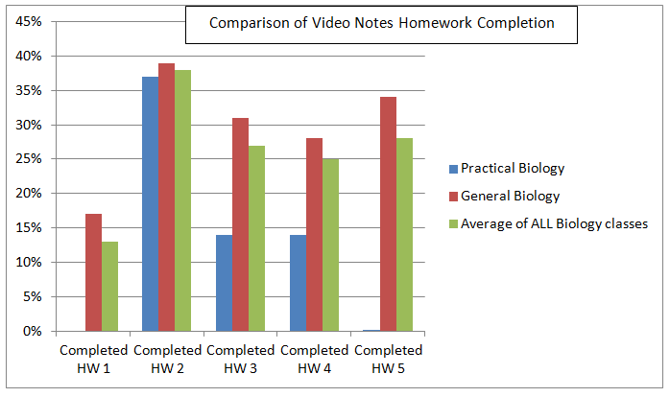
A major source of data collection for this study focused on the return rate of student notes. Students were expected to fill out a modified Cornell notes sheet complete with notes, images and questions from the content that was in the video. Notice in the graph below that the highest return rates were in weeks two and five. The motivating factor implemented those two weeks was providing students with the opportunity to use their notes from the video lectures on a quiz the next class period.
A student survey indicated that the number one motivating factor to watch the video lectures as homework was to get a good grade in Biology. The second motivating factor was so they could do well on the quizzes over the material. Student data indicates that extrinsic factors such as grades were more motivating than the intrinsic rewards of participating in classroom activities, which is at the heart of the Flipped Classroom model.
The unique motivating factors in weeks one, three and four were providing students with a variety of activity stations that they could participate in, to practice the content they had learned during the lecture. These were only mildly motivating to the students with about half of them doing the homework lecture so they could participate in the learning stations.
Each day the video notes were due, students were placed into small peer teaching groups of two to four students. During this time students discussed their notes, answered each others questions and filled in missing gaps. According to the survey, this peer group work was the least motiviating factor for students.
After their peer discussions each group was assessed as I asked specific questions related to the content. It was during this time that misconceptions could be addressed. Once students fully understood the content they were allowed to participate in a variety of learning stations. Some days there were differentiated stations that students could self select based upon their comfort level with the material. On other days there were current event articles and activties that groups would participate in to help increase their level of understanding.
According to the student survey, only 15% of students watched all five of the video lectures as homework, while 52% indicated that they had only watched some of the videos. Why did students not watch the videos as homework? The number one reason was because they “forgot”.
During a student interview a young lady mentioned that she liked the fact that I had the students program the assignment due date into their phones. “When my phone rings to remind me, it helps a lot.” In a different interview with Brad, he stated that “We have you in class to remind us, but after that we forget.” Perhaps giving students one week to complete the assignment is to long a duration for busy teenagers, even with constant reminders in class. Many people that use the Flipped Classroom model have students watch the video lectures every night as homework. Perhaps with more consistent expectations my results would have been different.
Approximatly one third of students indicated that they prefered the video lectures to classroom lectures because they could watch it at their own pace and rewind it if they missed something. One third of students said they they don’t have a preference and the final third indicated that they prefer the more in depth classroom lectures. This is a good reflection on the different lerning styles that these students have. Even though the Flipped model of teaching didn’t work in these Biology classes due to lack of student commitment, it is still a great tool to differentiate lectures for students that like to learn at their own pace.

