
Looking at satellite tracking data on Jimmy P.
Tracking a Loggerhead Turtle named Jimmy P.
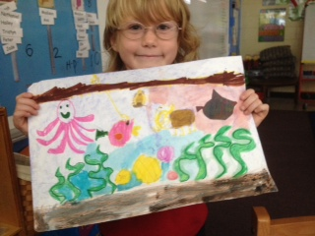
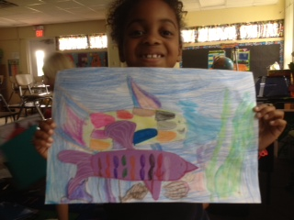
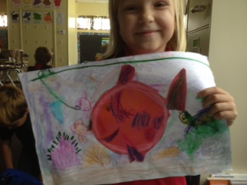
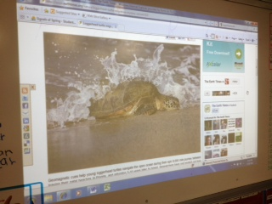
Our finished 3-D model of the Ocean Floor.
Marine organisms working together.

Marine Habitats and Ecosystems
Our Ocean Murals!
Giving our 3-D model some details and labels.
Making our 3-D model of the ocean floor using paper mache.
Learning about a continental shelf.
Driving our imaginary submarines!
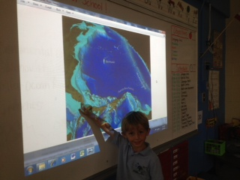
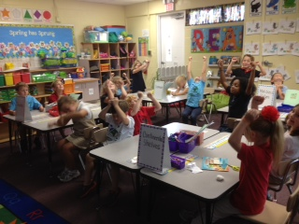
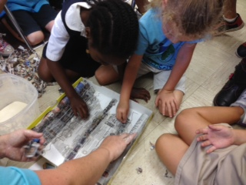
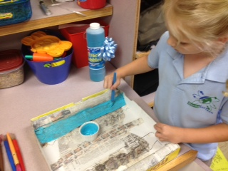

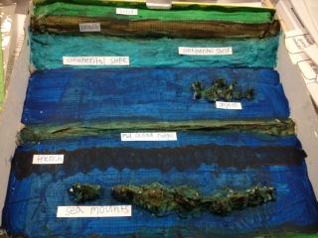
A Cohort 3 Fellow with the NASA Endeavor Project, and teacher at Burns SciTech Charter School
160 Ridge Road
Oak Hill, FL 32759
(386) 345-210-4915
burnsscitech.org

Burns Science & Technology

Charter School
Who Said
Ocean Literacy Was Only
For Big Kids?
Kindergarteners at
Burns Science and Technology Charter
School show how
it’s done!

By: Trisha Bray
- Ocean Habitats and Ecosystems- We studied the different habitats that are found in the ocean, and the ecosystems that are essential to life in the ocean.
- Tracking Marine Animals- After discovering my students’ interest in Sea Turtles, we tracked a female Loggerhead turtle named Jimmy P who was living right off of our coast and then traveled south through our Indian River; right past our school!

What is ACES?
ACES is an expansion of Signals of Spring, an award-winning curriculum where students track the movements of animals through satellite imagery.
The objective of ACES [Animals in Curriculum-based Ecosystem Studies] is to expand environmental and ocean literacy and to capture the interest of middle and high school students, grade 7 and higher. The lessons are to teach students Science based on the ocean using satellite data to develop authentic inquiry skills.
This brilliant website can be found at www.signalsofspring.net/aces/.

ask a kindergartener about the ocean floor. You’ll be “floored” by their answer
I sat down with my students on the rug the other day to go back over and revisit our ocean floor lessons. The question was asked: “If we were to use a gigantic sponge and soak up all of the water in the ocean, what would the ocean floor look like?” The answer I got from one of my students was: “It has mountains, and hills and trenches that are so deep that there isn’t any light down there. It [ocean floor] even has plains that are flat.” Another answer I got was: “It is just like our land, just under water all the time, and it’s not all sandy like in the movies”. My favorite answer was: “It’s a whole other world down there. We don’t even know everything about it! That’s what I am going to do when I get big. I’m going to go down there and find stuff!”
Since we began using the ACES website, my students come to school on Mondays and tell me about the things they observed, found or touched when they were at the beach that weekend. This valuable resource, ACES, has made my students, even at 5 and 6 years old, look at the ocean in a more in depth and scientific way. I am so grateful for that.

aces is a school wide resource at Burns
The ACES website and lesson plan ideas are being used all over Burns SciTech. Mr. Josh Daniel’s fifth grade class is using the website and learning about Ocean Literacy. They have completed lessons on the ocean floor, and tracking marine animals that are familiar to our students in Florida. They have also studied our special ecosystem that we have in our own Mosquito Lagoon. We are planning on having more marine based activities and projects using ACES next year during the school day and in our After-School program.
Ocean literacy is an understanding of the ocean’s influence on you-and your influence on the ocean. Our oceans contain 97% of the earth’s water. The vapor that these oceans release into the atmosphere, return as rain, sleet and snow; replenishing the earth’s freshwater. This freshwater is essential to life as we know it. It is important that children learn to understand the importance of the oceans, and are able to make informed and responsible decisions regarding the ocean and its resources.

THIS IS WHAT KINDERGARTENERS ARE CAPABLE OF
I used the ACES website for all of my lesson ideas and since these lessons are designed for 7th grade and beyond, I integrated the ideas and facts into kindergarten level lesson plans. I was even able to connect these lessons to the state standards. I began by asking my students simple questions about the ocean. What lives in the ocean? What does is look like under the water? How do we use the ocean? How is the ocean important to us? The answers did not surprise me. Many of my student’s ideas of the ocean were based on movies they had seen in the past or even shows such as SpongeBob Square Pants.
These are the lessons/projects that my Kindergarten class covered this year:
- Exploring the Ocean Floor- We learned all about the different topography of the ocean floor and made a 3-D model of it.

What is Ocean Literacy?

