Major Engineering Design Project
NASA’s Touchdown!

3rd graders at Notre Dame Academy
Facilitated by Soyoung Chon

Introduction
In my second year of teaching, I am excited to introduce my first interdisciplinary engineering design projects into my curriculum. This journey has been both challenging and exhilarating, significantly enriching my teaching experience. With my program for gifted 6th to 8th graders scheduled to begin in December, I sought a group of younger students who were eager for a hands-on learning experience during my October and November lessons. The third-grade teachers kindly agreed to collaborate with me.

During my weekly reading enrichment sessions with the third graders, I recognized an excellent opportunity to blend literature with an engineering design project, aiming to provide a holistic educational experience.

I incorporated NASA's Touchdown engineering design challenges into these classes. The students were captivated by 'Moonshot' by Brian Floca, a book that provides insights into the historic Moon landing. Inspired by this, I then encouraged them to apply their newfound knowledge by designing and constructing shock-absorbing landing gear.

I selected the “Touchdown” challenge from NASA and Design Squad, utilizing resources from NASA JPL and the Engineering is Elementary (EiE) Engineering Design Process, as recommended by Professor Josh. This project spanned approximately six weeks.

The first lesson involved reading “Moonshot,” which laid the groundwork for understanding the Moon landing and sparked the students' curiosity. The storybook provided historical insights and a basic grasp of engineering principles related to space travel.

In the subsequent lesson, I introduced the Engineering Design Process (Ask, Imagine, Plan, Create, and Improve) through engaging video clips. The students were then excited to apply these steps to design their own back scratchers using simple materials. Their enthusiasm was clear, and they looked forward to designing landing gears akin to those used by NASA engineers.

Over the next four weeks, the students dived into the engineering process—brainstorming, designing, building, testing, and refining their landing gears until they were successful. I facilitated this process with a simple engineering notebook for them to document their progress. I am excited to showcase their creative work and the outcomes of this project in my report.

Engineering Notebook by 3rd Graders at Notre Dame Academy in NJ
I introduced the Engineering Design Process from Engineering is Elementary (EiE) to my students. After watching short video clips, such as "Jessi Has a Problem" (available at https://www.youtube.com/watch?v=RM04n0-QtNo&t=231s), the students grasped the iterative nature of the engineering design process, which includes the steps: Ask, Imagine, Plan, Create, and Improve. Following this EiE process, the students were instructed to document their progress step by step in the provided engineering notebook.

- Identify the problem
The problem was to design and build a shock-absorbing system that could protect two "marshmallow astronauts" during their landing. This system was required to slow the descent and cushion the landing to prevent damage to the spacecraft and injury to the astronauts. The students formulated their own questions based on this information and recorded them in their engineering notebooks as below.

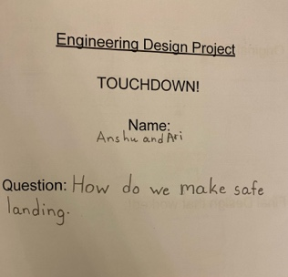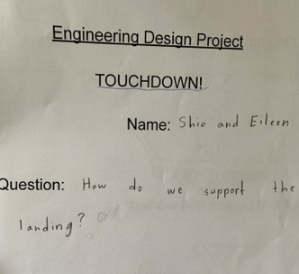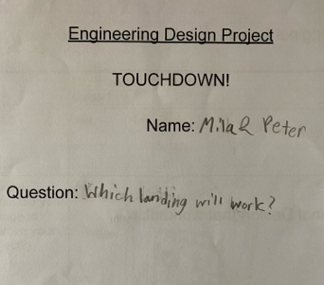

- Brainstorming & Design
Students brainstormed ideas for creating a shock absorber using the provided materials: index cards, straws, and mini-marshmallows. They considered how to construct a system that could absorb the impact of landing and prevent the lander from tipping over.

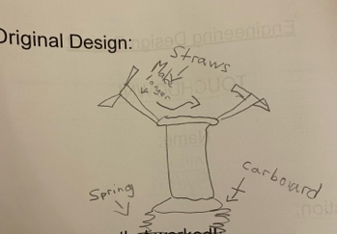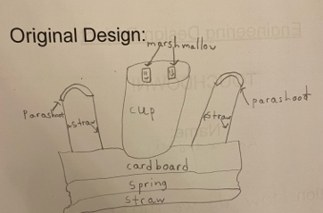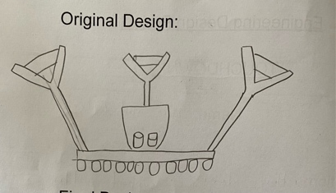

- Build
The students built their shock-absorbing system by attaching their designs to a cardboard platform and adding a cabin for the astronauts. They used their creativity to incorporate springs and cushions using the materials provided.

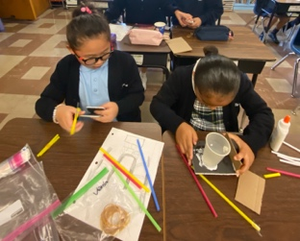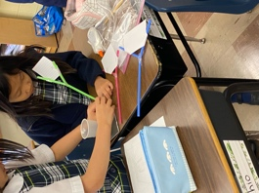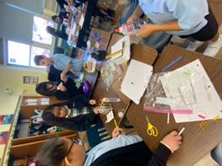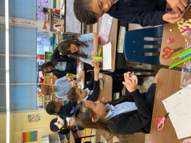

- Test and Evaluate
The students tested their designs by dropping the lander from either one or two meters high. They observed if the astronauts (marshmallows) stayed inside the cup and if the lander landed without tipping over. They evaluated the effectiveness of their shock-absorbing system and the stability of their lander. (Below, you will find two video clips embedded. Simply click on each to view.)

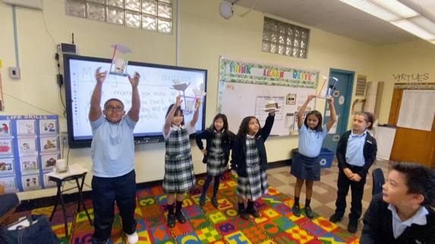
Video 1: Dropping from 2 meters high.

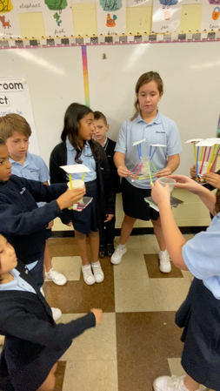
Video 2: Dropping from 1 meter high.

- Improve & Redesign
Based on the results of the tests, students identified any issues, such as the lander tipping over or the astronauts bouncing out. They then made adjustments to their designs to improve stability and shock absorption.

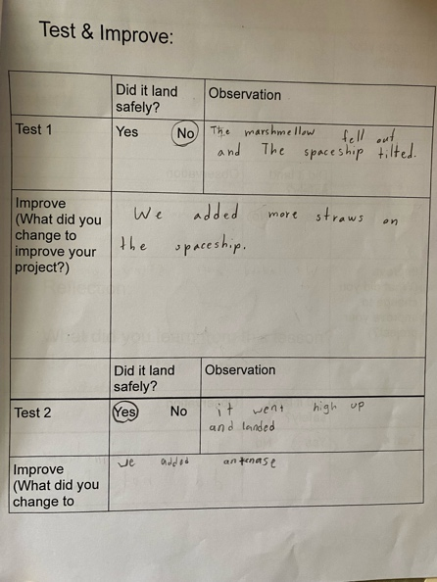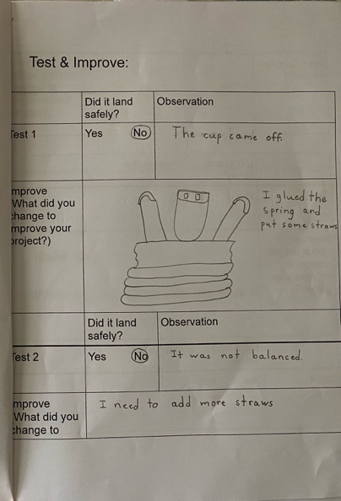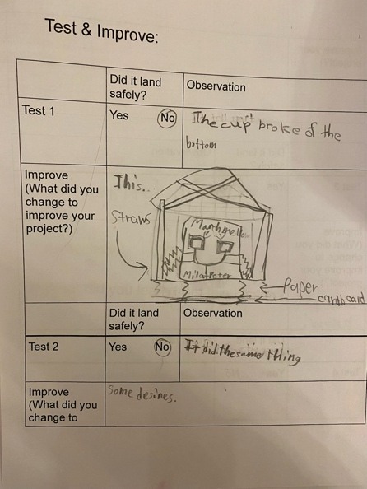

- Share the Solution & Reflection
After refining their designs, students shared their landers with the class. They discussed the forces that affected their landers during the fall, the changes they made after testing, and what they learned from the process and from observing others' tests.

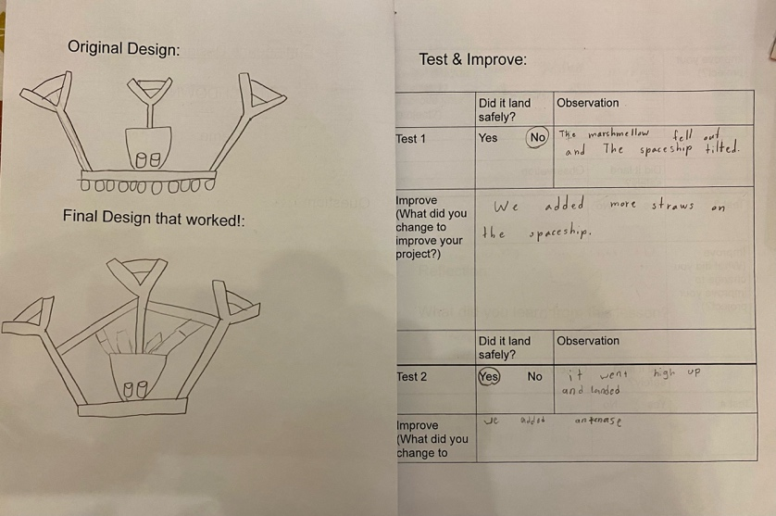

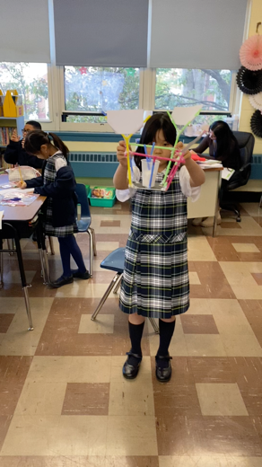

Video 3: Testing the improved lander design as described in the students’ engineering notebook above. The final design was successful!

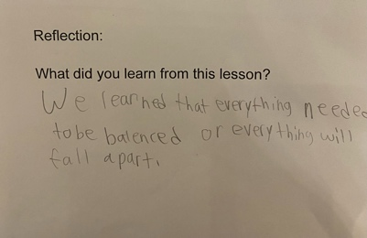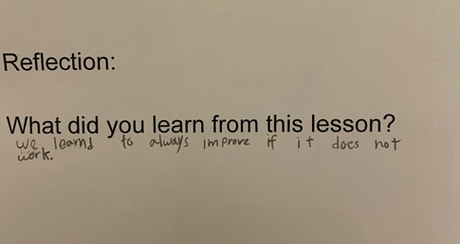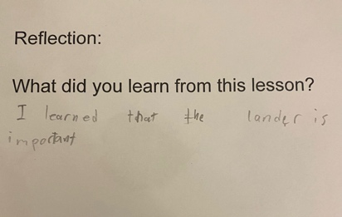

Instructor’s Reflection
The engineering design challenge was a big hit, especially since it was the first time our school's third graders had done something like this. Their excitement about being the first to try it kept them motivated and engaged during the whole six weeks of lessons.

During our weekly reading sessions, I integrated the engineering challenge with storytelling to create a rich, interdisciplinary learning environment. We explored "Moonshot: The Flight of Apollo 11" by Brian Floca, which recounts the historic Moon landing, sparking the students' curiosity. The book provided a glimpse into the basics of aerospace engineering and set the stage for the challenge ahead. Educational videos further clarified the engineering design process, helping students grasp its essential steps. This blend of reading and engineering enriched the lessons and emphasized the value of the design challenge.

Getting the right materials for the engineering design challenge was a bit tricky. Even though I sent notes home to parents, it was hard to get the same kinds of straws and items with the exact size and thickness we needed. Also, getting the students to work together in pairs was a challenge. I worked with their regular homeroom teachers to make pairs based on how they work and their personalities. Some pairs flourished, but others struggled in agreeing on designs and ideas. I emphasized the importance of teamwork, likening it to how engineers often work in groups, and the need for listening to each other.

Through the NASA Touchdown project, the third graders experienced gravity firsthand by dropping their landers and observing the impact. They experimented with basic concepts of energy by designing a system to cushion the lander's landing. This hands-on activity helped them grasp how forces act on objects and how to control motion for a gentle stop.

Throughout the iterative process of construction, testing, and refinement, the students practiced solving problems the way engineers do. They learned about the importance of weight distribution for stability by spreading out the lander's weight so it wouldn't tip over. They used math to figure out the height of their lander and to represent it on paper. They made guesses about what would happen when they dropped their lander, gave it a try, and then discussed the results. Sharing their lander designs with each other taught the kids about teamwork. They also learned the importance of documenting their progress in their engineering notebooks—a crucial skill that enabled them to think, design, build, test, and evaluate like real engineers.
Linking their tasks to the work of NASA scientists, the project turned learning about science and building into an exciting, hands-on experience.

The engineering design process we chose for the third graders was effective. The kids could understand the idea and why a shock-absorbing system is important for a safe landing. Initially, they were more concerned with how their landers looked rather than how they functioned. But after iterative testing and evaluating, they learned that safety isn't all about aesthetics. They shifted focus to the practicality of their designs. They started to think about and understand the properties of materials—like index cards, straws, and marshmallows—as shock absorbers. By changing their designs with these materials, they began to gain a basic understanding of gravity, motion and balance.

Since this was our first engineering design project, I let them use as many straws, index cards, and marshmallows as they wanted. Though well-intended, I realized that allowing unlimited materials wasn't ideal. It led to a quick depletion of supplies and unequal distribution among teams. In the future, I plan to give each team the same amount of materials to see how they handle having limited resources. By limiting materials, I can teach a valuable lesson about managing resources and being creative within limits. This change should help the students be more creative when they face limits, which will make their learning experience richer and more like the challenges engineers face in the real world.

Relevant Standards
Listed below are the primary NGSS standards associated with NASA’s Touchdown engineering design challenge.

NGSS Standards
- MS-ETS1-1: Define the criteria and constraints of a design problem with sufficient precision to ensure a successful solution, taking into an account relevant specific principles and potential impacts on people and the natural environment that may limit possible solutions.

- 3-5-ETS1-2: Generate and compare multiple possible solutions to a problem based on how well each is likely to meet the criteria and constraints of the problem.

- MS-PS-2: Motion and Stability- Forces and Interactions

- MS-ESS1-1 Earth's Place in the Universe

