Book and Technology Stands
This project will reuse plastic containers, such as detergent and fabric softener bottles to produce stands that hold books, tablets, laptops, paper, and phones in an upright position for easier use. Many different bottle sizes and styles can be used to create this product. They must be durable plastic, but thin enough to be cut through. The bottles will be cut into two stands, used to prop up items to make them easier to see for reading, viewing, or referencing. There is minimal waste remaining once the production has taken place.
- What additional materials would be needed to make this product?
In addition to the plastic bottles, paint may be used to make the product more attractive. For the production of the stands, a pattern, box cutters and scissors will also be needed. There are not any other items attached to the product.

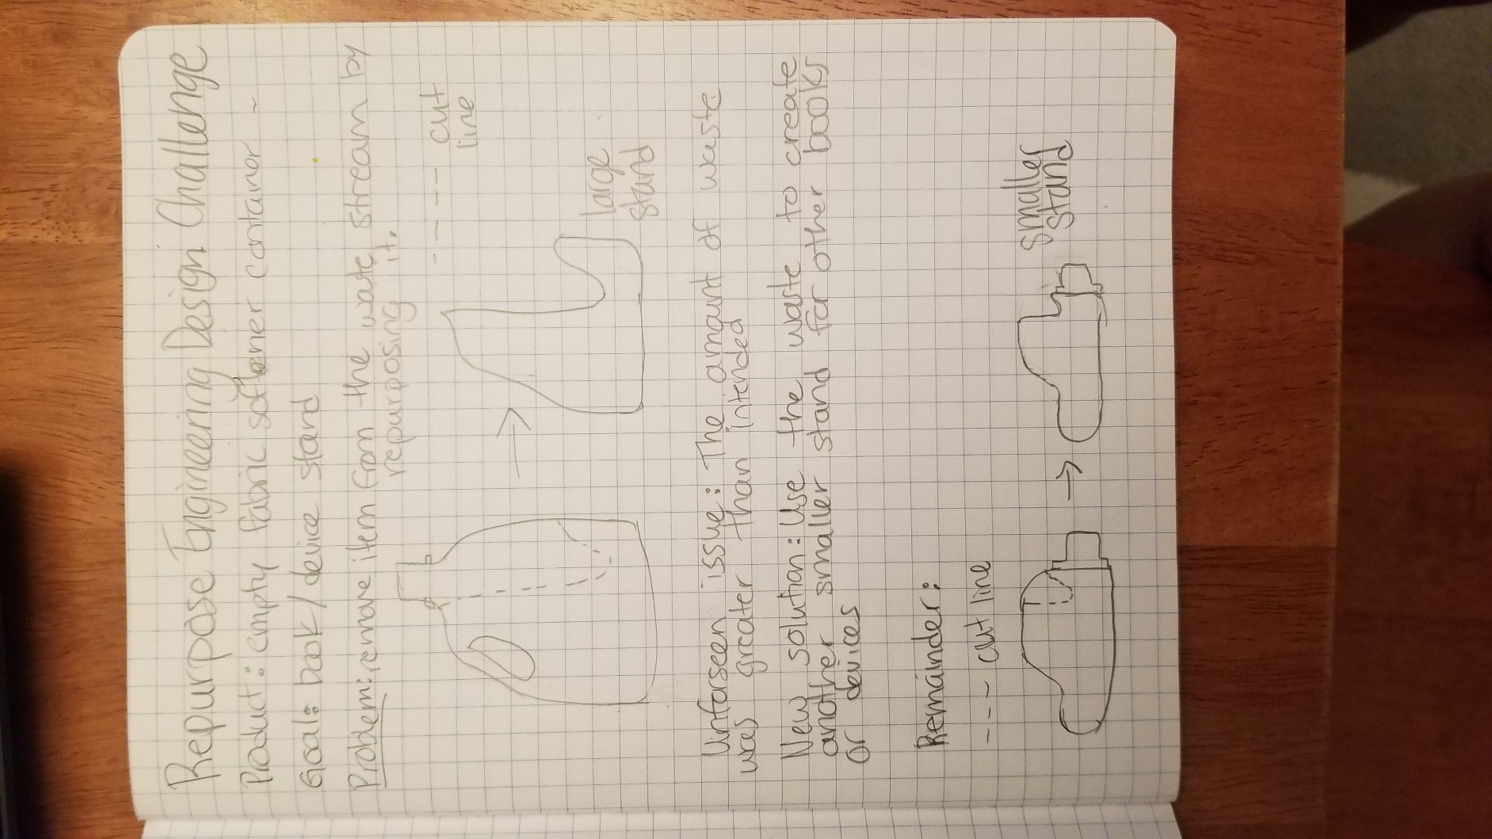

- How would a manufacturer make this product?
A manufacturer would use the following steps to create the product:
  - Collect empty plastic bottles.
  - Examine the bottles to ensure they are in decent shape and fit the size requirement for the product.
  - Clean the bottles.
  - Trace the large pattern onto the bottle.
  - Cut, beginning with a box cutter and refining with scissors.
  - Once the large stand has been created, trace the small pattern onto the “waste” of the first stand.
  - Again, cut along the pattern, first with a box cutter and refining with scissors.
  - Test both stands to ensure they are stable and even.
  - Adjust the base and the portion that holds the books or devices as needed.
  - Retest and readjust as needed.
  - Optional: Paint the stands and then let them dry.

- Who is the target audience for this product?
The target audience for this product would be:
  - People who read and need to prevent neck strain
  - Anyone who watches videos on their phone or tablet and likes the device to be upright
  - People who cook and bake while referring to a cookbook or recipe on a device
*Particularly people identified above who are environmentally conscious

- Why would this product appeal to the target audience?
This product would appeal to the people listed above because it helps them meet a need they have in their daily lives. Some people, such as college students or heavy readers, experience strain on their necks due to reading in a hunched-over position. This device would allow them to read without further hurting their necks and backs. Many people watch videos on their phones and tablets, but having to hold the device upright or prop it against another item can be annoying or unsteady. This device is easy to use and it is stable. For people who regularly cook and bake, having to constantly bend over to look at a recipe is much more frustrating than being able to see the recipe propped up. This product also takes up much less valuable counter space, so there is more room for ingredients and space to prepare the food. This product meets those needs and does so without creating more trash that is polluting the environment, an argument that is very important for many consumers.

- How will your engineered design remove one product from the waste stream?
This product removes plastic bottles, large and small, from the waste system by using almost the entire product to create two new goods. Once a plastic bottle has been emptied, rather than adding it to the landfill, or even the recycling stream, this product allows for it to be turned into something sturdy which extends its life far beyond the original intent. There is a small portion of waste which can be recycled after the stands are produced.

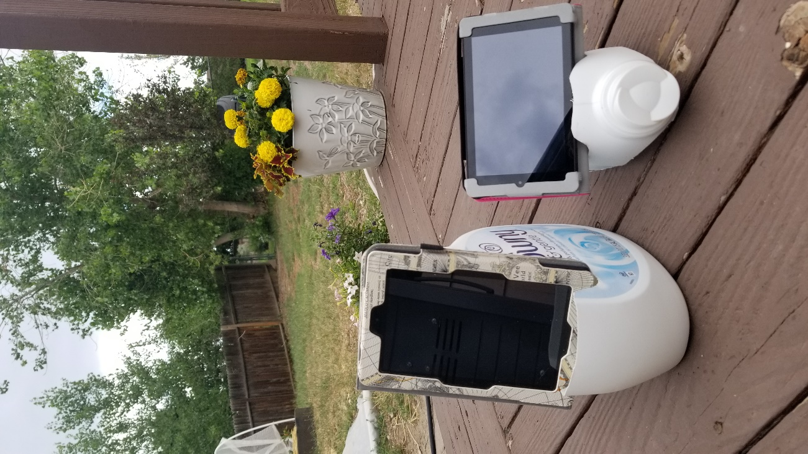
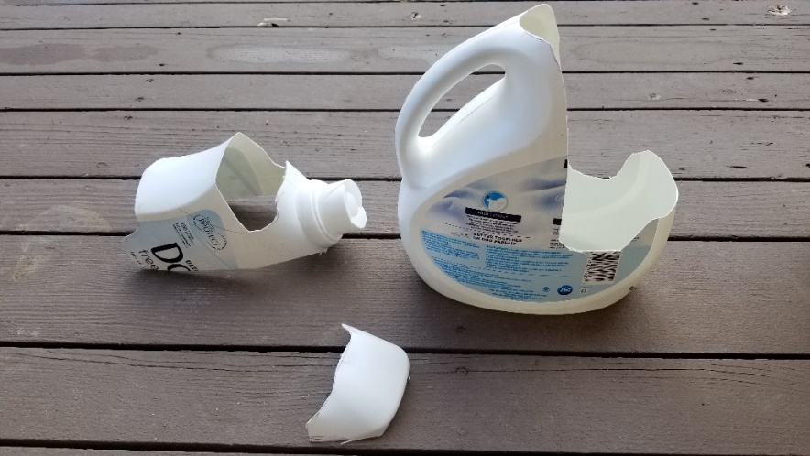
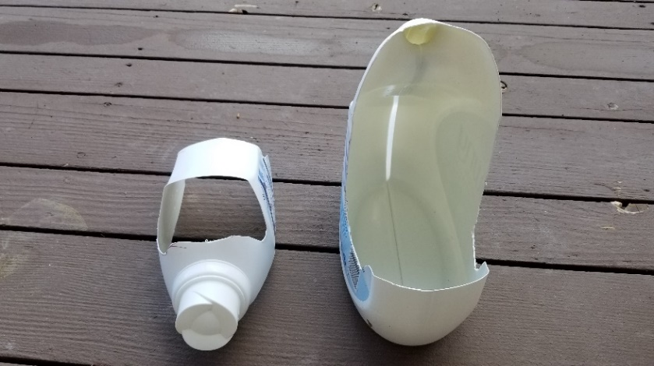
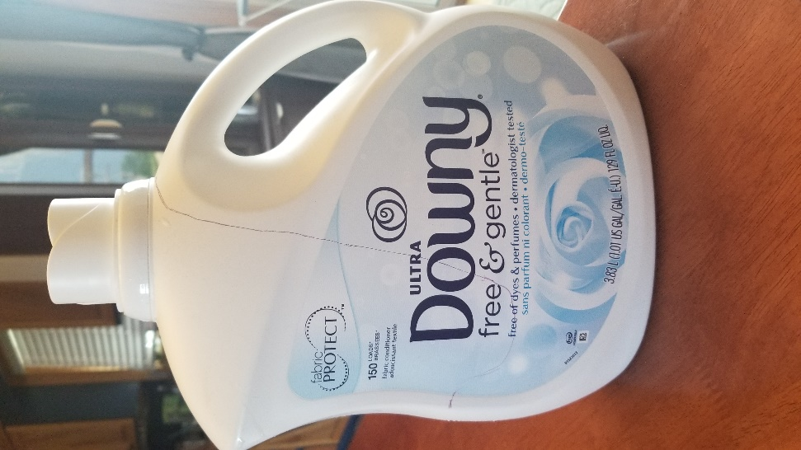
Bottle before constructing prototype.
Side view of stands after construction. The small piece in the front is the waste after construction.
The finished product holding devices.
Front view of stands after construction.

