Phase I – Research and Planning
- Identify the “Big” concept to be covered by the engineering design challenge.
  - Waves
  - Patterns and motion
  - Newton’s 1st law of motion
  - Newton’s 2nd law of motion
  - Create shaker table
- Research appropriate learning standards associated with the topic.
  - 4-PS3-1 Use evidence to construct an explanation relating the speed of an object to the energy of that object
  - 4-PS3-2 Make observations to provide evidence that energy can be transferred from place to place by sound, light, heat and electric currents
  - 4-PS4-1 Develop a model of waves to describe patterns in terms of amplitude and wavelength and that waves can cause objects to move
  - 4-PS4-3 Generate and compare multiple solutions that use patterns to transfer information
- Identify and discuss the different types of problem solving and declarative/procedure knowledge needed.
  - Declarative Knowledge
    - Definition of amplitude
    - Definition of wave
    - Definition of seismic activity
    - What causes seismic activity
    - Definition of pattern
    - Definition of motion
    - Definition of force
    - Definition of acceleration
    - Definition of mass
  - Procedural Knowledge
    - How seismic activity occurs
    - How waves create patterns and energy
- Explore objectives and ancillary concepts/content covered by the project.
  - Newton’s 1st law examples
    - Kicking soccer ball on grass vs gym floor
    - Tightening of seatbelt when car brakes suddenly
  - Newton’s 2nd law examples
    - Pushing down pedals on a bike
    - Pushing a bowling ball and volley ball at same time
  - Waves
  - Patterns
5. Identify possible activities.
- Design Squad= Bristle Bots-equal and opposite reactions/ or electric waves
- Design Squad= Build a better lunch box= how to prevent a lukewarm lunch, covers PS 2 standard with heat waves
- Design Squad= Doggie Door= invisible force/magnetic energy standard
- Design Squad= Extreme Kicking Challenge= working for Nike and need different balls for speed vs distance. Or for students to answer How to practice soccer with yourself, or how to play soccer with yourself?
6. Select the best activity for your classroom
- Design Squad- Seismic Shake Up- My teammate and I will be dividing up this activity to span across an entire semester. I am starting off this unit/activity by having students learn about waves and patterns. From there students will dive deep into Newton’s 1st and 2nd laws. With their knowledge on waves, patterns and physics laws students will create their shaker table.
PHASE II
- Select an engineering design process to be used in your class.
Design Squad- Seismic Shake Up
- Develop an implementation timeline.
Day | Concept
1 | Go over vocab: motion; acceleration, force
2 | Newton’s first law and examples
3 | Newton’s second law and examples
4 | Review 1st and second laws, start flip book of laws
5 | Go over vocab: seismic, amplitude, pattern
6 | Discuss/Answer using vocab and laws: How do earthquakes occur? How do waves create energy
7 | Start Challenge: Problem and Brainstorm
8 | Challenge: design
9 | Challenge: build 1
10 | Challenge: test 1/ reflect on + and – and changes
11 | Challenge: build 2
12 | Challenge: test 2 reflect on + and – and changes
13 | Class share of solutions
14 | Claire’s Plan that continues the challenge

- Perform the engineering design activity, either on your own or with your students.
This engineering design activity was not completed with my students due to the summer break and COVID-19. However, I was able to perform the activity with my own two boys, and my niece and nephew. Ages range from 4 years old to 9 years old. Although three out of the four children were younger than the students that I taught, they were able to give me some ideas on where problems would arise with my own students, and where would be natural breaks within the activity to stop for the day.

- Complete an engineering design notebook. The design notebook will include your progress at each level of the design process and organized using the following sections,
  - Prior learning activities to design challenge:
The picture below is of my “students” writing about what happened in our Newton’s law experiment. In this experiment they kicked a ball across the yard, and sat inside a car buckled and jerked forward like they would in a crash. When we came inside they wrote about the 1st law of motion: An object in motion stays in motion until another force acts upon it. Here they wrote about what force (ball,) was in motion and what force (ground) caused the ball to stop.

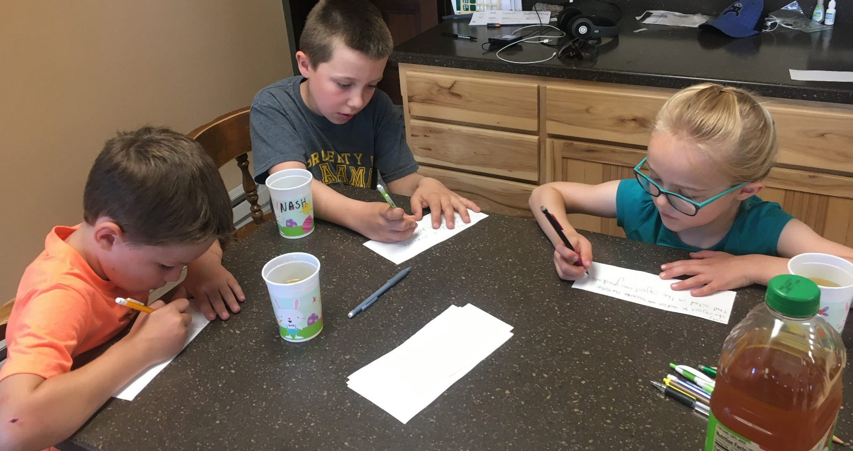

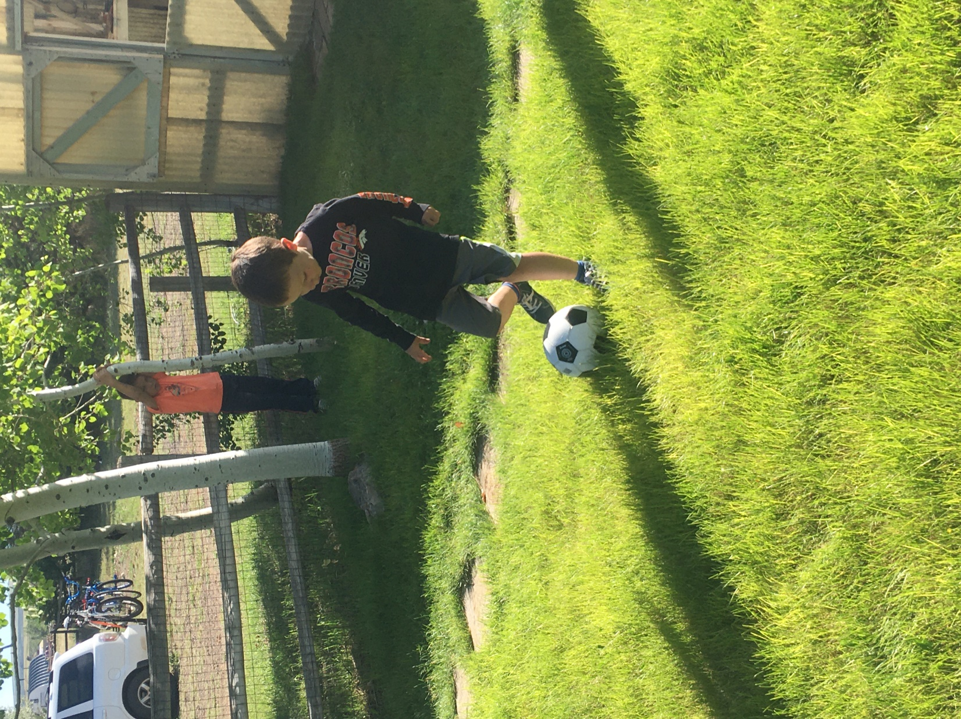

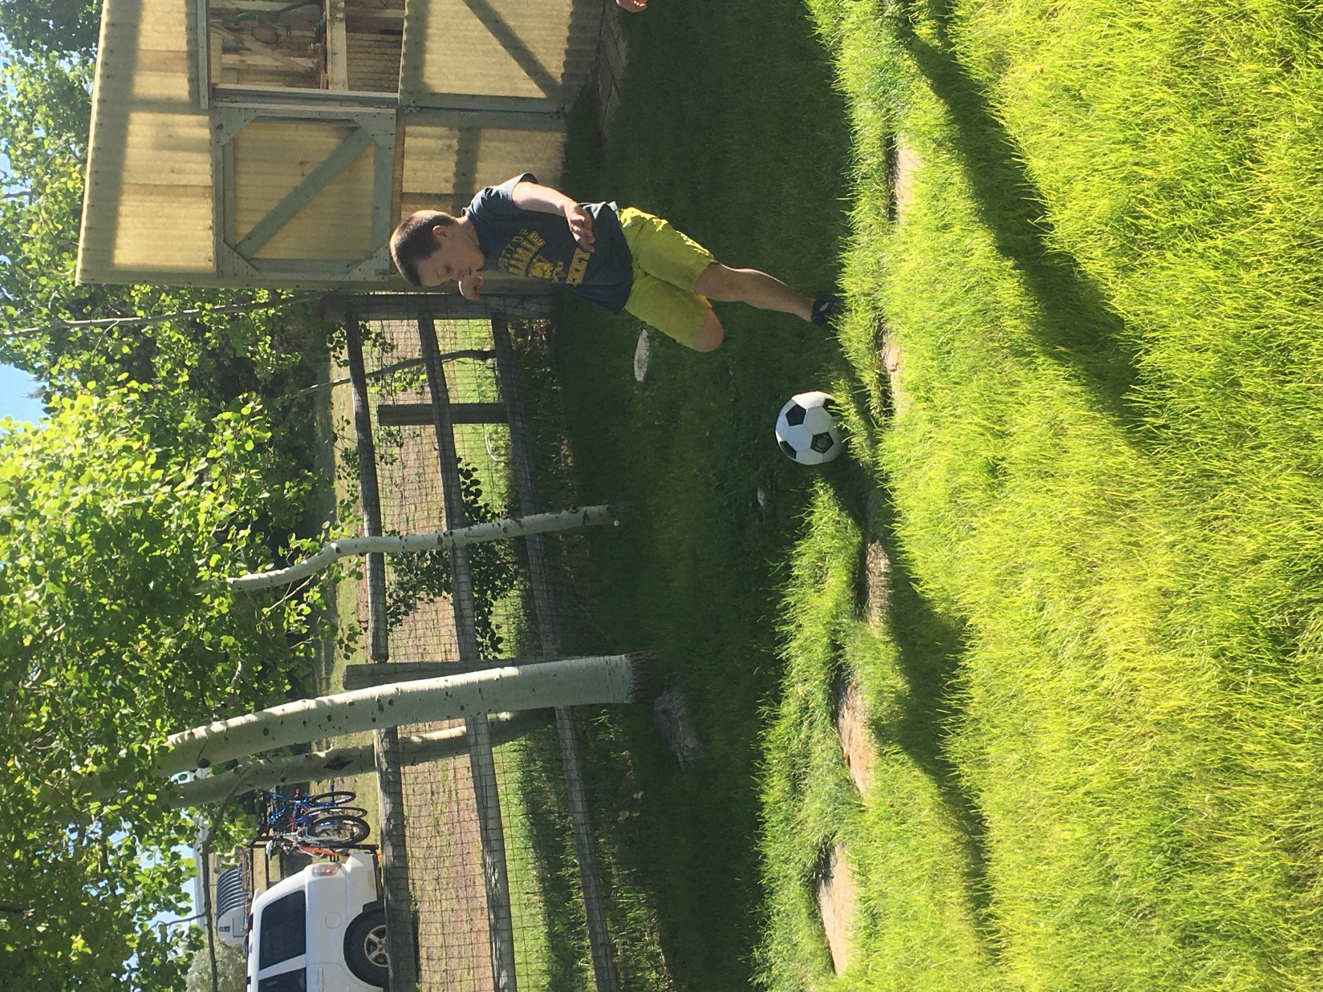

  - Identify the problem- Homes and stores collapse during an earthquake. What happens when there is an earthquake?
Hurts animals and people-Laney
Murders people-Nash, Miles
I don’t know-Porter
  - Brainstorming- How can we prevent this from happening?
Move somewhere else- Laney
Build better buildings- Nash
Live in a tent that can be taken down in an earthquake-Miles
I don’t know-Porter
Build shorter/ wider/ stronger buildings- Jessica

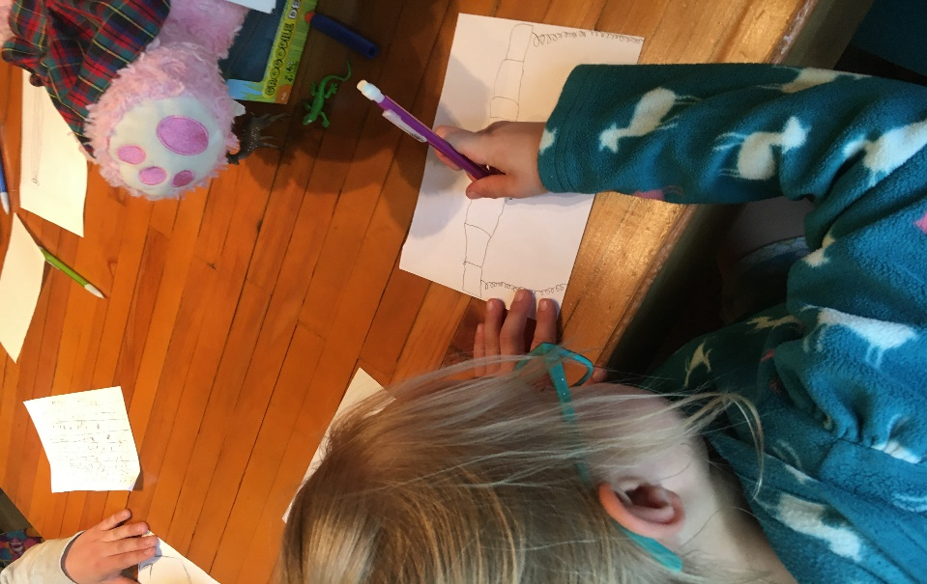
  - Design

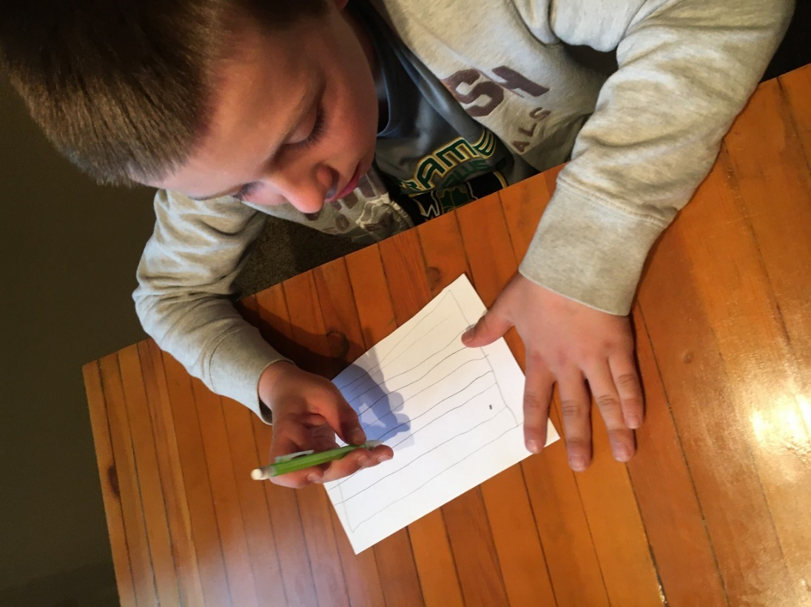

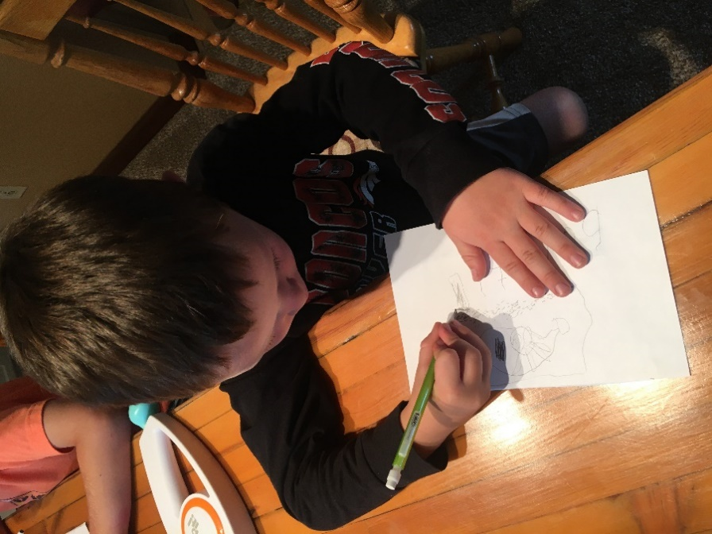

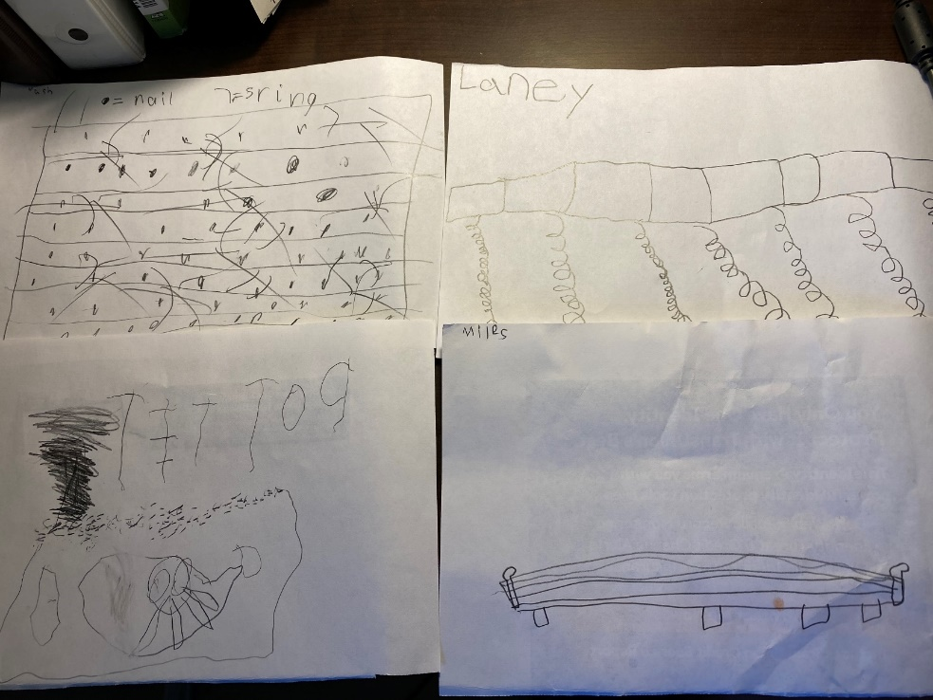

  - Build
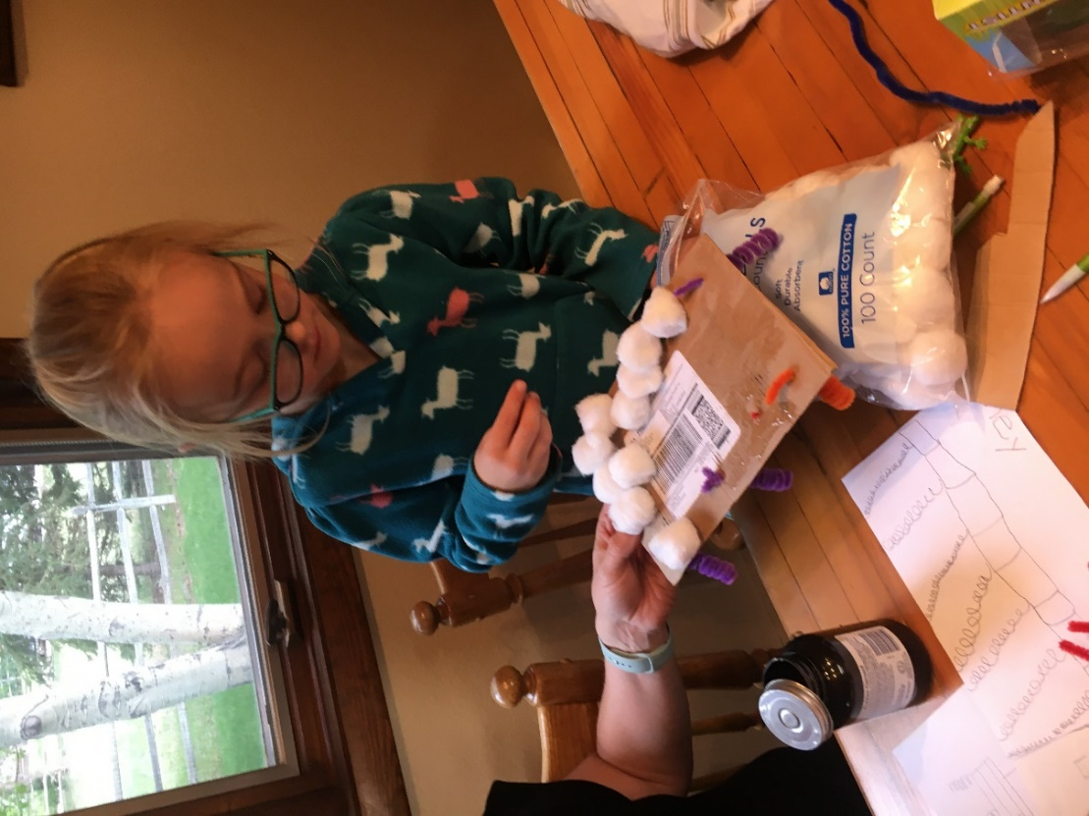
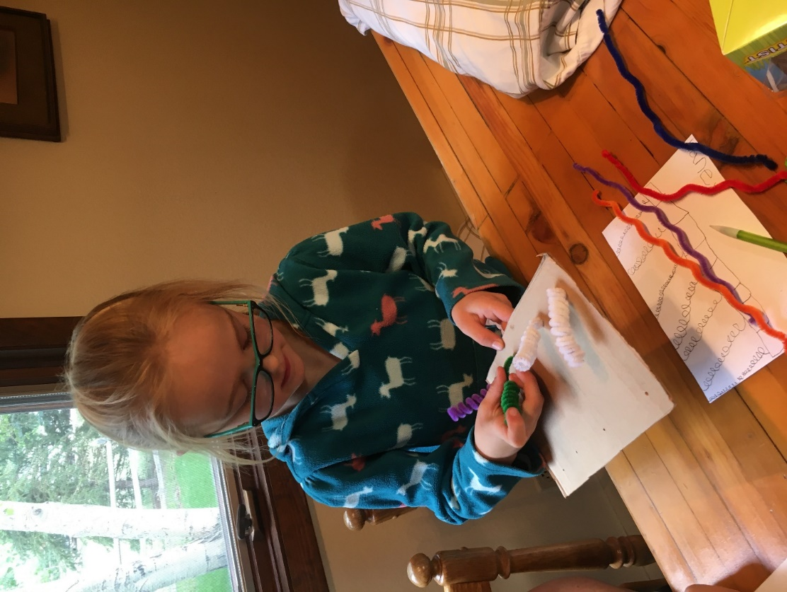

  - Test and Evaluate
Laney- “My board did not move very much. The springs on the bottom didn’t stay and they couldn’t help stop the shaking”
Nash- “My table moved but not enough. The earthquake waves will be stronger than me just pulling the ruler, so my table needs to be much stronger”
Miles- “My board moved, but I should do it again because I could use other materials and Nash and Laney are doing theirs again”
Porter- “Mine worked” (The truth is, his didn’t work at all. It fell apart with the first pull of the ruler. Porter is too young to understand what is suppose happen with the table.)
  - Redesign
What will be your next steps to make your shaker table better?

Laney- “Take the springs off, or add stronger springs, or add more springs. More stronger springs would help when the table shakes”

Nash- “Use a different material that will cause the table to shake more. Maybe change what I am pulling with into something smaller like a knife or a pencil. I maybe could make the table stand on something weaker to see if it is strong”

Miles- “Use other material and shake it differently”
Porter- “Paint it and pull it harder to make it better”

The actual construction of the redesign did not happen due to time constraints ( I only had them for a given amount of time. I misjudged how long it would take to complete the lesson) and attitudes of the participants.(I could tell by their facial and body expressions that they were done and did not want to do anymore). This was a big eye opener for me and it allowed me to make sure that I think about how much I ask my own students to do in a given amount of time for a challenge. Even though the kids that I did this challenge with did not complete the redesign, it gave me insight on many different concepts, protocols, and breaks that I need to implement into the lessons when I do the challenge with my classroom students.

  - Share the solution
The sharing of our solutions happened differently than it would in a real classroom. In a real classroom, I would put students in very small groups of 2-3 students and have them share their ideas of what worked and what didn’t work. They would also share what materials they used where and why, or why they felt some materials were stronger than others. Students in groups would also compare their different designs to and discuss what might happened if they combined parts of their ideas together. For this sharing with for this specific challenge, there really wasn’t one. All the kids were watching each other during the challenge so they knew how they were performing. That and due to time constraints, sharing did not happen like it would in the classroom.
5. Reflect upon your experience.
a. What went well with the engineering design challenge?
I think that there were several things that went well. Having the kids be able to experience Newton’s laws in hands on activities and be able to talk about the laws each time they did it really enforced the concept and the oldest was able to apply it to their build. Another thing that went well was the sketching/design portion. The paper that they were given was an appropriate size, so each student was able to fill up the paper with a nice sketch of what they hoped to create for their table.
b. What did not go well with the engineering design challenge?
The building portion of the challenge did not go as well as I had hoped. Due to the age of the children, there was a lot of adult help. Since I was the only adult and could only help one child at a time, patience ran thin among the kids. This was followed by frustration because their actual build did not turn out exactly how they designed it.
c. What concepts were covered (list standards and topics where appropriate)
- 4-PS3-1 Use evidence to construct an explanation relating the speed of an object to the energy of that object
- 4-PS3-2 Make observations to provide evidence that energy can be transferred from place to place by sound, light, heat and electric currents
- 4-PS4-1 Develop a model of waves to describe patterns in terms of amplitude and wavelength and that waves can cause objects to move
- 4-PS4-3 Generate and compare multiple solutions that use patterns to transfer information

  - Newton’s 1st law examples
    - Kicking soccer ball on grass vs gym floor
    - Tightening of seatbelt when car brakes suddenly
  - Newton’s 2nd law examples
    - Pushing down pedals on a bike
    - Pushing a bowling ball and volleyball at same time
  - Waves
  - Patterns
d. How did the ED process help teach the science and mathematics concepts?
The engineering process helped teach Newton’s laws of motion by allowing students to participate in a hands-on activity and then apply and think about them in their table design.
e. Did I choose an appropriate engineering design process?
I believe that I chose an appropriate engineering design challenge for the 3rd and 4th graders that I will be teaching. However, for the students that I practiced on, this challenge was too hard. It is appropriate for the students that I teach because the build is very easy but will reinforce the Newton’s Law concepts and allow them to apply it to their build.
f. Should I simplify or make more complex?
I believe that there will be several ways to make this more complex for my more advanced learners and simplify it for my learners who need more support. Ideas that could make this challenge more complex could be to have students request materials to build with before they even sketch their design, putting constraints on measurement or weight of their build, or putting constraints on the size or weight of the house their build must hold. To simplify it, I could give students specific materials to use, have them look at peers builds, or work together in small groups to gain ideas and work off each other’s strengths.
g. How can I improve this activity to use with future students?
To improve this challenge for my students, there are a few things that I could change. First, I would have a wider variety of items that they could pick from for their build. Having a bigger variety will allow for more unique builds as well as students to the results of their build as well. I would also add more stopping points along the way for more discussion and collaboration of ideas. This will ensure that most of my students are understanding the concepts being taught and are able to apply it to their shaker table.
References:
Build. (n.d.). Retrieved July 14, 2020, from https://pbskids.org/designsquad/build/seismic-shake-up/

