Madelyn Askin February 3, 2020
Scavenger Hunt Activity Spring 2020

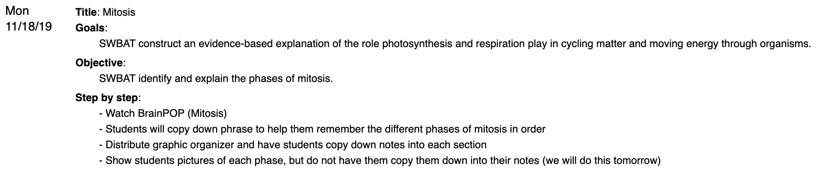
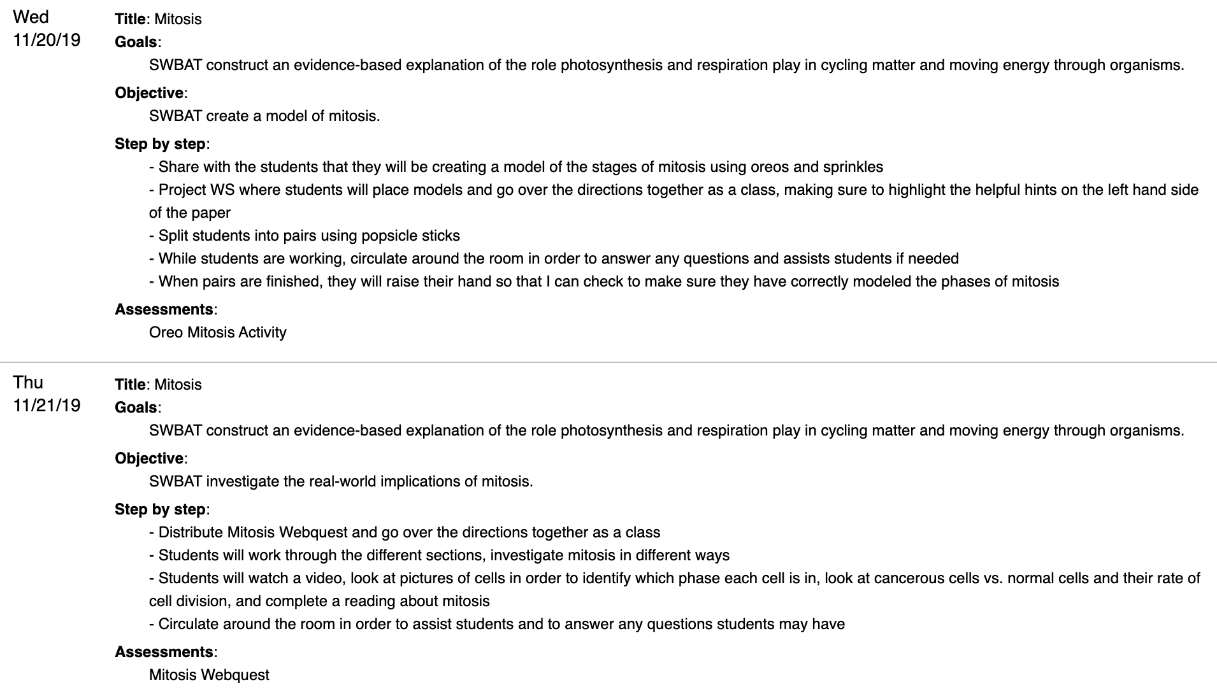

I chose this set of lessons because I believe that the arts standards will not only relate to the content being taught but will also enhance my lesson to make it more engaging for my students. These lessons are geared toward 7th grade students. I already have a few ideas as to what art standards could be used within these lessons. One possibility is to use the theatre standards. The students could create a skit about mitosis, having to cover each phase. They could have to focus on the characters and what their inner thoughts and objectives might be. Another possibility is to use the visual arts standards. The students could create some sort of visual representation of mitosis, focusing on the layout and organization of the work of art. I am sure there are many other possibilities when it comes to using the art standards to enhance this lesson, but there are the first two that came to mind when thinking about this assignment.
