Topic: The Seasons: Solstices and Equinoxes
Grade Level: 6th Grade
Time: 3 Days (45 minute class periods)

Standards:
CCSS
CCSS.ELA-LITERACY.RST.6-8.7
Integrate quantitative or technical information expressed in words in a text with a version of that information expressed visually (e.g., in a flowchart, diagram, model, graph, or table).

CCSS.ELA-LITERACY.RST.6-8.3
Follow precisely a multistep procedure when carrying out experiments, taking measurements, or performing technical tasks.

NGSS
MS-ESS1-1.
Develop and use a model of the Earth-sun-moon system to describe the cyclic patterns of lunar phases, eclipses of the sun and moon, and seasons. [Clarification Statement: Examples of models can be physical, graphical, or conceptual.]

Engaging Contexts: In order to get students “hooked” into solstices and equinoxes and how these affect the amount of daylight received, I will show them a video on YouTube which shows a 24-hour time lapse at four different points throughout the year. Each of the four time lapses were taken three months apart, during the summer solstice, autumnal equinox, winter solstice, and vernal equinox. The video also flashes specific times throughout in order to show that although the exact same time is being shown in all four frames, the daylight in each looks quite different. Students will then be asked to think about what is going on in this video and develop some initial explains of the phenomenon they just viewed. Additionally, students will be looking at real data, the times of sunrise and sunset, in New York City each month of 2012. Providing students with real data engages them in the material and enables them to explore the material in their own meaningful way.

Justification: The integration of this phenomena at the beginning of the lesson enables students to develop their own ideas in order to explain the process taking place. When talking about daylight, some students may have a difficult time visualizing what this means. By showing a video in which each of the four different seasons are represented, the students are better able to not only visualize, but also compare and contrast. This video is also used because this phenomenon is one that students most likely will be familiar with. Many children realize that it stays lighter for longer in the summer and gets darker earlier in the winter. By calling upon this prior knowledge, students will be able to take an idea they are familiar with and investigate why differences in the amount of daylight occur. The integration of the data set also enables students to think at a deeper level and be able to back-up their ideas based on the graph that they have created. The students will construct their own meaning of the graph and take part in discussion, both as a class and with their partner with whom they created the graph.

Measurable Objectives:
SWBAT develop a graphical model to describe the cyclic pattern of solstices and equinoxes.
SWBAT explain why the hours of daylight change depending on the season.
SWBAT integrate quantitative information expressed in the Sunrise and Sunset Times Data Table into a graph.
5E Lesson Plan
Engage – 10 minutes  The purpose for the ENGAGE stage is to pique student interest and get them personally involved in the lesson, while pre-assessing prior understanding. | - Students will watch a video that shows a 24-hour time lapse at four different points throughout the year, each 3 months apart. Before the video begins, the teacher will ensure that the students are aware of which month each section of the video is.  - The teacher will provide students with questions to consider while watching the video: What is happening in the video? What are some differences that you notice between the four months?  - https://www.youtube.com/watch?v=o5-4-E67Ryo  - After the video is over, the teacher will have the students turn and talk to the person next to them, providing these guiding questions for the discussion: What did you notice in the video? Which month did the sun go down first? Which month did the sun go down last? What surprised you about the video?  - Students will have three minutes to discuss with the person sitting next to them, while the teacher is walking around the room in order to observe what the students picked up while watching the video.  - The teacher will then bring the whole class back together and allow any students to share what was discussed in their pairs. The teacher will not give any additional information about or explain the phenomena going on in the video, but instead simply monitor the class discussion.
Explore – 50 minutes  The purpose for the EXPLORE stage is to get students involved in the topic; providing them with a chance to build their own understanding. | - The teacher will distribute the Sunrise and Sunset Times for the 22nd of each month of 2012 in New York City data set and briefly discuss with the students what information is included. The teacher should also make sure to note the use of military time and how it should be used on the graph.  - The teacher will also distribute and go over the direction page on how to graph the given data.  - Instead of completing the graph on the one provided at the bottom on the directions page, the students will be completing it on a piece of large construction paper in order to better analyze the graph.  - The teacher will split the students into partners in order to complete the graph.  - Students will gather the necessary supplies and may then begin working on their graph.  - As students are working, the teacher will circulate around the room in order to answer any questions students may have, as well as to observe the discussions going on between partners.
Explain – 30 minutes  The purpose for the EXPLAIN stage is to provide students with an opportunity to communicate what they have learned so far and figure out what it means. | - The teacher will provide each group with sheet of questions in order to help them to guide their discussion.  - After the students have had about 10 minutes or so to discuss the questions with their partners, the teacher will bring the class back together in order to have a whole class discussion.  - The teacher will move through the questions on the sheet and have the pairs share their thinking when it comes to the analysis of their graphs.  - The teacher will clear up any misconceptions and work to guide the students towards a deeper understanding of the science behind the relationship between the seasons or months and the amount of daylight.
Elaborate/Extend – 30 minutes  The purpose for the EXTEND stage is to allow students to use their new knowledge and continue to explore its implications. | - Students will watch BrainPOP on Solstice and Equinox.  - As a class, the students will read an article on solstices and equinoxes, further explaining.  - The teacher will spend a little extra time discussing the cultural celebrations of solstices and equinoxes that take place around the world.  - Students will get back with their partner and complete the comprehension questions that go along with the reading.  - Students will have the opportunity to discuss their answers with their partners and  - The teacher will circulate around the room in order to observe and to answer any questions that students may have.  - Students will turn in this reading comprehension worksheet in order to be graded.
Evaluate – 15 minutes  The purpose for the EVALUATION stage is for both students and teachers to determine how much learning and understanding has taken place. | - Students will put the equinox and solstice lines into their graphs.  - The teacher will then provide the students with the remaining pages of the graphing activity, which contains questions about the concepts represented in the graph.  - Students will have the remainder of class time to complete these remaining question pages with their partner.  - The teacher will be circulating around the room in order to observe for students understanding and to assist any students who may be struggling.  - The students will turn in graph and question pages in order to be graded by the teacher.

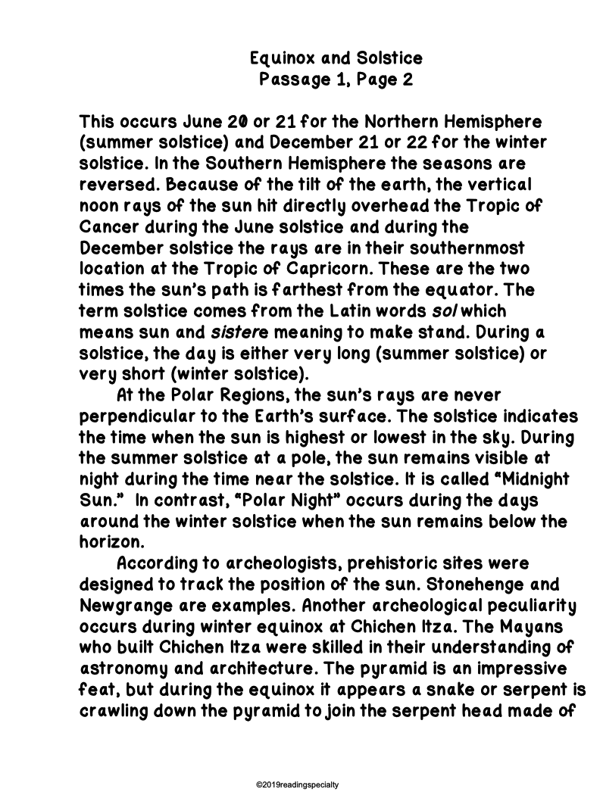
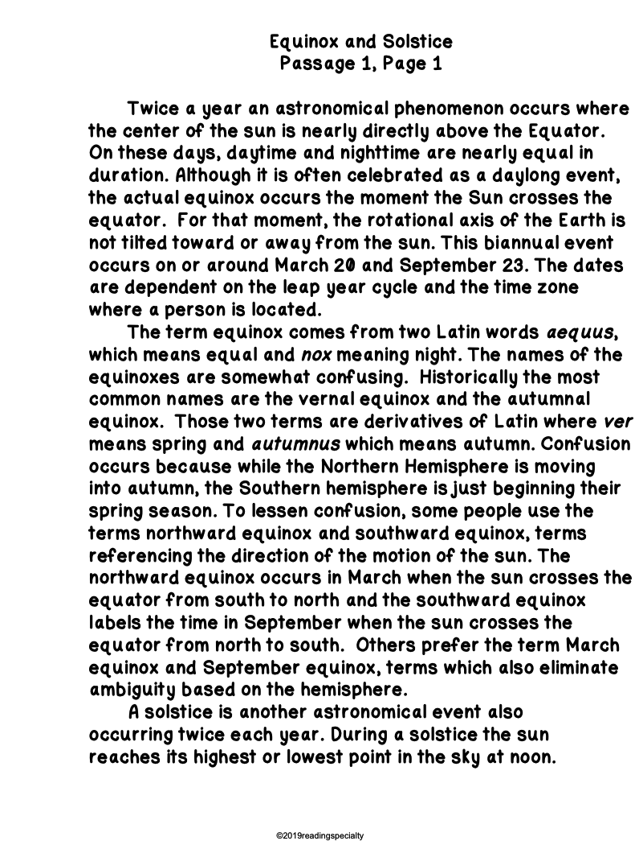
Elaborate and Extend Reading Comprehension

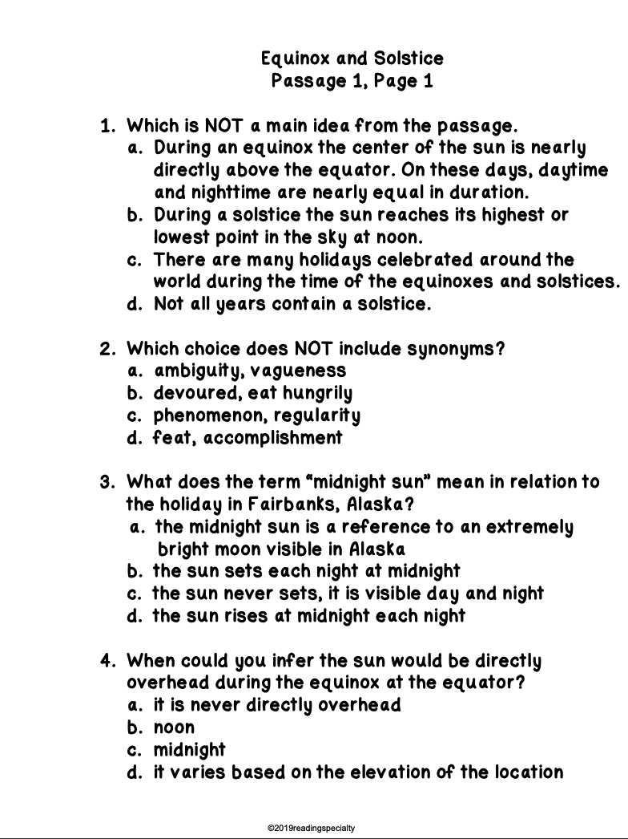
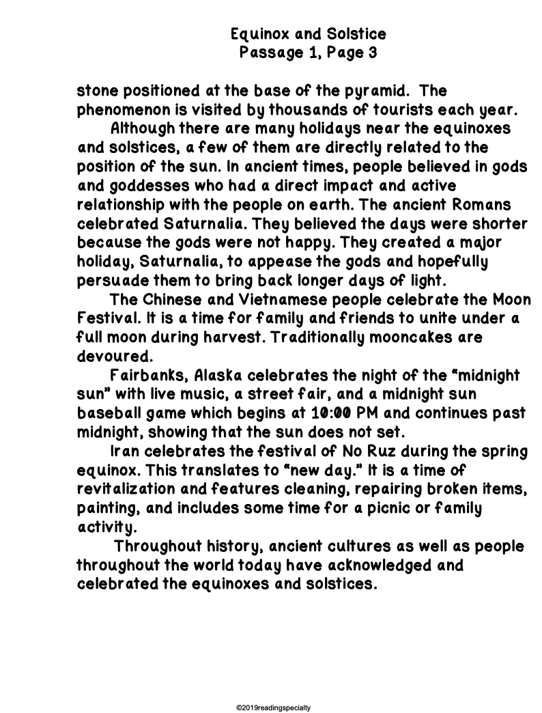

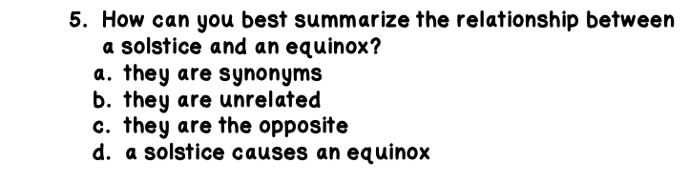

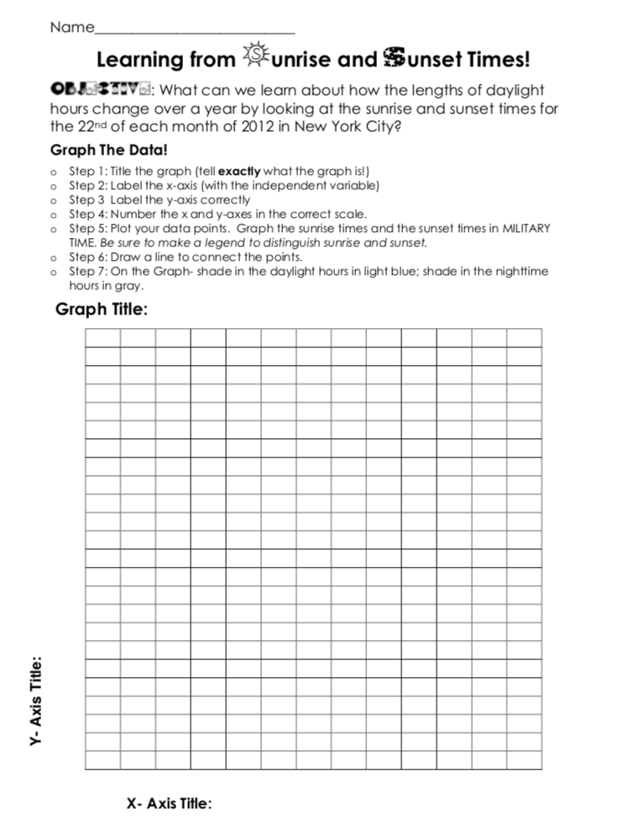
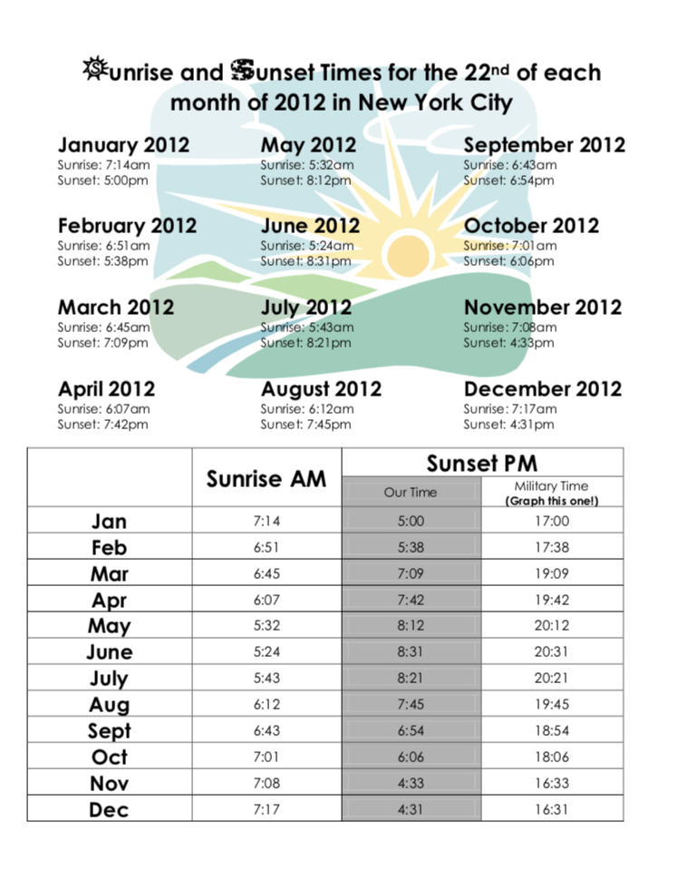
Explore Data Table and Directions

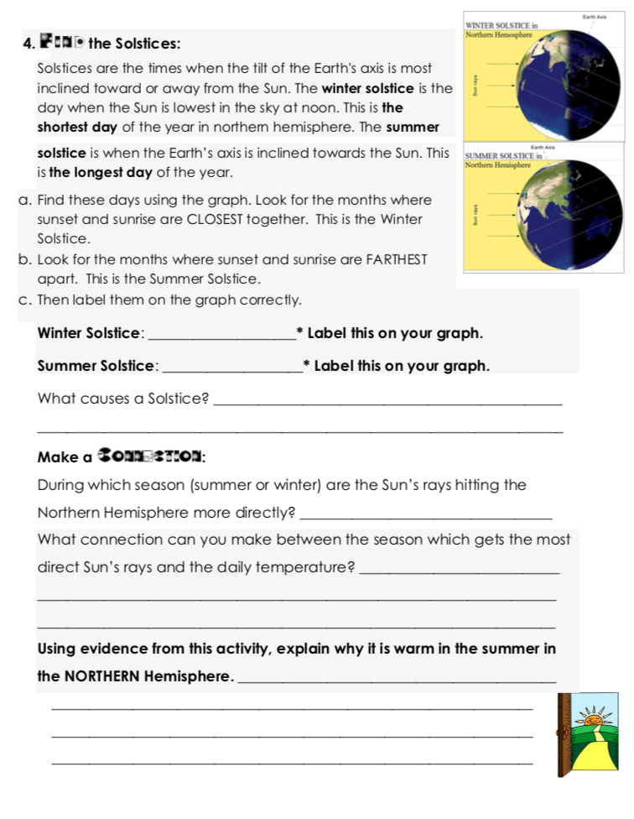
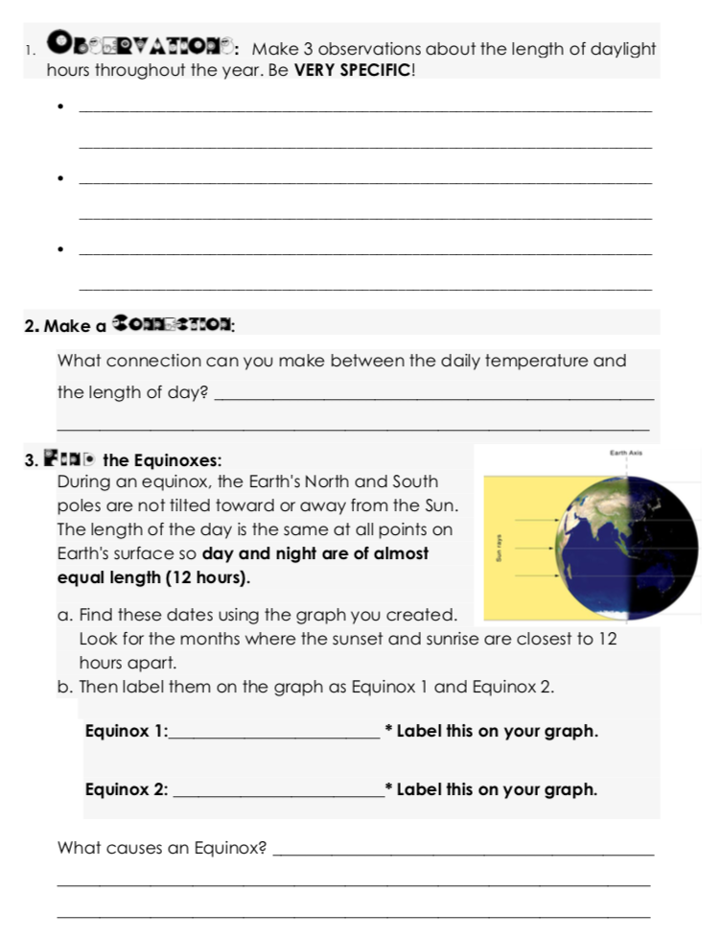
Evaluate Pages

Explain Guided Questions Sheet

1. What is the first thing that you notice about the graph?
2. Which months have the most hours of daylight?
3. Which months have the least hours of daylight?
4. Why do you think some months have more hours of daylight than others?
5. How the Earth play a role in amount of hours of daylight each month?

