Brad Peel
NASA Endeavor Space and Science

As my class was exploring the characteristics of the moon phases and the features of the moon, through the text Observing the Moon, they became highly interested in the Tycho Crater. By observing several of its features, my students began to generate a number of questions: Why does the Tycho Crater have a little mountain in the center?; Why do the rays from the Crater spread so far and only in one direction?; and Why are the rays from the Crater so white? This investigation lead into the activity, which I explored earlier in the semester in this class, “Whip Up a Moon Like Crater.” The activity is designed to allow students to explore the properties of physical motion through investigative techniques.

I provided the flour in the pans, but I asked the students to generate ideas to test their theories and hypotheses. They chose a number of projectiles, with a variety of mass, shape, and size. They also developed a number of scenarios regarding the angles from which to cast the projectiles, the speeds which they travel, the depths in which the projectiles would land, etc. They spent about 45 minutes observing and gathering data based on hypotheticals. Some chose to draw pictures, some chose to measure the rayed material which was cast or the depths and widths of the craters they created, some made observations regarding the relative mass, shape, and size of projectiles. After the period of testing, the students felt they had enough data to explain the presence of the Tycho Crater.

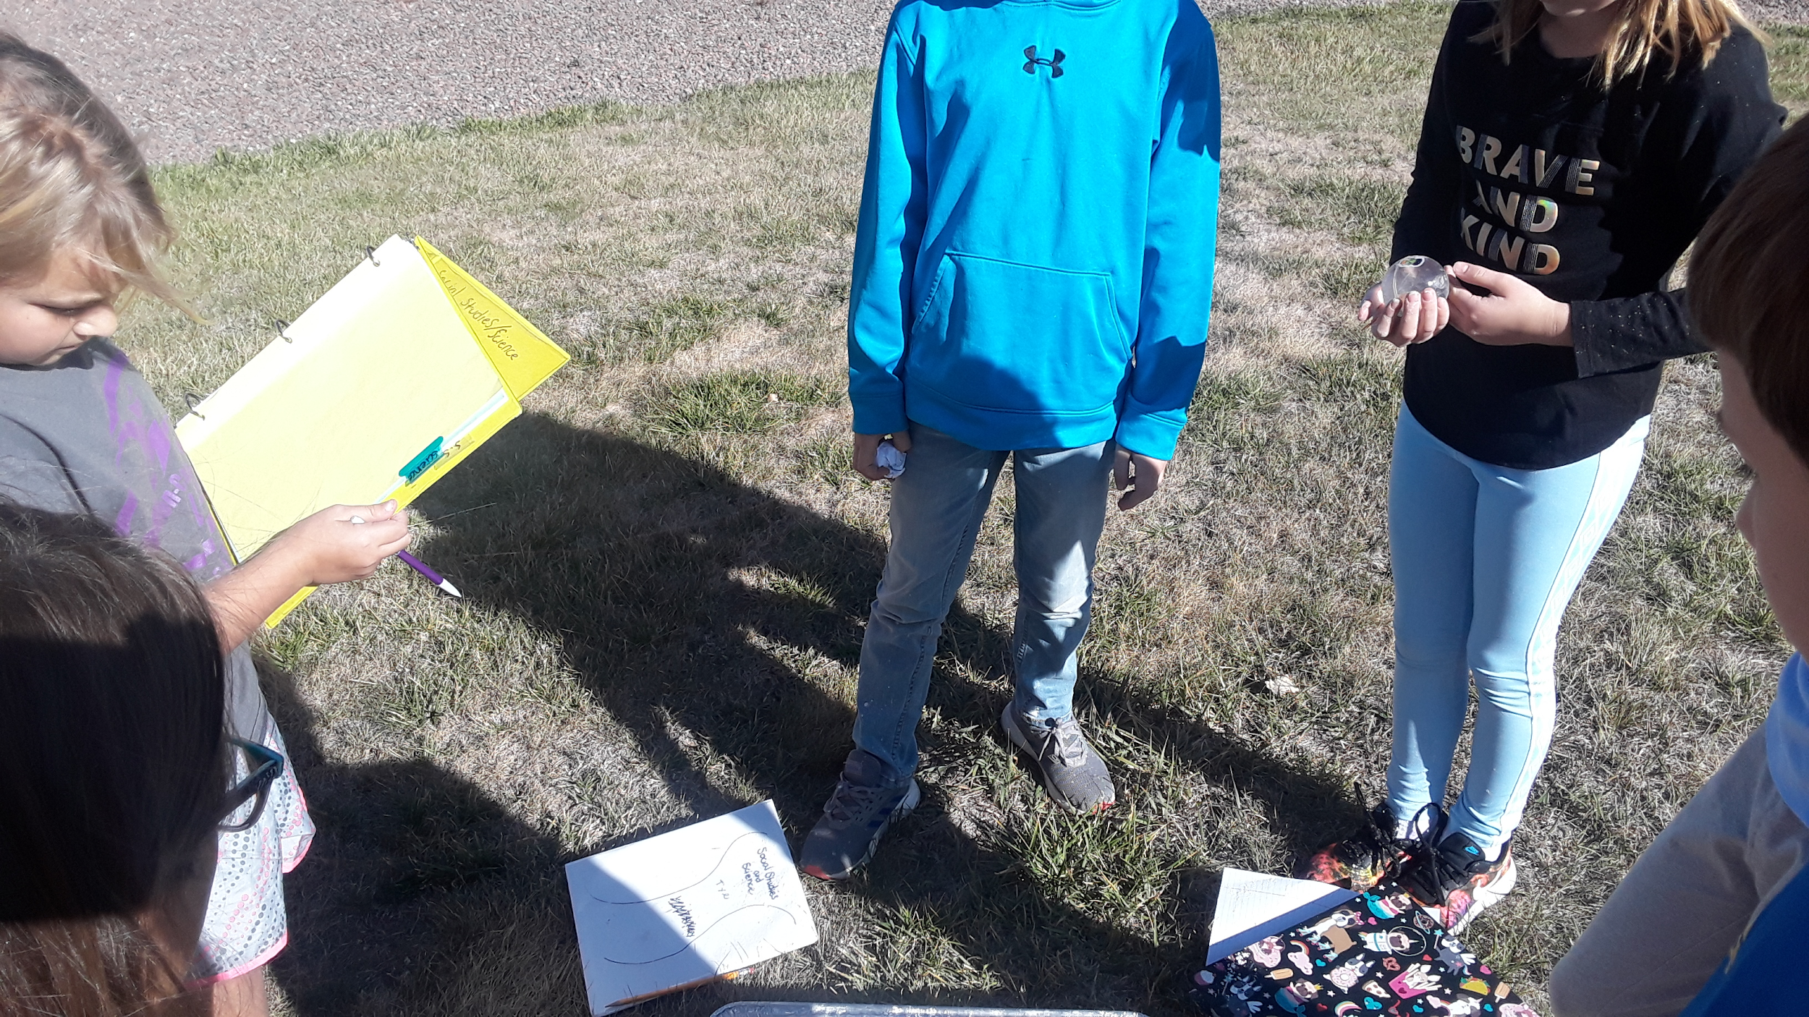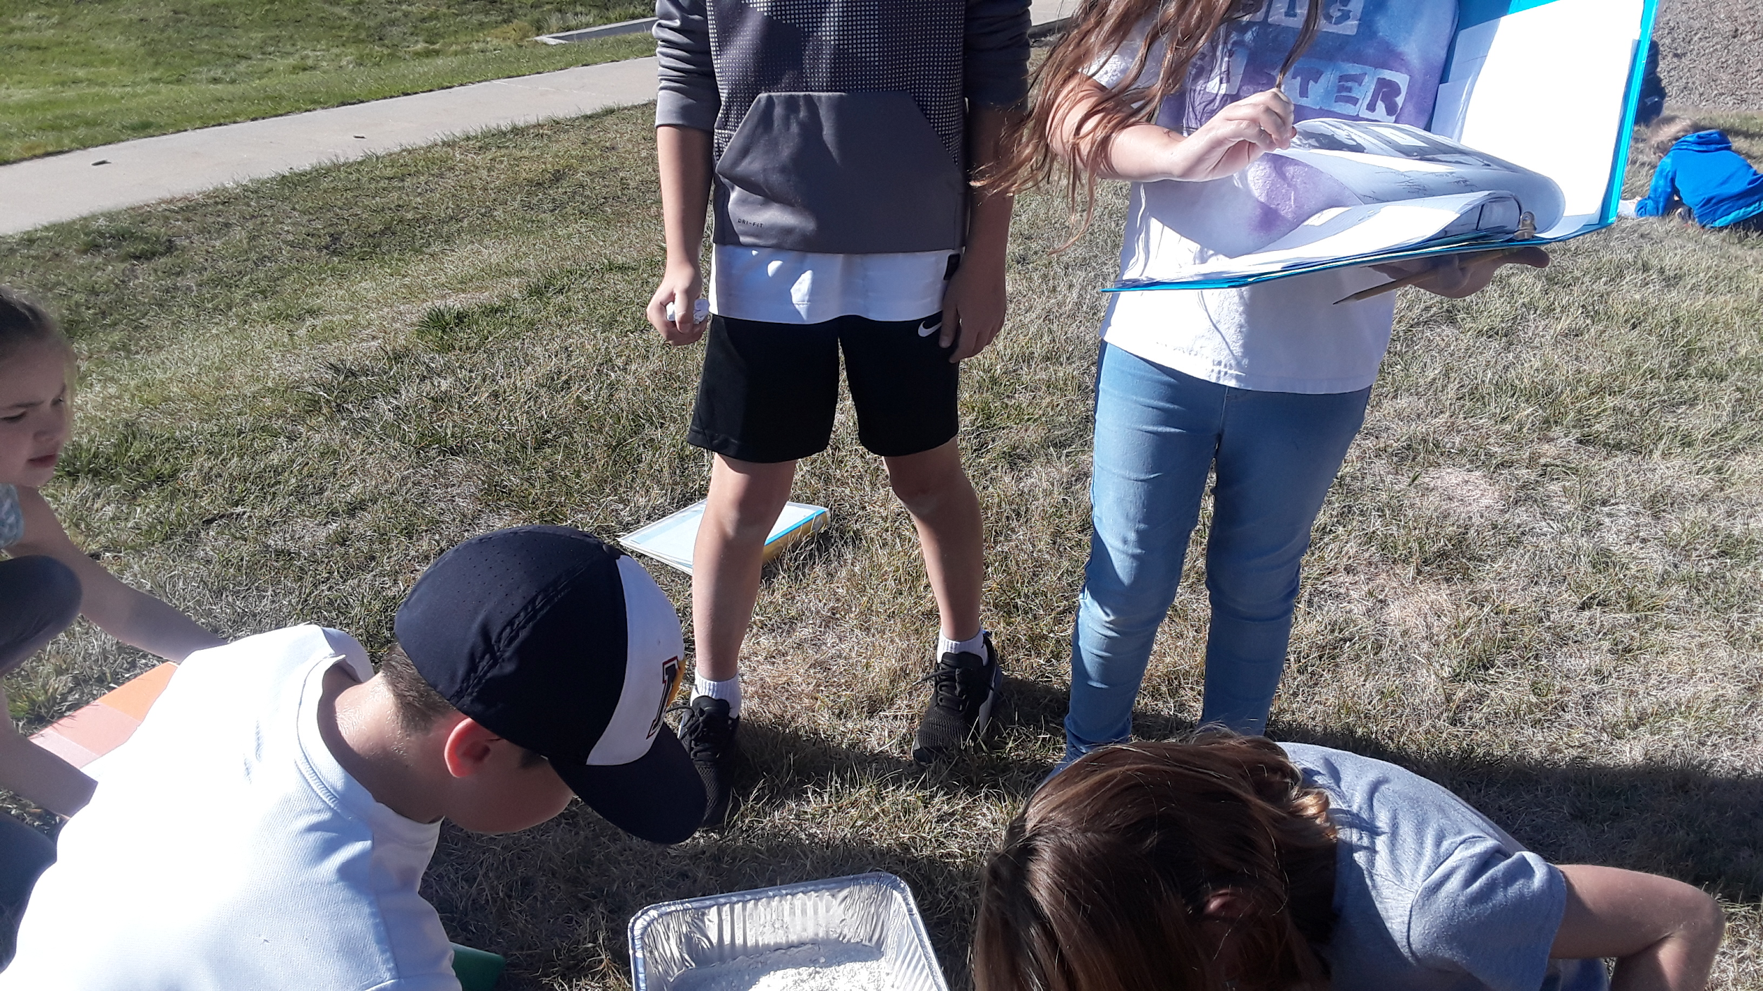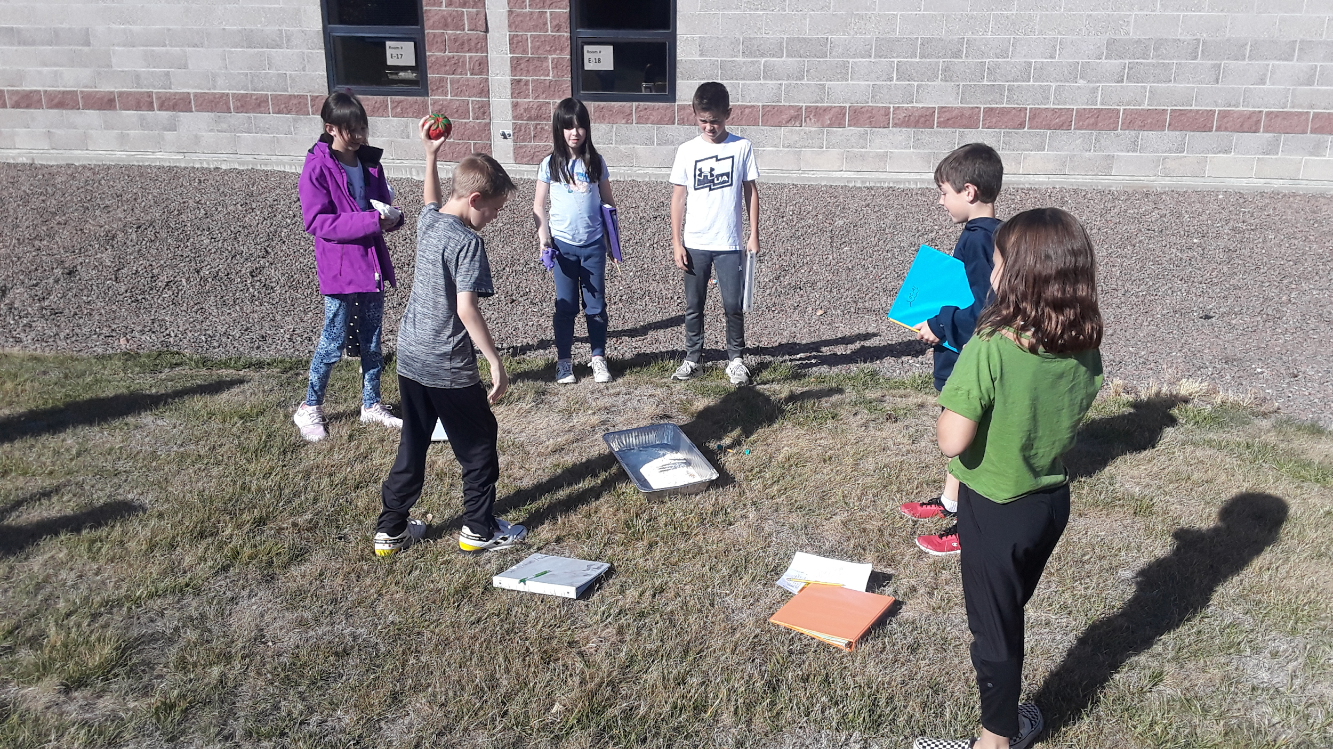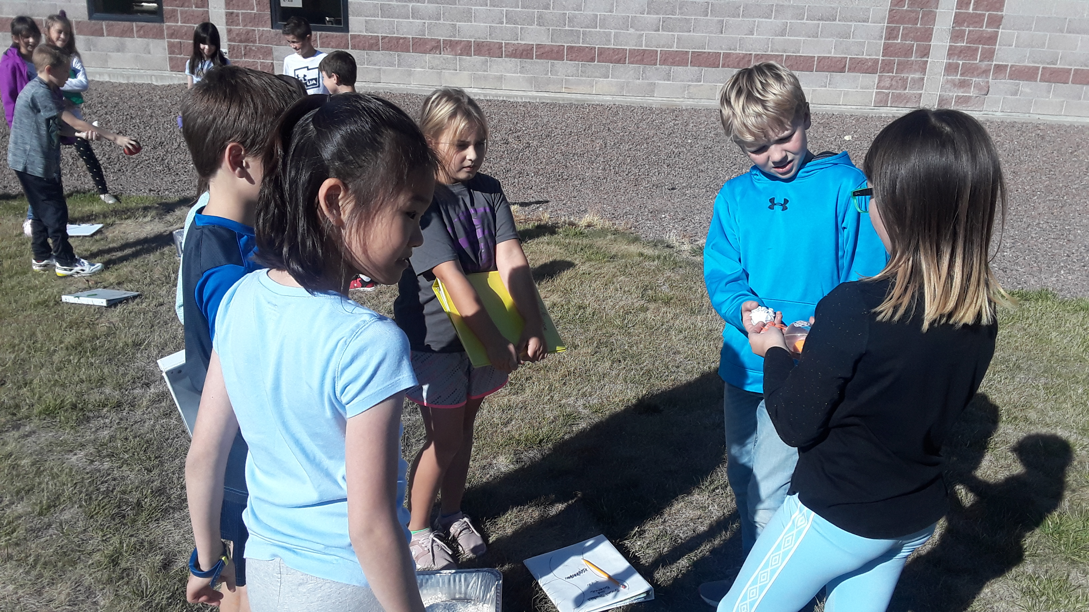
Students conduct experiments, observing the outcomes of the impacts of a variety of objects propelled at a variety of rates from a variety of angles.

We returned to the classroom, had a short class discussion to disseminate and verify data, and wrote explanations about the creation of the Tycho Crater according to their initial observations and questions. Their explanations were varied, yet supported with evidence. The projectiles landing provided evidence of indentation, material distribution, and repercussive effects of impact.

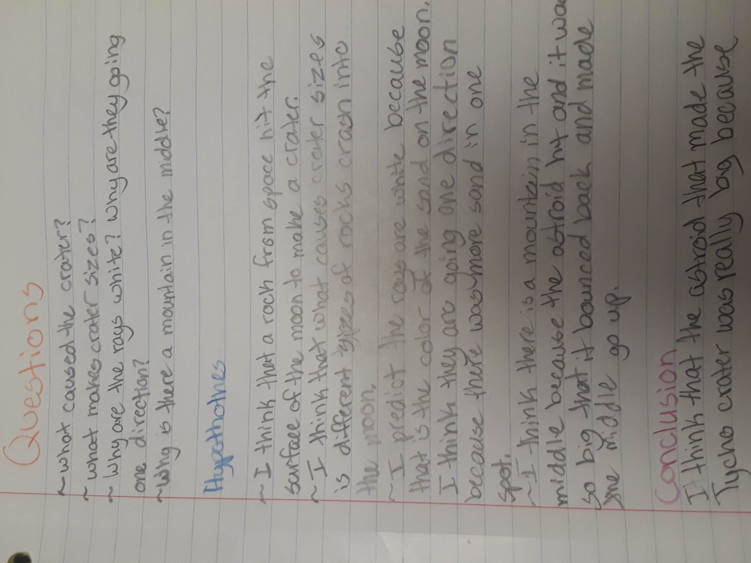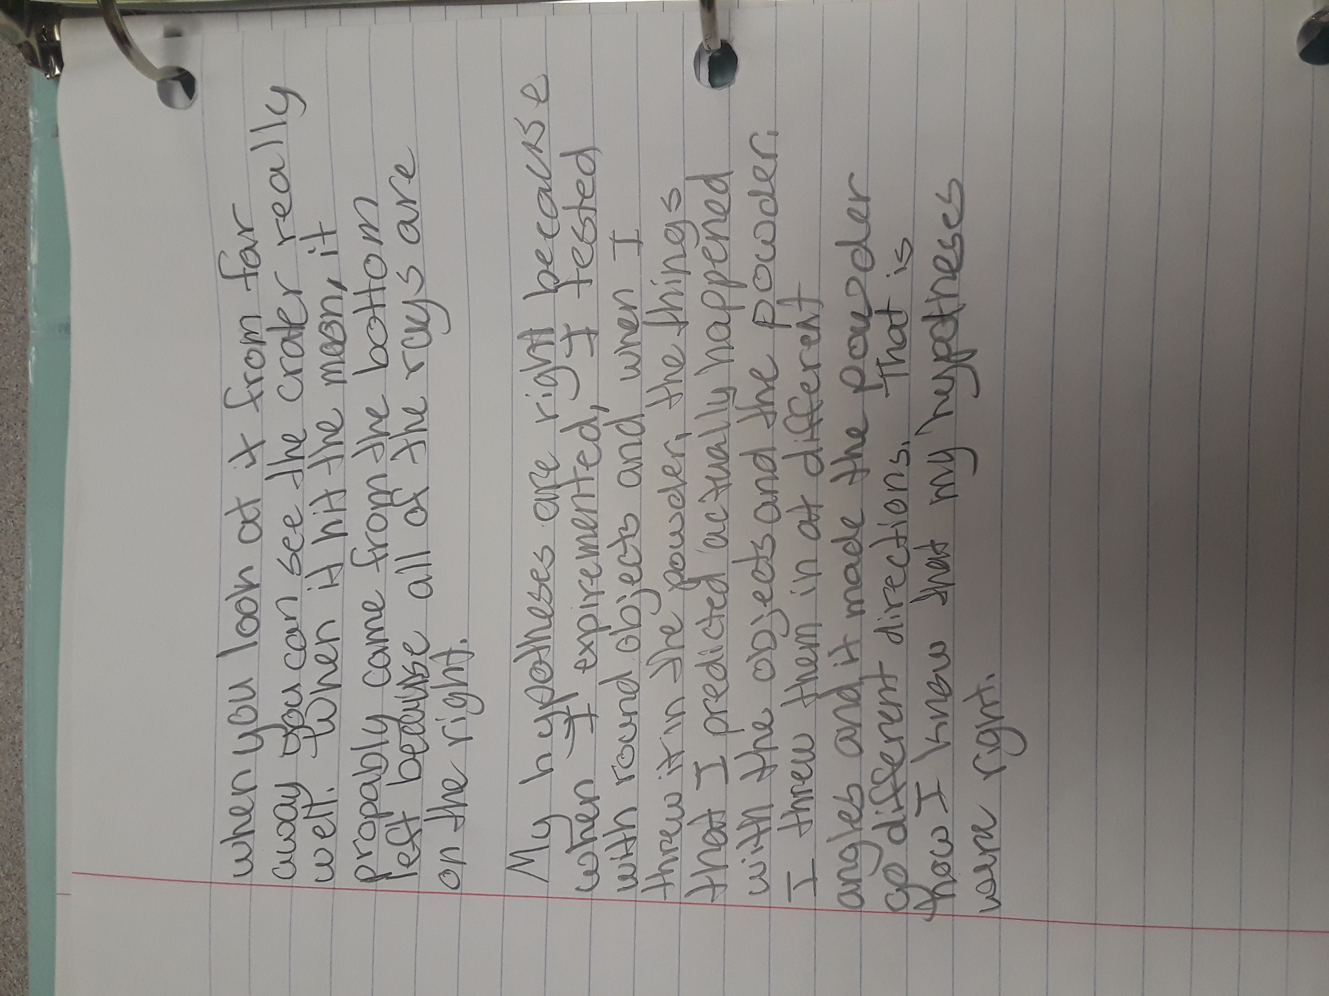
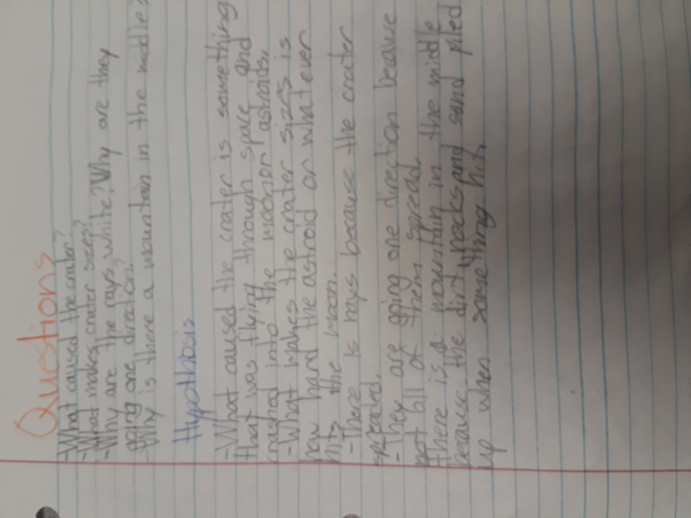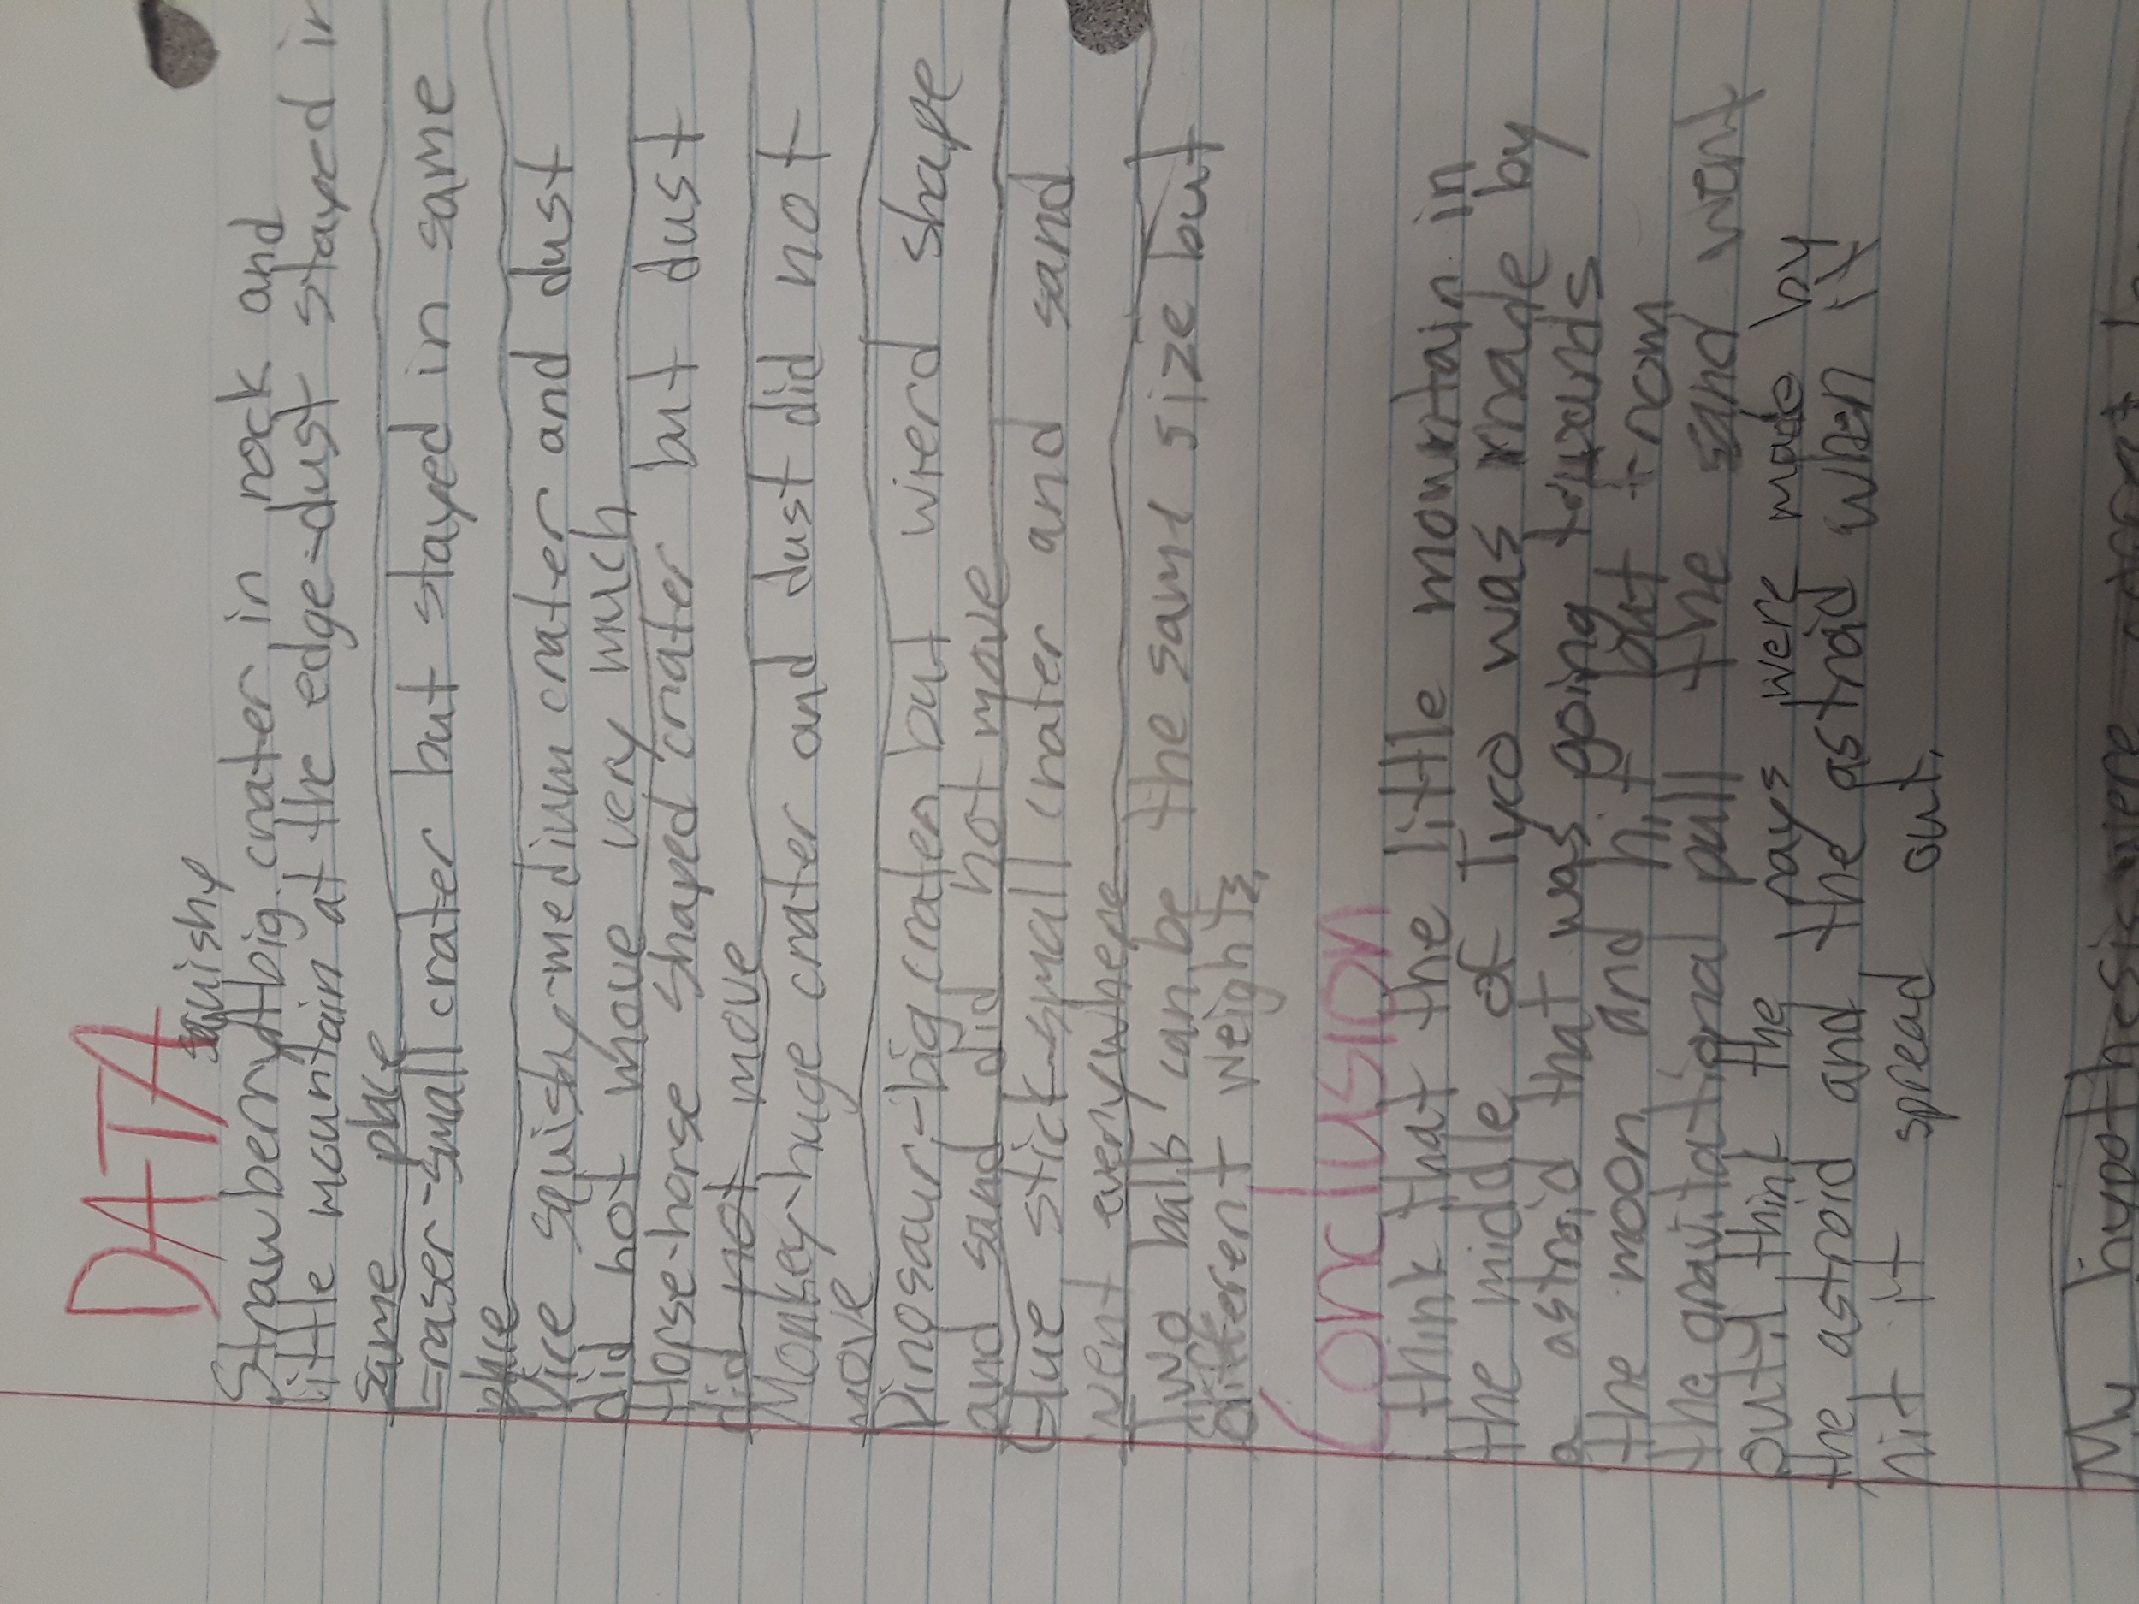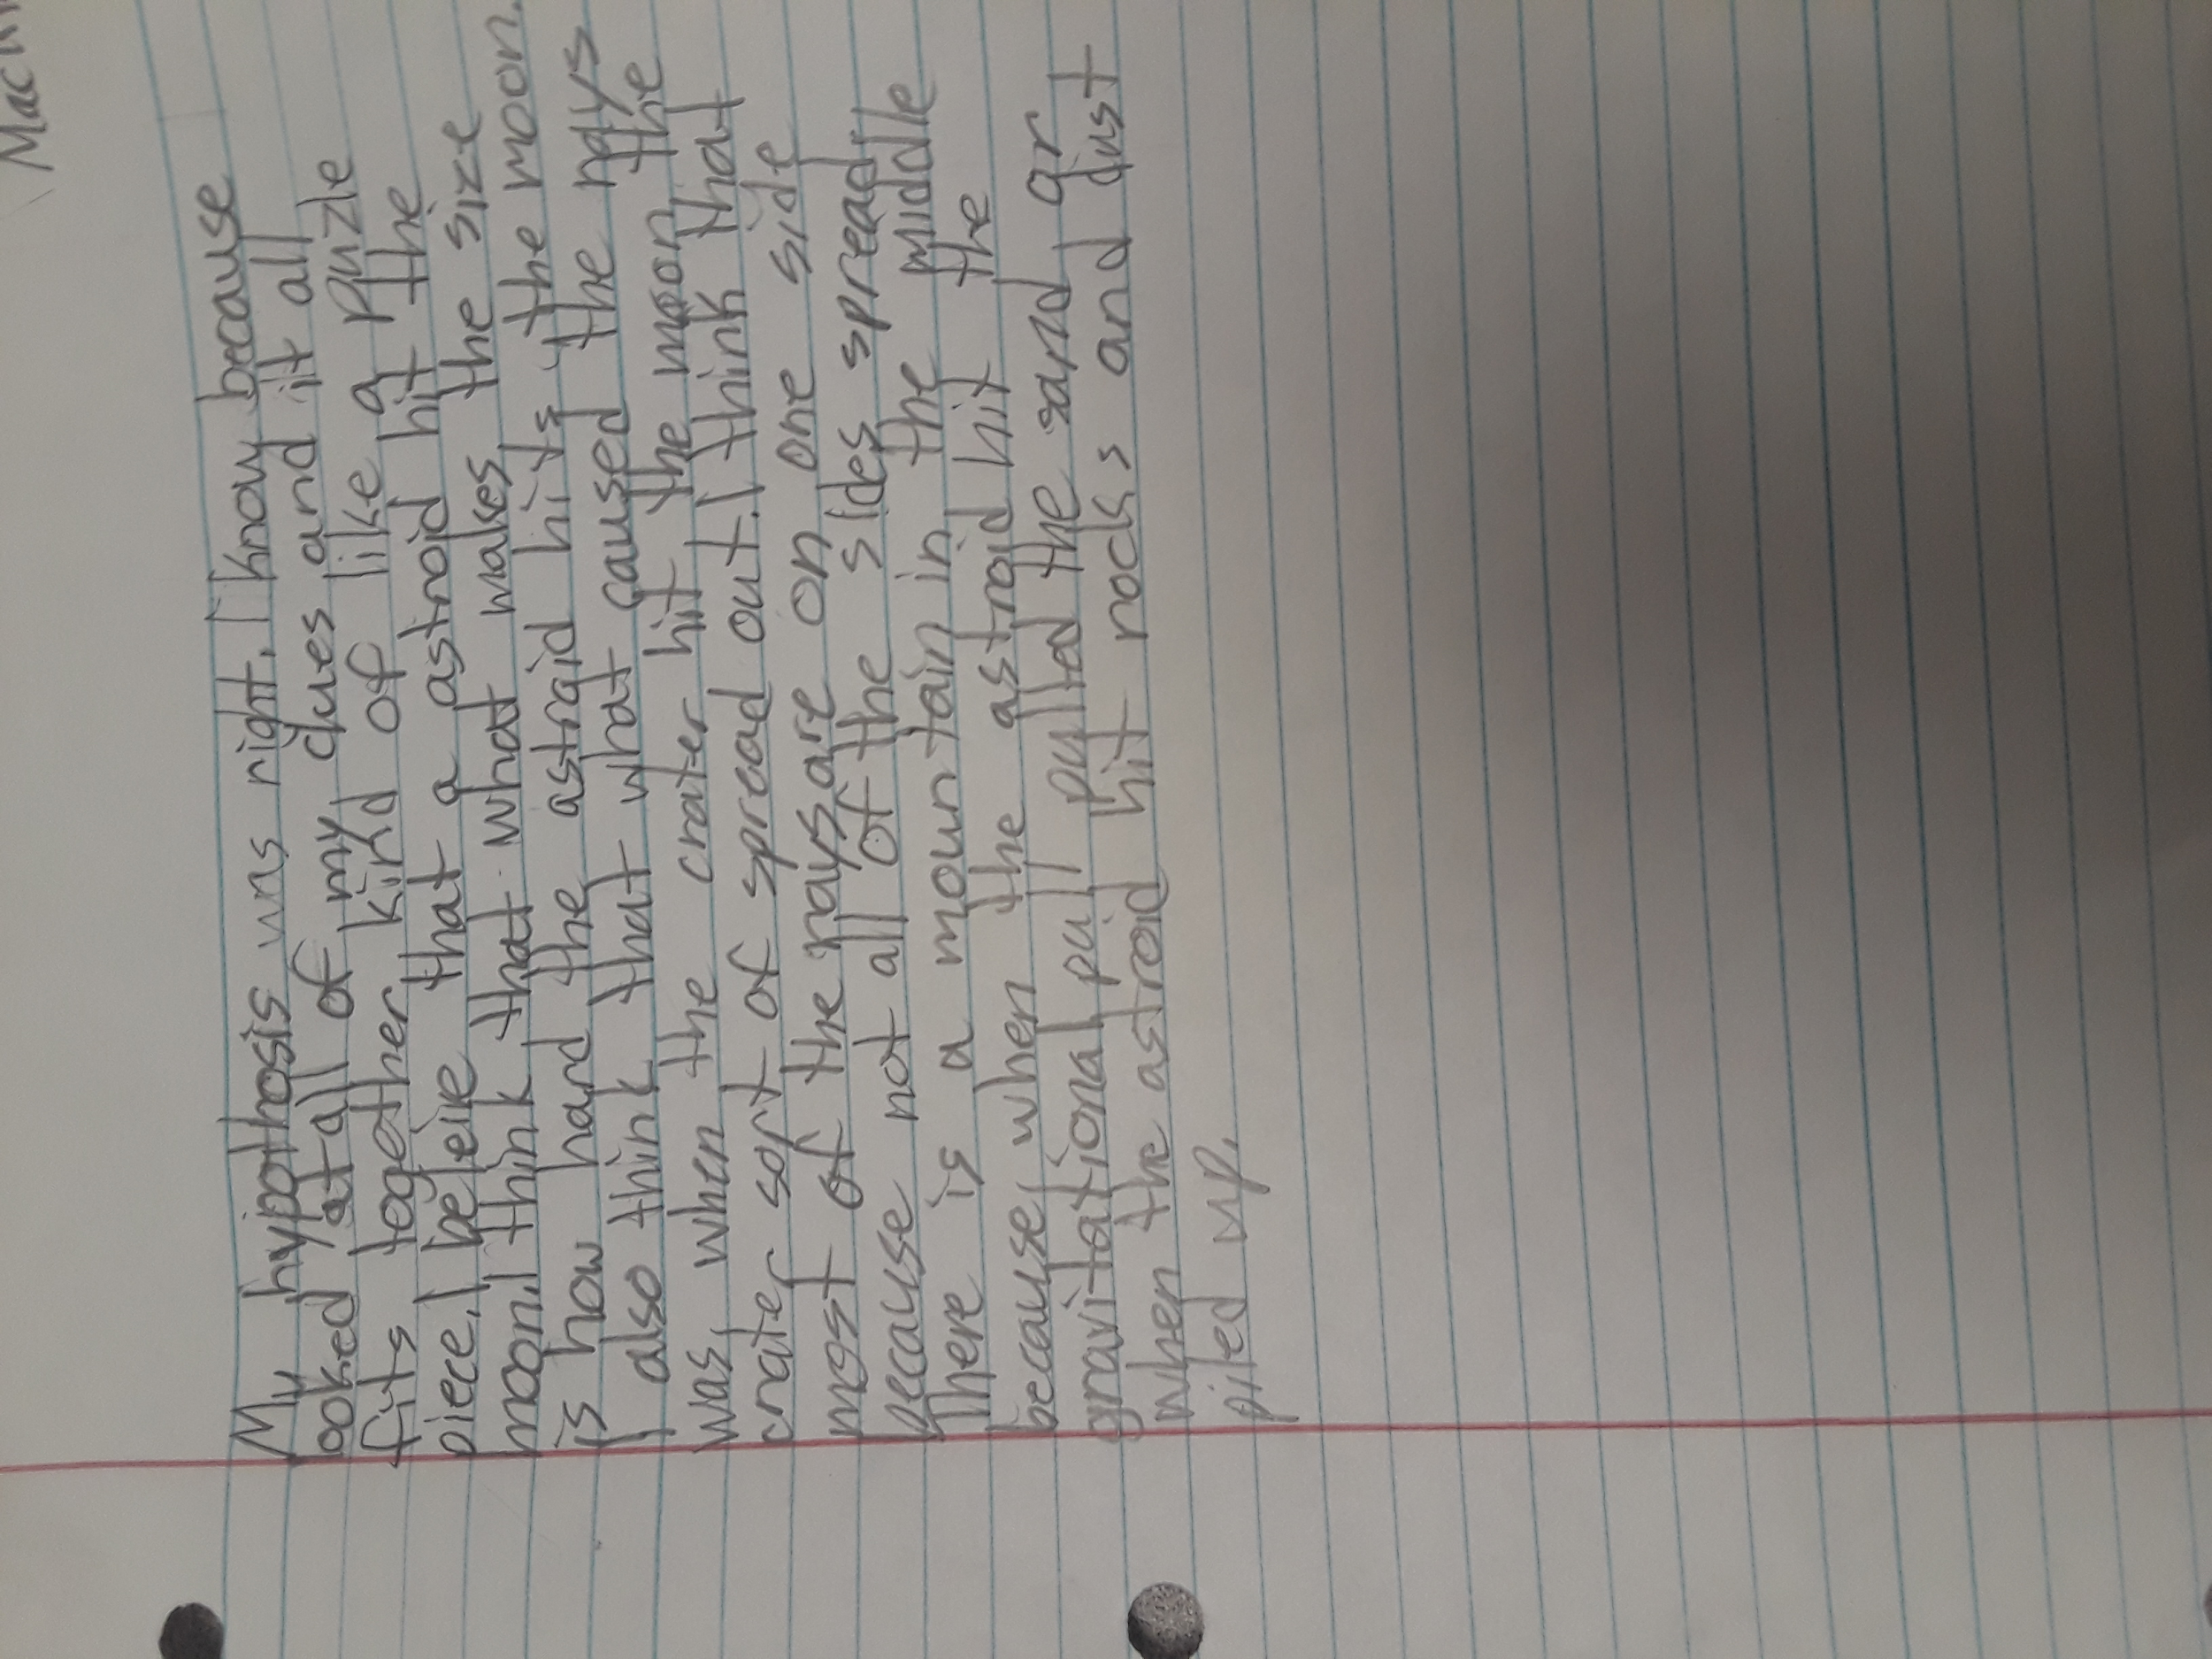
Student write ups with developed questions, hypotheses, data from observations, and conclusive statements.

At the initiation of the activity, I engaged the students more richly by asking if they wanted to “Make a mess!” This generated a lot of excitement. For the most part, the astronomy units which I have developed are rooted as research science, and this activity added a great deal of understanding through the scientific process. For me as an instructor, I am more aware to be able to elevate wonder through these explorations. The question “How did it get like that?” can be the initiation of more “messes” and more observation.

RESOURCE
(2017, October 17). Whip Up a Moon-Like Crater Activity | NASA/JPL Edu. Retrieved from https://www.jpl.nasa.gov/edu/teach/activity/make-a-crater/

Baker, J., & Erickson, J. (2011). Observing the Moon. Nashuya, NH: Delta Education.

