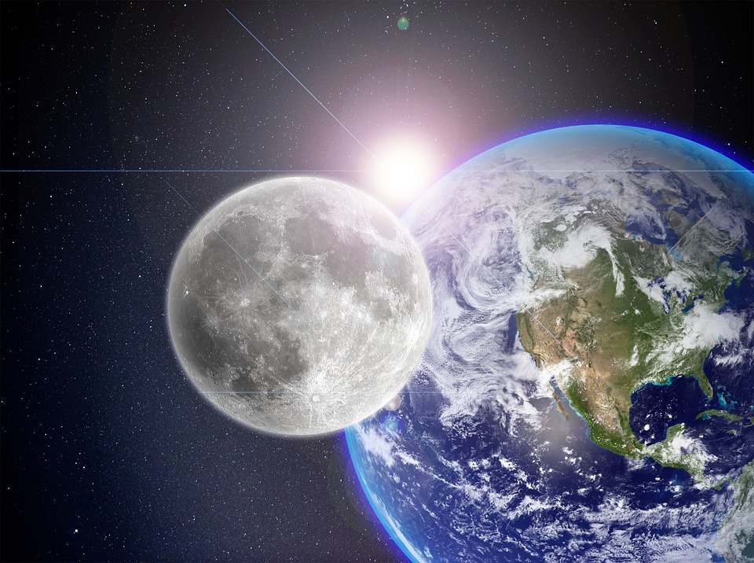
Planetary Explorer

Theme: Objects in the Solar System

Background:
NASA’s Solar System Exploration tool gives data about each planet in our solar system. Students will use the
data tools to evaluate the similarities
and differences between objects in
our solar system, and compare them to Earth. The tool allows them to compare planets to each other and to Earth, as well as all eight of our planets together. It also lets them evaluate dwarf planets, Moons, Asteroids, Comets and Meteors.

Grade Level: Middle School (6-8)

Time Requirement:
Basic requirement is 14-20 days
Add on up to a week if doing the STEM build
Extension time is open ended

Standards:
NGSS:
MS-ESS1-1: Develop and use a model of the Earth-sun-moon system to describe the cyclic patterns of lunar phases, eclipses of the sun and moon, and seasons.
MS-ESS1-3: Analyze and interpret data to determine scale properties of objects in the solar system.
CCSS.Math:
6.RP.A.1: Understand the concept of a ratio and use ratio language to describe a ratio relationship between two quantities.
6.RP.A.2: Understand the concept of a unit rate a/b associated with a ratio a:b with b ≠ 0, and use rate language in the context of a ratio relationship.
CCSS.ELA:
RST.6-8.1: Cite specific textual evidence to support analysis of science and technical texts.
RST.6-8.7: Integrate quantitative or technical information expressed in words in a text with a version of that information expressed visually
Engineering:
MS-ETS1-1: Define the criteria and constraints of a design problem with sufficient precision to ensure a successful solution, taking into account relevant scientific principles and potential impacts on people and the natural environment that may limit possible solutions.

Learning Objectives:
- Students will gather data about each of the planets, at least one dwarf planet and asteroid data.
- Students will compare the data in charts, graphical representations and a biography of each planet.
- Students will use data to draw a model of the solar system to scale.
- Students will explain the different types of objects in the universe using ratios, scales and other descriptive explanations.
- Students will be able to use this data to make classifications of solar system objects based on their characteristics.
- Students will be able to compare two planets’ similarities and differences based off of different scales.
- Students will explore missions that have allowed this data to be collected and analyze how technology has advanced our knowledge of our solar system.
- Students will design a rover that will be able to explore each of these terrains.
- Students will use the engineering design process to create their rover.
- Students will use scientific writing skills to describe their rover parts.

Vocabulary/Key Words:
Planet Orbit
Dwarf Planet Revolution
Asteroid Rotation
Meteor Diameter
Comet Atmosphere
Moon Planetary Rings
Solar System Asteroid Belt
Galaxy

Materials:
Computer for investigation and graphs
Large roll paper for scales
Meter sticks and rulers
Coloring supplies
Craft supplies to create rover
Rubrics for each activity
Paper/Construction paper to create biographies, or computers for digital versions
Food stuffs for extension visual model

Engage: 1 Day
Students will watch the Solar System Introduction video (https://www.youtube.com/watch?v=I0PR4pkZ-GE) (There are lots of options of different videos, a teacher may choose a different introduction video.)
Students will work together to create a Notice/Wonder class chart. What do they notice about the solar system? What do they wonder? (It is recommended to hand out mini sticky notes to each group that they can anonymously add their ideas to the group chart. Other methods can be digital or gallery walks, etc.)
Leading Questions could include:
- What do you notice about their sizes?
- What do you notice about how they look?
- How do you think they compare in their motion?
- How do you think we can compare them? They are so big, so what could we look at?

Explore: 6-10 Days
Task 1: (1-2 Days) Students will use the “Solar System in My Neighborhood” worksheet to create a scale model of the solar system. Students will need large paper, rulers and meter sticks as well as colored pencils/markers/crayons to create their solar system. (The worksheet shows the distance from the sun in billions of meters. Students will need to convert that to centimeters in order to make it an individual or group project.) Please follow the grading rubric here: https://docs.google.com/document/d/16l3phvmFH64OIiir12VFD2hGx23b-SHLREzOvwD8bwE/edit?usp=sharing
Task 2: (1-2 Days) Students will create a graphical representation of the differences between planets. Numbers can be found by comparing all 8 planets on the “By the Numbers” page of NASA’s Solar System Exploration resource. (It is suggested to use Excel to create the graphs, but if the technology is unavailable, graph paper could be used.) Students can create the comparisons on one graph, or use multiple representations for each data set. Students will compare diameters of each planet, their densities and their orbit around the Sun. The grading rubric is included here: https://docs.google.com/document/d/121UdWM4wHhB9a4yLFnCeVShtC3bqrzVzbXOTWgafK8E/edit?usp=sharing
Task 3: (2-3 Days) Students will use the Solar System Exploration resource to write a brief biography of each planet, a dwarf planet and asteroids. They will look at its discovery, surface features, composition of the planet and its atmosphere, and at least two neat facts about each. (Booklets can be created by hand or digitally through a resource such as PowerPoint) The rubric for this is here: https://docs.google.com/document/d/121UdWM4wHhB9a4yLFnCeVShtC3bqrzVzbXOTWgafK8E/edit?usp=sharing
Task 4: (3 Days) Students will use the Solar System Exploration tool to learn about the Earth-Sun-Moon system which includes lunar phases, eclipses and seasons.
Step 1: Students will use the information they’ve already gathered to create a model of how they think these three objects interact to include the phases, eclipses and seasons (Models can be drawn on paper but it is suggested to draw them on whiteboards so they are easily edited).
Step 2: Students will complete the investigation provided by NASA’s Jet Propulsion Laboratory called “Modeling the Earth-Moon System.” This will show how the moon, at different periods in its orbit, is receiving different levels of sunlight creating the different phases.
Step 3: Students will then be given time to read about the Earth on the “In Depth” page which talks about the angle of the axis and how it creates seasons. (Teachers can print the page for those that don’t have internet access)
Step 4: Students will go back to their original models and make changes, or create new ones (Student understanding would show the angle of the earth, the seasons created by this angle, the lunar phases and where eclipses would occur).
Task 5: (1-2 Days) Students will choose one planet, dwarf planet or moon and research it’s exploration. What technology did scientists use to learn more about this planet? Students will write a brief informative essay over the exploration of their chosen object.
Task 6: (1 Day) An engineering gallery walk. Students will share about the technology they researched. (This could be done in a presentation format if preferred)

Elaborate: 1 Day-1 Week (including build time)
Students will work with their groups to create a rover that can explore each of these planets more in depth. Students will follow the engineering design process. Standards for this found here: https://ngss.nsta.org/DisplayStandard.aspx?view=pe&id=206 (MS-ETS1-1) Please follow the steps laid out in the rubric here: https://www.jpl.nasa.gov/edu/teach/activity/modeling-the-earth-moon-system/
If supplies and time allow, students could design and build a model of their prototype.

Explain: 2 Days
Task 1: (1 Day) Students will be able to use their data to determine the ratio of each planet’s size to Earth. (Compare total volume or diameters for this evaluation.)
Task 2: (1 Day) Students will group objects together based off of their characteristics. This can be done through graphic organizers or concept maps. Students should be able to explain why they placed each object in its specific category. Students will write a brief claim-evidence-reasoning statement for each category which explains what evidence they used to group those objects. CER Rubric here: https://drive.google.com/file/d/0B2Im-XdKLBCBQ1I3eHE1bk1YYkU/view?usp=sharing
Task 3: (1 Day) Students will be able to explain their models either in writing or by presenting them to other groups or the teacher.

Evaluate:
Rubrics for each activity are included for grading purposes. These should also serve as a formative assessment for student understanding of each concept.
Students can be presented with two celestial objects and should be able to explain similarities and differences between the two. This can be done as a summative assessment or as a formative assessment.
Students should be able to explain the differences in groups of objects such as planets, dwarf planets, moons and asteroids.
Follow-Up questions/Summative Assessment:
- What characteristics do all planets have?
- What characteristics do dwarf planets have?
- What classifies a moon?
- What other properties can we compare between planets that might be too big, or too small, to observe?
- What are some other properties that we do not know about planets that advanced technology could help us learn more about them?
Students should be able to explain how the Earth experiences different seasons. They should be able to explain how the moon changes phase due to the reflection of the sun. Students should also be able to explain eclipses.

Extend: (Open Ended)
One extension project could be for students to create their own planet, either a two-dimensional picture or three-dimensional model. Students will need to defend their design with evidence from their exploration. Students can write a paper about their planet and its features. (Teachers may decide to have them present their planet to the rest of the class as well.)
A different extension could be students becoming an astronaut that might explore one of these planets. Using the information they collected about surface features on their selected planets, they will create a journal entry as if they were landing on that planet and what they could see.
(Both of these extensions: design a planet and become an astronaut, could be done together. A journal entry from an astronaut who is exploring this new planet.)
If students are struggling with the scale of objects, the “Solar System in my Neighborhood” worksheet includes food to represent sizes of objects in relation to each other. This could be a helpful visualization.

Resources:
Planetary Science Communications Team. (n.d.). Solar System Exploration. Retrieved from https://solarsystem.nasa.gov
Next Generation Science Standards. (n.d.). MS-ESS1-3 Earth’s Place in the Universe. Retrieved from https://www.nextgenscience.org/pe/ms-ess1-3-earths-place-universe
National Science Teaching Association. (2014) Middle School Engineering Design. Retrieved from https://ngss.nsta.org/DisplayStandard.aspx?view=pe&id=206
Common Core State Standards Initiative. (2019). Grade 6: Ratios & Proportional Relationships. Retrieved from http://www.corestandards.org/Math/Content/6/RP/
Common Core State Standards Initiative. (2019). English Language Arts Standards: Science and technical subjects: Grade 6-8. Retrieved from http://www.corestandards.org/ELA-Literacy/RST/6-8/
Lunar and Planetary Institute. (2017, November 28). Solar System in My Neighborhood. Retrieved from https://www.lpi.usra.edu/education/explore/solar_system/activities/3_PlanetScale_1Billion.pdf
Astrovisuals1. (2014, September 13). Solar System Introduction-Summary of the Planets (Video file). Retrieved from https://www.youtube.com/watch?v=I0PR4pkZ-GE
Jet Propulsion Laboratory (n.d.). Modeling the Earth-Moon System. Retrieved from https://www.jpl.nasa.gov/edu/teach/activity/modeling-the-earth-moon-system/

