Emily Lehnardt
FINAL 5E Lesson Plan
Methods of STEM-Secondary
April 23, 2019
Pelicans on Gunnison Island
I taught this lesson last week in my science classes. This lesson was adapted from a Science Specialist: Megan Black
Standards
- SEEd Standard 6.4.1 Analyze data to provide evidence for the effects of resource availability on organisms and populations in an ecosystem.
- SEEd Standard 6.4.4 Construct an argument supported by evidence that the stability of populations is affected by changes to an ecosystem.
- NGSS Standard MS-LS2-4: Construct an argument supported by empirical evidence that changes to physical or biological components of an ecosystem affect populations.

Theme: Pelican Ecosystem
Grade: 6
Time: This lesson should take 4-5 days.
Learning objectives:
Students will examine cause and effect relationships to predict phenomena in natural or designed systems.
Students will discuss why Small changes in one part of a system might cause large changes in another part
Driving Questions
Why do pelicans live on Gunnison Island on the Great Salt Lake? How do water levels effect the Pelican population?
Justification
This lesson discusses changes to a population. According to the Utah Division of Wildlife, 10-20,000 Pelicans migrate over 1,000 miles to live on Gunnison Island during the spring and summer. However, in 2017, the Utah Division of Wildlife counted 700 Pelicans. Students will discuss what is special about Gunnison Island, where and how Pelicans eat and how the Great Salt Lake water levels affect the Pelican population.

Prior Knowledge
Students should review the Great Salt Lake ecosystem. They should review that a population means the same species living in the same area. Students should understand that stability and change in an ecosystem can affect a population. They should know how to collect and interpret data from a graph. Our school has a class set of Chromebooks for each 6th grade class. The students should have a basic understanding of how to use google to look up information.
Vocabulary
Stability | Change
Population | Distribution
Analyze | Regurgitate
Fledgling | Migrate

Engage
Ask students: Why do Pelicans live on Gunnison Island on the Great Salt Lake for part of the year?
Students will view pelican photos, maps and migration patterns. They will use the slide show provided by the district to make their observations. They will also ask questions about Pelicans. They will use Google Earth to take a virtual field trip to Gunnison Island. After their “field trip,” student will write a claim as to why they think Pelicans live on Gunnison Island. Students will observe a Pelitracker to observe Pelican migration.

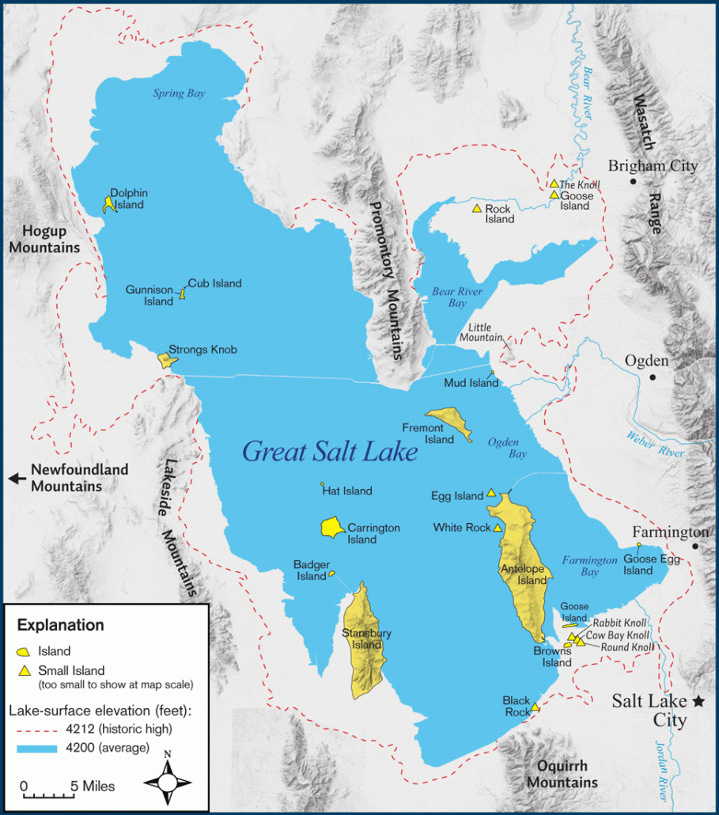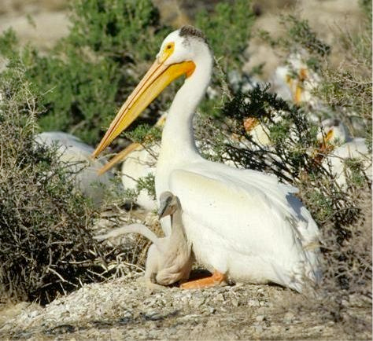
Here are sample claims my class wrote after their observations:
“I think that Pelicans go to the island to chill. Maybe they want to break from the heat? Or they want to made and birth their young?”
“I think that Pelicans are living on Gunnison Island because they need somewhere to stay. They are looking for mates. They are looking for a good place to raise their young.”
Explore
Ask students: What do Pelicans Eat? Where do they go to find food?
Students will begin the explore phase by analyzing this map to determine Pelican distribution. Review with students what distribution means. Discuss and write down any patterns in their science journals.

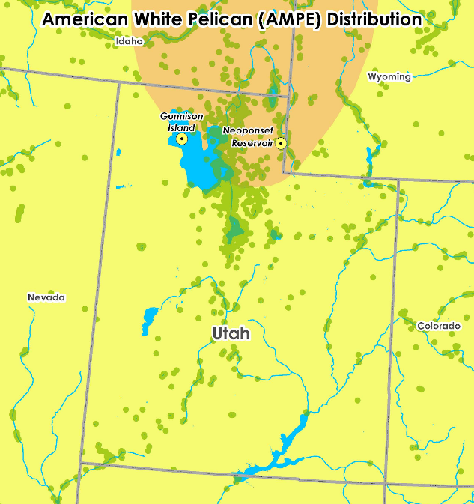
Through discussion, guide students to understand that there are no fish in Great Salt Lake, so the pelicans living on Gunnison Island must have to fly to find food.

Students will use Pelitrack data and data from piles of regurgitated food to think like a biologist. They will determine which waterways Pelicans use to find food. Students will receive a map of Utah. Student will use a ruler to measure how far Pelicans travel for food.

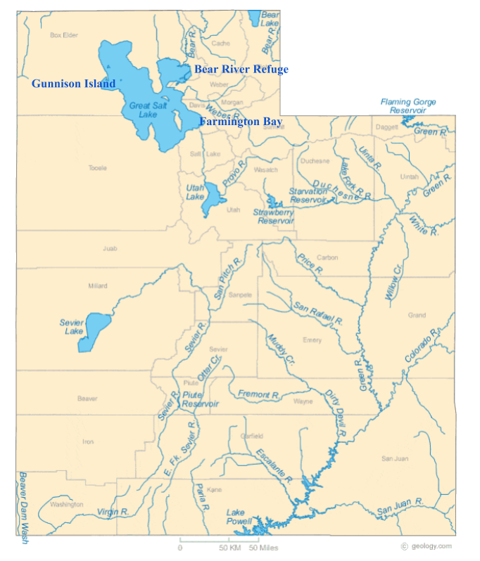

Students will go to https://wildlife.utah.gov/pelican_webmap/. Using this webpage, students can see where tagged pelicans have been. Provide students with the following directions:
- Go to https://wildlife.utah.gov/pelican_webmap/.
- Choose explore the map.
- Zoom in and out to see the movement of pelicans around Great Salt Lake.
- Use the filter menu to view the flight tracks of Cici, Yogi, and Loretta for the last year.

Next, tell students that pelicans regurgitate their food when afraid or when feeding young. Show a video of birds foraging and feeding young. Discuss observations. Then, tell students they will be biologists today, sorting through Pelican barf (Swedish fish, gummy worms). They will identify types of fish and infer the source of the fish.
1. Place 4 students in 6 groups.
2. Place 6 regurgitated facts data sheets around the room.
3. Students pull out the fish from the bowl and identify fish found in waterways
Pelicans use to find food.
The regurgitated fish data sheet can be found at:

Image Sources: https://www.nps.gov/media/photo/gallery.htm?id=62047290-155D-451F-67600E347A2E22DF, http://www.bigfishtackle.com/, http://fieldguide.mt.gov/speciesDetail.aspx?elcode=AFCJB13020, https://commons.wikimedia.org/wiki/File:Bonneville_Cutthroat_Trout_(6878987882).jpg, http://www.americanfishes.com/, http://staff.royalbcmuseum.bc.ca/2015/01/12/who-will-know-where-loaches-go/

Explain:

Ask students: If Gunnison Island is so far from food, why do pelicans go there?

In the Explain phase of the lesson, students obtain information about pelicans and how they care from their young from a variety of sources, an excerpt from the Great Salt Lake Bird book, a historical account of pelicans in Great Salt Lake, blogs about tagging pelicans, and an informational flyer on pelicans. Students use evidence from the text along with the information they gathered about where pelicans go to find food to develop a claim about why pelicans go to such a remote island in Great Salt Lake.
Students will share their claims about why pelicans go to Gunnison Island, and share the textual evidence they found that supports the claim.

Elaborate:

Ask students: How might changes to the ecosystem affect the pelicans on Gunnison Island?

Ask students share what they learned about pelicans on Great Salt Lake so far - how are pelicans dependent on interactions with living and nonliving things?

Share with students the following information: Normally, there are 10,000-20,000 Pelicans living on Gunnison Island. However, in 2017, the Utah Division of Wildlife counted 700 Pelicans.
Students will develop an argument as to why the Pelican population was so low…even though biologist’s aren’t sure why.
Students will analyze a Changing Environment data sheet. Great Salt Lake Elevation Levels from 2007 – 2017 from: https://nwis.waterdata.usgs.gov
They will also watch a timelapse video showing the shrinking Great Salt Lake: https://www.youtube.com/watch?v=RHRxmZPqvl0
Finally, they will watch a news report from Good4Utah to collect information: https://www.abc4.com/news/pelican-breeding-ground-threatened-at-great-salt-lake/806947095
Students will share their arguments to the class. Include in the discussion: how the changing Great Salt Lake ecosystem affects pelican populations. Students will discuss that if young pelicans can’t survive on the island, the pelicans will need to find a new area, away from predators and people, to breed, nest, and raise their young.

Evaluate:

Ask: Why do pelicans live on Gunnison Island for part of the year?

Use the rubric below to help grade the following two questions that students should answer in the evaluation phase of this lesson:

Why do pelicans live on Gunnison Island for part of the year?
How might changes to their environment affect the population of pelicans at Gunnison Island?

Rubric Credit: Megan Black

Criteria | 4 | 3 | 2 | 1
Explanation for American white pelicans on Gunnison Island | Explanation includes a concise claim about why pelicans live on the island and a claim about how the population may change.  Both claims are supported by more than one piece of evidence and/or reasoning.  Specific data is used to support the claims.  Reasoning connects the evidence to the claim and shows an understanding of the causal relationships that affect how pelicans interact with their environment. | Explanation includes a claim about why pelicans live on the island and a claim about how the population may change.  Claims are supported by at least one piece of evidence and/or reasoning.  Reasoning connects the evidence to the claim and shows evidence of student learning about the pelican population. | Explanation includes a claim about why pelicans live on the island, but may not address how the population may change.  Evidence or reasoning may not clearly support claim. | Explanation does not include a clear claim or makes an inaccurate claim.  Evidence or reasoning is not included or does not support the claim that was made.

