Melissa Schlank
Methods of STEM Education

Topic – Natural Selection

Title – Building a Better Beak

Grade – 8

Time – The students will have two 60 minute class periods. The first period will be used to introduce the lesson, brainstorm, collaborate and design. The second class period will be used for the students to build their design, collect, share, and analyze data, and draw conclusions.

Standards:
NGSS
MS-LS4-4 - Construct an explanation based on evidence that describes how genetic variations of traits in a population increase some individuals’ probability of surviving and reproducing in a specific environment.

Common Core
RST.6-8 - Compare and contrast the information gained from experiments, simulations, videos, or multimedia sources with that gained from reading a text on the same topic.

WHST.6-8.2 - Write informative/explanatory texts to examine a topic and convey ideas, concepts, and information through the selection, organization, and analysis of relevant content.

WHST.6-8.9 - Draw evidence from informational texts to support analysis, reflection, and research.

SL.8.4 - Present claims and findings, emphasizing salient points in a focused, coherent manner with relevant evidence, sound valid reasoning, and well-chosen details; use appropriate eye contact, adequate volume, and clear pronunciation.

6.SP.B.5 - Summarize numerical data sets in relation to their context.

MP.4 – Model with Mathematics

Justification – This lesson was chosen because it allows students to demonstrate what they know about natural selection and how it leads to the survival of a species as we reach the end of that section in the unit. It will use what the students have learned about those topics to design a beak that will ultimately lead to the survival of a particular bird species based on the food it is adapted to eat. It will also touch a bit on artificial selection during the final lesson discussion to introduce the next topic in the unit.

The lesson integrates Science, Technology, Engineering, and Mathematical practices. The students will use the topics they are studying in Science class, utilize their chromebooks for the assignment and Padlet to share data, design and build a “beak”, and collect, graph, and analyze data.

Objectives:
Students will design a beak capable of collecting food sources based on provided research.
Students will compare data to determine the best beak for survival.

Materials/Equipment/Technology:
1 beak device (per pair)
1 timer (per pair)
Cup of food containing gummy worms, goldfish, beans, mini marshmallows (per pair)
Construction paper (per pair)
Stomach cup (per pair)
Toothpicks
Plastic Spoons
Small Craft sticks
Straws
Pipe Cleaners
Paper cup
Plastic Forks
Paper Clips
Scissors
Tape/Rubber bands

Lesson Procedure
Day 1
Hook activity - The class will be given pictures of different foods (salad, ice cream, steak, cereal, fries, sandwich, pizza) and told they only have access to one type of utensil (fork, spoon, knife, chops sticks, hands, spatula), which will be assigned by the teacher. The students will describe how it would be possible (if at all) to effectively eat each type of food. They MUST use their utensil in order for the food to get into their mouth. The class will discuss the students’ explanations and decide what utensil is the most useful for eating. This will be used to lead into a discussion of whether having being specialized to eating a particular food or foods well is more or less effective than being a generalist capable of eating many foods, but maybe less effectively.

The STEM packet will be shared in Google Classroom. The class will discuss the problem and the students will individually complete the pre-activity questions. The students will share their answers with their groups and then as a class. The class will go over the criteria and constraints and the available materials. The teacher will demonstrate how to use the bird beak devices. (NOTE – These are made by drilling small holes in large craft sticks/tongue depressors and securing with paper fasteners. An image is seen in the students’ packet.) The class will go over the project rubric. The students will individually brainstorm and sketch and label their design ideas on a sheet of blank paper. They will use their chromebook cameras or phones to take a picture and inert it into their document. The students will be assigned a partner and share their brainstorming ideas. The pair will then choose a design idea through collaboration. They will sketch and label and once again insert the picture into their document. (Alternatively, the students may choose to use Google Draw to create their images.)

Day 2
The students will use their design ideas from the previous class to build their beaks. They will gather materials provided by the teacher and attach them (using tape or rubber bands) to the beak device. After the device has been built, the students will take a picture of it and insert it into their document. They will use Google Draw to include labels and measurements of their device. When ready, the group will be provided with a beaker of bird food (gummy worms, goldfish, beans, and mini marshmallows). The students will pour the food onto the construction paper (the habitat). One student will time the other for 30 seconds to see how much food they can collect and place into the large cup (the stomach) in tact. When time is up, the students will count how many of each type of food was eaten and record the information in their data table. They will switch jobs and repeat until six trials have been completed. The students will post their results to Padlet with a picture of their device, so all students in the class have access to the data. Each student will use Google Sheets to create a graph of their group’s data. They will use their own data and the data provided by the other students in class to complete the analysis questions and the CER.

Engage | The students will be introduced to the hook activity. They will be assigned a utensil and will work with their groups to determine what foods they will be able to eat and how they will eat them. The class will discuss the students’ results and determine the most effective utensil.  The class will relate the hook activity to what they have learned about the finches of the Galapagos Island. The class will discuss different beak shapes and sizes and what foods those species are most likely to eat.
Explore | The class will be introduced to the Building a Better Beak activity. The students will brainstorm their design ideas, work collaboratively, build, and collect data.
Explain  The purpose for the EXPLAIN stage is to provide students with an opportunity to communicate what they have learned so far and figure out what it means. | The students will use the analysis questions to explain what they have learned from the data collected by all of the students in class. Their CER response will allow them to communicate their understanding of Natural Selection.
Elaborate/Extend  The purpose for the EXTEND stage is to allow students to use their new knowledge and continue to explore its implications. | Once the students have complete their packet and CER, the class will discuss the choices that the students have made, paying close attention to any groups that chose different materials for the upper beak and lower beak. This will lead into an introduction to Artificial Selection (the next topic in the unit. Since students have designed the beaks, it will allow for a discussion of the difference between Natural Selection and Artificial Selection.
Evaluate | The students will be able to evaluate their own understanding by utilizing the final analysis question (redesign). They will demonstrate what they know about natural selection and survival of species.  The teacher will be able to evaluate students’ learning and understanding by grading the student packets and CERs.
Hook activity:

How Will You Eat?

Assigned Utensil:
Food | How will you eat it?
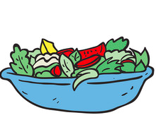
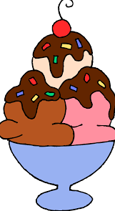
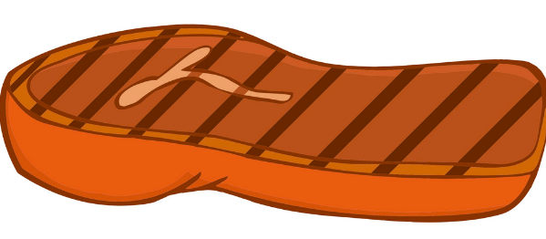
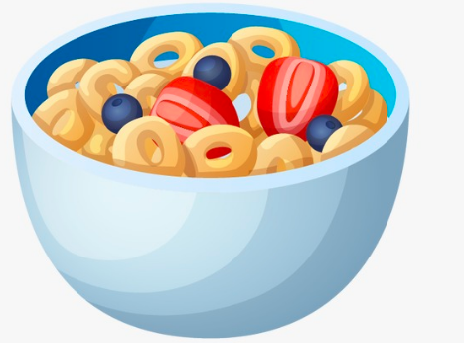
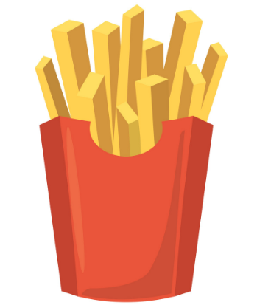
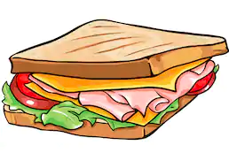


Lesson Activity:

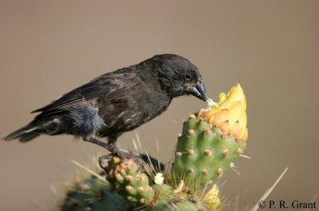
Building a Better Beak
Using a Unique Beak Physique

Step 1 - Identify the Problem
There are a wide variety of birds throughout the world. Each species of bird has its own unique adaptations that allow it to survive in its environment. Today we will be investigating how and why birds have developed different shaped beaks over time

Why do you think that birds have developed different shaped beaks?

In our activity today, you are going to design a bird beak that will be tested to illustrate how specific beak adaptations allow bird species to evolve. You will have to design a bird beak that is capable of collecting the most of a specific food source in 30 seconds.

In your own words, what problem are we trying to solve:

Step 2: Criteria and Constraints
Criteria | Constraints
- You may only use the beak materials listed in the table below.  - Your beak must be capable of collecting food and placing it in a cup.  - You may not touch the food with any part of your body, or use any force besides the beak to move the food. | - Your beak cannot exceed 7 cm in any direction.  - Only food that is intact will count  - Your beak will be attached to a “Scissor” device (pictured below).
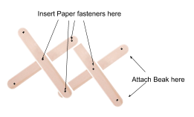

Materials
Toothpicks | Plastic Spoons | Small craft sticks | Plastic Straws
Pipe Cleaners | Paper cup | Plastic Forks | Paper clips
(You may use a limited amount of tape and rubber bands that will be supplied by the teacher.)

Step 3 - Brainstorm/Design
Look over the Beak shape information on page 3. Examine the materials given and come up with at least three different ways you could use those materials to create a bird beak. Describe in the box how that material will help you build a beak, and what challenges you may have using that material. Sketch and label your ideas on a separate piece of paper and take a picture to insert it in the Brainstorm Box below.
Material | How will it work? | Challenges?

Brainstorm Box - Neatly sketch and label your design ideas. Take a picture of your sketches and insert them into the box below.

Research
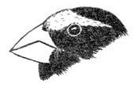 | A cone shaped bill is found in many birds such as finches and grosbeaks. It is a strong beak used for cracking seeds.
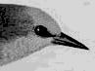 | Thin, slender, pointed beaks are found mainly in insect eaters. They are used to pick insects off leaves, twigs, and bark. This warbler is a good example.
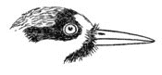 | Woodpeckers have strong beaks which taper to the tip, forming a chisel for pecking holes in trees for food or nests. Most feed on insects which live under the bark.
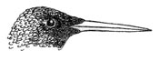 | Hummingbirds have long, tubular bills that resemble straws, which they use to sip nectar from flowers.
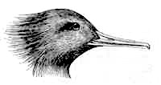 | Mergansers, specialized for eating fish, have sharp tooth-like structures on the edge of the bill to hold fish tightly.
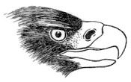 | Hawks, owls, and other birds of prey which catch and kill live prey have sharp, "hooked" beaks. These are used to bite the skull or neck and also to tear the body into pieces small enough to swallow.
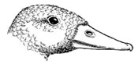 | The edges of a Mallard's bill are fringed to strain plants, seeds, and small animals from mud and water.
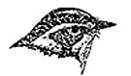 | Beaks which are flat and wide at the base are found in birds which catch insects in flight, such as flycatchers. These birds also often have "whiskers," which are actually modified feathers, at the corners of the mouth, which effectively widens the mouth opening, allowing more effective capture of prey.

Step 4 - Collaboration
Choose a design through collaboration with your partner and sketch it below. Be sure to label your design.

Step 5 - Build
Gather your materials and, build your prototype beak. After completing your design, take a picture and insert below. Use tools in Google Draw to label and show measurements.

Step 6 - Test Your Design and Collect Data
You will be provided with a beaker that contains all four types of food. Place it onto the “habitat” (construction paper). You will have 30 seconds to see how much food you call collect in your “stomach” (large cup). You will complete 6 trials, alternating which partner is the bird for each 30 second trial. Complete your data table at the end of each trial. Post a picture of your design and your results on the class Padlet.

Food | Gummy  Worms | Goldfish | Beans | Mini  Marshmallows
Trial 1
Trial 2
Trial 3
Trial 4
Trial 5
Trial 6
Average

Data Analysis: Create a bar graph, using Google Sheets, showing the average of each food collected. Make sure to include an appropriate title and label both the x-axis and y-axis. Insert your graph below.

Step 7 - Analyze Your Results
Answer each question completely using the information presented in class as well as the data collected in the lab.

- Where will competition be most intense--between members of different species (inter-species) or between members of the same species (intra-species)? Explain. Use another group’s design to support your answer.

- A specialist can be defined as a species that is very well adapted to a very specific food source. What are the benefits of being a specialist? What negative effects would being a specialist have on a species’ survival? Which of your classmates’ designs represents a specialist? Use their data to support your answer.

- A generalist is adapted to eating a wide range of food sources. What are the benefits of being a generalist? What negative effects would being a generalist have on a species’ survival? Which of your classmates’ designs represents a generalist? Use their data to support your answer.

- Based on your data, is your species a generalist or a specialist? Explain. Use data to support your claim.

- If you could redesign your beak, what different choices would you make? Why did you choose this new design? Relate it to what you know about Natural Selection. Use data that you collected or data collected by your classmates to support your choice.

CER
Which beak designed from the class gives the bird species the best chance of survival?

Rubrics:

STEM Packet:
 | 10 | 7 | 3 | 0
Step 3  Brainstorm | Sketches of the design are presented and it are neatly sketched, easily understood, and include labels. | Sketches of the design are presented but are messy or lack labels | Sketches lack effort and are messy and missing labels. | None present
Step 4  Collaborate | A sketch of the design is presented and it is neatly sketched, easily understood, and includes labels | A sketch of the design is presented but it is messy or lacks labels. | Sketch lacks effort and is messy and missing labels. | None present
Step 5  Build and Sketch | A sketch of the design is presented. Sketch is neatly presented, easily understood, and includes labels and measurements. | A sketch of the design is presented. Sketch is neatly presented and easily understood OR includes labels or measurements. | A sketch of the design is presented. Sketch is messy and is missing labels or measurements. | None present
Step 6  Test | Data collected from each test is included and matches partner’s data. The average is calculated correctly. | Data collected from each test is included. It either matches partner’s data OR the average is calculated correctly. | Data collected from each test is included. It does not match partner’s data and the average is not calculated correctly. | Data is not present
Graph | All data is graphed correctly. The graph contains a correct title, axis labels, and units and uses the correct type of graph. | All data is graphed correctly. The graph is missing one of the following: Title, axis labels, or units. | Data is not graphed correctly or is missing more than one of the required labels | No graph is included
Analysis Question 1 | Question is answered accurately and thoroughly. All parts of the question have been addressed. | Question is answered accurately and thoroughly, but not all parts of the question are addressed. | Question has been attempted, but is not answered correctly. | Not answered
Analysis Question 2 | Question is answered accurately and thoroughly. All parts of the question have been addressed. | Question is answered accurately and thoroughly, but not all parts of the question are addressed. | Question has been attempted, but is not answered correctly. | Not answered
Analysis Question 3 | Question is answered accurately and thoroughly. All parts of the question have been addressed. | Question is answered accurately and thoroughly, but not all parts of the question are addressed. | Question has been attempted, but is not answered correctly. | Not answered
Analysis Question 4 | Question is answered accurately and thoroughly. All parts of the question have been addressed. | Question is answered accurately and thoroughly, but not all parts of the question are addressed. | Question has been attempted, but is not answered correctly. | Not answered
Analysis Question 5 | Question is answered accurately and thoroughly. All parts of the question have been addressed. | Question is answered accurately and thoroughly, but not all parts of the question are addressed. | Question has been attempted, but is not answered correctly. | Not answered

CER:
 | 10 | 7 | 5 | 3 | 0
Claim | A precise statement of the claim that is based on the problem statement. | A statement of the claim that shows a good relationship to the problem statement. | A statement of the claim that shows some relationship to the problem statement. | A statement of the claim that shows no relationship to the problem statement. | No attempt has been made.
Evidence | Provides appropriate and sufficient evidence to support claim. All data was included. | Provides appropriate evidence but does not include enough data. | A connection has been made from analyzing the data collected. Does not include specific data. | No connection has been made from analyzing the data collected. | No attempt has been made.
Reasoning | All of the ideas to link the evidence to the claim are included using ALL of the scientific principles established in class and there are no incorrect ideas. | All of the ideas to link the evidence to the claim are included using SOME of the scientific principles established in class and there are no incorrect ideas. | Repeats evidence and links it to the claim, but does not include scientific principles. | Does not provide reasoning, or only provides inappropriate reasoning. | No attempt has been made.
Grammar and Spelling | Easy to understand, writing flows and keeps reader engaged, extensive vocabulary. Does not use first person sentences. | Fluent except for 1-2 errors that could cause confusion, 1-2 spelling & grammatical errors, or uses first person sentences. Has attempted a variety of vocabulary words. | Struggles with fluency/transitions, 2-3 spelling and grammatical errors, basic understanding of vocabulary but no attempt to elevate writing. | Poor fluency, hard to understand, 4 or more spelling & grammatical errors, limited vocabulary/hard to understand

