Regression Exploration
Algebra 2
Name:________________________________________________Period:_______________Date:____________
Learning Target: A.CED.2 I can create equations of two or more variables and graph equations on the coordinate plane_______

Directions: Follow the Steps below to complete the Practice, and learn how to find the best fit curve of data with regression.

STEPS |  |  |  | PRACTICE
1. Set up Calculator to find regression  a. Press “2nd” and “Catalog”  b. Select “DiagnosticOn”  c. Press Enter  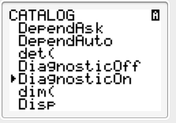  d. It should  look like this: |  |  |  | 1. Have you followed steps one?
2. Enter Data into Lists  a. Press “Stat”  b. Choose 1. Edit  c. L₁ is for the x values, and L₂ is for the y values  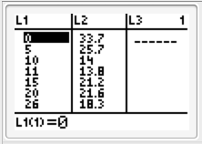  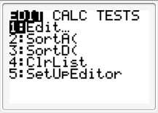  d. Enter the following data into L₁ and L₂  High School Seniors who use Marijuana from 1980-2009  Based on National Institute of Health Data |  |  |  | 2. Complete this step then answer the following questions.  a. What does an x value of 5 mean?  b. What was the percentage of seniors using marijuana in 2006?  c. What was the percentage of seniors using marijuana in 1995?
  Number of years after 1980 | Percentage of Seniors using Marijuana
  0 | 33.7
  5 | 25.7
  10 | 14.0
  11 | 13.8
  15 | 21.2
  20 | 21.6
  26 | 18.3
  27 | 18.8
  28 | 19.4
  29 | 20.6
3. Create a Scatter Plot  a. Press “2nd” and “STAT PLOT”  b. Select 1: Plot 1  c. Press Enter  d. Make sure that the Plot is “ON”  e. Press “Zoom”  f. Choose “9: ZoomStat”  g. Press Enter  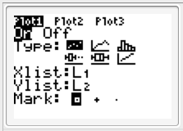  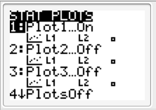 |  |  | 3. Sketch the graph that you see here:
4. Use Regression to find the equation of best fit  a. Go to “Y=” and clear out all the equations  b. Press “STAT” and choose CALC  c. Scroll down to 4: LinReg (ax + b)—this is the trend line!!  d. Press Enter  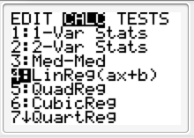  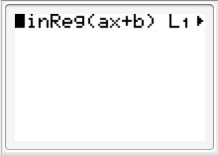  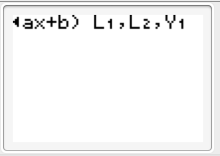  e. Press “2nd” and “L₁”  f. Press “,”  g. Press “2nd” and “L₂”  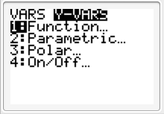  h. Press “VARS” and choose Y-Vars  i. Choose 1: Function  k. Press Enter  l. Choose “Y₁” and Press Enter  j. Press Enter once more  k. You should get a screen that looks  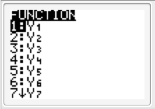  like this:  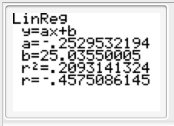  l. Press “Graph” and you should see your scatter plot with a linear equation going through it  m. Press “Y=” and you should seen the equation of your line |  |  |  |  | 4. a. Make a sketch of the scatter plot and the trend line that you see here:  b. Write down the equation of the Linear Function here: Round the decimals to the nearest one thousandth  Y₁= ___________________________  ___________________________  c. Use the equation to find f(21). What does this mean in terms of years and percentages?
5. Finding Other Types of Regression  Quadratic Regression:  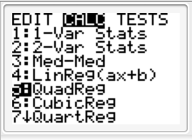  Cubic regression:  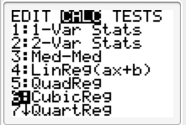  Quartic Regression:  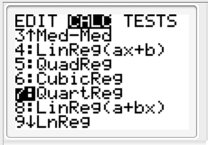  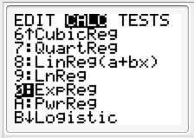  Exponential Regression: | 5. a. Find the Quadratic Regression and write the following:  R² = __________________ Take √ to get r = _________________  Rounded to the nearest thousandth:  Y₁ = __________________________________________________________  Make a sketch of the shape that it makes here:  b. Find the Cubic Regression and write the following:  R² = __________________ Take √ to get r = _________________  Rounded to the nearest thousandth:  Y₁ = ____________________________________________________________  Make a sketch of the shape that it makes here:  c. Find the Quartic Regression and write the following:  r = __________________  Rounded to the nearest thousandth:  Y₁ = .000003x⁴ + -.00598x³ + .256x² + - 3.727x + 34.671  Make a sketch of the shape that it makes here:  d. Find the Exponential Regression and write the following:  r = __________________  Rounded to the nearest thousandth:  Y₁ = ____________________________________________________________  Make a sketch of the shape that it makes here:
6. Identifying the best fit curve

The regression that gives the most accurate model of related data is the best fit curve.

You found the correlation coefficient , r, for each of the regressions above. The correlation coefficient indicates the strength of the correlation. The correlation coefficient always falls between 1 and -1.

The closer r is to 1 or -1, the more closely the data resembles the curve and the more accurate the regression is likely to be.

a. Would a correlation coefficient of r = .22 mean that a regression is a good fit for the data?

b. What would a correlation coefficient of r = 1 mean?

7. Analyzing the Correlation  You should have gotten the following Correlations on the above work: |  | 7. a. Which of the Types of Regression has the best Correlation?  b. Which of the types of correlation has the worst Correlation?
  Type of Regression | R² | R
  Linear (LinReg) | .209 | -.456
  Quadratic (QuadReg) | .633 | .796
  Cubic (CubicReg) | .788 | .888
  Quartic (QuartReg) | .788 | .888
  Exponential (ExpReg) | .117 | -.341
8. Try Yourself!!  Use the data set below and find which type of regression is the best, and identify the equation and correlation coefficient!  High School 10th graders who use Marijuana from 1991-2009  Based on National Institute of Health Data  Which type of regression is the best fit for the data? Why? |  | 8. Record the results of your regression analysis below:  a. Linear (LinReg)  Y₁ = ____________________________________  r = __________  b. Quadratic (QuadReg)  Y₁ = ____________________________________  r = __________  c. Cubic (CubicReg)  Y₁ = ____________________________________  r = __________  d. Quartic (QuartReg)  Y₁ = ____________________________________  r = __________  e. Exponential (ExpReg)  Y₁ = ____________________________________  r = _________
  Number of years after 1991 | Percentage of 10th graders using Marijuana
  0 | 8.7
  4 | 17.2
  9 | 19.7
  15 | 14.2
  16 | 14.2
  17 | 13.8
  18 | 15.9

Solutions:

3. 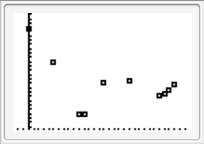

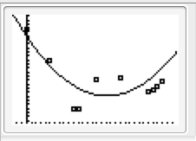
5. a. R² = .633 Y₁ = -.0467x² + - 1.72x + 31.926

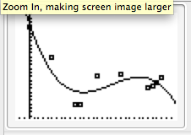
5. b. R² = .788 Y₁ = .004x³ + .222x² + - 3.356x + 34.576

5. c. R² = .788 Y₁ = .000003x⁴ + -.00598x³ + .256x² + - 3.727x + 34.671
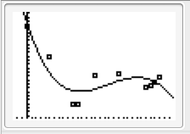

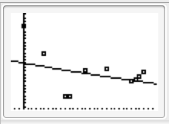
5. d. r = -.342, r² = .117 Y₁ = 23.251 ∗ .991^{x}

