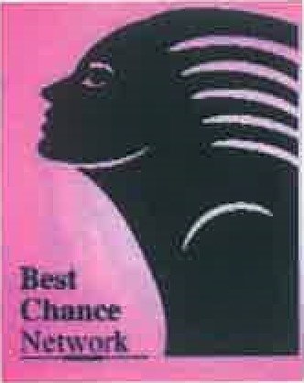

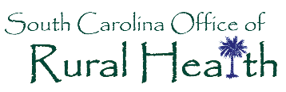

Well Integrated Screeninq and Evaluation
for Women Across the Nation (WiseWoman)

BCN-WW Rural Practice Interview Findings
(Interview Period: 12/12/16-1/12/17)

To increase the number of rural BCN and WiseWoman providers, SCORH’s Center for Practice Transformation Team members, Tiffany Simpson-Crumpley and LaShandal Pettaway-Brown contacted thirty practices to assess how well the BCN and WiseWoman programs were being implemented. The following battery of questions were asked of practice staff:

Interview Questions

- Are you currently a BCN/WW provider?
- If so, how is the process working for you?
- If you are not a WW provider, are you interested in signing up?
- Do you have concerns about billing or getting paid for providing BCN/WW services
- What are the top three things you change about participating in the BCN/WW program?

Based on key informant interview findings with existing BCN/WW providers, a key to increasing uptake for breast cancer, cervical cancer and cardiovascular screenings is having a "practice champion" or navigator whose sole job it is to manage the program’s day-to-day operations. Operational tasks include but are not limited to: ensuring poster/educational materials are available to patients, pulling reports and activating patient reminders out of the practice EHR system and effective follow-up/referral of patients with abnormal test results.

It is helpful to note that the majority of practices were implementing the BCN program but not the WiseWoman program.

An additional trend identified from key informant interviews was that while practices were signed up as BCN providers, they simply did not have the manpower to promote program services in the community. Several practice managers suggested that resources be dedicated to outreach strategies that include program promotion in local newspapers, local radio stations, social media platforms and cable TV ads- very similar to successful tobacco cessation and Back-to-Sleep (SIDS prevention) campaigns of times past.

One rural health clinic that was interviewed hosted their own community screening event and invited community members and local media to attend the event. Not only did it attract a large number of community residents, it also promoted re-screenings and placement of those patients in a primary medical home if they did not have one.

Recommendations
- Focus on re-activating BCN practices who are not utilizing PA codes.

- Use virtual training to promote the establishment of program champions in each practice (new or existing)

- Utilize existing BCN practice champions as co-trainers for virtual trainings to educate peers on how to develop workflow strategies to increase screening for patients.

- Emphasize education on the WiseWoman program to recruit and increase the number of rural practices providing these services.

- To strengthen referral loop for specialists, work with BCN/WW program leadership to develop a better tracking system so that practices know the outcome of patients referred out for follow-up diagnostics and treatment.

- To support practices in troubleshooting billing challenges as they arise, clearly communicating to practices who their regional coordinator is and contact information.

- Practices may need to be re-educated on how to retrieve Med-IT reports to determine how many patients they have seen in a given time period.

- Focus rural outreach, recruitment and engagement efforts on counties with the highest morbidity and mortality rates for breast cancer, cervical cancer and cardiovascular disease.

- Develop a Community Screening Event Toolkit to support practices in planning screening events to attract patients for screenings and establishment of medical home to address holistic primary care needs.

Breakdown of Practices by County (Source: Med-It Report 1.12.17)

County | # of BCN practices
Allendale | 2
Chester | 6
Clarendon | 1
Dillion | 2
Edgefield | 2
Barnwell | 1
Fairfield | 1
Florence | 3
Greenwood | 1
Lancaster | 2
Newberry | 4
Saluda | 1
Sumter | 2
Williamsburg | 2

