
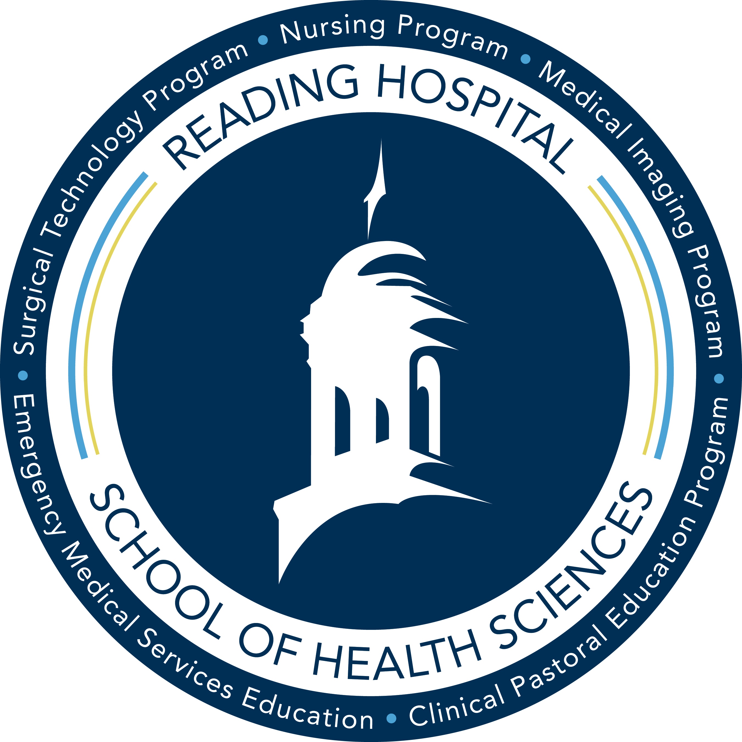
Course #: DMS 203 | Faculty Name: Juliene Erb, M.S., RDMS, RVT
Course Title: Sonographic Physics & Instrumentation | Office: School of Health Sciences, 2nd Floor
Course Credits: 4  Theory Hours: 3.0 (45 Hours)  Lab Hours: 1.0 (45 Hours) | Email: juliene.erb@towerhealth.org
Pre-Req: DMS 115, 120, 210 | Phone: (484) 628-0229
Co-Req: DMS 227, 245 | Office Hours: By appointment only
Semester/Year: Summer 2024
Days and Times: Wednesday, Lecture 10:30am-2:30pm; Lab 2:30-6:15pm

Course Description
This course examines acoustical physical principles, Doppler ultrasound principles and sonographic instrumentation. Clinical application and uses in the field for diagnostic medical sonography are reviewed. Theory and laboratory will demonstrate proper techniques to produce quality diagnostic images.

University Objectives
All courses at Alvernia University are designed to foster the core Catholic, Franciscan values of service, humility, peacemaking, contemplation, and collegiality as set forth by Alvernia’s Mission Statement, as well as to promote the General Objectives outlined in the University Catalog and the Student Handbook.
The university community supports peace and non-violence by respecting diversity and affirming the dignity of everyone in the community; civility and courtesy are practiced at all times.

Course Outcomes
Program Goal:
To prepare competent entry-level general sonographers in the cognitive (knowledge), psychomotor (skills), and affective (behavior) learning domains. Through active participation in all scheduled classes and clinical assignments, the student will learn the skills necessary to provide health care to their community in a professional, compassionate, and responsible manner.
General Course Objectives:
- Describe principles of ultrasound in the operation of sonography equipment
- Discuss the interaction of ultrasound with tissue for image acquisition and optimization
- Discuss features of sonography equipment including controls and image processing
- Describe transducers and their components
- Discuss the different types of display modes
- Describe quality assurance/quality control of sonographic instruments
- Discuss bioeffects and safety of ultrasound equipment

Course Specific Student Learning Outcomes:

- Explain the principles behind the formation of the ultrasound beam
- Describe the basis of sound waves and wave classifications
- Discuss the seven acoustic parameters of a continuous sound wave
- Distinguish the difference between continuous and pulse wave characteristics
- Discuss the five parameters of pulsed waves
- Discuss the five key words related to intensities of pulsed waves
- Discuss amplitude, pressure, power and intensity of acoustic waves
- Distinguish the difference between reflection, refraction, scatter, attenuation, and impedance
- Discuss propagation speed of sound waves through various tissues
- Describe axial and lateral resolution
- Discuss the basic features of ultrasound equipment
- Discuss the controls and their functions that directly affect the image quality
- Describe the operator controls and their effect on the final image
- Locate operator controls and describe the function of each control
- Discuss how a transducer is selected for a particular examination
- Explain the different types of real time transducers
- Discuss the various materials used as components in the manufacturing of transducers
- Describe ultrasound beam focusing and beam steering
- Describe the various fields of view produced by the different types of transducers used in sonography
- Discuss the component parts of A-Mode, B-Mode, and M-Mode instruments
- Describe limitations and artifacts in A, B, and M- Mode scanning
- Discuss displays and image storage
- Discuss the components of hemodynamics
- Explain what Doppler theory is and what the effects are on the final image
- List the component parts of Doppler instrumentation
- Differentiate between continuous wave Doppler (CWD), pulsed wave Doppler (PWD), color flow Doppler, and power Doppler
- Explain how pulsed Doppler, color flow imaging and amplitude imaging is achieved
- List the types and causes of image artifacts
- Describe techniques to minimize or eliminate image artifacts
- Describe the various artifacts and their effect on the sonographic image
- Describe the bioeffects in diagnostic medical ultrasound on human tissue
- Explain the AIUM standards and their implementation in the manufacturing process

Laboratory Learning Outcomes:

- Demonstrate the understanding of general ultrasound principles
- Locate operator controls and describe the function of each control
- Identify the controls that affect the image quality
- Demonstrate M-Mode scanning
- Produce images utilizing the test phantom of the various transducers and compare the results
- Identify the various artifacts produced by transducer defects or tissue differences
- Compare various reflectors on A-Mode, B-Mode and real time using the test phantom
- Compare the axial and lateral resolution of reflectors in the test phantom
- Demonstrate how magnification and a change in time gain compensation (TGC) affects image quality using the test phantom
- Demonstrate preprocessing and post processing on the final image
- Demonstrate the various Doppler techniques
- Demonstrate quality control tests using the test phantom
- Compare the reflectors within the test phantom in the near field and far field

Course Materials
Required Text: Penny, Steven M., and Traci B. Fox. Examination Review for Ultrasound: Sonographic Principles and Instrumentation. Wolters Kluwer, 2018.
Recommended Text: Edelman, Sidney K. Understanding Ultrasound Physics. ESP, 2012.
Attire: School issued scrubs and appropriate footwear must be worn during all scheduled laboratory sessions. Failure to comply will result in removal from lab and it will be counted as an absence. Please see the attendance policy in the syllabus for penalties.
Recommended Text: Tempkin, Betty Bates. Sonography Scanning: Principles and Protocols, 5th edition. Elsevier/Saunders, 2021.

Copyright Restriction
Materials used in conjunction with this course may be subject to copyright protection under Title 17 of the United States Code. Under certain Fair Use circumstances specified by law, copies may be made for private study, scholarship, or research. Electronic copies should not be shared with unauthorized users. If a user fails to comply with Fair Use restrictions, he/she may be liable for copyright infringement. For more information, including Fair Use guidelines, see the Alvernia University Copyright and Fair Use Policy: http://www.alvernia.edu/library/library_resources/copyright_policy.html.

Course Format
This course is designed to be a face-to-face course offered in a semester-long, 12-week format with all didactic experiences occurring in the classroom. A laboratory component is also built into the curriculum where students will have the advantage of scanning various organ systems in a controlled environment. The in-class format will include: lecture with PowerPoints, group discussions, interactive activities, demonstrations and handouts.

Responsibilities And Ethical Use Of Technology
It is the student’s responsibility to check the School of Health Sciences email and Edvance 360 accounts on a regular basis. Important information may be communicated by school faculty or staff through these means. All students are enrolled in the School’s electronic emergency notification system. The Alvernia University and School of Health Sciences community adheres to ethical use of technology at all times.

Course Requirements
Class Participation:
The expectation is that all students will be respectful, attentive, and actively participate in all classroom activities.
- Students are expected to bring the following to each class:
    - Notes from prior class
    - Notebook / Paper / Writing Utensil
    - Required textbook(s)
    - Cell phones are to be turned off and put away during class.
      - Use of texting or applications on such devices is not permitted
      - In the case of a family emergency, you may ask for permission to have your cell phone on vibrate for notification purposes. Please ask your faculty instructor prior to the start of class.
- Students are responsible for attending all classes and laboratory sessions prepared. Classroom preparation includes, but is not limited to, reading assignments, learning lecture content, and taking an active role in class.
  - Students are to have read the assignment/chapter before the lecture material is presented. Then questions/clarifications will be addressed.
- Students are responsible for keeping up with the weekly course material, including weekly lab assignments.
- Students are encouraged to seek additional readings in the library and to ask questions in class.
- Developing skills in the fine art of scanning can only come about through continued practice. It is, therefore, essential that the student take initiative to seek as much scanning time as possible. The same is true of recognition of sonographic anatomy. The student is encouraged to review file cases.
- Professional behavior is expected of all students at all times. Examples of professional behaviors include regular and punctual attendance, class participation and appropriate affect.
- Students must abide by the procedural and ethical policies and guidelines set by the School of Health Sciences and the DMS Program.
- Students who are guilty of violating any rules of the student code of conduct will receive counseling by the Program Director. Each violation will be dealt with by the Program Director according to the seriousness of the violation. Any of these violations can result in immediate and permanent removal from the Diagnostic Medical Sonography Program.
- Any type of cheating will result in immediate dismissal from the course and program.

Assignments:
Each student is expected to prepare for class by completing all reading assignments, participate in class discussion and complete all assignments in a timely manner.
- Classroom Assignments: All classroom assignments must be handed in on time. Late assignments will be penalized 5% for each day they are late and assignments handed in more than 3 days late will not be accepted. In the event of an unforeseen difficulty, please discuss the issue with the instructor.
- Laboratory Assignments: All lab assignments are mandatory. They will be assigned weekly and the student will have one week to complete the protocol(s). If the initial lab assignment is not turned in by the due date, the student will lose one point per assignment for every day it is late. Students not turning assignments in on time due to absence must turn the assignment in on the first day back to class. If the student fails to turn in the assignment on his/her first day back, they will be docked one point for every day it is late.
  - Multiple Attempts: Students may be asked to repeat select images or the entire lab to ensure that continuity and diagnostic quality is enforced. In the event of a “redo” being issued, they will not count against the point total for the course. Students must complete the “redo” in a timely manner so they do not miss important corrective measures as they progress through the curriculum. If the student fails to complete the “redo,” faculty will seek out the student and assign deadlines to help the student stay on track.
Attendance:
Each student is an important part of his/her total class. It is important to attend and participate in the exchange of ideas. At times, emergencies or illnesses arise where attendance is not possible. When these unavoidable circumstances present, the guidelines below will be followed:
- Absence – Students may miss one class and/or lab per semester without penalty. Students are responsible for obtaining any missed material on their own. Acquire copies of all information missed from your fellow classmates. You are responsible for all missed information. For each day missed after the first, the student will be docked 5% from his/her final point total for the course.
  - If an absence is unplanned, the student must notify Reading Hospital School of Health Sciences Diagnostic Medical Sonography Program secretary by calling (484) 628-0199 30 minutes prior to the start of the class period. Notification of the absence should include your full name and that you are a Diagnostic Medical Sonography student. Students are required to call for each consecutive day of absence.
  - Students are expected to arrive to scheduled laboratory sessions in the appropriate attire (school issued scrubs, ID badge, proper footwear, etc). If a student fails to wear the appropriate attire to a schedule lab session, the student will be sent home and marked absent for the day.
  - Exam Day - If a student is absent on a day when an exam is given, the student will be required to make up the test/quiz upon their first day back to class. The test will be different than the one administered to the rest of the class. Students may not take more than one makeup test/quiz per course.
- Tardy - Punctual attendance is expected for all class sessions. Students may be tardy/leave early for class one time per semester without penalty. Each subsequent time a student is tardy/leave early he/she will be docked 1% from their final grade for each incident. Students are responsible for obtaining any missed classroom material on their own from a fellow classmate.
  - A tardy is considered as a late arrival > than 5 minutes to the scheduled class session.

Inclement Weather – Refer to the SHS Policy 140 at: http://www.readinghealth.org/sohs/policies
Examinations:
Following completion of each chapter, in-class quizzes will be given to check for retention. Quizzes will be scheduled in advance and students will be notified during regularly scheduled class meetings. If a student is absent and misses a quiz, it is the responsibility of the student to contact the faculty regarding a make-up.
Make-up quizzes are strongly discouraged. Students should make every attempt to be present on the day and time a quiz is scheduled. If a student is absent on a day when a quiz is given, the student will be required to make up the quiz upon their first day back to class. The quiz will be different than the one administered to the rest of the class. Students may not take more than one make-up quiz per course.
A comprehensive final will be given at the end of the semester. If a student fails to take the final exam, a make-up exam with instructor permission will be given for extenuating circumstances only and you may be asked for documentation. The make-up exam must be completed within one week of the scheduled exam.

Communication:
It is the student’s responsibility to check School of Health Sciences, Alvernia and Blackboard email accounts on a regular basis. Failure to check these accounts is not an acceptable excuse for missing important information/deadlines that may be communicated by faculty or staff of Alvernia University. It is highly encouraged that students enroll in the electronic emergency notification system called e2Campus (www.alvernia.edu).
Conduct Policy:
Students must observe expected standards of conduct outlined in Reading Hospital School of Health Sciences Policy No. 334 – Conduct. Non-compliance is considered unprofessional behavior and therefore unacceptable conduct and will result in corrective and/or disciplinary action, up to and including dismissal from the program. This includes but is not limited to non-compliance with established policies, notification guidelines, and attire guidelines; unpreparedness for educational assignments; and excessive tardiness/absence.
Academic Honesty Policy:
Any student who is involved in unethical practices (e.g. plagiarism, cheating) will receive a grade of “F” for the course.
Any incident of plagiarism will be reported to the DMS Program Director and AU Registrar’s Office, in accordance with SHS and college policy. Faculty will abide by the academic honesty policy found in the SHS Policy 307: Academic Integrity.

All students are expected to adhere to Alvernia University’s Academic Honesty Policy, as outlined in the Undergraduate Student Handbook (http://www.alvernia.edu/current-students/PDF/StudentHandbookRev010812.pdf or Graduate Student Catalog http://www.alvernia.edu/academics/catalogs/Catalog_2015-16/15-16GraduateCatalog.pdf
Breaches of honesty include but are not limited to:
- Copying another student’s work
- Plagiarizing the published work of another
- Facilitating the dishonesty of another student
- Cheating on an examination
- Collaborating with a student to complete on-line tests
It is the student’s responsibility to read and understand the policy; failure to do so does not excuse the student from the consequences of the policy.
ADA Accommodations:
In accordance with Section 504 of the Rehabilitation Act and the Americans with Disabilities Act (“ADA”), the University offers accommodations to students with documented learning, physical and/or psychological disabilities. It is the responsibility of the student to contact the Disability Services Coordinator, preferably prior to the beginning of the semester, to initiate the accommodation process. Once accommodations are granted, it is the students’ responsibility to provide each professor with their letter of accommodation and have a discussion with their professor about these accommodations so they can be implemented as quickly as possible. Students needing assistance should contact the Disability Services Office in BH 105 (inside the Learning Center), for an intake meeting. Please contact Darla Timberlake by phone (610.568.1499), fax (484-335-4486), or e-mail @ disability.services@alvernia.edu. Please note, accommodations are not retroactive.
Academic Success Center:
The Academic Success Center (ASC) offers advising services, disability services, course-specific tutoring, writing support, academic skills coaching, and Supplemental Instruction for select courses.
We encourage you to access our writing support throughout the semester to help build a strong foundation for writing in all of your courses. Our writing tutors will work with you at any stage of the writing process, from developing and organizing ideas to revising and editing drafts. Rather than editing your work for you, writing tutors will actively engage you in meaningful conversations about your writing and help you learn new strategies.
The ASC is located in the Bernardine Hall 105. For general ASC inquires, call 610-796-8263. To schedule tutoring appointments, call 610-568-1494 or email academic.support@alvernia.edu. You can view the current schedule and make tutoring appointments through our online appointment system at https://alvernia.mywconline.com or visit us in person for assistance.
Tk20 Notice

Submission: Alvernia University strives to provide a quality educational experience through ongoing efforts to evaluate student learning outcomes. As part of this process, students may be asked to submit an electronic version of work by uploading one or more documents into Tk20 for assessment purposes. Assignments will be designated by the course faculty member. Additional information about Tk20 login and submission process is available on the student portal.
Confidentiality: Data gathered for assessment purposes are analyzed in aggregate form. No personal or student identifying information is revealed in disseminated reports. Alvernia University uses assessment related information to better understand what students are learning in relation to general education and student learning outcomes and improve understanding of the institution itself.
Recording and Publishing of Materials:
Picture taking, video and audio recording of faculty and students is prohibited without permission. Reading Hospital School of Health Sciences Policy No. 150 states, permission to record an activity for educational purposes DOES NOT also imply permission to publish the recording in any manner. A student’s sharing or publication of any type of picture, audio or video recording, or any form of a transcript of a recording requires written consent from all individuals whose image, voice, or statements are included in the recording. A student’s posting of school-related pictures or recordings on social media sites is prohibited unless written consent is obtained from all involved faculty and the Program Director.

Grading Policy & Grading Rubrics
SHS Grading System:
Percentage |  | Grade Points | Letter grade | Classification
94 – 100 | 4.00 |  | A
90 - 93 | 3.67 |  | A−
87 - 89 | 3.33 |  | B+
83 - 86 | 3.00 |  | B
80 - 82 | 2.67 |  | B−
75-79 | 2.33 |  | C+ (NOTE: min requirement for DMS students)
70-74 | 2.00 |  | C (NOTE: course failure for DMS students)
See program criteria below |  | 0.00 | F | Failure
Clinical “U” |  | 0.00 | F | Failure
W |  | No impact | W | Withdrew
WP |  | No impact | WP | Withdraw passing
WF |  | 0.0 | WF | Withdraw failing
I |  |  | I |  | Incomplete
AU Grading System:
A 94% - 100% C 73% - 76%
A- 90% - 93% C- 70% - 72%
B+ 87% - 89% D+ 67% - 69%
B 83% - 86% D 63% - 66%
B- 80% - 82% D- 60% - 62%
C+ 77% - 79% F Below 60%

Evaluation Criteria:
Chapter Quizzes (6 total) 300 points
Lab assignments (9 total) 27 points
Total: 327 points

- Students must achieve a 75% or better in order to pass this course to be able to continue in the DMS program.
- Chapter quizzes, a poster assignment, and laboratory assignments will be used to earn a grade in this class. Group work is a way to enhance learning the subject material and is not graded.
- Each student is encouraged to keep a current total of his/her earned points and the total possible points. In that way, each student will be aware of his/her progress at all times. To calculate your grade:

% Attained = Student earned points x 100
Total possible points

Course Schedule
Class Meeting/Week | Content | Evaluation
Week 1 | Introduction to Ultrasound Physics  Chapter 1 – Physical Principles | Lab assignment: Frequency
Week 2 | Chapter 1 – Physical Principles | Lab assignment: Output
Week 3 | Chapter 1 – Physical Principles  Chapter 2 – Ultrasound Transducers | Lab assignment: Color/Power/Gain Adjustments
Week 4 | Chapter 2 – Ultrasound Transducers | Lab assignment: Persistence  Quiz: Chapter 1 – Physical Principles
Week 5 | Chapter 2 – Ultrasound Transducers  Chapter 3 – Imaging Principles and Instrumentation | Lab assignment:  Biopsy and Sterile Techniques
Week 6 | Chapter 3 – Imaging Principles and Instrumentation | Lab assignment: M-Mode  Quiz: Chapter 2 – Ultrasound Transducers
Week 7 | Chapter 3 – Imaging Principles and Instrumentation  Chapter 4 – Doppler Imaging Concepts | Lab assignment: Dynamic Range and Sample Gate
Week 8 | Chapter 4 – Doppler Imaging Concepts | Lab assignment: Doppler Calibration  Quiz: Chapter 3 – Imaging Principles and Instrumentation
Week 9 | Chapter 4 – Doppler Imaging Concepts | Lab assignment: Color Doppler, Baseline, and Wall Filter
Week 10 | Chapter 5 – Quality Assurance and Lab Accreditation | Lab assignment: Tissue Equivalent Phantom  Quiz: Chapter 4 – Doppler Imaging Concepts
Week 11 | Chapter 6 – Patient Care and New Technologies  SDMS Learning Activity “Foundations of Original Research” | Lab assignment: Tissue Equivalent Phantom  Quiz: Chapter 5 – Quality Assurance and Lab Accreditation
Week 12 | ARDMS Board Scheduling/Board Prep | Quiz: Chapter 6 – Patient Care and New Technologies
Disclaimer: The instructor reserves the right to adjust the course requirements and schedule if necessary. Students will be given adequate notification of any alterations.
Helpful Links:
http://www.imaios.com/en/e-Anatomy
http://www.auntminnie.com/index.asp?sec=sup&sub=ult
http://www.online-medical-dictionary.org/

