
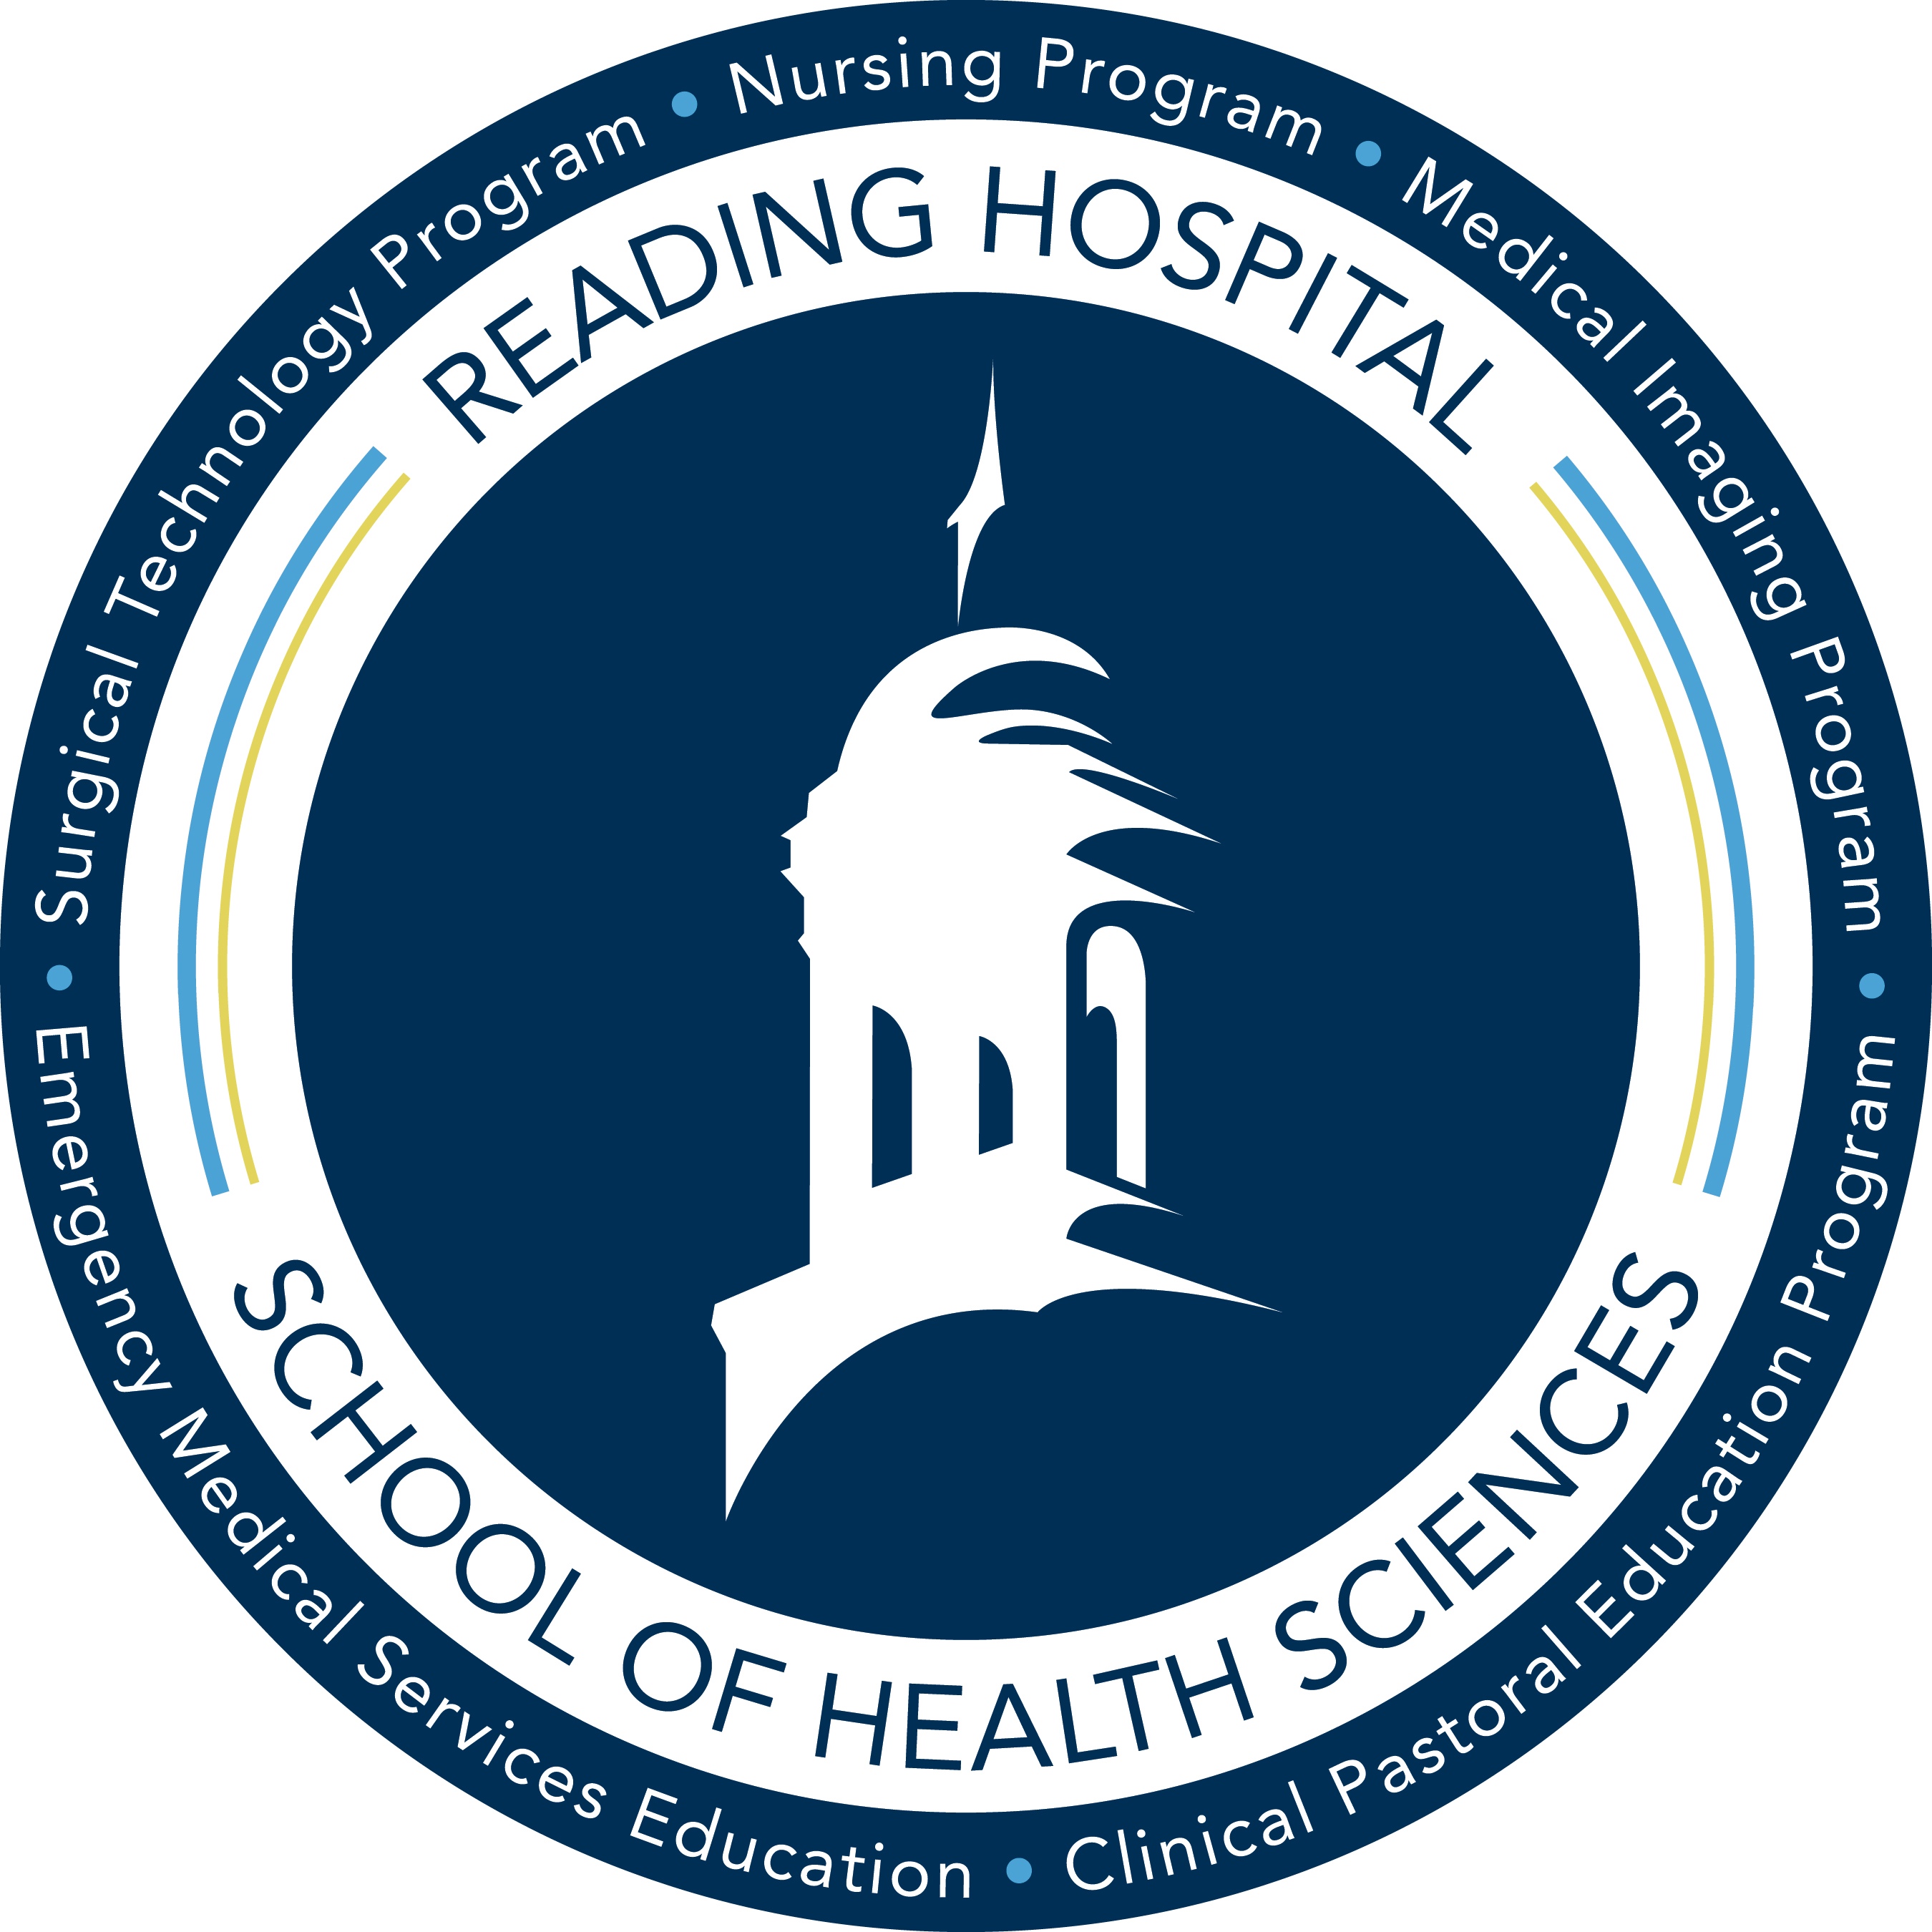
Course #: DMS 215 | Faculty Name: Juliene Erb, M.S., RDMS, RVT
Course Title: Obstetrics II | Office: School of Health Sciences, 2nd Floor
Course Credits: 3  Theory Hours: 3.0 credits (45 hours) | Email: juliene.erb@towerhealth.org
Pre-Req: DMS 203, 227, 245 | Phone: (484) 628-0229
Co-Req: DMS 228, 250 | Office Hours: By appointment only
Semester/Year: Fall 2022
Days and Times: Monday, 8:00am-10:45am

Course Description
The course presents the pathological and morphologic process of the first, second, and third trimesters. This includes both maternal diseases and complications and fetal abnormalities. Clinical features, laboratory data and the relevant histologic aspects of various conditions will be presented.

University Objectives
All courses at Alvernia University are designed to foster the core Catholic, Franciscan values of service, humility, peacemaking, contemplation, and collegiality as set forth by Alvernia’s Mission Statement, as well as to promote the General Objectives outlined in the University Catalog and the Student Handbook.
The university community supports peace and non-violence by respecting diversity and affirming the dignity of everyone in the community; civility and courtesy are practiced at all times.

Course Outcomes
Program Goal:
To prepare competent entry-level general sonographers in the cognitive (knowledge), psychomotor (skills), and affective (behavior) learning domains. Through active participation in all scheduled classes and clinical assignments, the student will learn the skills necessary to provide health care to their community in a professional, compassionate, and responsible manner.
General Course Objectives:
    - Describe the abnormal fetal anatomy, pathologies, and sonographic appearance of the first, second and third trimesters of pregnancy
    - Correlate clinical indications and laboratory values associated with abnormalities in the first, second and third trimesters of pregnancy
    - Describe the sonographic assessment associated with high-risk obstetrics
    - Identify associated fetal abnormalities relative to maternal disease processes
    - Discuss fetal anomalies associated with genetic abnormalities and syndromes
    - Discuss fetal therapies where appropriate
    - Identify fetal abnormalities in terms of sonographic appearance

Course Specific Student Learning Outcomes:

- Describe the abnormal appearances of a first trimester pregnancy
- Discuss first trimester complications
- Describe sonographic findings associated with ectopic pregnancy
- Describe the types and sonographic appearances of abortion
- List the clinical and sonographic findings associated with gestational trophoblastic neoplasia
- List anomalies associated with the placenta and the corresponding sonographic appearances
- Differentiate anomalies of the umbilical cord and their significance
- Discuss abnormal amniotic fluid volumes and the associated fetal risks
- Discuss clinical indications and manifestations of intrauterine growth restriction
- Differentiate sonographic findings of symmetric intrauterine growth restriction and asymmetric intrauterine growth restriction
- Discuss the role of Doppler in the fetal well-being assessment
- Define terminology associated with multi-fetal fertilization and development
- List the risks to the fetuses of mothers with maternal illnesses or diseases
- Differentiate fetal risks between maternal diabetes mellitus and gestational diabetes
- Discuss various fetal abnormalities and their sonographic appearances
- Define terminology associated with fetal face and skeletal anomalies
- Correlate clinical assessments with fetal abnormalities
- List maternal serum markers associated with chromosomal anomalies
- Characterize sonographic findings with genetic syndromes
- Discuss indications for invasive diagnostic procedures utilized in obstetrics
- List techniques and discuss the role of sonography with interventional procedures, including fetal therapies
- Discuss the role of sonography with post-partum pregnancy, infection, and hemorrhage

Course Materials
Required Text: Hagen-Ansert, Sandra L. Textbook of Diagnostic Sonography. Elsevier, 2018.
Recommended Text: Tempkin, Betty Bates. Sonography Scanning: Principles and Protocols. Elsevier/Saunders, 2015.

Copyright Restriction
Materials used in conjunction with this course may be subject to copyright protection under Title 17 of the United States Code. Under certain Fair Use circumstances specified by law, copies may be made for private study, scholarship, or research. Electronic copies should not be shared with unauthorized users. If a user fails to comply with Fair Use restrictions, he/she may be liable for copyright infringement. For more information, including Fair Use guidelines, see the Alvernia University Copyright and Fair Use Policy: http://www.alvernia.edu/library/library_resources/copyright_policy.html.

Course Format
This course is designed to be a face-to-face course offered in a semester-long, 16-week format with all didactic experiences occurring in the classroom. The in-class format will include: lecture with PowerPoints, group discussions, interactive activities, demonstrations and handouts.

Responsibilities And Ethical Use Of Technology
It is the student’s responsibility to check the School of Health Sciences email and Edvance 360 accounts on a regular basis. Important information may be communicated by school faculty or staff through these means. All students are enrolled in the School’s electronic emergency notification system. The Alvernia University and School of Health Sciences community adheres to ethical use of technology at all times.

Course Requirements
Class Participation:
The expectation is that all students will be respectful, attentive, and actively participate in all classroom activities.
- Students are expected to bring the following to each class:
    - Notes from prior class
    - Notebook / Paper / Writing Utensil
    - Required textbook(s)
    - Cell phones are to be turned off and put away during class.
      - Use of texting or applications on such devices is not permitted
      - In the case of a family emergency, you may ask for permission to have your cell phone on vibrate for notification purposes. Please ask your faculty instructor prior to the start of class.
- Students are responsible for attending all classes prepared. Classroom preparation includes, but is not limited to, reading assignments, learning lecture content, and taking an active role in class.
  - Students are to have read the assignment/chapter before the lecture material is presented. Then questions/clarifications will be addressed.
- Students are responsible for keeping up with the weekly course material.
- Students are encouraged to seek additional readings in the library and to ask questions in class.
- Developing skills in the fine art of scanning can only come about through continued practice. It is, therefore, essential that the student take initiative to seek as much scanning time. The same is true of recognition of sonographic anatomy. The student is encouraged to review file cases.
- Professional behavior is expected of all students at all times. Examples of professional behaviors include regular and punctual attendance, class participation and appropriate affect.
- Students must abide by the procedural and ethical policies and guidelines set by the School of Health Sciences and the DMS Program.
- Students who are guilty of violating any rules of the student code of conduct will receive counseling by the Program Director. Each violation will be dealt with by the Program Director according to the seriousness of the violation. Any of these violations can result in immediate and permanent removal from the Diagnostic Medical Sonography Program.
- Any type of cheating will result in immediate dismissal from the course and program.

Assignments:
Each student is expected to prepare for class by completing all reading assignments, participate in class discussion and complete all assignments in a timely manner. All assignments must be handed in on time. Late assignments will be penalized 5% for each day they are late and assignments handed in more than 3 days late will not be accepted. In the event of an unforeseen difficulty, please discuss the issue with the instructor.
Attendance:
Each student is an important part of his/her total class. It is important to attend and participate in the exchange of ideas. At times, emergencies or illnesses arise where attendance is not possible. When these unavoidable circumstances present, the guidelines below will be followed:
- Absence – Students may miss one class per semester without penalty. Students are responsible for obtaining any missed classroom material on their own. Acquire copies of all information missed from your fellow classmates. You are responsible for all missed information. For each day missed after the first, the student will be docked 5% from his/her final point total for the course.
  - If an absence is unplanned, the student must notify Reading Hospital School of Health Sciences Diagnostic Medical Sonography Program secretary by calling (484) 628-0199 30 minutes prior to the start of the class period. Notification of the absence should include your full name and that you are a Diagnostic Medical Sonography student. Students are required to call for each consecutive day of absence.
  - Exam Day - If a student is absent on a day when an exam is given, the student will be required to make up the test/quiz upon their first day back to class. The test will be different than the one administered to the rest of the class. Students may not take more than one makeup test/quiz per course.
- Tardy - Punctual attendance is expected for all class sessions. Students may be tardy/leave early for class one time per semester without penalty. Each subsequent time a student is tardy/leave early he/she will be docked 1% from their final grade for each incident. Students are responsible for obtaining any missed classroom material on their own from a fellow classmate.
  - A tardy is considered as a late arrival > than 5 minutes to the scheduled class session.

Inclement Weather – Refer to the SHS Policy 140 at: http://www.readinghealth.org/sohs/policies
Examinations:
Following completion of each chapter, in-class quizzes will be given to check for retention. Quizzes will be scheduled in advance and students will be notified during regularly scheduled class meetings. If a student is absent and misses a quiz, it is the responsibility of the student to contact the faculty regarding a make-up.
Make-up examinations are strongly discouraged. Students should make every attempt to be present on the day and time a quiz is scheduled. If a student is absent on a day when a quiz is given, the student will be required to make up the quiz upon their first day back to class. The quiz will be different than the one administered to the rest of the class. Students may not take more than one make-up quiz per course.
A comprehensive final will be given at the end of the semester. If a student fails to take the final exam, a make-up exam with instructor permission will be given for extenuating circumstances only and you may be asked for documentation. The make-up exam must be completed within one week of the scheduled exam.

Communication:
It is the student’s responsibility to check School of Health Sciences, Alvernia and Blackboard email accounts on a regular basis. Failure to check these accounts is not an acceptable excuse for missing important information/deadlines that may be communicated by faculty or staff of Alvernia University. It is highly encouraged that students enroll in the electronic emergency notification system called e2Campus (www.alvernia.edu).
Conduct Policy:
Students must observe expected standards of conduct outlined in Reading Hospital School of Health Sciences Policy No. 334 – Conduct. Non-compliance is considered unprofessional behavior and therefore unacceptable conduct and will result in corrective and/or disciplinary action, up to and including dismissal from the program. This includes but is not limited to non-compliance with established policies, notification guidelines, and attire guidelines; unpreparedness for educational assignments; and excessive tardiness/absence.
Academic Honesty Policy:
Any student who is involved in unethical practices (e.g. plagiarism, cheating) will receive a grade of “F” for the course.
Any incident of plagiarism will be reported to the DMS Program Director and AU Registrar’s Office, in accordance with SHS and college policy. Faculty will abide by the academic honesty policy found in the SHS Policy 307: Academic Integrity.
All students are expected to adhere to Alvernia University’s Academic Honesty Policy, as outlined in the Undergraduate Student Handbook (http://www.alvernia.edu/current-students/PDF/StudentHandbookRev010812.pdf or Graduate Student Catalog http://www.alvernia.edu/academics/catalogs/Catalog_2015-16/15-16GraduateCatalog.pdf
Breaches of honesty include but are not limited to:
- Copying another student’s work
- Plagiarizing the published work of another
- Facilitating the dishonesty of another student
- Cheating on an examination
- Collaborating with a student to complete on-line tests
It is the student’s responsibility to read and understand the policy; failure to do so does not excuse the student from the consequences of the policy.
ADA Accommodations:
In accordance with Section 504 of the Rehabilitation Act and the Americans with Disabilities Act (“ADA”), the University offers accommodations to students with documented learning, physical and/or psychological disabilities. It is the responsibility of the student to contact the Disability Services Coordinator, preferably prior to the beginning of the semester, to initiate the accommodation process. Once accommodations are granted, it is the students’ responsibility to provide each professor with their letter of accommodation and have a discussion with their professor about these accommodations so they can be implemented as quickly as possible. Students needing assistance should contact the Disability Services Office in BH 105 (inside the Learning Center), for an intake meeting. Please contact Darla Timberlake by phone (610.568.1499), fax (484-335-4486), or e-mail @ disability.services@alvernia.edu. Please note, accommodations are not retroactive.
Academic Success Center:
The Academic Success Center (ASC) offers advising services, disability services, course-specific tutoring, writing support, academic skills coaching, and Supplemental Instruction for select courses.
We encourage you to access our writing support throughout the semester to help build a strong foundation for writing in all of your courses. Our writing tutors will work with you at any stage of the writing process, from developing and organizing ideas to revising and editing drafts. Rather than editing your work for you, writing tutors will actively engage you in meaningful conversations about your writing and help you learn new strategies.
The ASC is located in the Bernardine Hall 105. For general ASC inquires, call 610-796-8263. To schedule tutoring appointments, call 610-568-1494 or email academic.support@alvernia.edu. You can view the current schedule and make tutoring appointments through our online appointment system at https://alvernia.mywconline.com or visit us in person for assistance.
Tk20 Notice

Submission: Alvernia University strives to provide a quality educational experience through ongoing efforts to evaluate student learning outcomes. As part of this process, students may be asked to submit an electronic version of work by uploading one or more documents into Tk20 for assessment purposes. Assignments will be designated by the course faculty member. Additional information about Tk20 login and submission process is available on the student portal.
Confidentiality: Data gathered for assessment purposes are analyzed in aggregate form. No personal or student identifying information is revealed in disseminated reports. Alvernia University uses assessment related information to better understand what students are learning in relation to general education and student learning outcomes and improve understanding of the institution itself.
Recording and Publishing of Materials:
Picture taking, video and audio recording of faculty and students is prohibited without permission. Reading Hospital School of Health Sciences Policy No. 150 states, permission to record an activity for educational purposes DOES NOT also imply permission to publish the recording in any manner. A student’s sharing or publication of any type of picture, audio or video recording, or any form of a transcript of a recording requires written consent from all individuals whose image, voice, or statements are included in the recording. A student’s posting of school-related pictures or recordings on social media sites is prohibited unless written consent is obtained from all involved faculty and the Program Director.

Grading Policy & Grading Rubrics

SHS Grading System:
Percentage |  | Grade Points | Letter grade | Classification
94 – 100 | 4.00 |  | A
90 - 93 | 3.67 |  | A−
87 - 89 | 3.33 |  | B+
83 - 86 | 3.00 |  | B
80 - 82 | 2.67 |  | B−
75-79 | 2.33 |  | C+ (NOTE: min requirement for DMS students)
70-74 | 2.00 |  | C (NOTE: course failure for DMS students)
See program criteria below |  | 0.00 | F | Failure
Clinical “U” |  | 0.00 | F | Failure
W |  | No impact | W | Withdrew
WP |  | No impact | WP | Withdraw passing
WF |  | 0.0 | WF | Withdraw failing
I |  |  | I |  | Incomplete

AU Grading System:
A 94% - 100% C 73% - 76%
A- 90% - 93% C- 70% - 72%
B+ 87% - 89% D+ 67% - 69%
B 83% - 86% D 63% - 66%
B- 80% - 82% D- 60% - 62%
C+ 77% - 79% F Below 60%

Evaluation Criteria:
Chapter Quizzes (12 total) 334 points
Final (1 total) 100 points
Presentation (1 total) 40 points
Lab/Med-Simulator Assignment (4) 12 points
Total: 486 points

- Students must achieve a 75% or better in order to pass this course to be able to continue in the DMS program.
- Chapter quizzes, a presentation, simulator assignments and a final examination will be used to earn a grade in this class. Group work is a way to enhance learning the subject material and is not graded.
- Each student is encouraged to keep a current total of his/her earned points and the total possible points. In that way, each student will be aware of his/her progress at all times. To calculate your grade:

% Attained = Student earned points x 100
Total possible points

Course Schedule
Class Meeting/Week | Content | Evaluation
Week 1 | Introduction to Obstetrical Pathology  Chapter 50 – First Trimester Complications
Week 2 | Labor Day Holiday (no classes)
Week 3 | Chapter 54 – Sonography and High-Risk Pregnancy | Quiz: Chapter 50 – First Trimester Complications  Med-Sim Case #7
Week 4 | Chapter 55 – Prenatal Diagnosis of Congenital Anomalies | Quiz: Chapter 54 – Sonography and High-Risk Pregnancy
Week 5 | Chapter 56 – Placenta | Quiz: Chapter 55 – Prenatal Diagnosis of Congenital Anomalies  Med-Sim Case #8
Week 6 | Chapter 58 – Amniotic Fluid and Fetal Membranes | Quiz: Chapter 56 - Placenta
Week 7 | Columbus Day (no classes)
Week 8 | Chapter 59 – Fetal Face and Neck | Quiz: Chapter 58 – Amniotic Fluid and Fetal Membranes  Med-Sim Case #9  Student Presentations
Week 9 | Chapter 60 – Fetal Neural Axis | Quiz: Chapter 59 – Fetal Face and Neck  Student Presentations
Week 10 | Chapter 61 – Fetal Thorax | Quiz: Chapter 60 – Fetal Neural Axis  Student Presentations
Week 11 | Chapter 62 – Fetal Anterior Abdominal Wall | Quiz: Chapter 61 – Fetal Thorax  Med-Sim Case #2  Student Presentations
Week 12 | Chapter 63 – Fetal Abdomen | Quiz: Chapter 62 – Fetal Anterior Abdominal Wall  Student Presentations
Week 13 | Chapter 64 – Fetal Urogenital System | Quiz: Chapter 63 – Fetal Abdomen  Student Presentations
Week 14 | Chapter 65 – Fetal Skeleton | Quiz: Chapter 64 – Fetal Urogenital System
Week 15 | Chapter 35 – Fetal Echocardiography: Beyond the Four Chambers | Quiz: Chapter 65 – Fetal Skeleton
Week 16 |  | Comprehensive Final

Disclaimer: The instructor reserves the right to adjust the course requirements and schedule if necessary. Students will be given adequate notification of any alterations.

Helpful Links:
http://www.imaios.com/en/e-Anatomy

http://www.auntminnie.com/index.asp?sec=sup&sub=ult

http://www.online-medical-dictionary.org/

