The approximate frontal plane of section through the upper lip, nose, and chin

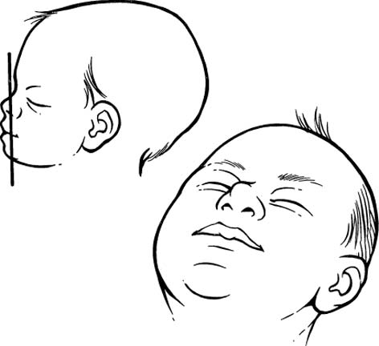

(A)Coronal ultrasound of the lips demonstrates the nose (N), upper lip (U), lower lip (L) and hypoechoic linear region in the midline between the upper lip and the nose corresponding to the normal philtrum (P). (B) Coronal view of the lips with open mouth shows nose (N), upper (U) and lower (L) lips, and the normal philtrum (P).
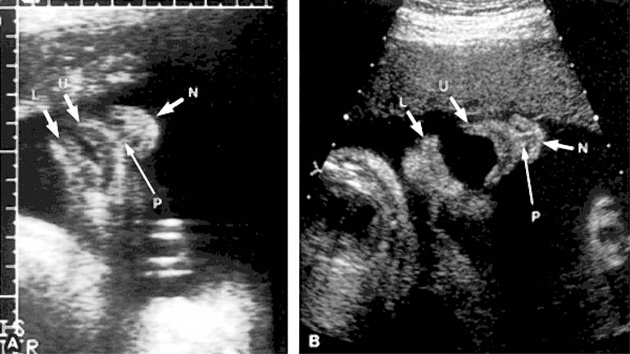

The normal mid-sagittal facial profile view. Note the echogenic nasal bridge, the normal maxilla, and the normally formed mandible.

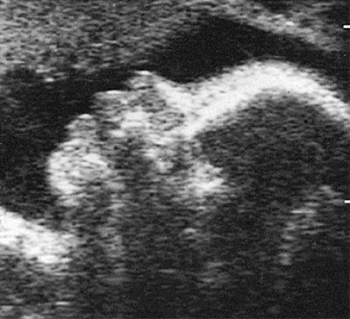

The variable facial features of holoprosencephaly in contrast to the normal facial features.

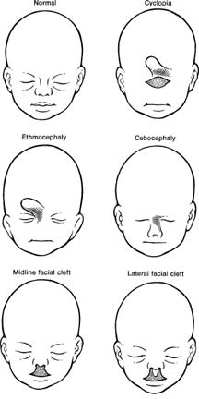

Cyclopia. (A) In utero coronal ultrasound of the face shows two fused orbits (O). F, forehead; M, mandible. (B) Axial ultrasound of the face demonstrates two fused orbits (O) and anteriorly located proboscis (P). (C) Mid-sagittal profile view demonstrates the proboscis (P) above the fused orbits (O). (D) Gross specimen shows cyclopia with median fused orbits (C) and the proboscis (P). Note that the normal fold of upper lip, the philtrum, is absent (open curved arrow).

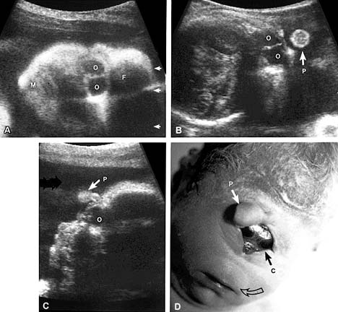

Various types of cleft lip and cleft palate. (A) Normal lip and palate. (B) Unilateral cleft lip extending into the nose. (C) Complete unilateral cleft of the lip and alveolar process with unilateral cleft of the anterior or primary palate. (D) Bilateral cleft of the lip and alveolar process with bilateral cleft of the anterior palate. (E) Isolated cleft palate. (F) Bilateral cleft of the lip and alveolar process with bilateral cleft of the anterior and posterior palate. Can also occur with unilateral anterior cleft.

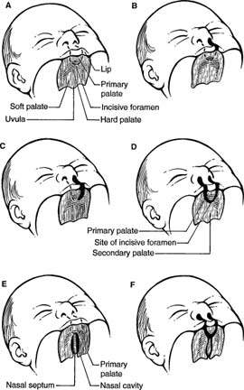

Lateral cleft lip. (A) Coronal scan through the nose (N) demonstrates a small, hypoechoic region lateral to the midline in the upper lip, which extends to the nares and corresponds to a lateral cleft lip (C). (B) Specimen from another fetus demonstrates typical findings of isolated lateral cleft lip extending lateral of midline in the upper lip to the nares.

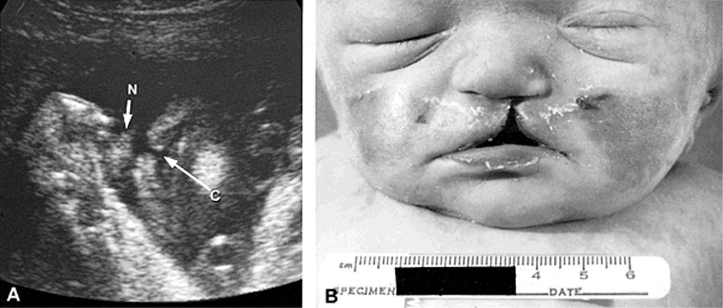

Macroglossia. Sagittal sonogram (A) and corresponding drawing (B) of the mouth show a protuberant tongue extending through the open mouth in this 30-week fetus with Beckwith-Wiedemann syndrome. UL, upper lip (labrale superius); T, enlarged tongue (lingua); LL, lower lip (labrale inferius); C, chin. (Cobellis G, Iannoto P, Stabile M, et al. Prenatal ultrasound diagnosis of macroglossia in the Wiedemann-Beckwith syndrome. Prenat Diagn 1988;8:79)

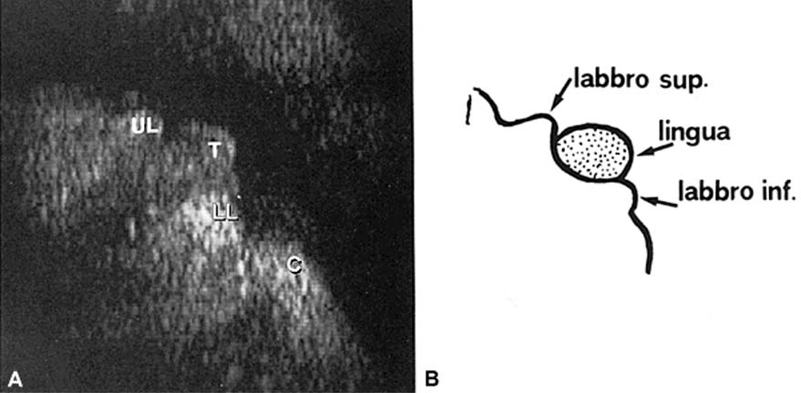

Cystic hygroma plus hydrops. Septated cystic hygroma (curved arrow) posterior to the occiput (O) with associated skin thickening (open arrows.
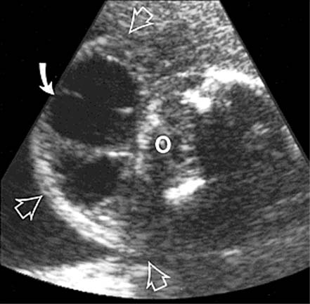

Diagram demonstrating typical features of cystic hygroma.

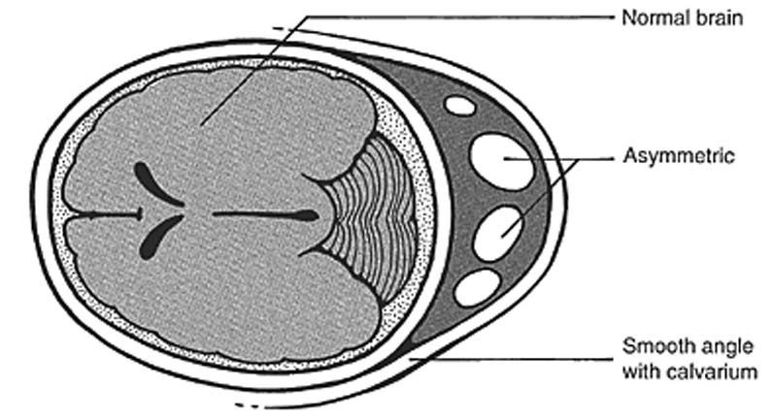

Various appearances of cephaloceles. Diagram of a cephalocele demonstrating several common features, including occipital location, bony defect, and variable herniation of brain into cephalocele sac. Note acute angulation of the margin of the cephalocele and the bony calvarium.

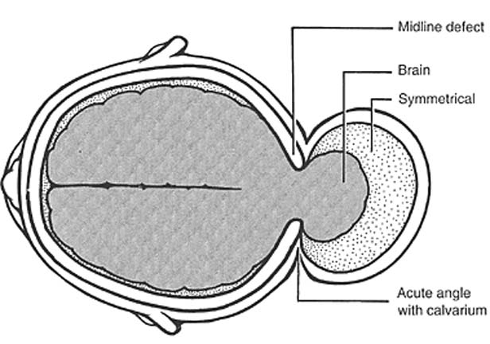

Cystic cephalocele (arrows) with herniation of meninges but little or no brain. Note acute angulation of cephalocele with bony calvarium (curved arrow). Cerebellar hemispheres (C) are identified, but with obliteration of cisterna magna.

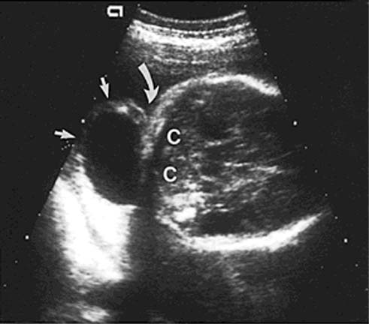

Occipital cephalocele (outlined by arrows) is a complex mass due to both herniated meninges and brain tissue. LV, dilated lateral ventricles.

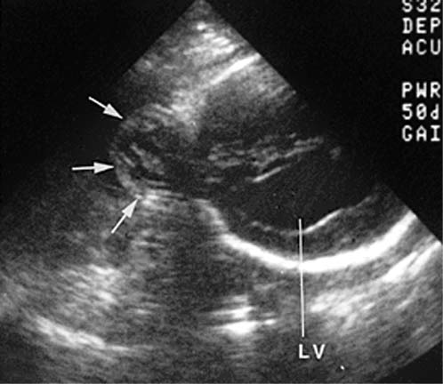

Fetal goiter. Axial scan of neck (closed arrows) demonstrating a goiter. The neck vessels are indicated by open arrows. The trachea (T) can be seen between the lobes of the thyroid. B, vertebral body of spine. (Bromley B, Frigoletto FD Jr, Cramer D, et al. The fetal thyroid: normal and abnormal sonographic measurements. J ultrasound Med 1992;11:25)

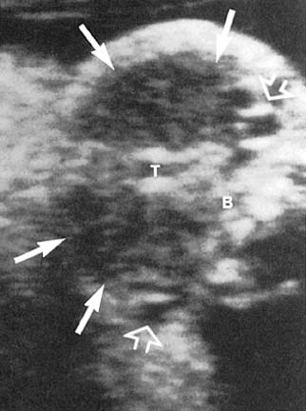

Teratoma. (A) Prenatal fetal sonogram demonstrating a complex mass (large curved arrow), chin (solid arrow), and anterior chest wall (open arrow). A pleural effusion is also identified (small curved arrow). (B) Postmortem photograph of the same patient demonstrating the extent of the complex mass. (C) Diagram demonstrating the technique of intubation in utero. The head is brought out through a low transverse uterine incision, and the endotracheal tube is placed. The infant is then delivered and the cord clamped. (Langer JC, Tabb T, Thompson P et al. Management of prenatally diagnosed tracheal obstruction: access to the airway in utero prior to delivery. Fetal Diagn Ther 1992;7:12)

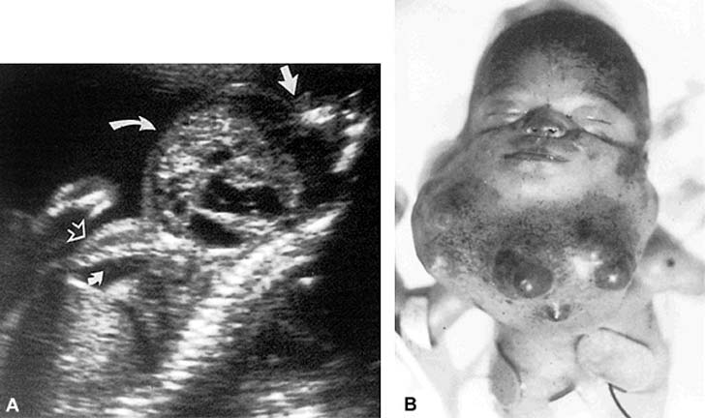

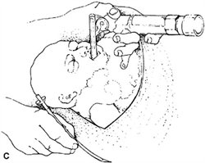

Nuchal thickening (Down syndrome). Transverse view of the head in a second-trimester fetus with Down syndrome. Note the thickened nuchal fold of 6.2mm (arrows). C, cerebellar hemispheres; T, thalami. (Benacerraf BR, Greene MF, Barss VA. Prenatal sonographic diagnosis of congenital hemivertebra. J Ultrasound Med 1986;5:257)

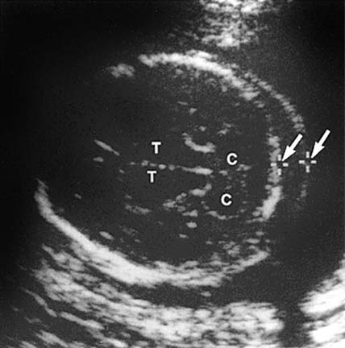

Nuchal skin thickness. (A) Correct plane and technique for measuring nuchal skinfold thickness. Critical landmarks include the cavum septi pellucidi (short arrow), cerebral peduncles (long arrow), and cerebellar hemispheres (broad arrow). Calipers are placed from the outer skull table to the outer skin surface. (B) If the transducer is not angled in the correct plane (1) but is too steep (2), this produces incorrect measurement of nuchal skin thickness. (A from Crane JP, Gray DL. Sonographically measured nuchal skinfold thickness as a screening tool for Down syndrome: results of a prospective clinical trial. Obstet Gynecol 1991;77:533)

