Uterine synechiae. Scan along the axis of the adhesion shows a linear structure (arrowheads) that is centrally hypoechoic, extending to the endometrial margin at both ends. The fetus (F) is neither tethered nor deformed by the synechia.
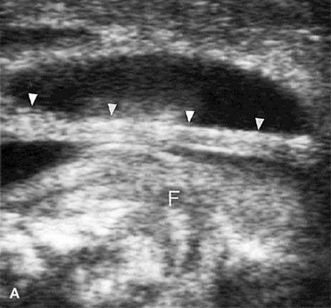

Scan axial to the synechia, in a different patient, shows the free edge to be bulbous (curved arrow), with the overlying membranes separating from each other at the endometrial margin, producing a Y-shaped split (straight arrows). (Finberg H. Umbilical cord and amniotic membranes. In: McGahan J, Porto M, eds. Diagnostic obstetrical ultrasound. Philadelphia, JB Lippincott, 1994)

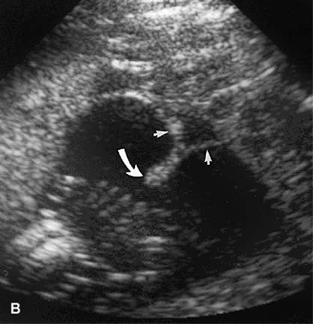

Circumvallate placenta in an 18-week, asymptomatic pregnancy. Scan along a diameter of the placenta shows the infolded margins (arrows).
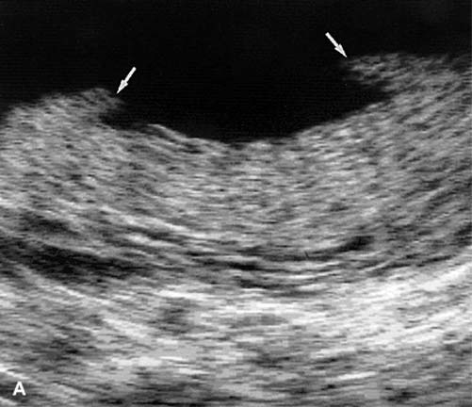

Scan along a more peripheral arc of the placenta shows the infolded margin as a continuous linear band parallel to the chorionic surface, with fluid (F) trapped in the fold. (Finberg H. Umbilical cord and amniotic membranes. In: McGahan J, Porto M, eds. Diagnostic obstetrical ultrasound. Philadelphia, JB Lippincott, 1994)
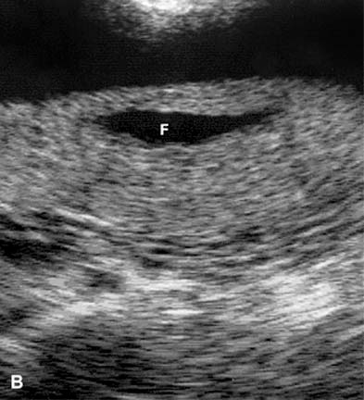

The amniotic fluid index (AFI) is calculated by adding the largest vertical pocket of amniotic fluid in the four quadrants of the pregnant uterus.

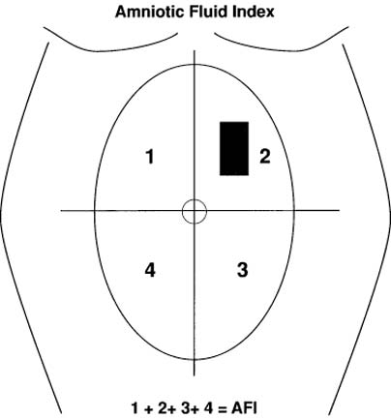

Fetus with bilateral infantile polycystic kidney disease and oligohydramnios. The kidneys are enlarged and echogenic.

