Normal four chamber view of the heart. (A). Schematic drawing through the normal fetal thorax shows four cardiac chambers. A line drawn through the interventricular septum traverses a plane approximately 45 degrees with a line drawn between the fetal spine and the sternum. (B) Magnified sonogram of the fetal heart and thorax shows four chambers. The muscles of the right ventricle (RV; arrowhead) and atrioventricular valves (arrows) have a trabeculated appearance. LV, left ventricle; RA , right atrium; LA, left atrium; S, spine. (A from Comstock CH. Normal fetal heart axis and position. Obstet Gynecol 1987;70:2; B from McGahan JP. Sonography of the fetal heart: findings on the four-chamber view. AJR Am J Roentgenol 1991;156:547)

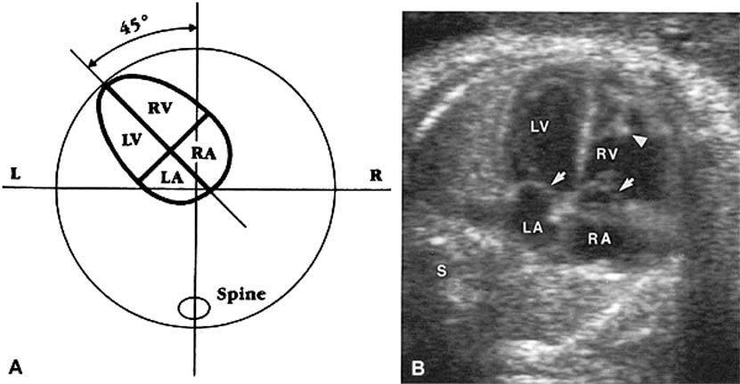

Ventricular septal defect (VSD): color imaging. A VSD lies in the muscular portion of the ventricular septum (arrow).

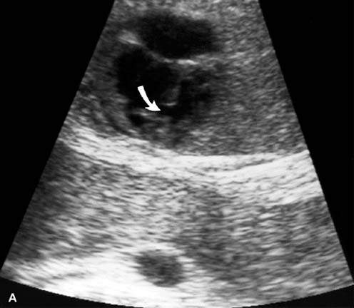

Echogenic foci. These foci (arrows) are observed within both right (R) and left (L) ventricles in this fetus. S, fetal spine.

