Scan at 31 weeks shows separate placental tissue at three locations (P1,P2, P3). The examination demonstrated five separate placental lobes.
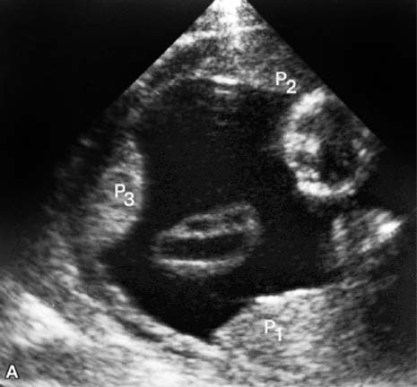

Maternal surface of the placenta after delivery. Four succenturiate lobes (arrows) were connected to the main placenta (P) by vessels.
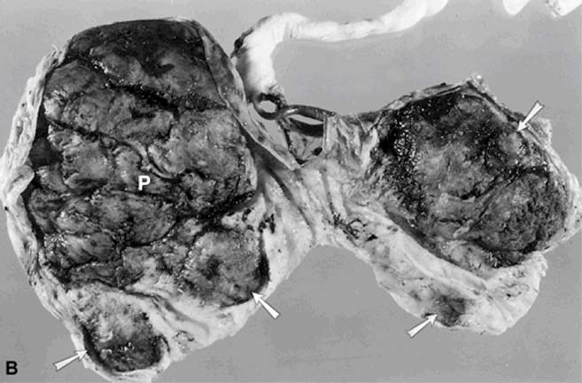

Anatomy of the placenta. Drawing of the placental circulation. U, umbilical cord; arrow, umbilical artery branching in chorion; arrowhead, umbilical vein in chorion; SA, spiral arteriole; V, maternal draining veins. (Spirt BA, Kagan EH. Sonography of the placenta. Semin Ultrasound 1980;1:293)
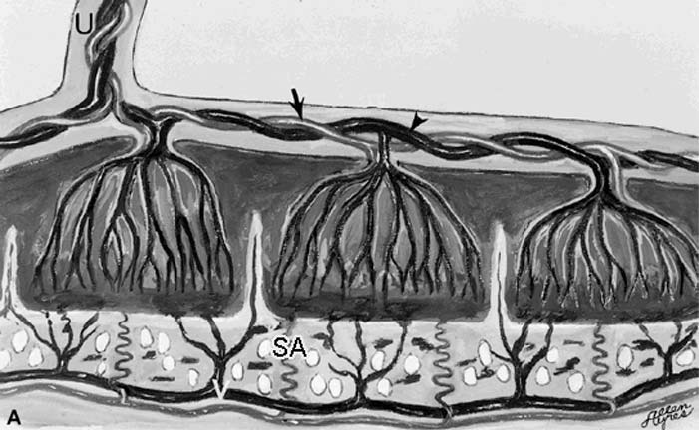

Anterior placenta at 29.6 weeks. The placenta (P) maintains a typical granular echotexture. Vessels are seen along the fetal surface, particularly adjacent to the umbilical cord insertion (arrow). Retroplacental draining veins (arrowheads) are visible. F, fetus. (Spirt BA, Gordon LP. The placenta and cervix. In: McGahan JP, Porto M, eds. Diagnostic obstetrical ultrasound. Philadelphia, JB Lippincott, 1994:83)
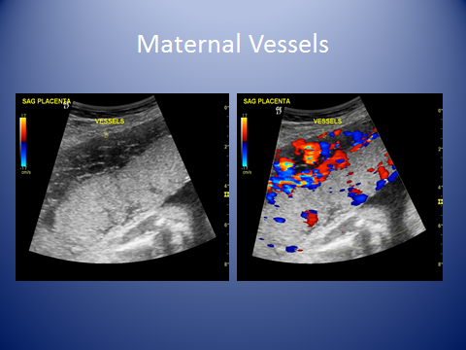
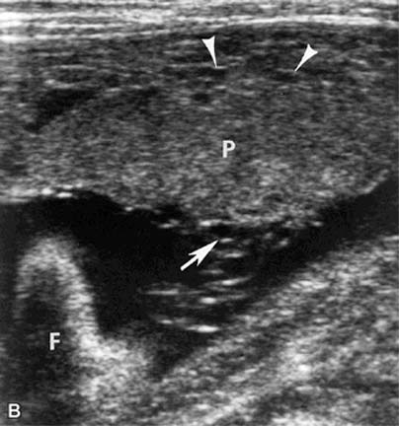

Hydatidiform mole with coexistent fetus. Sector scan at 13 weeks shows a large anterior mass (arrows) containing multiple anechoic vesicles of varying sizes, along with a fetus (F) and a separate posterior placenta (P). (Spirt BA, Gordon LP. Imaging of the placenta. In: Taveras JM, Ferrucci JT, eds. Radiology: diagnosis, imaging, intervention. Philadelphia, JB Lippincott, 1992)
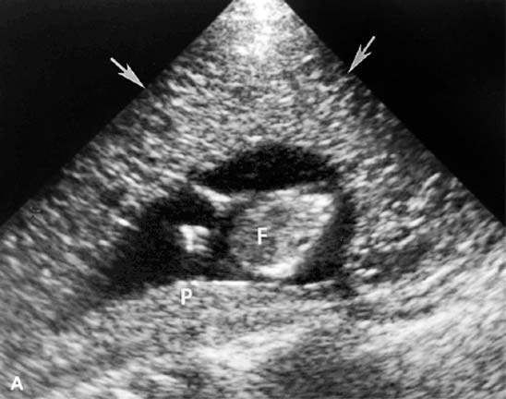

At delivery, a hydatidiform mole (M) was found separate from the placenta (P) and fetus. (Spirt BA, Gordon LP. Practical aspects of placental evaluation. Semin Roentegenol 1991;26:32)
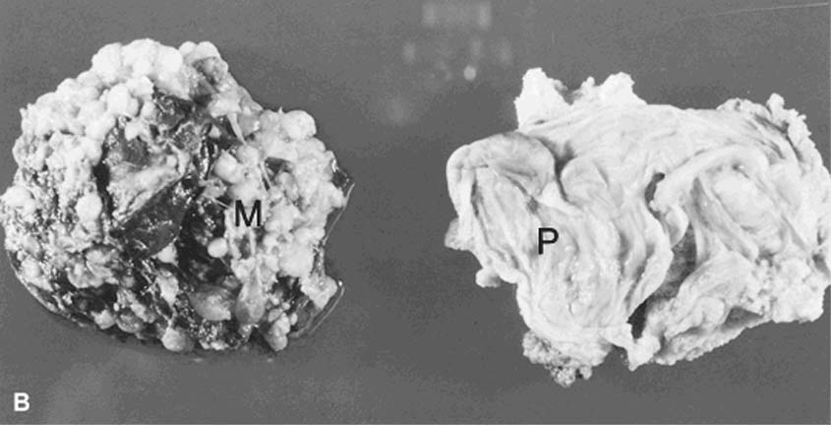

Cross section of the placenta shows a large subchorionic chorioangioma beneath the umbilical cord insertion. Vessels of varying size are visible within the mass. (Spirt BA, Gordon LP, Cohen WN et al. Antenatal diagnosis of chorioangioma of the placenta. AJR Am J Roentgenol 1980;135:11273)
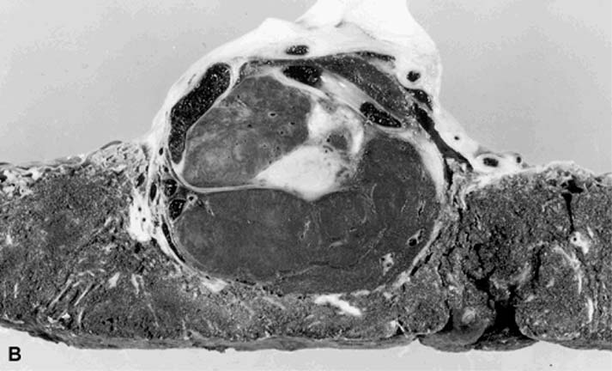

Chorioangioma. A Doppler cursor placed within a well-circumscribed mass bulging from the fetal surface of the placenta (P) confirms the vascularity of the lesion (Spirt BA, Gordon LP. The placenta and cervix. In: McGahan JP, Porto M, eds. Diagnostic obstetrical ultrasound. Philadelphia, JB Lippincott, 1994:83)
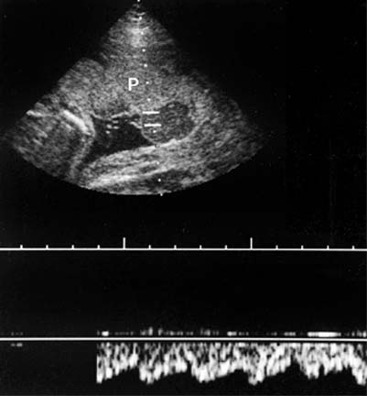

Contraction. Sagittal scan at 16 weeks shows a contraction involving the anterior placenta (P). The retroplacental myometrium shows a hypoechoic "pseudomass" (arrows). The myometrium of the posterior wall of the uterus appears smooth and thin (arrowhead). F, fetus.
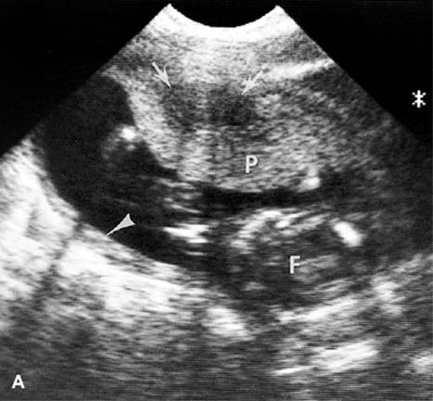

After 20 minutes, the anterior placenta (P) appears smooth and the retroplacental myometrium is uniform and thin (arrows). The contraction involves the posterior myometrium (arrowhead) . (Spirt BA, Gordon LP. The placenta. IN: Rumack CM, Wilson SR, Charbonneau JW, eds. Diagnostic ultrasound. St. Louis, Mosby-Year Book, 1991:935)
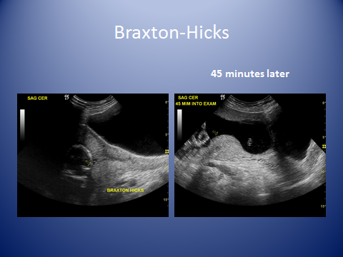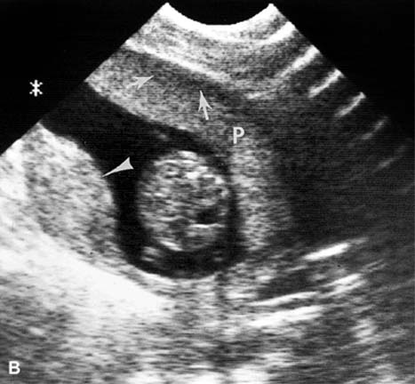
Abruptio placenta. Transverse scan at 35 weeks shows a large hyperechoic retroplacental hematoma (arrows). P, placenta; F, fetus. The patient was hypotensive, with acute vaginal bleeding. At cesarean section, a 75% abruption was found. (Sprit BA, Gordon LP. Sonography of the placenta. IN: Fleischer AC, Romero R, Manning FA, et al eds. The principles and practice of ultrasonography in obstetrics and gynecology, ed 4. Norwalk CT, Appleton and Lange, 1991)
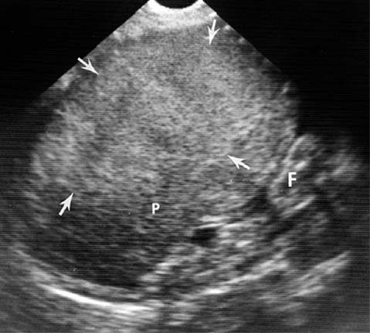

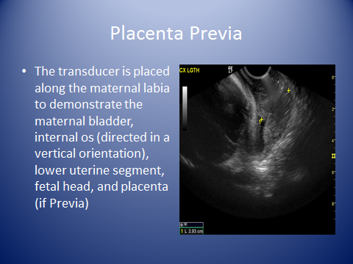

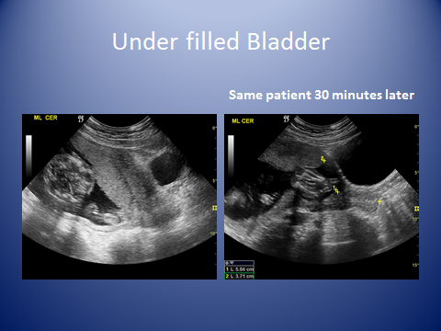
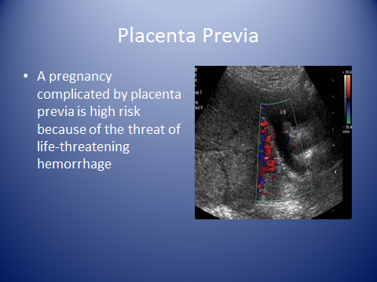
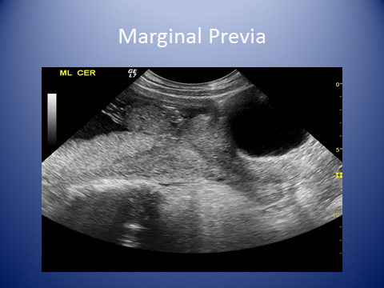
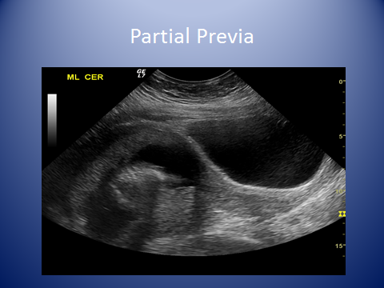
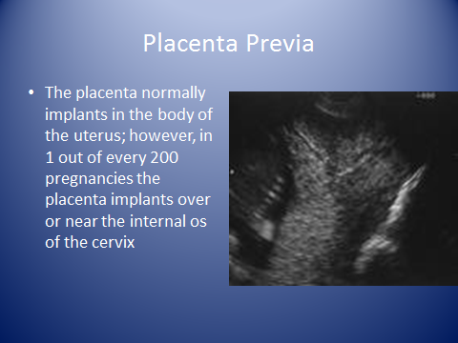
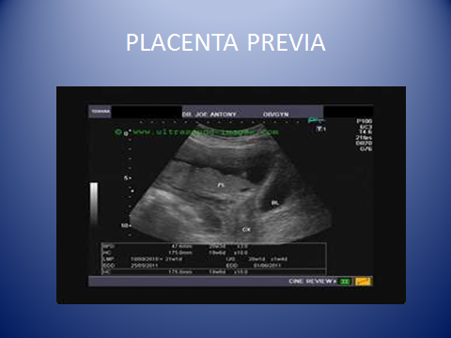

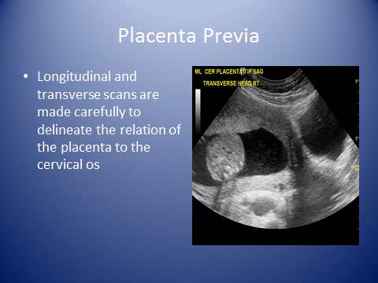

Placenta previa. Midline sagittal scan at 28 weeks shows the posterior placenta (P) completely covering the cervix (C). B, maternal bladder. (Spirt BA, Gordon LP. Practical aspects of placental evaluation. Semin Roentgenol 1991;26:32)
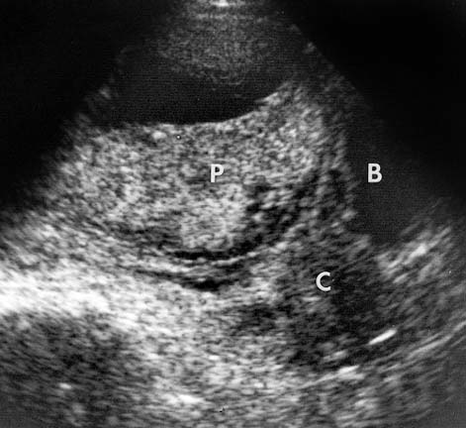

Bladder effect mimicking placenta previa. Sagittal midline scan at 22.5 weeks shows an apparent placenta previa. B, maternal bladder
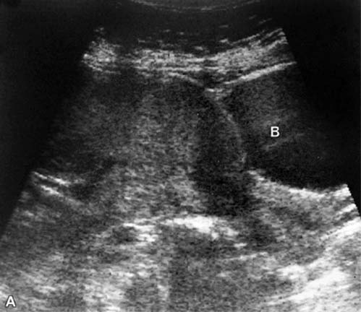

Repeat scan after voiding shows the anterior placenta (P) to be well away from the internal cervical os (arrow), (Spirt BA, Gordon LP. Imaging of the placenta. In: Taveras JM, Ferrucci JT, eds. Radiology: diagnosis, imaging, intervention. Philadelphia, JB Lippincott, 1992)
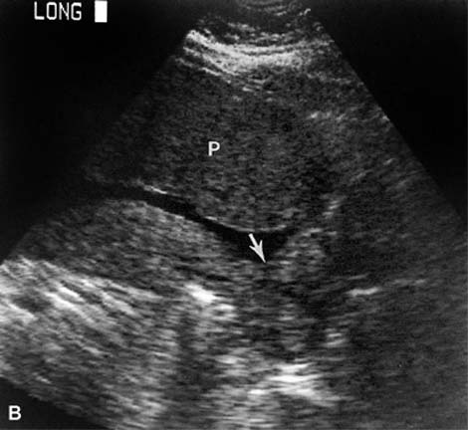

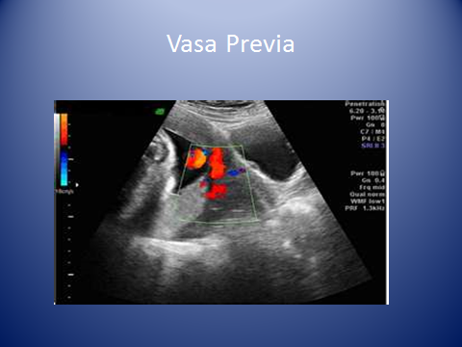

Cervical incompetence. Transabdominal scan at 16 weeks shows the amniotic sac protruding through the open cervix (C) into the vagina (V). The patient miscarried several hours after the examination. B, maternal bladder. (Spirt BA, Gordon LP. The placenta and cervix. In: McGahan JP, Porto M, eds. Diagnostic obstetrical ultrasound. Philadelphia, JB Lippincott, 1994:83)
