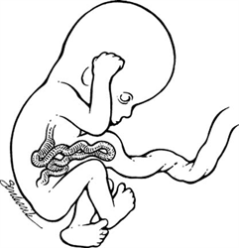

Figure - 15-2.
Normal gut migration. The bowel normally herniates into the base of the umbilical cord between 8 and 12 menstrual weeks and returns to the abdominal cavity by 12 weeks. This early herniation should not be confused with an omphalocele. (Modified from Cyr DR, Bach LA, Schoeneker SA, et al. Bowel migration in the normal fetus: US detection. Radiology 1986;1961:119)

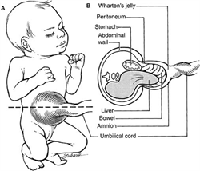

Figure - 15-12.
Typical features of omphalocele containing liver and bowel on (A) external examination and (B) cross-sectional view. This defect, unlike gastroschisis, is covered by both the amnion and peritoneum and can contain a number of structures, including the liver, bowel, and fetal stomach. (Modified from Callen PW, ed. Ultrasonography in obstetrics and gynecology, ed 2. Philadelphia, WB Saunders, 1988:245.)

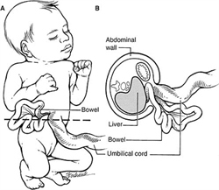

Typical features of gastroschisis demonstrated on (A) external examination and (B) cross-sectional view. The ventral wall defect is right paraumbilical, with bowel loops floating free in the amniotic fluid. (Modified from Callen PW, ed. Ultrasonography in obstetrics and gynecology, ed. Philadelphia, WB Saunders, 1988:241)

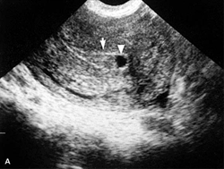

Figure - 6-13a.
Decidual cast. (A) Sagittal and (B) coronal sonograms of the uterus. The "pseudogestational sac" is composed of fluid (arrowhead) and debris (c) within the endometrium, surrounded by a single layer of decidua. (Levi C, Dashefsky D, Lyons E, et al. First trimester ultrasound: a practical approach. In: McGahan J, Porto M, eds. Diagnostic obstetrical ultrasound. Philadelphia, JB Lippincott, 1994)

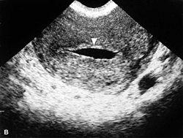

Figure - 6-13b.
Decidual cast. (A) Sagittal and (B) coronal sonograms of the uterus. The "pseudogestational sac" is composed of fluid (arrowhead) and debris (c) within the endometrium, surrounded by a single layer of decidua. (Levi C, Dashefsky D, Lyons E, et al. First trimester ultrasound: a practical approach. In: McGahan J, Porto M, eds. Diagnostic obstetrical ultrasound. Philadelphia, JB Lippincott, 1994)

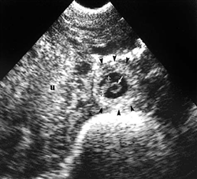

Figure - 6-15.
Live ectopic pregnancy. A 7 mm embryo (calipers) and yolk sac (arrow) are visualized within a well-defined trophoblastic ring (arrowheads). The sac is situated in the posterior cul-de-sac, adjacent to the uterus (u). Embryonic cardiac activity was identified at sonography. (Levi C, Dashefsky D, Lyons E, et al. First trimester ultrasound: a practical approach. In: McGahan J, Porto M, eds. Diagnostic obstetrical ultrasound. Philadelphia, JB Lippincott, 1994)

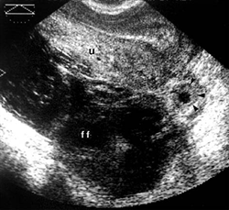

Figure - 6-16.
Ectopic pregnancy: tubal ring. An extrauterine trophoblastic ring (arrowheads) is visualized adjacent to the uterus (u). Fluid (ff) and blood clot are present in the posterior cul-de-sac. The uterus is retroverted. (Levi C, Dashefsky D, Lyons E, et al. First trimester ultrasound: a practical approach. In: McGahan J, Porto M, eds. Diagnostic obstetrical ultrasound. Philadelphia, JB Lippincott, 1994)

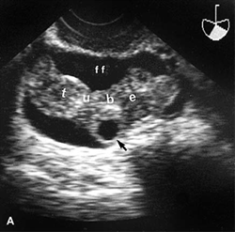

Figure - 6-18a.
Ectopic pregnancy: gray scale and Doppler findings. Coronol sonogram through the right adnexa shows a fallopian tube (tube) filled with echogenic fluid (blood) and a trophoblastic ring (arrow) Echo-free fluid (ff)
surrounds the tube

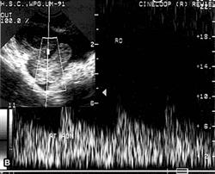

Figure - 6-18b.
Doppler interrogation of the right adnexa demonstrates high-velocity, low-resistance flow. (Levi C, Dashefsky D, Lyons E, et al. First trimester ultrasound: a practical approach. In: McGahan J, Porto M, eds. Diagnostic obstetrical ultrasound. Philadelphia, JB Lippincott, 1994)

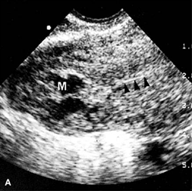

Figure - 6-19a.
Interstitial ectopic pregnancy. Coronal sonogram through the right cornu of the uterus shows the endometrium (arrowheads) extending into a inhomogeneous mass (M).

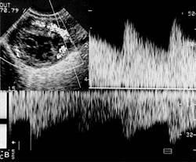

Figure - 6-19b.
Endovaginal color flow Doppler and (C) pulsed Doppler demonstrate peritrophoblasic flow. (Levi C, Dashefsky D, Lyons E, et al. First trimester ultrasound: a practical approach. In: McGahan J, Porto M, eds. Diagnostic obstetrical ultrasound. Philadelphia, JB Lippincott, 1994)

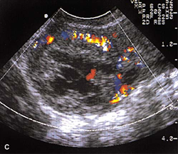

Figure - 6-19c.
Endovaginal color flow Doppler and (C) pulsed Doppler demonstrate peritrophoblasic flow. (Levi C, Dashefsky D, Lyons E, et al. First trimester ultrasound: a practical approach. In: McGahan J, Porto M, eds. Diagnostic obstetrical ultrasound. Philadelphia, JB Lippincott, 1994)

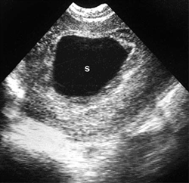

Figure - 6-23.
Early pregnancy failure: abnormal gestational sac size. Coronal endovaginal sonogram shows a gestational sac (s) with a mean diameter of approximately 3cm. Neither a yolk sac nor an embryo is identified. (Levi C, Dashefsky D, Lyons E, et al. First trimester ultrasound: a practical approach. In: McGahan J, Porto M, eds. Diagnostic obstetrical ultrasound. Philadelphia, JB Lippincott, 1994)

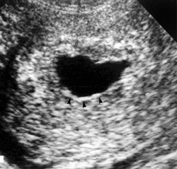

Figure - 6-25.
Early pregnancy failure: distorted gestational sac, thin decidual reaction, weak decidual amplitude. Coronal sonogram shows a sac with a grossly irregular shape and a thin decidual reaction (arrowhead). (Levi C, Dashefsky D, Lyons E, et al. First trimester ultrasound: a practical approach. In: McGahan J, Porto M, eds. Diagnostic obstetrical ultrasound. Philadelphia, JB Lippincott, 1994)

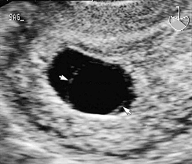

Figure - 6-26.
Early pregnancy failure: endovaginal sonogram in the sagittal plane in a patient presenting with bleeding. The amnion (arrows) is visualized in the absence of the detectable embryo.

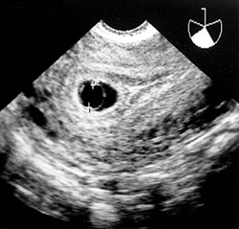

Figure - 6-30.
Large yolk sac. Endovaginal sonography (sagittal plane) at 5.5 weeks shows an abnormally large yolk sac (calipers) with an internal diameter of 7.5 mm. (Levi C, Dashefsky D, Lyons E, et al. First trimester ultrasound: a practical approach. In: McGahan J, Porto M, eds. Diagnostic obstetrical ultrasound. Philadelphia, JB Lippincott, 1994)

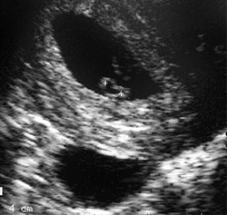

Figure - 6-31.
Irregular yolk sac. Endovaginal sonography shows an irregular, 3 mm yolk sac (calipers). (Levi C, Dashefsky D, Lyons E, et al. First trimester ultrasound: a practical approach. In: McGahan J, Porto M, eds. Diagnostic obstetrical ultrasound. Philadelphia, JB Lippincott, 1994)

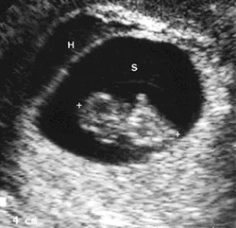

Figure - 6-32.
Subchorionic hemorrhage. Endovaginal sonogram demonstrates a subchorionic hemorrhage (H) within the endometrial canal adjacent to a gestational sac (S) that contains a live embryo with a crown-rump length of 18.5 mm (8.5 to 9 weeks menstrual age). (Levi C, Dashefsky D, Lyons E, et al. First trimester ultrasound: a practical approach. In: McGahan J, Porto M, eds. Diagnostic obstetrical ultrasound. Philadelphia, JB Lippincott, 1994)

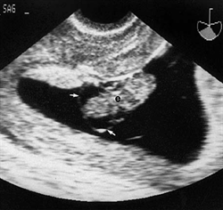

Figure - 6-33.
Cystic hygromas (9.5 weeks menstrual age). Endovaginal sonography shows bilateral cystic hygromas (arrows) in an embryo (e) with Turner syndrome. (Levi C, Dashefsky D, Lyons E, et al. First trimester ultrasound: a practical approach. In: McGahan J, Porto M, eds. Diagnostic obstetrical ultrasound. Philadelphia, JB Lippincott, 1994)

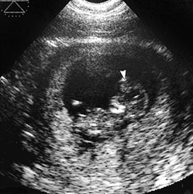

Figure - 6-34.
Encephalocele. Anterior encephalocele (arrowhead) at 10.5 weeks menstrual age. (Levi C, Dashefsky D, Lyons E, et al. First trimester ultrasound: a practical approach. In: McGahan J, Porto M, eds. Diagnostic obstetrical ultrasound. Philadelphia, JB Lippincott, 1994)

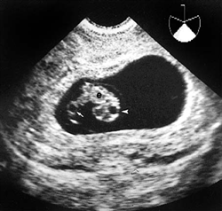

Figure - 6-36.
Umbilical cord cyst. A 2 mm cyst (arrow) is present in the umbilical cord of this normal embryo (e) at 9 weeks menstrual age. A normal fourth ventricle (arrowhead) is also shown. A subsequent sonogram at 16.5 weeks showed a normal fetus and disappearance of the cord cyst. (Levi C, Dashefsky D, Lyons E, et al. First trimester ultrasound: a practical approach. In: McGahan J, Porto M, eds. Diagnostic obstetrical ultrasound. Philadelphia, JB Lippincott, 1994)

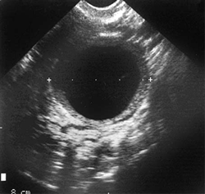

Figure - 6-37.
Corpus luteum cyst of pregnancy. Endovaginal sonogram in the coronal plane through the left adnexa of a patient in early pregnancy shows a 4.5 cm corpus luteum cyst (calipers). (Levi C, Dashefsky D, Lyons E, et al. First trimester ultrasound: a practical approach. In: McGahan J, Porto M, eds. Diagnostic obstetrical ultrasound. Philadelphia, JB Lippincott, 1994)

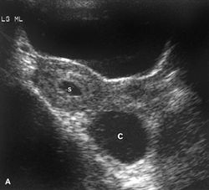
Figure - 6-38a.
Hemorrhagic corpus luteum cyst. Sagittal transvesical sonogram show the uterus with an early gestational sac (s) and a 4-cm corps luteum cyst (c) in the posterior cul-de-sac.

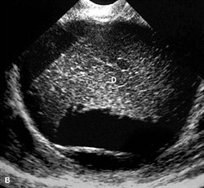

Figure - 6-38b.
Endovaginal sonography of the corpus luteum cyst show internal echogenic material (D) consistent with hemorrhage. (Levi C, Dashefsky D, Lyons E, et al. First trimester ultrasound: a practical approach. In: McGahan J, Porto M, eds. Diagnostic obstetrical ultrasound. Philadelphia, JB Lippincott, 1994)

