  
  Help your students perform, read, and interpret parasitology tests with confidence
  Now in full color, the second edition of Clinical Parasitology contains several new student-friendly features designed to hone students' skills and give them all the information needed to perform, read, and interpret parasitology tests in a clear and understandable way.
  - NEW! Full-color design throughout the book provides a more accessible look and feel.
  - NEW! Quick Quizzes, or periodic self-assessments, are included in each chapter to help students assess their knowledge.
  
   |  | 
    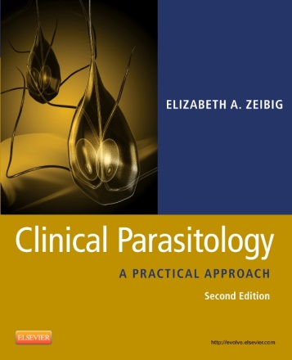
    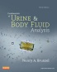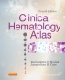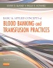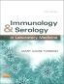
  
  Clinical Parasitology, 2nd Edition
  Elizabeth Zeibig, PhD, MT(ASCP), CLS(NCA)
  ISBN: 978-1-4160-6044-4



